**What is Selenium**

**Selenium** is a free (open-source) automated testing framework used to validate web applications across different browsers and platforms. You can use multiple programming languages like Java, C#, Python etc to create Selenium Test Scripts.

Selenium Software is not just a single tool but a suite of software, each piece catering to different Selenium QA testing needs of an organization. Here is the list of tools

* Selenium Integrated Development Environment (IDE)
* Selenium Remote Control (RC)
* WebDriver
* Selenium Grid

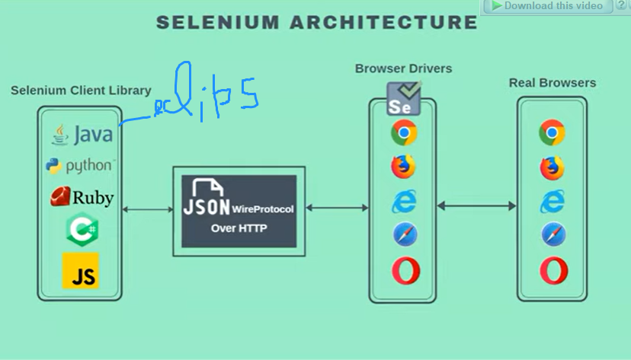

Yha eclips me jo code likhte h wo JSON me convert hta h and sent or post the request over HTTP to selenium browser driver then ye real browser k pas jata h and jo b response milta h wo wps eclips ko deta h broser driver and JSON se the hue ,tbhi ye arraow bi-directional h

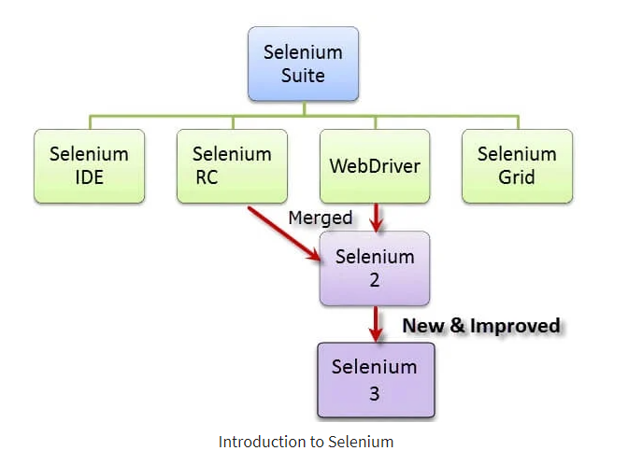

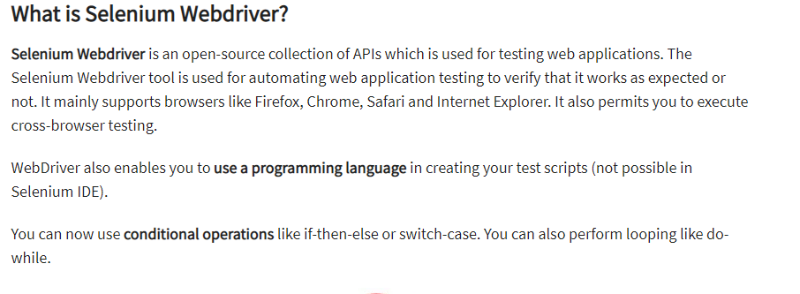

Following programming languages are supported by WebDriver

Java, .NET, PhP, Python, Perl, Ruby

## Difference between Selenium RC and Webdriver

Before the advent of WebDriver in  2006, there was another, **automation tool called Selenium Remote Control.**Both WebDriver and Selenium RC have following features:

* They both allow you to **use a programming language** in designing your test scripts.
* They both allow you to **run your tests against different browsers.**

So how do they differ? Let us discuss the answers.

* **WebDriver’s architecture is simpler than Selenium RC’s**.
* **WebDriver is faster than Selenium RC since it**speaks directly to the browser uses the browser’s own engine to control it.
* **Selenium RC is slower since it uses a Javascript program called Selenium Core.**This Selenium Core is the one that directly controls the browser, not you.

