1. Problem Statement
- To develop a user-friendly web application using HTML, CSS, and JavaScript to display and search college clubs, register students with validation, manage club memberships, display members, and publish upcoming events. Local Storage is used to save membership and event details.

2. Objectives
- To display college clubs dynamically.
- To search and filter clubs easily.
- To display club information and members.
- To register students with validation.
- To manage joining and leaving clubs.
- To add and display event announcements.

3. Architecture
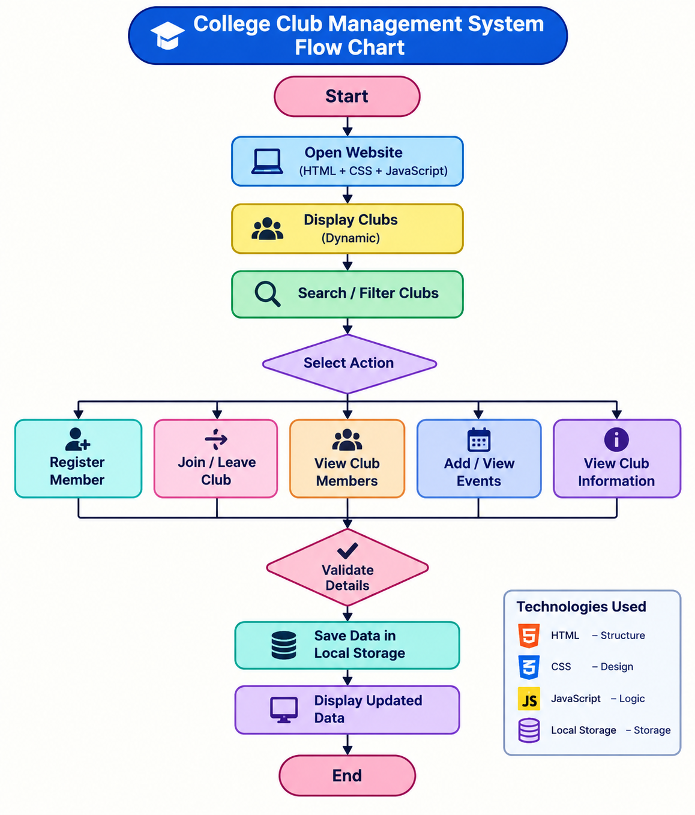

4. Practical Implementation
- Display college clubs and their details dynamically.
- Allow students to register, join clubs, and view events.
- Store membership and event details using Local Storage.
Dynamic display, search, and filter of college clubs.

4.1 Features Implemented
- Dynamic display, search, and filter of college clubs.
- Student registration, join/leave clubs, and member details.
- Event announcements, upcoming events, and Local Storage.

4.2 Source Code
HTML
<!DOCTYPE html>
<html lang="en">
<head>
<meta charset="UTF-8">
<meta name="viewport" content="width=device-width,initial-scale=1">
<title>Campus Club Hub</title>
<link rel="stylesheet" href="style.css">
</head>
<body>
<header>
<h1>🎓 Campus Club Hub</h1>
<p>Discover Clubs | Join Communities | Explore Events</p>
</header>
<main class="container">
<div class="stats">
<div class="stat"><h2 id="clubCount">0</h2>Available Clubs</div>
<div class="stat"><h2 id="memberCount">0</h2>Memberships</div>
<div class="stat"><h2 id="eventCount">0</h2>Upcoming Events</div>
</div>
<section class="panel">
<h2>🔎 Explore Clubs</h2>
<input id="search" placeholder="Search clubs...">
<select id="categoryFilter">
<option value="All">All Categories</option>
<option>Technology</option>
<option>Arts</option>
<option>Sports</option>
<option>Social Service</option>
<option>Literature</option>
</select>
</section>
<section class="panel" id="registration">
<h2>📝 Student Registration</h2>
<form id="registrationForm">
<input id="studentName" placeholder="Full Name" minlength="3" required>
<input id="studentId" placeholder="Student ID" required>
<input id="studentEmail" type="email" placeholder="Email" required>
<input id="studentPhone" type="tel" pattern="[0-9]{10}"
placeholder="10-digit Phone" required>
<select id="joinClub" required></select>
<button type="submit">Register & Join Club</button>
</form>
<p id="message" class="notice" hidden></p>
</section>
<section>
<h2>🌟 Available Clubs</h2>
<div id="clubList" class="clubs"></div>
</section>
<section class="panel">
<h2>👥 Club Memberships</h2>
<div id="myMemberships"></div>
</section>
<section class="panel">
<h2>📢 Publish Event</h2>
<form id="eventForm">
<input id="eventTitle" placeholder="Event Title" required>
<select id="eventClub" required></select>
<input id="eventDate" type="date" required>
<input id="eventVenue" placeholder="Event Venue" required>
<textarea id="eventDescription" placeholder="Event Description" required></textarea>
<button type="submit">Publish Event</button>
</form>
</section>
<section class="panel">
<h2>📅 Upcoming Events</h2>
<div id="eventList" class="events"></div>
</section>
</main>
<script src="script.js"></script>
</body>
</html>

CSS
* { box-sizing: border-box; }
body {
margin: 0;
font-family: Arial;
background: #f1f5f9;
color: #1e293b;
}
header {
background: linear-gradient(120deg,#312e81,#7c3aed);
color: white;
text-align: center;
padding: 25px 12px;
}
.container {
max-width: 1100px;
margin: auto;
padding: 16px;
}
.stats, .clubs, .events {
display: grid;
grid-template-columns: repeat(auto-fit,minmax(220px,1fr));
gap: 14px;
}
.panel, .card, .stat {
background: white;
padding: 16px;
border-radius: 14px;
box-shadow: 0 3px 12px #0001;
margin-bottom: 16px;
}
.stat { text-align: center; }
.stat h2, .card h3 { color: #7c3aed; }
input, select, textarea, button {
width: 100%;
padding: 11px;
margin: 6px 0;
border: 1px solid #cbd5e1;
border-radius: 8px;
font-size: 15px;
}
button {
background: #6d28d9;
color: white;
border: 0;
font-weight: bold;
cursor: pointer;
}
button:hover { opacity: .85; }
.secondary { background: #475569; }
.danger { background: #dc2626; }
.tag {
background: #ede9fe;
color: #5b21b6;
padding: 5px 9px;
border-radius: 15px;
font-size: 12px;
}
.member-list, .notice {
background: #f8fafc;
padding: 10px;
border-radius: 8px;
}

JavaScript
const defaultClubs = [
{id:1,name:"Coding Club",category:"Technology",icon:"💻",description:"Learn web development."},
{id:2,name:"Arts Club",category:"Arts",icon:"🎨",description:"Explore art and creativity."},
{id:3,name:"Sports Club",category:"Sports",icon:"🏆",description:"Join games and tournaments."},
{id:4,name:"Social Service Club",category:"Social Service",icon:"🤝",description:"Help people through volunteering."},
{id:5,name:"Literature Club",category:"Literature",icon:"📚",description:"Enjoy reading and writing."},
{id:6,name:"Robotics Club",category:"Technology",icon:"🤖",description:"Explore robotics and innovation."}
];

function loadData(key, fallback) {
try {
const data = JSON.parse(localStorage.getItem(key));
return data === null ? fallback : data;
} catch {
return fallback;
}
}

let clubs = loadData("campusClubs", defaultClubs);
let members = loadData("campusMembers", []);
let events = loadData("campusEvents", []);

function saveData() {
localStorage.setItem("campusClubs", JSON.stringify(clubs));
localStorage.setItem("campusMembers", JSON.stringify(members));
localStorage.setItem("campusEvents", JSON.stringify(events));
}

function safe(value) {
return String(value).replace(/[&<>"']/g, char => ({
"&":"&amp;", "<":"&lt;", ">":"&gt;",
'"':"&quot;", "'":"&#39;"
}[char]));
}

function updateClubOptions() {
const options = clubs.map(c =>
`<option value="${c.id}">${safe(c.name)}</option>`
).join("");
document.getElementById("joinClub").innerHTML =
'<option value="">Select a Club</option>' + options;
document.getElementById("eventClub").innerHTML =
'<option value="">Select a Club</option>' + options;
}

function renderClubs() {
const query = document.getElementById("search").value.toLowerCase();
const category = document.getElementById("categoryFilter").value;
const filtered = clubs.filter(c =>
(c.name + " " + c.description + " " + c.category)
.toLowerCase().includes(query) &&
(category === "All" || c.category === category)
);
document.getElementById("clubList").innerHTML =
filtered.map(c => {
const count = members.filter(m => m.clubId === c.id).length;
const joined = members.some(m => m.clubId === c.id);
return `
<article class="card">
<h3>${c.icon} ${safe(c.name)}</h3>
<span class="tag">${safe(c.category)}</span>
<p>${safe(c.description)}</p>
<p><b>Members:</b> ${count}</p>
<button class="secondary" onclick="viewMembers(${c.id})">View Members</button>
${joined
? `<button class="danger" onclick="leaveClub(${c.id})">Leave Club</button>`
: `<button onclick="chooseClub(${c.id})">Join Club</button>`}
<div id="memberList${c.id}" class="member-list" hidden></div>
</article>`;
}).join("") || "<p>No clubs found.</p>";
document.getElementById("clubCount").textContent = clubs.length;
document.getElementById("memberCount").textContent = members.length;
}

document.getElementById("search").addEventListener("input", renderClubs);
document.getElementById("categoryFilter").addEventListener("change", renderClubs);

function chooseClub(id) {
document.getElementById("joinClub").value = id;
document.getElementById("registration").scrollIntoView({behavior:"smooth"});
}

document.getElementById("registrationForm").addEventListener("submit",
function(e) {
e.preventDefault();
const name = document.getElementById("studentName").value.trim();
const studentId = document.getElementById("studentId").value.trim();
const email = document.getElementById("studentEmail").value.trim();
const phone = document.getElementById("studentPhone").value.trim();
const clubId = Number(document.getElementById("joinClub").value);

if (name.length < 3 || !/^[0-9]{10}$/.test(phone)) {
alert("Enter a valid name and 10-digit phone number.");
return;
}
if (members.some(m =>
m.studentId.toLowerCase() === studentId.toLowerCase() &&
m.clubId === clubId
)) {
alert("Already joined this club.");
return;
}
members.push({
id: Date.now(), name, studentId, email, phone, clubId,
joinedOn: new Date().toISOString().slice(0,10)
});
saveData();
this.reset();
renderAll();
showMessage("Registration successful!");
});

function leaveClub(clubId) {
if (!confirm("Are you sure you want to leave?")) return;
const index = members.findIndex(m => m.clubId === clubId);
if (index === -1) return;
members.splice(index, 1);
saveData();
renderAll();
showMessage("You have left the club.");
}

function viewMembers(clubId) {
const box = document.getElementById("memberList" + clubId);
box.hidden = !box.hidden;
if (box.hidden) return;
const list = members.filter(m => m.clubId === clubId);
box.innerHTML = "<b>Club Members</b>" +
(list.map(m => `<p>👤 ${safe(m.name)} — ${safe(m.studentId)}</p>`).join("")
|| "<p>No members yet.</p>");
}

function renderMemberships() {
document.getElementById("myMemberships").innerHTML =
members.map(m => {
const club = clubs.find(c => c.id === m.clubId);
return `<div class="member-list">
<b>${safe(m.name)}</b> — ${safe(club ? club.name : "Club")}
<p>Student ID: ${safe(m.studentId)}</p>
<small>Joined: ${safe(m.joinedOn)}</small>
</div><br>`;
}).join("") || "<p>No members registered yet.</p>";
}

document.getElementById("eventForm").addEventListener("submit",
function(e) {
e.preventDefault();
const date = document.getElementById("eventDate").value;
const today = new Date().toISOString().slice(0,10);
if (date < today) {
alert("Choose today or a future date.");
return;
}
events.push({
id: Date.now(),
title: document.getElementById("eventTitle").value.trim(),
clubId: Number(document.getElementById("eventClub").value),
date,
venue: document.getElementById("eventVenue").value.trim(),
description: document.getElementById("eventDescription").value.trim()
});
saveData();
this.reset();
renderAll();
showMessage("Event published successfully!");
});

function renderEvents() {
const today = new Date().toISOString().slice(0,10);
const upcoming = events.filter(e => e.date >= today)
.sort((a,b) => a.date.localeCompare(b.date));
document.getElementById("eventCount").textContent = upcoming.length;
document.getElementById("eventList").innerHTML =
upcoming.map(e => {
const club = clubs.find(c => c.id === e.clubId);
return `<article class="card">
<h3>📢 ${safe(e.title)}</h3>
<span class="tag">${safe(club ? club.name : "Club")}</span>
<p>📅 ${safe(e.date)}</p>
<p>📍 ${safe(e.venue)}</p>
<p>${safe(e.description)}</p>
</article>`;
}).join("") || "<p>No upcoming events available.</p>";
}

function showMessage(text) {
const box = document.getElementById("message");
box.textContent = text;
box.hidden = false;
}

function renderAll() {
updateClubOptions();
renderClubs();
renderMemberships();
renderEvents();
}

renderAll();

4.3 Project Execution
- Run the website using a web browser.
- Search clubs, register students, and manage memberships.
- Add events and save details using Local Storage.

5. Output Screenshots
Step 1: Display Clubs Dynamically
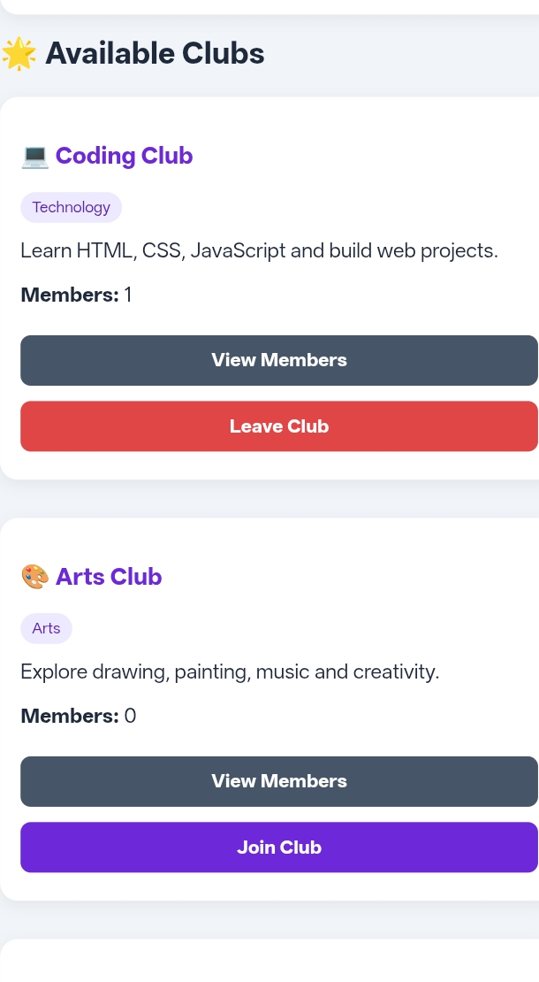
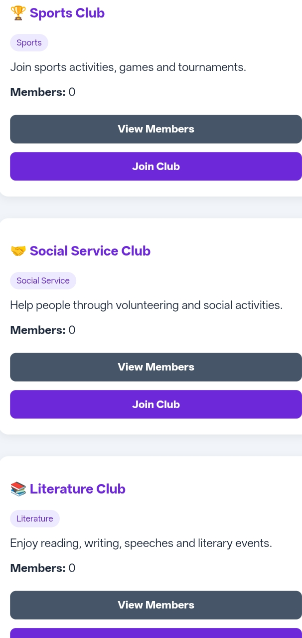
Step 2: Search and Filter Clubs
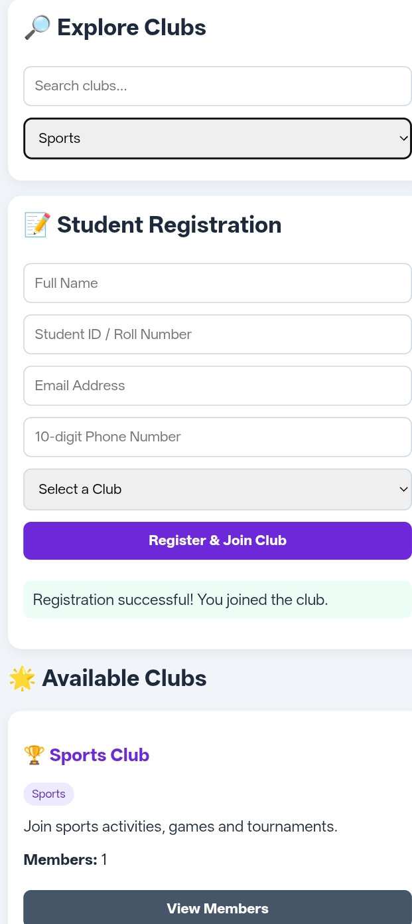
Step 3: Display Club Information
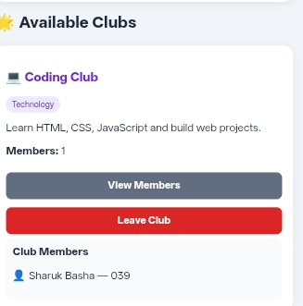
Step 4: Member Registration with Validation
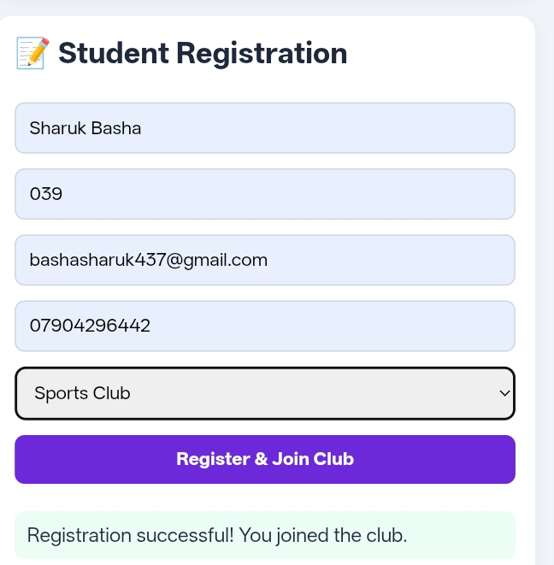
Step 5: Join and Leave Club
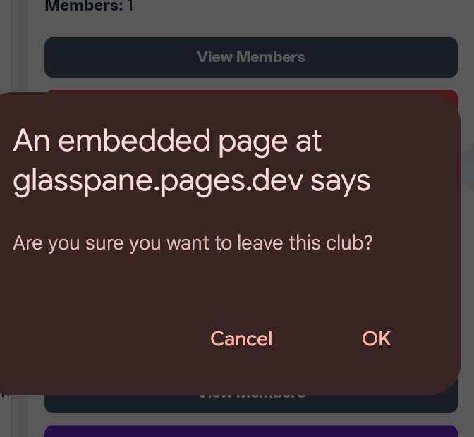
Step 6: Display Club Members
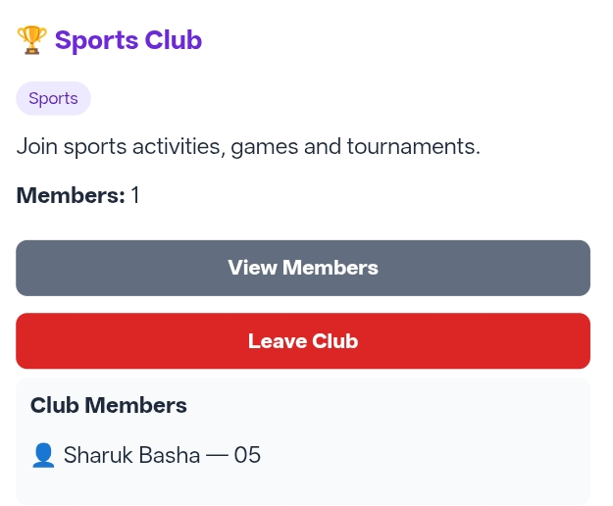
Step 7: Add Event Announcements
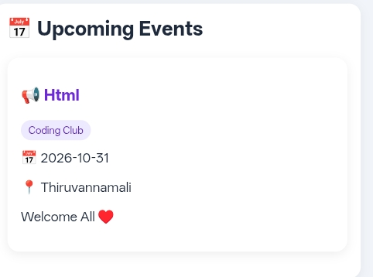
Step 8: Display Upcoming Club Events
Step 9: Store Membership Details Using Local Storage
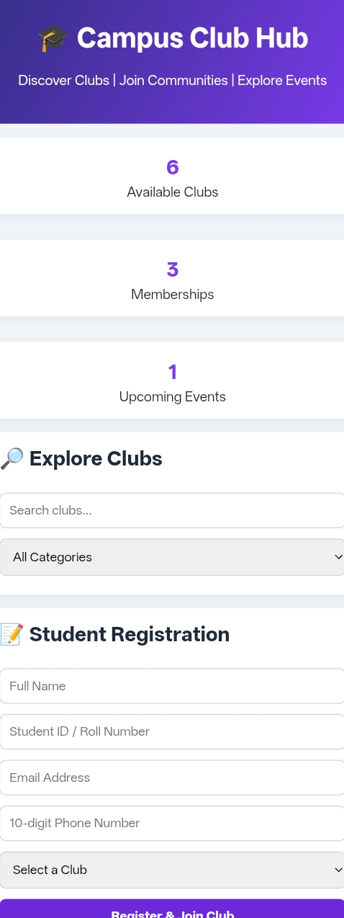

6. Technical Explanation
HTML: Creates the structure of the College Club Management System.
CSS: Designs the website with colors, cards, and layouts.
JavaScript: Handles club search, student registration, event management, and Local Storage.

7. Conclusion
The College Club Management System was developed using HTML, CSS, and JavaScript. It helps students search for college clubs, register as members, and view upcoming events. Local Storage is used to save membership and event details. This project makes college club activities simple, organized, and user-friendly.

8. Future Enhancements
- Add student login and admin login.
- Connect the system to a database.
- Add online event registration.
- Send notifications about upcoming events.
- Make the website more mobile-friendly.
- Add reports to manage club members and events.

