PROJECT DOCUMENTATION
EduGenie
Google Gemini Powered Learning Assistant
Ask · Explain · Quiz · Summarize · Learn
Submitted by
Tella Divya Sree
Mentor: Siri
Date: 11/04/2025

Contents
01 | Project Description
02 | Scenarios
03 | Architecture
04 | Prerequisites
05 | Project Workflow
06 | Exploring EduGenie
07 | Conclusion

1. Project Description
EduGenie is a lightweight AI-powered educational assistant that simplifies learning through generative AI. Designed for students of all academic levels, it turns any question, topic or passage into clear answers, quizzes, summaries and study plans.
Capability | What the learner gets
Ask questions | Smart, concise answers
Understand concepts | Complex ideas explained in simplified language
Generate quizzes | MCQs from a topic or text
Personalized recommendations | Structured learning paths, beginner to advanced
Summarize passages | Large educational text condensed for quick revision

EduGenie is built with FastAPI for the backend and a simple HTML+CSS frontend. It combines lightweight local AI with cloud-based models for local efficiency and cloud power, and works well on devices like the Mac M1, making it accessible to a broad range of learners and developers.

2. Scenarios
Scenario | Need | How EduGenie helps
Scenario 1 | Learn about oceans and rivers | The student asks “Which is the largest ocean?” and receives an instant answer from the Q&A module.
Scenario 2 | Check understanding of the Pythagoras Theorem | The student clicks “Generate Quiz” and answers multiple-choice questions to see how well she understands.
Scenario 3 | Explore SQL | The learner requests a learning path: a structured plan with beginner to advanced topics, timelines and suggestions.

3. Architecture
The learner submits a request from the web interface. The FastAPI backend routes it to the matching module, which calls either the local LaMini-Flan-T5 model (explanations) or Gemini 1.5 Pro through the API (everything else). The result is returned and shown below the input box.
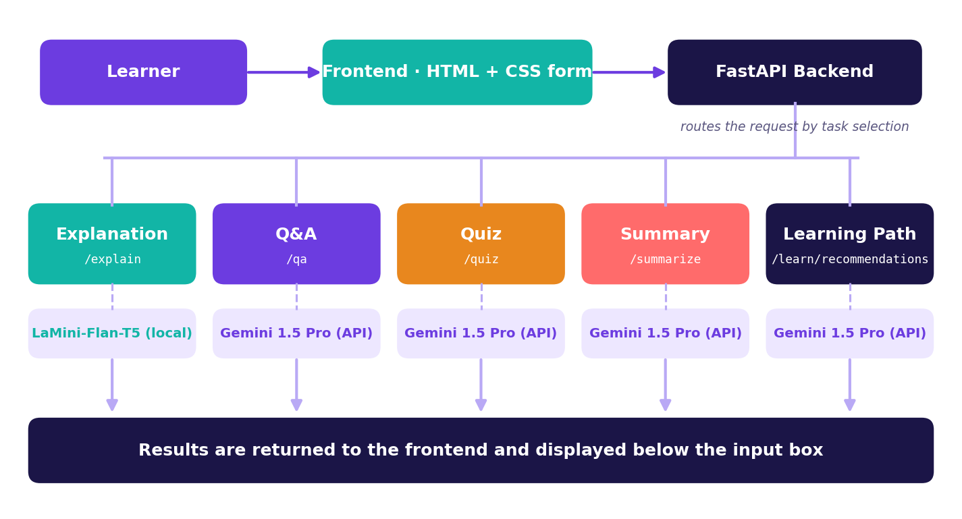
Fig 1. EduGenie architecture

4. Prerequisites

Python 3.10+
- Download the latest Python 3.10+ installer for your operating system from the official website.
- Run the installer and tick “Add Python to PATH”, then follow the prompts.
- Verify the installation with python --version.
Resources: python.org downloads · Python Programming Tutorial (video)

FastAPI Framework
Official documentation · User guide · FastAPI Crash Course (video)

HTML & CSS
Basic templating used in the /templates and /static folders.

Google Gemini API Key
- Visit Google AI Studio and sign in with your Google account.
- Create a new project and enable the Gemini API.
- Generate an API key and store it securely.
Official documentation · Setup guide (GeeksforGeeks)

Uvicorn (ASGI Server) and Jinja2 (HTML Templating)
Install with pip install uvicorn jinja2. Uvicorn on PyPI · Jinja2 documentation

5. Project Workflow

Milestone 1: Model Selection and Architecture

Activity 1.1: Select AI models
Model | Used for | Benefits
Gemini 1.5 Pro (via API) | Q&A, summarization, quiz generation, learning paths | Advanced reasoning, structured outputs and cloud inference
LaMini-Flan-T5-783M (local) | Concept explanation | Instruction-tuned, lightweight, CPU-compatible

Folder architecture
EduGenie/
├── main.py # FastAPI app
├── explanation_module.py # Concept explanation logic
├── qna.py # Question answering
├── quiz_module.py # Quiz generation
├── summary_module.py # Summarization
├── learning_path.py # Learning recommendations
├── templates/index.html # HTML frontend
├── static/style.css # Styling
└── requirements.txt # Python dependencies

Milestone 2: Core Functionalities Development

Activity 2.1: Module implementation

Explanation module
EduGenie uses the LaMini-Flan-T5 model, a lightweight yet powerful generative model, to deliver educational content in a simplified, highly readable form. The model is fine-tuned to give concise, context-aware responses that break complex topics into easy language, so learners with minimal background can grasp essential concepts without feeling overwhelmed. It suits beginners, school students and self-learners who want straightforward explanations.
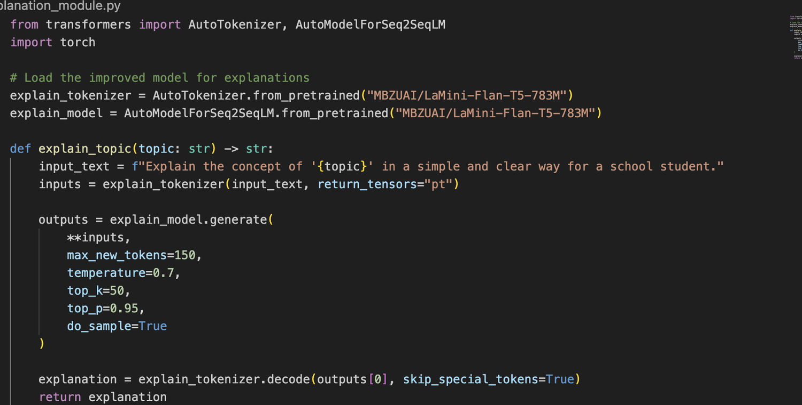
Fig 2. Explanation module logic

Q&A module
Powered by Gemini 1.5 Pro, this module handles a wide range of general knowledge and academic questions with precision. Its contextual understanding makes it an effective source of accurate, AI-driven answers across subjects.
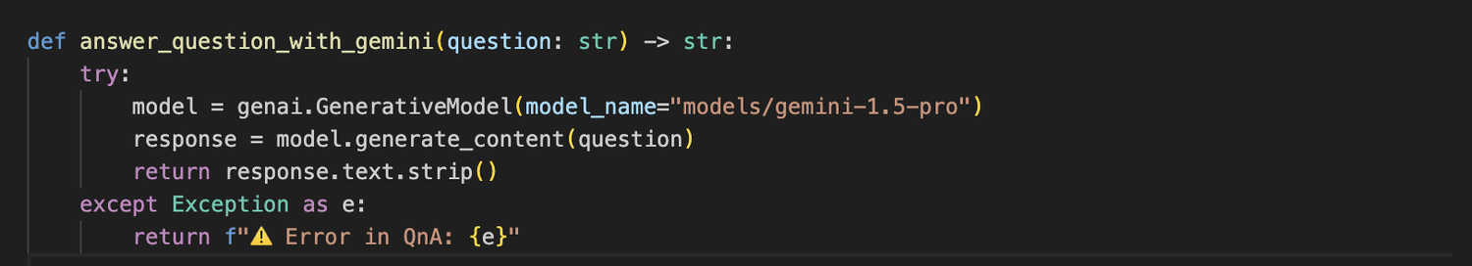
Fig 3. Q&A module

Quiz module
The quiz module generates three multiple-choice questions from a passage, each with four carefully crafted options. Gemini reads the passage so that the questions are relevant and the distractors plausible. The output is structured as JSON for easy integration.
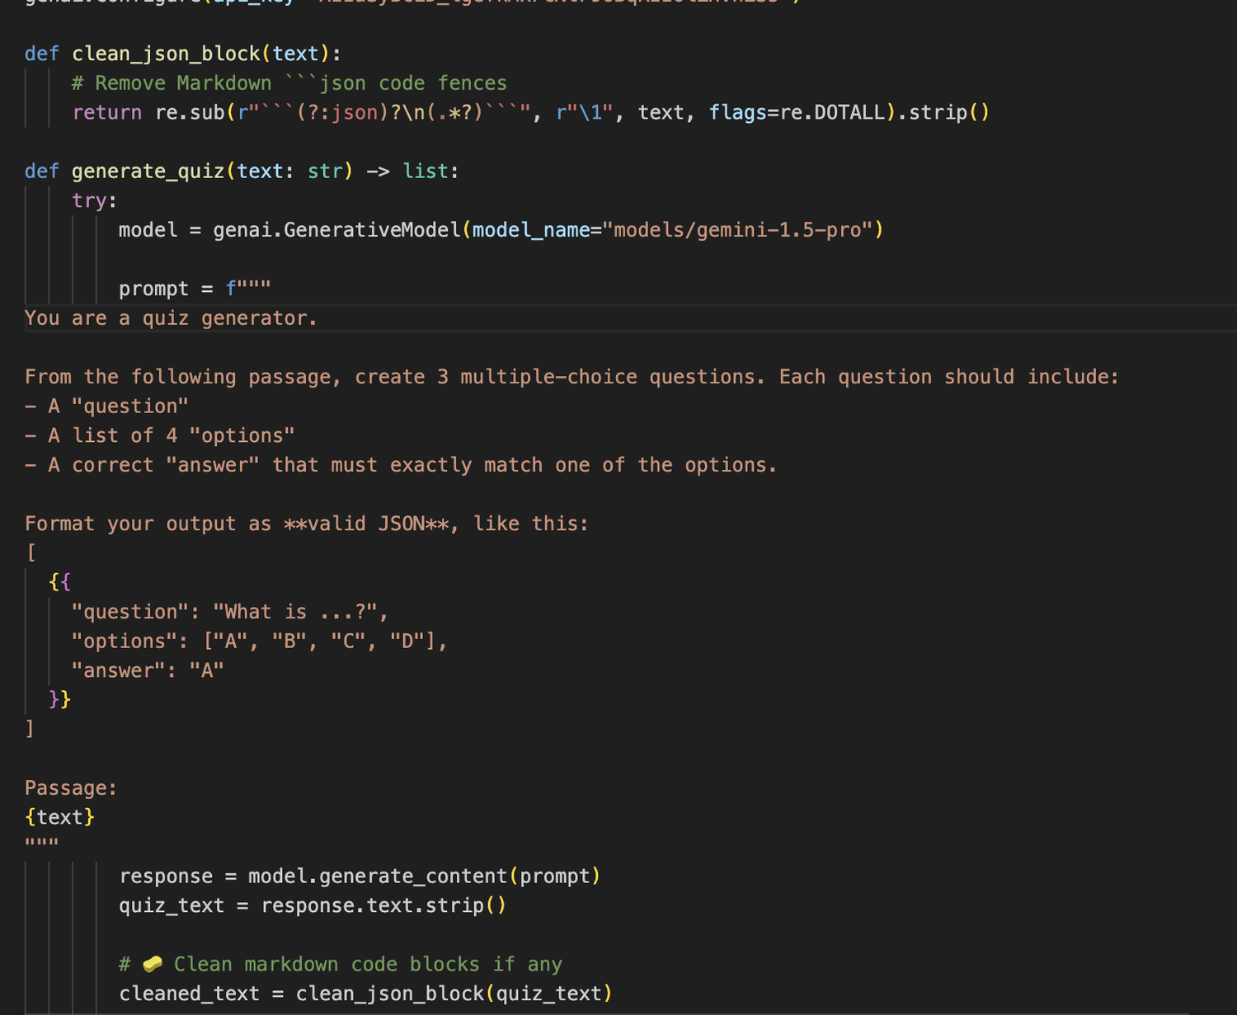
Fig 4. Quiz module logic
A structured prompt asks the model for valid JSON, with each question holding four options and a correct answer. The clean_json_block function strips any Markdown code fences so the response can be parsed into a Python list. If generation or parsing fails, a detailed error message is returned for debugging.

Summary module
Using Gemini’s generative capabilities, this module condenses long paragraphs into concise, easy-to-understand versions that are ideal for quick revision. Core information is kept while redundancy is removed.
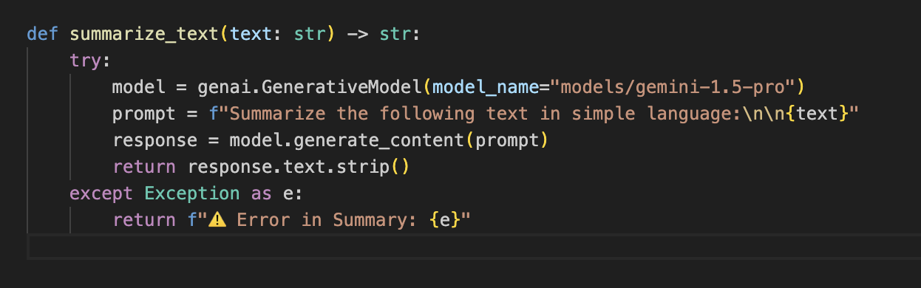
Fig 5. Summary module

Learning path module
The get_learning_recommendations function asks Gemini for a personalized, structured learning path for any topic. The prompt requests beginner to advanced concepts organized by difficulty and supported by resources such as videos, articles and books, adapting to the learner’s level. API responses and errors are handled safely, returning either the generated text or a helpful error message.
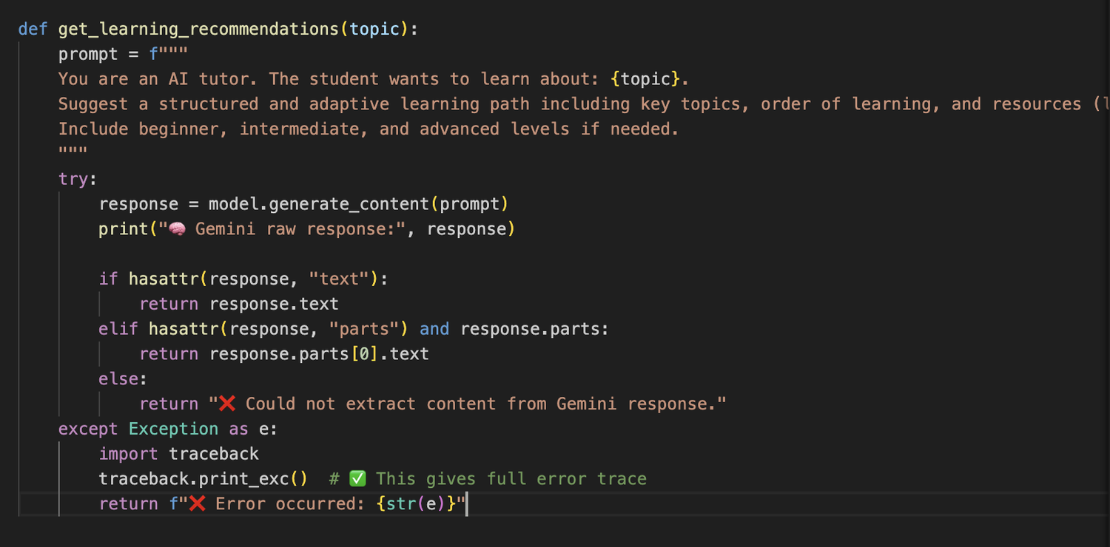
Fig 6. Learning path module

Activity 2.2: Backend API with FastAPI
Each module is exposed through its own RESTful endpoint and connected to the matching module logic. Missing input returns a 400 error with a clear message.
Method | Endpoint | Input | Output
GET | /qa | question | answer
POST | /explain/ | topic | topic, explanation
POST | /summarize/ | text | summary
POST | /quiz | text | quiz
GET | /learn/recommendations | topic | topic, recommendation
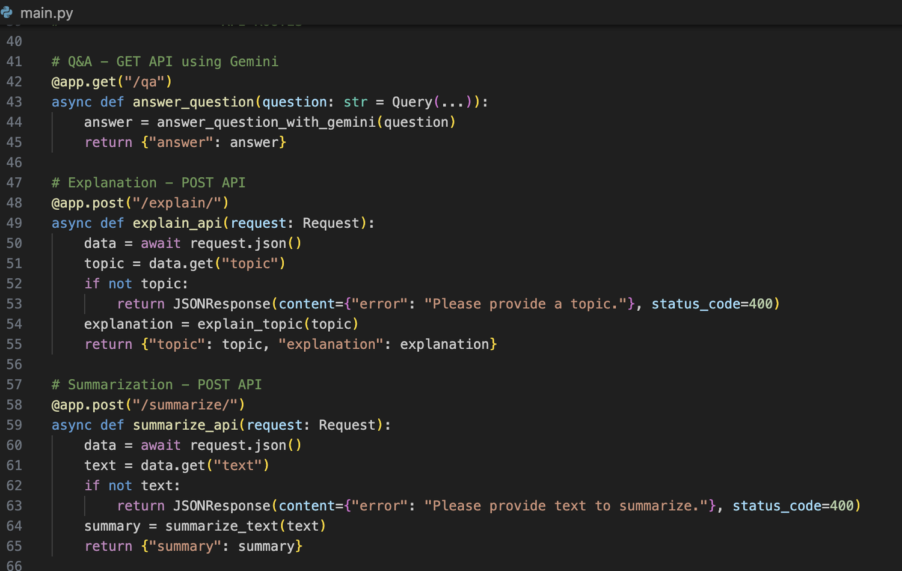
Fig 7. API endpoints in main.py (Q&A, explanation, summarization)
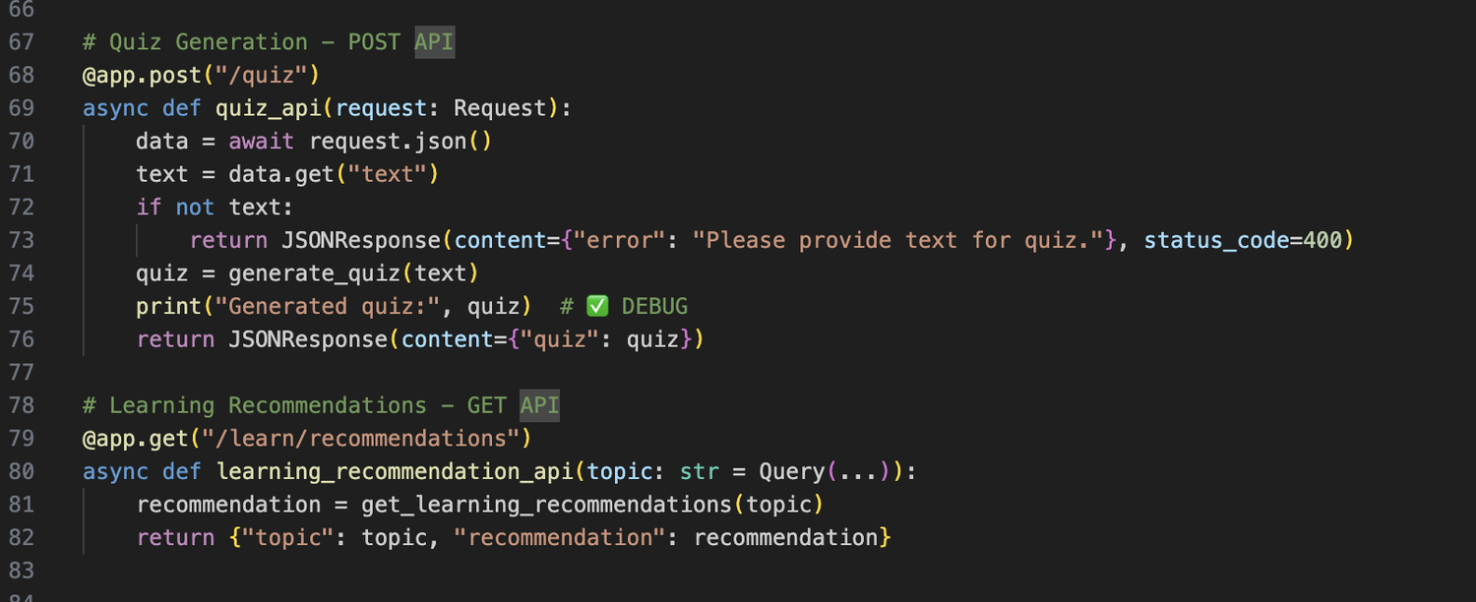
Fig 8. API endpoints in main.py (quiz, learning recommendations)

Milestone 3: Frontend Development

Activity 3.1: Build the web interface
- index.html: task dropdown (Explain, QnA, Quiz, Summary, Recommend Path), a text area for input and a submit button.
- style.css: responsive design with styled buttons, input areas and result container.
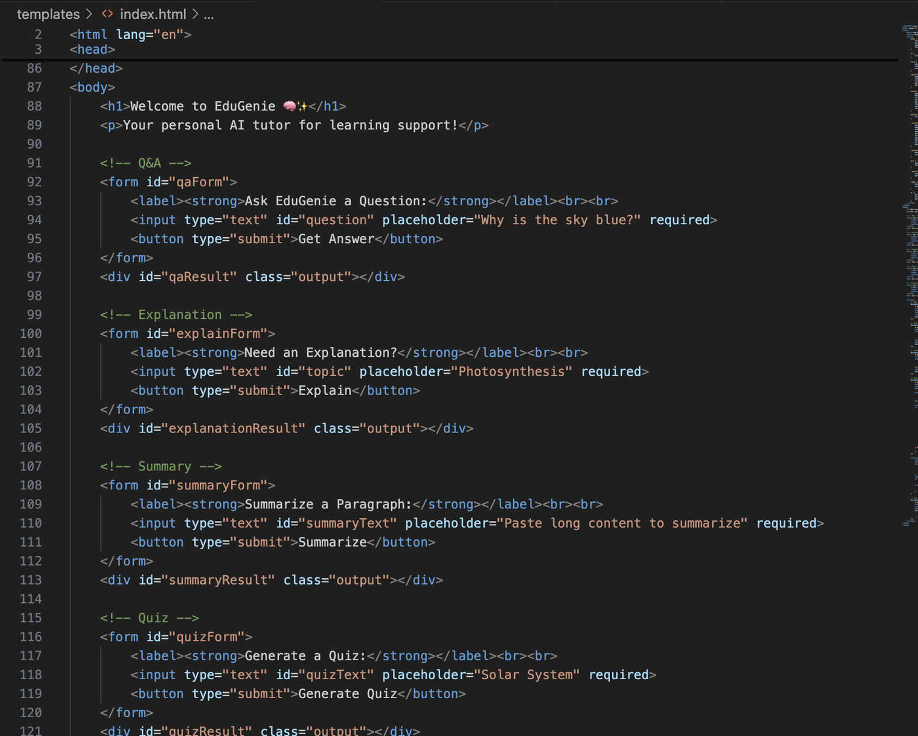
Fig 9. Frontend integration (index.html)

Activity 3.2: Live integration
- The form submission sends a request to the FastAPI backend.
- The result appears below the input box in real time.

Milestone 4: Deployment

Activity 4.1: Run locally
uvicorn main:app --reload

Open http://127.0.0.1:8000 in your browser.
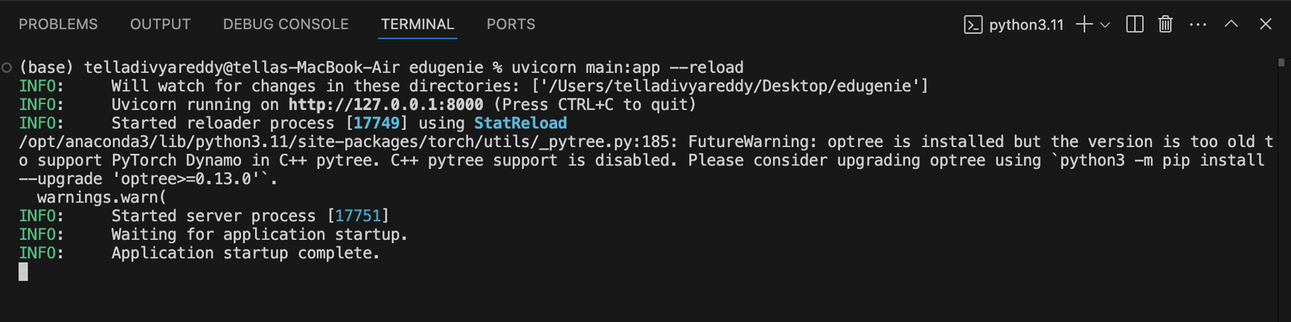
Fig 10. Application started successfully with Uvicorn
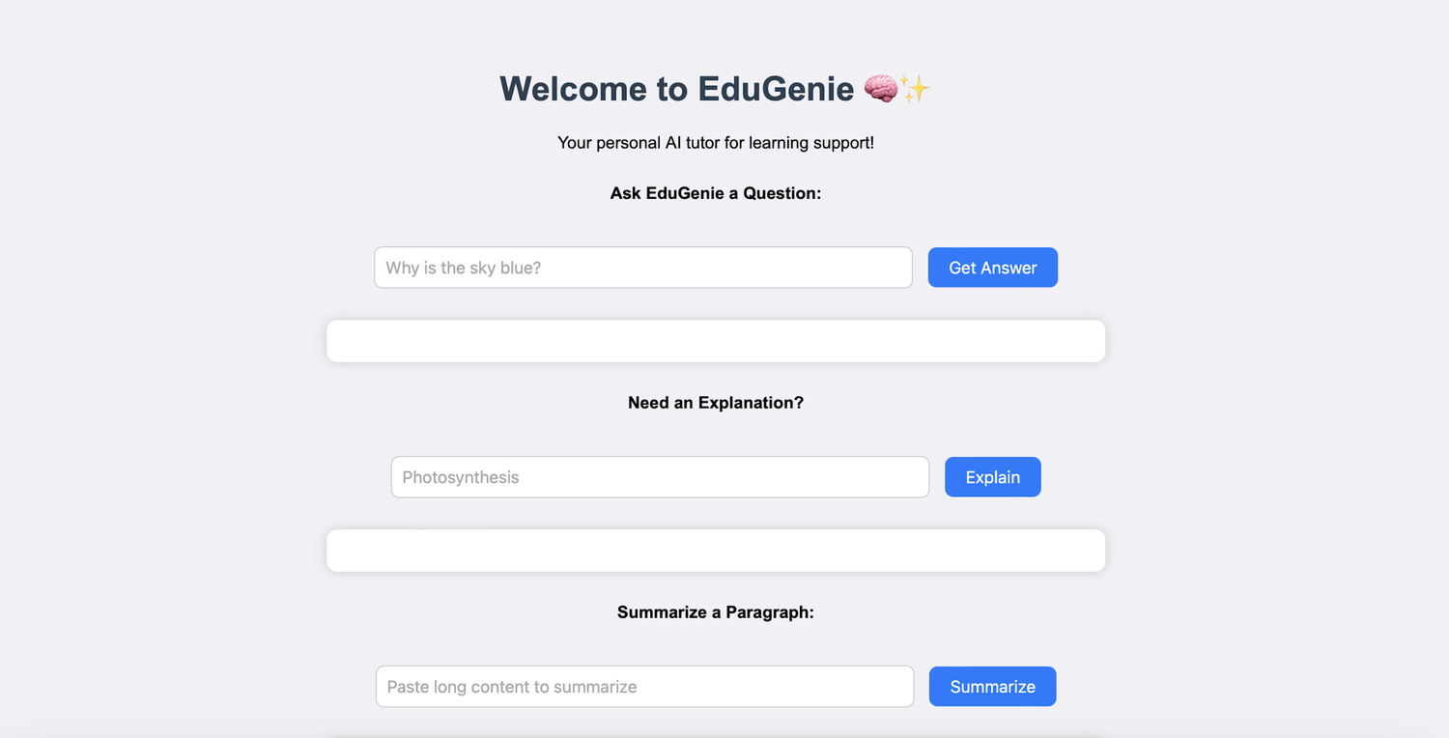
Fig 11. EduGenie home screen

Activity 4.2: Functional testing
# | Test
1 | Ask a question
2 | Get an explanation
3 | Generate a quiz
4 | Summarize content
5 | Get a personalized learning plan

6. Exploring EduGenie

Asking questions
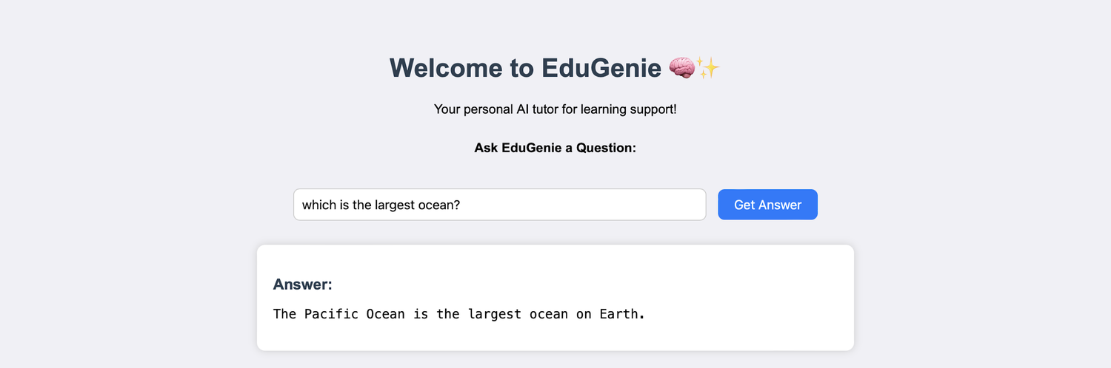
Fig 12. Q&A: “Which is the largest ocean?”

Explanation of any topic
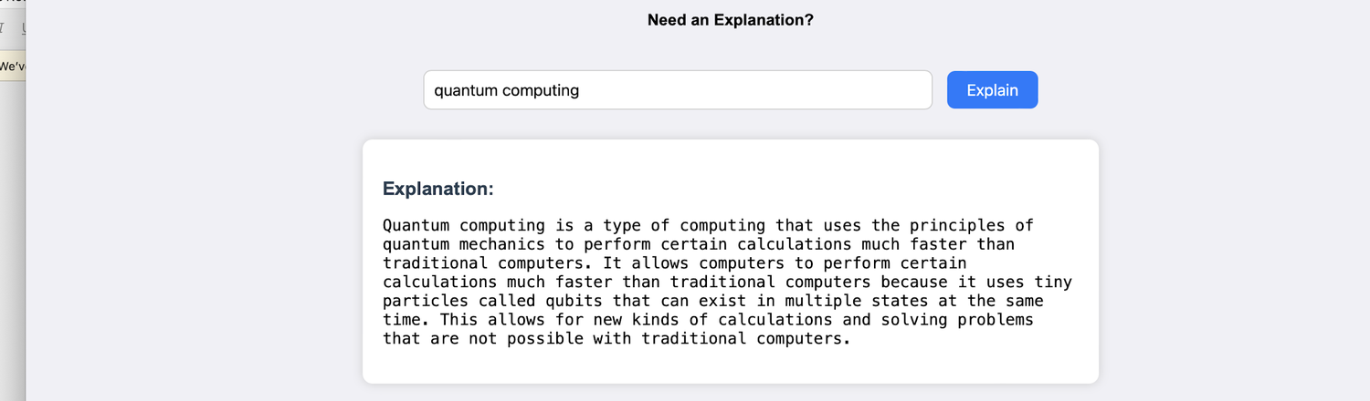
Fig 13. Simplified explanation of quantum computing

Summarizing long paragraphs
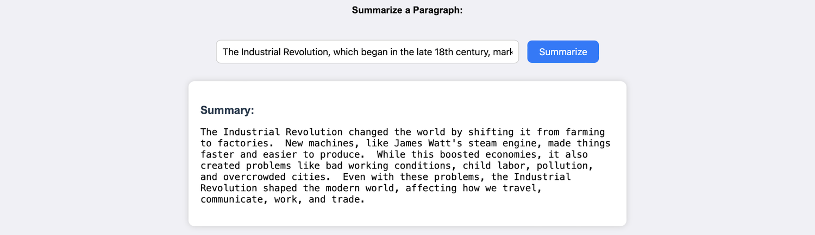
Fig 14. Summary of a long passage

Generating quizzes
EduGenie generates three questions with four options each and corrects the answer if a wrong option is chosen.
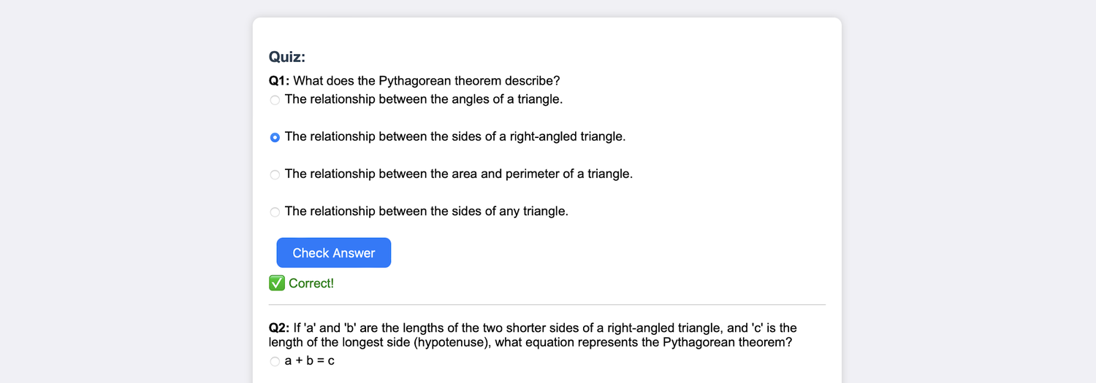
Fig 15. Quiz generated for the Pythagoras Theorem
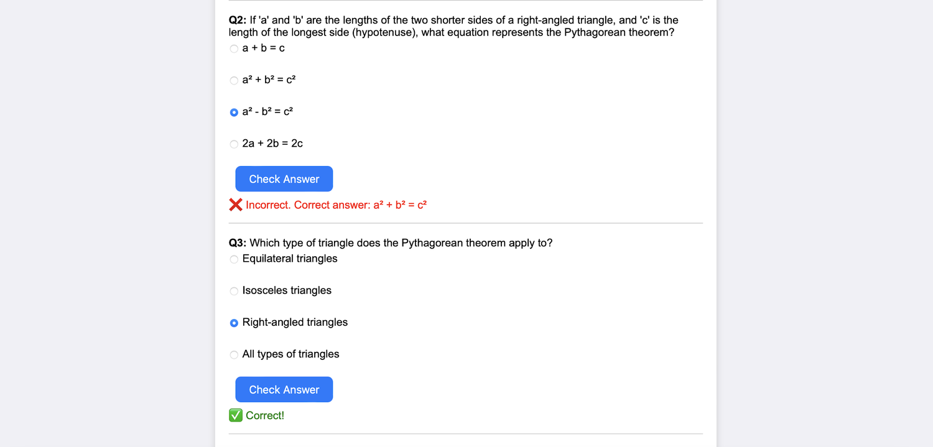
Fig 16. Answer checking with correction

Learning recommendations
Guidance runs from beginner to advanced level, with details of where to learn and step-by-step direction throughout.
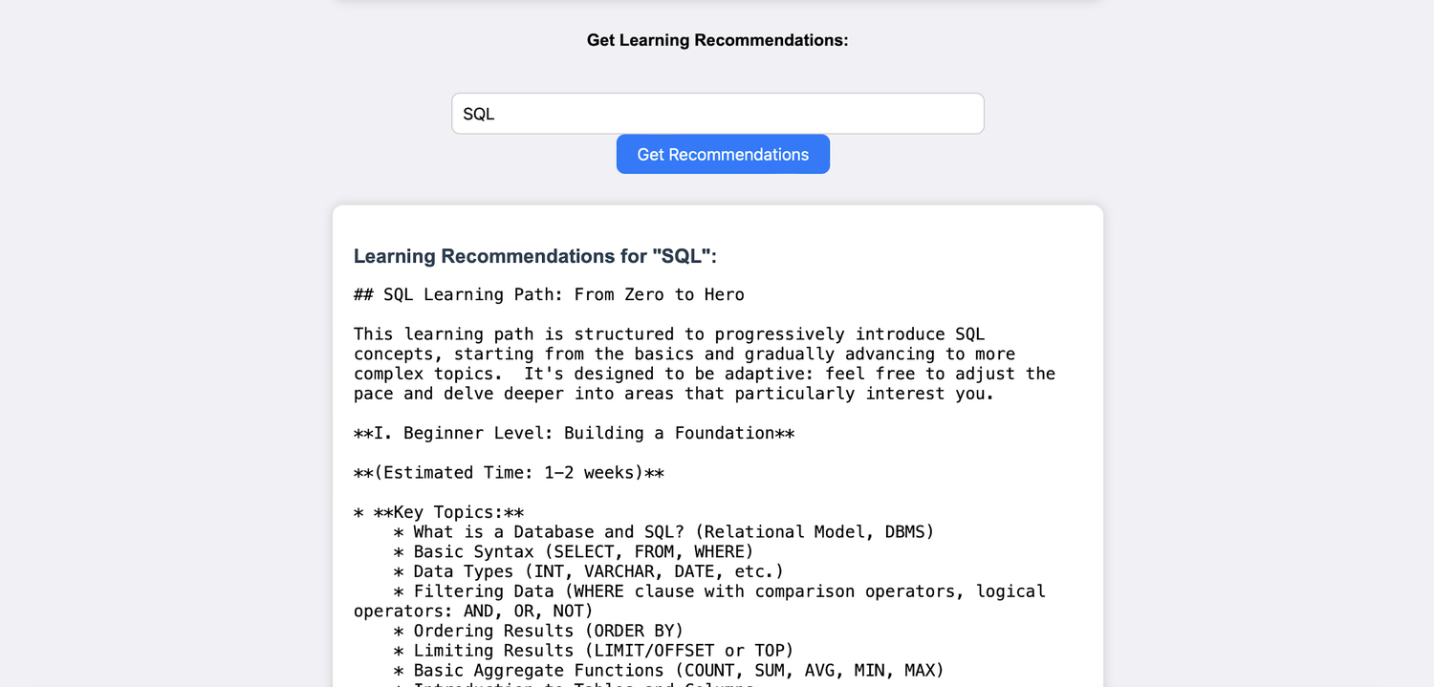
Fig 17. Learning path recommendations for SQL

7. Conclusion
EduGenie is a robust, accessible AI-powered educational assistant that combines cloud-based intelligence with an intuitive, low-footprint web interface. It supports self-learners, educational institutions and content platforms by simplifying complex concepts, answering questions instantly, generating quizzes and summaries, and tailoring learning paths. Its lightweight infrastructure lets users with minimal hardware access high-quality, personalized education.

Achievements
- Integrated advanced generative AI into a modular, scalable platform.
- Delivered a simple, clear interface for learners of all levels.
- Turned static learning into a dynamic, interactive process.

Challenges and learnings
Key hurdles were the accuracy of AI-generated responses, performance across devices, balancing personalization with general usability, and data privacy. Continuous testing, refined prompt structures and a clearer UI addressed them, and built skills in prompt engineering, cloud integration, user-centric design and scalable architecture.

Future scope
Direction | Ideas
Accessibility & reach | Voice-based interaction; multilingual support; a mobile app with offline features
Engagement | Progress-tracking dashboards; badges, streaks and challenge-based assessments; adaptive learning paths driven by analytics
Collaboration | Group study sessions; teacher and parent dashboards; LMS integration such as Moodle or Google Classroom
Richer input | Image and PDF recognition for snapshot-based doubt solving and resource summarization; real-time sync and smart notifications

In short
EduGenie is a foundation for the future of personalized, inclusive and intelligent education: smart, scalable and learner-first.

Submitted by: Tella Divya Sree Mentor: Siri Date: 11/04/2025

