Split ratio = 90/10

Lr = 0.5

Ep = 5000

MSE: 0.0168914695931969

RMSE: 0.1299671866018377

Accuracy: 95.73%

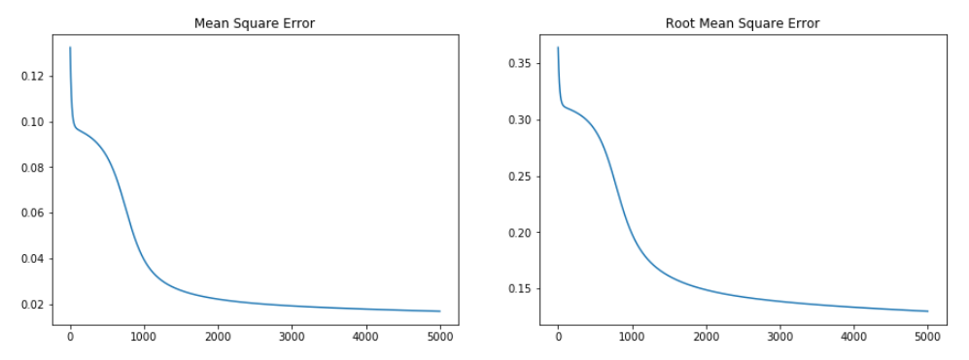

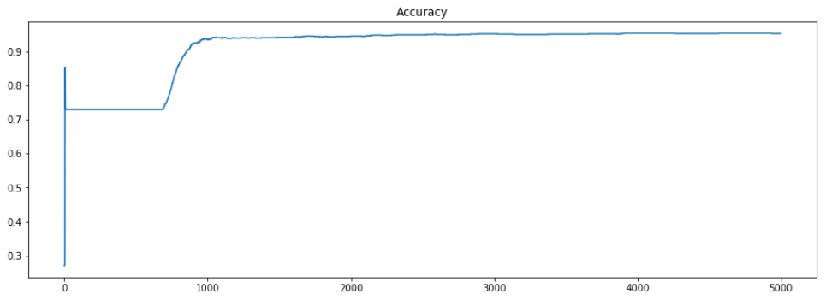

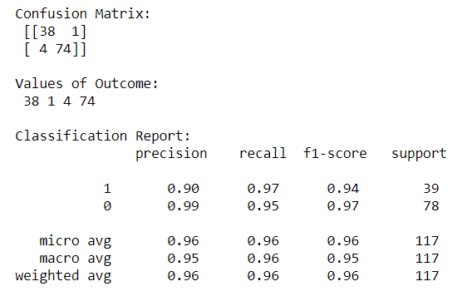

Split ratio = 70/30

Lr = 0.5

Ep = 5000

MSE: 0.017192980127081755

RMSE: 0.13112200474017224

Accuracy: 94.27%

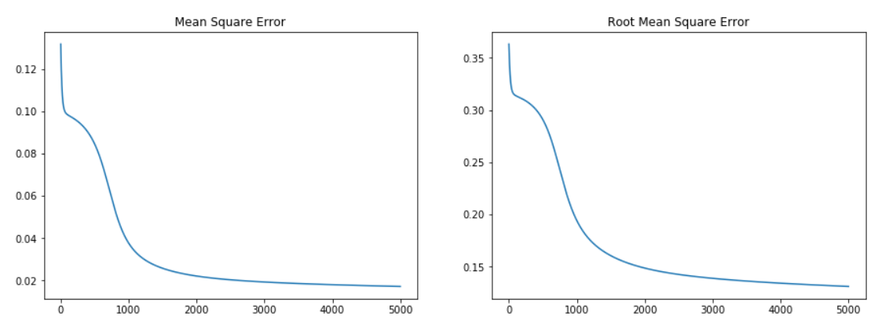

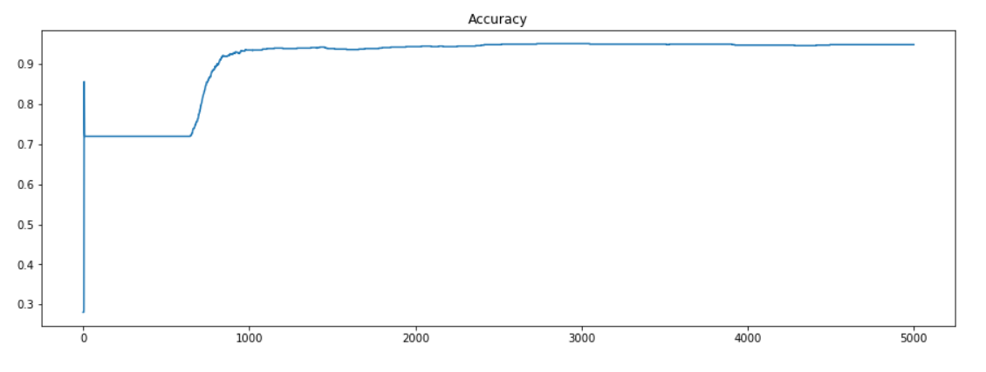

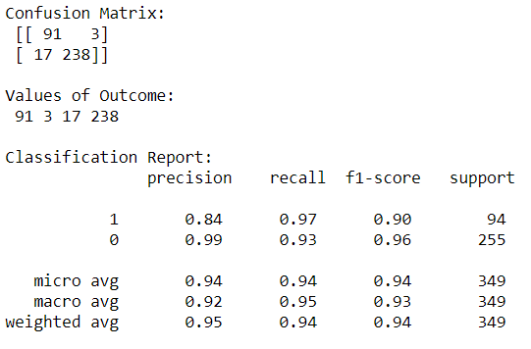

Split ratio = 90/10

Lr = 0.1

Ep = 5000

MSE: 0.03932822344284343

RMSE: 0.1983134474584198

Accuracy: 90.60%

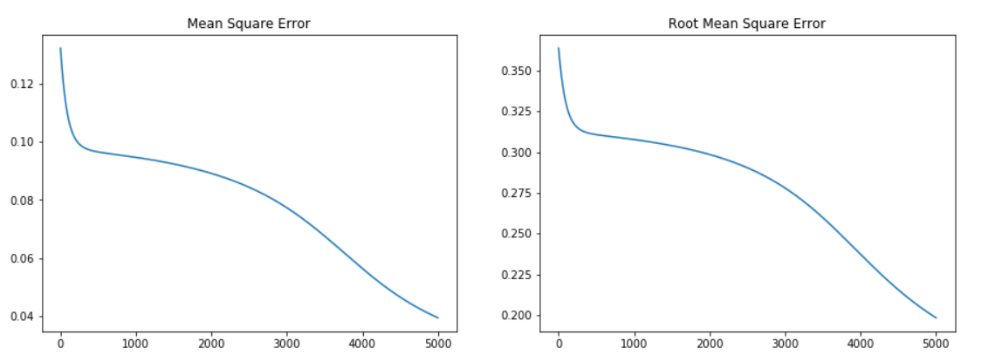

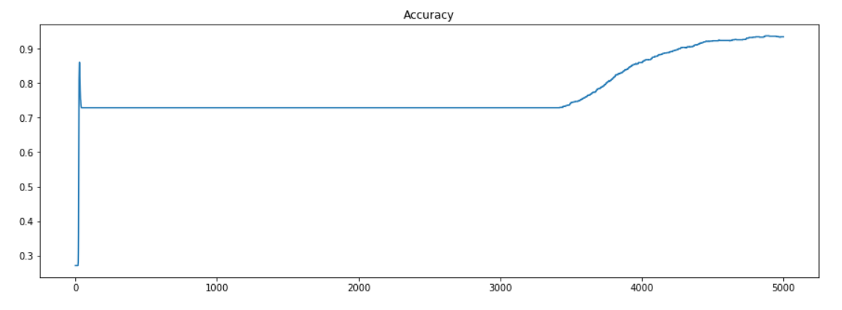

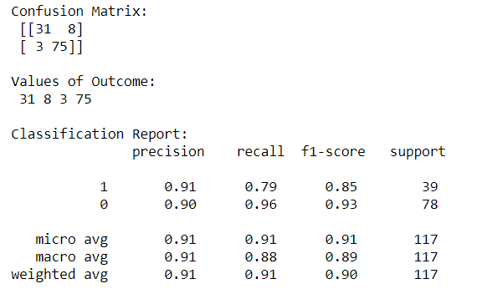

Split ratio = 70/30

Lr = 0.1

Ep = 5000

MSE: 0.03766395713804342

RMSE: 0.1940720411034094

Accuracy: 93.41%

