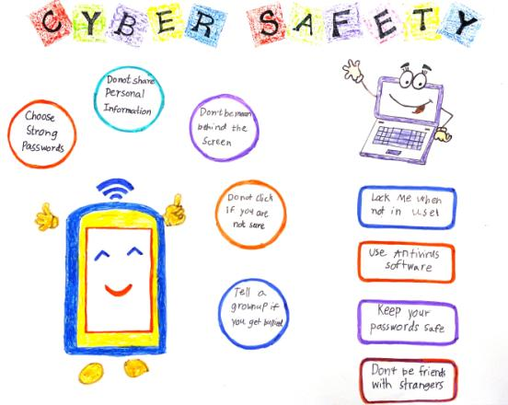


Don’t be friends with stranger
Keep your password safe
Use antivirus software

Lack me when not in use

Tell a grownup if you get bullied
Do not click if you are not sure
Don’t be mean behind the screen
Do not share personal information
Choose strong password

