SEMINAR
ON
UTERINE MALFORMATION AND
UTERINE FIBROIDS
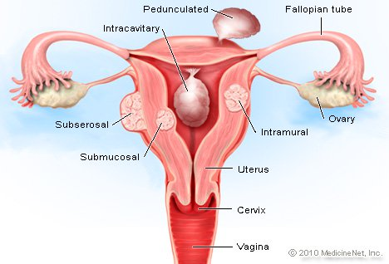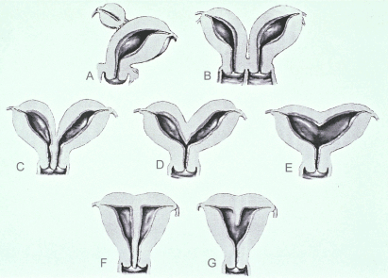
SUBMITTED BY
RENCY MOL JABOI
MSC NURSING, I YEAR
COLLEGE OF NURSING
JIPMER
SUBMITTED TO
MRS.VAHITHA.S
LECTURER
COLLEGE OF NURSING
JIMPER

INTRODUCTION
An abnormal uterus can sometimes be a risk factor for miscarriage and, in some cases, a cause of recurrent miscarriages. However, only some types of uterine malformations increase the risk of miscarriage and require treatment. Others may not cause any problems with pregnancy at all. About 8% to 23% of women who have recurrent miscarriages have some type of uterine abnormality. Some uterine malformations are present from birth, while others develop during adulthood. Most often, women with uterine abnormalities do not have any symptoms and are not aware of these malformations before they become pregnant. Diagnosis of congenital uterine malformations usually comes after a hysterosalpingogram (HSG), but this test can miss some conditions, such as uterine septum. Any abnormal HSG should be followed by a hysteroscopy.

UTERINE MALFORMATIONS
INTRODUCTION
For pregnancy and labour to be achieved with minimal difficult, a woman must have normal reproductive anatomy. When structural abnormality of the pelvic organs exists, problems arise that can place an extra burden on mother and fetus.
DEFINITION
- A uterine malformation is the result of an abnormal development of the Mullerian ducts during embryogenesis.
- Symptoms range from amenorrhea, infertility, recurrent pregnancy loss, and pain, to normal functioning depending on the nature of the defect.
EMBRYOLOGICAL DEVELOPMENT OF UTERUS
The female genital tract is formed in early embryonic life when a pair of ducts develops. These paramesonephric or mullerian ducts come together in the midline and fuse into a Y shaped canal. The open upper ends of this structure lead into the peritoneal cavity and the unfused portions become the uterine tubes. The fused lower portion forms the uterovaginal area, which further develops into the uterus and vagina.
INCIDENCE
- The prevalence of uterine malformation is estimated to be 6.7% in the general population.
- Slightly higher (7.3%) in the infertility population.
- Significantly higher in a population of women with a history of recurrent miscarriages (16%).
AMERICAN FERTILITY SOCIETY CLASSIFICATION
- Class I : Müllerian Agenesis or hypoplasia: segmental or complete (absent uterus)
- Class II : Unicornuate uterus with or without rudimentary horn (a one-sided uterus)
- Class III : Didelphys uterus also uterus didelphis (double uterus)
- Class IV : Bicornuate uterus: complete or partial (uterus with two horns)
- Class V : Septate Uterus: complete or partial (uterine septum or partition)

- Class VI : Arcuate uterus: There is a concave dimple in the uterine fundus within the cavity
- Class VII : DES related abnormalities: The uterine cavity has a "T-shape" as a result of fetal
exposure to diethylstilbesterol
ANOTHER CLASSIFICATION
- Imperfect fusion of two mullerian ducts
- Aplasia and hypoplasia of the mullerian ducts
Imperfect Fusion Of Two Mullerian Ducts
- Uterus Didelphys
- Uterus Bicomis Bicollis
- Uterus Bicoris Unicollis
- Septate uterus
- Subsepted
- Uterus unicomis
Aplasia and hypoplasia of the mullerian ducts
There can be absence of uterus or rudimentary, infantile and hypoplastic uterus. Congenital atresia of cervix may very rarely occur. Likewise, congenital elongation of cervix may also occur.
CLASSIFICATION OF CONGENITAL UTERINE MALFORMATIONS
- Malformations due to arrested development of the Mullerian ducts
They occur during the first phase of embryonic development, i.e. in the plume of craniocaudal growth of the Mullerian ducts. They may be
- Symmetrical or bilateral: uterine aplasia
- Asymmetrical or unilateral: uterus unicornis unicollis
- Malformations due to failure of fusion of the Mullerian ducts
The malfonnalions vary according to whether failure of fusion is total or partial
- Uterus didelphys
- Uterus bicornis bieallis
- Uterus bicomis unicollis
- Uterus arcualus : the least marked degree of failure of fusion
- Malformations from incomplete resorption of the sagittal septum
- Uterus septus, due to non resorption of the sagittal septum, residuum of the primitive duality
- Uterus subseptus, due to partial resorption of the septum
- Developmental defects of the uterine cavity
- Uterine hypoplasia in the strict sense
- Infantile uterus with disproportion between body and cervix
- Uterus with gaping cervix and isthmus
- Pencil uterus
- Star-shaped uterus.

MALFORMATION OF THE FALLOPIAN TUBES AND OVARY
- Congenital elongation
- Accessory abdominal ostium
- Small diverticulum or atresia
- Absence of the fallopian tube may seldom occur
- Absent, rudimentary or accessory ovary or ovarian aplasia ate the congenital failure of the ovarian function.
PREGNANCY AND LABOUR IN UTERINE MALFORMATION
- Minor degrees of developmental defects of the uterus do not usually interfere with pregnancy and labour.
- In most cases of uterine deformities, the two portions of the uterus and a false decidua may form in the other half.
- Abortion does not occur infrequently in some cases premature labour is the result; in the minor malformations, the pregnancy often goes on to term and ends normally.

- UTERUS DIDELPHYS
- Pregnancy may take a normal course
- Occasionally, delivery may be impeded by the septum in the vagina
- In the early weeks of pregnancy the presence of the non-gravid uterus may give rise to the mistaken diagnosis of an extrauterine gestation
- In some of these cases menstruation may occur throughout the course of pregnancy form the non-pregnant uterus
- The pregnancy may be complicated by abortion, preterm delivery, fetal growth restriction and malpresentation.

- UTERUS BICORNIS BICOLLIS
- Pregnancy may occur either half of the uterus, and when it occurs in one horn of a bicornuate uterus, the other undergoes some degree of hypertrophy and a decidua is formed in its cavity.
- Repeated abortions and breech presentations may occur more frequently than in a normal uterus.
- Usually, the pregnancy takes a normal course and the delivery is spontaneous.

- UTERUS SEPTUS AND SUBSEPTUS
- The fundus of the uterus may be normal in outline or occasionally there may be a depression at the fundus (arcuate uterus).
- In some, pregnancy and labour proceed normally but sometimes repeated abortion may occur
- Malpresentation, specially breech, may be more frequent.
- In some cases, the placenta may be retained or adherent and it is during the manual removal of the placenta that the condition is generally diagnosed.
- In a few cases, the head or part of the fetus may pass through the septum.

- UTERUS UNICOLLIS
- Pregnancy is extremely rare in this type of uterine deformity.
- Pregnancy in the rudimentary horn is attended with grave risks.
- Increased incidence of abortion, preterm labour, IUGR, breech presentation, uterine dysfunction in labour and caesarean section occur.

- ARCUATE UTERUS
- There is depression at fundus.
- Fundal notching can be detected at late pregnancy.
- This results in transverse lie.
EFFECTS OF ABNORMALITY ON PREGNANCY
- When pregnancy occurs in the woman with an abnormal uterus, the outcome depends on the ability of the uterus to accommodate the growing fetus.
- A problem exists only if the tissue is insufficient to allow the uterus to enlarge for a full term fetus lying longitudinally.
- If there is insufficient hypertrophy, the possible difficulties are abortion, premature labour and abnormal lie of the fetus.
- In labour, poor uterine function may be experienced.
- Minor defects of structure cause little problem and might pass unnoticed with the woman having a normal outcome to her pregnancy.
- Occasionally problems arise when a fetus is accommodated in one hem of a double uterus and the empty horn has filled the pelvic cavity.
- In this situation the empty horn had grown owing to the hormonal influences of the pregnancy, and its size and position will cause obstruction during labour.
- Caesarean section would be the method of delivery.
CLINICAL FEATURES
Gynecological
- Infertility and dyspareunia are often related in association with vaginal septum
- Dysmenorrhea in bicornuate uterus or due to cryptomenorrhoea (pent up menstrual blood in rudimentary horn)
- Menorrhagia due to increased surface area in bicornuate uterus
Obstetrical
- Mid-trimester abortion which may be recurrent.
- Cornual pregnancy with inevitable rupture around 16th week of pregnancy occurs in the rudimentary horn.
- Increased incidence of malpresentation transverse lie in arcuate or subseptate, breech in bicornuate, unicornuate or complete septate uterus.
- Preterm labour
- Prolonged labour due to incordinate uterine action

- Obstructed labour obstruction by the non-gravid hem of the bicornuate uterus or rudimentary horn.
- Retained placenta and postpartum hemorrhage where the placenta is implanted over the uterine septum.
DIAGNOSIS
- Physical examination
- Gynaecologic ultrasonography
- Pelvic MRI
- Hysterosalphinography
- Laparoscopy and/or Hysteroscopy may be indicated
- In some patients the Vaginal development may be affected
TREATMENT
- Uterine malformations like absence, rudimentary or infantile ate not amenable to treatment.
- Hypoplastic uterus in young girls may gradually develop with advance of age.
- Oestrogen therapy may be temporarily given for amenorrhea, oligomenorrhoea; dilation and curettage may be helpful in some cases with dysmenorrhoea.
- Chance pregnancy develops in the hypoplastic uterus.
- Surgery of the double uterus is indicated in haematometra or pyometra in the rudimentary uterine horn or in cases with habitual abortion.
- Noncommunicating uterine horn with haematometra or pyometra is to be excised.
- Bicornuate uterus with habitual abortion or infertility may indicate for unification of both uterine cavities after the excision of the tissue in between two cavities. (Strassmann operation).
- Likewise removal of the septum may rarely called for septate uterus.
Cerclage
Cervical cerclage is indicated in women with uterine didelphys, unicornuate or bicornuate uterus and poor reproductive performance.
Metroplasty
Women with septate or bicornuate uterus, uterine didelphys and recurrent pregnancy loss are likely to benefit from uterine repair. A septate or bicornuate uterus may occasionally be the etiological factor in repeated abortions. Corrections of this abnormality by excision of the septum or any form of Strassman’s operation will often result in successful pregnancies.
Strassmann Hysteroplasty Operation
- Paul Strassmann from Berlin, 1907 first did the hysteroplasty by making a transverse incision on the double uterus and the septum and repaired on the anteroposterior plane. He did not remove the septum. His son, E.O.Strassmann, 1952 popularized this operation in U.S.
- Jones and Jones, 1953 from U.S.A. modified the operation by incising the uterus vertically from fundus to the internal 05. A triangular wedge of tissue including the septum is removed and the walls of the two cavities are sutured in layers.

COMPLICATIONS
- Abortion
- Weak uterine action
- Postpartum hemorrhage
- Adhesion of the placenta
- Malpresentation
- Prolonged or obstructed labour
- Uterine rupture due to its poor development
- The placenta, if it is formed on the septum, may be adherent and may cause postpartum hemorrhage

UTERINE FIBROID
A uterine fibroid is the most common benign (not cancerous) tumor of a woman's uterus (womb). It is also called uterina myoma. Fibroids are tumors of the smooth muscle found in the wall of the uterus. They can develop within the uterine wall itself or attach to it. They may grow as a single tumor or in clusters. Uterine fibroids can cause excessive menstrual bleeding, pelvic pain, and frequent urination.
These growths occur in up to 50% of all women and are one leading cause of hysterectomy (removal of the uterus) in the United States. An estimated 600,000 hysterectomies are performed in the US annually, and at least one-third of these procedures are for fibroids. Medications and newer, less invasive surgical treatments are now available to help control the growth of fibroids.
Fibroids start in the muscle tissues of the uterus. They can grow into the uterine cavity (submucosal), into the thickness of the uterine wall (intramuscular), or on the surface of the uterus (subsersoal) into the abdominal cavity. Some may occur as pedunculated masses (fibroids growing on a stalk off of the uterus).Although these tumors are called fibroids, this term is misleading because they consist of muscle tissue, not fibrous tissue. The medical term for a fibroid is leiomyoma, a type of myoma or mesenchymal tumor.
DEFINITION
Myomas are benign, monoclonal tumors of the smooth muscle cells of the myometrium. They are composed of large amounts of extracellular matrix containing collagen, fibro-nectin, and proteoglycan.
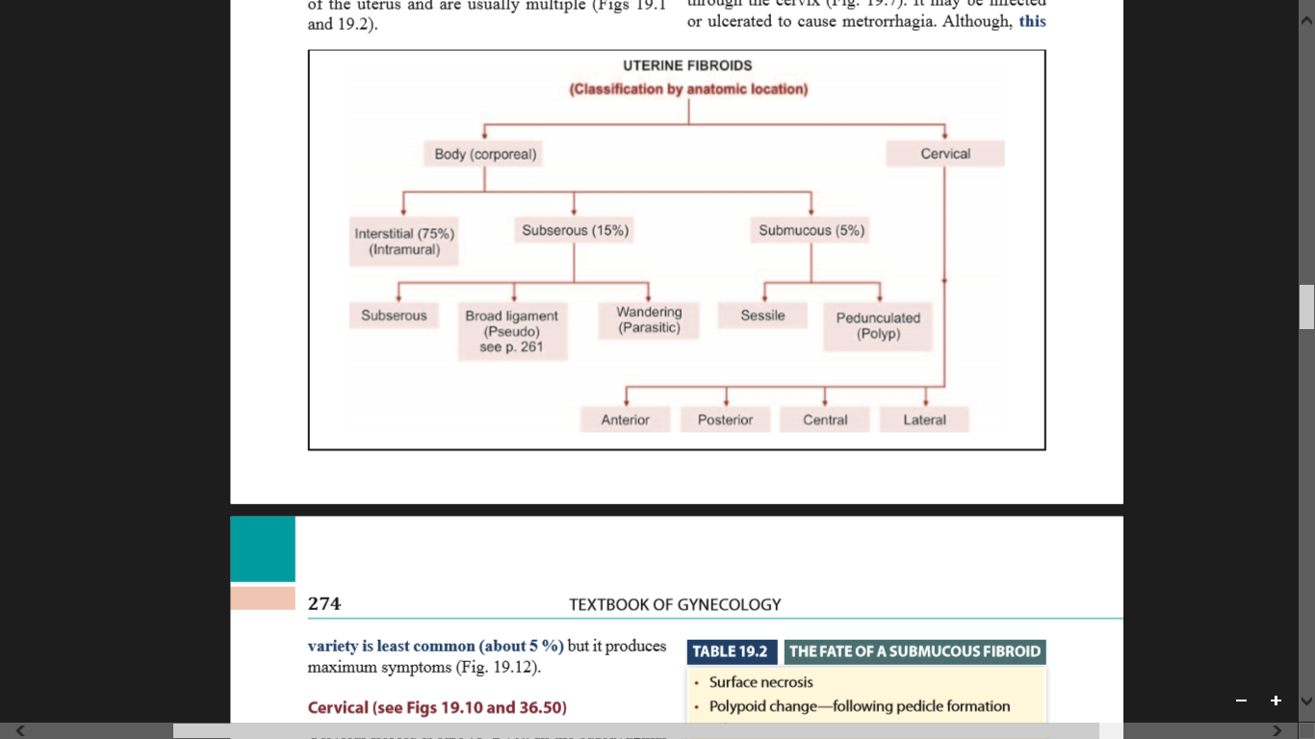

INCIDENCE
It has been estimated that at least 20 percent of women at the age of 30 have got fibroid in their wombs. Fortunately, most of them (50%) remain asymptomatic. The incidence of symptomatic fibroid in hospital outpatient is about 3 percent. A high incidence of 10 percent prevails in England. In colored races (black women), the incidence is even higher. These are more common in nulliparous or in those having one child infertility. The prevalence is highest between 35–45 years.
HISTOGENESIS
Origin
The etiology still remains unclear. The prevailing hypothesis is that, it arises from the neoplastic single smooth muscle cell of the myometrium. The stimulus for initial neoplastic transformation is not known. The following are implicated:
- Chromosomal abnormality- In about 40 percent of cases, there is a varying type of chromosomal abnormality, particularly the chromosome six or seven (rearrangements, deletions). Somatic mutations in myometrial cells may also be the cause for uncontrolled cell proliferation.
- Role of polypeptide growth factors- Epidermal growth factor (EGF), insulin-like growth factor-1 (IGF-1), transforming growth factor (TGF), stimulate the growth of leiomyoma either directly or via estrogen.
- A positive family history is often present.
Growth
It is predominantly an estrogen-dependent tumor. Estrogen and progesterone is incriminated as the cause. Estrogen dependency is evidenced by:
- Growth potentiality is limited during childbearing period.
- Increased growth during pregnancy.
- They do not occur before menarche.
- Following menopause, there is cessation of growth and there is no new growth at all.
- It seems to contain more estrogen receptors than the adjacent myometrium.
- Frequent association of anovulation.
The growth potentiality is not squarely distributed amongst the fibroids which are usually multiple, some grow faster than the others. On the whole, the rate of growth is slow and it takes about 3–5 years for the fibroid to grow sufficiently to be felt per abdomen.
RISK FACTORS FOR FIBROID
INCREASED RISK
- Nulliparity
- Obesity
- Hyperestrogenic state
- Black women

REDUCED RISK
- Multiparity
- Smoking
However, the fibroid grows rapidly during pregnancy or amongst pill users (high dose pills). Rapid growth may also be due to degeneration or due to malignant change.
TYPES: • Body • Cervical
Body: The fibroids are mostly located in the body of the uterus and are usually multiple.
Interstitial or intramural (75%)
Initially, the fibroids are intramural in position but subsequently, some are pushed outward or inward. Eventually, in about 70 percent, they persist in that position.
Subperitoneal or subserous (15%)
In this condition, the intramural fibroid is pushed outwards towards the peritoneal cavity. The fibroids are either partially or completely covered by peritoneum. When completely covered by peritoneum, it usually attains a pedicle called pendunculated subserous fibroid. On rare occasion, the pedicle may be torn through; the fibroid gets its nourishment from the omental or mesenteric adhesions and is called ‘wandering’ or ‘parasitic’ fibroid.
Submucous (5%)
The intramural fibroid when pushed toward the uterine cavity, and is lying underneath the endometrium, it is called submucous fibroid. Submucous fibroid can make the uterine cavity irregular and distorted. Pendunculated submucous fibroid may come out through the cervix. It may be infected or ulcerated to cause metrorrhagia. Although, this variety is least common (about 5 %) but it produces maximum symptoms.
Cervical
Cervical fibroid is rare (1–2 %). In the supravaginal part of the cervix, it may be interstitial or subperitoneal variety and rarely polypoidal. Depending upon the position, it may be anterior, posterior, lateral or central. Interstitial growths may displace the cervix or expand it so much that the external os is difficult to recognize. All these disturb the pelvic anatomy, specially the ureter. In the vaginal cervix, the fibroid is usually pedunculated and rarely sessile.
Pseudocervical fibroid
A fibroid polyp arising from the uterine body when occupies and distends the cervical canal, it is called pseudocervical fibroid.

ASSOCIATED CHANGES IN THE PELVIC ORGANS
Uterus
- Shape is distorted
- Myohyperplasia is almost a constant finding
- Features of anovulation with evidences of hyperplasia
- Dilatation and congestion of the myometrial and endometrial venous plexuses
- The endometrium as a result becomes thick, congested and edematous. The endometrium overlying the submucous fibroid may be thin and necrotic with evidences of infection.
- The uterine cavity may be elongated and distorted in intramural and submucous varieties.
Uterine tubes
The frequent tubal infection (about 15%) detected in association with fibroid seems coincidental.
Ovaries
The ovaries may be enlarged, congested and studded with multiple cysts. The cause may be due to hyperestrinism.
Ureter
There may be displacement of the anatomy of the ureter in broad ligament fibroid. The compression effect results in hydroureter and or hydronephrosis.
Endometriosis
There is increased association of pelvic endometriosis and adenomyosis (30%).
Endometrial carcinoma
The incidence remains unaffected.
COMPLICATIONS OF FIBROIDS
- Degenerations
- Necrosis
- Infection
- Sarcomatous change (rare)
- Torsion of subserous pedunculated fibroid
- Hemorrhage
- Intracapsular
- Ruptured surface vein of subserous fibroid → intraperitoneal 
- Polycythemia due to
- Erythropoietic function by the tumor
- Altered erythropoietic function of the kidney through ureteric pressure

CLINICAL FEATURES
Patient Profile
The patients are usually nulliparous or having long period of secondary infertility. However, early marriage and frequent childbirth make its frequency high even amongst the multiparous women. The incidence is at its peak between 35–45 years. There is a tendency of delayed menopause.
SYMPTOMS
The majority of fibroids remain asymptomatic (75%). They are accidentally discovered by the physician during routine examination or at laparotomy or laparoscopy. The symptoms are related to anatomic type and size of the tumor. The site is more important than the size. A small submucous fibroid may produce more symptoms than a big subserous fibroid.
- Asymptomatic—majority (75%)
- Menstrual abnormality: Menorrhagia, metrorrhagia
- Dysmenorrhea
- Dyspareunia
- Infertility
- Pressure symptoms
- Recurrent pregnancy loss (miscarriage, preterm labor)
- Lower abdominal or pelvic pain
- Abdominal enlargement.
Menstrual abnormalities
- Menorrhagia (30%) is the classic symptom of symptomatic fibroid
The menstrual loss is progressively increased with successive cycles. It is conspicuous in submucous or interstitial fibroids. The causes are:
- Increased surface area of the endometrium (Normal is about 15 sq cm)
- Interference with normal uterine contractility due to interposition of fibroid
- Congestion and dilatation of the subjacent endometrial venous plexuses caused by the obstruction of the tumor.
- Endometrial hyperplasia due to hyperestrinism (anovulation).
- Pelvic congestion.
- Role of prostanoids—imbalance of thromboxane (TXA2) and prostacyclin (PGI2) with relative deficiency of TXA2.

- Metrorrhagia or irregular bleeding may be due to:
- Ulceration of submucous fibroid or fibroid polyp.
- Torn vessels from the sloughing base of a polyp.
- Associated endometrial carcinoma.

Dysmenorrhea
The congestive variety may be due to associated pelvic congestion or endometriosis. Spasmodic type is associated with extrusion of polyp and its expulsion from the uterine cavity. Subserous, broad ligament or cervical fibroids are usually unassociated with menstrual abnormalities.
Infertility: Infertility (30%) may be a major complaint.
- Uterine
- Distortion and or elongation of the uterine cavity → difficult sperm ascent.
- Preventing rhythmic uterine contraction due to fibroids during intercourse → impaired sperm transport.
- Congestion and dilatation of the endometrial venous plexuses → defective nidation.
- Atrophy and ulceration of the endometrium over the submucous fibroids → defective nidation.
- Menorrhagia and dyspareunia.
- Tubal
- Cornual block due to position of the fibroid.
- Marked elongation of the tube over a big fibroid.
- Associated salpingitis with tubal block.
- Ovarian
- Anovulation
- Peritoneal
- Endometriosis unknown—(majority)
Pregnancy-related problems
- Abortion
- Preterm labor
- Intrauterine growth restriction are high
- Defective implantation of the placenta
- Poorly developed endometrium, reduced space for the growing fetus and placenta
- Red degeneration and torsion of subserous pendunculated fibroid is common in pregnancy
- Labor dystocia
- Postpartum hemorrhage
Pain lower abdomen
The fibroids are usually painless. Pain may be due to some complications of the tumor or due to associated pelvic pathology. Due to tumor:
- Degeneration
- Torsion subserous pedunculated fibroid
- Extrusion of polyp
Associated pathology
- Endometriosis
- PID

Abdominal swellings (lump)
The patient may have a sense of heaviness in lower abdomen. She may feel a lump in the lower abdomen even without any other symptom.
Pressure symptoms
Pressure symptoms are rare in body fibroids. The fibroids in the posterior wall may be impacted in the pelvis producing constipation, dysuria or even retention of urine. A broad ligament fibroid may produce ureteric compression → hydroureteric and hydronephrotic changes → infection → pyelitis.
SIGNS
General examination reveals varying degrees of pallor depending upon the magnitude and duration of menstrual loss.
Abdominal examination
The tumor may not be sufficiently enlarged to be felt per abdomen. But if enlarged to 14 weeks or more, the following features are noted.
- Palpation
- Feel is firm, more toward hard; may be cystic in cystic degeneration.
- Margins are well-defined except the lower pole which cannot be reached suggestive of pelvic in origin.
- Surface is nodular; may be uniformly enlarged in a single fibroid.
- Mobility is restricted from above downwards but can be moved from side to side.
- Percussion
The swelling is dull on percussion.
Pelvic examination
Bimanual examination reveals the uterus irregularly enlarged by the swelling felt per abdomen. That the swelling is uterine is evidenced by:
- Uterus is not felt separated from the swelling and as such a groove is not felt between the uterus and the mass.
- The cervix moves with the movement of the tumor felt per abdomen.
INVESTIGATIONS
The investigations aim at
- To confirm the diagnosis
- Preoperative assessment
To confirm the diagnosis
Although, the majority of uterine fibroids can be diagnosed from the history and pelvic examination but at times pose problems in diagnosis.

Ultrasound and Color Doppler (TVS) findings are:
- Uterine contour is enlarged and distorted.
- Depending on the amount of connective tissue or smooth muscle proliferation, fibroids are of different echogenecity-hypoechoic or hyperechoic.
- Vascularization is at the periphery of the fibroid.
- Central vascularization indicates degenerative changes.
Transvaginal ultrasound can accurately assess the myoma location, dimensions volume and also any adnexal pathology. Hydroureter or hydronephrotic changes can be diagnosed.
Three-dimensional ultrasonography can locate fibroids accurately. Serial ultrasound examination is needed during medical or conservative management.
Saline Infusion Sonography (SIS) is helpful to detect any submucous fibroid or polyp.
Magnetic resonance imaging (MRI) is more accurate compared to ultrasound. It helps to differentiate adenomyosis from fibroids. MRI is not used routinely for the diagnosis. It is expensive and not widely available.
Laparoscopy: It is helpful, if the uterine size is less than 12 weeks and associated with pelvic pain and infertility. Associated pelvic endometriosisand tubal pathology can be revealed. It can also differentiate a pedunculated fibroid from ovarian tumor, not revealed by clinical examination and ultrasound.
Hysteroscopy is of help to detect submucous fibroid in unexplained infertility and repeated pregnancy wastage. The presence and site of submucous fibroid can be diagnosed by direct visualization during hysteroscopy. Submucosal fibroid can be resected at the same time using a resecting hysteroscope. HSG when done, a filling defect can be seen.
Uterine curettage-In the presence of irregular bleeding, to detect any co-existing pathology and to study the endometrial pattern, curettage is helpful. It additionally helps to diagnose a submucous fibroid by feeling a bump. However, hysteroscopy and biopsy is a better alternative.
DIFFERENTIAL DIAGNOSIS
The fibroid of varying sizes may be confused with:
- Pregnancy
- Full bladder
- Adenomyosis
- Myohyperplasia
- Ovarian tumor
MANAGEMENT OF FIBROID UTERUS
- Symptomatic
- Asymptomatic

Symptomatic fibroids
- MEDICAL MANAGEMENT
The objectives of medical treatment are:
- To improve menorrhagia and to correct anemia before surgery.
- To minimize the size and vascularity of the tumor in order to facilitate surgery.
- In selected cases of infertility to facilitate hysteroscopic or laparoscopic surgery.
- As an alternative to surgery in perimenopausal women or women with high-risk factors for surgery. ™
- Where postponement of surgery is planned temporarily.
Treatment for the symptoms of fibroids may include:
- Birth control pills (oral contraceptives) a help control heavy periods
- Intrauterine devices (IUDs) that release the hormone progestin to help reduce heavy bleeding and pain
- Iron supplements to prevent or treat anemia due to heavy periods
- NSAID'S such as ibuprofen or naprosyn for cramps or pain
- Short-term hormonal therapy injections to help shrink the fibroids

Pharmacological Management
Drug therapy has established a firm place in the management of symptomatic fibroids. The drugs are used either as a temporary palliation or may be used in rare cases, as an alternative to surgery. Prior to drug therapy, one must be certain about the diagnosis.
- Antiprogesterones
- Mifepristone (RU 486) is very effective to reduce fibroid size and also menorrhagia. It may produce amenorrhea. It reduces the size of the fibroid significantly. A daily dose of 25–30 mg is recommended for 3 months. 5 mg daily dose is also found effective. Long-term therapy is avoided as it causes endometrial hyperplasia.
- Asoprisnil is used with success. It is a selective progesterone receptor modulator. It does not cause endometrial hyperplasia.
- Danazol
It can reduce the volume of a fibroid slightly. Because of androgenic side effects, danazol is used only for a period of 3–6 months. Danazol administered daily in divided doses ranging from 200-400 mg for 3 months minimizes blood loss or even produce amenorrhea by its antigonadotropin and androgen agonist actions.
- GnRH agonists
Drugs commonly used are goserelin, luporelin, buserelin or nafarelin. Mechanism of action is sustained pituitary down regulation and suppression of ovarian function. Optimal duration of therapy is 3 months. Addback therapy may be needed to combat hypestrogenic symptoms.

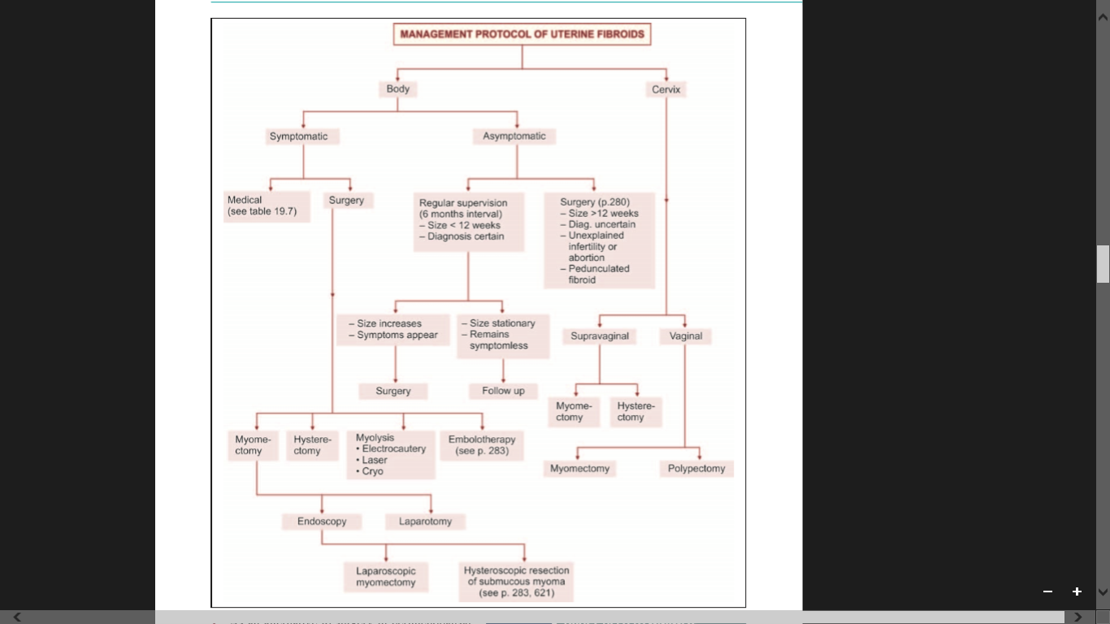

- GnRH antagonists
Cetrorelix or ganirelix causes immediate suppression of pituitary and the ovaries. They do not have the initial stimulatory effect. Benefits are same as that of agonists. Onset of amenorrhea is rapid.
- Prostaglandin synthetase inhibitors
These are used to relieve pain due to associated endometriosis or degeneration of the fibroid. They cannot improve menorrhagia due to fibroids.
- Levonorgestrel-releasing Intrauterine System (LNG-IUS) reduces blood loss and uterine size. However, this is not recommended when the uterine size is >12 weeks or there is distortion of uterine cavity.

- SURGICAL MANAGEMENT OF FIBROID UTERUS
- Myomectomy
- Laparotomy
- Laparoscopy
- Hysterectomy 
- Embolotherapy
- Myolysis
- Hysteroscopy
Myomectomy
- Myomectomy is the enucleation of myomata from the uterus leaving behind a potentially functioning organ capable of future reproduction.
- Pretreatment with GnRH analogs may be used to reduce the size and vascularity of the uterus.
- Vaginal myomectomy: Submucous pedunculated myoma can be removed vaginally. Morcellation (removal by piecemeal) is needed if the tumor is large. A moderate size fibroid can be removed by twisting. In that case, fibroid is grasped with a sponge forceps.
Endoscopic Surgery
- Hysteroscopy: Generally a fibroid of 3–4 cm in diameter or a polyp is resected with a hysteroscope. Pedicle or the base of the fibroid is coagulated using electrocautery. Complications of hysteroscopic surgery are uterine perforation, fluid overload, hemorrhage and others,
- Laparoscopy: Subserous and intramural fibroids could be removed laparoscopically. Electrocautery, laser and extra-corporeal sutures are used for hemostasis. Laparoscopic surgery is not suitable when the fibroid is large, deep intramural, multiple or technically inaccessible. Leiomyomas can be desiccated (myolysis) using laser or bipolar diathermy.
Embolotherapy
- Uterine artery embolization (UAE) causes avascular necrosis followed by shrinkage of fibroid. Uterine arteries are occluded by injecting polyvinyl alcohol particles through percutaneous femoral catheterization.
- Result: Improvement of menorrhagia is observed in 80–90 percent with 60 percent reduction in size.

- Complication of UAE: Postembolization syndrome: Fever, sepsis, myometrial infarction and necrosis, amenorrhea and ovarian failure. Complications related to the procedure: femoral artery injury.
- Contraindications: Active pelvic infection, desire for future pregnancy, drug allergy.
Hysterectomy
- Hysterectomy in fact, is the operation of choice in symptomatic fibroid when there is no valid reason for myomectomy.
- The patients over the age of 40 years and in those not desirous of further child are the classic indications.
- Total hysterectomy is performed.
- However, a subtotal hysterectomy may have to be done in few conditions.
- Removal of the ovary: It is preferable to remove the ovaries in postmenopausal women and to preserve the same in earlier age, if they are found healthy.
- Advantages of hysterectomy
- There is no chance of recurrence.
- Adnexal pathology and the unhealthy cervix, if any, are also removed.
- Vaginal hysterectomy: Fibroids with size of 10–12 weeks of pregnancy associated with uterine prolapse are better dealt by the vaginal route. Vaginal hysterectomy with repair of pelvic floor is the operation of choice. Pretreatment with GnRH analog may facilitate vaginal hysterectomy.

NURSING DIAGNOSIS
- Anticipatory grieving related to expected poor prognosis.
- Acute pain related to effects of diagnostic tests (or surgery).
- Powerlessness related to lack of control over prognosis.
- Altered patterns of sexuality related to loss of libido secondary to medically imposed restrictions.
- High risk for social isolation related to impaired fertility, its investigation and management.
- Anxiety related to unknown outcome of diagnostic work up.
- Body image or self-esteem disturbance related to impaired fertility.
- High risk for impaired individual/family coping related to methods used in the investigation of impaired fertility.
- Decisional conflict related to therapies for impaired fertility and alternatives to therapy: childlessness or adoption.
- Altered family processes related to unmet expectations for pregnancy.

JOURNAL STUDY

Reproductive outcomes in women with congenital uterine anomalies: a systematic review
AUTHORS: Y. Y. Chan, K. Jayaprakasan, A. Tan , J. G. Thornton, A. Coomarasamy, N. J. Raine‐Fenning

ABSTRACT

Objective
Congenital uterine anomalies are common but their effect on reproductive outcome is unclear. We conducted a systematic review to evaluate the association between different types of congenital uterine anomaly and various reproductive outcomes.

Methods
Searches were performed using MEDLINE, EMBASE, the Cochrane Library and Web of Science. The Newcastle‐Ottawa Quality Assessment Scale was used for quality assessment. Uterine defects were grouped into arcuate uteri, canalization defects (septate and subseptate uteri) and unification defects (unicornuate, bicornuate and didelphys uteri). Pooled risk ratios (RR) with 95% confidence intervals (CI) were computed using random effects models.

Results
We identified nine studies comprising 3805 women. Meta‐analysis showed that arcuate uteri were associated with increased rates of second‐trimester miscarriage (RR, 2.39; 95% CI, 1.33–4.27, P = 0.003) and fetal malpresentation at delivery (RR, 2.53; 95% CI, 1.54–4.18; P < 0.001). Canalization defects were associated with reduced clinical pregnancy rates (RR, 0.86; 95% CI, 0.77–0.96; P = 0.009) and increased rates of first‐trimester miscarriage (RR, 2.89; 95% CI; 2.02–4.14; P < 0.001), preterm birth (RR, 2.14; 95% CI, 1.48–3.11; P < 0.001) and fetal malpresentation (RR, 6.24; 95% CI, 4.05–9.62; P < 0.001). Unification defects were associated with increased rates of preterm birth (RR, 2.97; 95% CI, 2.08–4.23; P < 0.001) and fetal malpresentation (RR, 3.87; 95% CI, 2.42–6.18; P < 0.001).

Conclusions
Canalization defects reduce fertility and increase rates of miscarriage and preterm delivery. None of the unification defects reduces fertility but some are associated with miscarriage and preterm delivery. Arcuate uteri are specifically associated with second‐trimester miscarriage. All uterine anomalies increase the chance of fetal malpresentation at delivery.

- Prevalence, symptoms and management of uterine fibroids: an international internet-based survey of 21,746 women
AUTHOR: Zimmermann A, Bernuit D, Gerlinger C, Schaefers M, Geppert K

ABSTRACT

Background
In 2009 the Uterine Bleeding and Pain Women's Research Study (UBP-WRS) was conducted interviewing 21,479 women across 8 countries in order to gain patient-based prevalence data on uterine pain and bleeding indications and investigate uterine symptoms and women's treatment experiences. This article shows relevant results of the study for the indication uterine fibroids providing data on self-reported prevalence, symptomatology and management of uterine fibroids.

Methods
2,500 women (USA: 4,500 women) in each country (Brazil, Canada, France, Germany, Italy, South Korea, the UK, the USA) completed an online survey. Women included were in their reproductive age (age group 15-49 years; USA: 18-49 years) and had ever experienced menstrual bleedings. Quotas were applied for age, region, level of education and household income of respondents. Variables have been analyzed descriptively and exploratory statistical tests have been performed.

Results
The self-reported prevalence of uterine fibroids ranged from 4.5% (UK) to 9.8% (Italy), reaching 9.4% (UK) to 17.8% (Italy) in the age group of 40-49 years. Women with a diagnosis of uterine fibroids reported significantly more often about bleeding symptoms than women without a diagnosis: heavy bleedings (59.8% vs. 37.4%), prolonged bleedings (37.3% vs. 15.6%), bleeding between periods (33.3% vs. 13.5%), frequent periods (28.4% vs. 15.2%), irregular and predictable periods (36.3% vs. 23.9%). Furthermore women with diagnosed uterine fibroids reported significantly more often about the following pain symptoms: pressure on the bladder (32.6% vs. 15.0%), chronic pelvic pain (14.5% vs. 2.9%), painful sexual intercourse (23.5% vs. 9.1%) and pain occurring mid-cycle, after and during menstrual bleeding (31.3%, 16.7%, 59.7%, vs. 17.1%, 6.4%, 52.0%). 53.7% of women reported that their symptoms had a negative impact on their life in the last 12 month, influencing their sexual life (42.9%), performance at work (27.7%) and relationship & family (27.2%).

Conclusions
Uterine fibroid is a common concern in women at fertile age causing multiple bleeding and pain symptoms which can have a negative impact on different aspects in women's life.

SUMMARY
Today we discussed about uterine malformation and uterine fibroid. We discussed about the incidence, risk factors, pathophysiology, sign and symptoms, diagnostic evaluation, medical and surgical management. We also focused on the nursing management of both the disorders.
CONCLUSION
Congenital malformations are anomalies which may be either hereditary or occurring during gestation and evident at the time of birth. Development of the female genital tract is a complex process dependent upon a series of events involving cellular differentiation, migration, fusion and canalization. Failure of any one of these processes results in congenital anomaly.
A uterine malformation is the result of an abnormal development of the mullerian ducts during embryogenesis. Developmental anomalies of the external genitalia along with ambiguity of sex are usually genetic in origin. Major anatomic defect of the genital tract is usually associated with urinary tract abnormality, skeletal malformation and normal gonadal function. Many women have uterine fibroids sometime during their lives. But most women don't know they have uterine fibroids because they often cause no symptoms.
Treatment success and future outcome in both cases depend on the severity of the fibroid or fibroids prior to treatment and the chosen treatment. Fibroids may affect fertility, but this depends on the size and location of the fibroids.

BIBLIOGRAPHY
- Dutta.D.C.Textbook of Gynaecology. 6th ed. Daryaganj. Jaypee Brothers Medical Publishers (P) Ltd;2013.272-83.
- Dutta.D.C.Textbook of Obstetrics.7thed.London.New Central Book Agency(P)Ltd;2011.306-310.
- Pillitteri A. Maternal and child health nursing. Care of the childbearing and childrearing family. Sixth edition. Philadelphia; Lippincott Williams & wilkins: 2010.
- Elizabeth M.Midwifery for Nurses.2nded.New Delhi.CBS Publishers and Distributors Pvt Ltd;2013.
- Seth.S.S.Essential of Obstetrics.2nded.Jaypee Brothers Medical Publishers(P)Ltd;2011.
- Cooper.M, Fraser.D.Textbokk for Midwives.15thed.New York.Churchill Livingstone Elsevier;2009.
- Swan D. Obstetrics Nursing Procedure Manual. New Delhi. The Health Science Publishers.2017.

- Anamma J. A comprehensive textbook of midwifery. 2nd ed. JAYPEE Brothers Medical Publishers. 2008

- Mudaliar A L. Clinical obstetrics. 10th ed. University’s press India Pvt.Ltd. 2008.

- Perry L. maternity nursing 7th ed. Mosby Elseiver. St . Louis, Missouri, 2006, Pg no: 146-54.

- Y. Y. Chan, K. Jayaprakasan, A. Tan, J. G. Thornton, A. Coomarasamy, N. J. Raine‐Fenning. Reproductive outcomes in women with congenital uterine anomalies: a systematic review. Ultrasound Obstet Gynecol. 2011;38: 371 – 38.

- Zimmermann A, Bernuit D, Gerlinger C, Schaefers M, Geppert K. Prevalence, symptoms and management of uterine fibroids: an international internet-based survey of 21,746 women. BMC Women's Health. 2012; 12: 6.

