A Novel Bangla Font Recognition Approach Using Deep Learning

Md. Majedul Islam¹, A K M Shahariar Azad Rabby ^{1,} Nazmul Hasan¹, Jebun Nahar¹ and Fuad Rahman²
¹Apurba Technologies, Dhaka, Bangladesh.
²Apurba Technologies, Sunnyvale, CA, USA
{majed,rabby,nazmul,jebunnahar,fuad}@apurbatech.com
Abstract. Font detection is an essential preprocessing step for printed character recognition. In this era of computerization and automation, computer composed documents such as official documents, bank checks, loan applications, visiting cards, invitation cards, educational materials, etc. are used everywhere. Beyond just editing and processing documents, converting documents from one format to another, such as an invitation card, billboards, etc., is another major application area where a designer has to recognize the font details from the images. There is a lot of research on automatic font detection published for high resource languages such as English. Still, not much has been reported for a low resource language such as Bangla. Bangla has a complex structure because of the use of diacritics, compound characters, and graphemes. Furthermore, because of the popularity of digital, online publications, there has been a recent surge of fonts in Bangla. Font detection can also help analysts detect changes in font choices based on socio-political divides: for example, consider that fonts common in Bangladesh may not be as popular among Bangla publications in India. In this paper, we present a Convolutional Neural Network (CNN) approach for detecting Bangla fonts, using a space adjustment method dependent on a Stacked Convolutional Auto-Encoder (SCAE). As part of the work, we built a large corpus of printed documents consisting of 12,187 images in 7 different Bangla fonts, forming a total of 77,728 samples by augmentations to train and validate our model. Our proposed model achieves 98.73% average font recognition accuracy in the validation set.
Keywords: Bangla typeface, Deep Learning, Stacked Convolutional Auto-Encoder (SCAE), Pattern Recognition
- Introduction
Bangla is the only language on the planet for which blood was spilt, and human lives were lost—only to protect it and get it recognized as a state language of erstwhile East Pakistan—now independent Bangladesh. Bangla is currently ranked the 5th most-spoken language in the world [1]. But compared to other high-resource languages such as English, Chinese, Hindi, etc., the state of Bangla is in a rather poor shape. Common resources for language automation include annotated corpora, parts of speech identification, anaphora resolution, entity extraction, frame representation, language modelling, parallel speech corpora for machine translation, OCR, font detection, and so on, all of which are yet to be developed for Bangla.
Font detection is often a preprocessing step in many OCR pipelines. It is often important to know what type of fonts are being used before OCRs are run because that information may help in customizing the recognition tasks. Another group of users who have very practical need is graphic designers. They often want to know what specific fonts are used in an image so that they can use that in some other creative projects. In that sense, the ability to correctly detect font in images will have a significant impact on Bangla language computerization. It can help in automatically processing computers composed of Bangla documents such as official documents, bank checks, loan applications, educational materials, and so on. It can also be useful for graphic artists to design visiting cards, invitation cards, advertising banners, and so on.
- Literature review
Md. Zahid Hasan et al. [2] proposed a deep convolutional neural network solution for Bangla font detection. In their system, they used a total of 6,000 images of 10 different Bangla fonts and achieved 96% accuracy. Aniruddha Rakshit et al. [3] proposed a 1-D Discrete Wavelet Transform solution for Bangla font on basic Bangla vowel characters. In their data set for training, they used 200 sets of Bangla character images with 3 different fonts and 2 styles: italic and non-italic. Their model detection accuracy is above 96% for an inclination angle of 10 degrees. Sukalpa Chanda et al. [4] proposed the Support Vector Machine (SVM) and Multiple Support Vector Machine (MKL SVM) approach for 10 different fonts for Indic scripts, including Bangla. They used 400 text documents, 40 for each font, to train their model and get 94.00% accuracy for SVM and 98.5% for MKL SVM.
A complete review of font detection in other languages is outside the scope of this paper. However, the following is a short snapshot of what is being done in other resource-rich languages.
Ravi Kant Yadav et al. [5] proposed a programmatic approach to identify the bold and italic format in Hindi printed documents. In their approach, they give characters headline and vertical line pixel value condition to identify bold or italic. Gurpreet Singh Lehal et al. [6] introduces an n-gram based similarity method to identify fonts and use 50,000 Hindi words to train their system. This method achieved an average accuracy of 99.6% for both Gurmukhi and Devanagari fonts. Subhankar Ghosh et al. [7] proposed a convolutional neural network (CNN) approach, where they use 10,000 English fonts images database. They achieved a 63.45% top-1 accuracy and 70.76% top-3 accuracy at the character level, and 57.18% top-1 accuracy and 62.11% top-3 accuracy at the word level.
Fouad et al. [8] proposed a system for Arabic font detection. In their system, they tried to solve font recognition and font size recognition using Gaussian Mixture Models (GMMs) and evaluated the APTI database. They reported a reduction of 70% errors to the character and word recognition for OCR. Tensmeyer C. et al. [9] presented a simple CNN based solution for Arabic letters of 40 Arabic fonts. They produced little picture patches into textual style classes using CNN. In their model, they used two CNN architectures of AlexNet and ResNet-50. They achieved 98.8% text line accuracy on the King Fahd University Arabic Font Database (KAFD), which has 4 styles and 10 different sizes. Zhangyang et al. [10] developed a large-scale visual font recognition (VFR) dataset for English, named AdobeVFR, which consists of both labelled synthetic data and partially labelled real-world data. Next, they introduced a Convolutional Neural Network (CNN) decomposition approach, using a domain adaptation technique based on a Stacked Convolutional Autoencoder (SCAE). SCAE based structure helped their model to achieve an 80% accuracy of their collected dataset. Their system also gives a good font similarity measure for font selection and suggestion. Y. Wang et al. [11] proposed a technique dependent on deep learning and transfer learning for perceiving the textual styles of computer type in regular pictures of the Chinese language. From images containing writings in 48 fonts and styles, and by combining those writings, they trained their deep neural network system to detect text styles. They have modified two popular CNN models AlexNet and VGG16. They achieve 77.68% accuracy in top-1 and 93.97% in top-5, respectively. Ramanathan R et al. [12] proposed a Support Vector Machine (SVM) solution to identify different fonts of the English Language. To extract the featured vectors, they used Gabor filters. They used six most-used English fonts in four styles: regular, bold, italic, and bold italic and used 216 block images. They achieved an average accuracy of 93.54%. Khoubyari and Hull [13] used a 1,000-word image dataset in English, with 33 font styles, in their proposed model, and reported an 85% accuracy. Ding et al. [14] proposed a model for Chinese font recognition. They used 2,741,150-character sample images of 7 different font styles to training their model and achieved an accuracy of 91.3%.
- Datasets
We built a 12,187-image corpus of seven different Bangla fonts. They are AdorshoLipi, Kalpurush, Ekushey Lohit, Nikosh, Rupali, SolaimanLipi, Sonar Bangla fonts. Fig-1 shows some examples of this dataset. From Fig-1, it is evident that a lot of the fonts are very similar to each other, making the task of font detection quite tricky.


- AdorshoLipi (b) Kalpurush (c) Ekushey Lohit (d) Nikosh

(e) Rupali (f) SolaimanLipi (g) Shonar Bangla

Fig. 1. Example of Dataset
  - Image Preparation and Preprocessing
We built a large dataset into three steps. Firstly, we created a set of documents using 7 fonts with different font sizes and different formats such as bold, italic, and so on, as seen in Fig 2. We built a segmentation tool designed explicitly for Bangla. Our segmentation tool can separate lines of a given document; from the segmented line, we can segment the words, and from a given word, we can segment characters. We built our database of word images from these documents using this segmentation tool. We stored these word samples in 7 different folders, which are labelled with font names, each folder containing 1,700 images of the corresponding font.
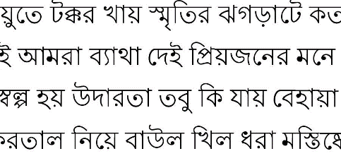
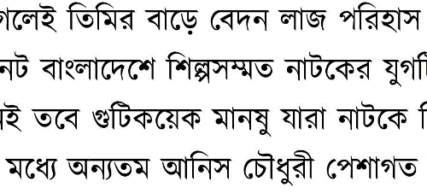

(a) Kalpurush (b) Ekushey Lohit
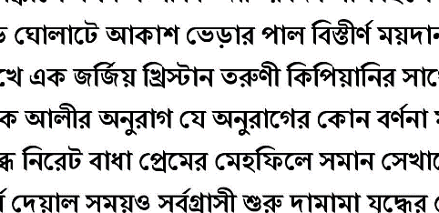
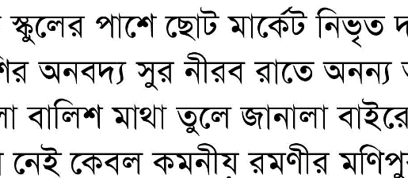

(c) AdorshoLipi (d) Shonar Bangla
Fig. 2. Some sample document for font size 16
To address the issue of model overfitting, it is a well-known technique to artificially augment training data using label-preserving transformations before fitting data into the model for training. To achieve the required variability from these font images, we used some preprocessing and augmentation methods such as adding noise, blurring, changing perspective, adding rotation, adding shading or "gradient illumination," along with:
- Rotation: Images were rotated 30 degrees randomly.
- Zooming: Images were 20% zoomed in and zoomed out.
- Width shift: Randomly shift images 10% horizontally.
- Height shift: Randomly shift images 10% vertically.

After the preprocessing, we compiled a dataset of 77,728 annotated images to train our model.
- Proposed Method
  - Model Preparation and Tuning
In our proposed model, we have two different algorithm layers. One is Stacked Convolutional Auto-Encoder layers, and another one is CNN, as seen in Fig. 3. Stacked Convolutional Auto-Encoder (SCAE) structures a convolutional neural system (CNN). Each SCAE is prepared to utilize ordinary online gradient descent without additional regularization terms. In our SCAE layers, the first layer is a convolutional layer with filter size 64, and kernel size 48 with ReLU activation. The output of this layer goes through batch normalization (1) "layer 2" and connected with max-pooling "layer 3". Layers 4, 5, and 6 are the same as 1, 2, and 3. The convolutional layers' filter size is 128 for "layer 4," and the kernel size is 24. Then layers 7 and 9 are transposed convolutional layers with filter sizes of 128 and 64 and kernel sizes of 24 and 12, respectively, using the same padding and activation ReLU, followed by up sampling layers 8 and 10, which simply doubles the dimensions of the input.
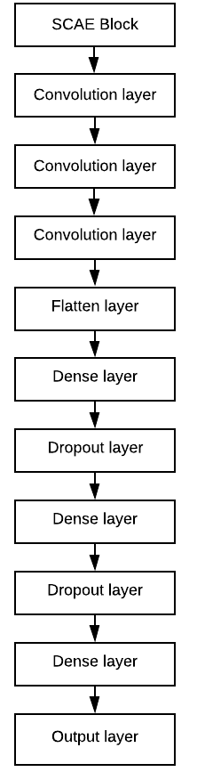
(a) SCAE Block
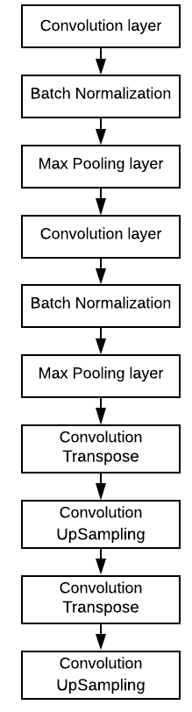
(b) Full Model
Fig. 3. Model Architectures
A Convolutional Neural Network (CNN) is a deep learning algorithm that can take in an input image, assign importance to various aspects in the image, and be able to differentiate one from the other. In our proposed model, layers 11, 12, 13 are convolutional layers of filter size 256, having kernel size 12 with ReLU (2) activation.
${\hat{ϰ}}_{i}^{\left(k\right)}=\frac{x_{i}^{\left(k\right)}-μ_{B}^{\left(k\right)}}{\sqrt{σ_{B}^{{\left(k\right)}^{2}}+ϵ}}$ (1)
Afterwards, the output is flattened into an array and passed through a fully connected dense layer (15 to 18 layers) with 4,096 hidden units with activation ReLU and regularized with 50% dropout. The output of layer 18 is connected with the fully connected dense layer 19, again with ReLU activation, followed by dense layer 20 with seven nodes with SoftMax (3), which is also the output layer of our model.
$ReLU(X) = MAX(0, X)$ (2)
$σ{\left(z\right)}_{j}=\frac{ⅇ^{z_{j}}}{\sum_{k=1}^{K}{ⅇ^{z_{k}} }}for j=1, …k$ (3)
Our proposed model used a Stochastic gradient descent (SGD) (4) optimizer with a learning rate of 0.01. SGD calculates the cost of one example for each step. Rather than relying just on the present gradient to refresh the weight, gradient descent with momentum replaces the present gradient with momentum. In our proposed model, we use the default momentum value of 0.9. To calculate the error of the optimizer algorithm, we used the Mean Squared Error (5). We follow a common heuristic to manually divide the learning rate by 10 when the validation error rate stops decreasing with the current rate.
$θ=θ-η⋅∇_{θ^{J}}(θ;x^{(i)};y^{(i)})$ (4)
$MSE=\frac{1}{n}\sum_{i=1}^{n}{{\left(y_{i}-{\hat{y}}_{i}\right)}^{2}}$ (5)
- Performance
The performance of the proposed model gives us satisfactory results on our training and validation sets.
  - Train-Test Split
After augmenting the data, we have a total of 77,728 images in our dataset. We split the dataset into two parts, one for training and another one for validation. We took 25% of the data for validation and reserved 75% for training. After the split, we had 58,296 samples in the training set and 19,432 samples in the validation set.
  - Model Performance
Our proposed model achieves 98.73% average font recognition accuracy in the validation set.
We originally fit it for 25 epochs, however, as we had no meaningful change in validation loss after 10 consecutive epochs, we stopped the training early, thus achieving our results after 20 epochs instead. Fig. 4 shows the graph of model loss and validation accuracy fluctuations.
  - Discussion
One clear observation from Section 5.2 is that our accuracy is not very stable. Usually, when that happens, it is a sign of model overfitting. This can sometimes happen if certain portions of the samples are classified randomly. Since random guesses are, by their very nature, random, the model can sometimes exhibit severe fluctuations, as seen in our model.

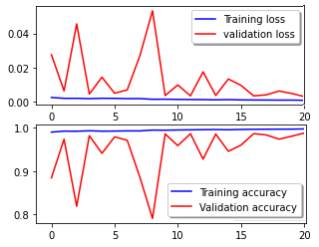
Fig. 4. Training loss and validation accuracy graph

But then that argument may also not be entirely correct. Usually, overfitting should be accompanied by increased loss, something we do not observe form our model.
It is often said that deep learning is sometimes as much science as it is an art. There are many other possible explanations for our model performance. One possibility is that we may have overcapacity and not enough training data. Since we are operating at the level of Bangla words, and we had only 58,296 samples in the training set, that may well be true. Another, the more conventional idea is that our model needs fine-tuning in terms of ordering the layers, and there may be not-so-effective combinations of these layers that are responsible for this instability. Another more iterative idea is that we may need to work on adjusting our learning rates, something that needs further evaluation and testing on our part.
This short discussion indicates that although we have achieved relatively good accuracy rates on our validation set, there is room for further improvement and additional work.
- Future Work
We plan to continue work on this project, and we would like to outline here several areas for future growth specifically. Other than the issues discussed in the discussion section above, we would also like to look at some other aspects of this work in the future.
After analyzing the error and confusion matrices, we found that most fonts were so similar that even human eyes could not reliably distinguish between them. We plan to create additional models that are explicitly trained to solve such confounding clusters of groups—resolving frequent areas of confusion. If our current model identifies a sample as belonging to one of these suspect classes, a specialist classifier specially trained in those classes will reclassify them. In addition, there are many fonts in Bangla that we have not worked with yet. In future efforts, we will add more Unicode and ASCII fonts to create a broader-reaching dataset for Bangla font images.
- Conclusion
In this paper, we provided a detailed outline of our proposed model and have shown a great deal of success towards our objective. As stated in the previous section, we have already established many potential avenues for improving the efficiency and reliability of our solution, which are ready for further examination. This is merely the beginning of a long journey for our research endeavor.

References
- "The World Factbook." www.cia.gov. Central Intelligence Agency. Archived from the original on 13 February 2008. Retrieved 21 February 2018.
- Hasan, M. Z., Rahman, K. T., Riya, R. I., Hasan, K. Z., & Zahan, N. (2020). A CNN-Based Classification Model for Recognizing Visual Bengali Font. In Proceedings of International Joint Conference on Computational Intelligence (pp. 471-482). Springer, Singapore.
- Rakshit, A., Barshan, R. A., & Islam, M. I. Bangla Font Detection Using 1-D Discrete Wavelet Transform.
- Chanda, S., Pal, U., & Franke, K. (2012, November). Font identification—In context of an Indic script. In Proceedings of the 21st International Conference on Pattern Recognition (ICPR2012) (pp. 1655-1658). IEEE.
- Yadav, R. K., & Mazumdar, B. D. (2012). Detection of Bold and Italic Character in Devanagari Script. International Journal of Computer Applications, 39(2), 19-22.
- Lehal, G. S., Saini, T. S., & Buttar, S. P. K. (2014). Automatic Bilingual Legacy-Fonts Identification and Conversion System. Research in Computing Science, 86, 9-23.
- Ghosh, S., Roy, P., Bhattacharya, S., & Pal, U. (2019, November). Large-Scale Font Identification from Document Images. In Asian Conference on Pattern Recognition (pp. 594-600). Springer, Cham.
- Slimane, F., Kanoun, S., Hennebert, J., Alimi, A. and Ingold, R., 2013. A study on font-family and font-size recognition applied to Arabic word images at ultra-low resolution. Pattern Recognition Letters, 34(2), pp.209-218.
- Tensmeyer C, Saunders D, Martinez T (2017) Convolutional neural networks for font classification. In: 2017 14th IAPR international conference on document analysis and recognition (ICDAR), pp 985–990
- Wang Z, Yang J, Jin H, Shechtman E (2015) DeepFont: Identify your font from an image. In: Proceedings of the 23rd ACM international conference on multimedia, pp 451–459. ACM, Brisbane, Australia
- Wang Y, Lian Z, Tang Y, Xiao J (2018) Font recognition in natural images via transfer learning. In: Tang Y, Xiao J (eds) International conference on multimedia modeling 2018, LNCS, vol 10704, pp 229–240. Springer.
- Ramanthan R, Thaneshwaran L, Viknesh V, Arunkumar T, Yuvaraj P, Soman DKP (2009) A novel technique for English font recognition using support vector machines. In: 2009 international conference on advances in recent technologies in communication and computing, pp766–769
- Khoubyari, Siamak, Hull, Jonathan, 1996. Font and function word identification in document recognition. Comput. Vis. Image Underst. 63, 66–74, Elsevier Science Inc., New York, NY, USA.
- Ding, Xiaoqing, Chen, Li, Wu, Tao, 2007. Character independent font recognition on a single Chinese character. IEEE Trans. Pattern Anal. Mach. Intell. 29,195–204.

