**Exercise No: 1**

**Date:17/11/2020**

**Aim:**

In this program, We aim to display calendar of the particular month given as the input by the user.

**Program:**

import calendar

y = int(input("Input the year: "))

m = int(input("input the month: "))

print("\n")

try:

val = int(y)

val1 = int(m)

if(1600<y<3001):

if(0<m<13):

print(calendar.month(y,m))

else:

print("Invalid input")

else:

print("Invalid input")

except ValueError:

print("Invalid input")

**Link:**

**http://103.53.53.18/mod/vpl/view.php?id=229**

**Output:**

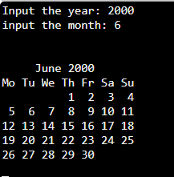

**Result:**

The output has been successfully executed and verified.