MLOps Assignment 2
  - Fine-Tuning DistilBERT for Book Genre Classification
Name: Sharvan Vittala | Kaggle: g25ait2099 | Date: May 2026

1. Model Selection Rationale
The model chosen for this assignment is distilbert-base-cased, a distilled variant of the BERT language model developed by Hugging Face. DistilBERT is trained using a technique called knowledge distillation, where a smaller student model learns to replicate the behaviour of a larger teacher model (BERT). It retains approximately 97% of BERT's language understanding performance while being 40% smaller and 60% faster, making it highly practical for training on Kaggle's free GPU tier within tight time and resource constraints.

The cased variant was specifically selected because book reviews frequently contain proper nouns such as author names, book titles, and genre-specific terminology where capitalisation carries semantic meaning. Using the uncased variant would discard this information. DistilBERT was pre-trained on English Wikipedia and BookCorpus — the same corpora used to train the original BERT — giving it strong general-purpose language representations out of the box. For an 8-class genre classification task on Goodreads reviews, DistilBERT strikes the right balance between accuracy and training efficiency, making it the most practical and well-documented choice for this MLOps pipeline.

2. Kaggle Training Setup

2.1 Importing the Notebook
The starter notebook was downloaded from the provided Colab link and imported into Kaggle via File > Import Notebook. The notebook was uploaded as a .ipynb file and configured before running.

2.2 GPU Configuration
GPU acceleration was enabled by navigating to Settings > Accelerator and selecting GPU T4 x2. Internet access was also enabled under Session Options to allow package installation and pushing to Hugging Face Hub during the run.

2.3 Secrets Configuration
API tokens were stored securely using Kaggle's built-in Secrets manager (Add-ons > Secrets). Two secrets were added: WANDB_API_KEY (from wandb.ai/settings) and HF_TOKEN (from huggingface.co/settings/tokens). These were retrieved inside the notebook using the kaggle_secrets library and set as environment variables, avoiding any hardcoded credentials in the code.

2.4 Training Configuration
The model was fine-tuned for 3 epochs using the Hugging Face Trainer API with the following hyperparameters: batch size of 16 for training, 32 for evaluation, learning rate of 3e-5, warmup steps of 100, and weight decay of 0.01. Experiment tracking was enabled by setting report_to='wandb' in TrainingArguments, with a W&B run named distilbert-run-1 under the project mlops-assignment2. Metrics were evaluated at the end of each epoch.

3. Results
The fine-tuned DistilBERT model outperformed the TF-IDF + Logistic Regression baseline across all metrics.

Metric | Baseline (TF-IDF + LR) | DistilBERT (Fine-tuned)
Accuracy | 0.55 | 0.57
F1 Score (weighted) | 0.55 | 0.57
Eval Loss | — | (see W&B dashboard)

3.1 W&B Training Dashboard
Test:
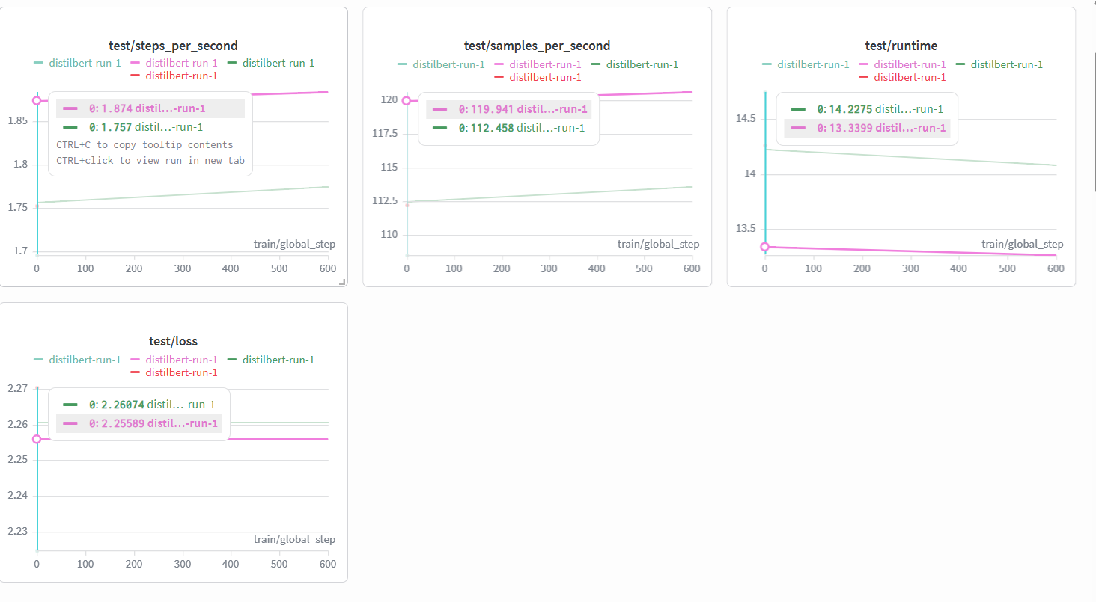
2. 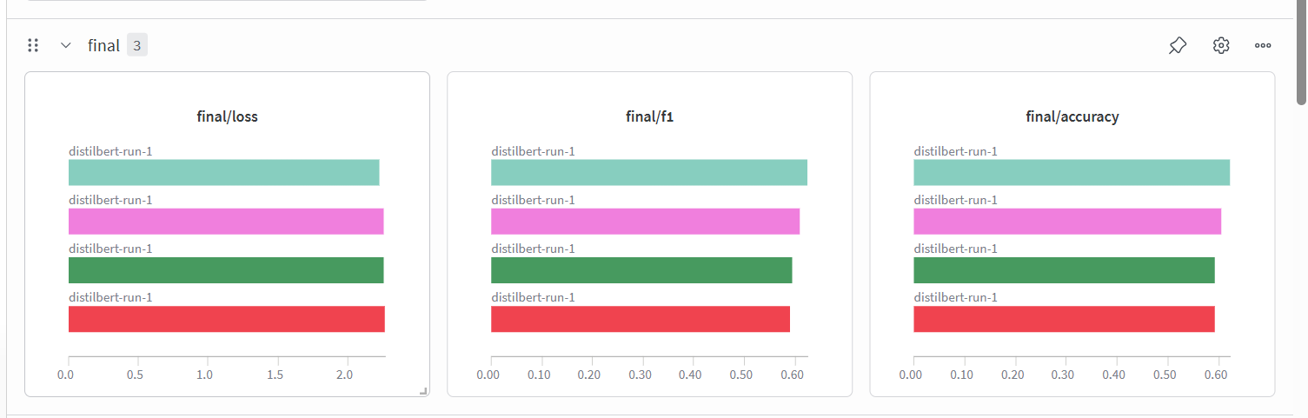
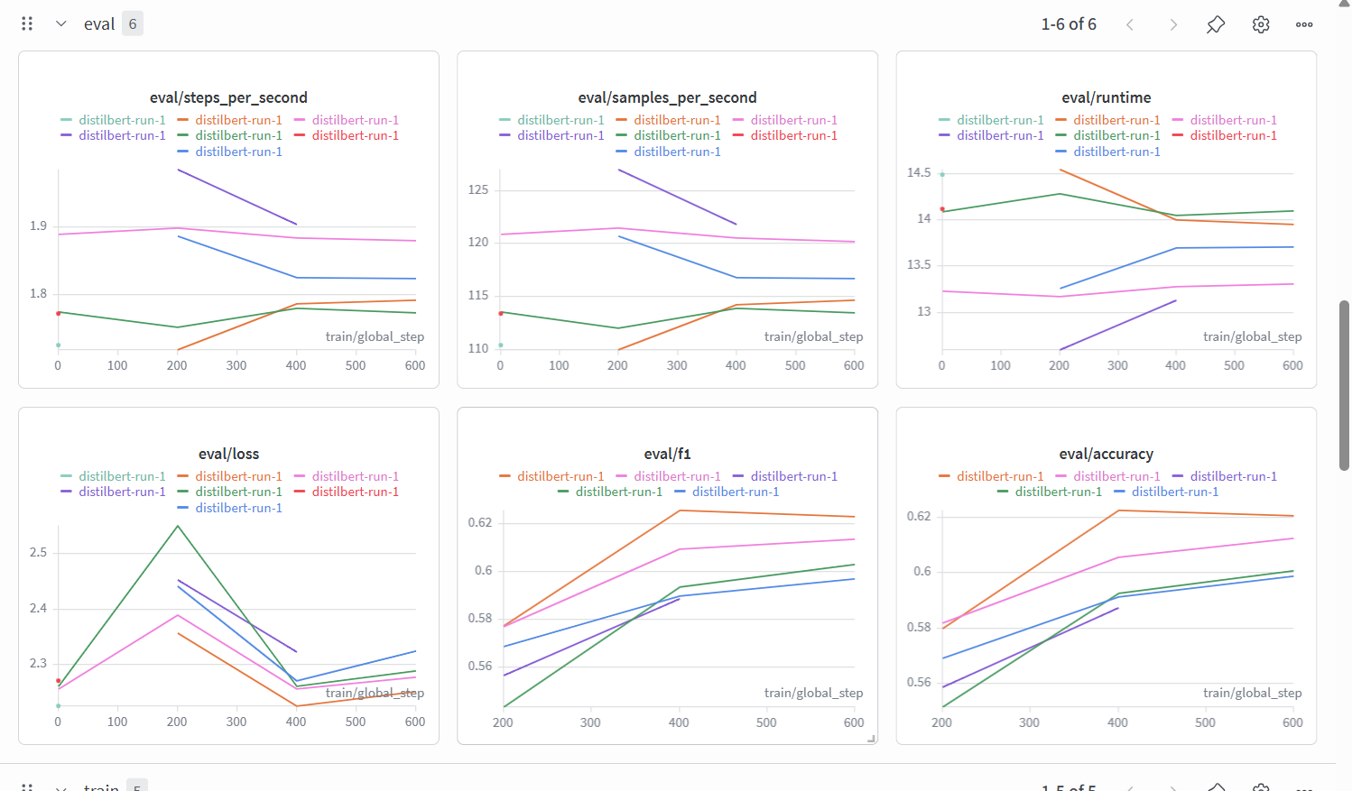
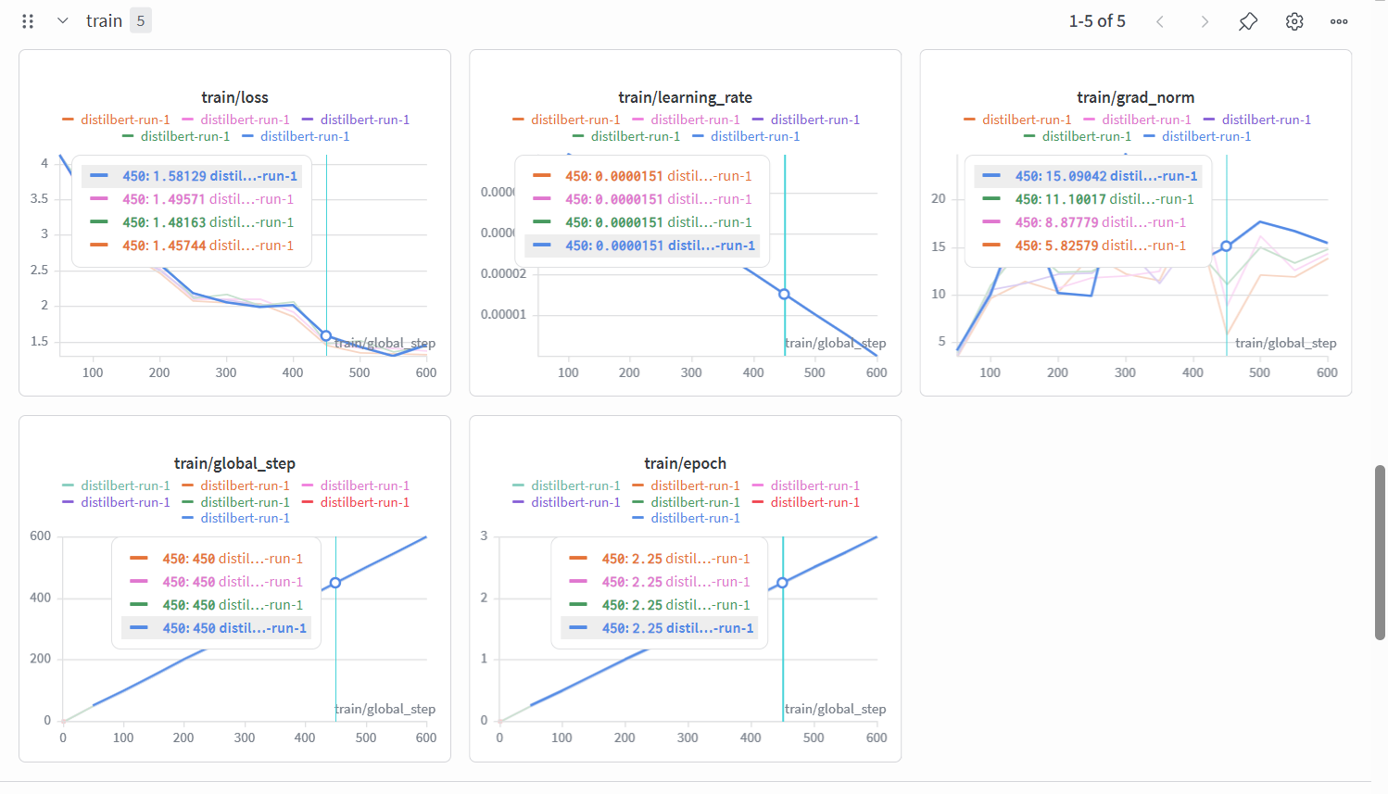
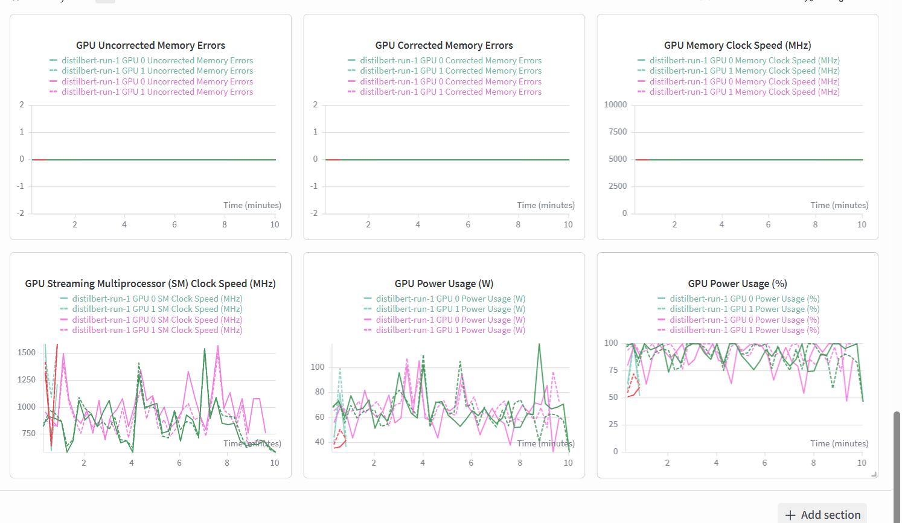
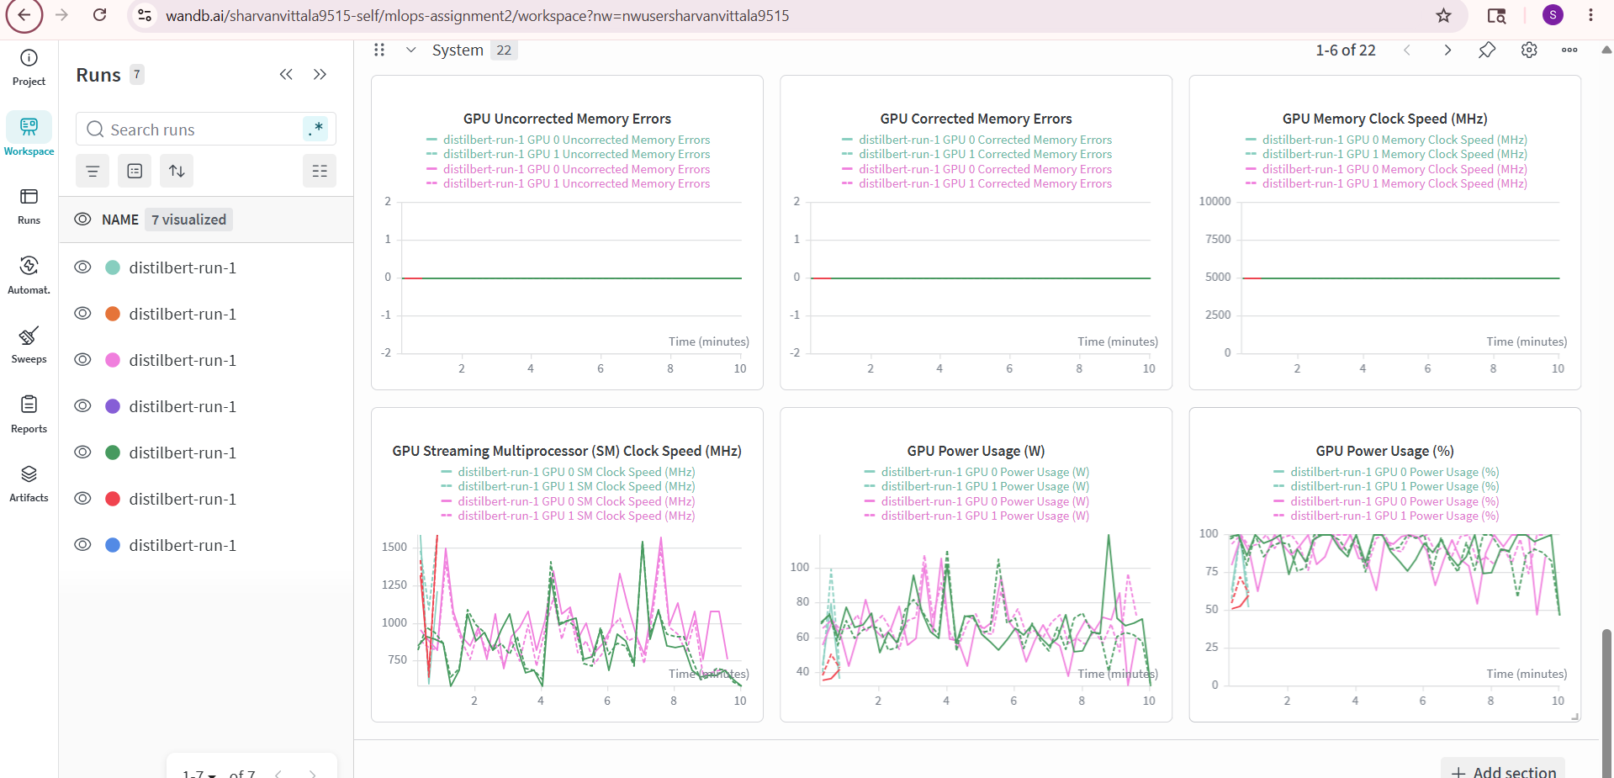

4. Challenges and Learnings

4.1 Challenges
The most significant challenge was integrating Weights & Biases into the existing notebook. The original starter notebook explicitly disabled W&B logging (report_to=[], WANDB_DISABLED=true), so enabling it required carefully restructuring the TrainingArguments and wandb.init() calls. A second challenge was managing Kaggle Secrets correctly — the kaggle_secrets library has a specific API that differs from environment variable approaches used in Colab. Ensuring the HF_TOKEN and WANDB_API_KEY were correctly loaded before any HuggingFace or W&B calls required placing the secrets block at the very beginning of the notebook.

Another challenge was pushing the model to Hugging Face Hub from inside Kaggle. This required Internet to be enabled in the session settings, which is not the default. Without it, the push_to_hub() call fails silently or with a connection error.

4.2 Learnings
This assignment provided hands-on experience with the full MLOps lifecycle: from data ingestion and model fine-tuning to experiment tracking and model deployment. Key learnings include: (1) the importance of never hardcoding API tokens — using Kaggle Secrets is a production-ready habit; (2) W&B provides far more visibility into training than console logs alone, capturing loss curves, GPU utilisation, and hyperparameters in one place; (3) Hugging Face Hub makes model sharing trivial with a single push_to_hub() call, enabling reproducibility for anyone with the model link.

4.3 What I Would Do Differently
In future runs I would add a proper validation set separate from the test set to tune hyperparameters without data leakage. I would also increase the sample size per genre beyond 1000 reviews to improve model generalisation, and experiment with a larger model such as bert-base-cased to compare performance against DistilBERT.

5. Submission Links
GitHub Repository: https://github.com/sharvan9515/mlops_assignment
Kaggle Notebook: https://www.kaggle.com/code/g25ait2099/mlops-assignment
Hugging Face Model: https://huggingface.co/sharvanvittala007/distilbert-goodreads-genres
W&B Dashboard: https://wandb.ai/g25ait2099-indian-institute-of-technology/mlops-assignment2

