Design Proposal for Predictive Modeling to Forecast Air Quality Trends

Table of Contents

1. Introduction

* Problem Statement
* Objectives

2. Methodology

* Data Collection
* Data Preprocessing
* Model Selection

3. Sensors requirement

4. Implementation

* Data Collection
* Data Preprocessing
* Model Building
* Model Evaluation

5. Block Diagram

6. Benefits and Impacts

7. Conclusion

1. Introduction

* Problem Statement

Air quality is a critical concern for public health and the environment. Poor air quality can lead to various health issues and environmental degradation. To address this, we propose to incorporate predictive modeling to forecast air quality trends based on historical data.

* Objectives

The primary objectives of this proposal are as follows:

1. Develop a predictive model to forecast air quality trends.

2. Provide advance warnings to the public and relevant authorities about potential air quality issues.

3. Enable timely and effective measures to mitigate air quality problems.

2. Methodology

* Data Collection

The first step is to gather historical air quality data. This data can include information on various air pollutants (e.g., PM2.5, PM10, NO2, SO2, CO, O3) collected from monitoring stations. Data sources may include government agencies, environmental organizations, and academic institutions.

* Data Preprocessing

Data preprocessing is a crucial step in ensuring the quality of the dataset. It involves:

* Data cleaning to remove outliers and missing values.
* Feature selection to determine which air quality indicators are most relevant.
* Data aggregation to create meaningful time series data.
* Model Selection

Choosing the appropriate predictive model is vital. Some suitable models for air quality forecasting include:

* + Time Series Models (e.g., ARIMA, SARIMA)
  + Machine Learning Models (e.g., Random Forest, XGBoost)
  + Deep Learning Models (e.g., LSTM, CNN)

The choice of the model depends on the complexity of the data and the forecasting requirements.

3. Sensors requirement

Gas Sensors:

Detect gases such as CO2, CO, NO2, SO2, O3 and VOCs.

Temperature and humidity Sensors :

Provides data of environmental conditions.

Pressure Sensors:

Compensates for atmospheric pressure changes.

Particulate matter (PM) Sensors:

Measures concentration of PM2.5 and PM10.

VOC Sensors:

It measures atmospheric volatile components.

4. Implementation

* Data Collection

Collect historical air quality data from various sources and organize it in a structured format for analysis.

* Data Preprocessing

Clean the dataset, remove outliers, and aggregate data to create meaningful time series data.

* Model Building

Select an appropriate predictive model based on the dataset and build the forecasting model. Ensure that the model is capable of providing forecasts for different time horizons (e.g., daily, weekly, monthly).

* Model Evaluation

Evaluate the model's performance using appropriate metrics such as Mean Absolute Error (MAE), Root Mean Squared Error (RMSE), and R-squared. Fine-tune the model if necessary to improve accuracy.

5. Block Diagram

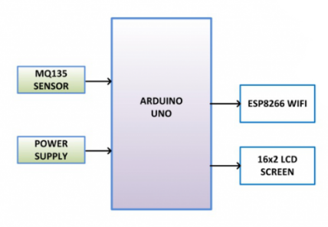

6. Benefits and Impacts

Implementing predictive modeling for air quality forecasting offers several benefits and impacts:

Public Health Improvement: Early warnings allow individuals to take precautions when air quality is predicted to deteriorate, reducing health risks.

Environmental Protection: Timely actions can be taken to reduce pollution sources and protect the environment.

Resource Allocation: Authorities can allocate resources efficiently for mitigation measures.

Policy Formulation: The data and forecasts can help in formulating effective environmental policies.

7. Conclusion

Incorporating predictive modeling to forecast air quality trends is a proactive approach to address air quality issues. By using historical data and advanced modeling techniques, we can provide valuable insights and early warnings, ultimately leading to improved public health and environmental well-being.