**Module 2.3 - Course Update/Delete**

**Allow the employee of admin department to login. Display the list of courses and allow the user to update/ delete a course. If a pre-requisite course is updated/deleted then the update should cascade throughout**

**UML Diagram:**

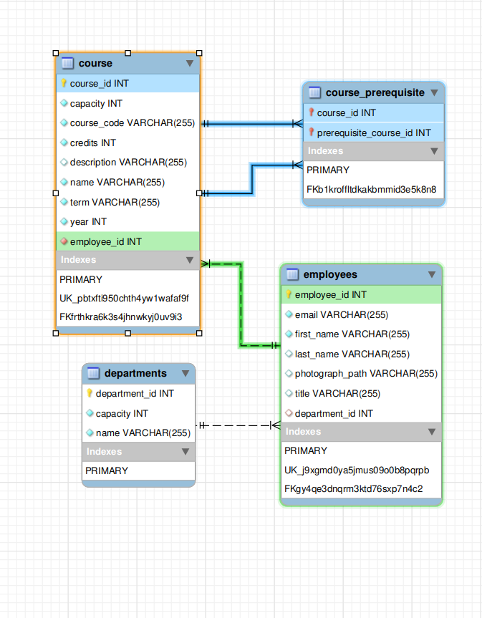Conceptual design using class diagram covering the relevant classes needed

### **Object–Relational Mapping:**

Logical design using OR mapping of the class diagram

**Table Name: Course**

|  |  |  |
| --- | --- | --- |
| **Name of column** | **Data type** | **Constraints**  **(PK, FK, Surrogate, UNIQUE, NOT NULL, etc.)** |
| Course_ID | Number | PK, Surrogate |
| Capacity | Number | Not Null |
| Course_Code | String | Unique, Not Null |
| Credits | Number | Not Null |
| Description | String |  |
| Name | String | Not Null |
| Term | String | Not Null |
| Year | Number | Not Null |
| Employee_ID | Number | FK References Employees(Employee_ID) Not Null |

**Table Name: Course_Prerequisite**

|  |  |  |
| --- | --- | --- |
| **Name of column** | **Data type** | **Constraints**  **(PK, FK, Surrogate, UNIQUE, NOT NULL, etc.)** |
| Course_ID | Number | FK References Course(Course_ID) Not Null  On Delete Cascade  FK References Course(Course_ID) Not Null  On Delete Cascade |
| Prerequisie_Course_ID | Number |

**Table Name: Employees**

|  |  |  |
| --- | --- | --- |
| **Name of column** | **Data type** | **Constraints**  **(PK, FK, Surrogate, UNIQUE, NOT NULL, etc.)** |
| Employee_ID | Number | PK, Surrogate |
| Email | String | Unique, Not Null |
| First_Name | String | Not Null |
| Last_Name | String |  |
| Photograph_Path | String |  |
| Title | String |  |
| Department_ID | Number | FK References Departments(Department_ID) |

**Table Name: Departments**

|  |  |  |
| --- | --- | --- |
| **Name of column** | **Data type** | **Constraints**  **(PK, FK, Surrogate, UNIQUE, NOT NULL, etc.)** |
| Department_ID | Number | PK, Surrogate |
| Capacity | Number | Not Null |
| Name | String | Not Null |

**Implementation design in the form of database script:**

The required scripts for database is shown (create_xxx.sql, alter_xxx.sql, insert_xxx.sql)

**create_courses.sql**

DROP DATABASE IF EXISTS coursesdb;

CREATE DATABASE IF NOT EXISTS coursesdb;

USE coursesdb;

DROP TABLE IF EXISTS course, course_prerequisite, employees, departments;

create table course(

course_id int,

capacity int,

course_code varchar(255),

credits int,

description varchar(255),

name varchar(255),

term varchar(255),

year int,

employee_id int,

constraint course_id PRIMARY KEY (course_id)

);

create table course_prerequisite(

course_id int,

prerequisite_course_id int

);

create table employees(

employee_id int,

email varchar(255),

first_name varchar(255),

last_name varchar(255),

photograph_path varchar(255),

title varchar(255),

department_id int,

constraint employee_id PRIMARY KEY (employee_id)

);

create table departments(

department_id int,

capacity int,

name varchar(255),

constraint department_id PRIMARY KEY (department_id)

);

**alter_courses.sql**

-- Add foreign key constraint for employee_id in course table

ALTER TABLE course

ADD CONSTRAINT fk_employee_id

FOREIGN KEY (employee_id)

REFERENCES employees(employee_id);

-- Add foreign key constraint for course_id in course_prerequisite table

ALTER TABLE course_prerequisite

ADD CONSTRAINT fk_course_id

FOREIGN KEY (course_id)

REFERENCES course(course_id);

-- Add foreign key constraint for prerequisite_course_id in course_prerequisite table with ON DELETE CASCADE

ALTER TABLE course_prerequisite

ADD CONSTRAINT fk_prerequisite_course_id

FOREIGN KEY (prerequisite_course_id)

REFERENCES course(course_id)

ON DELETE CASCADE;

-- Add composite foreign key constraint for course_id and prerequisite_course_id in course_prerequisite table with ON DELETE CASCADE

ALTER TABLE course_prerequisite

ADD CONSTRAINT fk_composite_key

FOREIGN KEY (course_id, prerequisite_course_id)

REFERENCES course(course_id, course_id)

ON DELETE CASCADE;

-- Add foreign key constraint for department_id in employees table

ALTER TABLE employees

ADD CONSTRAINT fk_department_id

FOREIGN KEY (department_id)

REFERENCES departments(department_id);

**insert_courses.sql**

INSERT INTO `departments` VALUES (1,100,'CSE');

INSERT INTO `departments` VALUES (2,50,'ECE');

INSERT INTO `departments` VALUES (3,30,'Mathematics');

INSERT INTO `employees` VALUES (1,'bhumikajindal@gmail.com','Bhumika','Jindal','/path/to/photo','Software Engineer',1);

INSERT INTO `employees` VALUES (2,'asijit@gmail.com','Asijit','Paul','/path/to/photo','Software Engineer',1);

INSERT INTO `employees` VALUES (3,'priyanka@iiitb.ac.in','Priyanka','Das','/path/to/photo','Professor',2);

INSERT INTO `employees` VALUES (4,'sachit.rao@iiitb.ac.in','Sachit','Rao','/path/to/photo','Professor',3);

INSERT INTO `employees` VALUES (5,'tapan@iiitb.ac.in','Tapan','Saha','/path/to/photo','Professor',3);

INSERT INTO `employees` VALUES (6,'murali@iiitb.ac.in','Muralidhara','V N','/path/to/photo','Professor',1);

INSERT INTO `employees` VALUES (7,'moutushi@iiitb.ac.in','Moutushi','Banerjee','/path/to/photo','Professor',1);

INSERT INTO `course` VALUES (8,60,'CS-301',4,'Database Management Systems','DBMS','Spring',2023,7);

INSERT INTO `course` VALUES (9,100,'CS-511',10,'Data Structures & Algorithms','Algorithms','Fall',2023,6);

INSERT INTO `course` VALUES (10,200,'CS-501',10,'Coding in C and C++','Programming','Spring',2023,2);

INSERT INTO `course` VALUES (11,50,'M-101',5,'Engineering Mathematics','Probability & Statistics','Summer',2021,3);

INSERT INTO `course` VALUES (12,100,'M-102',4,'Engineering Mathematics','Linear Algebra','Winter',2022,4);

INSERT INTO `course` VALUES (13,50,'AI-511',6,'Data Science','Machine Learning','Spring',2023,5);

INSERT INTO `course` VALUES (14,40,'AI-512',10,'Mathematics for ML & AI','Maths for Machine Learning','Spring',2023,1);

INSERT INTO `course` VALUES (15,100,'AI-611',10,'Natural Langauage Processing','NLP','Spring',2023,2);

INSERT INTO `course` VALUES (16,100,'AI-612',10,'Few-Shot Learning','FSL','Fall',2023,3);

INSERT INTO `course` VALUES (17,150,'CS-512',8,'Linux and Full-Stack Development','Software Systems','Fall',2023,5);

INSERT INTO `course_prerequisite` VALUES (9,10);

INSERT INTO `course_prerequisite` VALUES (17,10);

INSERT INTO `course_prerequisite` VALUES (14,11);

INSERT INTO `course_prerequisite` VALUES (9,12);

INSERT INTO `course_prerequisite` VALUES (14,12);

INSERT INTO `course_prerequisite` VALUES (15,13);

INSERT INTO `course_prerequisite` VALUES (16,13);

INSERT INTO `course_prerequisite` VALUES (16,14);