NAME:-Sharvari Mandavkar ROLL_ NO:433 SUB:-MP LAB

**Aim :**-To realize the truth table for logic gates and full adder.

* Basic gates:-

There are three basic logic gates

1. AND Gate
2. OR Gate
3. NOT Gate

* **AND Gate:-**

In AND gate the output of an AND gate attains the state 1 if and only if all the inputs are in state 1.

Boolean expression :- Y=A AND B =A.B



Truth table-

|  |  |  |
| --- | --- | --- |
| **A** | **B** | **Y** |
| 0 | 0 | 0 |
| 0 | 1 | 0 |
| 1 | 0 | 0 |
| 1 | 1 | 1 |

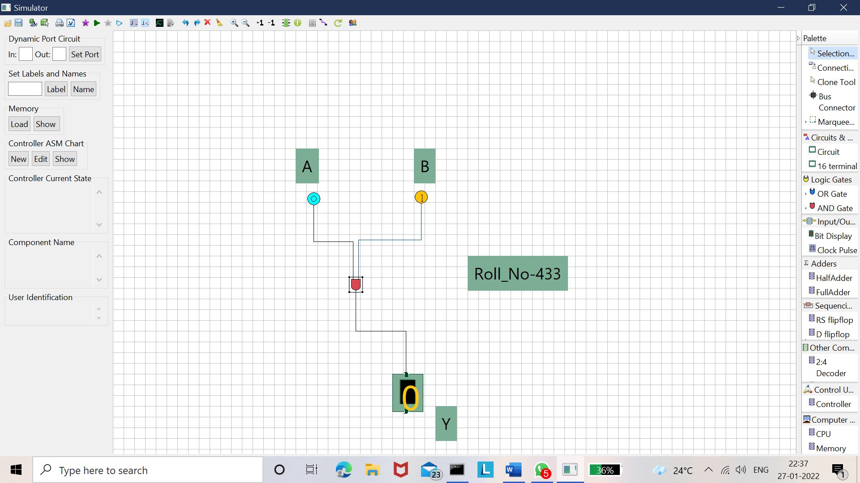

* **OR Gate-**

The Boolean expression of OR gate is Y = A + B, read as Y equals A ‘OR’ B.



Truth table-

|  |  |  |
| --- | --- | --- |
| **A** | **B** | **Y** |
| 0 | 0 | 0 |
| 0 | 1 | 1 |
| 1 | 0 | 1 |
| 1 | 1 | 1 |

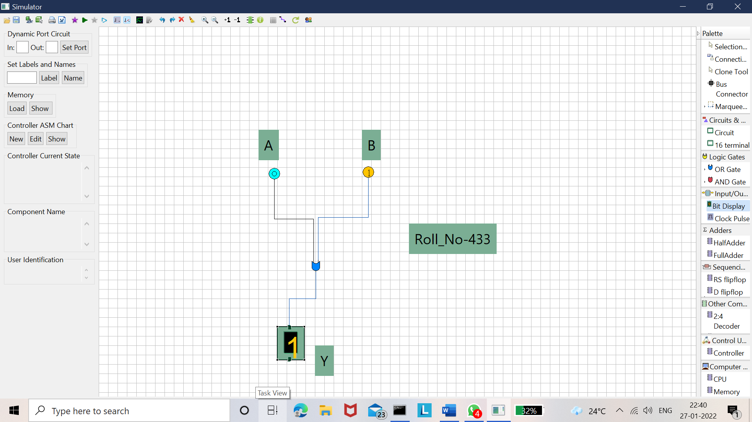

* **NOT Gate-**

Boolean expression:-Y=NOT A=



Truth Table-

|  |  |
| --- | --- |
| **A** | **Y** |
| 0 | 1 |
| 1 | 0 |

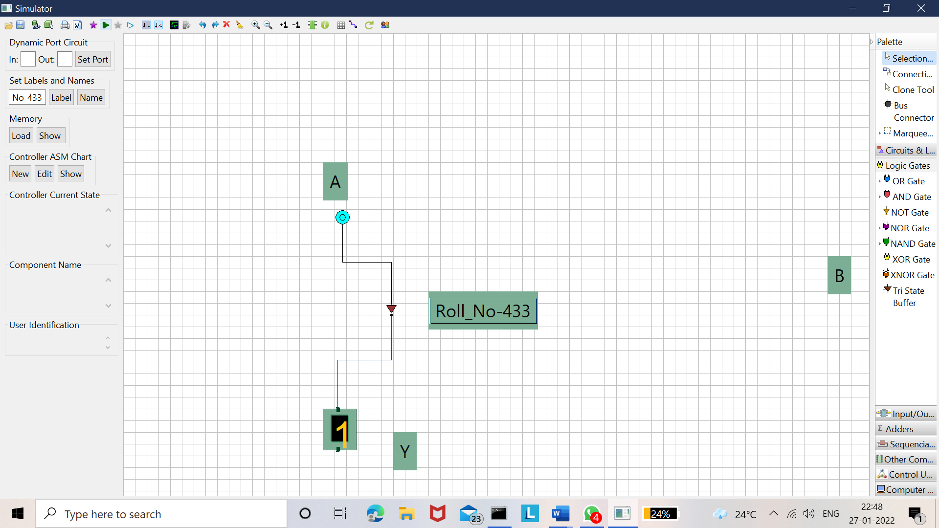

* **Exclusive Gate-**

1)Ex-OR

2)Ex-NOR

* **Ex-OR**

n XOR gate the output of a two-input XOR gate attains the state 1 if one adds only input attains the state 1.



Boolean expression:-Y= 

Truth table-

|  |  |  |
| --- | --- | --- |
| **A** | **B** | **Y** |
| 0 | 0 | 0 |
| 0 | 1 | 1 |
| 1 | 0 | 1 |
| 1 | 1 | 0 |

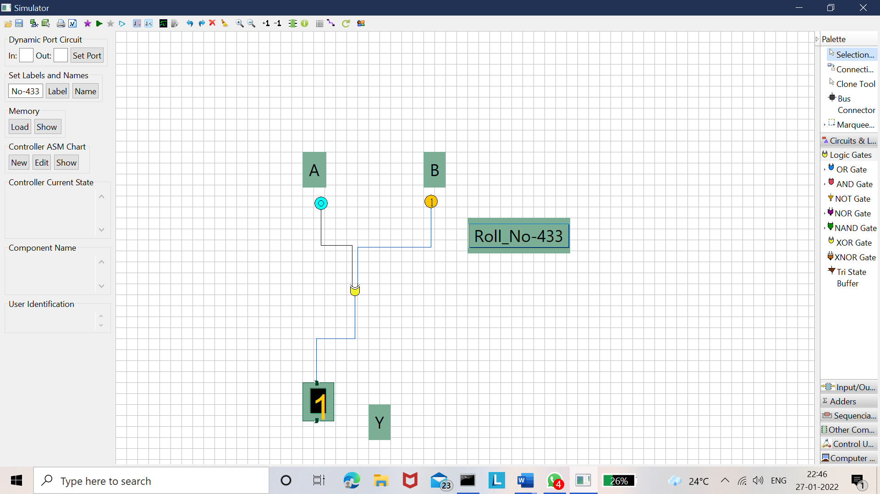

* **Ex-NOR Gate**

In EXNOR gate the output is in state 1 when its both inputs are the same that is, both 0 or both 1.



The Boolean expression of XNOR gate XNOR gate Boolean expression JEE 

Truth table -

|  |  |  |
| --- | --- | --- |
| **A** | **B** | **Y** |
| 0 | 0 | 1 |
| 0 | 1 | 0 |
| 1 | 0 | 0 |
| 1 | 1 | 1 |

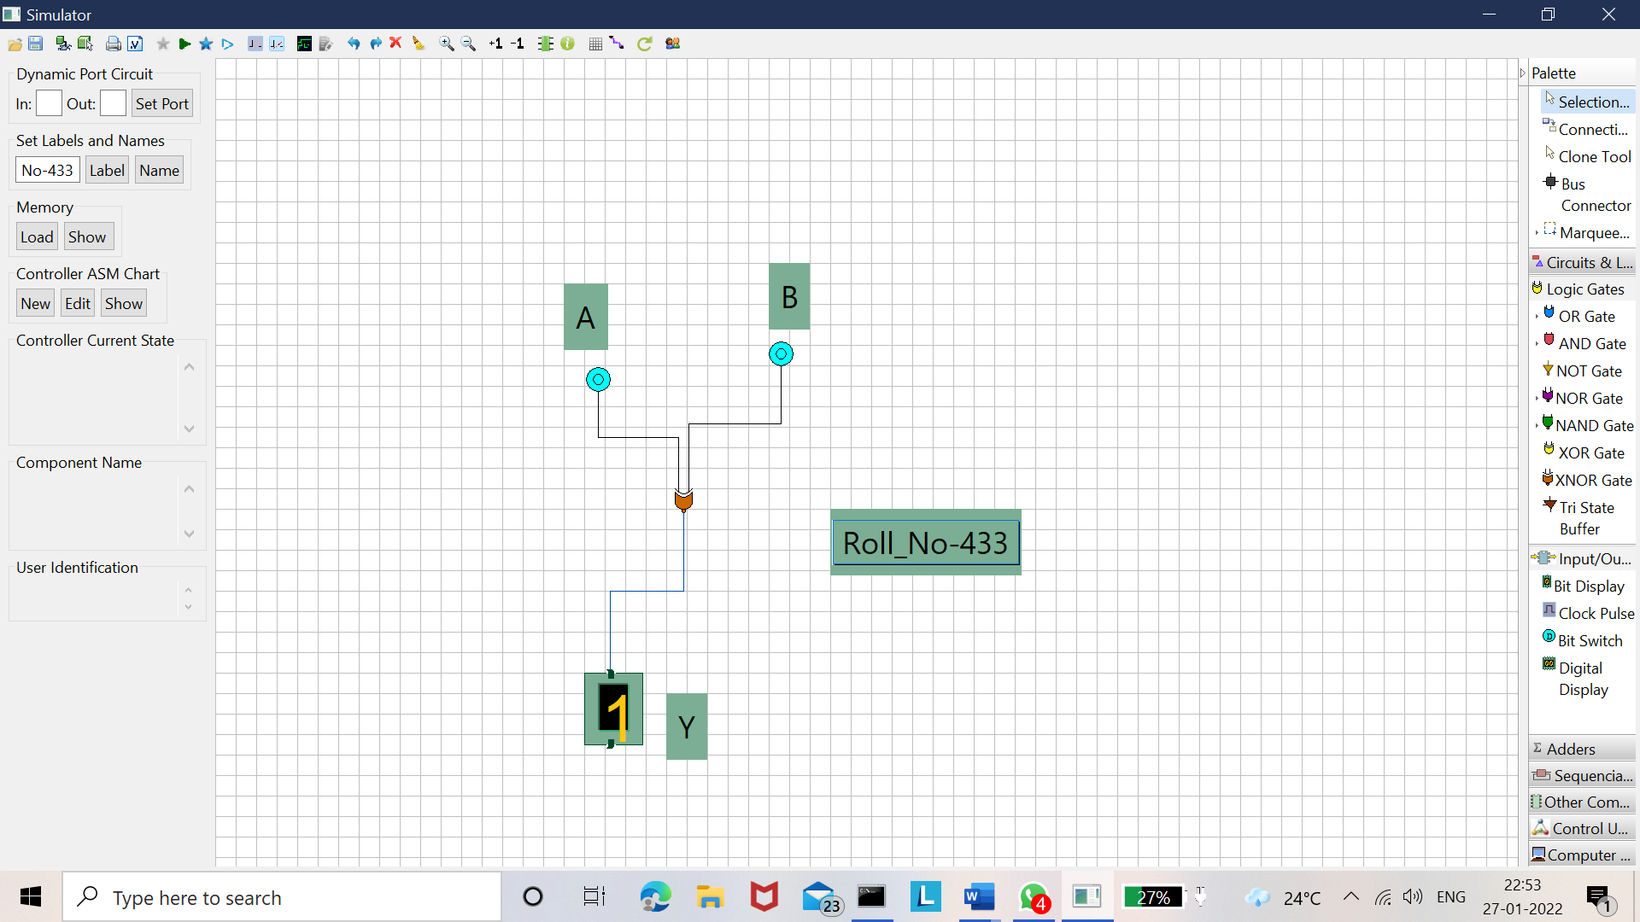

* **Universal Gate-**

There are two Types of universal gate.

1. NAND Gate
2. NOR Gate

* **NAND Gate**

This basic logic gate is the combination of AND and NOT gate.



Truth table -

|  |  |  |
| --- | --- | --- |
| **A** | **B** | **Y** |
| 0 | 0 | 1 |
| 0 | 1 | 1 |
| 1 | 0 | 1 |
| 1 | 1 | 0 |

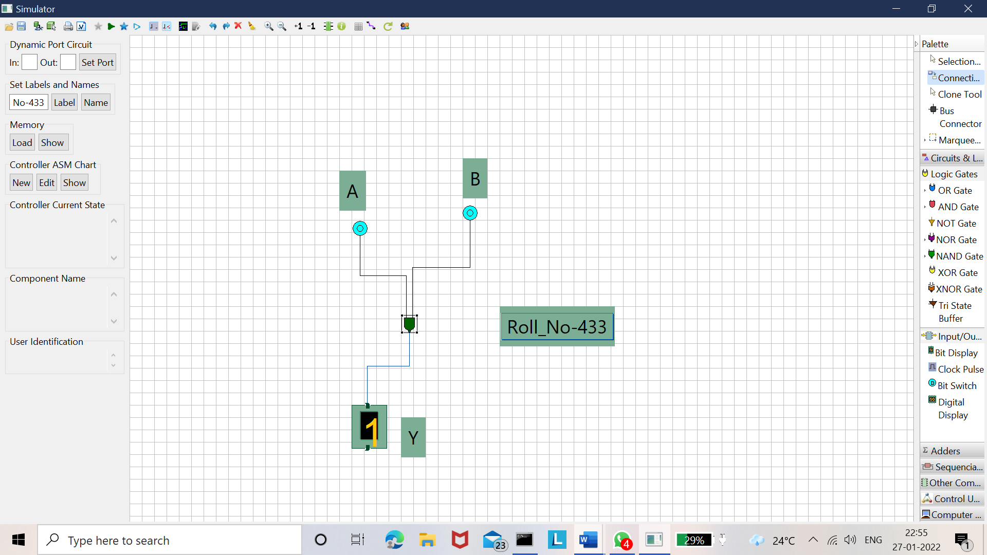

* **NOR Gate-**

This gate is the combination of OR and NOT gate.



**Boolean expression:-Y=** 

Truth Table-

|  |  |  |
| --- | --- | --- |
| **A** | **B** | **Y** |
| 0 | 0 | 1 |
| 0 | 1 | 0 |
| 1 | 0 | 0 |
| 1 | 1 | 0 |

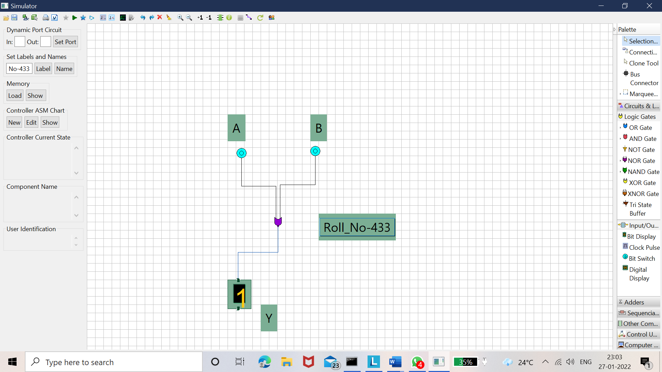

* **FULL ADDER**

CARRY-OUT = AB + BCin + ACin

SUM = (A ⊕ B) ⊕ Cin

Truth table-

|  |  |  |  |  |
| --- | --- | --- | --- | --- |
| **Input** | | | **Output** | |
| A | B | Cin | SUM | CARRY OUT |
| 0 | 0 | 0 | 0 | 0 |
| 1 | 1 | 1 | 1 | 1 |
| 0 | 1 | 1 | 0 | 1 |
| 1 | 0 | 1 | 0 | 1 |
| 0 | 0 | 1 | 1 | 0 |
| 0 | 1 | 0 | 1 | 0 |
| 1 | 0 | 0 | 1 | 0 |
| 1 | 1 | 0 | 0 | 1 |

* **(0,0,0)**

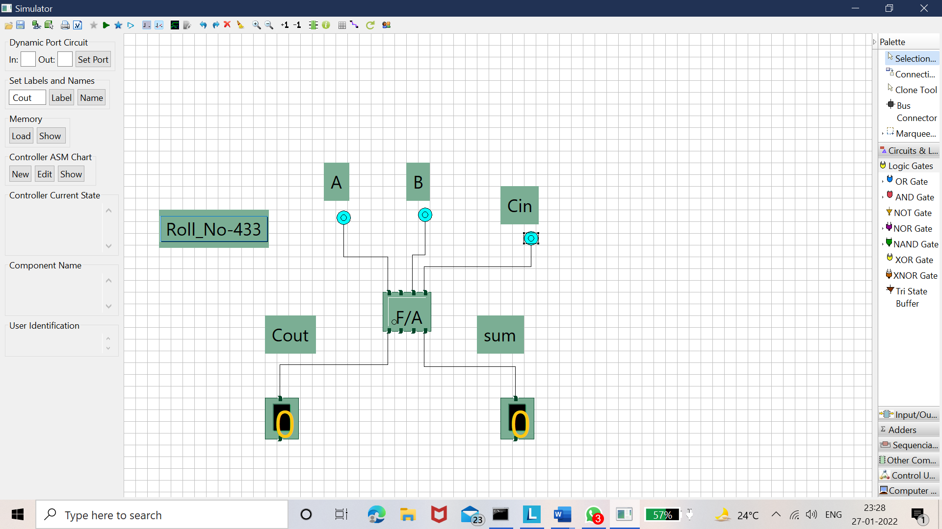

* **(0,0,1)**

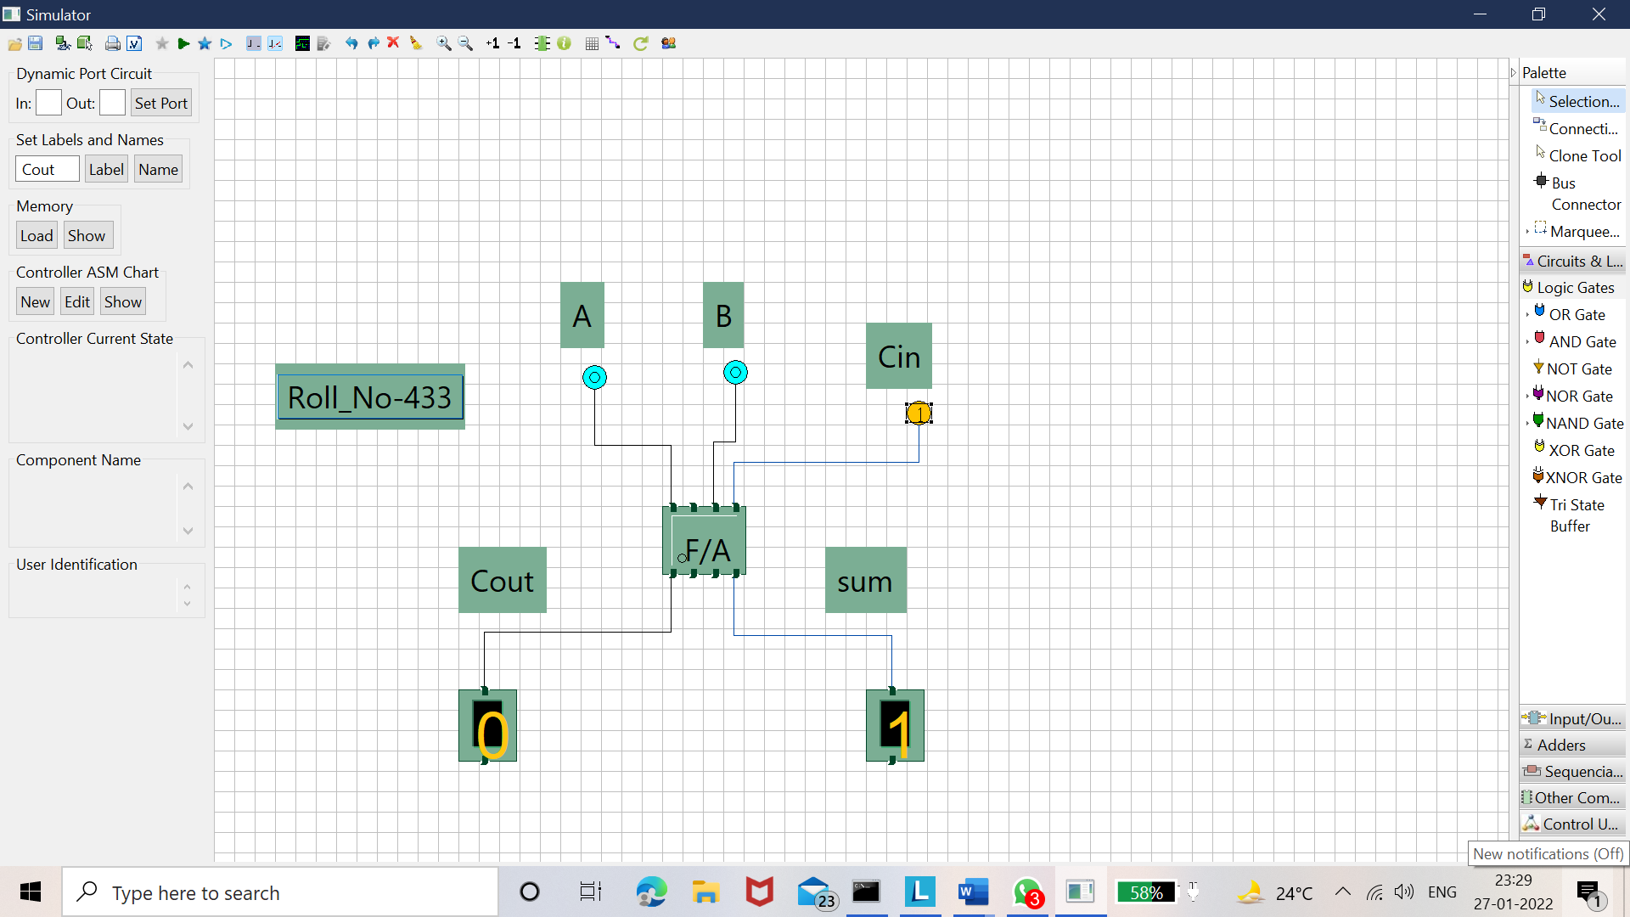

* **(0,1,0)**

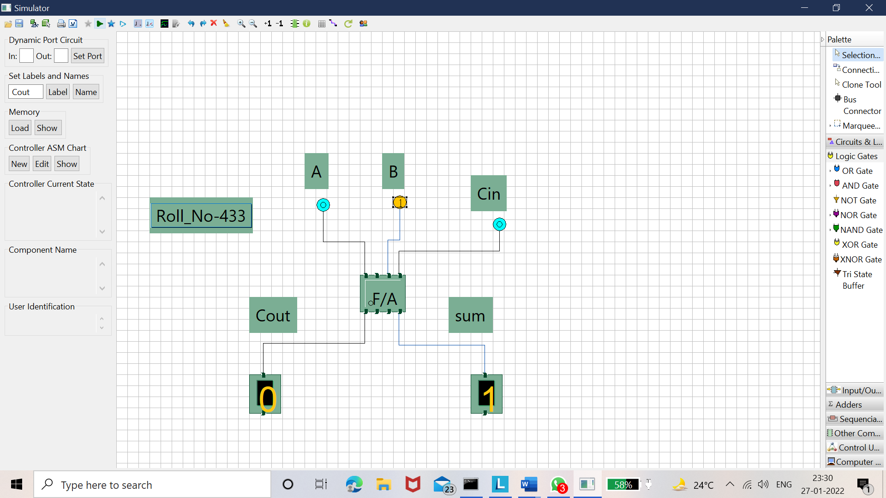

* **(1,0,0)**

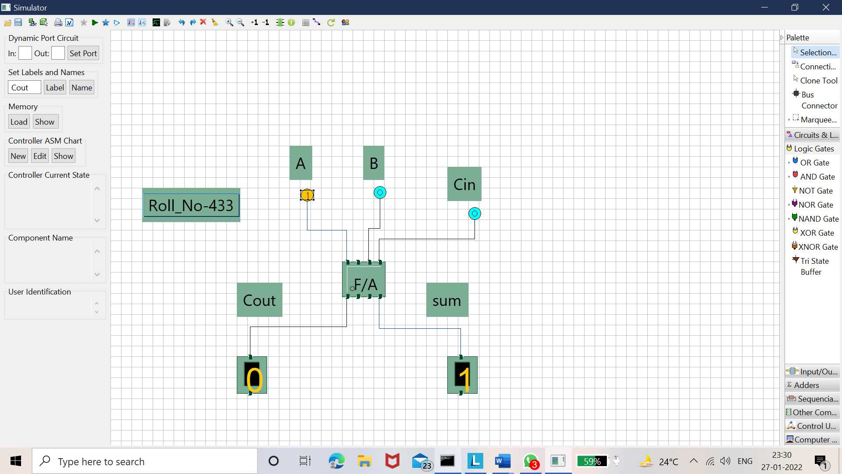

* **(0,1,1)**

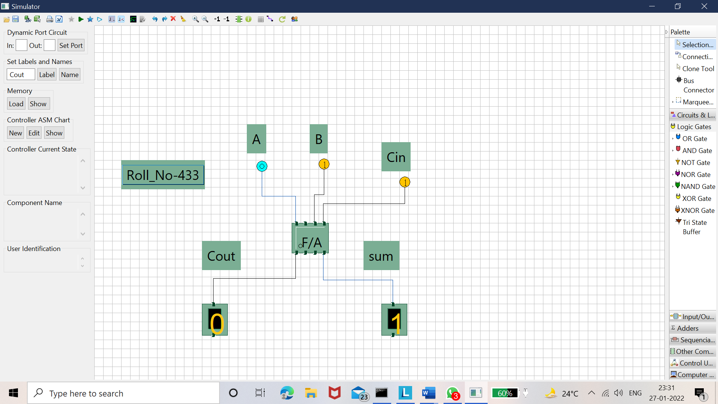

* **(1,0,1)**

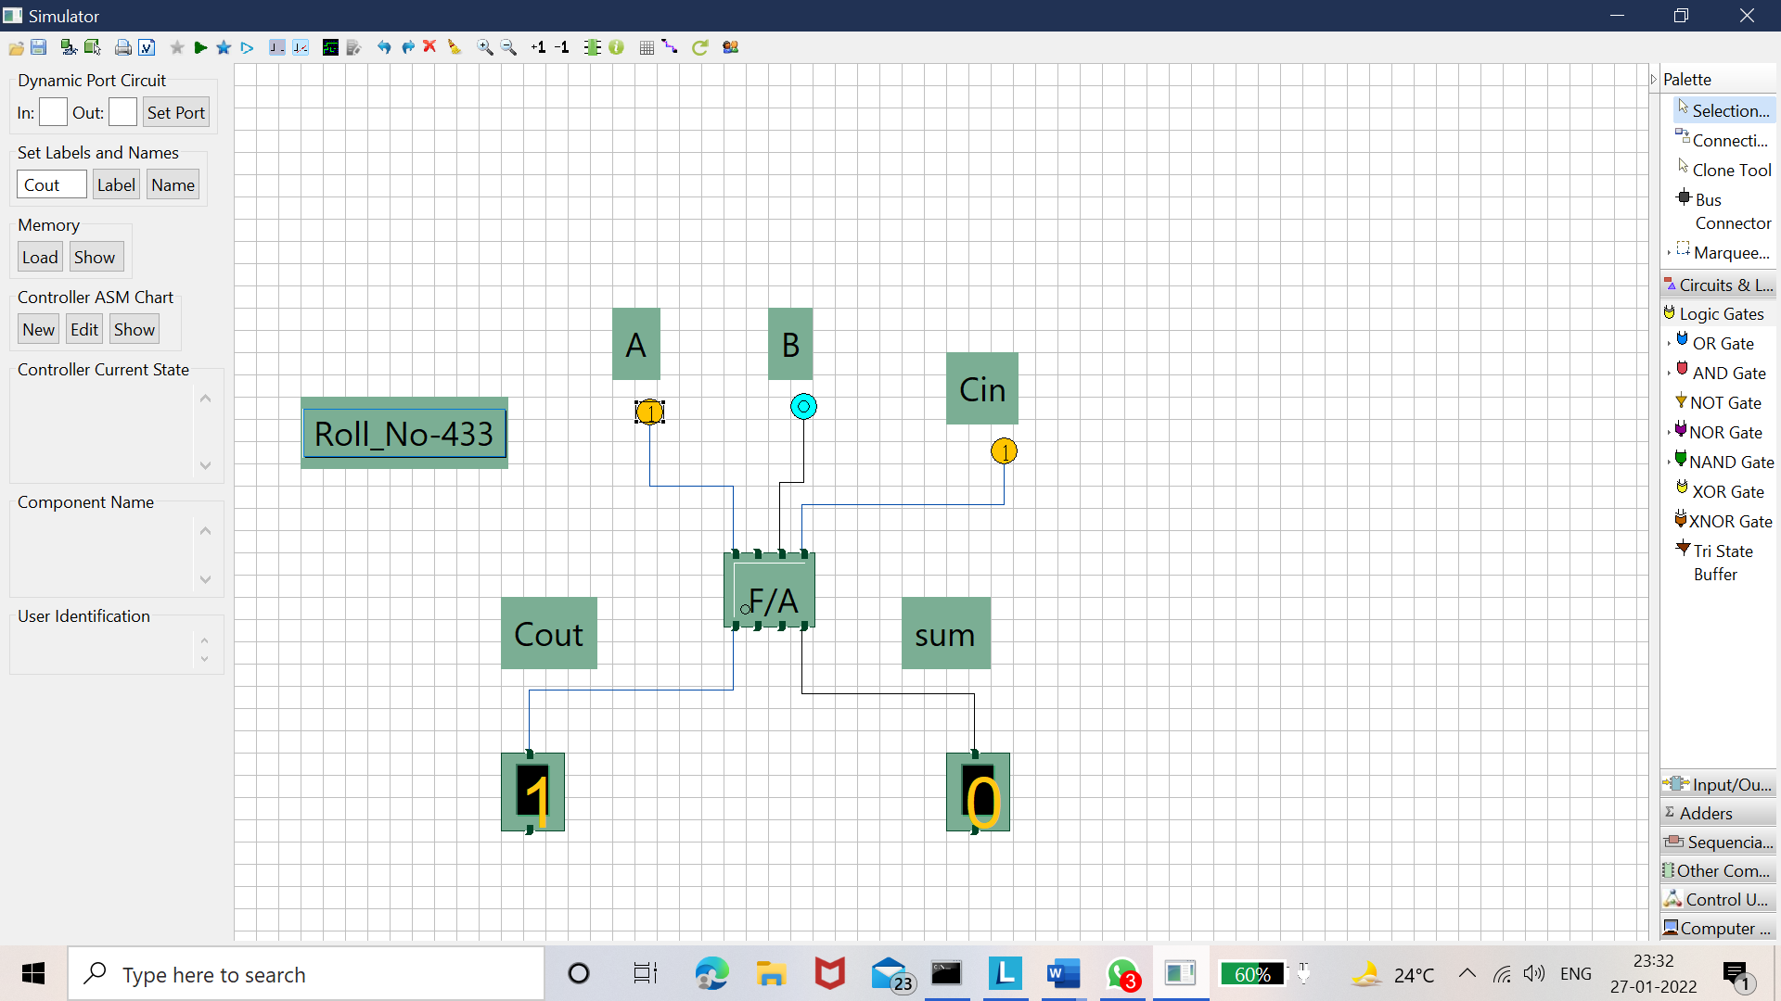

* **(1,1,0)**

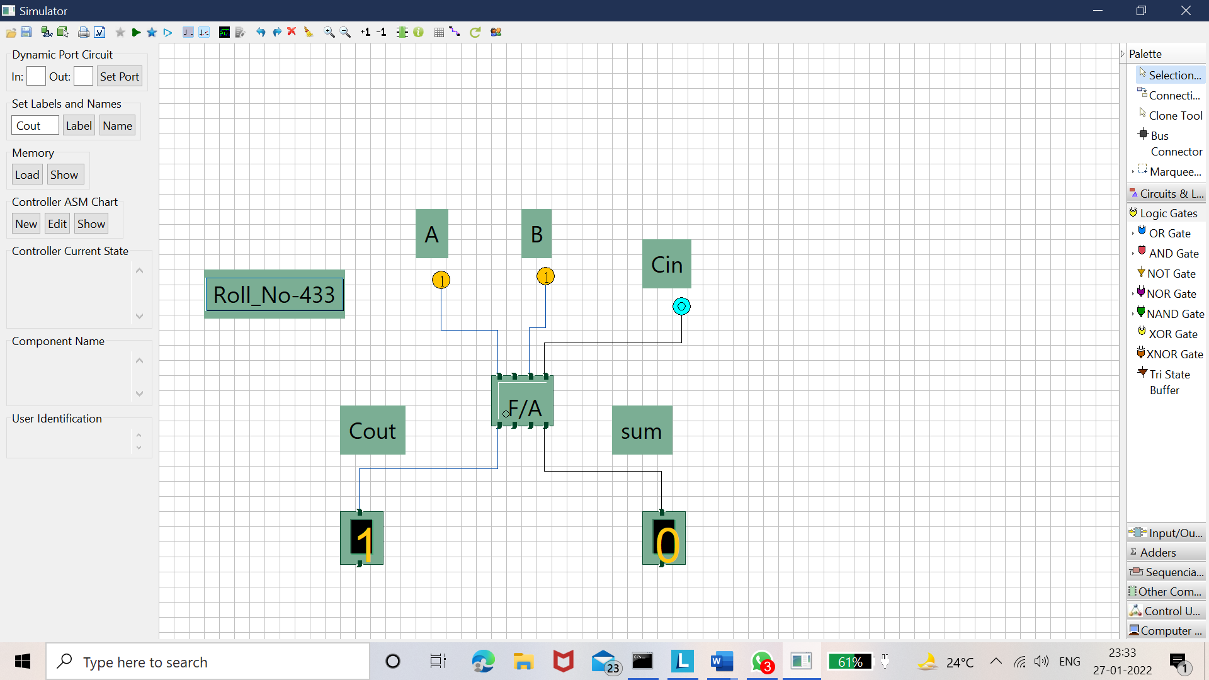

* **(1,1,1)**

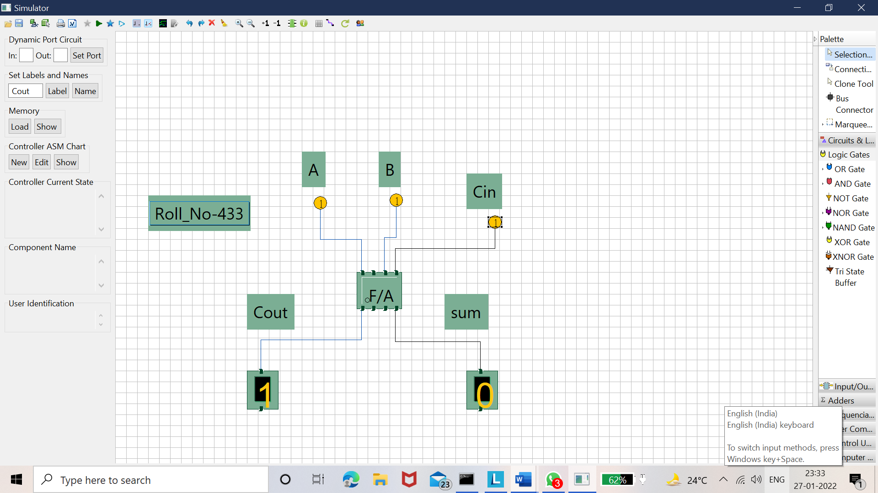

**CONCLUSION-**

* Logic gate are small circuits that implement Boolean Operators.
* Boolean functions are completely described by truth tables.
* The basic gates are AND, OR, NOT. The Exclusive Gates are EX-OR and EX-NOR.
* The Universal Gates are NAND and NOR.
* Complex combinational logic functions can be achieved simply by interconnecting NAND or NOR Gate.
* Full Adder is the adder which adds three inputs and produces two outputs**.**