

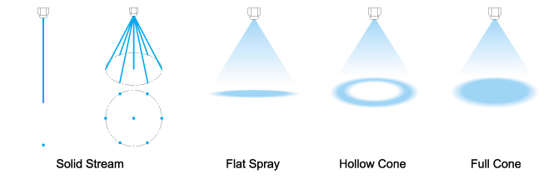

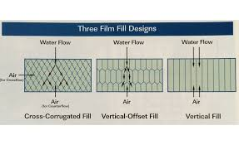

Drift eliminator: Water droplets carried over by outgoing air is called as Drift. A drift eliminator arrests the floating water droplets by impaction as air passes through it.

Types are:

[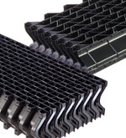](http://www.brentwoodindustries.com/products/cooling-tower/drift-eliminators/cellular/)

1. [Cellular](http://www.brentwoodindustries.com/products/cooling-tower/drift-eliminators/cellular/)

Cellular drift eliminators provide the greatest effective surface area for maximum drift removal efficiency. Their cellular design allows great flexibility in trimming parts to the tightest fit and finish during installation, a key factor in overall drift emissions of a cooling tower.

[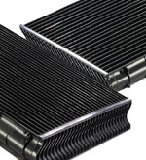](http://www.brentwoodindustries.com/products/cooling-tower/drift-eliminators/blade/)

2) [Blade](http://www.brentwoodindustries.com/products/cooling-tower/drift-eliminators/blade/)

Blade drift eliminators allow for longer span capabilities and rugged durability due to their heavier gauge blades. They are designed for effective droplet capture but it was utilized earlier.

**It is found that from third layer in the stack are not increasing further efficiency of drift elimination rather it is just contributing to pressure drop in air flow.**

FAN:

Fans in cooling tower should deliver large amount of air efficiently. The fan blades should be properly balanced to minimize vibration.

Fans are equipped with adjustable pitch blades to regulate air flow rate as per requirement in order to minimize wastage of electricity.

Fan has MOC of FRP. It is found that as FRP material is hand mould it gives optimum aerodynamic profile as compared to steel that is produced by casting and extrusion.

Basin: The design of basin is on basis of following factors:

1. The size should have 20% of total water flow rate

2. Should accommodate all water in pipelines.

3. NPSH of pump

Mechanical accessories:

1. Bellows: to stabilize the equipment against vibrations.

2. Non return Valve: so that in case of power cut there would be no returning of pumped fluid.

3.Sand filters: to remove airborne dust in water.

4.Level indicator and transmitter