1. **Simulating Random Variables**

* Simulate random variates using both Matlab routines

as well as the rejection method, for

{*Xi*}i=1,…T, *T* = 100, 1000, 10000 with a PDF that is

* Normal with mean= 0 and variance=1
* Uniform on [0, 1]
* Exponential with parameter 1

Here, the MATLAB routines used were as follows:

* ‘normrnd’ and ‘randn’ for Normal Distribution
* ‘rand’ for Uniform Distribution
* ‘exprnd’ for Exponential Distribution

The rejection method was applied for all three cases as well.

The corresponding outputs were as follows:

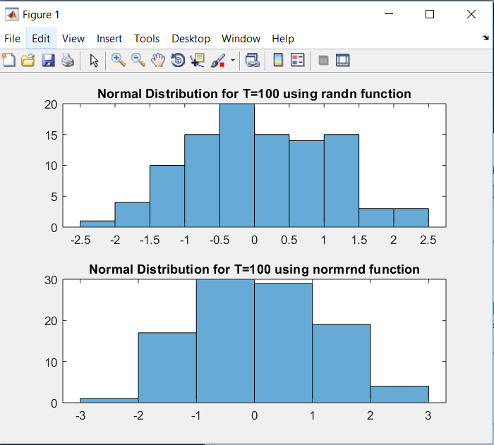

Figure 1 : Normal Distribution for T=100 using randn and normrnd function

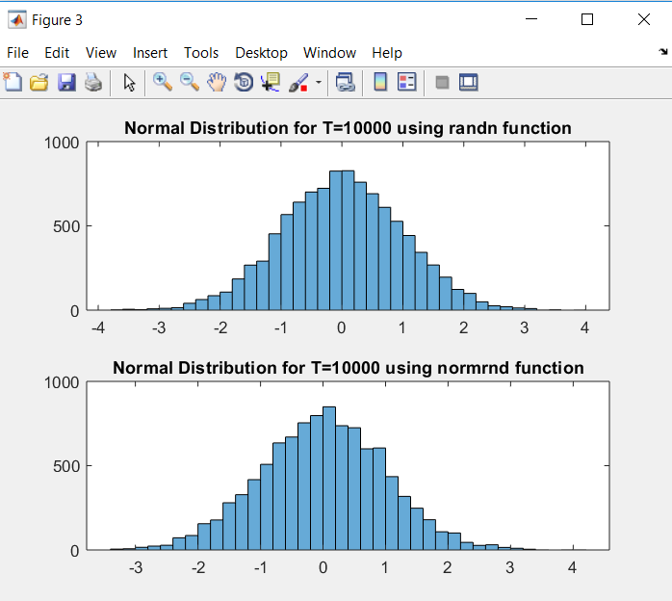

Figure 2: Normal Distribution for T=1000 using randn and normrnd function

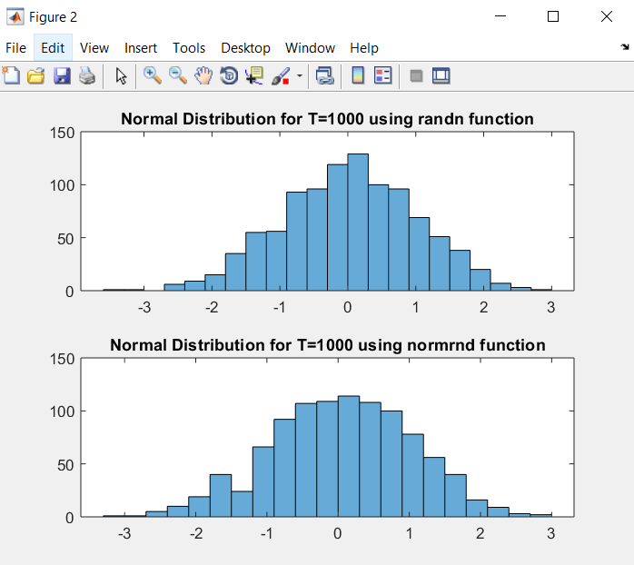

Figure 3: Normal Distribution for T=10000 using randn and normrnd function

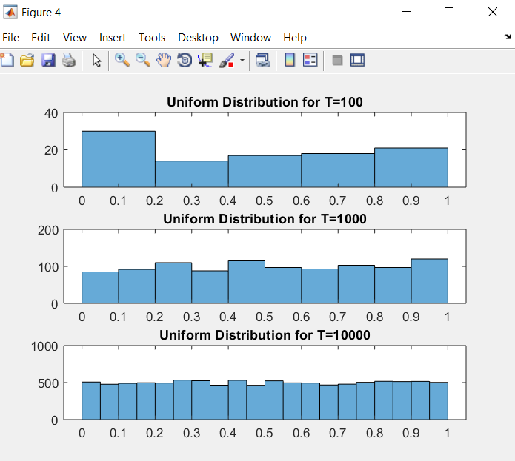

Figure 4: Uniform Distribution for T=100,1000,10000

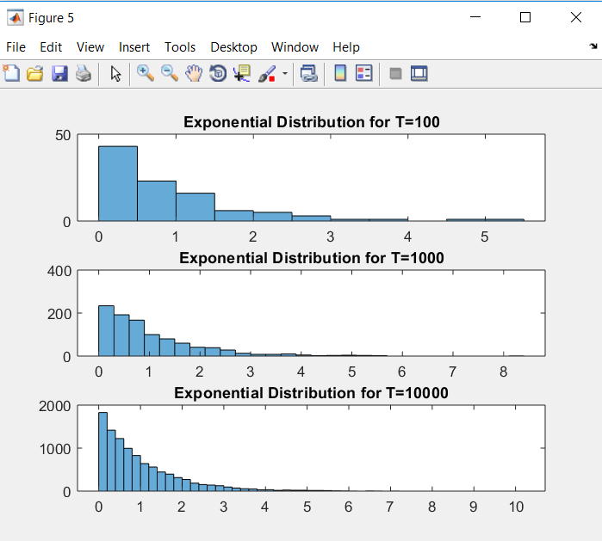

Figure 5: Exponential Distribution for T=100,1000,10000

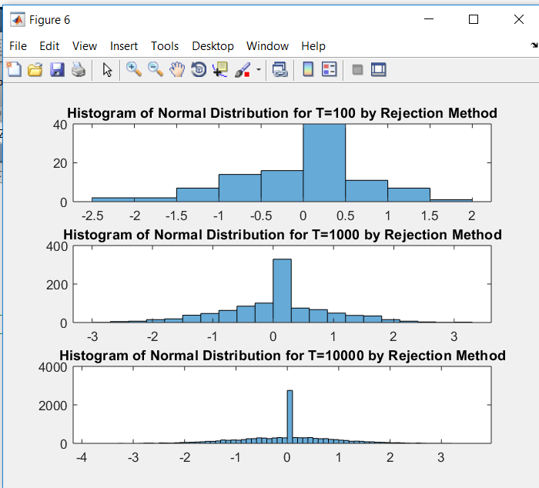

Figure 6: Histogram of Normal Distribution for T=100,1000,10000 by Rejection Method

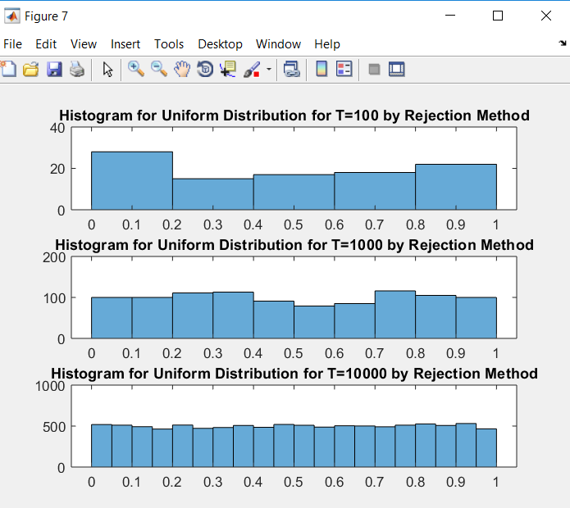

Figure 7: Histogram of Uniform Distribution for T=100,1000,10000 by Rejection Method

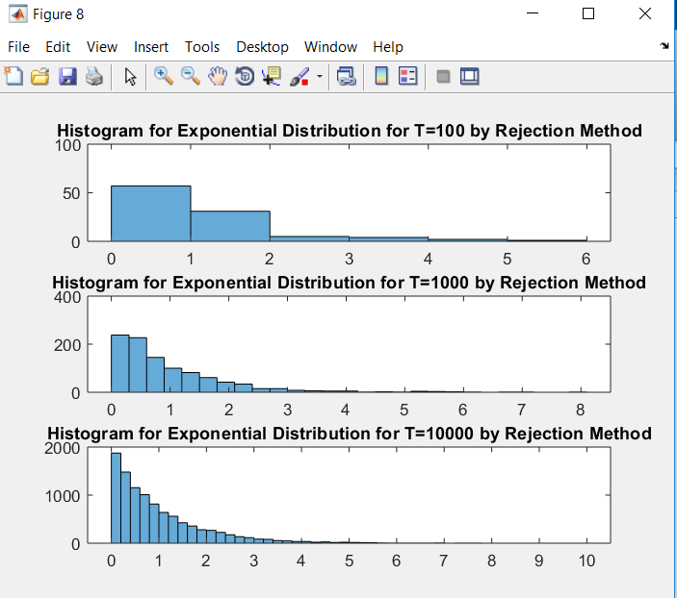

Figure 8: Histogram of Exponential Distribution for T=100,1000,10000 by Rejection Method

**COMMENTS:**

The histograms for each of the cases, and their respective parameters of each of the populations were computed in each of the observation length cases. The empirical parameters obtained were found to be very close to the theoretical parameter values. For example,

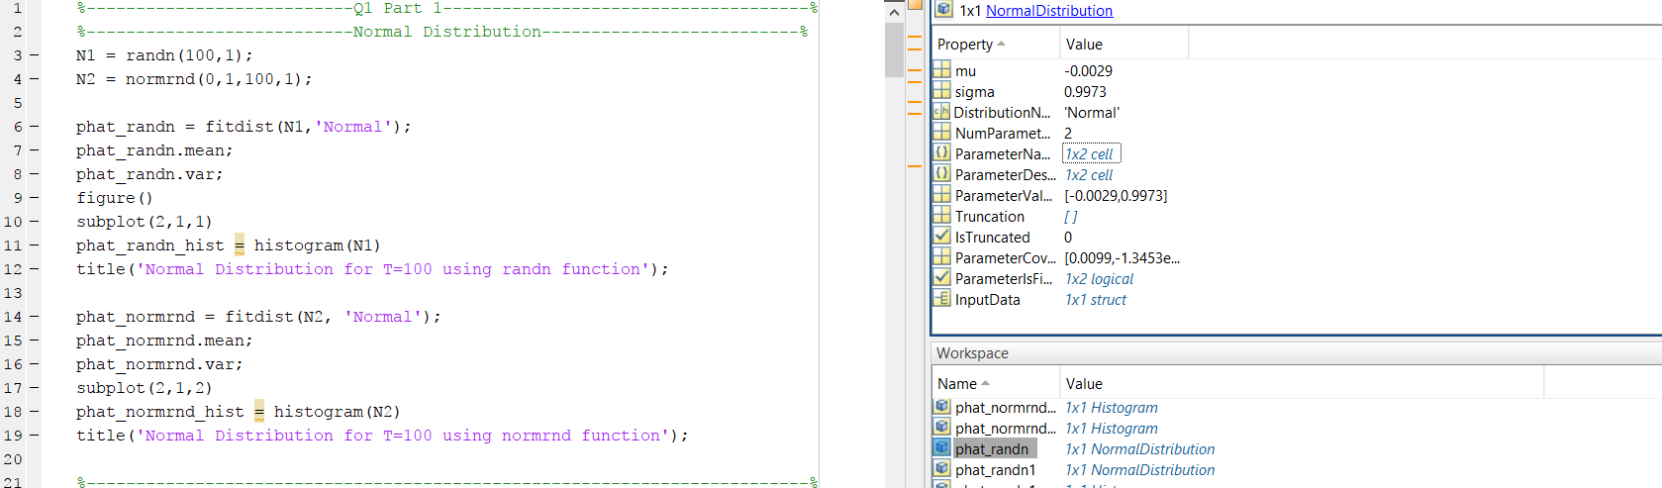

Figure 9

The mean and sigma of the first histogram of Normal Distribution T=100 are -0.0029 and 0.9973 respectively. These are very close to the theoretical mean and sigma which are (0,1). The reason for this discrepancy between empirical values and theoretical values is the value of T. We’re considering small value of T. As T goes on increasing the empirical value will approach accurate theoretical value.

A comparison of mean and sigma for all three cases , i.e. T = 100,1000,10000 is shown below:

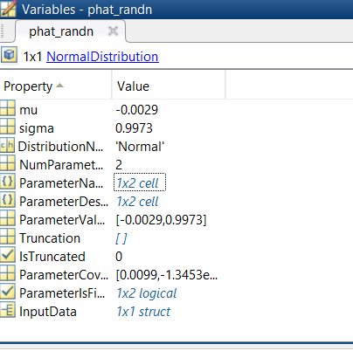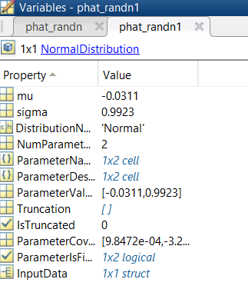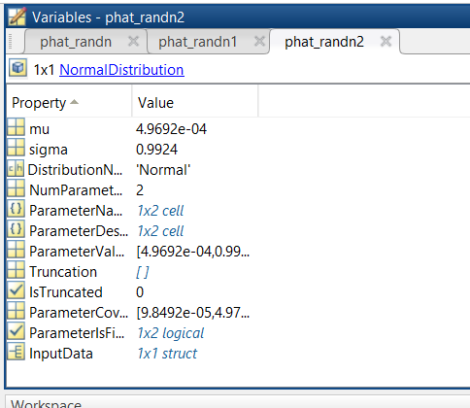

Figure 10

The mean approaches zero as T increases while sigma drifts from it’s theoretical value as T increases. The reason for these changes is the value of T.

**2. Transforming Random Variables**

Here Yi is given as Yi = (1/T)*∑Xi. The RV Xi is to be transformed into another RV Yi.

All the histograms of the transformed random variables for all T’s are close to Gaussian function. This is due to the fact that summation of ‘n’ independent RV’s when n tends to infinity is Gaussian according to the Central Limit Theorem. Hence, the closest PDF is Gaussian PDF. Therefore, as T increases the transformed RV becomes perfectly Gaussian.

Gaussian PDF is given by the equation:

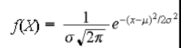

where , σ denotes the standard deviation , and ,

µ denotes the mean

Through observation, it is observed that as T increases the **standard deviation** of the function reduces. The mean in different distributions is as follows:

* Mean of Exponential Distribution approaches 1 as T increases (Figure 10).
* Mean of Normal Distribution approaches 0 as T increases (Figure 11).
* Mean 0.5 of Uniform Distribution approaches as T increases (Figure 12).

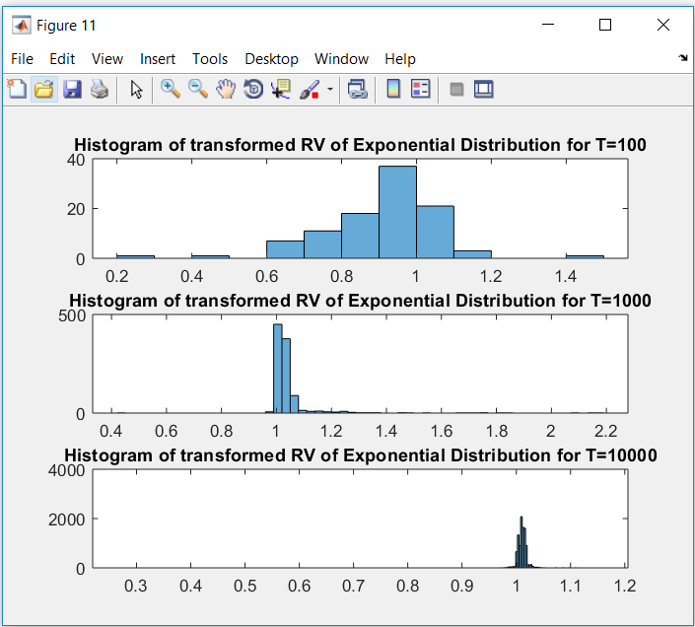

Figure 11

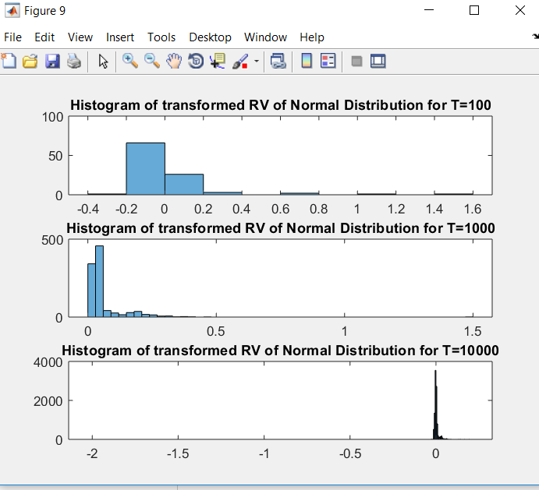

Figure 12

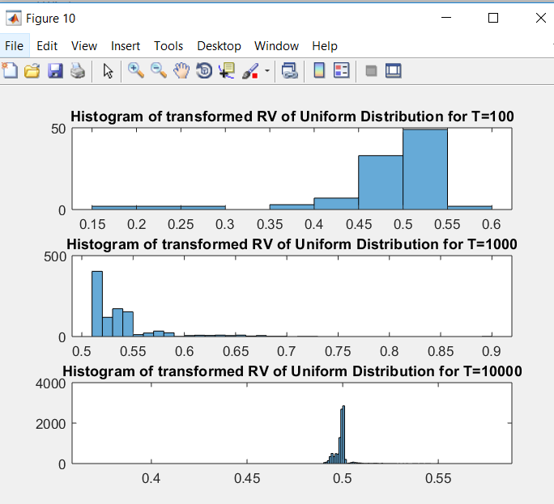

Figure 13

**3. Convergence of Random Variables**

Obtaining a demo in GUI , we can say that YT  converges to zero for In Probability, In Law, Mean Square and Almost Sure convergences for all distributions which are Normal, Uniform and Exponential. This can be demonstrated by the GUI’s below.

YT converges in probability for all three distributions. Hence, YT 🡪 0 In Probability. Same can be said about other convergences.

Since, YT  is Gaussian. Any RV usually converges to it’s mean. But since YT is Gaussian, it’s mean is zero. Hence it converges to zero.

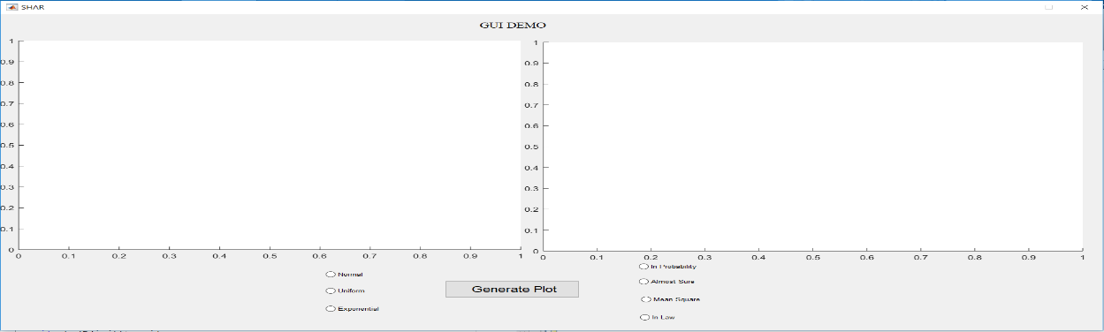

Figure 14: Blank GUI

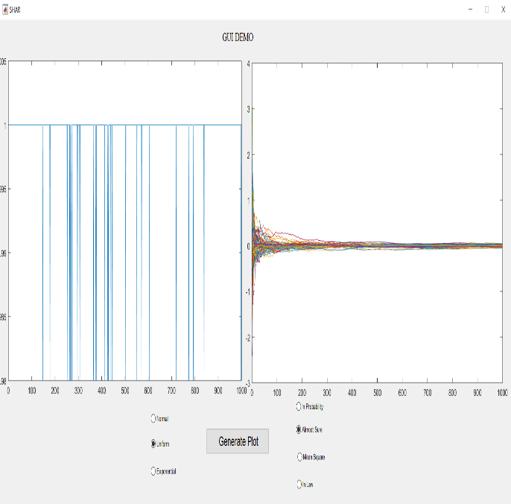 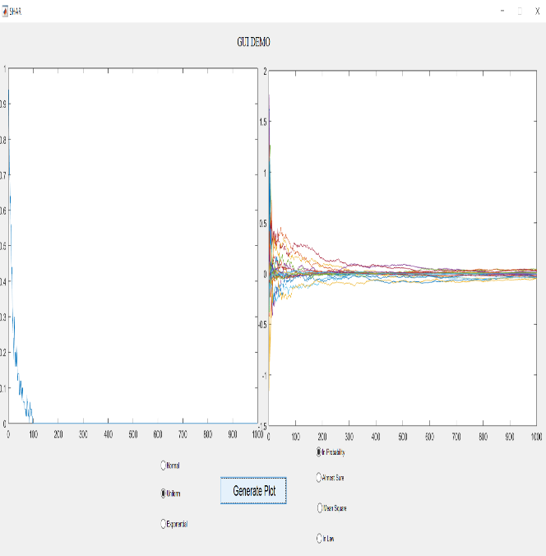

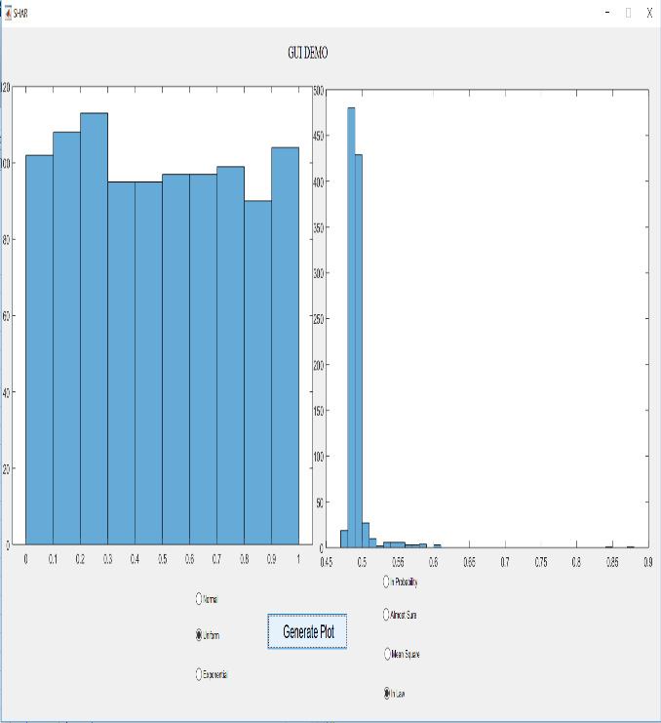 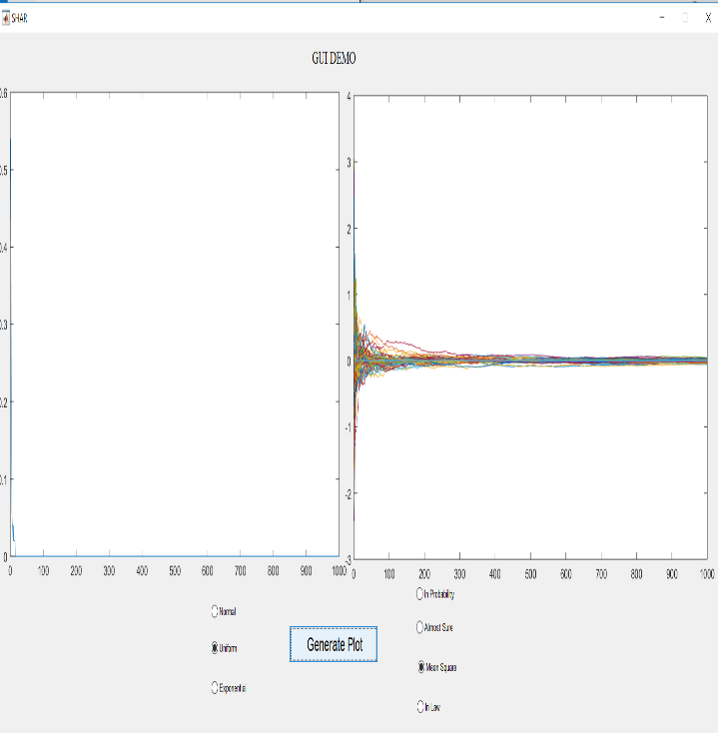

Figure 15: Uniform distribution convergence to zero In Probability, In Law, Mean Square and Almost Sure convergences

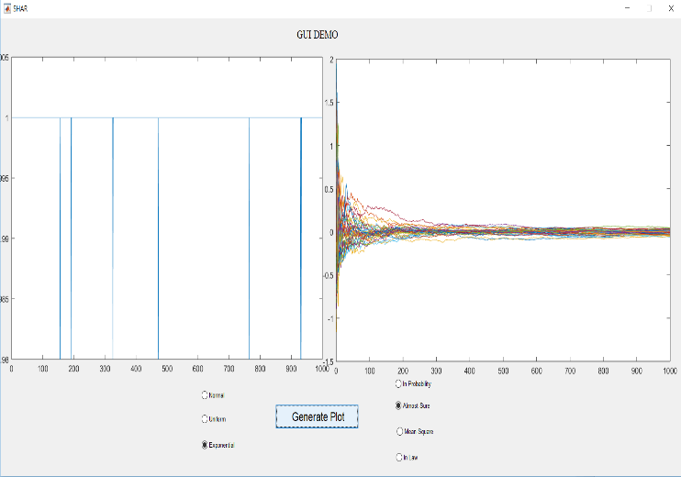 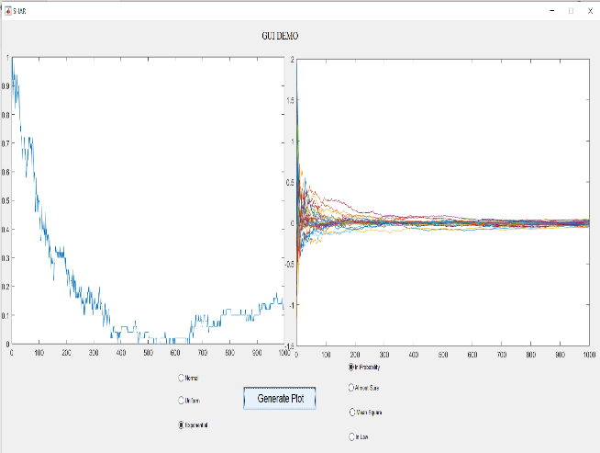

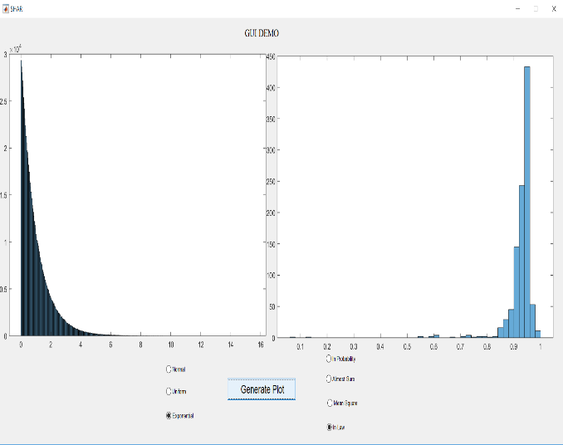 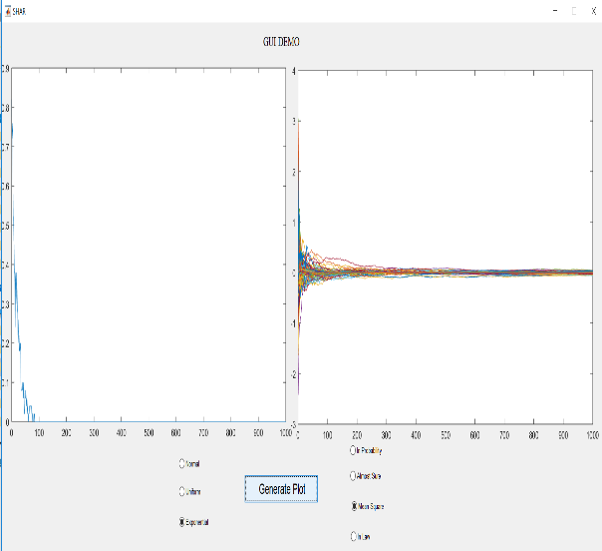

Figure 16: Exponential distribution convergence to zero In Probability, In Law, Mean Square and Almost Sure convergences

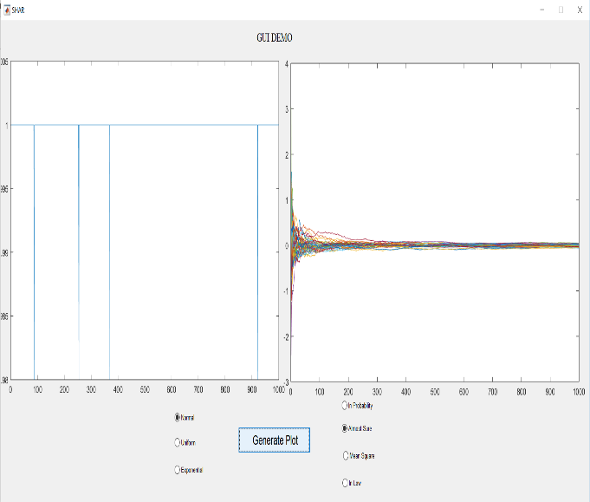 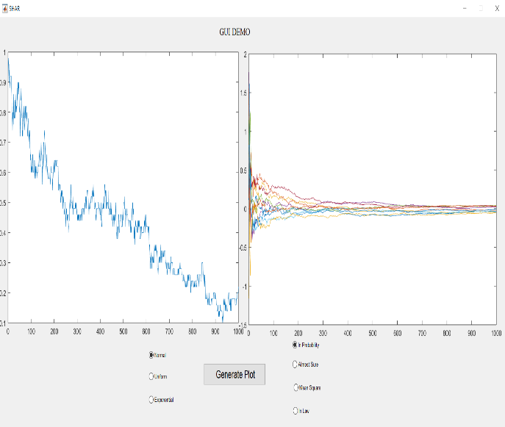

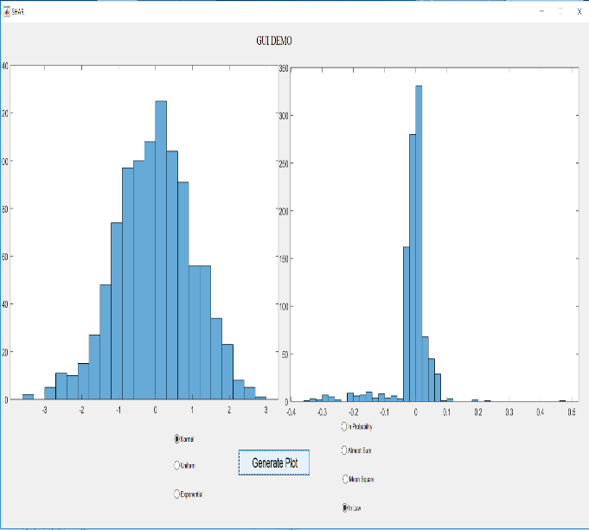 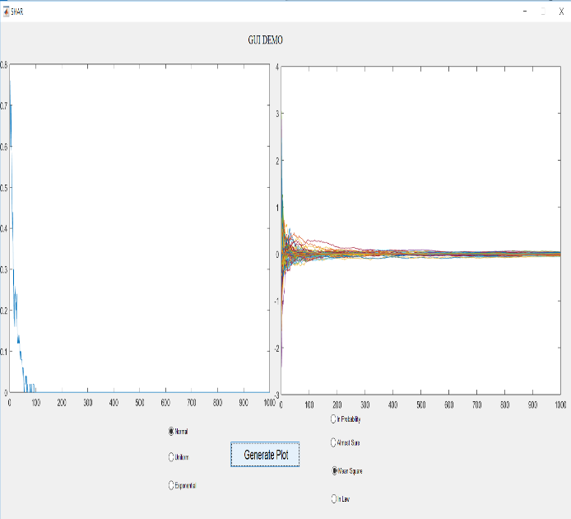

Figure 17: Normal distribution convergence to zero In Probability, In Law, Mean Square and Almost Sure convergences