**Capstone Proposal**

**Machine Learning Engineer Nanodegree**

**Starbuck's Capstone Challenge**

**Domain Background**:

With the advancement of ML and AI, application of AI has been ever expanding universe in various fields. Digital marketing changed the face of marketing. However, with the application of AI in marketing, businesses are able to target right customers and help reduce the marketing budget. Ai is helping in digital marketing at different stages in digital marketing.

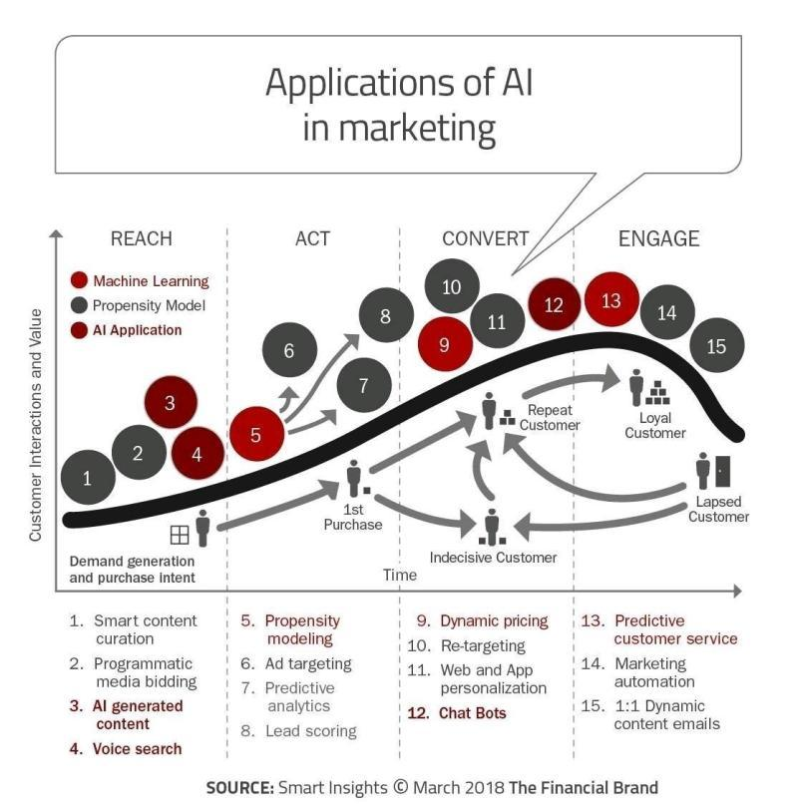

* A **problem statement** — a problem being investigated for which a solution will be defined;
* The **datasets and inputs** — data or inputs being used for the problem;
* A **solution statement** — the solution proposed for the problem given;
* A **benchmark model** — some simple or historical model or result to compare the defined solution to;
* A set of **evaluation metrics** — functional representations for how the solution can be measured;
* An outline of the **project design** — how the solution will be developed and results obtained.

**References**

1. [**https://www.linkedin.com/posts/nabihbawazir_datascience-machinelearning-artificialintelligence-activity-6633592461170171904-VbXw**](https://www.linkedin.com/posts/nabihbawazir_datascience-machinelearning-artificialintelligence-activity-6633592461170171904-VbXw)
2. **https://altadigital.com/blog/machine-learning-email-marketing**