**SONA_IDEATHON_2021**

**QUESTIONNAIRE**

**TEAM ID: ID-162**

**TEAM NAME: “UYIR”**

**BY-**

**R.SHARVESHWAR**

**(TEAM LEADER)**

**R.SURUTHI**

**J.KESAVAN**

**R.DEEPAK**

**SONA COLLEGE OF ARTS AND SCIENCE**

**DEPARTMENT OF MATHEMATICS**

**2ND B.Sc., MATHEMATICS**

**INTRODUCTION:**

As per the guidelines of the competition we have approached the doctors and made a study of people’s needs and mindsets and medical protocols. The doctor’s profile will be given in the next page. Basically doctors have diagnosed patients according to their prior medical history.

That is if a patient has DIABITIES and also infected by covid-19 have been diagnosed in different way and people with HYPERTENSION and BLOOD PRESSURE have been diagnosed in different way so the QUESTIONNAIRE have been prepared with the help of DOCTORS advice in such way that every covid affected patient will give their view about the happening.

And doctors have advised some common medicines for covid affected patients whose attack percentage is below 40%.

**DOCTORS PROFILE:**

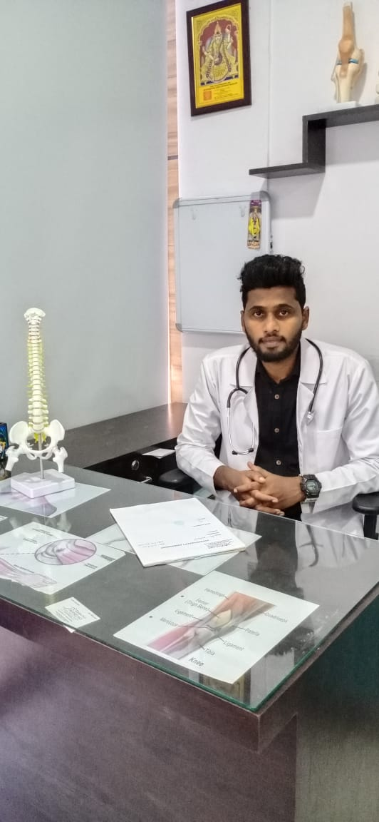

**1)Dr.V.Balaji (PT)**

**Consultant physical Therapist**

**Current :PHYSIO 365 ,Bangalore.**

**Experience : more than a year at MIOT International hospital , chennai .**

**Contact no : 9698687009.**

**2)DR.Vaishnavi M.D (Allopathy)**

**VINAYAKA MISSION HOSPITALS,SALEM**

**Contact no : 7598206026**

**QUESTIONNAIRE:**

**SURVEY-1**

**1) WHAT KIND OF DIFFICULTY YOU ARE FACING WHILE LOCKDOWN?**

**2) HAVE EVER FACED ANY MEDICAL EMERGENCY SITUATION? IF YES THE SITUATION YOU FACED IS OF WHAT KIND?**

**3) DO YOU HAVE PROPER INFORMATION PROVIDER LIKE APPS OR WEBSITES ABOUT COVID-19 UPDATES?**

**4) WHAT KIND OF INFORMATION SOURCE YOU ARE LOOKING FOR, IN LOCKDOWN PERIOD?**

**5) DID YOU HAVE PROPER GOVERMENT HELPLINE LIST OF YOUR AREA DURING EMERGENCY PERIOD?**

**6) ARE YOU LOOKING FOR ALTERNATE SOURCE OR COMPLETE INFORMATION PROVIDER?**

**SURVEY-2**

**7) HAVE YOU EVER FACED ANXIETY, LONELYNESS THAT MAKES YOU DEPRESSED? நீங்கள் தனிமைபடுத்தி கொண்ட காலத்தில் என்றாவது கவலை,தனிமையில் உள்ளதை உணர்ந்து வேதனைபட்டது உண்டா?**

**8) DO YOU HAVE PROPER MEDICAL EQUIPMENTS LIKE SPIROMETER TO BE USED IN EMERGENCY CONDITIONS? உங்களிடம் அவசரகால நிலையில் பயன்படுத்தப்படும் SPIROMETER போன்ற மருத்துவ உபகரனங்கள் உள்ளதா?**

**9) WHAT COMBINATION OF TABLETS DO YOU TAKE?எந்தவிதமான மாத்திரை கலவைகளை நீங்கள் பயன்படுத்துகிரீர்கள்?**

**10) DO YOU WANT YOUR MEDICINES AND GROCERIES TO BE DELIVERED IN HOME? உங்களுக்கு உங்களுடைய மருந்துகள் மற்றும் மளிகை பொருட்கள் வீட்டிலேயே டெலிவரி செய்தாள் உபயோகமாக இருக்கும் என்று கருதுகிரீர்களா?**

**MEDICINES SUGGESTED: (FOR PEPOLE WHO ARE AFFECTED 40% AND BELOW)**

**Tablets:**

**Antibiotics:**

**1. Pipiracillin with tazobactum/ ceftrioxone -QID (4 Times a day)**

**Steroids:**

**1. Dexamethasone - BD (2 times a day)**

**These all drugs we have to give who has below level of saturation (below 94) &**

**If the pts has x-ray findings suggestive of pneumonia.**

**And most important thing along the side of this medication we have to give some medication for if the pt has a history of diabetic, hypertension, cardiac problem, respiratory problem and renal problem.**