**SONA_IDEATHON_2021**

**FINDINGS**

**TEAM ID: ID-162**

**TEAM NAME: “UYIR”**

**BY-**

**R.SHARVESHWAR**

**(TEAM LEADER)**

**R.SURUTHI**

**J.KESAVAN**

**R.DEEPAK**

**SONA COLLEGE OF ARTS AND SCIENCE**

**DEPARTMENT OF MATHEMATICS**

**2ND B.Sc., MATHEMATICS**

**FINDING’S:**

**1) They don’t have proper information provider like government updates, they lack of awareness about digital media!**

**2) Some are in need of all available information and resources that is around them in extensive care.**

**3) they don’t have proper updates on government updates about covid-19 or covid-19 second wave!**

**4)they are in need of complete information provider as like a hub or all they want in single interface which will guide them!**

**5) People don’t have proper awareness about the vaccine! Proper awareness should be created**

**6) As per doctor’s advice people who are quarantined are suffering a mental stress which affects them more and make them difficult to overcome the situation which makes their health worse. So continuous and frequent contact with the person with their family member by call or FACE TIME makes them feel comfort and helps them to overcome the situation.**

**7) People do not have emergency medical equipments especially they don’t have pyrometer which provides oxygen in critical condition.**

**8) People are diagnosed by their health condition and medicated according to their body condition people are in need of different set of medicines according to their prior affected disease.**

**9) People want their medicines and groceries to be delivered home as they can’t go out for purchase! So according redirection should be given to full fill their need!**

The questions and the answers given by them are as follows: (**SURVEY-1)**

**1)WHAT KIND OF DIFFICULTY YOU ARE FACING WHILE LOCKDOWN?**

**Some most important answers: from quarantined pepole**

1)“Even after going through these many lockdowns I don’t see a well planed improvement or the use of being locked down. If they announce a lockdown it should be a very strict one and govt. can handle the needy during that strict lockdown period if well planned. The last one year has been a total spoilage of educating students, even if we have online classes, the discomforts are at the top list. I see finance and education of my own family as the main difficulty in this lockdown.since families economy is based on my salary”

2)Difficulty to buy the necessary things.

3)Financial crises

4)Full of stress

5)Mental Instability

6)During lockdown yarukaadhu edhadhadhuna heart attack like that takkunu veliya poga mudiyala appdiye pona neraiya questions pannuvnagga. and enga kitta proper evidence source illa to show as proof in that emergency situation.

7)Food items like In bakeries etc

8)Food and Money

9)Travelling problems for important medical checkups for my dad and me

10)Daily needs

11)Grocery, medicine etc

12)Medicine masks and groceries insufficiency

13)Unable to get the required raw material for our industry so the production gets reduced and oru income gets affected

14)Mentally stressed

15)No job no money

16)Middle cls families dont have food and proper medical care we don’t know how we can buy since we cant go out.

17)Many problems facing in this lockdown period

Unable to go out even for some emergency

18)Daily needs are available in less quantity and thus people rush to get theirs...this is the main cause of the overspread of covid19...No food available for the downtrodden people...

19) Social and economical issue..and basically iam a student so I suffered more in classes which taken under online systematic and it affect the mental strength of more students

20) the pepole who are affected are treated like untouchables by the society pepole do not have proper awareness

Financial problems

21)   
I'm not most us have trouble in handle your families groceries, medical issues,and financially...

**2)HAVE EVER FACED ANY MEDICAL EMERGENCY SITUATION? IF YES THE SITUATION YOU FACED IS OF WHAT KIND?**

1)Yes, plasma donor haven't gotten for treatment

2)Yes, lack of care at govt hospital

**This is a comment given by A SON WHO LOST HIS FATHER DURING QUARENTINE;**

No beds available in hospital...even if it is of any other mecical issues than covid,people are asked to wait until the covid pcrt reports is negative.... hospitals hesitate to provide beds for the patients in an immediate mannner and this makes the patient's health severe and sometimes even the patients even die. My mother who is suffering from a serious health issue was made to wait until the pcrt reports even when she was critical...No first aid was done until that...this made her health more worse!!

yes, during qurantine we havnt got proper medical care , even some doctors refused to treat us , we dont know what to do we quarentined ourself with the help of a goverment officer , we dont know who to contact. we suffered a lot

When I had fever during lockdown no hospital allowed me to have a checkup near my place.

Yes,we have a normal problem in your body but we gone check the doctor they told you had a high temperature,in your states ever have a high temperature on summer season...most of the doctor was if their patients came first of all they taught they want to fill their's pocket so,if we gone for a normal fever they took us emergency ward...and we come through an empty pocket...

Yes... My father had a injury in leg.. as we are in covid situation it was difficult for us to get bed immediately

In Some emergency situation there is no chance to meet the doctor

**PICTURE OF SOME MEDICINES THAT ARE GIVE TO COVID AFFECTED PATIENTS IN GOVERNMENT HOSPITALS:**

**NAME OF THE PATIENT GIVEN: RAJKUMAR.R**

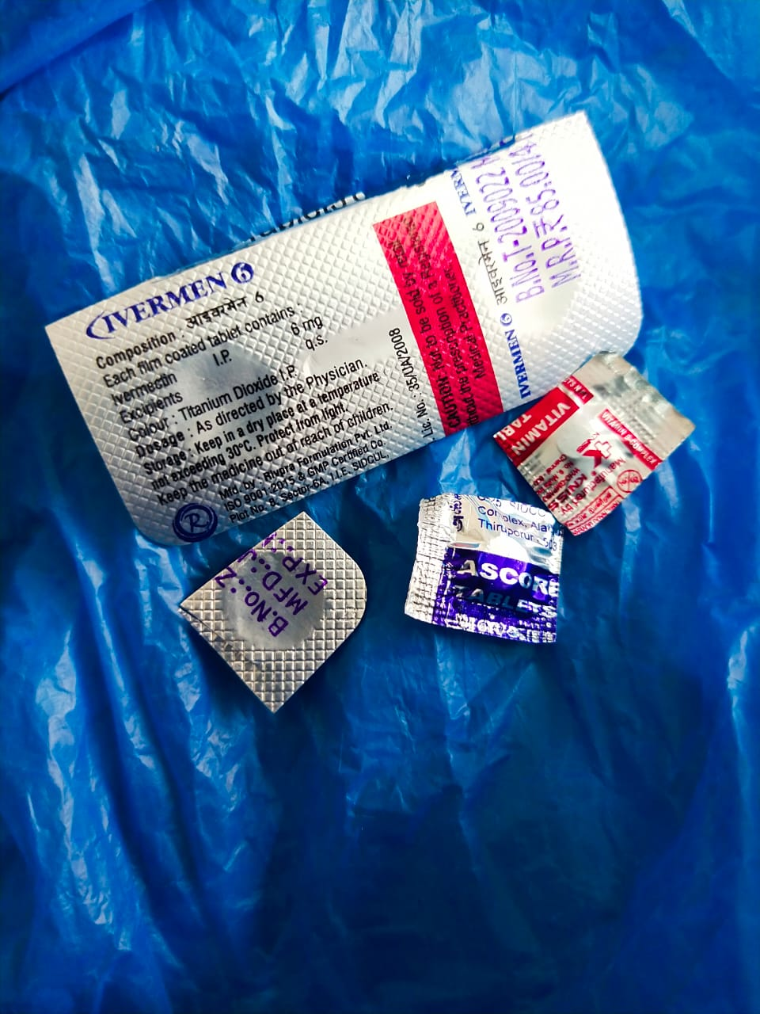

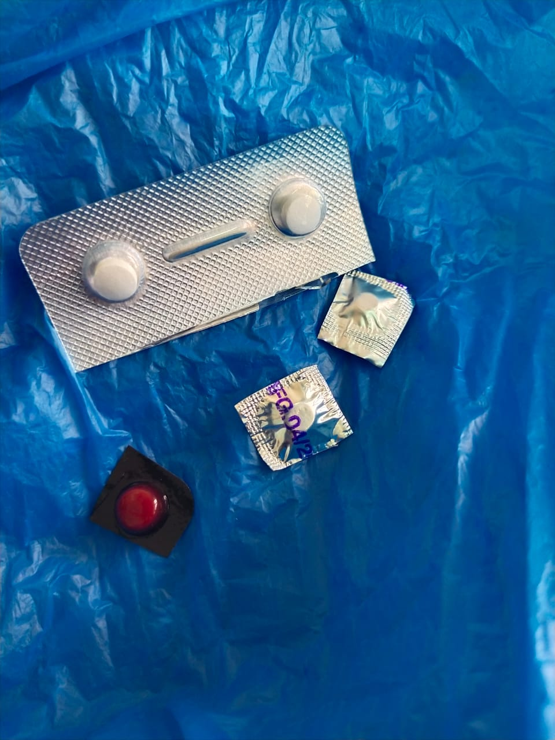

**DO YOU HAVE PROPER INFORMATION PROVIDER LIKE APPS OR WEBSITES ABOUT COVID-19 UPDATES?**

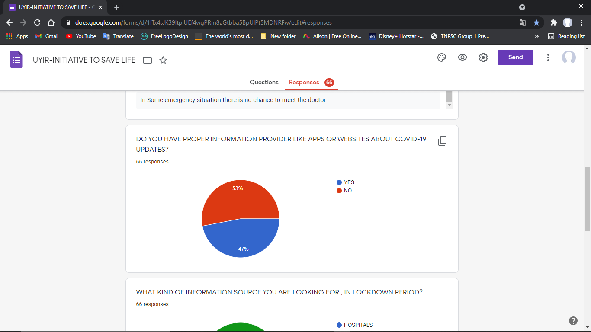

**53% NO**

**47% YES**

**1)they don’t have proper information provider like government updates, they lack of awareness about digital media!**

**WHAT KIND OF INFORMATION SOURCE YOU ARE LOOKING FOR , IN LOCKDOWN PERIOD?**

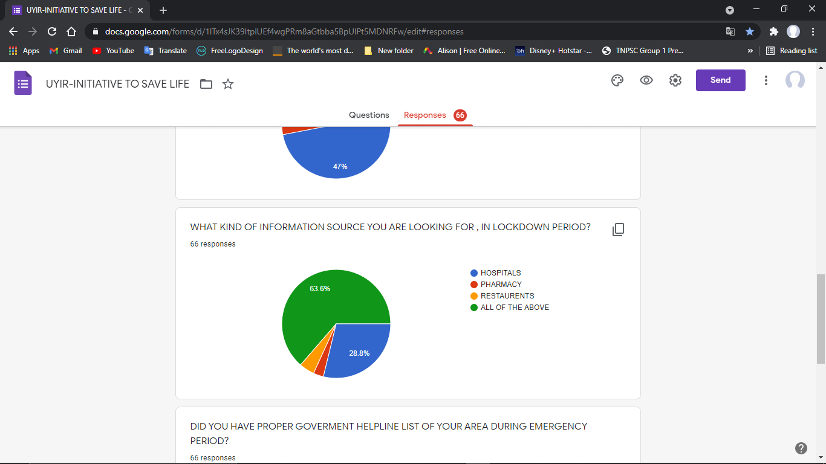

|  |  |
| --- | --- |
|  | RESPONSE |
| ALL OF THE ABOVE | 42 |
| HOSPITALS | 28 |
| RESTAURENTS | 20 |
| PHARNACY | 10 |

**2) Some are in need of all available information and resources that is around them in extensive care.**

**DID YOU HAVE PROPER GOVERMENT HELPLINE LIST OF YOUR AREA DURING EMERGENCY PERIOD?**

|  |  |
| --- | --- |
|  | RESPONSE |
| YES | 65 |
| NO | 34 |

**3) they don’t have proper updates on government updates about covid-19 or covid-19 second wave!**

**ARE YOU LOOKING FOR ALTERNATE SOURCE OR COMPLETE INFORMATION PROVIDER?**

|  |  |
| --- | --- |
|  | RESPONSE |
| YES | 84 |
| NO | 16 |

**4)they are in need of complete information provider as like a hub or all they want in single interface which will guide them!**

**WILL YOU GET VACCINATED?**

|  |  |
| --- | --- |
|  | RESPONSE |
| YES | 1 |
| NO | 99 |

**5)Pepole don’t have proper awareness about the vaccine! Proper awareness should be created**

**(SURVEY-2)**

**HAVE YOU EVER FACED ANXIETY,LONELYNESS THAT MAKES YOU DEPRESSED? நீங்கள் தனிமைபடுத்தி கொண்ட காலத்தில் என்றாவது கவலை,தனிமையில் உள்ளதை உணர்ந்து வேதனைபட்டது உண்டா?**

**6) As per doctor’s advice people who are quarantined are suffering a mental stress which affects them more and make them difficult to overcome the situation which makes their health worse. So continuous and frequent contact with the person with their family member by call or FACE TIME makes them feel comfort and helps them to overcome the situation.**

**DO YOU HAVE PROPER MEDICAL EQUIPMENTS LIKE SPIROMETER TO BE USED IN EMERGENCY CONDITIONS? உங்களிடம் அவசரகால நிலையில் பயன்படுத்தப்படும் SPIROMETER போன்ற மருத்துவ உபகரனங்கள் உள்ளதா?**

**7) Pepole Do not have emergency medical equipments especially they don’t have spirometer which provides oxygen in critical condition.**

**WHAT COMBINATION OF TABLETS DO YOU TAKE?எந்தவிதமான மாத்திரை கலவைகளை நீங்கள் பயன்படுத்துகிரீர்கள்?**

**8)Pepole are diagnosed by their health condition and medicated according to their body condition people are in need of different set of medicines according to their prior affected disease.**

**DO YOU WANT YOUR MEDICINES AND GROCERIES TO BE DELIVERED IN HOME? உங்களுக்கு உங்களுடைய மருந்துகள் மற்றும் மளிகை பொருட்கள் வீட்டிலேயே டெலிவரி செய்தாள் உபயோகமாக இருக்கும் என்று கருதுகிரீர்களா?**

**9) Pepole want their medicines and groceries to be delivered home as they cant go out for purchase! So according redirection should be given to full fill their need!**

**AS A ANSWER AND RESULT OF ALL THESE QUESTIONS AND ANALYSIS**

**PROJECT: “UYIR” HAVE BEEN CREATED.**

**BLOG:** [**https://uyir-initiativetosavelife.blogspot.com/**](https://uyir-initiativetosavelife.blogspot.com/)

**APP (powered by appsgeyser.com):** [**http://app.appsgeyser.com/13633930/UYIR**](http://app.appsgeyser.com/13633930/UYIR)