**SONA_IDEATHON_2021**

**PROPOSED_SOLUTION**

**TEAM ID: ID-162**

**TEAM NAME: “UYIR”**

**BY-**

**R.SHARVESHWAR**

**(TEAM LEADER)**

**R.SURUTHI**

**J.KESAVAN**

**R.DEEPAK**

**SONA COLLEGE OF ARTS AND SCIENCE**

**DEPARTMENT OF MATHEMATICS**

**2ND B.Sc.,MATHEMATICS**



**PROJECT “UYIR”**

**SONA COLLEGE OF ARTS AND SCIENCE**

**INTRODUCTION:**

**UYIR** is an online redirectional app (powered by:appsgeyser.com) . It provides all the information about covid-19 thorugh online official government websites. It directs people to see covid-19 information through arogyasethu web runned by govt of india, It provides tamilnadu covid-19 updates by again redirecting people to national health care mission website runned by govt of tamil nadu.

I t had been made by analyzing pepole’s needs through both online and offline modes.

**BLOG:** [**https://uyir-initiativetosavelife.blogspot.com/**](https://uyir-initiativetosavelife.blogspot.com/)

**APP (powered by appsgeyser.com):** [**http://app.appsgeyser.com/13633930/UYIR**](http://app.appsgeyser.com/13633930/UYIR)

**HOW IT WORKS?**

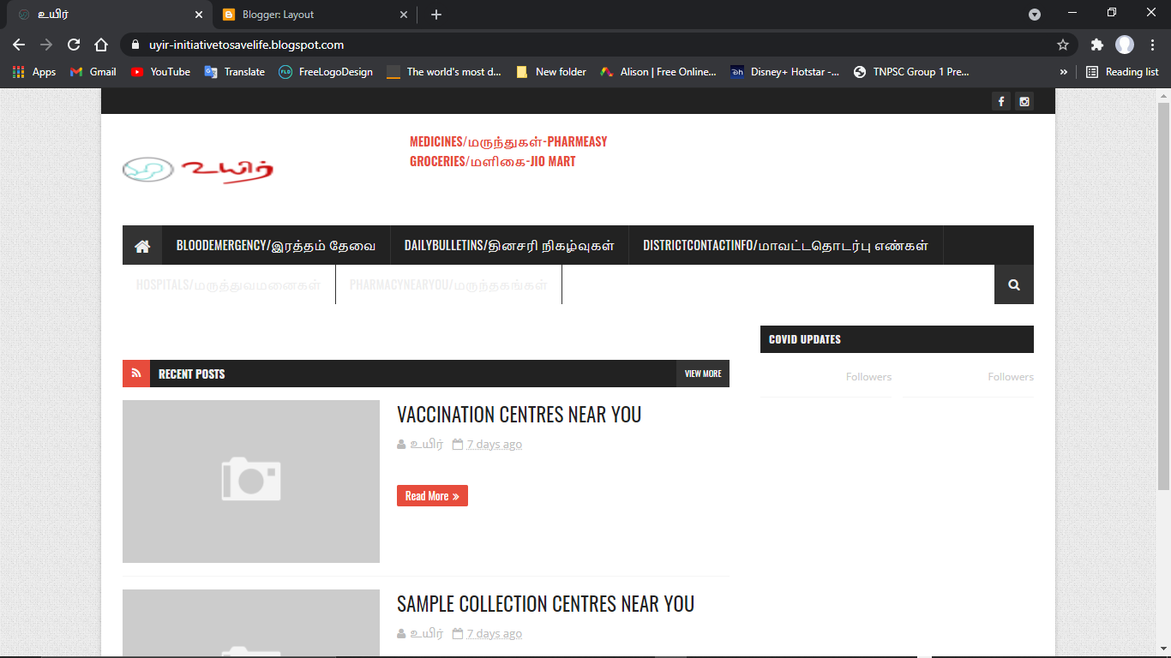

**It actually a web app,** that it function with the help of blog

NAMED: <https://uyir-initiativetosavelife.blogspot.com/> **“UYIR”**

It functions with the help of link provided where all information sources needed are collected as link from their original websites and had been hyperlinked with the text as the main menu in blog.

**WHY IT HAVE BEEN CREATED?**

As a part of SONA COLLEGE OF TECHNOLOGY “IDEATHON” COMPETITION. We have got an opportunity to meet people who are suffered during lockdown and survey had been taken and another survey had been taken through online to the people who are quarantined. So as a result of solving maximum difficulties the people “**UYIR”** have been created.

**WHAT ARE THE INFORMATION DOES IT PROVIDE?** 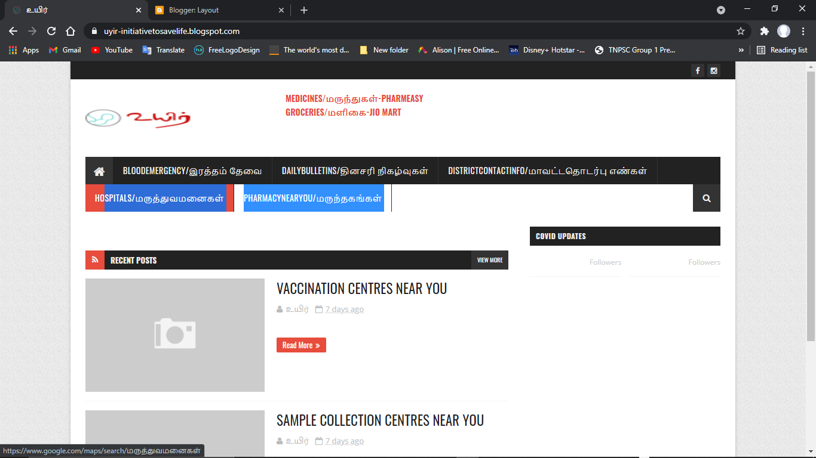

|  |
| --- |
| HOSPITALS |

|  |
| --- |
| HOME |

|  |
| --- |
| DISTRICT CONTACT INFO |

|  |
| --- |
| TN UPDATES |

|  |
| --- |
| MEDICINE |

|  |
| --- |
| GROCERIES |

|  |
| --- |
| COVID INFO |

|  |
| --- |
| BLOOD EMERGENCY |

|  |
| --- |
| DAILY BULLETINS |

|  |
| --- |
| PHARMACY NEAR YOU |

**HOME**:REDIRECTS TO “**UYIR”**

**MEDICINE**: REDIRECTS TO PHARMEASY(WHICH DELIVER MEDICINE DOOR TO DOOR)

**GROCERIES**: REDIRECTS TO JIO MART (WHICH DELIVER GROCERIES DOOR TO DOOR)

**COVID INFO**: REDIRECTS TO WEB OF AROGYA APP

**TN UPDATES**: REDIRECTS TO NATIONAL HELTH MISSION WEBISTE OF TAMIL NADU

**HOSPITALS:** REDIRECTS TO GOOGLE MAP AND GIVES INFORMATION ABOUT NEARBY HOSPITALS

**PHARMACY NEAR YOU** : REDIRECTS TO GOOGLE MAP AND PROVIDES INFORMATION ABOUT PHARMACHY NEAR YOU.

**BLOOD EMERGENCY: REDIRCTS** TO FRIENDS2SUPPORT.ORG

AND GIVE INFORMATION ABOUT BLOOD DONORS AND PLASMA DONORS

**DISTRICT CONTACT INFO**: PROVIDES LIST OF PHONE NUMBERS OF GOVT OFFICIALS DISTRICT WISE.

**DAILY BULLETIN:** PROVIDES UPDATE OF PRESSMEETS OF GOVT ABOUT COVID-19

**FACEBOOK,YOUTUBE,INSTAGRAM TABS**: REDIRECTS YOU TO THE OFFICIAL NHM PAGES OF CORRESPONDING SOCIAL MEDIA

|  |
| --- |
| FACEBOOK-NHM |

|  |
| --- |
| INSTAGRAM-NHM |

1)It provides all complete active,vaccinated,discharged covid-19 affected patients numbers all over india by connecting it to AROGYA app : <https://www.mygov.in/covid-19> through the tab in the main menu called covid info

2)TN UPDATES: it gives all complete information of avtive and discharged cases of tamilnadu by redirecting it to NATIONAL HEALTH MISSION TAMIL NADU WEBSITE

<https://stopcorona.tn.gov.in/>

3) HOSPITALS AND PHARMECY NEAR YOU: It gives the list of hospitals and pharmacy near by redirecting it to google maps.

<https://www.google.com/maps/search/%E0%AE%AE%E0%AE%B0%E0%AF%81%E0%AE%A4%E0%AF%8D%E0%AE%A4%E0%AF%81%E0%AE%B5%E0%AE%AE%E0%AE%A9%E0%AF%88%E0%AE%95%E0%AE%B3%E0%AF%8D>

4) DISTRICT CONTACT INFO AND DAILY BULLETINS: provides information and list of official that people must contact to get help from government

By redirecting it to NHM-TAMIL NADU

<https://stopcorona.tn.gov.in/whom-to-contact/>

5) MEDICINE AND GROCERIES: this tabs allows peoples to order medicines and groceries online and it will be home deleivered

It will redirect to pharmeasy and jio mart

[https://pharmeasy.in/?isSEM=true&&utm_source=google&utm_medium=cpc&utm_campaign=[GSB_New_cx]&utm_term=pharmeasy&utm_adgroup=[Core]&placement_id_identifier=&ad_group_id_identifier=117065995609&device=c&location=9040218&gclid=CjwKCAjwj6SEBhAOEiwAvFRuKH-11F9A6_u0GkvA6JZmR2o5Li0Q4MYBsAldId6dn8L1TRzcmprqHxoCZD0QAvD_BwE](https://pharmeasy.in/?isSEM=true&&utm_source=google&utm_medium=cpc&utm_campaign=%5bGSB_New_cx%5d&utm_term=pharmeasy&utm_adgroup=%5bCore%5d&placement_id_identifier=&ad_group_id_identifier=117065995609&device=c&location=9040218&gclid=CjwKCAjwj6SEBhAOEiwAvFRuKH-11F9A6_u0GkvA6JZmR2o5Li0Q4MYBsAldId6dn8L1TRzcmprqHxoCZD0QAvD_BwE)

**THANK YOU:**

**-BY**

**R.SHARVESHWAR AND TEAM**

**TEAM MEMBERS:**

**R.SURUTHI**

**J.KESAVAN**

**R.DEEPAK.**