**SONA_IDEATHON_2021**

**STUDY**

**TEAM ID: ID-162**

**TEAM NAME: “UYIR”**

**BY-**

**R.SHARVESHWAR**

**(TEAM LEADER)**

**R.SURUTHI**

**J.KESAVAN**

**R.DEEPAK**

**SONA COLLEGE OF ARTS AND SCIENCE**

**DEPARTMENT OF MATHEMATICS**

**2ND B.Sc., MATHEMATICS**

**INTRODUCTION:**

There are many countries which are affected by COVID and so for the coordination of the people and for the data management required for effective implementation of strategies, most successful countries relied on adopting digital technology and integrating it into policy and health care .Here we are going to show some of the digital solutions available in the market for the quarantined people.

**AVAILABLE SOLUTIONS IN MARKET ARE:**

**AROGYA Setu:**

The stated purpose of this app is to spread awareness of COVID – 19 related health services to the people of India. The app augments the initiatives of the Department of health to contain COVID-19 and shares best practices and advisories. This app also helps in Digital contact tracing, self – diagnosis, and data intelligence.

**COVA Punjab:**

Cova stands for corona virus alert and has been developed in consultation with the health and family welfare department to spread awareness by sharing various travelling and preventive care advisories. This app provides options to check out for symptoms of infection. Users can follow advisory if the symptoms are serious and need attention. COVA also suggests the nearest hospital and nodal officer to reach out.

**Mahakavach:**

It is a home quarantine assist and contact tracing app for COVID. It helps citizens to contribute and assist in tracing the contacts with potential risk of covid-19 by helping health administration. 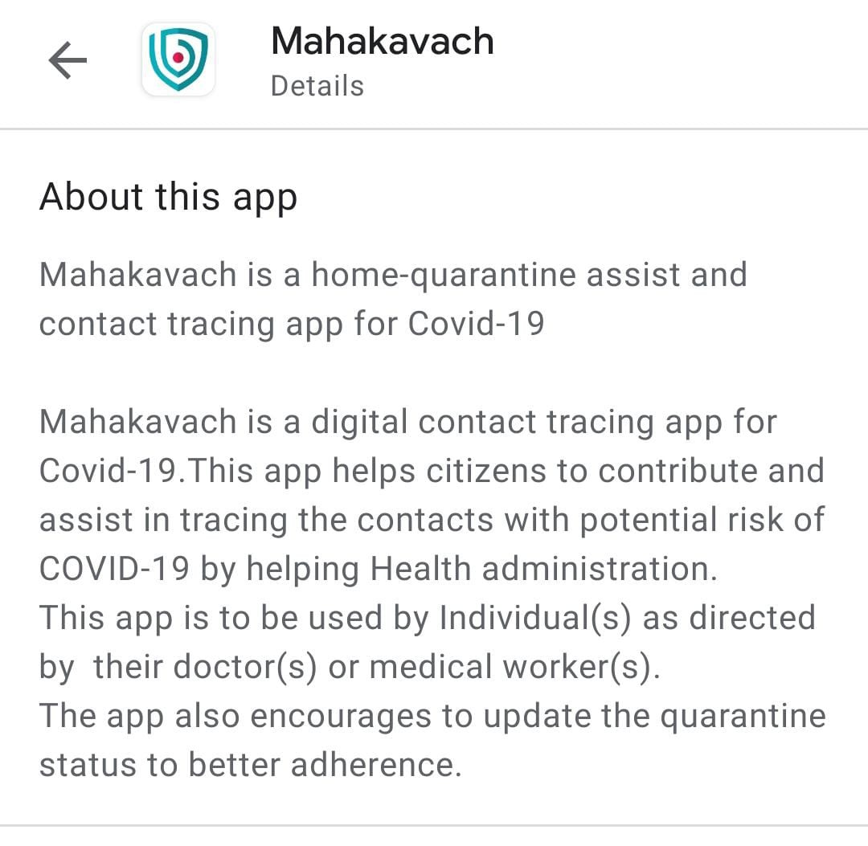

**CORONA MUKT HIMACHAL:**

The App is for people in Himachal Pradesh, who have been home quarantined after registering with the Department of Health, Himachal Pradesh.

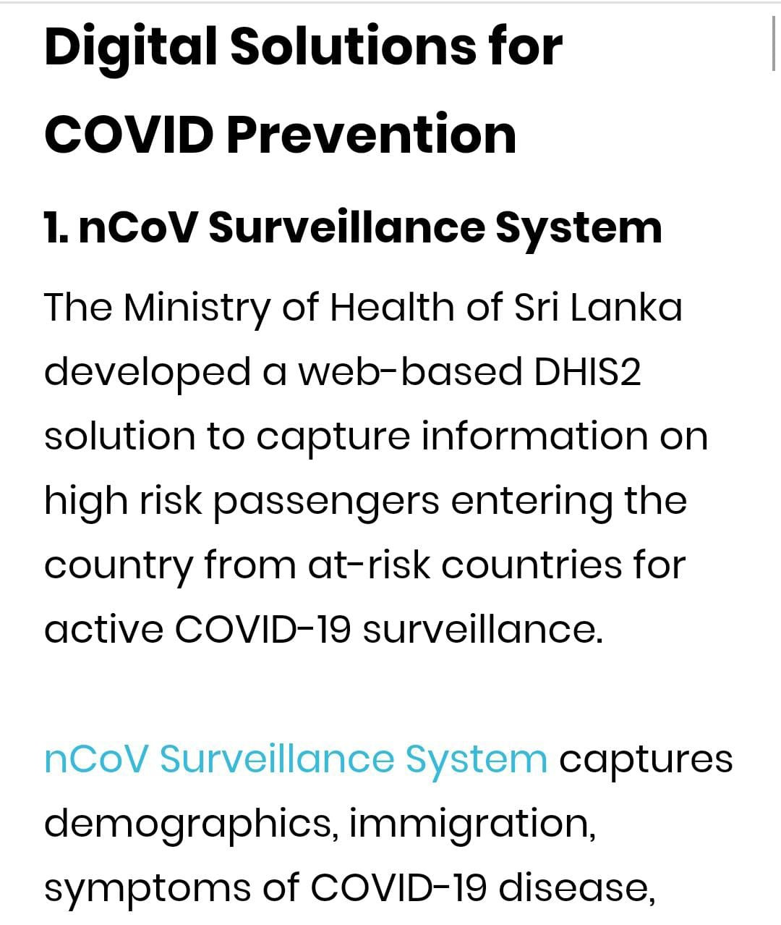

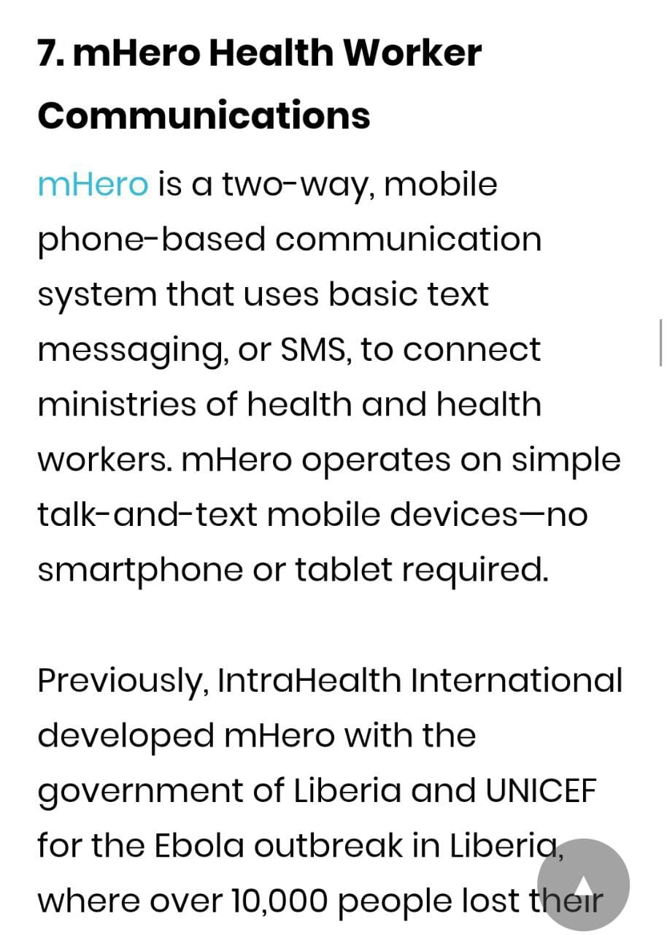

**WHAT PEPOLE WANT?**

**\***Services and apps in India are providing their services by monitoring their phone and gathering contacts of the users. But people want a HUB of all available sources.

*Some services provided in foreign countries are improvised but only available in their countries eg: mHERO (it alerts people who do not have a Smartphone through SMS).