|  |  |  |  |  |  |  |  |  |  |  |  |  |  |  |  |
| --- | --- | --- | --- | --- | --- | --- | --- | --- | --- | --- | --- | --- | --- | --- | --- |
| **DIPLOMA IN COMPUTER SCIENCE 2022/2023**  **FACULTY OF HUMANITIES, MANAGEMENT AND SCIENCE**  **PERSONAL PORTFOLIO WEBSITE PLANNING DOCUMENT**  **WEB PROGRAMMING / SSE2150-1**  **LECTURER: DR JUNIZA BINTI MD SAAD**   |  |  |  | | --- | --- | --- | | No. | Name | Matrices Number | | **1** | **SHARVESSH A/L SANTHARA SAGERAN** | **S32387** | |  |  |  | |  |  |  | |  |  |  | |

## **Personal Portfolio Website Planning Document**

|  |  |  |
| --- | --- | --- |
| **Checklist for Planning a Website** | |  |
| Topic | Web Developer Questions | Answers (Give brief but thoughtful and realistic answers with the cooperation of all team members. No, the website will not be *real* but it does need to be *realistic.*) |
| Purpose of the Website | What is the purpose and goal of the website? | The purpose of the website is to display the personal portfolio and also showcase my skills, projects and accomplishments to the potential employer, clients or collaborator. |
|  | What is the company’s mission statement? | The mission statement is to get employed in a company where the salary is up to the mark and work in a healthy environment. |
| Target Audience | Describe the target audience (age, gender, demographics) | The target audience of this website is for the employers who are currently active in the Information Technology (IT) industry.   * In terms of age, the target audience for the personal portfolio would likely be adults of working age, typically between 25 and 55 years old (this may vary depending on the specific subfield of IT). * In terms of gender, the target audience for the personal portfolio would likely both male and female employers * In terms of demographics, the target audience for the personal portfolio includes people who is currently active in the IT field. |
|  | What information is most pertinent to the users? | The information that are the most pertinent to the users who view the portfolio is my biodata, skills, projects and accomplishments |
| Multiplatform Display | Will your design for multiple platforms display or only focus on a desktop or mobile design? | The website is designed for multi-platform display and the user can view the website in both desktop and mobile. |
| Wireframe | How many pages will be included in the website? | This will be a single page website. Most of the details of the personal portfolio will be displayed in the index or the home page to make it easier for the employer to view. However, the user can view more details of the personal portfolio by clicking   * **Go to About Me page** * **Learn more!** * **Go to Contact Me page**   The user can view the more detailed version of the navigation page by clicking the hyperlinks named above. The user can also return to the home page by clicking the “Home” nav bar. This summarizes that there will be 4 pages (index.html, about.html, expertise.html & contact.html) in the website. |
|  | How will the pages be organized? | 1. Home page: The home page will showcase my abilities, expertise, and accomplishments while also being visually appealing and simple to navigate. A brief introduction, an outline of my services or areas of expertise, and hyperlinks to other pages on my website are all acceptable inclusions. 2. About page: This page ought to include more specifics about my identity, upbringing, and professional background. I will provide any pertinent information that will assist visitors understand my education background and what am I capable for, such as my schooling, employment background, talents, and other qualifications. 3. Expertise & Proficiency page: In this page, I will exhibit and state the list of software that I’m currently expert and proficient at. 4. Programming Skills: In this page, I will exhibit and state the list of programming languages that I’m currently expert and proficient at. 5. Contact page: This page contains a contact form or other methods for the employers to get in touch with me, such as my phone number, email address, and social network accounts. This page also includes download resume button for the employer to download and take a look on my resume file. |
|  | What type of website structure is appropriate for the content? | The appropriate website structure for the website is a hierarchical structure. This means that the website will have a clear and organized hierarchy of pages, where each page leads to more specific and detailed information. |
| Graphics | What graphics will you use on the website? | 1. High-quality photographs: Photos of your work, professional headshots, and images that represent your skills and personality. 2. Icons and illustrations: Small graphics or illustrations that help communicate important information, such as skill levels or areas of expertise. 3. Infographics: Visual representations of data or information that are easy to understand and visually appealing. |
| Color | What colors will you use within the site to enhance the purpose and brand? | I’m planning to achieve a minimalistic design website by using the combinations of 3 colors for the website which is orange, black and white. |
| Typography | What font styles will you use within the website? | I will be using a combination of the common sans-serif font, Poppins and also a geometric sans serif font, which is Montserrat. 3 of these fonts are a web safe font and Montserrat shines for short pieces of all caps and the geometric simplicity of the letters. |
| Accessibility | How will the website accommodate people with disabilities? |  |

Sketch the wireframe for the home page below:

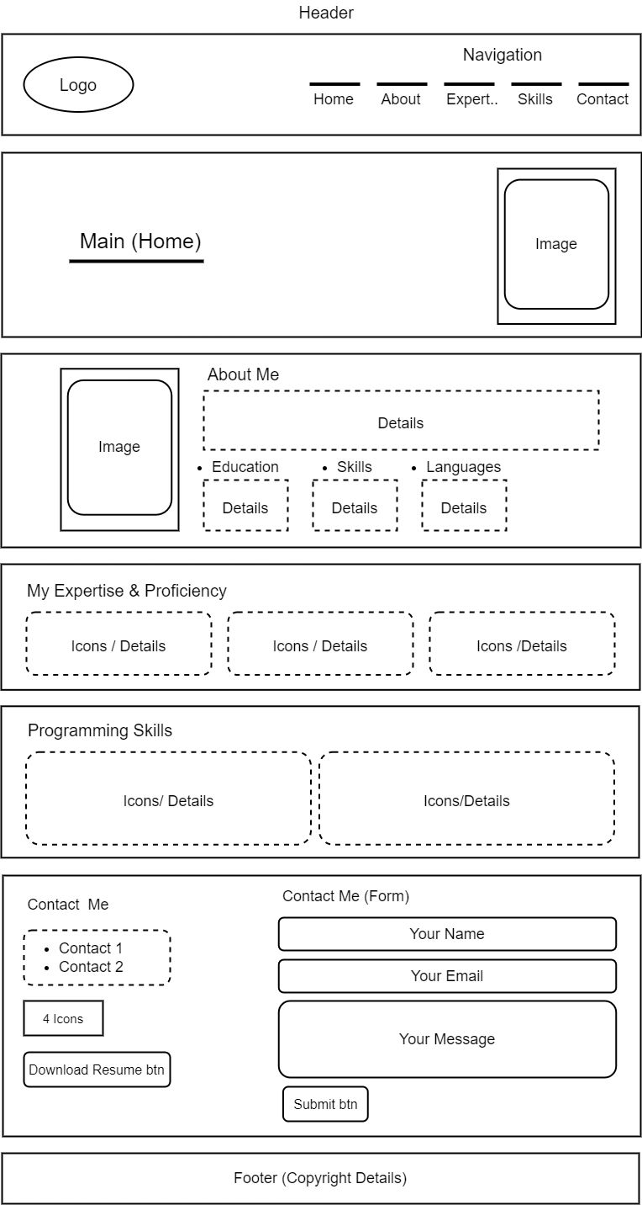

1. Use your favorite search engine to find articles and images for electronic portfolios. What new ideas did you find that you want to incorporate into your own personal electronic portfolio? Include at least three links to sites that you like and your reasons for choosing those sites in your answer.

This is the first time I am working on building a website from scratch and as many ideas that I would like to incorporate in my personal portfolio website, I’ve discovered that building website is not easy as we thought and to incorporate ideas of other electronic portfolio requires lot of time and dedication put towards it. As a beginner, there’s no better way to build a website in this day than learning through YouTube Tutorials. However, while exploring different resources on YouTube, I came across a video on personal portfolio websites by Easy Tutorials that provided me with some valuable ideas. One idea that I want to incorporate into my own portfolio website is the use of a responsive design that adapts to different screen sizes. Another idea that I found interesting was the use of interactive elements such as animations and hover effects to make the website more engaging. The third idea that caught my attention was the use of a consistent color scheme throughout the website, which can help in establishing a strong brand identity. I have included the link to the video below as it has been a helpful resource for me.

Link 1: <https://www.youtube.com/watch?v=0YFrGy_mzjY>

Link 2: <http://sendamessage.to/>

Link 3: <https://www.freecodecamp.org/news/how-to-create-a-portfolio-website-using-html-css-javascript-and-bootstrap/>

2. Use your favorite search engine to find articles on search engine optimization (SEO). Identify three tips that you can add to your webpage to improve its SEO performance.

1. Use relevant keywords in the content: Keywords is an important tool for the search engine to understand what the page is all about. You need to implement relevant keywords in the webpage content, including the page title, meta description, and headers, as it can likely increase the chances of your webpage suggester higher in search results by the search engine. However, it is important to use keywords naturally and avoid overusing them as they can impact user experience using the webpage.
2. Optimize page loading speed: The page reload or loading speed is a utmost factor in SEO performance, as search engines recommends websites that load quickly for the user than the laggy. To improve page load speed, you can compress images, reduce CSS code and JavaScript files, and use a content delivery network (CDN) to serve static assets. In addition, optimizing server response time and using browser caching will contribute in improving the page load speed.
3. Use internal linking: Try to link any other relevant pages on your website from within your content. By doing so, the search engine understand the structure of your website and can improve the user experience by providing additional context and information if needed for the user.