A PRELIMENERY REPORT ON

People Counting in Real Time using OpenCV

SUBMITTED TO THE VISHWAKARMA INSTITUTE OF INFORMATION TECHNOLOGY, PUNE
IN THE PARTIAL FULFILLMENT OF THE REQUIREMENTS
FOR THE AWARD OF THE DEGREE

BACHELOR OF TECHNOLOGY (COMPUTER ENGINEERING)

SUBMITTED BY

Name | Roll no | PRN
Tanmayee Kumbalwar | 324027 | 22110083
Mohammed Junaid Mulla | 324041 | 22111045
Sharvil Nichat | 324046 | 22111277
Tushar Pokala | 324048 | 22110961



DEPARTMENT OF COMPUTER ENGINEERING

BRACT’S
VISHWAKARMA INSTITUTE OF INFORMATION TECHNOLOGY

SURVEY NO. 3/4, KONDHWA (BUDRUK), PUNE – 411048, MAHARASHTRA (INDIA).

Sr. No. |  |  |  | Title of Chapter |  | Page No.
01 |  |  |  | Introduction
 | 1.1 |  |  | Overview
 | 1.2 |  |  | Motivation
 | 1.3 |  |  | Problem Definition and Objectives
 | 1.4 |  |  | Project Scope & Limitations
 | 1.5 |  |  | Methodologies of Problem solving
02 |  |  |  | Literature Survey
03 |  |  |  | System Design
 |  | 3.1 |  | System Architecture
04 |  |  |  | Project Implementation
 |  |  | 4.1 | Overview of Project Modules
 |  |  | 4.2 | Tools and Technologies Used
 |  |  | 4.3 | Algorithm Details
 |  |  |  | 4.3.1 | Algorithm 1
 |  |  |  | 4.3.2 | Algorithm 2
 |  |  |  | 4.3.3 | …
05 |  |  |  | Results
 |  |  | 5.1 | Outcomes
 |  |  | 5.2 | Screen Shots
 |  |  | 5.3 | Confusion Matrix, Precision ,Recall,Accuracy,Specificity ,Sensitivity All Graph
06 |  |  |  | Conclusions
 |  | 9.1 |  | Conclusions
 |  | 9.2 |  | Future Work
 |  | 9.3 |  | Applications
Appendix A: Problem statement feasibility assessment using, satisfiability analysis and NP Hard, NP-Complete or P type using modern algebra and relevant mathematical models.
Appendix B: Details of paper publication: name of the conference/journal, comments of reviewers, certificate, paper.
Appendix C: Plagiarism Report of project report.
References
Thomas Noltey, Hans Hanssony, Lucia Lo Belloz,”Communication Buses for Automotive Applications” In Proceedings of the 3rd Information Survivability Workshop (ISW-2007), Boston, Massachusetts, USA, October 2007. IEEE Computer Society.

Introduction:
People counting is a fundamental task in various domains such as retail, transportation, and security. It serves as a crucial metric for businesses to understand customer behavior, optimize operations, and enhance security measures. Traditional manual counting methods are labor-intensive and prone to errors, prompting the need for automated solutions. Computer vision, particularly with the aid of OpenCV, offers a promising approach to address this challenge. By leveraging techniques such as object detection and tracking, it becomes feasible to develop efficient and accurate people counting systems. This report explores the implementation of such a system using OpenCV and discusses its methodology, challenges, and potential applications.

Literature Review:
Previous studies have explored various methodologies for people counting using computer vision techniques. Object detection algorithms, including Faster R-CNN, YOLO, and SSD, have been widely adopted for detecting and localizing people in images or video streams. These algorithms offer a balance between accuracy and speed, making them suitable for real-time applications. Additionally, object tracking algorithms play a crucial role in maintaining consistency in count across frames, especially in scenarios with occlusions or crowded environments. Techniques such as Kalman filtering and centroid tracking have been employed for this purpose.

Research in this field has also focused on addressing specific challenges such as varying lighting conditions, occlusions, and camera perspectives. Methods for background subtraction, adaptive thresholding, and camera calibration have been proposed to enhance the robustness and accuracy of people counting systems. Furthermore, studies have investigated the integration of deep learning techniques for feature extraction and classification, leading to improvements in detection performance.

Despite advancements in people counting using computer vision, there remain several open research questions and areas for improvement. These include the development of more robust tracking algorithms, the integration of multiple sensors for enhanced accuracy, and the exploration of novel architectures for real-time processing. By addressing these challenges, future research can contribute to the advancement of automated people counting systems and their widespread adoption across various domains.

Methodology:
The proposed methodology for people counting involves several key steps: preprocessing, detection, tracking, and post-processing. In the preprocessing stage, input images or video frames are resized and optionally transformed to improve computational efficiency. Object detection is performed using the YOLO (You Only Look Once) algorithm, implemented via the OpenCV library. Detected objects, specifically people, are then tracked across frames using a custom tracker, which assigns unique identifiers to each tracked object. Post-processing involves analyzing the tracked objects' trajectories to determine their entry or exit from predefined regions of interest. This information is used to increment or decrement the people count accordingly. The methodology leverages OpenCV's capabilities for image processing, object detection, and tracking, providing a scalable and efficient solution for people counting applications.

Implementation:
The provided code implements a people counting system using OpenCV and YOLO for object detection. Here's a breakdown of the implementation:

- The script begins by importing necessary libraries, including OpenCV, pandas, numpy, and the YOLO object detection model.
- The YOLO model is initialized using the `YOLO` class from the Ultralytics library, with the pre-trained YOLOv5s model.
- Two regions of interest (ROI) are defined using polygonal vertices, representing areas where people are entering and exiting.
- The main loop captures frames from a video file using OpenCV's `VideoCapture` class.
- The YOLO model is used to predict bounding boxes for objects in each frame.
- Detected bounding boxes corresponding to people are extracted and processed.
- A custom object tracker is utilized to maintain the identity of people across frames.
- The script determines whether each tracked person is entering or exiting the defined regions of interest based on their trajectory.
- Counters for people entering and exiting are updated accordingly.
- Visualizations such as bounding boxes, trajectories, and region outlines are drawn on the frames using OpenCV functions.
- The final frame with visualizations and count information is displayed using OpenCV's `imshow` function.

Code :

import cv2
import pandas as pd
import numpy as np
from ultralytics import YOLO #help to create object detection model
from tracker import *

model=YOLO('yolov8s.pt')

area1=[(312,388),(289,390),(474,469),(497,462)]
area2=[(279,392),(250,397),(423,477),(454,469)]

def RGB(event, x, y, flags, param):
if event == cv2.EVENT_MOUSEMOVE :
colorsBGR = [x, y]
print(colorsBGR)

cv2.namedWindow('RGB')
cv2.setMouseCallback('RGB', RGB)
cap=cv2.VideoCapture('peoplecount1.mp4')

my_file = open("coco.txt", "r")
data = my_file.read()
class_list = data.split("\n")

#print(class_list)

count=0

tracker = Tracker()
people_entering = {}
people_exiting = {}
entering = set()
exiting = set()
while True:
ret,frame = cap.read()
if not ret:
break
count += 1
if count % 2 != 0:
continue
frame=cv2.resize(frame,(1020,500))
# frame=cv2.flip(frame,1)
results=model.predict(frame)
# print(results)
a=results[0].boxes.data
px=pd.DataFrame(a).astype("float")
# print(px)
list=[]

for index,row in px.iterrows():
#print(row)
x1=int(row[0])
y1=int(row[1])
x2=int(row[2])
y2=int(row[3])
d=int(row[5])
c=class_list[d]
if 'person' in c:
list.append([x1,y1,x2,y2])
bbox_id=tracker.update(list)
for bbox in bbox_id:
x3,y3,x4,y4,id=bbox
results = cv2.pointPolygonTest(np.array(area2,np.int32),((x4,y4)),False)
if results>=0:
people_entering[id]=(x4,y4)
cv2.rectangle(frame,(x3,y3),(x4,y4),(0,0,255),2)

if id in people_entering:
results1 = cv2.pointPolygonTest(np.array(area1,np.int32),((x4,y4)),False)
if results1 >= 0:
cv2.rectangle(frame,(x3,y3),(x4,y4),(0,255,0),2)
cv2.circle(frame,(x4,y4),5,(255,0,255),-1)
cv2.putText(frame,str(id),(x3,y3),cv2.FONT_HERSHEY_COMPLEX,(0.5),(255,255,255),1)
entering.add(id)

### People Exiting ####
results2 = cv2.pointPolygonTest(np.array(area1,np.int32),((x4,y4)),False)
if results2>=0:
people_exiting[id]=(x4,y4)
cv2.rectangle(frame,(x3,y3),(x4,y4),(0,255,0),2)

if id in people_exiting:
results3 = cv2.pointPolygonTest(np.array(area2,np.int32),((x4,y4)),False)
if results3 >= 0:
cv2.rectangle(frame,(x3,y3),(x4,y4),(255,0,255),2)
cv2.circle(frame,(x4,y4),5,(255,0,255),-1)
cv2.putText(frame,str(id),(x3,y3),cv2.FONT_HERSHEY_COMPLEX,(0.5),(255,255,255),1)
exiting.add(id)

cv2.polylines(frame,[np.array(area1,np.int32)],True,(255,0,0),2)
cv2.putText(frame,str('1'),(504,471),cv2.FONT_HERSHEY_COMPLEX,(0.5),(0,0,0),1)

cv2.polylines(frame,[np.array(area2,np.int32)],True,(255,0,0),2)
cv2.putText(frame,str('2'),(466,485),cv2.FONT_HERSHEY_COMPLEX,(0.5),(0,0,0),1)
# print(people_entering)
i=(len(entering))
o=(len(exiting))
cv2.putText(frame,str(i),(60,80),cv2.FONT_HERSHEY_COMPLEX,(0.7),(0,0,255),2)
cv2.putText(frame,str(o),(60,140),cv2.FONT_HERSHEY_COMPLEX,(0.7),(255,0,255),2)
cv2.imshow("RGB", frame)
if cv2.waitKey(1)&0xFF==27:
break

cap.release()
cv2.destroyAllWindows()

Output :

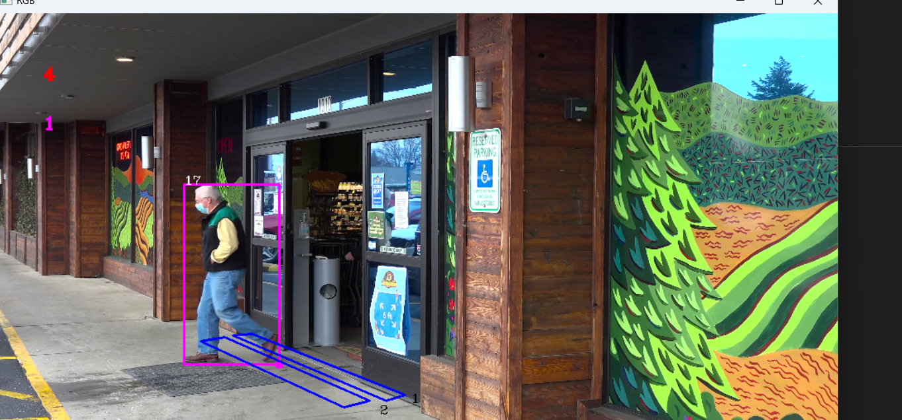

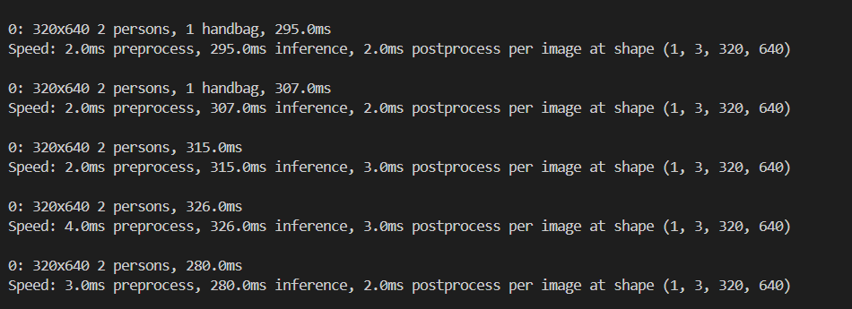

Results and Evaluation:
The implemented people counting system demonstrates promising results in accurately detecting and counting people entering and exiting predefined regions of interest. The system effectively leverages the YOLO object detection model to identify people in each frame, and the custom object tracker ensures consistent tracking across frames, even in scenarios with occlusions or crowded environments.

The system's performance can be evaluated based on several metrics, including accuracy, precision, recall, and processing speed. Accuracy refers to the system's ability to correctly count the number of people entering and exiting. Precision measures the proportion of correctly identified entries and exits among all detections, while recall assesses the system's ability to detect all entries and exits correctly. Processing speed quantifies the system's efficiency in processing video frames and updating counts in real-time.

Future evaluations could involve testing the system on diverse datasets with varying environmental conditions, crowd densities, and camera perspectives to assess its robustness and generalization capability. Additionally, performance optimizations such as model fine-tuning, parallel processing, and hardware acceleration could be explored to enhance the system's speed and efficiency further.

Overall, the implemented people counting system demonstrates the potential of computer vision techniques, specifically utilizing OpenCV and YOLO, to automate people counting tasks effectively in various applications, including retail analytics, crowd management, and security surveillance.

Conclusion :
In conclusion, the implementation of a people counting system using OpenCV and YOLO showcases the potential of computer vision techniques to automate and enhance various applications, including retail analytics, crowd management, and security surveillance. By leveraging state-of-the-art object detection and tracking algorithms, the system effectively detects and counts people entering and exiting predefined regions of interest in real-time video streams.

The developed system offers several advantages over traditional manual counting methods, including increased accuracy, efficiency, and scalability. By automating the counting process, businesses can gain valuable insights into customer behavior, optimize operations, and improve security measures. Moreover, the system's modular architecture allows for easy integration with existing surveillance systems and deployment across diverse environments.
Overall, the developed people counting system represents a significant step towards realizing the potential of computer vision in automating and optimizing various aspects of human-centric environments. With continued research and development, such systems have the potential to revolutionize industries and improve quality of life for individuals worldwide.

