**Project Title**

* N-Queen Problem

**Project Description**

The **N Queens puzzle** is the problem of placing **N** chess queen on an **N x N** chessboard so that no two queens threaten each other. Thus, a solution requires that no two queens share the same row, column, or diagonal. In N **queens problem** there exist solution for all natural numbers **N** with the exception of **n=2** and **n=3.**

**Data Structures to be used**

Basically this problem can be solved using recursion only. But, it can also be represented using **Tree.** Which is easy to understand. It can help us to visualize that from where we cannot go further and take another path. So internally it also uses **Backtracking.** Below is the example for the same.

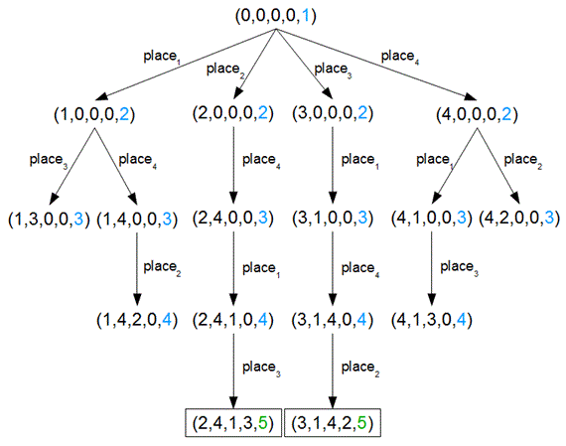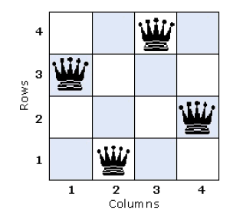

So, basically we will use **Recursion, Backtracking** and **Tree** to solve this problem.

**Reason for Undertaking N-Queen Problem**

* To concur Data Structures Like **Link List** and **Trees**
* Better understand **Recursion** concept and **Backtracking** process

**Project Mentor**

* 201512077 – Khushbu Watwani

**Project Participants (Group 17)**

* 201612023 – Shah Sharvil
* 201612048 – Gupta Aditi
* 201612051 – Abhilash Mandaliya
* 201612059 – Farhan Ansari
* 201612089 – Desai Pritesh
* 201612099 – Vaghasiya Gopal