Smart Campus Lab & Resource Optimizer
Frontend Integration & Implementation Steps
React Frontend → Express UI-BFF → Team A/B Logic → Supabase PostgreSQL

1. What this document covers
This document converts the supplied system architecture and database design into a practical frontend integration sequence. The frontend should act as the user-facing layer for Student, Faculty and Lab Admin roles. Normal writes should go through the Express backend/UI-BFF, while Supabase Auth handles sign-in and Supabase Realtime provides row-change subscriptions.
The supplied schema defines profiles, campus graph nodes/edges, labs, resources, bookings, scheduling decisions, routes and audit logs. The inventory extension adds categories, suppliers, equipment models, purchase batches, asset events, resource serial numbers and equipment-specific specification tables.

2. Target architecture to implement
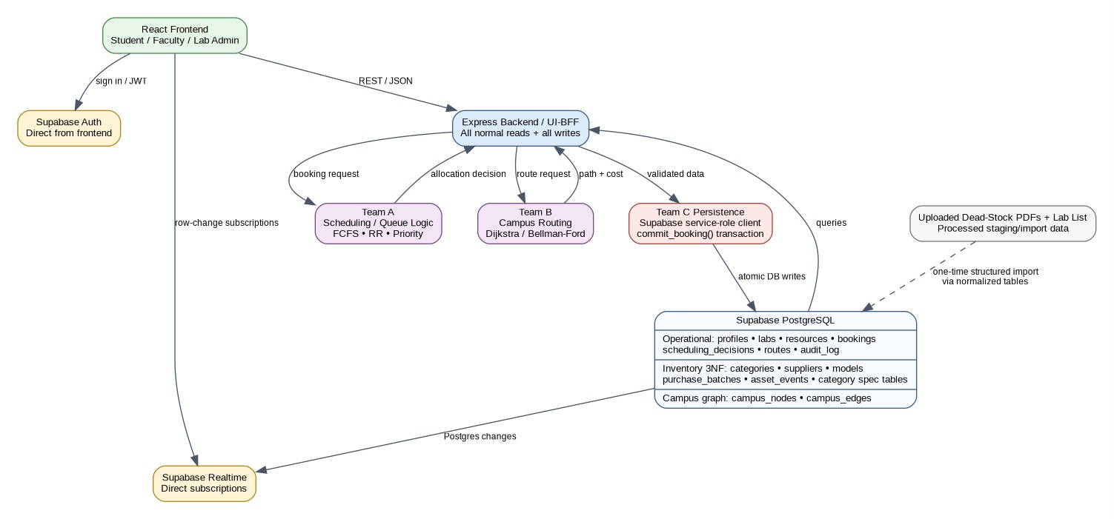
Figure 1 — Supplied application architecture
Important implementation rule: the React app should not directly perform booking writes with the Supabase client. The supplied SQL explicitly states that authenticated frontend access is read-oriented and writes are intended to happen through the backend service-role path.

3. Database structure the frontend must consume
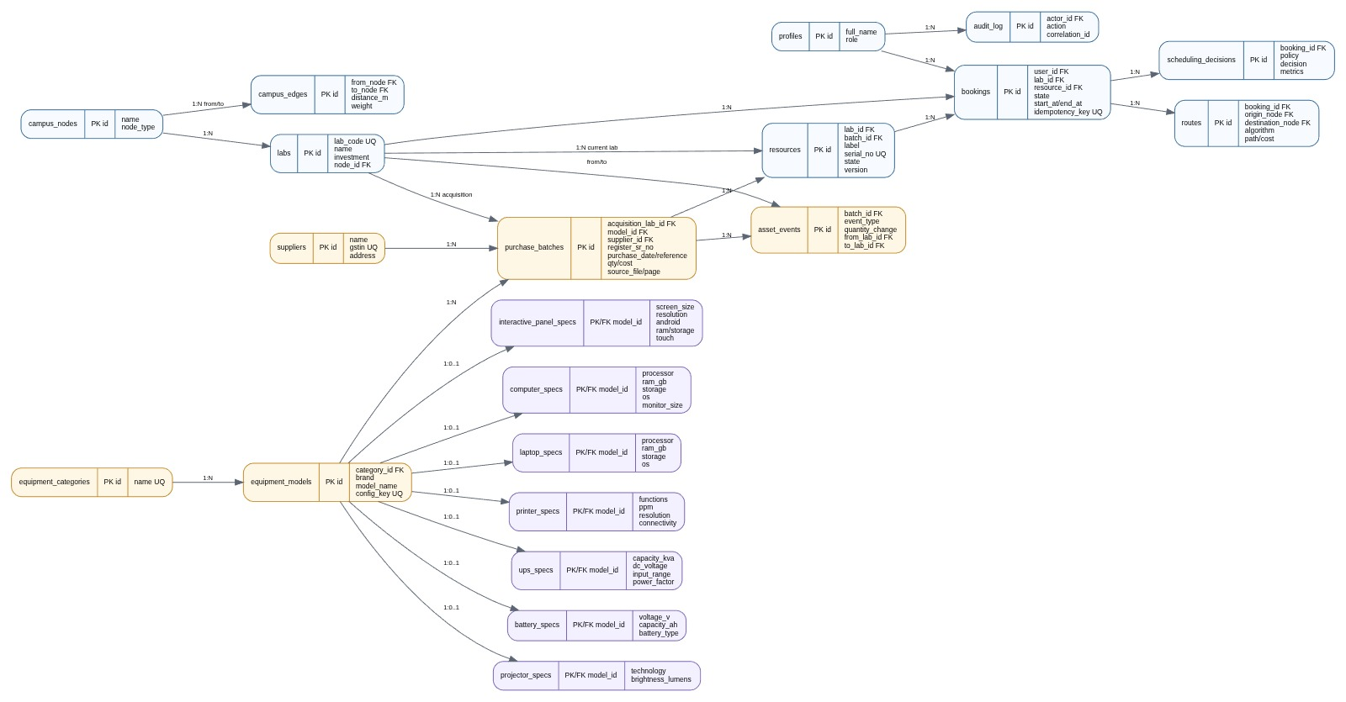
Figure 2 — Supplied ER/data model
The frontend does not need to reproduce the ER diagram. It needs to map these entities into screens, API requests, tables/cards and real-time updates.

4. Frontend modules by role
Role | Main screens | Main actions | Data used
Student | Dashboard, Labs, Resources, My Bookings, Route | View availability, request booking, cancel/release where permitted, view route/status | labs, resources, bookings, scheduling_decisions, routes
Faculty | Dashboard, Priority Booking, Batch Booking, Queue, Resources | Create priority/batch requests, monitor queue, view decisions and routes | bookings, resources, scheduling_decisions, routes, labs
Lab Admin | Admin Dashboard, Inventory, Labs, Bookings, Audit | Monitor resources, manage inventory state, inspect booking activity and audit history | profiles, labs, resources, bookings, inventory tables, audit_log

5. Step-by-step implementation
1. Prepare the React project structure
Create a clean feature-based frontend structure before connecting screens.
- src/components — reusable UI components such as ResourceCard, BookingModal, StatusBadge and RouteMap.
- src/pages — StudentDashboard, FacultyDashboard, AdminDashboard, Labs, Inventory, Bookings and Routes.
- src/services — authService, apiService, bookingService, inventoryService and routeService.
- src/hooks — useAuth, useLabs, useResources, useBookings and useRealtime.
- src/types — TypeScript interfaces for Profile, Lab, Resource, Booking, Route and Inventory records.
2. Connect Supabase Authentication
Use Supabase Auth for sign-in and session handling. After login, load the user's profile and role.
- Sign in through Supabase Auth.
- Read public.profiles using the authenticated session.
- Route the user to the correct dashboard based on role: student, faculty or lab_admin.
- Protect application routes so unauthenticated users cannot access the dashboard.
3. Create the common application shell
Build the layout shared by all roles.
- Sidebar/top navigation.
- User profile and role badge.
- Notification area for booking/realtime changes.
- Responsive desktop/tablet/mobile layout.
- Global loading, empty, error and unauthorized states.
4. Build the Lab & Resource module
Start with read operations because labs and resources are core dependencies for booking.
- GET /api/labs — list labs.
- GET /api/labs/:id — lab details.
- GET /api/labs/:id/resources — resources in a lab.
- Show resource state: AVAILABLE, RESERVED, ALLOCATED, RELEASING or MAINTENANCE.
- Show resource label, serial number and model/specification information where available.
5. Build the Student booking flow
Implement the complete booking request from the UI, but send the write request to Express.
- Select lab.
- Select date/time range.
- Select resource if required.
- Submit booking request.
- Show REQUESTED/VALIDATED/QUEUED/CONFIRMED/REJECTED/WAITLISTED states.
- Display final resource allocation and route when returned by the backend.
6. Integrate Team A — Scheduling
The architecture shows Team A handling FCFS, RR and Priority scheduling. The frontend should not implement this scheduling decision itself; it should display the backend result.
- Send booking request to Express.
- Express passes the request to Team A scheduling logic.
- Receive allocation decision and metrics.
- Persist/display scheduling_decisions through the backend.
- Show the user whether the request was ALLOCATED, WAITLISTED or REJECTED.
7. Integrate Team B — Campus Routing
For navigation, the frontend requests a route from the backend. Team B calculates the path using Dijkstra or Bellman-Ford according to the architecture.
- Send origin and destination nodes.
- Receive algorithm, path and cost.
- Render the path on the campus UI/map.
- Display distance/cost and route steps.
- Store/read the resulting route through the backend.
8. Integrate Team C — Atomic booking commit
The supplied SQL defines commit_booking as the authoritative transaction that updates booking state, scheduling decision, resource state, optional route and audit information.
- Frontend sends one booking request to Express.
- Express validates the request and invokes the backend commit flow.
- Do not perform separate frontend writes to bookings/resources/routes.
- Refresh the booking/resource state from the backend response.
9. Add inventory management screens
Map the 3NF inventory extension into an inventory browser rather than one giant flat table.
- Equipment Categories → equipment_categories.
- Equipment Models → equipment_models.
- Suppliers → suppliers.
- Purchase Batches → purchase_batches.
- Asset Events → asset_events.
- Computer/Laptop/Printer/UPS/Battery/Projector/Interactive Panel specifications → respective *_specs tables.
- Resources connect operational assets to purchase/dead-stock history through batch_id and serial_no.
10. Create inventory detail UI
Use a master-detail interface so administrators can inspect an asset without losing context.
- Inventory list with search, lab filter, category filter and state filter.
- Asset detail drawer/page.
- Model specifications card.
- Purchase information card.
- Serial number and current resource state.
- Asset event/history timeline.
- Dead-stock/transfer/write-off information where the corresponding event exists.
11. Add Supabase Realtime
Use Realtime for live dashboard updates. The architecture shows frontend row-change subscriptions connected to Supabase Realtime.
- Subscribe to resources for availability/state changes.
- Subscribe to bookings for booking-state changes relevant to the current user/staff.
- Update UI state immediately when a subscribed row changes.
- Avoid duplicate subscriptions by centralizing subscription logic in a hook/service.
12. Implement role-based UI permissions
Role checks should control what users can see and which actions are available. Database RLS remains the security boundary.
- Student: personal booking information and normal lab/resource discovery.
- Faculty: staff-level booking/queue views and priority-related workflows.
- Lab Admin: inventory, audit and operational management screens.
- Never treat hidden frontend buttons as the only security mechanism.
13. Add loading, error and concurrency handling
Booking and resource availability are concurrent operations, so the UI must clearly communicate state.
- Disable duplicate submit while a booking request is in progress.
- Use idempotency keys for booking requests as defined by the bookings schema.
- Show conflict/availability errors without losing the form.
- Refresh affected resource cards after booking completion.
- Handle expired, cancelled and compensation-required states.
14. Testing sequence
Test from the smallest dependency upward.
- Authentication → profile/role routing.
- Labs → resources.
- Read-only dashboard data.
- Booking request → scheduling decision.
- Allocation → resource state.
- Route request → route result.
- Atomic commit → booking/resource/decision/route/audit consistency.
- Realtime updates → second browser/session.
- Inventory filters/detail/history.
- Role and unauthorized-access tests.

6. Recommended frontend API contract
Frontend action | Endpoint | Expected purpose
Load current user | GET /api/me | Profile + role
List labs | GET /api/labs | Labs and basic capacity
List resources | GET /api/labs/:labId/resources | Bookable resource availability
Create booking | POST /api/bookings | Submit booking request
Get my bookings | GET /api/bookings | Student/faculty booking history
Get booking | GET /api/bookings/:id | Status + allocation + route
Request route | POST /api/routes | Campus path calculation
Inventory | GET /api/inventory | Inventory list/filter
Asset detail | GET /api/inventory/:id | Model, batch, serial/specification data
Audit | GET /api/audit | Admin audit view
These endpoint names are a recommended frontend contract for implementation; they are not stated as existing endpoints in the supplied SQL. The supplied schema establishes the underlying tables, RLS rules and RPC functions, not a complete REST route list.

7. Main booking data flow
- User signs in → Supabase Auth.
- React loads profile/role → chooses Student, Faculty or Lab Admin UI.
- React loads labs/resources → user selects booking parameters.
- React → Express UI-BFF: booking request.
- Express → Team A: scheduling decision.
- Express → Team B: route/path calculation when navigation is needed.
- Express → Team C/Supabase: atomic booking commit.
- Supabase updates bookings/resources/decisions/routes/audit.
- Supabase Realtime → React: live state change.
- React updates cards, booking status and route without a full-page refresh.

8. Inventory-to-UI mapping
Database area | Frontend component | What to show
labs | LabCard / LabTable | Lab code, name, capacity, location
resources | ResourceCard | Label, serial number, state, lab
equipment_models | ModelCard | Brand, model, category
computer_specs / laptop_specs | ComputerSpecsCard | Processor, RAM, storage, OS, monitor
printer_specs | PrinterSpecsCard | Functions, PPM, resolution, connectivity, tray
purchase_batches | PurchaseInfoCard | Purchase date, quantities, rate, cost, supplier
asset_events | AssetTimeline | Transfer, write-off, condition and inspection events
scheduling_decisions | DecisionCard | Policy, decision, lease, metrics
routes | RoutePanel | Algorithm, path, cost
audit_log | AuditTable | Actor, action, before/after, correlation ID

9. Recommended development order
Phase | Module | Deliverables
Phase 1 | Auth + App Shell | Supabase Auth, profile/role routing, protected routes, navigation.
Phase 2 | Labs + Resources | Lab list, resource list, availability states, filters.
Phase 3 | Booking | Booking form, API integration, booking status, idempotency handling.
Phase 4 | Scheduling + Routing | Team A decisions, Team B routes, decision/route UI.
Phase 5 | Realtime | Live booking/resource changes and notifications.
Phase 6 | Inventory | 3NF inventory tables, search/filter, asset details, specifications.
Phase 7 | Admin + Audit | Inventory operations, booking monitoring and audit logs.
Phase 8 | Testing + Polish | Concurrency, permissions, responsive UI, error handling and deployment.

10. Final integration checklist
- ☐ React login works with Supabase Auth.
- ☐ Profile role is loaded after authentication.
- ☐ Student/Faculty/Lab Admin dashboards are separated.
- ☐ Labs and resources load from the backend/database.
- ☐ Booking writes go through Express UI-BFF.
- ☐ Scheduling result is visible to the user.
- ☐ Route result is visible when navigation is requested.
- ☐ Booking commit keeps booking/resource/decision/route/audit data consistent.
- ☐ Realtime changes update the UI.
- ☐ Inventory screens consume the 3NF model.
- ☐ Resource serial number and batch history are visible.
- ☐ Equipment-specific specifications are shown in detail views.
- ☐ RLS/security is respected; frontend hiding is not treated as security.
- ☐ Loading, errors, conflicts and expired/cancelled states are handled.
- ☐ Responsive UI is tested on desktop and mobile.

11. Source-grounded notes
The supplied SQL defines Supabase Auth-related profiles, campus graph, labs/resources, bookings, scheduling decisions, routes and audit logging. It also explicitly describes authenticated users as read-oriented through RLS and directs writes through the backend service-role path.
The inventory extension defines 3NF tables for categories, suppliers, equipment models, purchase batches, asset events, resource batch/serial linkage and equipment-specific specification tables.
The supplied inventory workbook contains the lab master list and recorded PC/printer/projector inventory/specification information. The document therefore uses those database entities and UI mapping rather than inventing new inventory fields.

