# Overview of the project

The project that we chose for our Assignment work is Apache/Maven project. Maven is a software project management and comprehension tool that can be used for building and managing any Java-based project. Maven can manage a project's build, reporting and documentation from a central piece of information based on the concept of a project object model (POM). Maven allows a project to build by using POM to provide a uniform build system so that it can make the build process easy in the shortest period of time. It also provides the quality information about the project and guidelines for best practices development.

# Continuous Integration Server (CI)

We used Jenkins as our continuous integration (CI) server for this project. This because Jenkins is one of leading open source automation server written in Java. Besides, it also easy and free to install and use in any operating system. It can support the source control management (SCM) such as Git, CVS, RTC and also can execute Apache Maven based projects. Moreover, Jenkins can be configured via its web interface. It also provides help and error check with the use of built-in help. On top of that, Jenkins has a lot of plugins which is very handy in the continuous integration and continuous delivery. The plugins can add the new functionality and change the way looks of the Jenkins. The test reports will be generated in various formats supported by plugins when the project build. It also can display the reports and show the trend in GUI.

# Overall configuration of CI

For this project to work well, apache maven and Java JDK files have to installed and configured correctly in the operating system. Besides that, under the ‘Global Tool Configuration’ in Jenkins, the maven path and JDK path has to be specified as shown below.

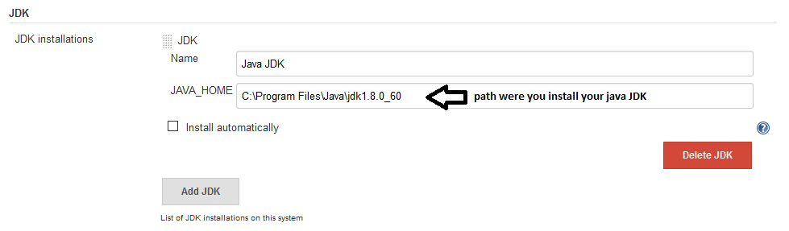

**Figure 1: JDK setting in Global Tool Configuration**

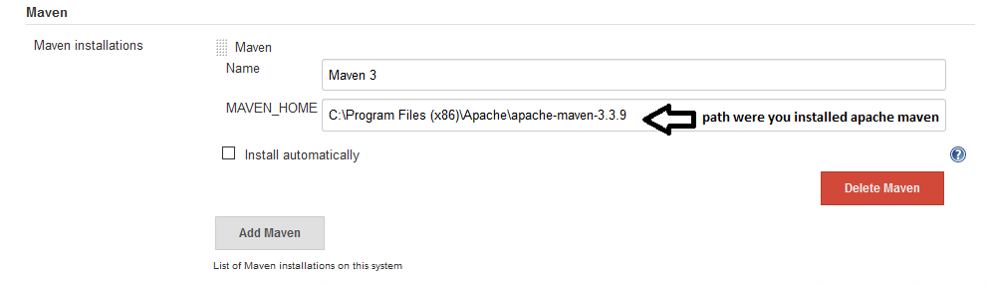

**Figure 2: Maven setting in Global Tool Configuration**

Besides that, we also have to include the maven path in the system path configuration so that we can execute the maven commands through CMD. The Jenkins maven project was configured has followed:

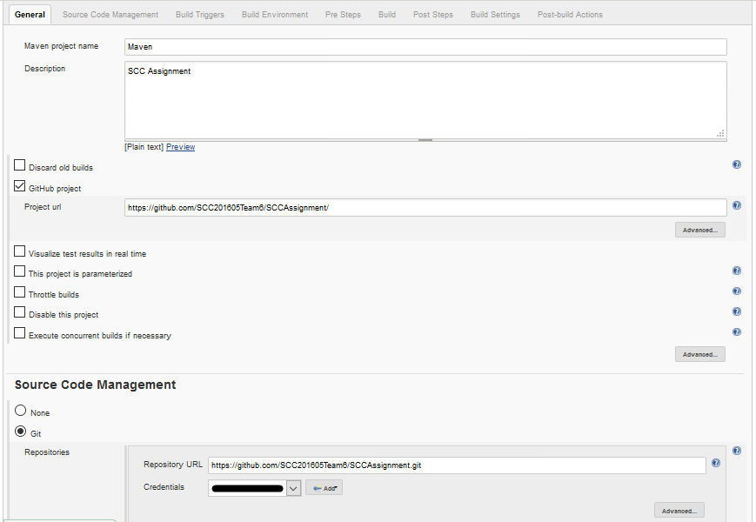

**Figure 3: Maven project configuration 1**

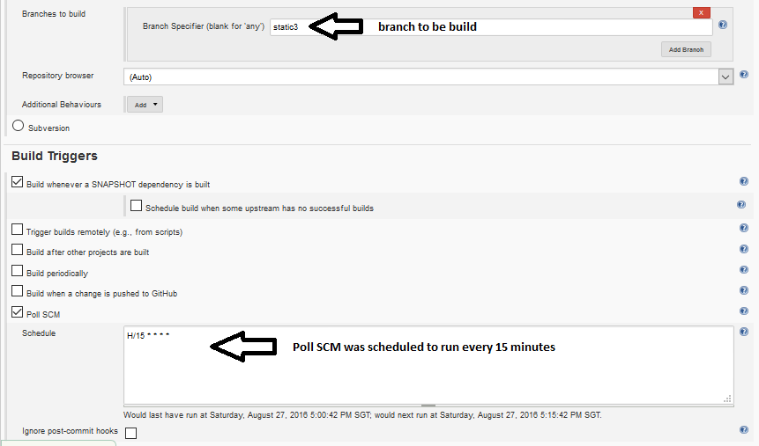

**Figure 4: Maven project configuration 2**

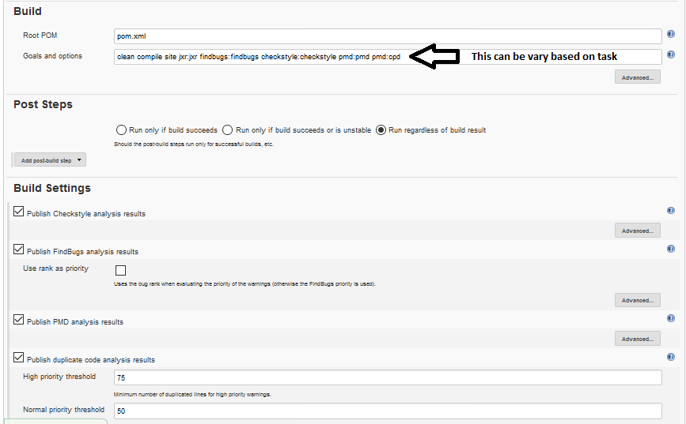

**Figure 5: Maven project configuration 3**

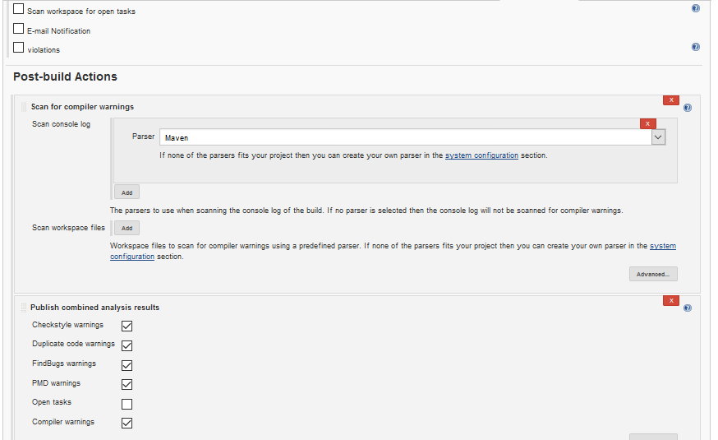

**Figure 6: Maven project configuration 4**

Moreover, the pom.xml files have to edit so that the file can use the intended plugins.

# Process of CI

The Jenkins server will check for the changes in respective branches that configured in Jenkin project every 15 minutes. If there are any changes pushed to the repository, Jenkins server will pull the repository and start to build. The build script will be varied for each member for specific tasks. For example, for static analysis, the build script that used was “clean compile site findbugs:findbugs jxr:jxr checkstyle:checkstyle pmd:pmd pmd:cpd”. This line will execute and run the plugins present in the project.

# Action of CI

The Jenkins will produce a detailed data of the build result. If the project is built successfully, the Jenkins will show green ball and all the result according to the build script will be formed meanwhile if the build is failed the Jenkins will display the red ball and additional detail about the error can be view from console out.

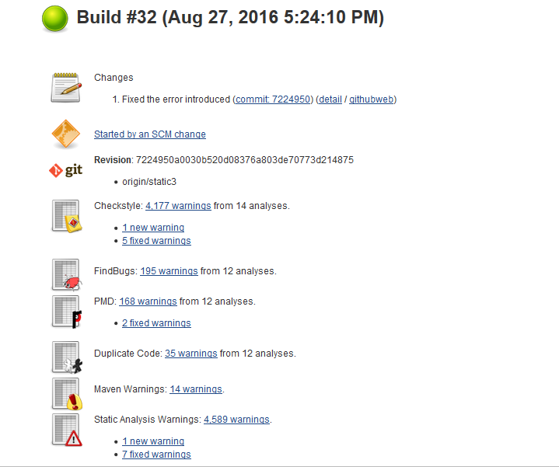

**Figure 7: Build Success**

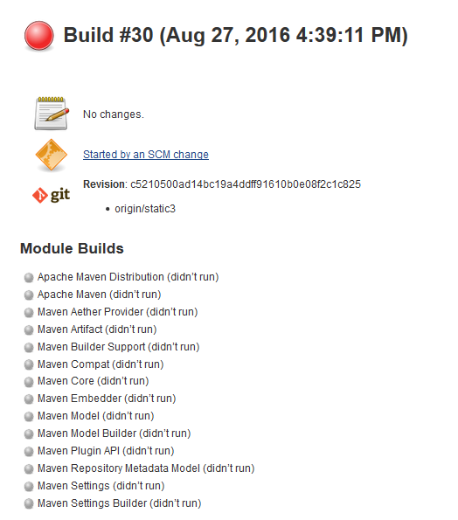

**Figure 8: Build Failed**

# Branch handling

Each new feature and bug is handled in new branch and the branch was tested using Jenkins for correctness before merging with master. If the Jenkins builds the branch successfully, a pull request will be sent. The project manager will check again for the correctness and approve the pull request if the branch did not produce any error on other files.

# Collaboration

Before we start to contribute the project, we fork the target project to our own group repository and we clone it to our own local machine. We create new branches to work on different versions of same repository at one time. Then, we make and commit changes by following our roles. We need to create a pull request by using different viewer on Github. The requested will make when we open the pull request. The pull request is then merge into the master branch and the topic branch will be deleted from the upstream repository.

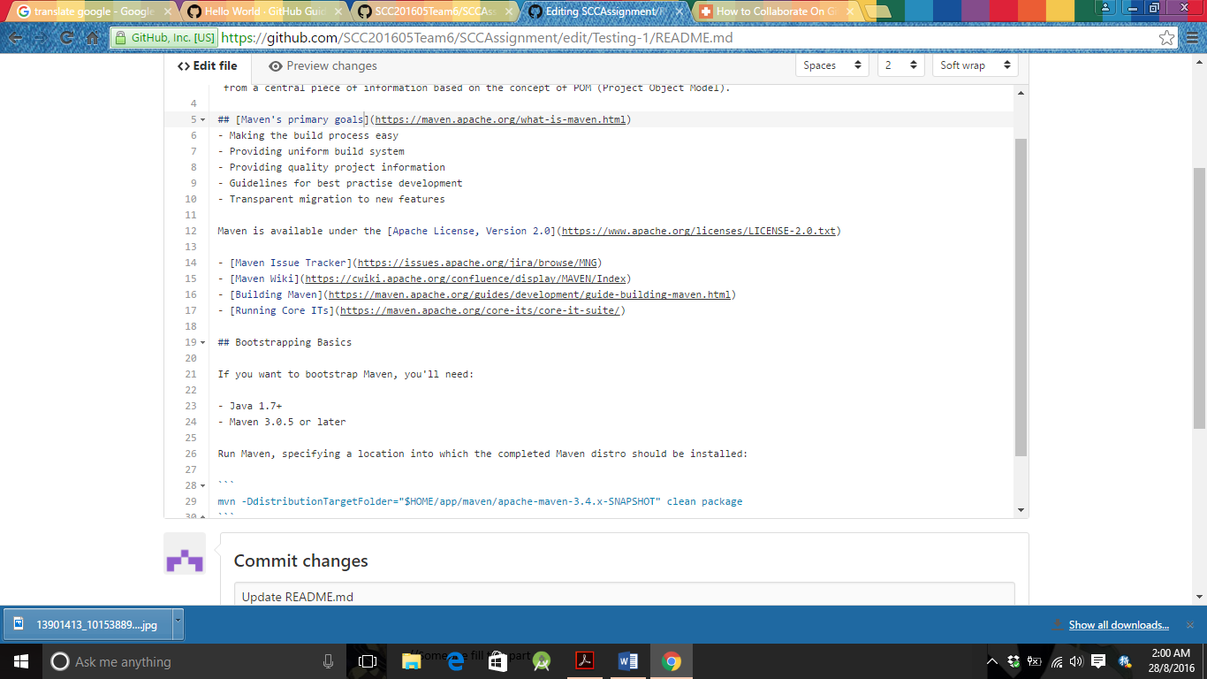

* The README.md files will change and commit in testing-1 branch, so its content is different from master branch.

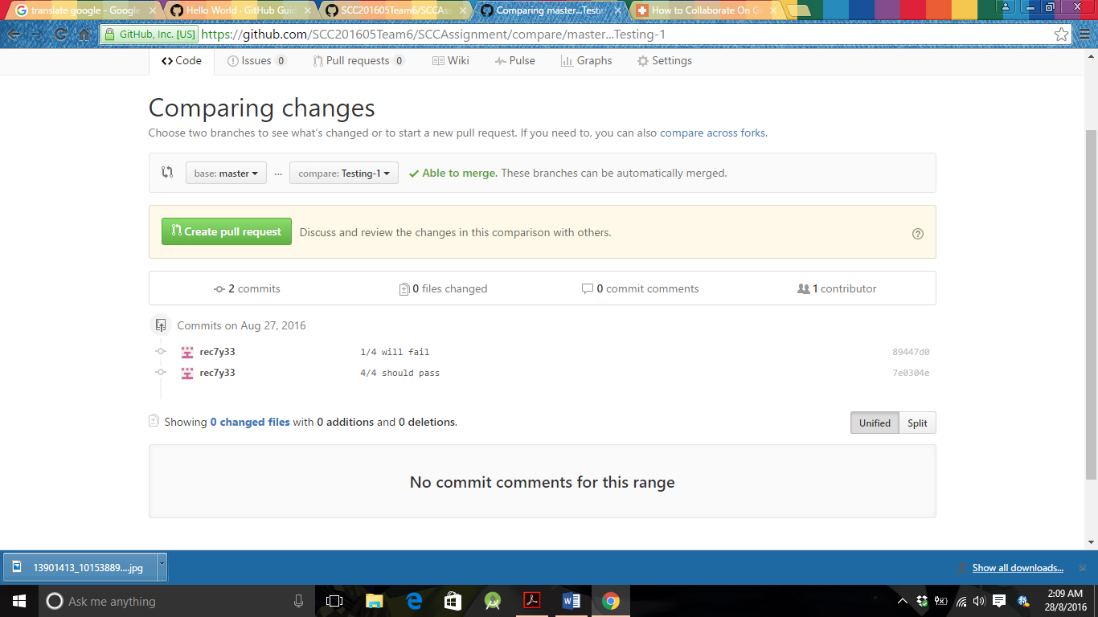

* Look over and compare the changes from master branch when the pull request is created.

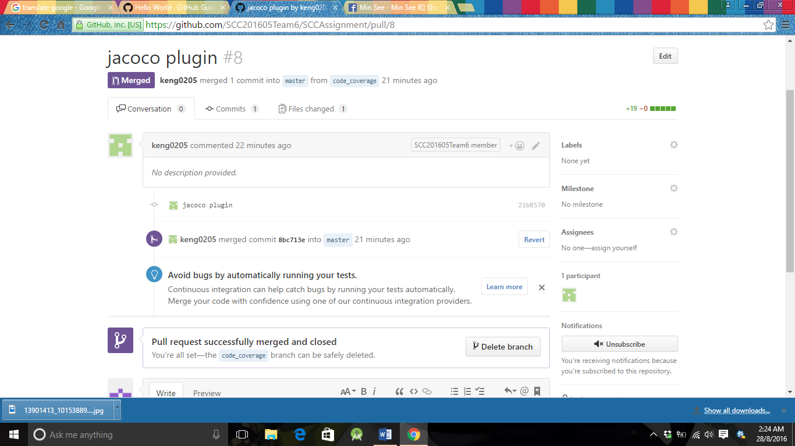

* The pull request has successfully merged into master from code_coverage branch.

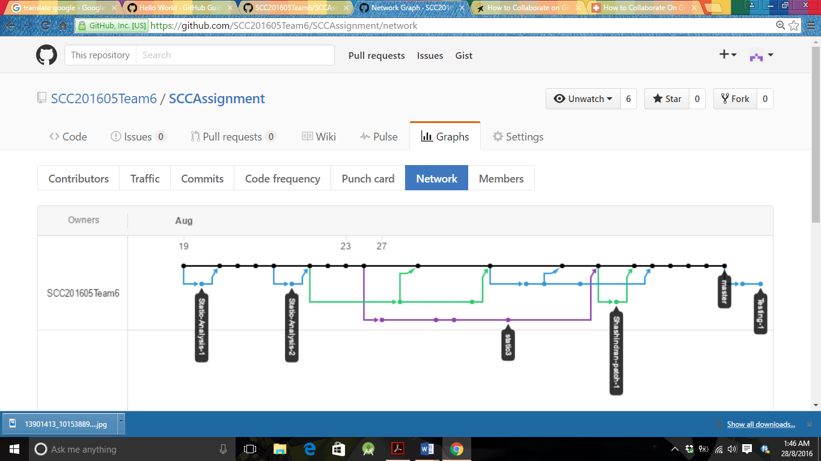

* The network graph shows the branch history of the branches of the root repository and branches of forks that contain commits unique to the network.

# CI server’s report

## Build History

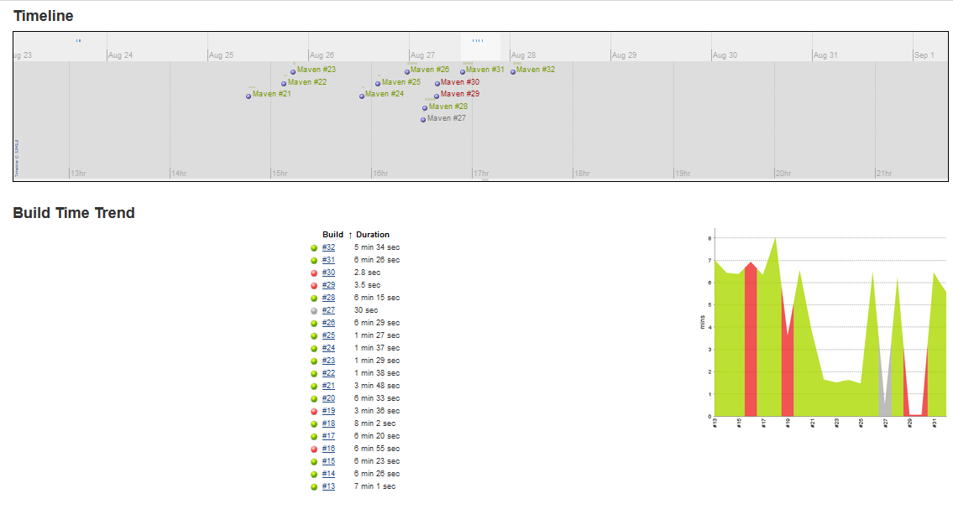

**Figure 9: Build History**

## Static Analysis

The static analysis was carried out using these plugins:

* Findbugs
* Pmd
* Checkstyle
* Dry
* Warning

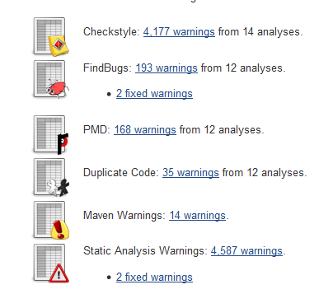

**Figure 10: Static Analysis Report for build**

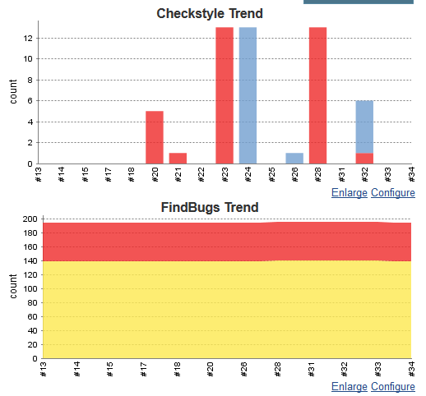

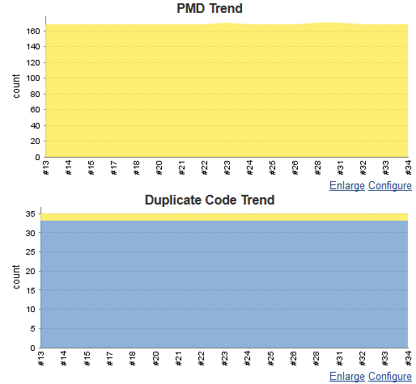

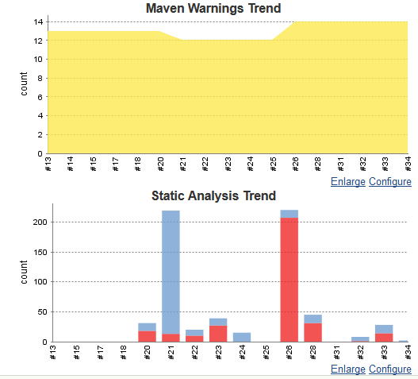

**Figure 11: Static Analysis Graph**