**INSILICO SYSTEMS BIOLOGY PRACTICALS**

**EXPERIMENT – 11**

**Aim** – To explore Database RHEA

**Theory-**

Rhea is an expert curated resource of biochemical reactions designed for the annotation of enzymes and genome-scale metabolic networks and models. Rhea uses the [ChEBI](http://www.ebi.ac.uk/chebi%22%20/t%20%22_blank) (Chemical Entities of Biological Interest) ontology of small molecules to precisely describe reactions of participants and their chemical structures. All reactions are balanced for mass and charge and are linked to source literature, metabolic resources and other functional vocabularies such as the enzyme classification of the NC-IUBMB.

An important goal of the Rhea project is to link the chemical information from ChEBI to that in resources describing enzymatic reactions, such as IntEnz (Integrated relational Enzyme database) that contains data on enzymes organized by EC numbers. ChEBI provides information on chemical compounds for the creation of chemical reactions in Rhea. The resulting Rhea reactions are used in IntEnz to describe the enzymes catalyzing the reactions. ENZYME is generated from IntEnz data and currently uses the textual representation reactions also used by the IUBMB EC list.

Rhea includes 4321 master reactions (each associated with three directional reactions) that involve 3788 distinct ChEBI chemical entities. Among them, 251 are transport reactions. In the corresponding IntEnz database (release 71) 3145 of the 4596 enzyme entries (EC numbers) have their reactions described in Rhea. This corresponds to a total of 3658 distinct Rhea reactions (as there may be a many-to-many relationship between reactions and enzymes).

All data in Rhea is freely accessible and available for anyone to use.

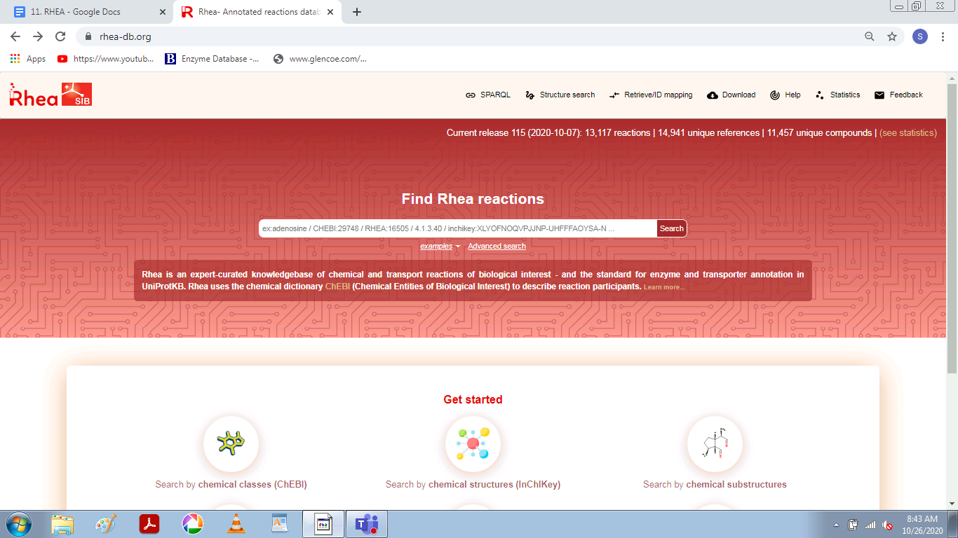

**PROCEDURE**

1. Enter the URL - <https://www.rhea-db.org/home>
2. In the search box, look for E. coli or any desired organism, reaction, metabolite etc.

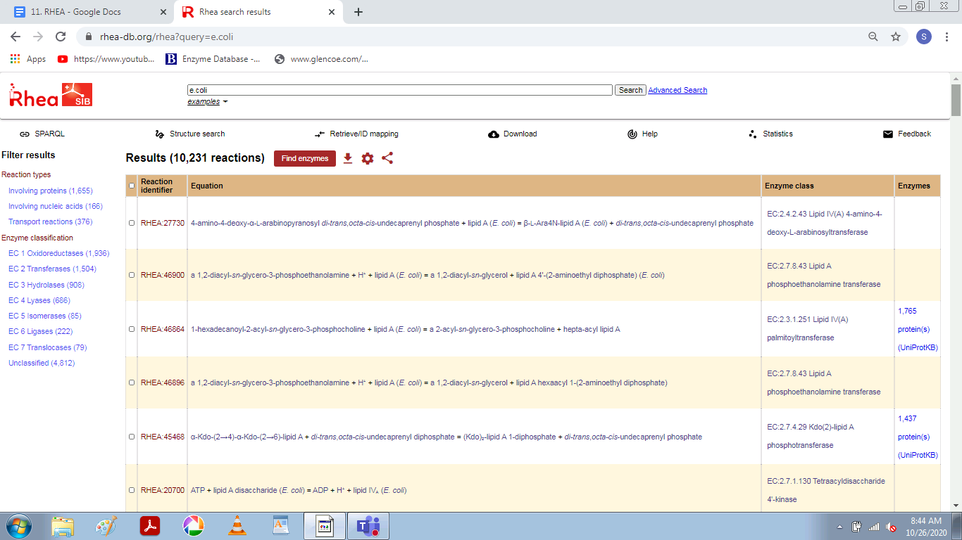

1. From this list, choose the respective hit in which you are interested and click on its accession id.

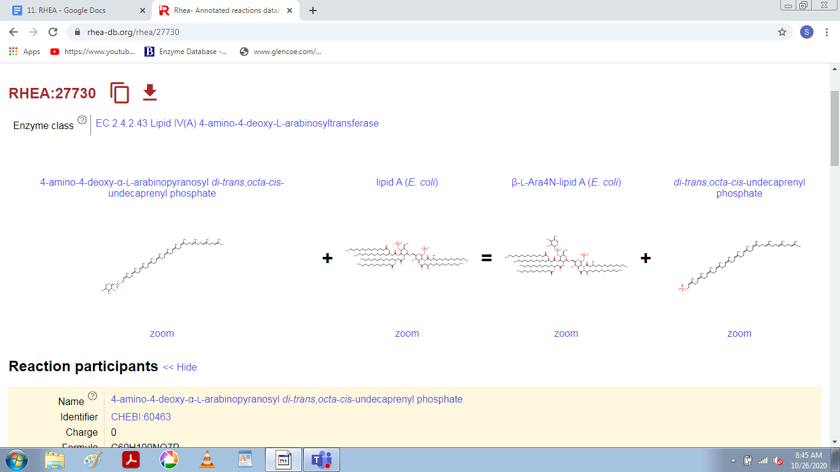

1. Other information like reaction relation and links to other resources can also be obtained.

