**INSILICO SYSTEMS BIOLOGY PRACTICALS**

**EXPERIMENT -12**

**Aim:** To explore ModelSEED Database.

**URL:** <http://modelseed.org/>

**Theory:** ModelSEED is a resource for the reconstruction, exploration, comparison, and analysis of metabolic models. The **ModelSEED** resource is based upon work supported by the U.S. Department of Energy, Office of Biological and Environmental Research; under contract DE-AC02-06CH11357 and by the National Science Foundation grant number MCB-1153357.

The **PlantSEED** resource was created with support by the National Science Foundation Grant IOS-1025398, by an endowment from the C. V. Griffin Sr. Foundation, and by the Office of Science, Office of Biological and Environmental Research, of the US Department of Energy (DOE) under Contract DE-ACO2-06CH11357, as part of the DOE Systems Biology Knowledgebase.

The National Science Foundation Grant IOS-1444202 has provided support for both the improvement of the PlantSEED resource and the production of new modeling tools within ModelSEED to be able to annotate plant genomes using the PlantSEED platform and develop plant metabolism models. This grant also supports the implementation of four PlantSEED metabolic modeling workshops to train faculty, post-doctoral fellows and graduate students of American universities (with an emphasis on recruitment of faculty from minority serving institutions) in the use of these novel computational tools.

Much of the data included in the ModelSEED is dervied from numerous published manuscripts and databases.

PROCEDURE –

1. Create an account on - rast.nmpdr.org , which takes approx 24 hrs to activate the modelseed account.

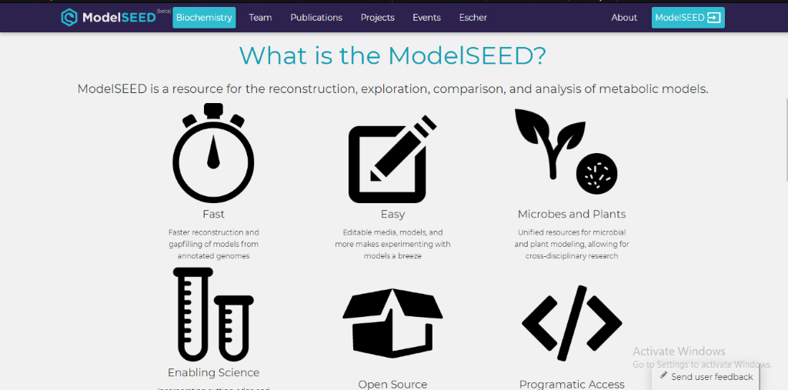

*Figure 1: Homepage of ModelSEED*

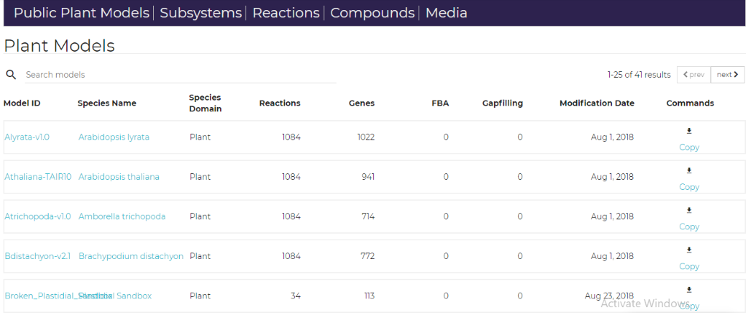

*Figure 2: Menu Bar on top with different components.*

1. Clicking on first model, i.e.  Alyrata-v1.0, in the given list, the following page shows up.

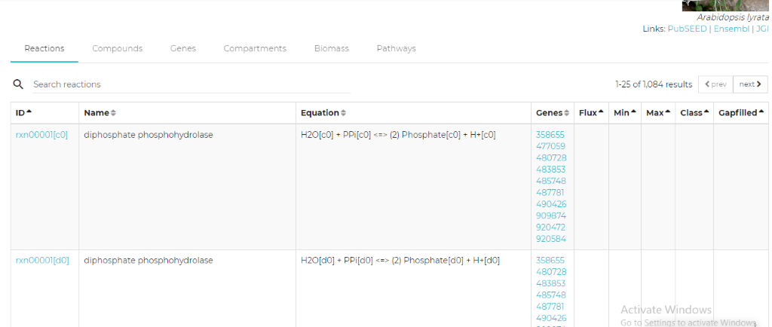

*Figure 3: Showing the reactions invovled in Arabidopsis lyrata plant*

1. Clicking on compounds tab from menu bar, opens up the below page:

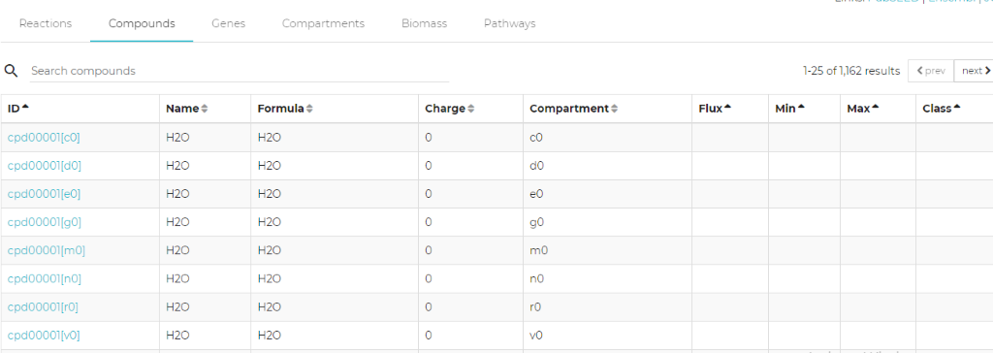

*Figure 4: List of Compounds present in the reactions and model*

1. Clicking on Genes tab from menu bar, opens up the below page:

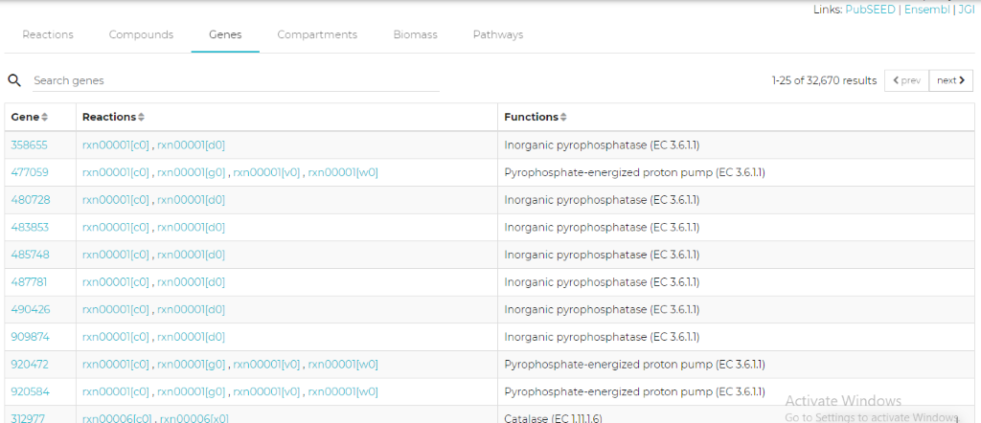

*Figure 5: Genes*

1. Clicking on Compartments tab from menu bar, opens up the below page:

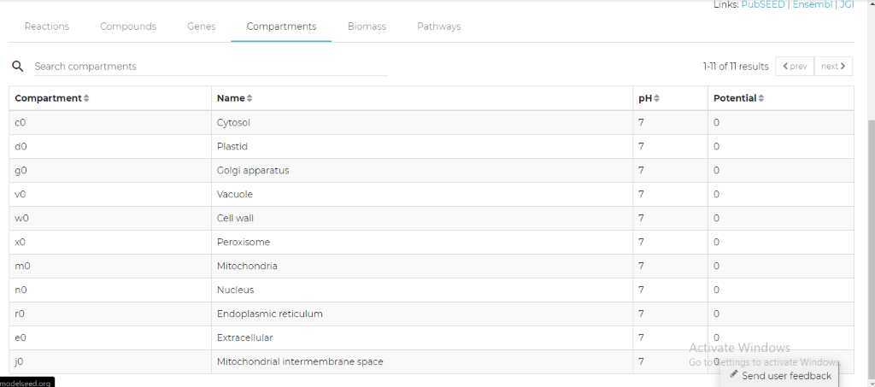

*Figure 6: Compartments of the plant cell*

1. The mass of each product is provided in the Biomass tab of the result and the Pathways in which these compounds involved are given in the pathways tab of the page.

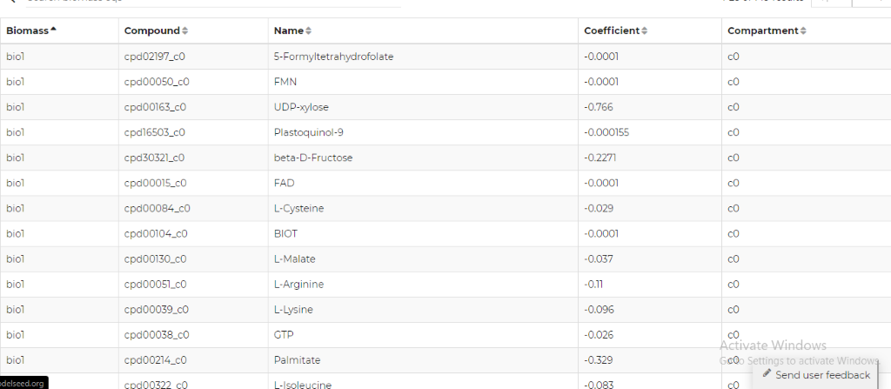

*Figure 7: BIOMASS*

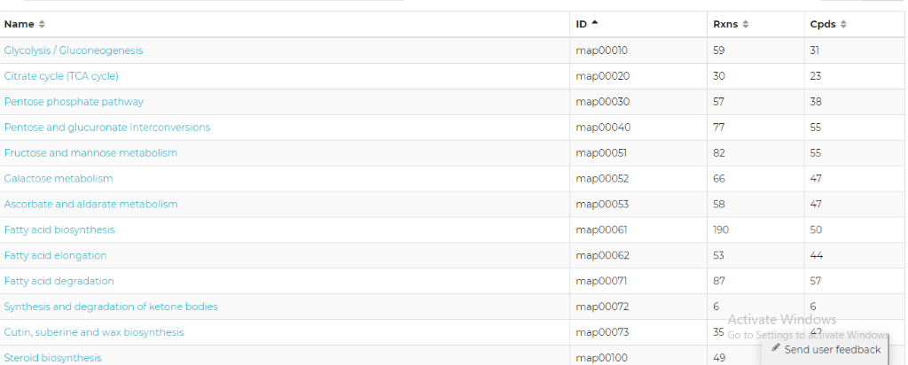

*Figure 8: Pathways*

* The user can build its own model in ModelSEED by adding the FASTA sequence of the plants or microbes.