**INSILICO SYSTEMS BIOLOGY PRACTICALS**

**EXPERIMENT – 16 (CellDesigner)**

**Aim:** To upload,import/export SBML file of MAPK pathway (from PANTHER database) and glycolysis (from BioModels database) in CellDesigner

**Tools used:** [**http://www.ebi.ac.uk/biomodels-main/**](http://www.ebi.ac.uk/biomodels-main/)

[**http://pantherdb.org/**](http://pantherdb.org/)

CellDesigner, [www.celldesigner.org](http://www.celldesigner.org/)(download the latest version 4.4)

**Theory**: CellDesigner is a structured diagram editor for drawing gene-regulatory and biochemical networks. CellDesigner can store all the model information and interaction informations inSBML file format. The model which has been created in the CellDesigner, will saved it in the complete SBML document.Synergistic integration characterizes systems biology of theory, computational modeling, and experiment. The aim in developing CellDesigner is to supply a process diagram editor with the standardized technology (SBML in this case) for every computing platform, so that it could confer benefits to as many users as possible. The main standardized features that CellDesigner supports could be summarized as “graphical notation”, “model description” and “application integration environment.” The standard for graphical notation plays an important role for efficient and accurate dissemination of knowledge and the standard for model description will enhance the portability of models between software tools.

**CellDesigner = SBML + SBGN + Simulation + Databases Connections**

One of our aims is to use CellDesigner as a simulation platform, and thus integration capability with native simulation library has been implemented. SBML ODE Solver could be invoked directly from CellDesigner, which enables us to run ODE-based simulations. The SBML ODE Solver Library (SOSlib) is a programming library for symbolic and numerical analysis of chemical reaction network models encoded in SBML.CellDesigner, a process diagram editor for gene-regulatory and biochemical networks based on standardized technologies and with wide transportability to other SBML-compliant applications and SBW-enabled modules.

The overriding advantage of CellDesigner is that it uses open and standard technologies. The models created by CellDesigner could be used on many other (over 100) SBML-compliant applications, and its graphical notation system will make the representation of models in a more efficient and accurate manner.

The advantages of CellDesigner over other pathway design tools could be summarized as follows:

* Based on standard technology (i.e., SBML compliant and SBW enabled);

* Supports clearly expressive and unambiguous graphical notation systems (SBGN),which is aimed at contributing to eventual standard formation;
* Runs on many platforms (e.g., Windows, MacOS X, Linux).

**Procedure:**

**A. To upload a model from database**

**Step 1: Open CellDesigner :**

Click on CellDesigner icon from your desktop or go to programs and select the CellDesigner on a windows machine.

**Step 2: Select the file from the list of databases :**

Go to CellDesigner Database menu and click on open. It is easy to open the SBML file which has been saved in these databases. Upload the models from these databases by selecting it.

**Another way to import a model**

**Step 3: Select the file to be open :**

Select the SBML file which has to be open.

**Step 3: Visualizing and exploring the SBML model using CellDesigner :**

Click on the file which has to be open using CellDesigner and write down the important observations with screenshots.

**Interface of Cell Designer:**

* Drag the borders (left or right) of the Draw Area to change the area size.
* **Zoom**

You can change the zoom view of the model by clicking the following icons.

**Selecting a Component**

* A component is a general term for a Species (including a Complex), a Reaction, or a Compartment. Thus, any shape you see on the Draw Area ---a rectangle, an oval, or a line segment--- is a component.

* A Compartment is a container for other components and can also hold other Compartments in it. A Compartment represents a generic bounded container, such as a cell or an intracellular compartment. The change in its size and shape only affects its appearance on canvas, and has no effect on semantics of biochemical and gene networks.

**Species and Reactions:** A Species represents, for example, a protein or some othermolecule in a biochemical network, or a gene in a gene regulatory network. A Reaction represents a state transition of the connected Species such as a biochemical reaction, an interaction between proteins, and a regulatory relation between genes.

**Close a Model: To close a file without saving any changes.**

Select File – Close.

**Macros**

To draw the diagram easier, some of the most frequently used components sets are available as “macros”. You can select the macros from the tool bar to draw the following components set.

**To change the default settings of the color and shape**

**To change the layout of your working model**

On the Layout menu, select one of the layout types

* **Orthogonal Layout**

* **Organic Layout**

* **Smart Organic Layout**

* **Hierarchic Layout**

* **Incremental Hierarchic Layout**

* **Circular Layout**

* **Tree Layout**

* **Edge Router**

**Orthogonal Layout:**

**Procedure to import MAPKinase pathway in cell designer:**

1. Import model from panther database.

Go to Database tab and select “Import model from pantherdb.org

**2.** Type MAPK in the white skinny search box. Select p38 MAPK pathway and click on ‘IMPORT’ button.

**Results**:

Click on Compartments in the tree area. Two compartments are displaying i.e. cytoplasm and nucleus. Click on cytoplasm, all the components in the model within the cytoplasm gets highlighted and similarly when click on nucleus.

**LAYOUT NOTE:**

**1.Species:** All the components present in the model is annotated in the species table. It annotates class(protein/rna/dna/complex), ID no, name, species type, compartment (c1/c2), position (transmembrane/inside/inner surface) quantity, initial quantity, substance units, has only substance units, b.c., constants. A screenshot of a social media post

We can export this table by just clicking on “EXPORT” button.

**2.Click on Proteins tab:** It provides what type of proteins present in the model (receptor/generic) along with the name and ID of the proteins.

**3.Click on Reactions tab:** All the reactions within the model is annotated in the reaction table. The table contains type of the reaction, ID no, name, reversible(F/T), fast(F/T), reactants, products, modifiers, and math.

**4.Click on Unit Definitions:** It contains ID(substance/volume/area/length/time), name and corresponding unit of given IDs. 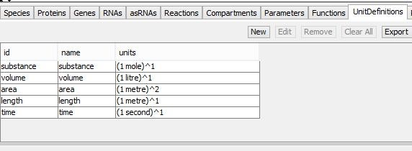

**5.Export Image:** Go to FILE menu and click on ‘EXPORT IMAGE’ and select file type (JPEG/PNG).

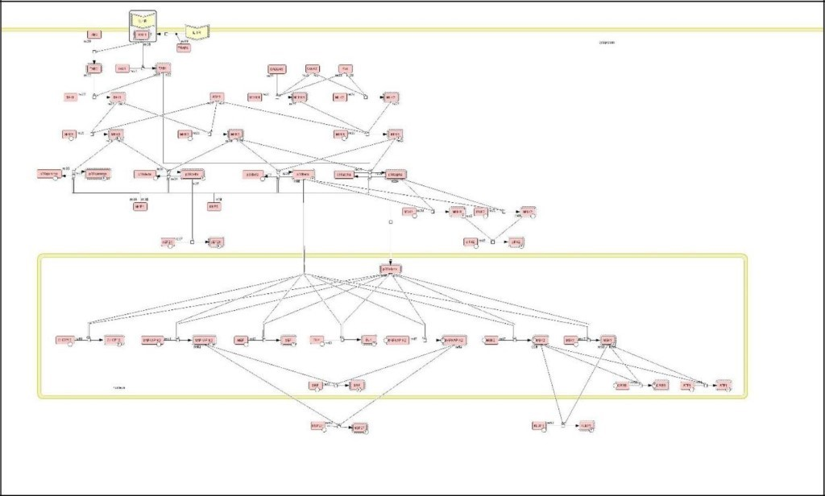

**Part 2**

**Theory:** Reaction kinetics is the study of how fast chemical reactions take place, what factors influence the rate of reaction and what mechanisms are responsible. Many variables can affect the reaction rate including temperature, pressure, and composition. A chemical

reaction is usually depicted in the form of a chemical equation which describes the

transformation of one or more reactants into one or more products. The reactants appear on

the left of the equation and the products on the right.

The rate of reaction, v, is often found to be proportional to the concentration of species A, or:

v = kA

This property is often called the law of mass-action and the corresponding kinetics called

mass-action kinetics. The proportionality constant, k, is called the rate constant.

**Procedure:**

**1. Assigning Reaction ID**

1.1 To show Reaction ID on Draw Area

On the View menu, select Show Reaction ID

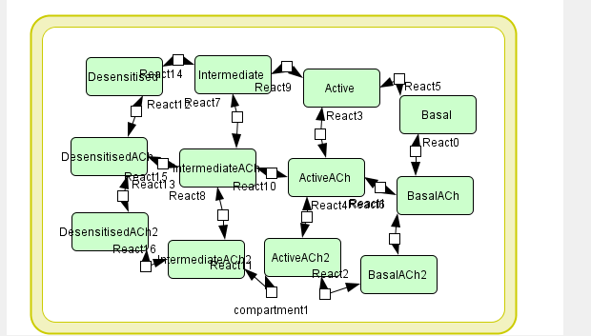

**2. Editing a reaction**

2.1 Right click on a Reaction.

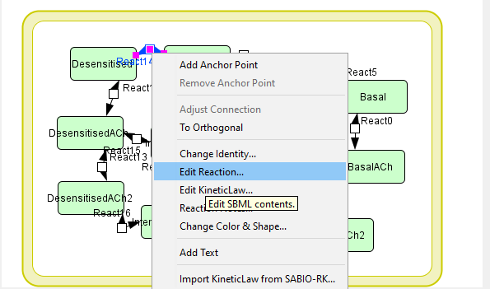

2.2 Select a menu item from the right-click context menu.

2.3 Select a menu item depending on which value you want to edit.

2.4 Selecting Change Identity will show you Change properties of the reaction dialog.

2.5Selecting Edit Reaction will show you Reaction dialog.

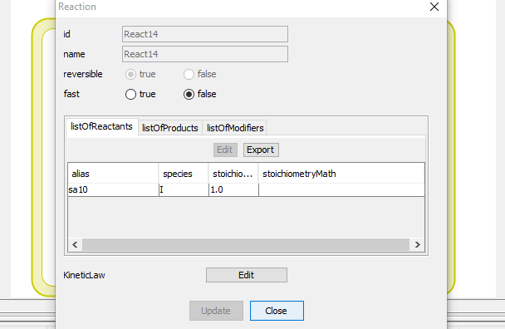

**3. Reactions List**

You can view all the data concerning a Reaction in the Reactions tab in the List Area. This is

useful when you want to check all the Reactions specified in the model.

You can swap columns by drag-and-drop.

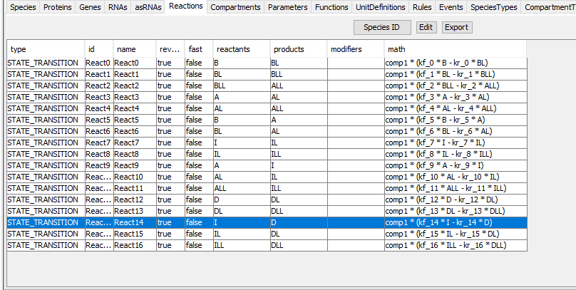

You can export the contents of the list into .CSV file format by clicking Export button on the top

of the list.

**4. Assigning Kinetic Law**

You can specify a Kinetic Law to a Reaction using the Kinetic Law dialog. You can input your

own math functions, or you can use the predefined functions from the Kinetic Law dialog.

4.1. To add a Kinetic Law to a Reaction

4.2. In the List Area, click on the Species tab.

4.3 Select the row for the Protein A.

4.4 Double click on the cell under InitialQuantity column.

4.5 Set the value to “0.1”.

4.6 In the List Area, click on the Reactions tab and double click on the STATE_TRANSITION Reaction to open the Reaction dialog.

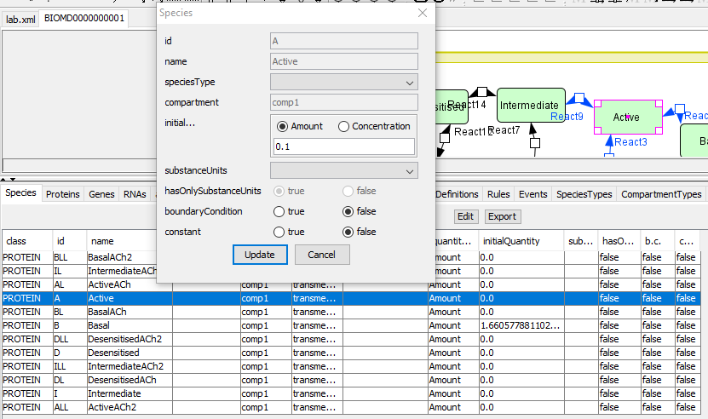

**5. Click KineticLaw Create button**

Instead of doing the steps 5 and 6, you can also click on the Reaction with the right

mouse button, and then select **Edit KineticLaw...** menu.

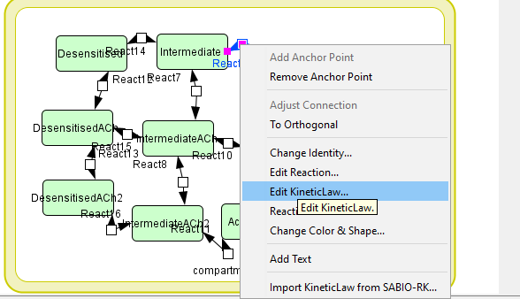

6. The KineticLaw dialog will open.

7. In the Predefined Functions pane, click Mass_Action_Kinetics.

8. The Formula dialog will be displayed.

9. Enter “0.3” in the k text box, then click OK.

10. See that “s1*k1” has been entered in math field, then click Update, then Close.

11. In the Reaction dialog, click Close.

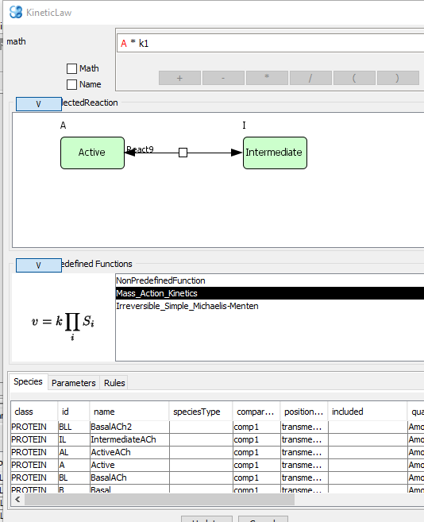

**The Kinetic Law for the Reaction was successfully set.**

**Now you can run the simulation.**

**Part 3**

**Aim:** To create a basic model in CellDesigner

**Software:** CellDesigner version 4.4

**Theory:** CellDesigner can store all the model information and interaction informations in SBML file format. The model which has been created in the CellDesigner, will saved it in the complete SBML document. Synergistic integration characterizes systems biology of theory, computational modeling, and experiment. The aim in developing CellDesigner is to supply a process diagram editor with the standardized technology (SBML in this case) for every computing platform, so that it could confer benefits to as many users as possible. The main standardized features that CellDesigner supports could be summarized as “graphical notation”, “model description”, and “application integration environment.” The standard for graphical notation plays an important role for efficient and accurate dissemination of knowledge and the standard for model description will enhance the portability of models between software tools.

**Steps:**

1. Open CellDesigner

2. Click on the CellDesigner icon from your desktop.

3. Create a new model

In the menu, choose [File] => [New].

1. A window opens. Name the file: test.

5. Set the dimensions. By default, the dimensions are set to 600 x 400.

6. Click [OK].

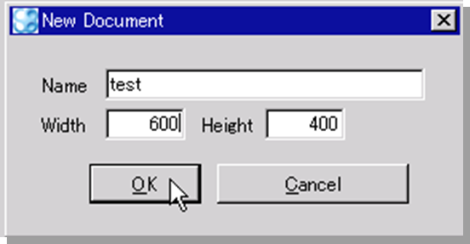

1. Create a reaction
2. Add two proteins: A and B.
3. Click in the "Species" menu bar on the protein shape.



A window pops up.

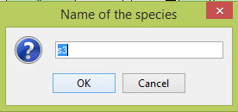

1. Name the protein A.
2. Repeat the process and name the second protein B.
3. Click in the "Reaction" menu bar on state transition.
4. Go back to the drawing frame and click on protein A.
5. Several grey squares appear around the protein, choose one of them from which the arrow will start.
6. Click on protein B and choose a grey square on which you want the arrow to point.
7. Click Add anchor point

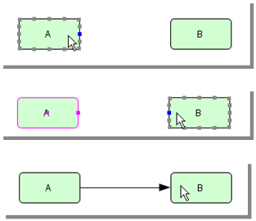

A line links two species. The anchor points are the points from which each segment of a line starts or ends. That way, more freedom is given to the user to place the species where the user wants.

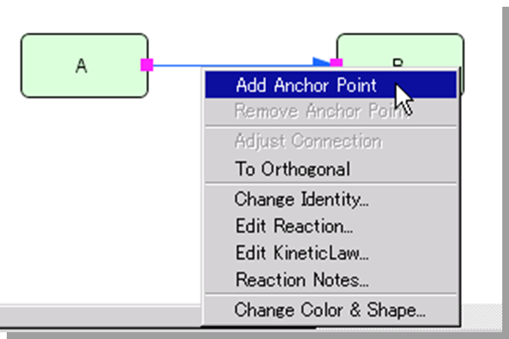

1. Click right on the line where you want to add the anchor point.
2. Choose [Add Anchor Point].
3. Repeat the process as many times as needed.

**Note:** if you choose [To Orthogonal] as opposed to [To Polyline], the segments will automatically be arranged according to the orthogonal grid. However, the anchor points can only be added when the mode is Polyline.

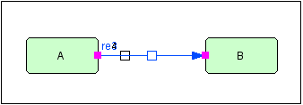

1. Add catalysis reaction
2. Add protein C.
3. Click on "Catalysis" in the "Reactions" menu bar.

23.Select protein C on the square of the transition reaction that links A to B.

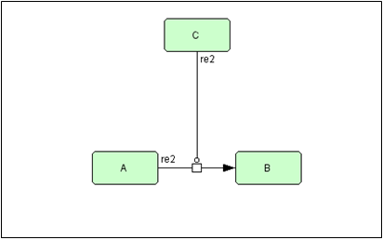

24. Set active state

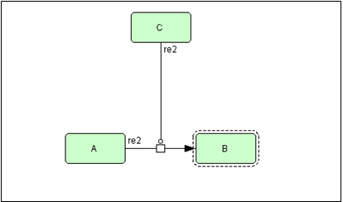

24.1 Select protein B.

24.2 From the menu [Components], select the option [Set Active].

1. Change color

25.1 Right-click on protein C.

25.2 Select [Change Color & Shape]

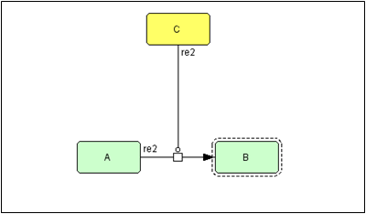

26. Insert compartment

26.1 Click on the "Compartment" icon in the drawing menu bar.

26.2 Drag the mouse cursor to specify the area of the compartment around our small network.

26.3 Name the compartment: Cell.

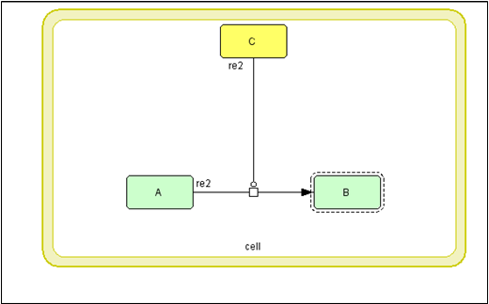

27. Add residue

27.1 Create new model.

27.2 Name it: test2.

28. Create protein A

28.1 Select protein A in [Proteins] Tab

28.2 Click [Edit] button

(or right-click on the protein and choose [Edit Protein])

28.3 Click on the [add..] button in the [Protein] dialog

28.4 Name the residue (tst1).

28.5 Click on the [Close] button. Click on the [Update] button.

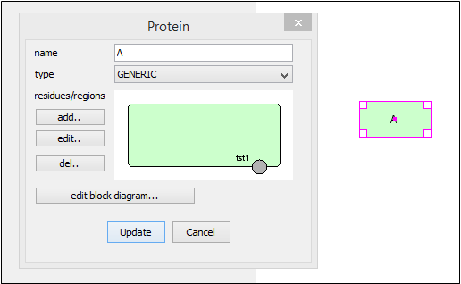

**29. Making a Residue network**

29.1 Copy & Paste protein “A” and then draw the “State Transition” arrow from “A” to “A”.

29.2 Right-click on “A” (right side) and select [Change Identity...].

(or double-click on the protein).

29.3 Click on the residue “tst1” in the Dialog window.

29.4 Select [phosphorylated] to modify the state of the residue.

**29.5 Click on the [Apply] button.**

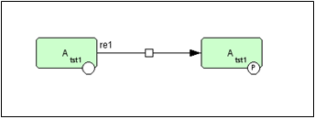

**30. Changing position of the residue**

30.1 Select protein “A” in [Proteins] Tab (lower panel).

30.2 Click [Edit] (you need to click on the protein in the list to be able to edit it).

30.3 Click on residue “tst1” in Dialog.

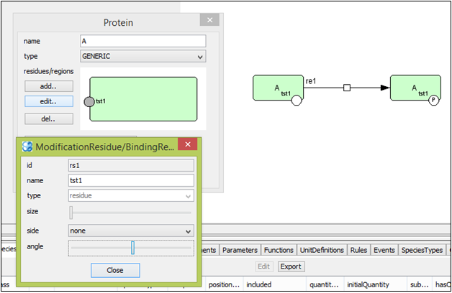

30.4 Click [edit...].

30.5 Drag [angle] slidebar (or you can also click on the residue, hold the mouse and drag the residue where you want)

30.6 Update the changes.

**31. Creating complexes**

31.1 Create new model (test3).

31.2 Create Proteins “A” and “B”.

31.3 Copy and Paste both “A” and “B”.

31.4 Click on the [Complex] icon and create complex “C”.

31.5 Drag Proteins “A” and “B” into complex C.

31.6 Draw “Association” arrow.

(you can also use the macro to create a complex).

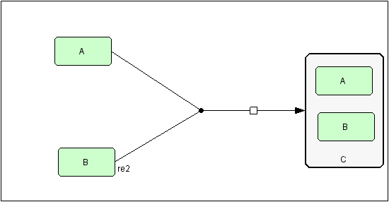

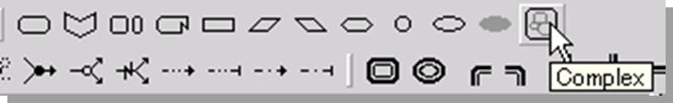

**32. Including genes and RNAs**

32.1 Create new model (test4)

32.2 Create gene, RNA and Protein

32.3 Draw “Transcription” and “Translation”

