**INSILICO SYSTEMS BIOLOGY PRACTICALS**

**EXPERIMENT-17**

**Aim: Building and simulating models using COPASI.**

**Theory:**

* **COPASI**(Complex Pathway Simulator) is an open-source software application for creating and solving mathematical models of biological processes such as metabolic networks, cell-signaling pathways, regulatory networks, infectious diseases, and many others.
* History- COPASI is based on the Gepasi simulation software that was developed in the early 1990s by [Pedro Mendes](https://en.wikipedia.org/wiki/Pedro_Pedrosa_Mendes). The initial development of COPASI was funded by the [Virginia Bioinformatics Institute](https://en.wikipedia.org/wiki/Virginia_Bioinformatics_Institute), and the [Klaus Tschira Foundation](https://en.wikipedia.org/wiki/Klaus_Tschira_Foundation).
* Features- COPASI includes features to define models of biological processes, simulate and analyze these models, generate analysis reports, and import/export models in [SBML format](https://en.wikipedia.org/wiki/SBML).
* **Model definition**: Models are defined as [chemical reactions](https://en.wikipedia.org/wiki/Chemical_reactions) between molecular species. The dynamics of the model is determined by [Rate law](https://en.wikipedia.org/wiki/Rate_law) associated with individual reactions. Models can also include compartments, events, and other global variables that can help specify the dynamics of the system.
* **Tasks**: Tasks are different types of analysis that can be performed on a model. They include [steady-state analysis](https://en.wikipedia.org/wiki/Steady_state_(chemistry)), [stoichiometric analysis](https://en.wikipedia.org/wiki/Stochiometry), time course simulation using deterministic and stochastic simulation algorithms, [metabolic control analysis](https://en.wikipedia.org/wiki/Metabolic_control_analysis), computation of [Lyapunov exponent](https://en.wikipedia.org/wiki/Lyapunov_exponent), time scale separation, parameter scans, optimization, and parameter estimation.
* **Importing and Exporting**: COPASI can read models in [SBML](https://en.wikipedia.org/wiki/SBML) format as well as in Gepasi format. COPASI can write models in several different formats including the [SBML](https://en.wikipedia.org/wiki/SBML), source code in the [C](https://en.wikipedia.org/wiki/C_(programming_language)) programming language, [Berkeley Madonna](https://en.wikipedia.org/wiki/Berkeley_Madonna) files, and [XPPAUT](http://www.math.pitt.edu/~bard/xpp/xpp.html) files.
* COPASI is software used for the creation, modification, simulation and computational analysis of kinetic models in various fields.
* It is open-source, available for all major platforms and provides a user-friendly graphical user interface, but is also controllable via the command line and scripting languages. These are likely reasons for its wide acceptance.

**BIOMODELS:** BioModels is a repository of mathematical models of biological and biomedical systems. It hosts a vast selection of existing literature-based physiologically and pharmaceutically relevant mechanistic models in standard formats.

**Model:** The mitogen Activated Protein Kinase cascade is a prototypic example of behavior emerging from a system.

* Mitogen activated protein kinase (MAPK) cascades are ubiquitous and highly conserved signaling modules, found in almost all eukaryotes. MAPK cascades are involved in many cellular processes such as cell proliferation, differentiation, movement, survival etc.
* The response of a MAP kinase to an upstream signal is shaped by the whole cascade of successive phosphorylation.
* The prediction that such a cascade would engender ultra sensitivity is one of the great successes of mathematical modeling in biochemistry, made in 1981 by Albert Goldbeter and Daniel Koshland, a decade before the discovery of MAP kinase cascades.

**MAPK Cascade – Ultra sensitivity: BIOMD0000000009- Hung1996**

* Huang CY, Ferrell JE Jr. Ultra sensitivity in the mitogen activated protein kinase cascade. This was the first detailed model of MAPK signaling showing the effect of cascading phosphorylation steps on MAPK signaling.
* This model demonstrates that the cascade arrangement has unexpected consequences for the dynamics of the MAPK signaling
* All intermediate complexes for modeled explicitly with reactions using mass action kinetics. Parameters and concentrations estimated from experimental results. The rate equation of the cascade was solved numerically.

**PROCEDURE:**

a) Time course simulation

1. Download a model using the format SBML from the BioModels repository of EMBL (BIOMD0000000009).

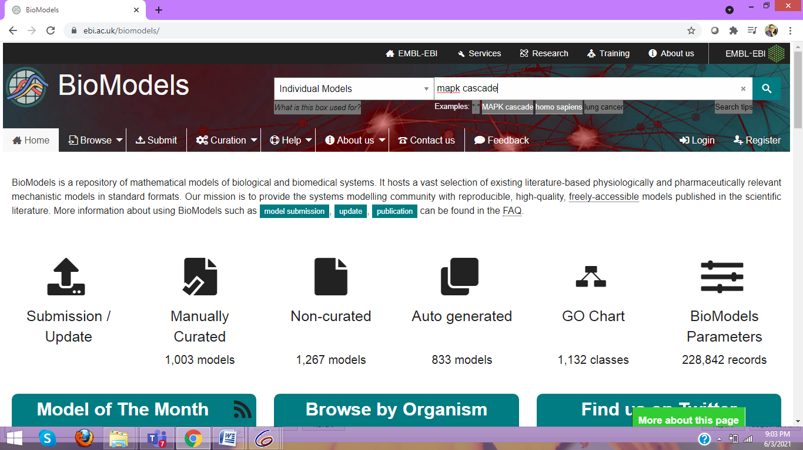

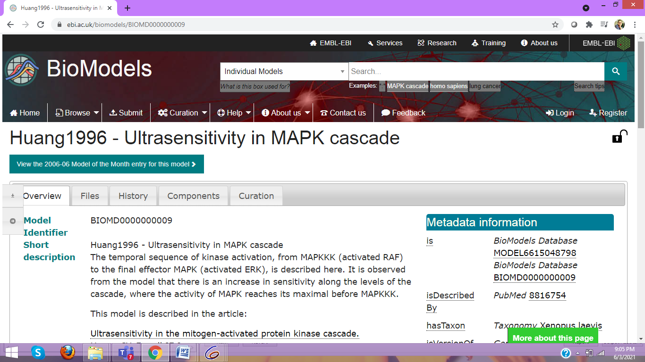

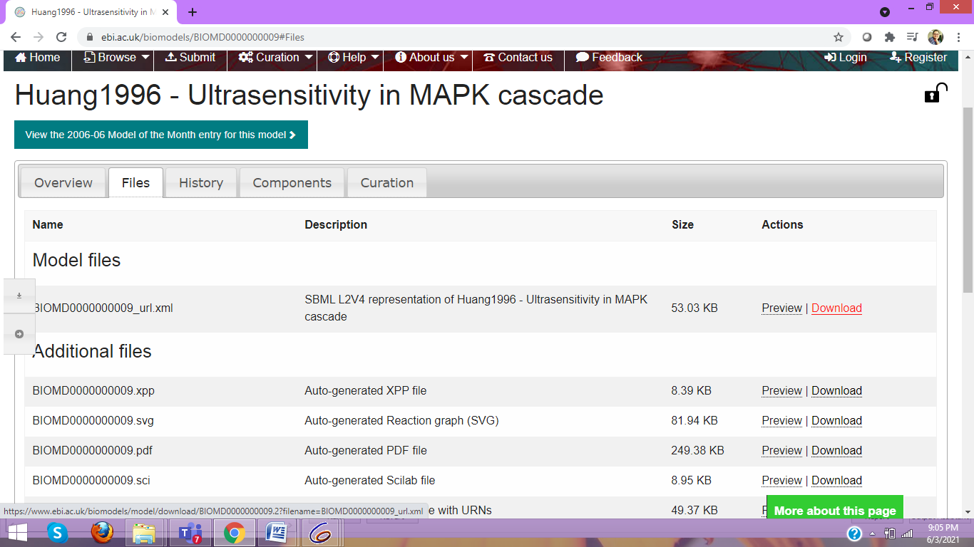

2. Import a biomodel in the SBML format (BIOMD0000000009).

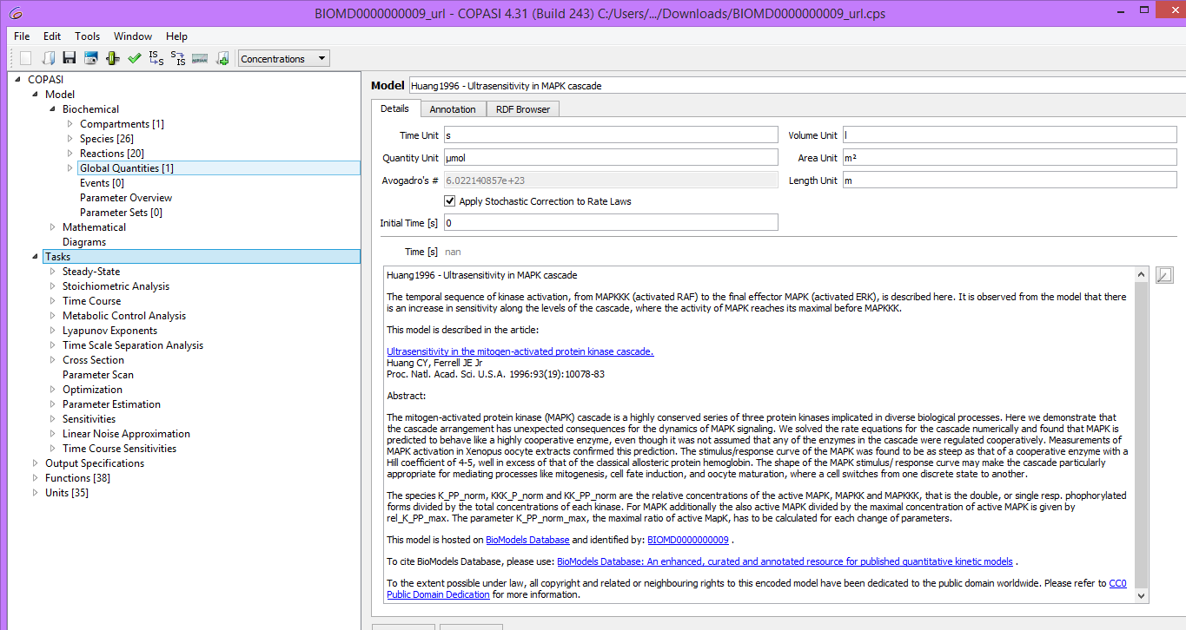

3. Explore the model and try to understand what happens in each reaction

4. Look at the “Annotation” tab of “Model”, a selected “Species” and a “Reaction”.

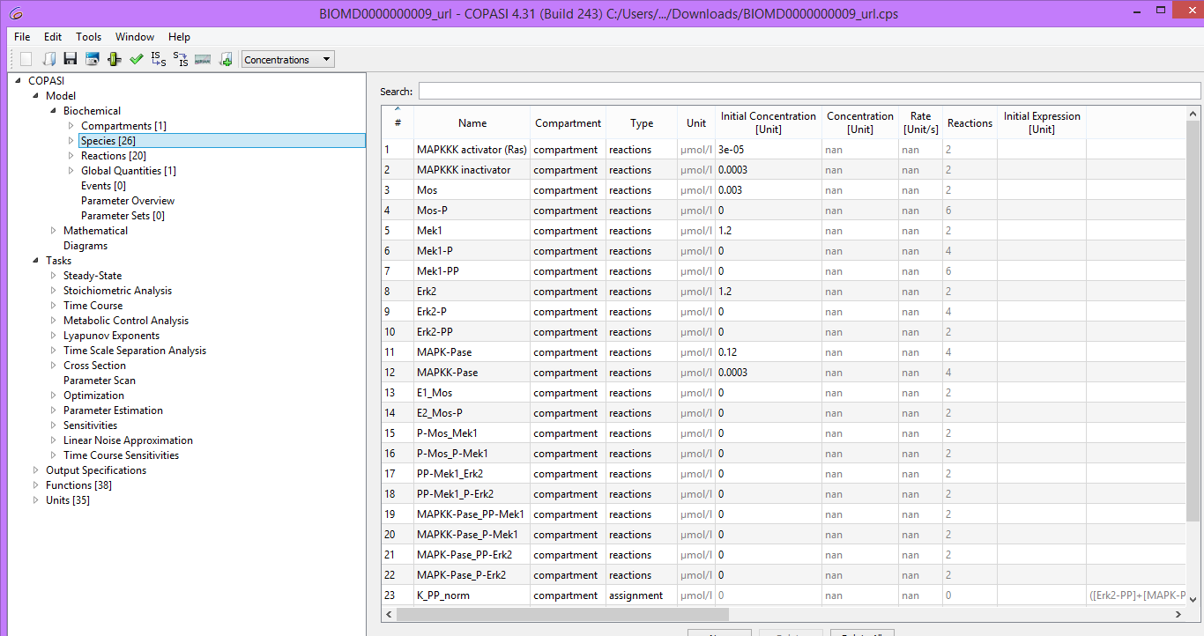

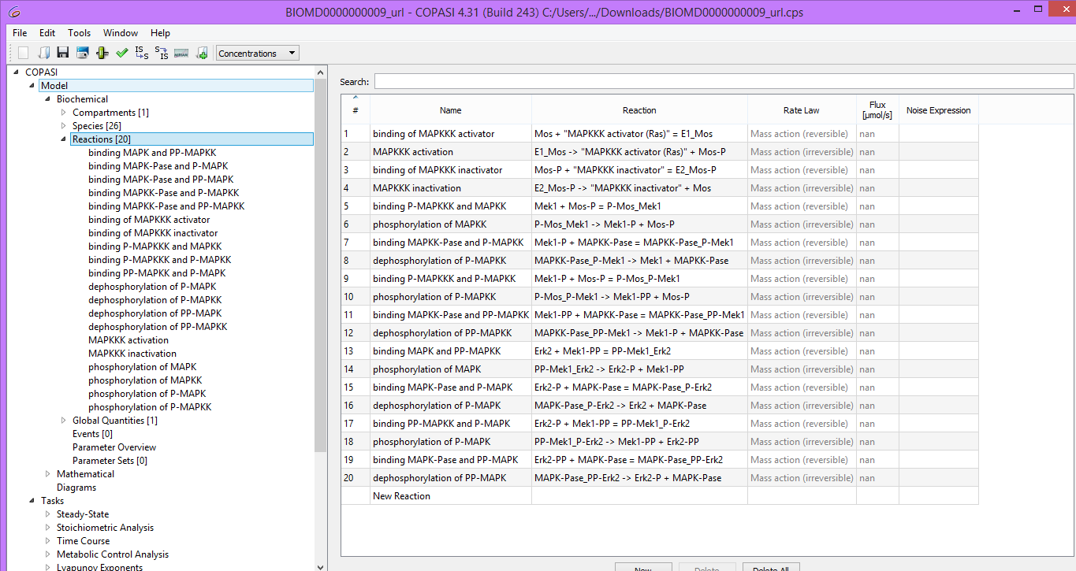

5. A Time Course (from Tasks dropdown menu on the left hand side select time course) is prepared whose duration = 100 seconds, interval size = 0.1 seconds, method = Deterministic (LSODA).

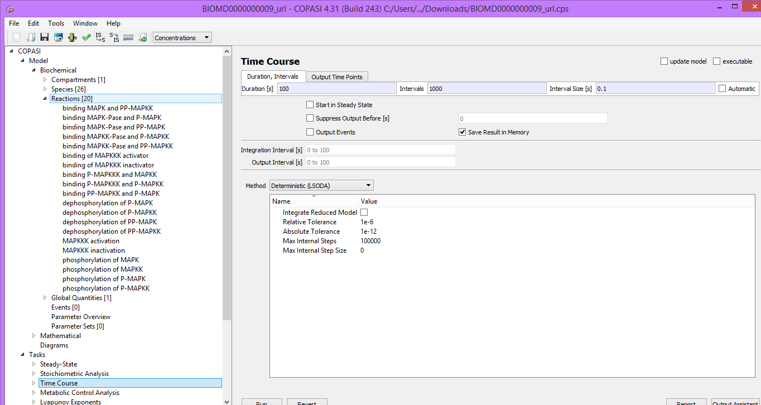

6. Using the Output Assistant a time course of “concentrations, volumes and global quantities “is created and then run.

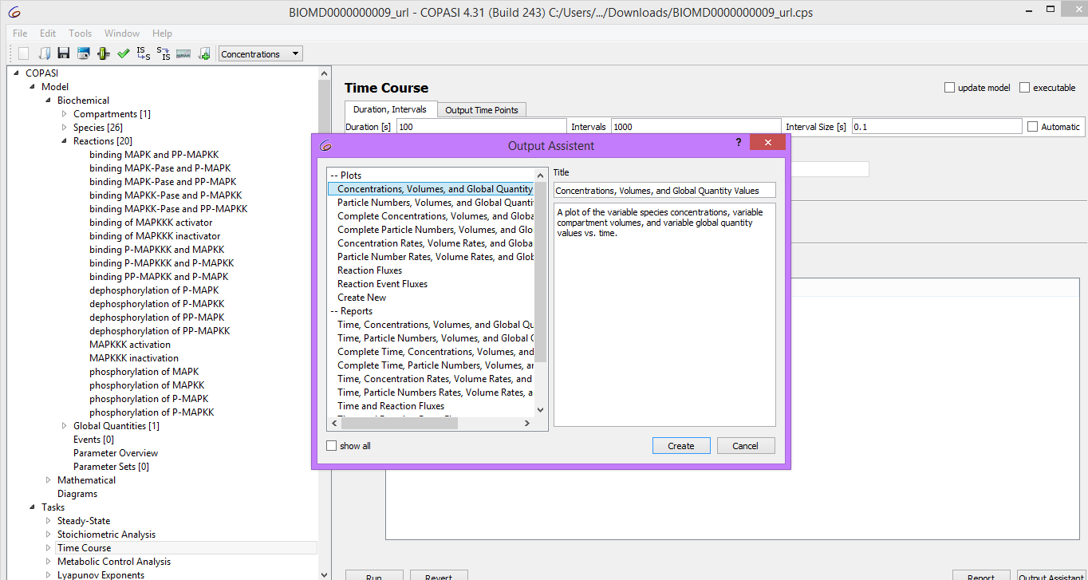

7. All of the curves except for the normalized active forms of MAPK,

(“K_PP_norm”), MAPKK (“KK_PP_norm”) and MAPKKK (“KKK_P_norm”) are hidden.

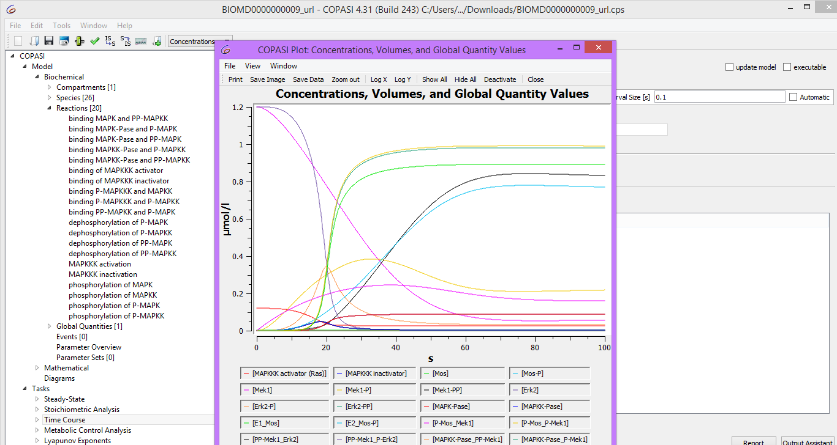

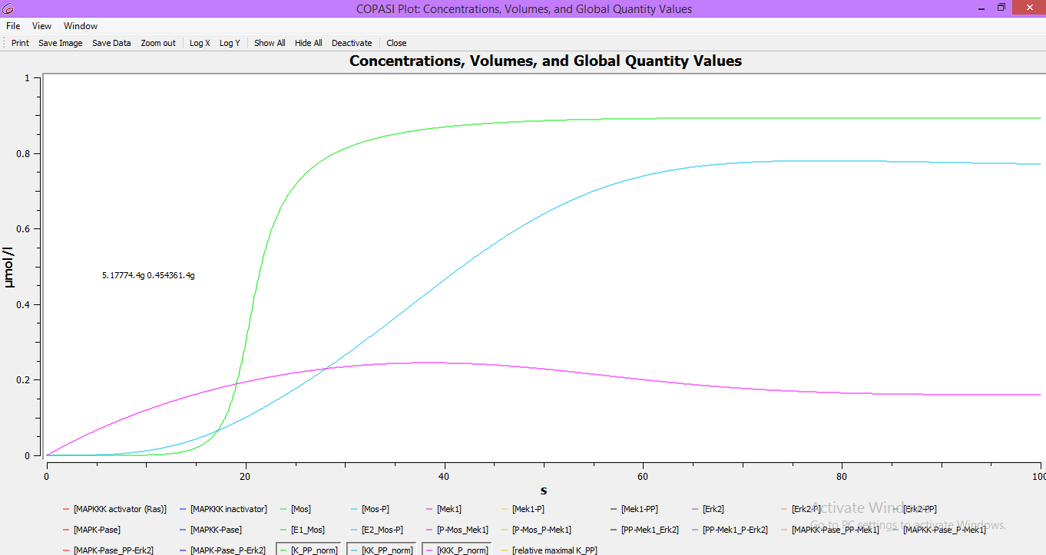

8. Save your model for further analysis.

**1b. Creating a dose-response curve – sensitivity to signal:**

* The **dose–response relationship**, or **exposure–response relationship**, describes the magnitude of the [response](https://en.wikipedia.org/wiki/Stimulus%E2%80%93response_model) of an [organism](https://en.wikipedia.org/wiki/Organism), as a [function](https://en.wikipedia.org/wiki/Function_(mathematics)) of exposure (or [doses](https://en.wikipedia.org/wiki/Dose_(biochemistry))) to a [stimulus](https://en.wikipedia.org/wiki/Stimulus_(physiology)) or [stressor](https://en.wikipedia.org/wiki/Stressor) (usually a [chemical](https://en.wikipedia.org/wiki/Chemical)) after a certain exposure time.
* Dose–response relationships can be described by **dose–response curves**.
* Dose response studies help us understand any change caused by varying a dosage on the dynamics of the system.
* These are used for instance to determine the efficient, “safe” and “hazardous” dosages of drugs and optimize any perturbation protocol.
* The numerical procedure is called parameter scan, or parameter sweep. As the name indicates, they can also be used to study the effect of varying parameters in a model and study the sensitivity of a system towards this parameter

Here we will study the stimulus response curves for three components of the MAPK cascade, the

input stimulus being the MAPKKK_activator (INPUT (E1) on the map above, for instance Ras). We will compute the steady state of all concentrations (when their values do not vary anymore) for increasing values of the MAPKKK_activator.

**PROCEDURE:**

1. Select Parameter Scan (from Tasks dropdown menu) and change the Task type to “Steady State”.



2. Set new scan item to scan and click create.

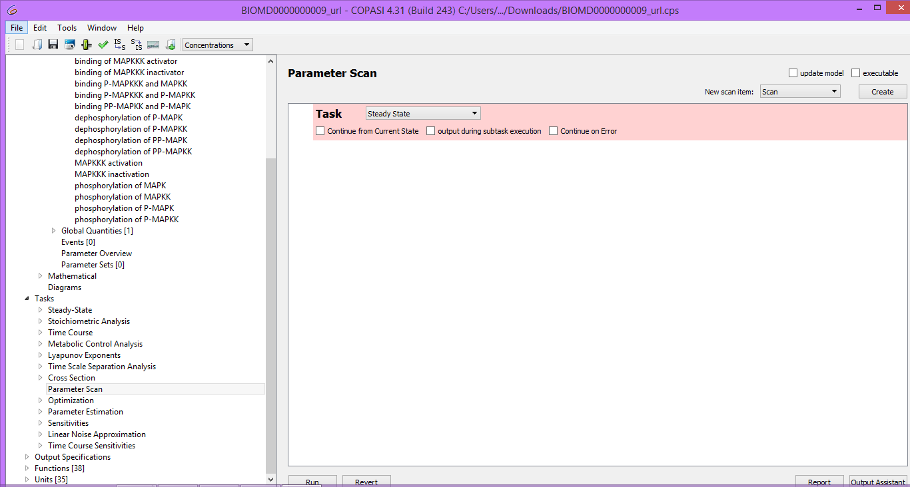

3. Select the parameter to be scanned as initial concentration of the [MAPKKK activator](t=0)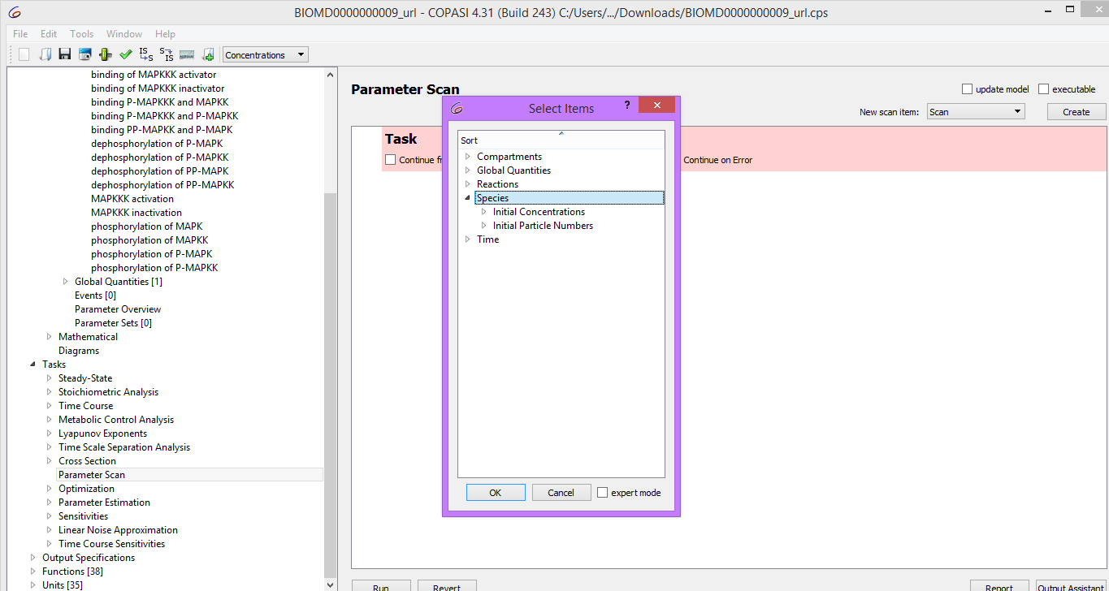

4. In the scan item you have just created set: the parameters of intervals = 100, minutes =1e-6, max = 0.1 and select logarithmic.

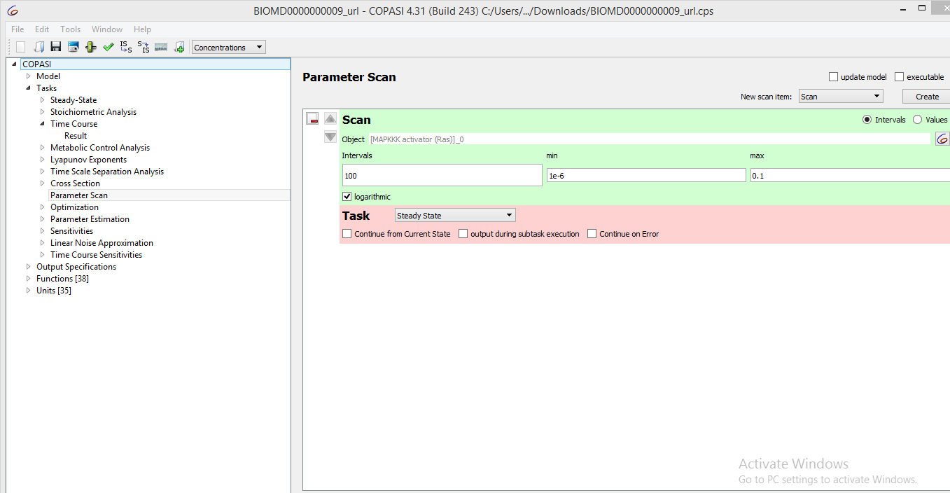

5. Use of the output assistant to create a “scan of concentrations, volumes and global quantity values” plot. Use a log scale for the x axis (MAPKKK_activator). Run the scan to get the dose response curves.

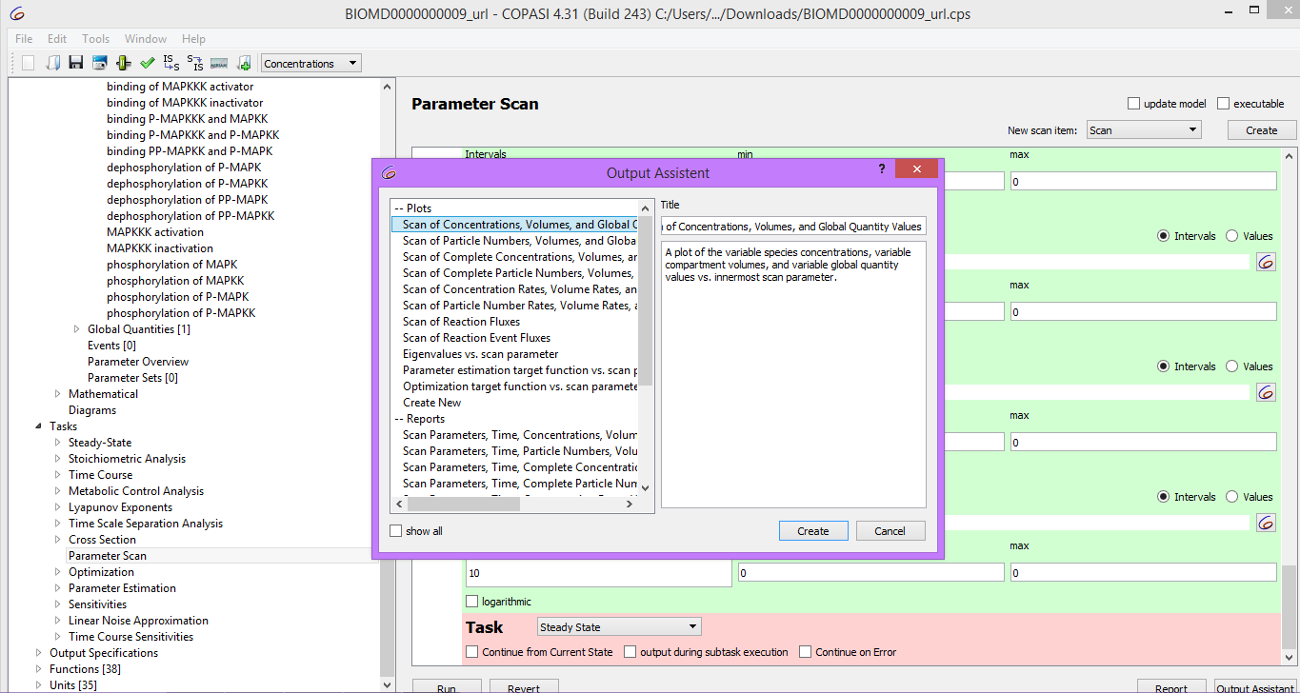

6. Hide all the curves except for the normalized active form of the MAPK

(“K_PP_norm”).MAPKK (“KK_PP_norm”) and MAPKKK (“KKK_P_norm”).

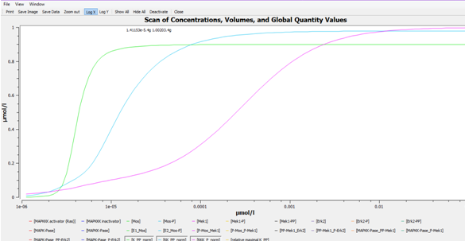

7. Save your model

Inference from the time-course and the dose-response curve:

* The simple time course simulation shows the expected temporal sequence of kinase activation, from MAPKKK to the final effector MAPK.
* It shows that the activity of MAPK reaches its maximal level before MAPKKK and also hints at the increase in sensitivity along the levels of the cascade.
* The dose-response plot directly shows the strong increase in sensitivity along the levels of the cascade with the MAPK curve predicted to be the steepest.
* This plot also teaches us two different very important characteristic of the mapkinase cascade.
* The half activation of the ERK happens at lower RAS concentration (4.4muM) than that of MEK (13muM) or RAF (260nuM).
* Thus the slope of the curve for ERK is steeper than for MEK itself steeper than for RAF.
* Such a cascade of covalent modifications provided a new mechanism to generate ultra sensitivity, in addition to the allosteric regulation of multisite, multimeric proteins, in addition this is a brilliant demonstration of the emergent properties of biological systems, and the absolute need to study the behavior of the whole system.