**INSILICO SYSTEMS BIOLOGY PRACTICALS**

**EXPERIMENT -18**

**Aim:** Building Biological Networks using Cytoscape and explore GeneMania App.

**Theory:**

* Cytoscape is an open source software platform for visualizing molecular interaction networks and biological pathways and integrating these networks with annotations, gene expression profiles and other state data. Although Cytoscape was originally designed for biological research, now it is a general platform for complex network analysis and visualization.
* Cytoscape core distribution provides a basic set of features for data integration, analysis, and visualization. Additional features are available as Apps (formerly called Plugins). Apps are available for network and molecular profiling analyses, new layouts, additional file format support, scripting, and connection with databases. For example: GeneMania, Bingo, String, cyCHART, Network Merge, ClueGO, CluePedia, MCODE.
* Cytoscape supports many use cases in molecular and systems biology, genomics, and proteomics:
* Load molecular and genetic [interaction data sets](http://www.imexconsortium.org/) in [many standards formats](http://manual.cytoscape.org/en/stable/Supported_Network_File_Formats.html)
* Project and integrate global datasets and functional annotations
* Establish powerful visual mappings across these data
* Perform advanced analysis and modeling using [Cytoscape Apps](http://apps.cytoscape.org/)
* Visualize and analyze human-curated pathway datasets such as [WikiPathways](http://www.wikipathways.org/index.php/WikiPathways), [Reactome](http://www.reactome.org/), and [KEGG](http://www.genome.jp/kegg/pathway.html).

**Procedure:**

1. Download Cytoscape from <https://cytoscape.org/> and Install Cytoscape in your system.

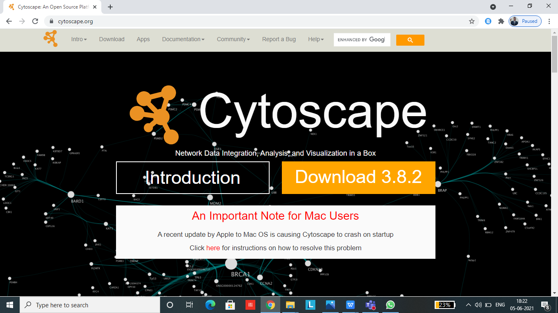

2. Open Cytoscape and the home page will look like this:

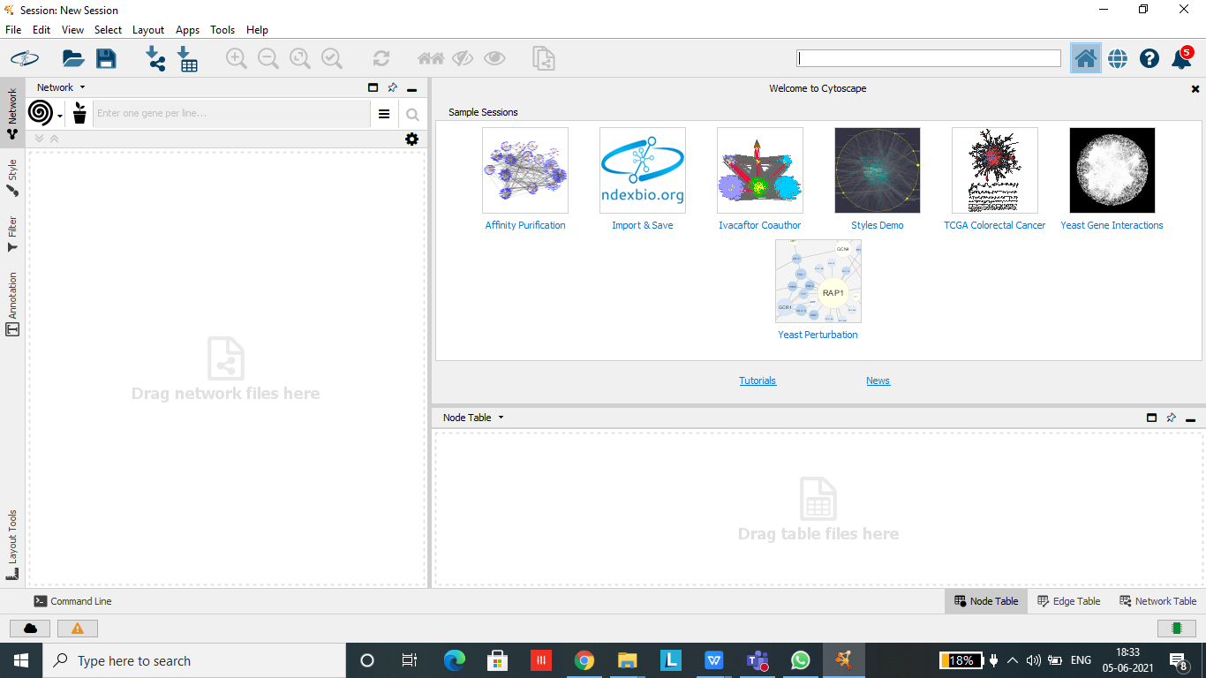

3. Go to Files >> New >> Network >> Empty Network. On clicking Empty, a box named “Create New Network” will appear, enter the network name and click OK.

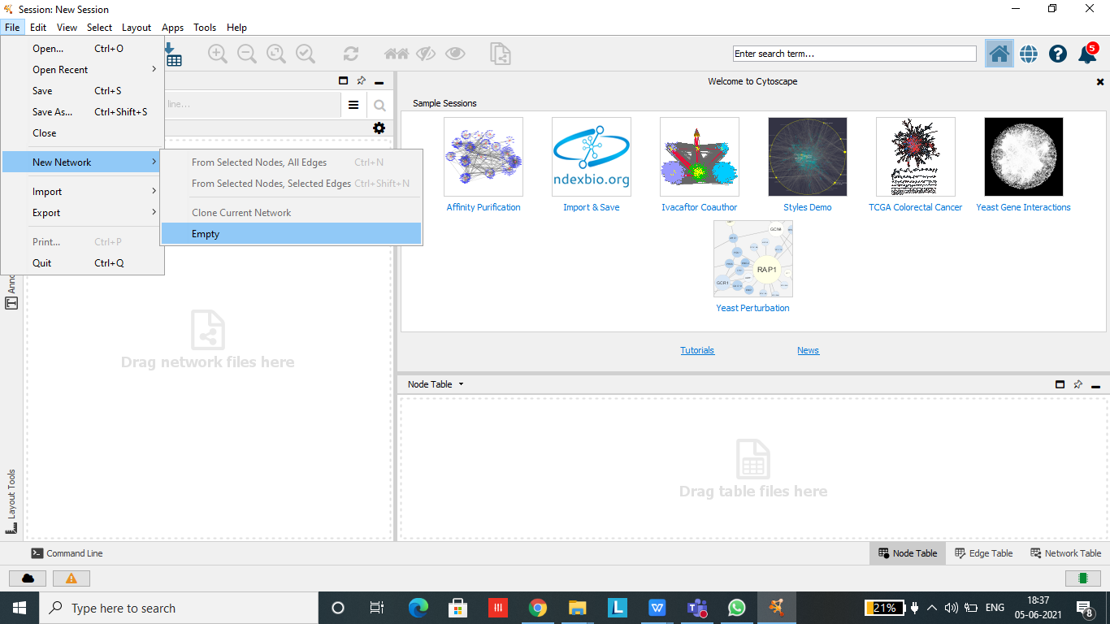

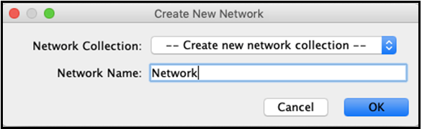

4. New network window which is white in colour will open now where we can make a network.

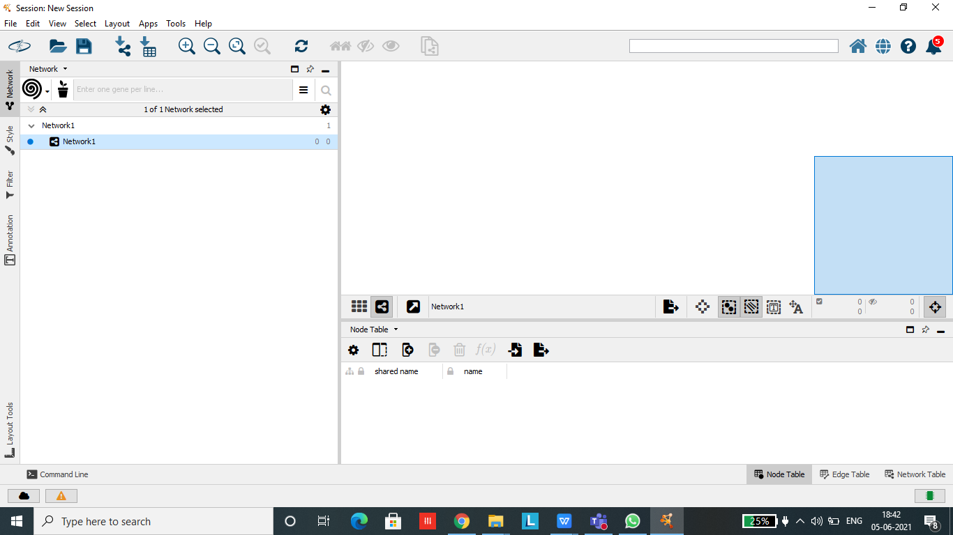

1. Right click on the empty window to add nodes and edges and build network.

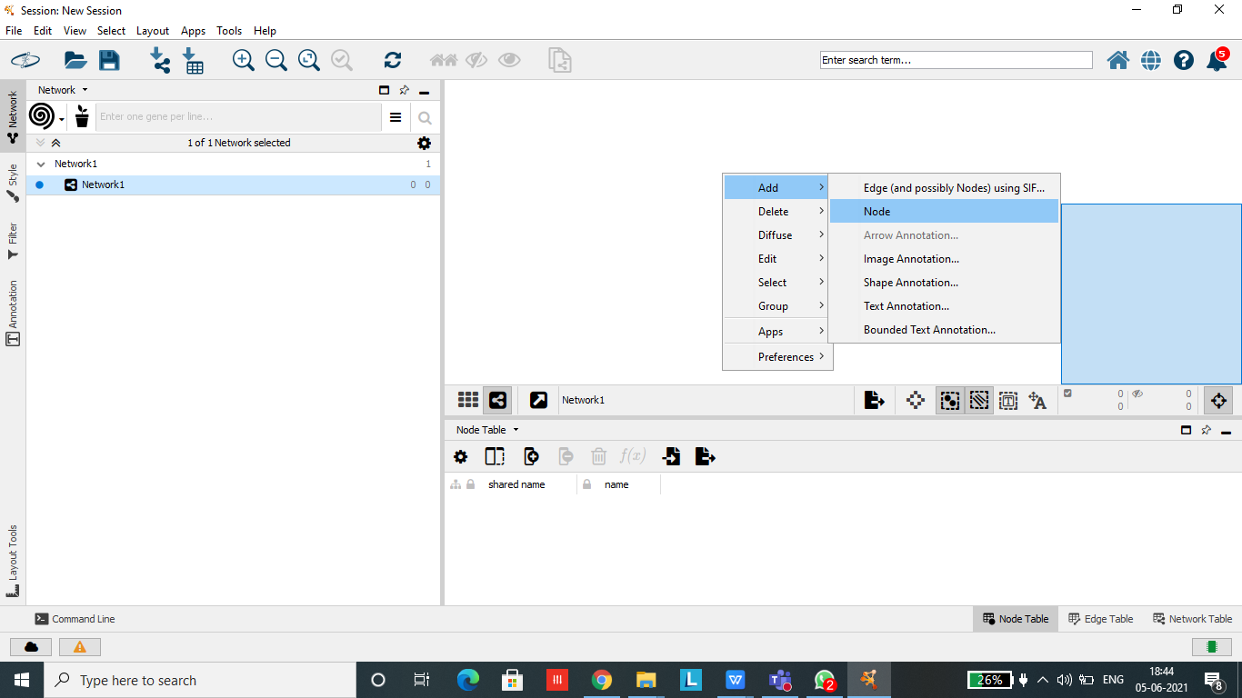

1. After building the network we need to annotate the network. For this Go to Annotation >> Select the annotation you want to add >> Click on the node or edge that you want to annotate.

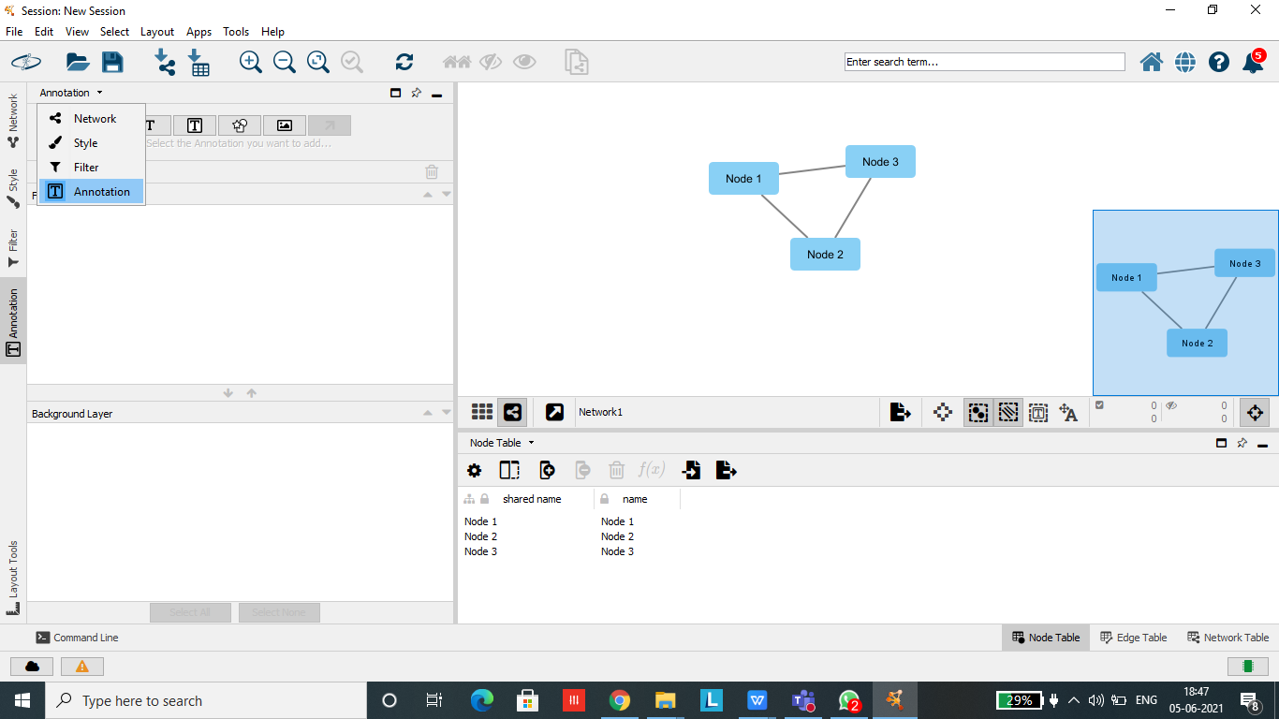

* **GeneMania Exercise : Network Construction and exploration using GeneMania App.**

**Step 1**: Go to Apps >> Apps Manager >> Download GeneMania app for your Cytoscape.

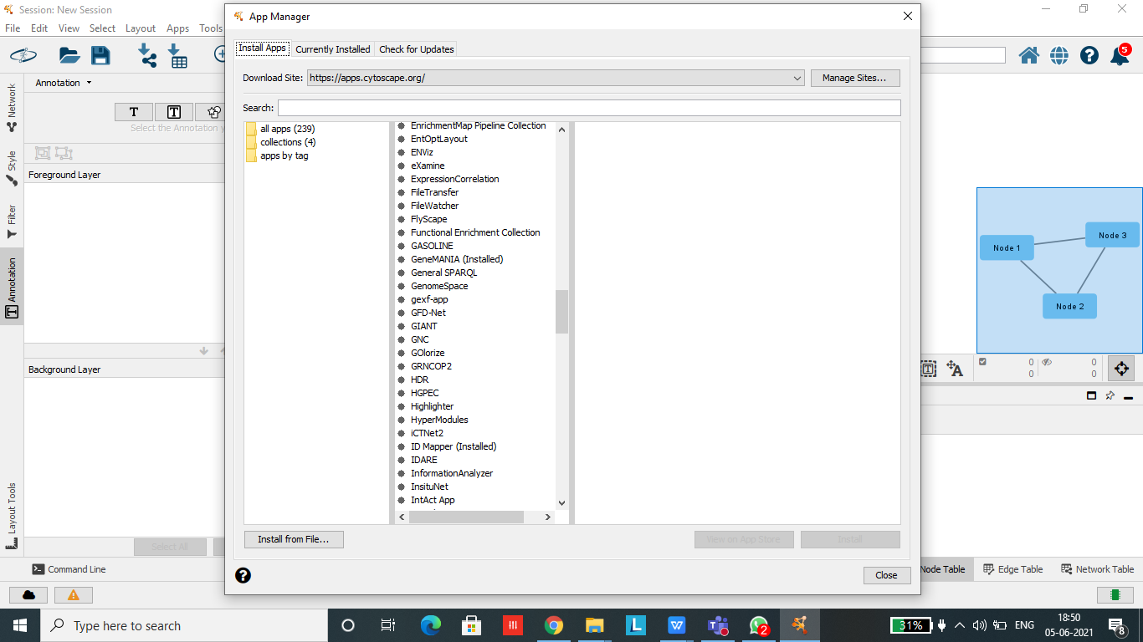

**Step 2** : Select GeneMania from the dropdown menu on the left hand side and *Homosapiens* from the dropdown menu adjacent to it.

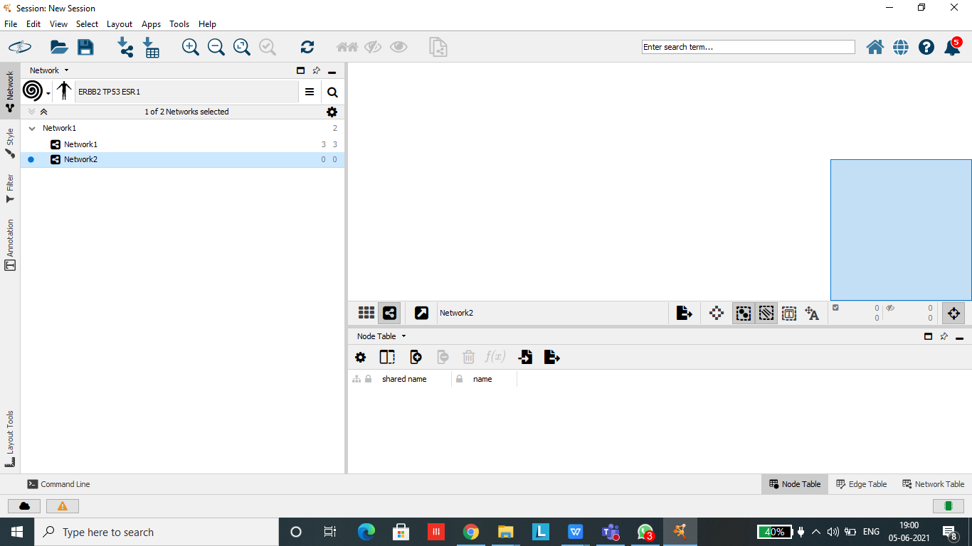

**Step 3**: Copy and paste the genes in the provided space and click on more options to set the desired values for building the network and click search.

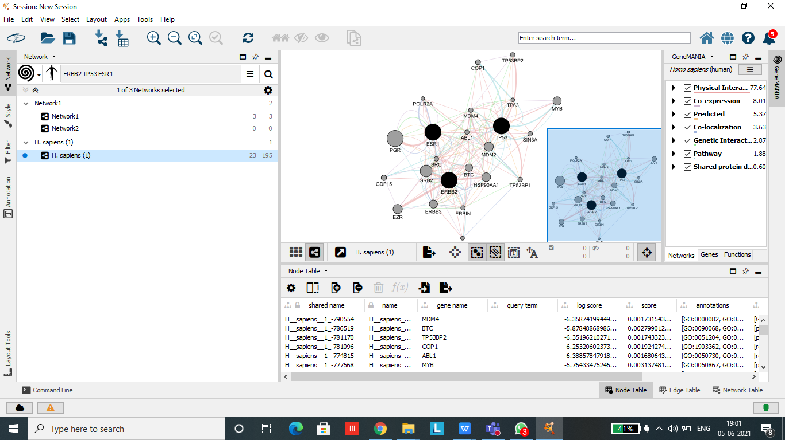

Page Break

**Step 5** : The constructed multiple network should appear. Manually move the nodes of the network until you are happy with the layout.

**Step 6** : Save the image of the network.

**Step 7** : Save the interaction information so that we could import the network into other programs, such as Cytoscape, for manipulation and analysis.