**EXPERIMENT-1**

**Aim:** To explore BioModels database- a repository of mathematical models of biological /biomedical Systems.

**Theory**

**BioModels Database- Definition**

BioModels Database is a repository of computational models of biological processes. It hosts models described in peer-reviewed scientific literature and models generated automatically from pathway resources (Path2Models). A large number of models collected from literature are manually curated and semantically enriched with cross-references from external data resources (such as publications, databases of compounds and pathways, ontologies, etc.). The resource allows scientific community to store, search and retrieve mathematical models of their interest. In addition, features such as generation of sub-models, online simulation, conversion of models into different representational formats, and programmatic access via web services, are provided.

Users can browse and search the content of the repository, and download models in SBML format, as well as various other formats, such as XPP, VCML, SciLab, Octave, BioPAX, PNG, SVG, ... A human readable summary of each model is also available in PDF.

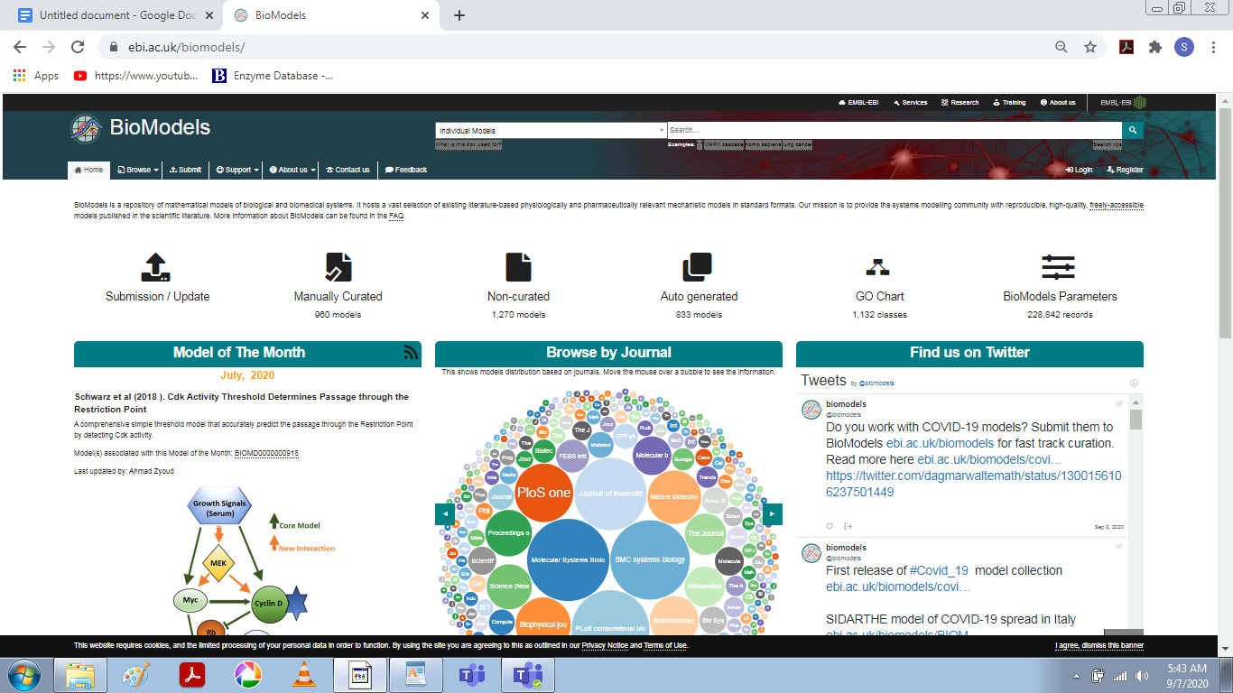

**Difference between BioModels database and other model database**

BioModels Database is more than just a repository of models, it is a true database. The models, their controlled annotation and all related information is stored in a set of MySQL tables. This allows users to search not only for particular models based on their internal components elements, but also based on the extensive additional annotation. In addition, this annotation allows the exploration of the relevant linked resources, thereby facilitating the understanding of the concepts upon which the model is founded.

**Difference between BioModels Database and biological pathway database**

BioModels Database is not a database of biochemical pathways. The current state of the field of Computational Systems Biology means that these models are largely dominating the resource at the moment, but the scope of BioModels Database itself is larger than just biochemical events. A quantitative model also differs from a pathway in several respects:

A pathway need not contain quantitative information on the amount of objects, their behaviour, nor on their location.

A pathway is static, while a model can be instantiated into dynamic simulations.

A formal model can merge several biochemical reactions into one, or conversely, can contain reactions without counterparts in the corresponding biological context. The purpose is that the simulations performed with the model produce quantitative results commensurate with the available experimental knowledge.

**Difference between BioModels Database and Reactome**

Reactome is a database of reactions and pathways, not a database of quantitative models. The SBML files exported by Reactome (or KEGG for that matter) do not contain any quantitative information, whether quantities (amount or concentration of species) or kinetics. Reactome aims to describe the human cellular pathways accurately and in great details, not to distribute abstract quantitative description of their functions.

**MIRIAM guidelines**

MIRIAM is the Minimum Information Required in the Annotation of Models (publication and press Release). Initiated by the BioModels.net project, it is a set of guidelines defining how a model should be encoded and annotated in order to be successfully distributed, exchanged and ultimately reused.

In particular MIRIAM requires that a model provides all the information necessary to instantiated in a simulation, such as the initial conditions. In addition, the reaction graph generated from this simulation must reproduce the results of the original publication, in which the model was first described. Moreover, the MIRIAM guidelines require that all model components contain sufficient controlled annotation such that each component can be unambiguously identified. The MIRIAM Registry and Identifiers.org have been developed specifically to provide generation and resolution services for unique and perennial identifiers to be used in controlled annotations.

All models stored in the curated branch of BioModels Database are MIRIAM-compliant.

All the models in the curated branch are fully MIRIAM compliant. Each of the MIRIAM requirements is satisfied in the following way:

**Models are encoded in a public standard format**-All models in BioModels Database are converted into valid SBML.

**Models must be clearly related to a single reference**-Each model is derived from a scientific publication.

**The model must correspond to the biological processes represented in the publication**-Models are manually checked to confirm accurate biological representation in the model.

**The simulation results generated from the model must reflect those in the reference publication**-Models are manually checked to confirm accurate simulation results are generated from the model. The result of this step is available in the "Curation" tab.

**External data resources annotation**-Models elements are well annotated.

Model elements can describe a plethora of different entities, such as genes, proteins or metabolites. The usage of free text or non-standard nomenclature to identify those elements is not reliable, as it can introduce ambiguity to the model components, such that subsequent users of a model would struggle to identify the precise entities involved.

Annotation is useful to identify model elements. This ensures that users will be able to understand the models and increases the possibility of their reuse. Moreover, annotation is a key element for processes such as data comparison, data integration and data conversion. Finally, this also allows provision of accurate search engines (BioModels Database makes heavy use of annotation when users search for models of interest).

Models in BioModels Database are provided with consistent annotation using unambiguous identifiers. Those identifiers are generated by the MIRIAM Registry and Identifiers.org services. They can be used to reference records from external databases (such as Taxonomy, EMBL-Bank or UniProt), terms from ontologies (such as Gene Ontology, SBO or ChEBI), publications, etc.

**Annotations stored in SBML files of the models**

The annotation of each model component is stored in the corresponding SBML element using the a scheme initially designed by Nicolas Le Novère and Andrew Finney, and now part of SBML (since Level 2 Version 2). It relies on the use of RDF, Dublin Core, vCard and the BioModels.net qualifiers.

Tools used by the curators of BioModels Database

Our curators use a wide range of tools to perform their curation tasks: CellDesigner, COPASI, Jarnac, MathSBML, RoadRunner, SBMLOdeSolver, SBMLeditor, SemanticSBML, JigCell, XPP-Aut, ..

**PROCEDURE**

To explore Hodgkin-Huxley 1952 squid-axon (BIOMD0000000020)

Ways to browse and search BioModels Database

There are two main ways in which the BioModels Database can be browsed:

There are two options available on the left side of the home page namely Recently published models and Recently accessed models which provides better browsing options.

To search a model, there is a search option available on the top right hand side of the home page.

There are enhanced search options available on the left side of the browse page namely the models curation status, the model format, the modelling approach, model flag, the organism, disease, GO, and the UNIPROT model.

**Ways to Download a model from BioModels Database-**

There are several ways to download the models:

Each model can be downloaded from its own description page, via a "Download " option present at the top menu by clicking on the checkbox of the model we want to download.

Then by clicking on the “Files” option, you can choose the format of the file you want to download it.

Under the History option, you can even choose the version of the model you want to download depending on the revisions.

**Aim**- To explore BioModels database and retrieve one each for five organisms namely- Homo sapiens, Eukaryotes, Bacteria, Yeast and one for cancer.

Tool Used- BioModels Database from EMBL- EBI

URL- https://www.ebi.ac.uk/biomodels

**FOR HOMO SAPIENS:-**

Model Name- Hancioglu2007-Human Immune Response to Influenza A virus infection

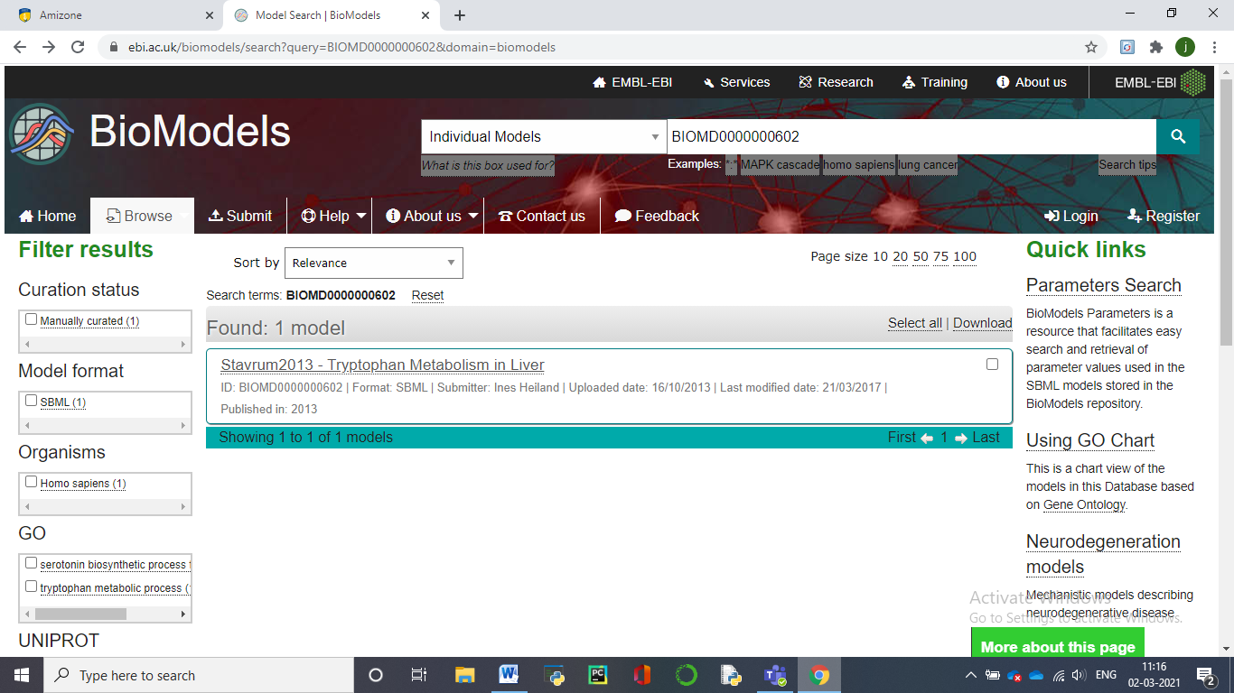

Model Identifier-BIOMD0000000602

Given By- Ines Heiland

Short Description- We present a simplified model of Stavrum2013 - Tryptophan Metabolism in Liver. Tryptophan is utilized in various metabolic routes including protein synthesis, serotonin, and melatonin synthesis and the kynurenine pathway. Perturbations in these pathways have been associated with neurodegenerative diseases and cancer. Here we present a comprehensive kinetic model of the complex network of human tryptophan metabolism based upon existing kinetic data for all enzymatic conversions and transporters. By integrating tissue-specific expression data, modeling tryptophan metabolism in liver and brain returned intermediate metabolite concentrations in the physiological range. Sensitivity and metabolic control analyses identified expected key enzymes to govern fluxes in the branches of the network.

Format- SBML(L2V4) as shown below:-

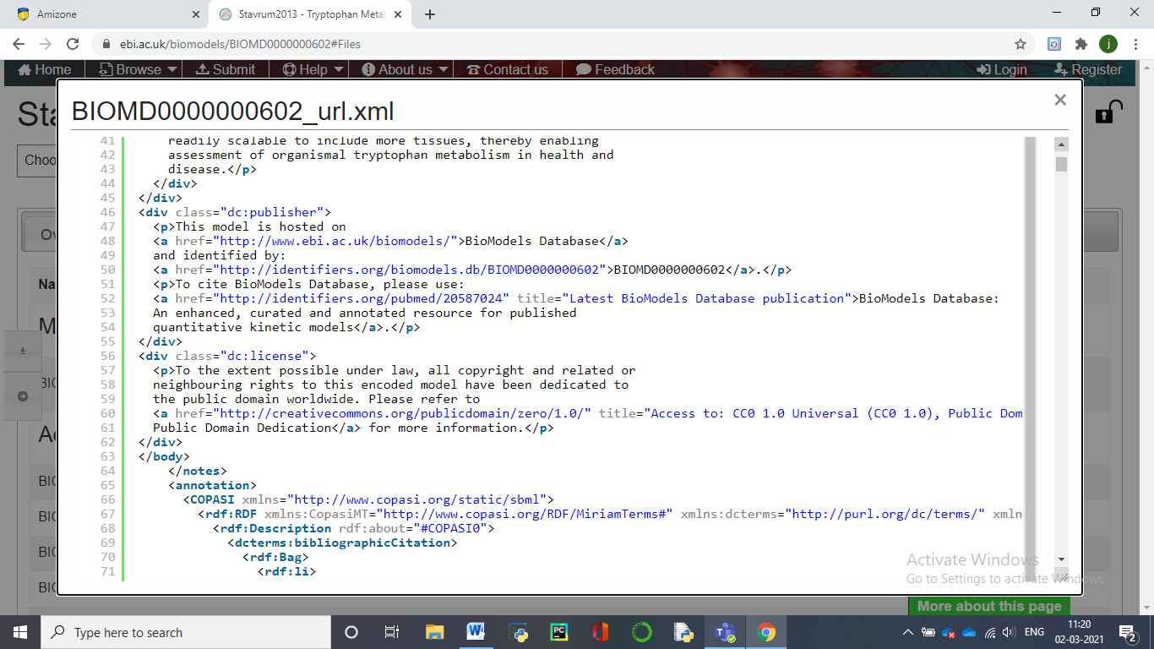

Curation status- Manually curated as shown:-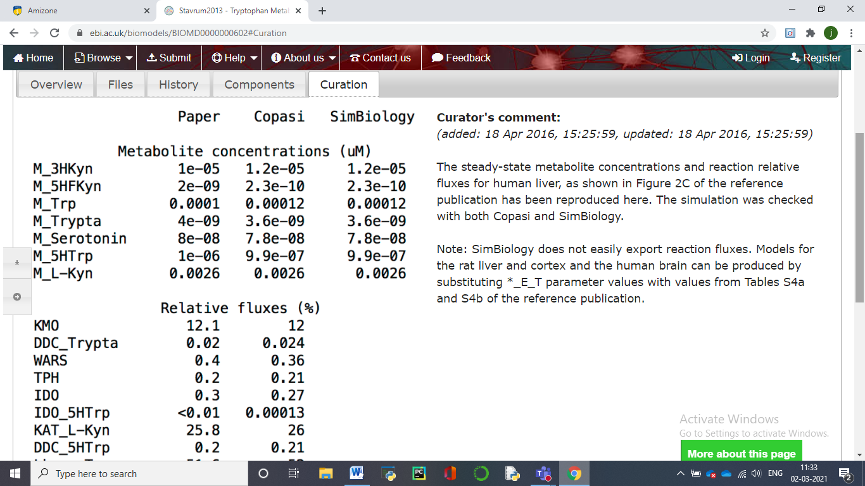

Number of species- 11

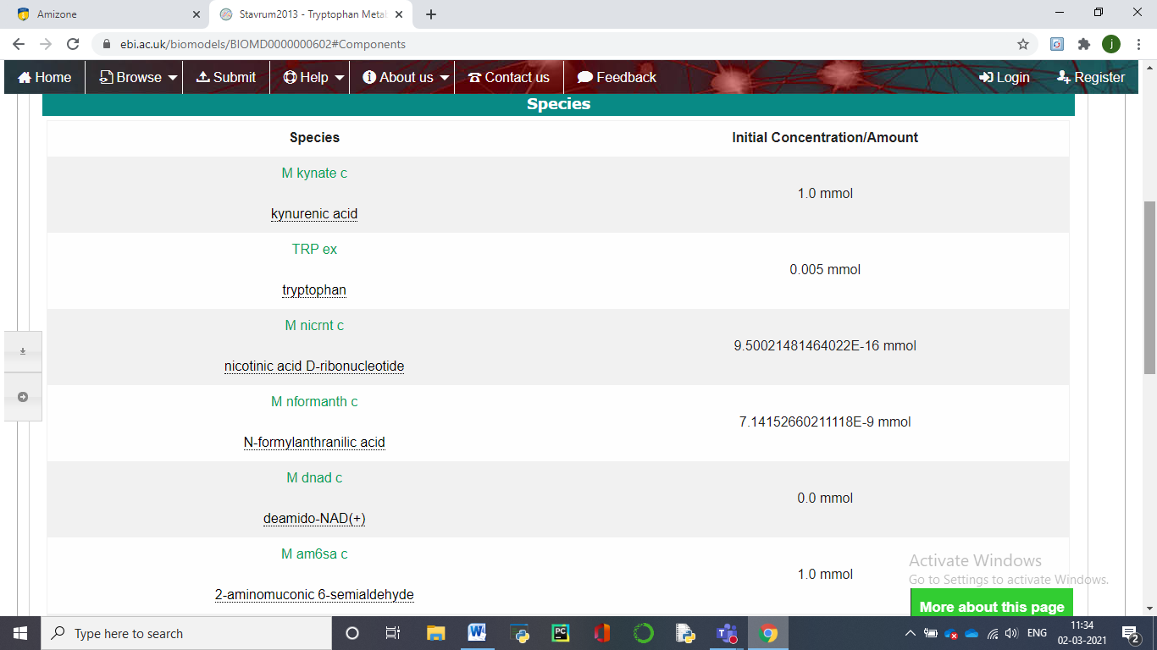Number of reactions- 10

**B) FOR EUKARYOTES-**

Model Name- Firczuk2013-Eukaryotic mRNA translation machinery

Model Identifier- BIOMD0000000457

Given By- Szeyi Ng on 05-Sep-2019

Short description- Firczuk2013 - Eukaryotic mRNA translation machineryThis is a model of *Saccharomyces cerevisiae* mRNA translation which includes the initiation, elongation and termination phases. The model is for 20 condon mRNAs. The building of a multi-factor complex in initiation and also the different processes in elongation and termination are modelled in detail. The model takes into account that ribosomes cover more than one codon of mRNA so that the movement of ribosomes are effectively blocked by other ribosomes several codons downstream. It is assumed that 15 codons are occupied by each ribosome. This blocking effect is considered in reaction R18 in initiation and also reaction R26, the reaction where translocation of ribosomes takes place in elongation. The kinetic functions of these two reactions are based on MacDonald et al. 1968 and Heinrich & Rapaport 1980. All other kinetic functions follow mass-action kinetics. The concentrations of transfer RNA species (Met-tRNA, aa-tRNA and tRNA in the model) are kept constant, while the other species' concentrations can change in the course of the simulation. The model describes the translation of a short mRNA with 20 codons. Therefore, all reactions in the elongation cycle (R22, R23, R25, R26, R28 and R29) and the corresponding species are replicated accordingly to model the species with ribosomes bound at different positions. In summary, the model contains 165 different species and 141 reactions.

Format- SBML(L2V4)

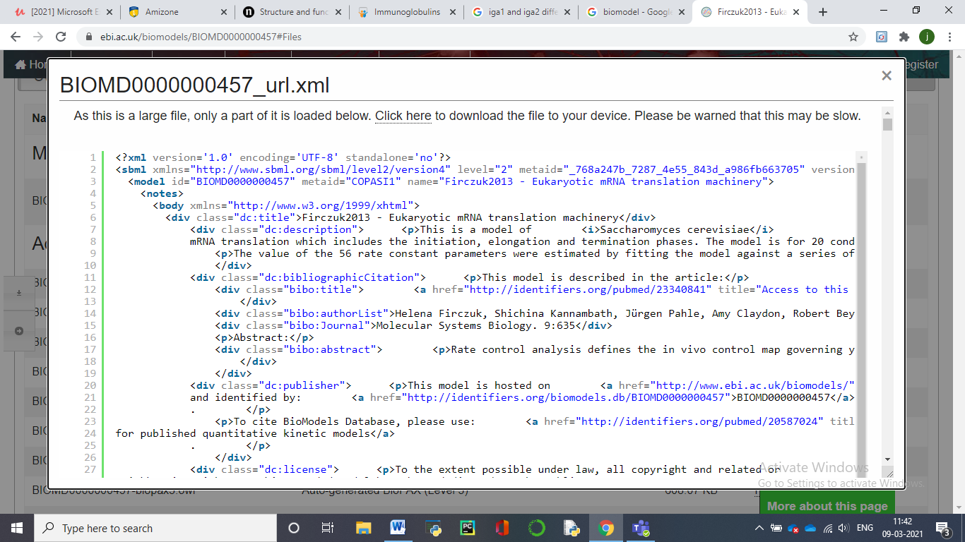

Curation status- Manually curated

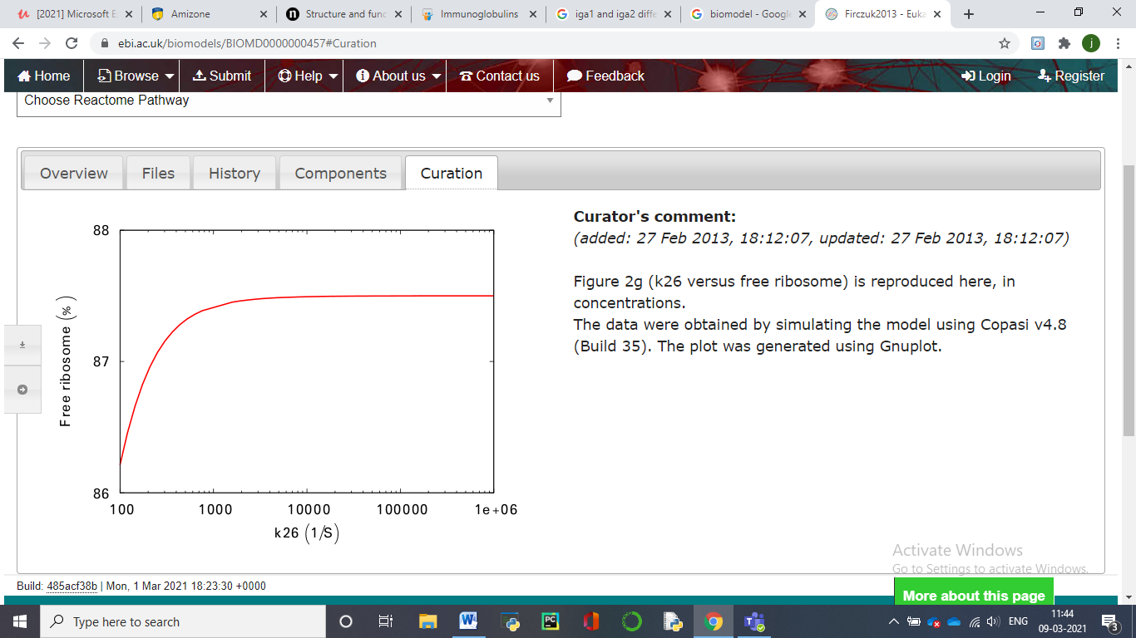

Number of species- 13

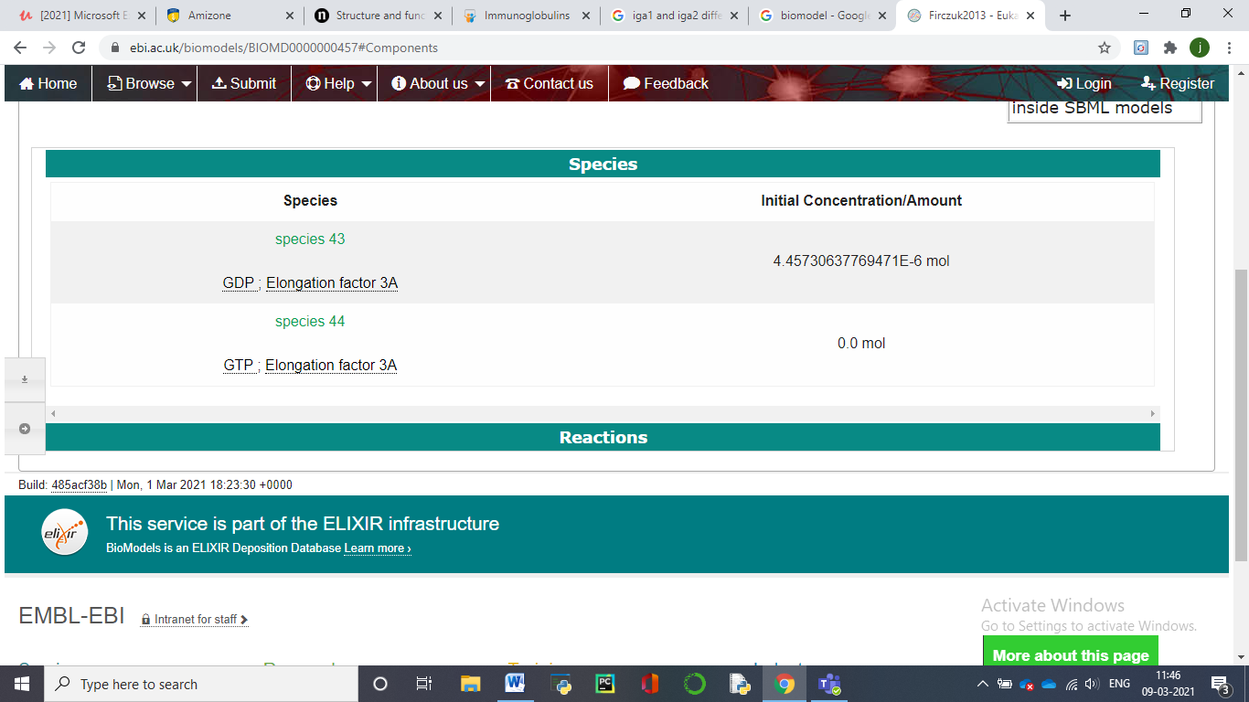

Number of reactions- 14

**C). FOR BACTERIA**

Model Name- Leber2015-Mucosal immunity and gut microbiome interaction during C difficile infection

Model Identifier- BIOMD0000000583

Given By- Andrew Leber on 20-Jul-2015

Taxon- Peptoclostridium difficile (strain 630) in Mus musculus

Short Description- The model demonstrates a crucial role of T helper 17 (Th17) effector responses in the colonic lamina propria and luminal commensal bacteria populations in the clearance of C. difficile and colonic pathology, whereas regulatory T (Treg) cells responses are associated with the recovery phase. In addition, the production of anti-microbial peptides by inflamed epithelial cells and activated neutrophils in response to C. difficile infection inhibit the re-growth of beneficial commensal bacterial species.

Format- SBML(L2V4)

Curation status- Manually curated

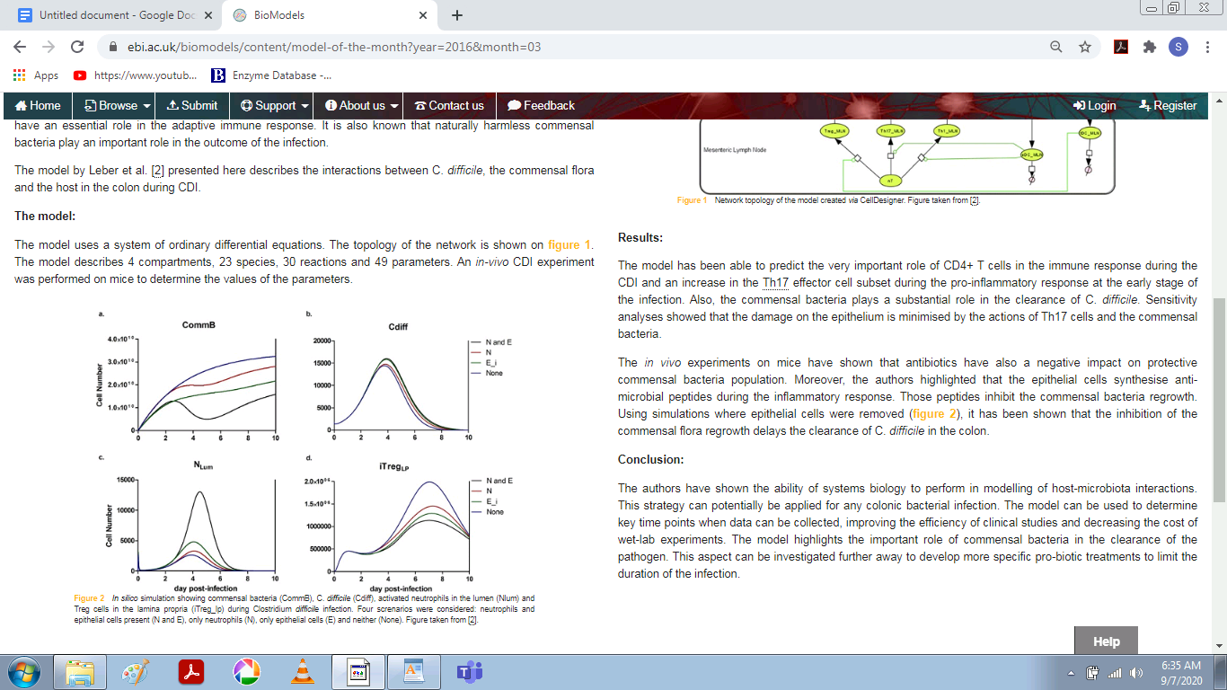

Fig- *In silico* simulation showing commensal bacteria (CommB), C. *difficile* (Cdiff), activated neutrophils in the lumen (Nlum) and Treg cells in the lamina propria (iTreg_lp) during Clostridium *difficile* infection. Four screnarios were considered: neutrophils and epithelial cells present (N and E), only neutrophils (N), only epithelial cells (E) and neither (None).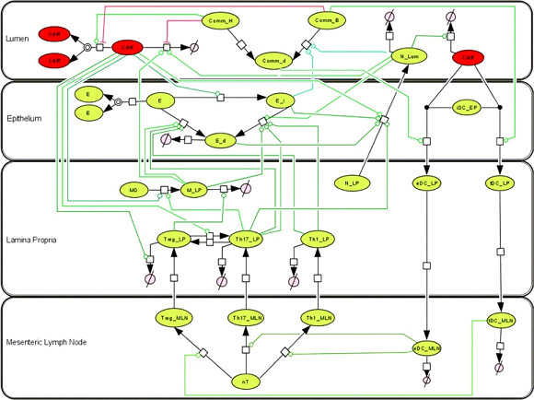Fig - Network topology of the model created *via* CellDesigner.

Number of species- 9

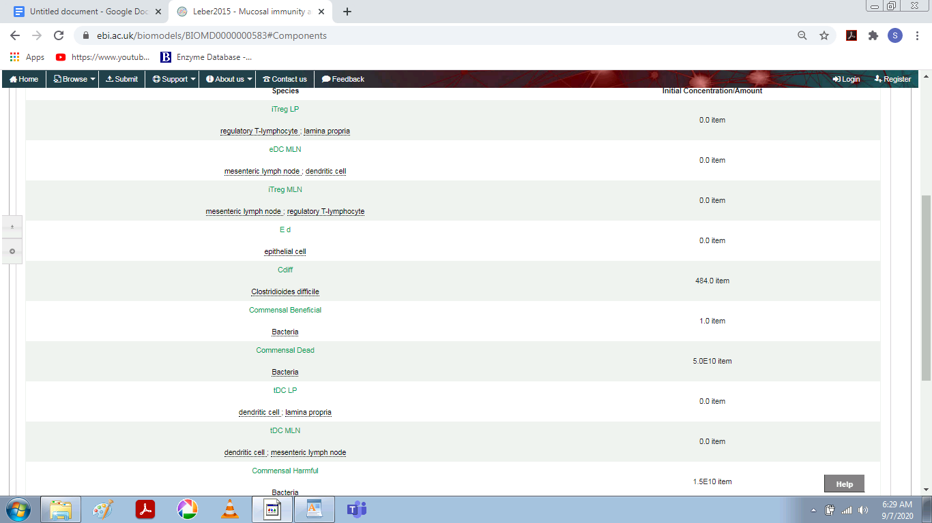

Number of reactions- 14

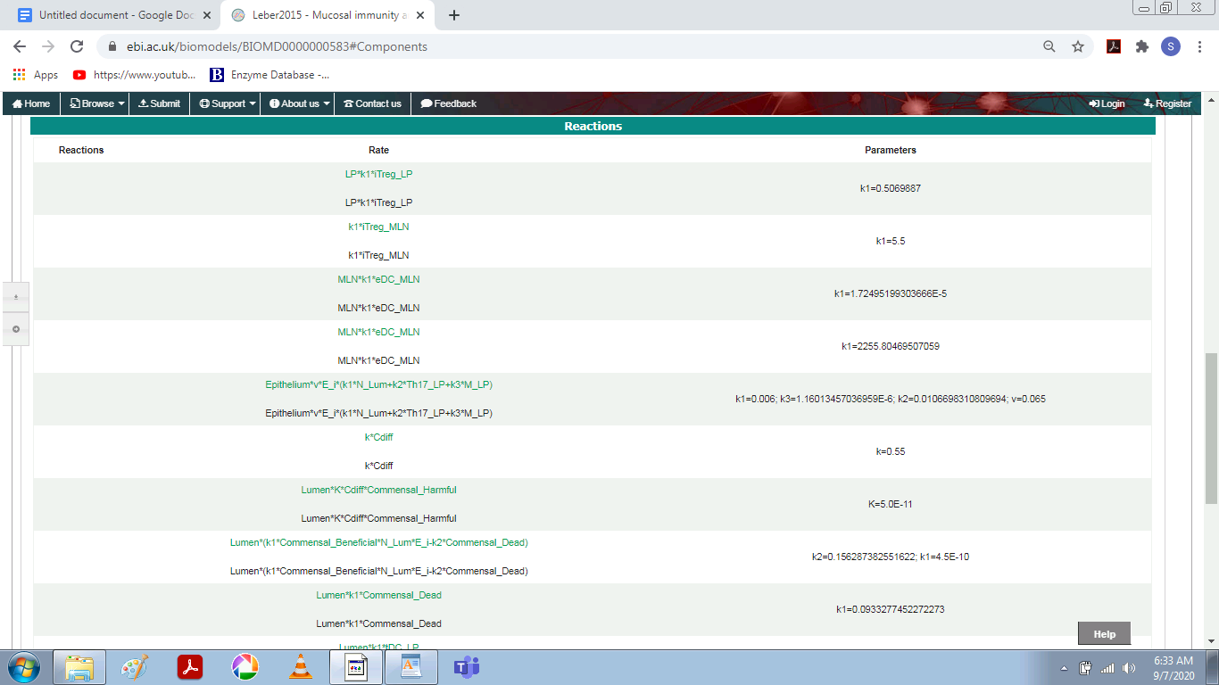

**D). FOR YEAST**

Model Name- Voit2003-Trehalose Cycle

Model Identifier- BIOMD0000000266

Given By- Kieran Smallbone, Rahuman Sheriff on 21-Jul-2010

Short Description- The physiological hallmark of heat-shock response in yeast is a rapid, enormous increase in the concentration of trehalose. Normally found in growing yeast cells and other organisms only as traces, trehalose becomes a crucial protector of proteins and membranes against a variety of stresses, including heat, cold, starvation, desiccation, osmotic or oxidative stress, and exposure to toxicants. Trehalose is produced from glucose 6-phosphate and uridine diphosphate glucose in a two-step process, and recycled to glucose by trehalose. Even though the trehalose cycle consists of only a few metabolites and enzymatic steps, its regulatory structure and operation are surprisingly complex.

Taxon- Saccharomyces cerevisiae (strain ATCC 204508 / S288c)

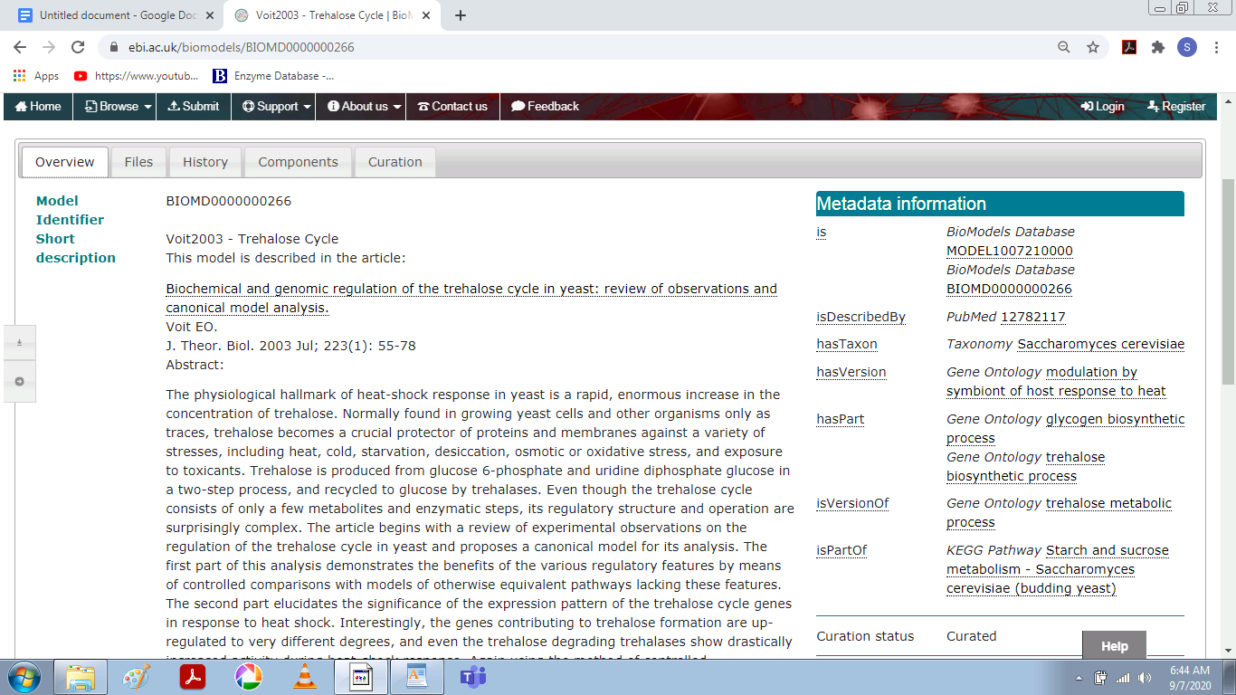

Format- SBML(L2V4)

Curation status- Manually curated

Number of species- 7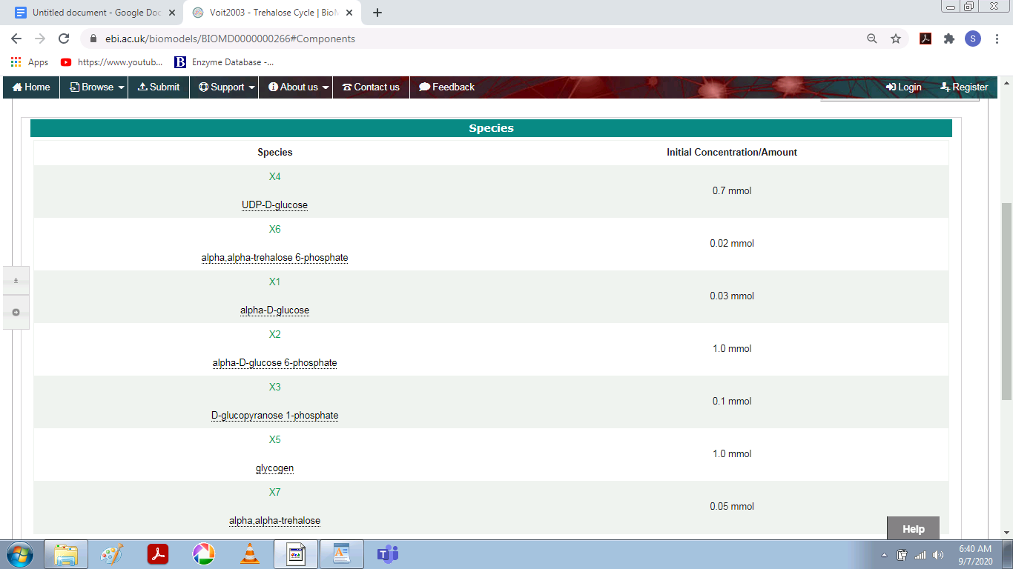

Number of reactions- 7

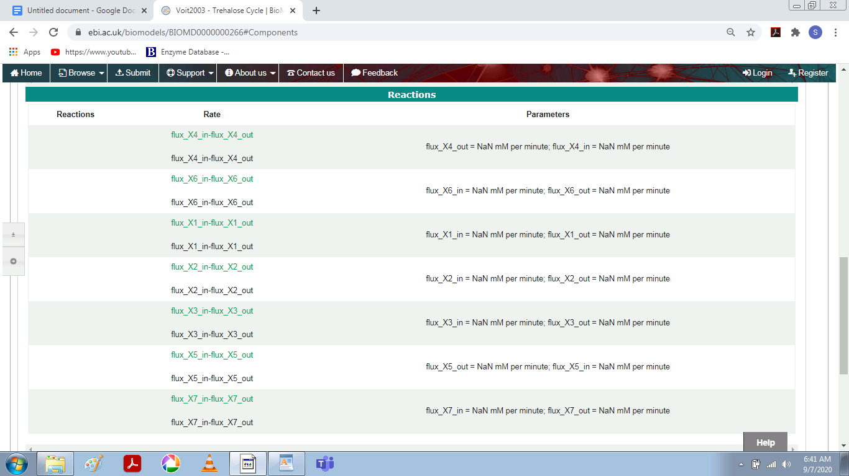

**E). FOR CANCER**

Model Name- Orton2009 - Modelling cancerous mutations in the EGFR/ERK pathway - EGF Model

Short Description-This model studies the aberrations in ERK signalling for different cancer mutations. The authors alter a previously existing EGF model (Brown et al 2004) to include new interactions that better fit empirical data. Predictions show that the ERK signalling is a robust mechanism taking different courses for different cancer mutations. Most parameter values are used from the previous model and the new parameters are estimated using experimental data performed by the authors on PC12 cells (adrenal gland, rat). The authors provide an SBML version of the model in the paper.

Model Identifier- BIOMD0000000623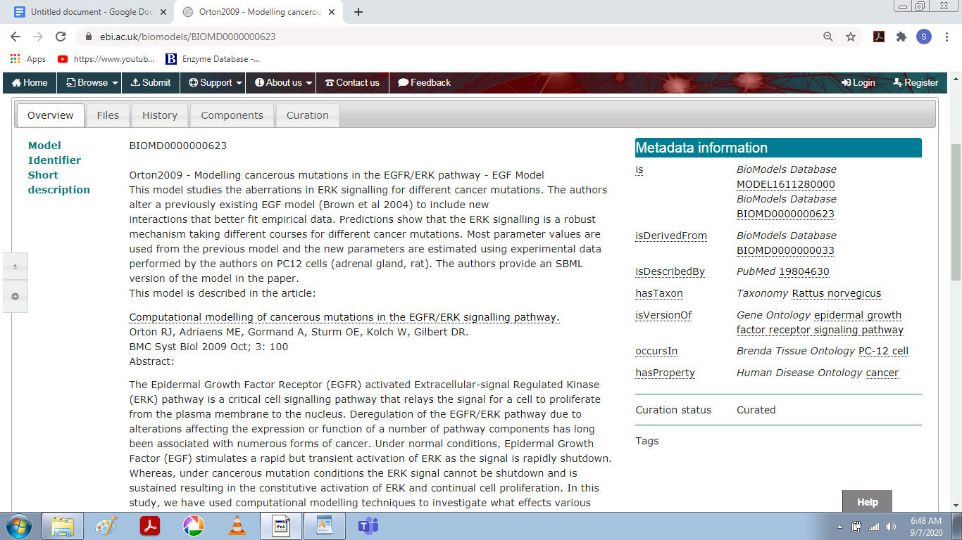

Given By- Thawfeek Varusai on 28-Nov-2016

Taxon- Rattus norvegicus

Format- SBML(L2V4)

Curation status- Manually curated

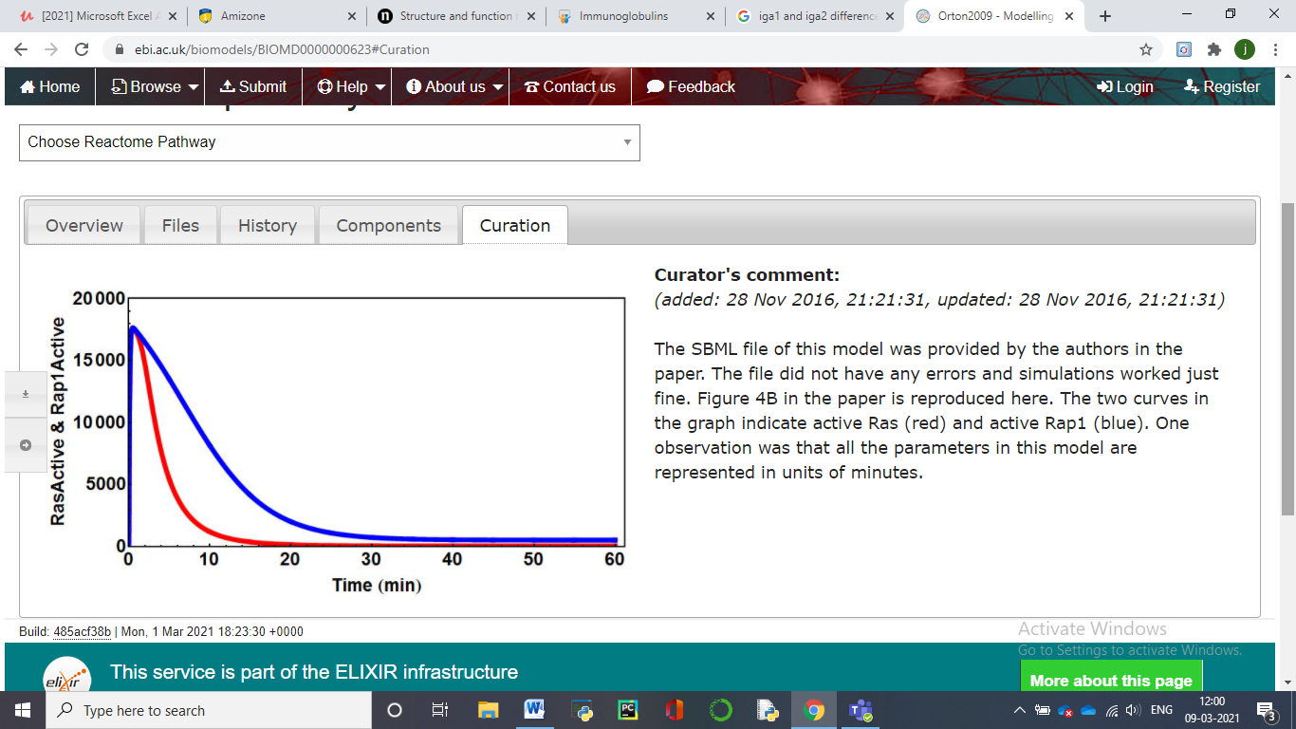

Number of species- 12

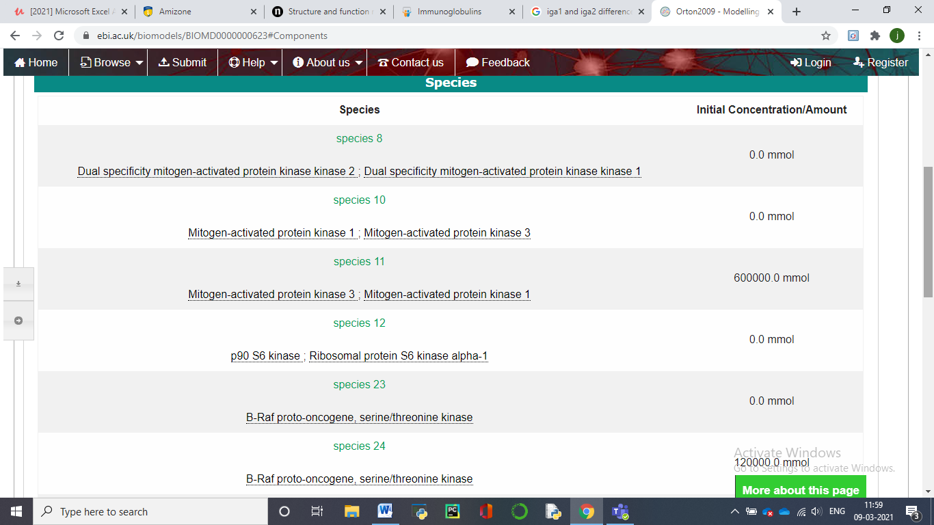

Number of reactions- 13