**EXPERIMENT-2**

**Aim**-

To explore Reactome database through the following questions.

**Theory**-

REACTOME is an open-source, open access, manually curated and peer-reviewed pathway database. Our goal is to provide intuitive bioinformatics tools for the visualization, interpretation and analysis of pathway knowledge to support basic and clinical research, genome analysis, modeling, systems biology and education. Founded in 2003, the Reactome project is led by Lincoln Stein of OICR, Peter D’Eustachio of NYULMC, Henning Hermjakob of EMBL-EBI, and Guanming Wu of OHSU.

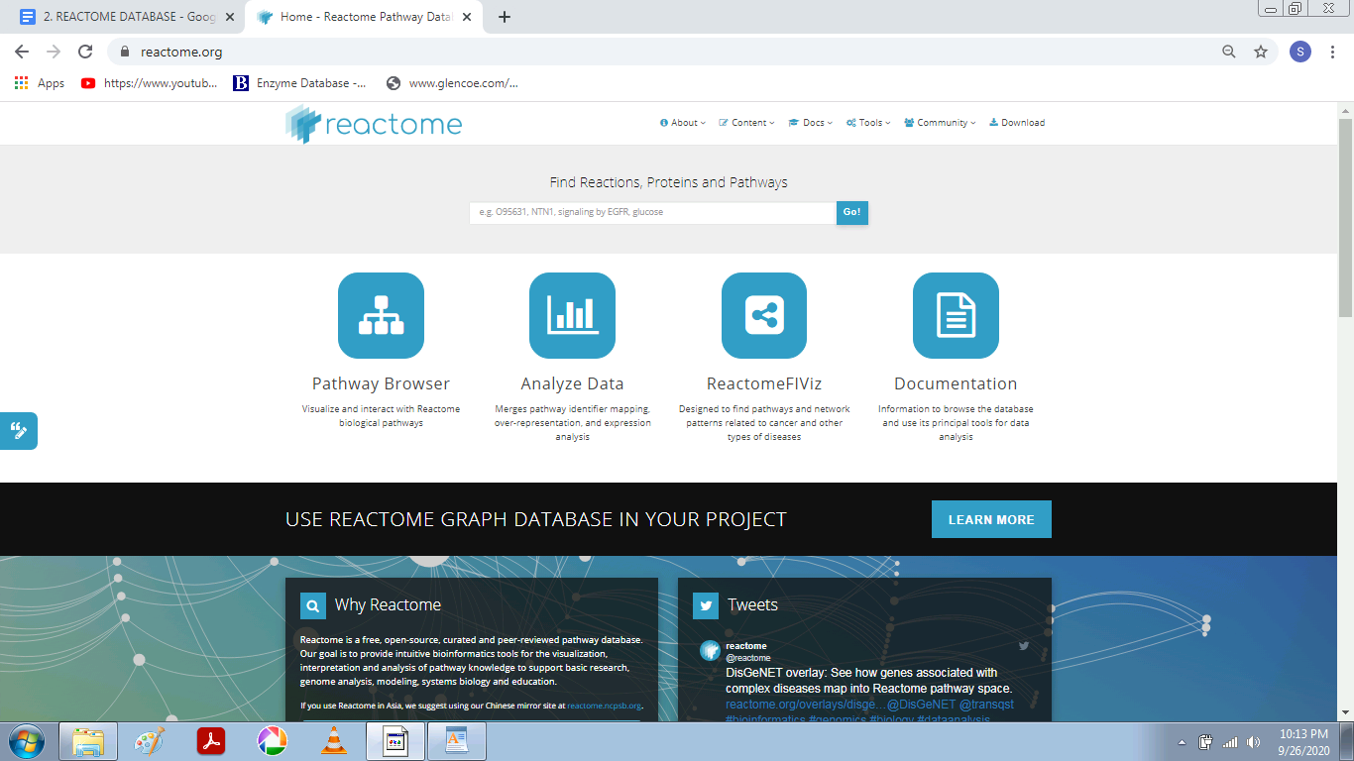

**How many human proteins are represented in Reactome?**

11,285

**What’s the first item listed that will be included in the next release?**

Autophagy [Homo sapiens] (DOI)

- Macroautophagy (DOI)

- Chaperone Mediated Autophagy (DOI)

- Late endosomal microautophagy (DOI)

4. **Is VAV2 in Reactome?**

Yes

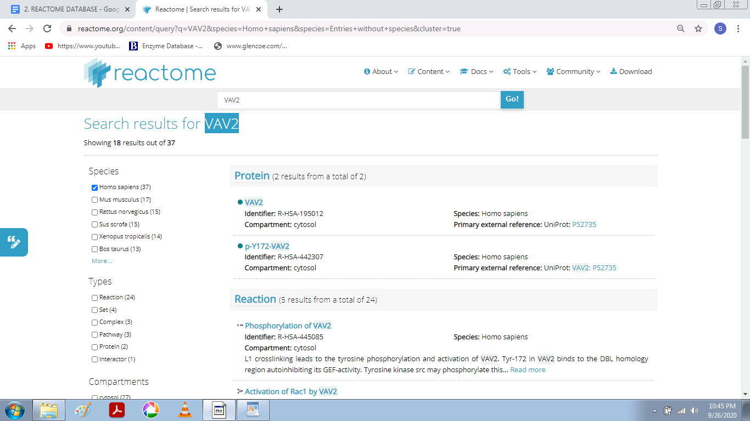

**How many reactions involve VAV2?**

36

**Are there any complexes that include VAV2?**

3

**Is CRB2 in Reactome?**

Yes

**Disease in Reactome**

Reactome can annotate and display pathways associated with disease. Disease events or processes are overlaid onto their normal counterparts to provide a pathway context to the disease event. Disease events have red connecting lines; abnormal molecules involved in these processes are outlined in red. For cancer-related processes, it is useful to view the altered disease events alongside their normal counterparts in the same diagram. The user can then see where normal processes diverge into ones that are implicated in cancer.

For infection processes, events involved in the life cycle of the infecting agent and host interactions with the infecting agent have red connecting lines. Molecules derived from the infecting agent are outlined in red, while those derived from the host are outlined as normal in black.

For metabolic processes, proteins that have lost all or most of their functional activity towards a substrate causes the majority of defects. The diagram displays these disease reactions as &#39;stop points&#39; in the pathway. Defective enzyme catalysts are outlined by a red dashed line; products that are no longer made are shown greyed- out with a superimposed red cross.

**Exercise**

1. **Search for the pathway FGFR1 mutant receptor activation and open it.**

Here we searched for FGFR1 mutant receptor activation pathway and the below displayed screen was displayed.

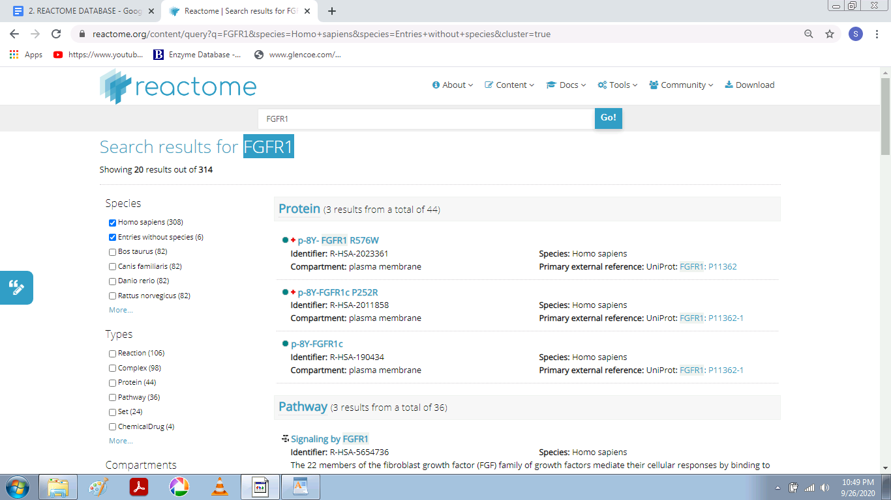

**The screen shows the protein molecule with the name FGFR1 and below that the pathways in which it is involved.**

**2. What disease(s) is/are associated with this pathway? (Hint: look at the Description tab, in the Details section)**.

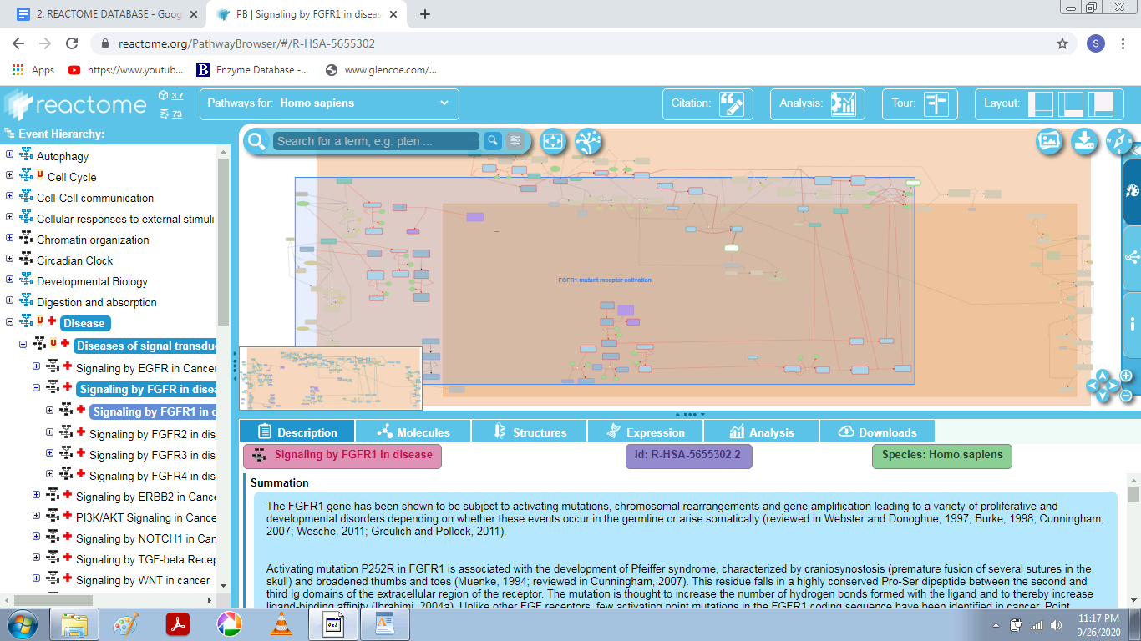

In the description tab, we can see that the **summation** of the FGFR1 gene is given,

Below that disease tab is given and it mentions **‘Bone development disease and Cancer’.**

**2. Search for the reaction Defective MMADHC does not bind MMACHC:B12r.**

What type of defect has caused this loss of function? (Hint: look at the

Functional Status category for the reaction).

Defects in MMADHC cause methylmalonic aciduria and homocystinuria type cblD (MMAHCD; MIM:277410), a disorder of cobalamin metabolism characterized by decreased levels of the coenzymes adenosylcobalamin (AdoCbl) and methylcobalamin (MeCbl) (Coelho et al. 2008). There are 3 biochemical phenotypes for this disorder; sufferers with homocystinuria (mutants L259P, T182N and Y249C), methylmalonic aciduria (mutants S20*, and R54*), and combined homocystinuria and methylmalonic aciduria (mutants R250* and Y140*)

How many mutations of MMADHC are represented?

MMADHC L259P [cytosol] (Homo sapiens)

MMADHC R250* [cytosol] (Homo sapiens)

MMADHC R54* [cytosol] (Homo sapiens)

MMADHC S20* [cytosol] (Homo sapiens)

MMADHC T182N [cytosol] (Homo sapiens)

MMADHC Y140* [cytosol] (Homo sapiens)

MMADHC Y249C [cytosol] (Homo sapiens)

**Here the below Screenshot shows the interaction with other molecules:**

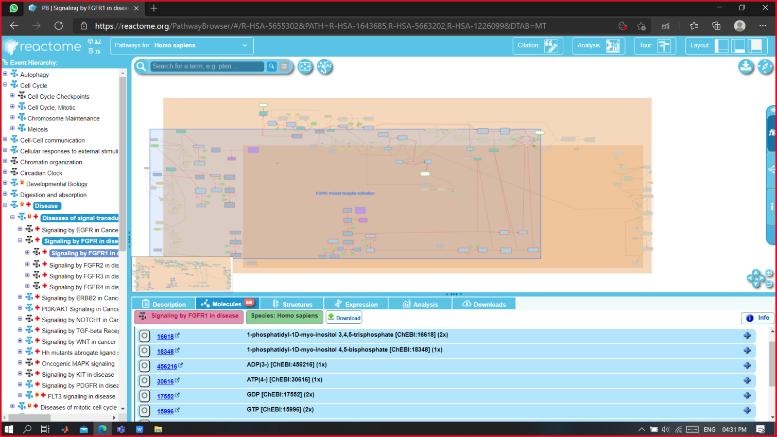

1. The molecules tab shows all the molecules of the complete pathway diagram.
2. Molecules are grouped in chemical compounds, Proteins, Sequences and other.
3. The molecules of a selected object appear highlighted in the diagram (as shown in the picture).
4. For each molecules we can see a symbol and a link to the main reference Database, a name and the number of occurrences in the pathway.
5. Clicking on the symbol several times will allow to circle through all **its occurrences** in the diagram.
6. Expanding by clicking on the **‘+’** will provide with further external links.
7. Lists can be downloaded. Just click on the button in the top right corner, select the fields and types with interest and click **‘Start Download’**.

**In the expression tab we can view the expression level of the disease related molecules :**

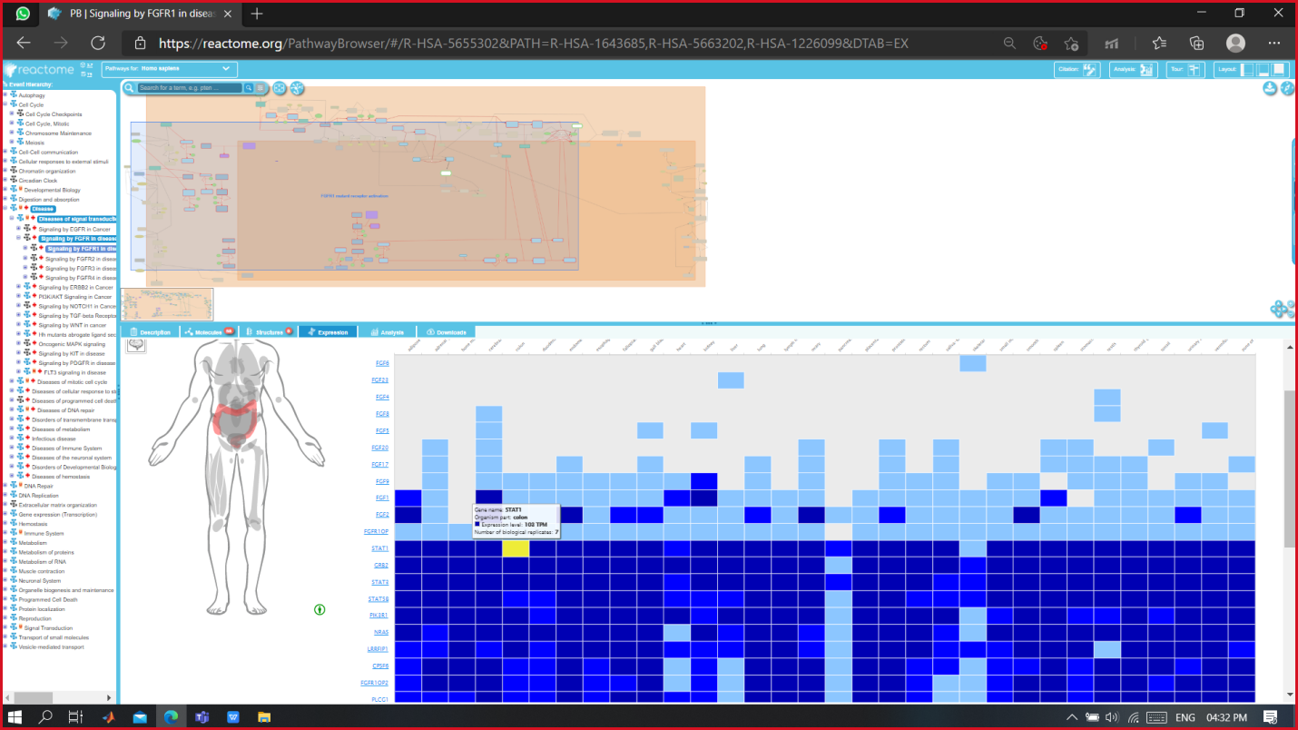

The expression tab gives the amount of molecule expressed in various parts of the body.

**How to look for the expressions?**

When we hover the mouse cursor over the expression blocks we can see the organ highlighted on which that expression is concerned.

**The darker blue color blocks show greater expression rates as compared to light blue zones.**

**When we click on any molecule from the tab to see its expression, the below window opens. The selected molecule is the highlighted in the network.**

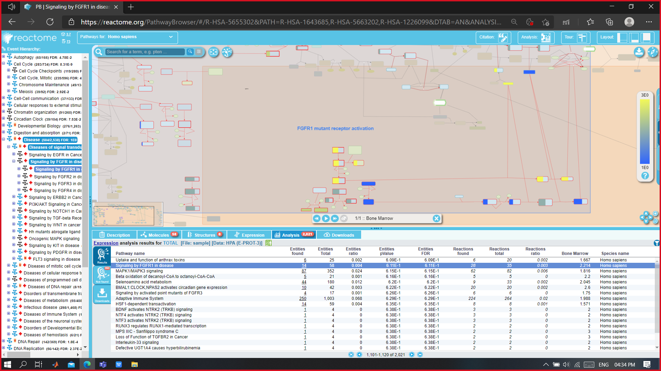

**Further zooming-in : We can visualize the network molecules with their interactions.**

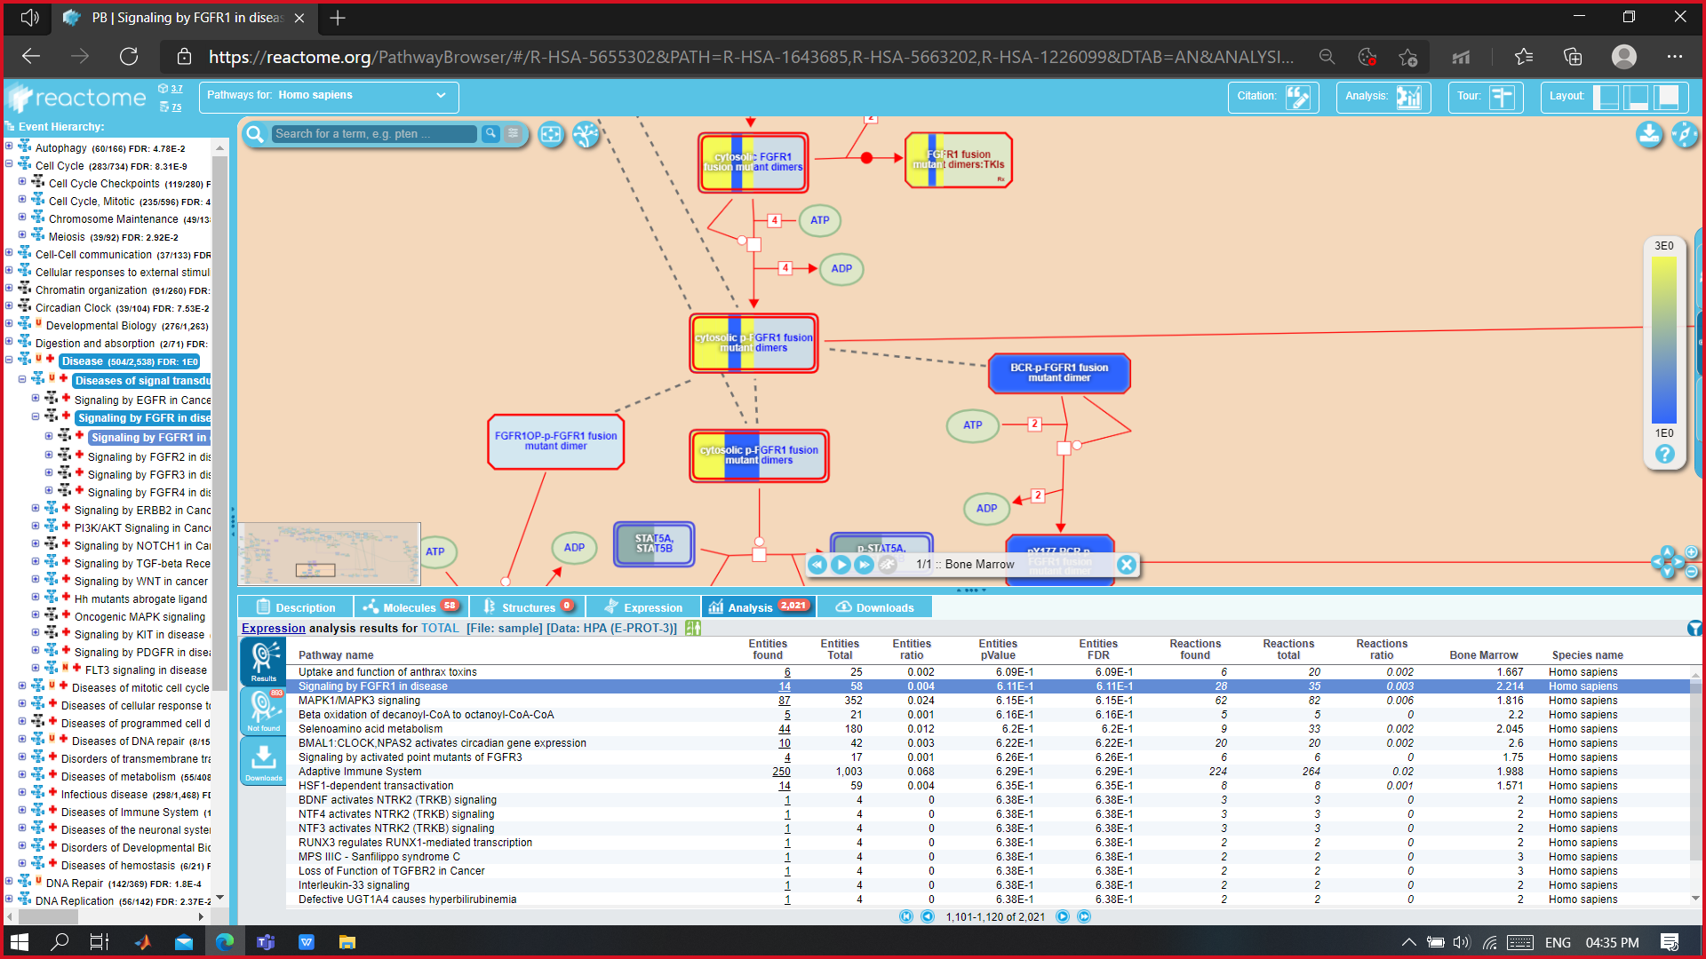

Here we can see the signaling of FGFR1 in disease.

From the download tab, we can download the structural data of any molecule of interest:

We can choose from various formats available for downloads for **Pathway Format** and for **Pathway Diagram**

**Pathway Formats:**

* SBML
* SBGN
* BIOPAX 2
* BIOPAX 3
* PDF

**Pathway Diagram formats:**

* SVG
* PNG
* JPEG
* GIF

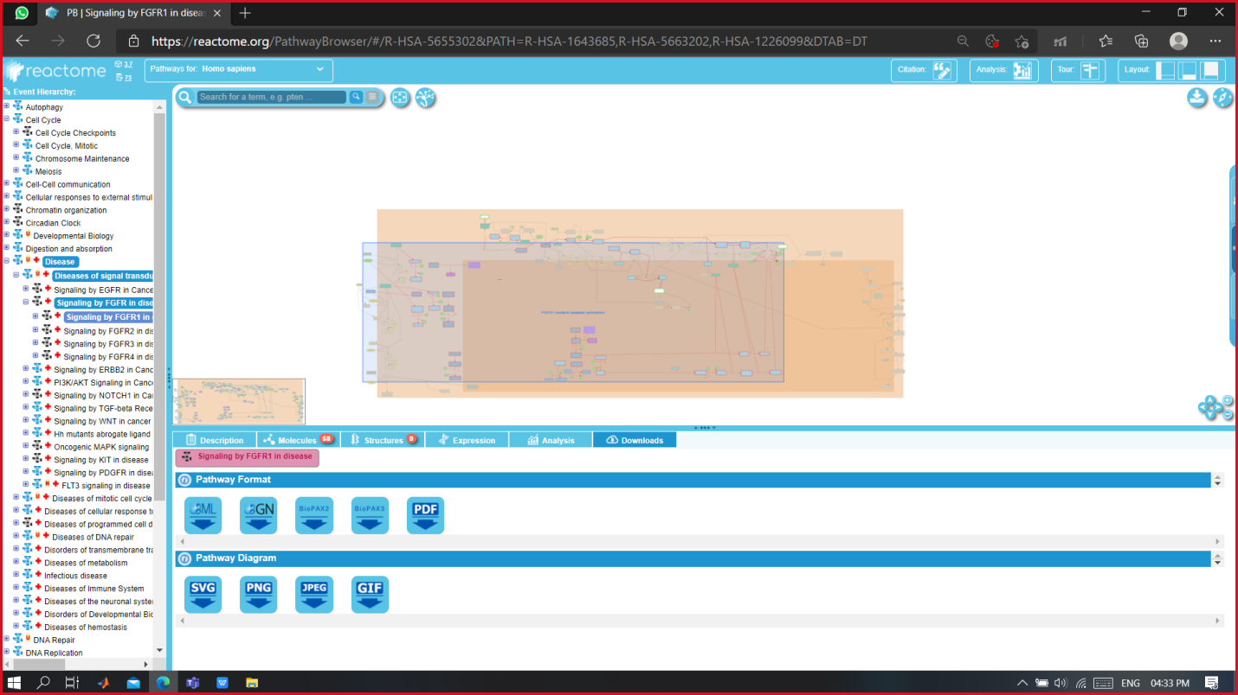

**Species Comparison Analysis**

If we wish to compare the molecule or pathway of interest of one organism to another we can do that too:

Click on the analysis button on the top right bar.a window will pop up: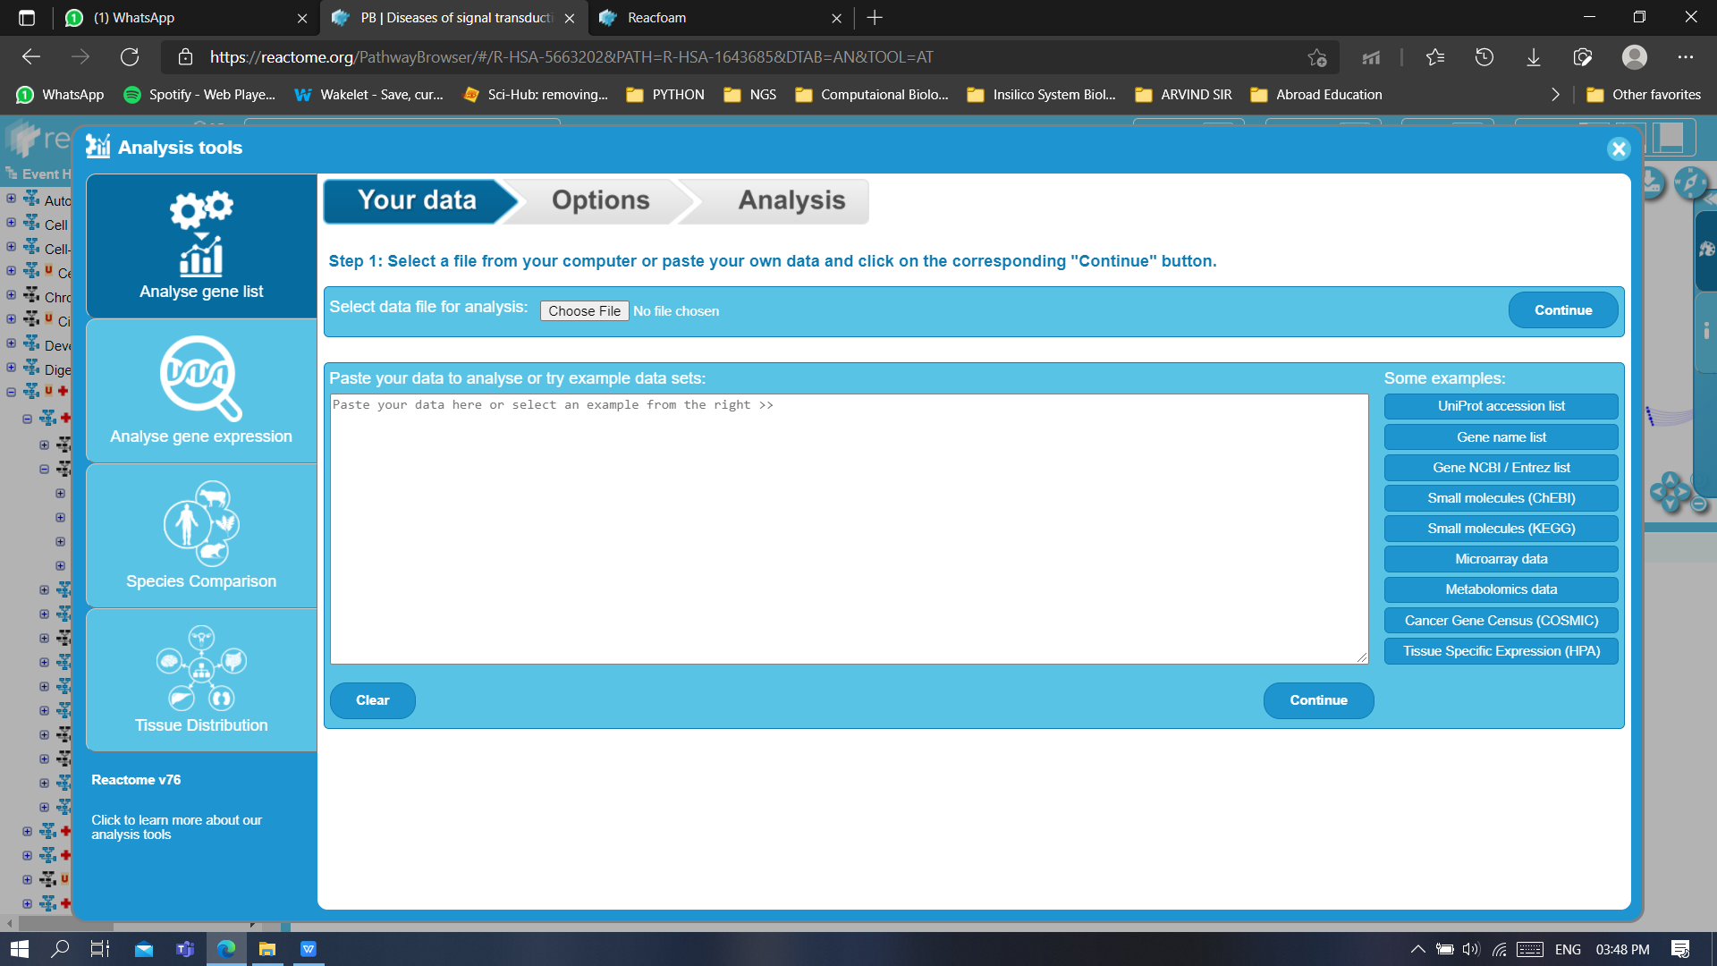

1. Here we get different options for our analysis. Lets go to Species comparison:

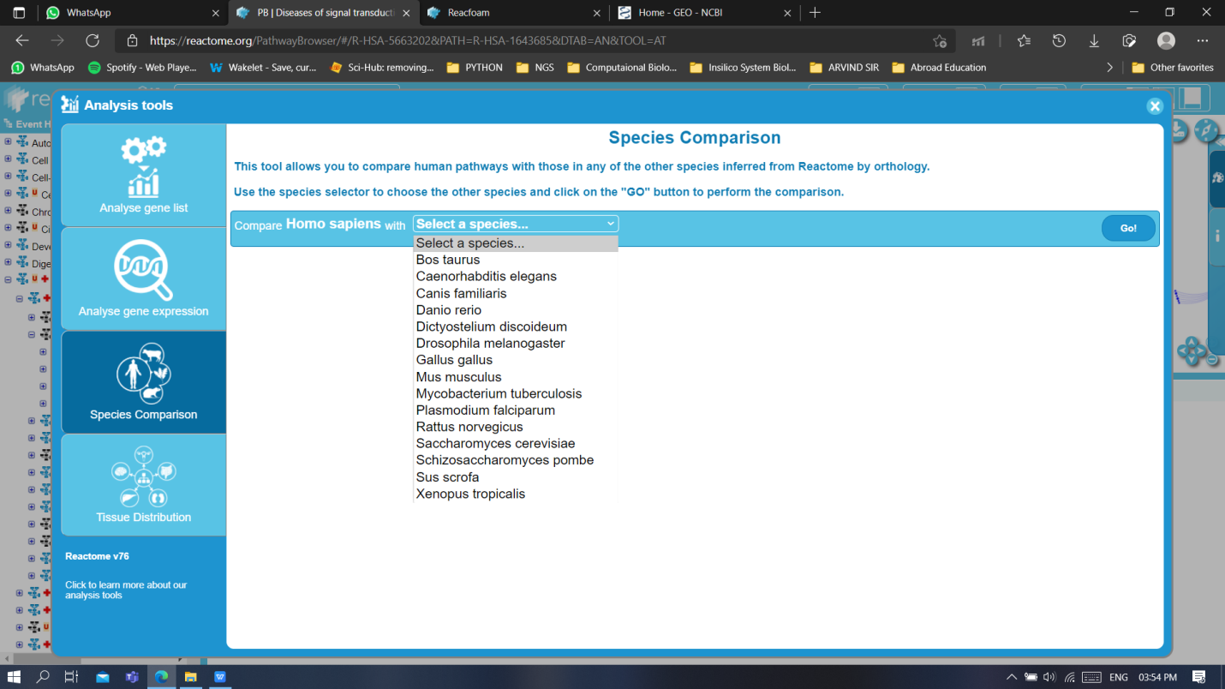

1. From the drop-down menu let’s choose *Mus musculus* and hit **GO!**.
2. We can now see the comparison of *Homo sapiens* with *Mus musculus.*

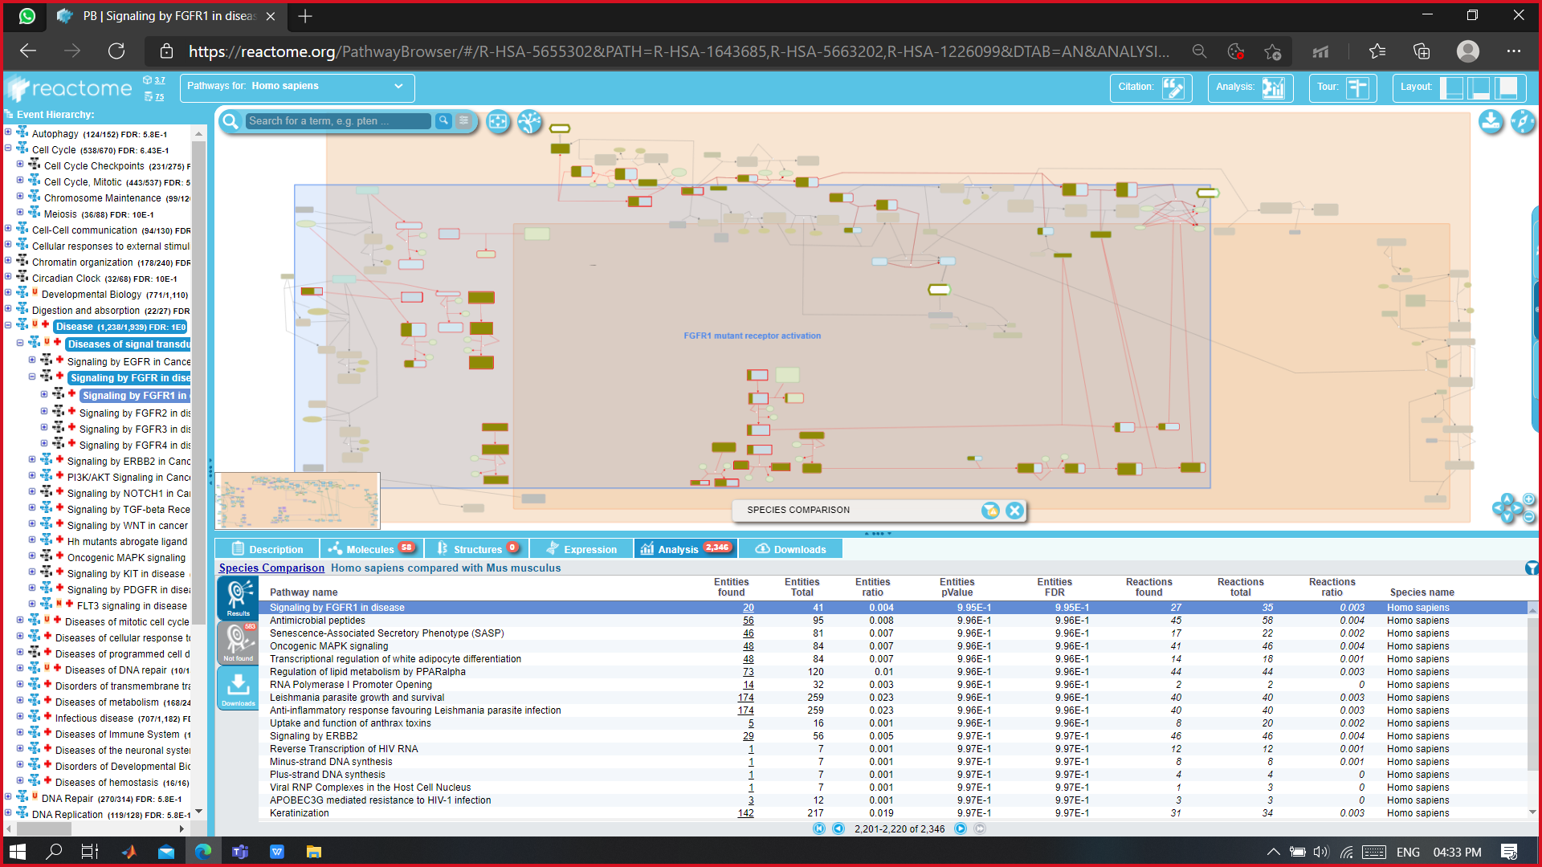

**There are various other species as well with which these comparative analysis can be seen.**