**EXPERIMENT -6**

**AIM:** To explore the Brenda Database and search for all the glycolytic enzymes.

URL - <https://www.brenda-enzymes.org/index.php>

**Q1. What is BRENDA database?**

BRENDA (BRaunschweig ENzyme DAtabase) is a comprehensive relational database on functional and molecular information of enzymes, based on primary literature.

* The database contains information extracted and evaluated from approximately 46 000 references, holding data of at least 40 000 different enzymes from more than 6900 different organisms, classified in approximately 3900 EC numbers.
* BRENDA was created at the former German National Research Center for Biotechnology (GBF, now HZI, Helmholtz Zentrum für Infektionsforschung, Braunschweig, Germany) in 1987.
* First online version in 1998 via the SRS system at the EBI.
* BRENDA is an important tool for biochemical and medical research covering information on properties of all classified enzymes, including data on the occurrence, catalyzed reaction, kinetics, substrates/products, inhibitors, cofactors, activators, structure and stability.
* 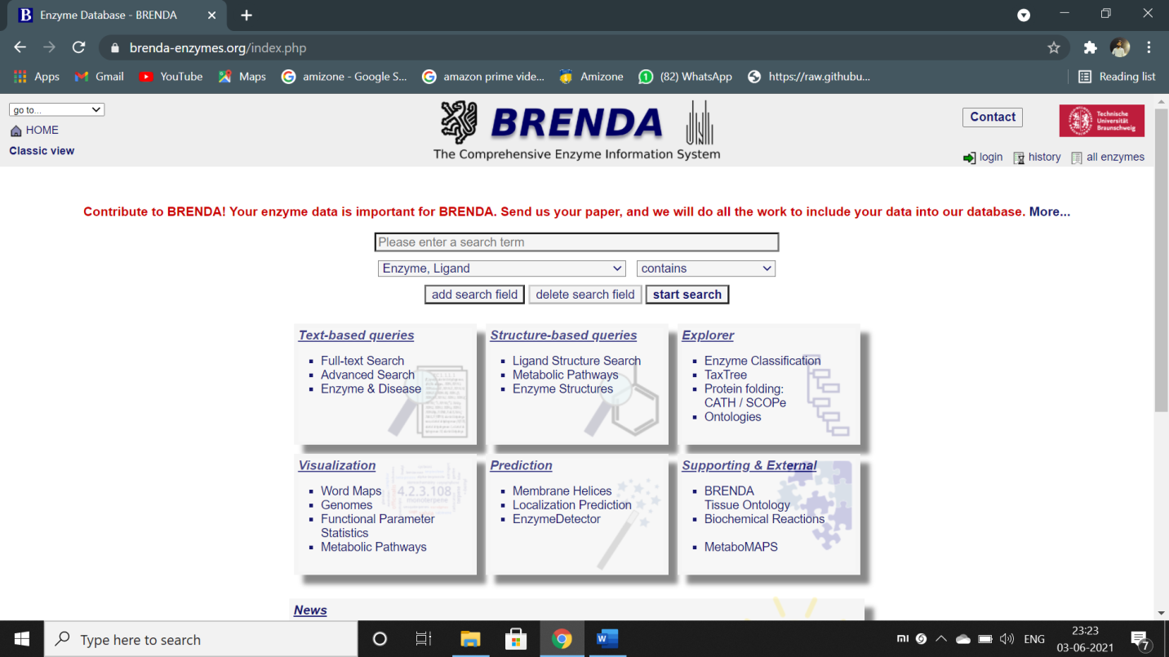

Figure – home page of Brenda database

**Q2. What is EC number?**

**Ans.** Enzyme Commission numbers (EC Numbers) are defined according to the catalyzed reaction

by the IUBMB (International Union of Biochemistry and Molecular Biology). The enzymes are classified according to the Enzyme Commission list of enzymes. Some 6500 "different" enzymes are covered. Frequently enzymes with very different properties are included under the same EC number.

**Q3. What types of information provided by BRENDA?**

**Ans.**  Information that we get from the BRENDA database are :

* Enzyme and ligand nomenclature
* Organisms
* Reaction and specificity
* Kinetic energy
* Structure and role of ligand
* Stability information
* Ligand - enzyme information
* Enzyme sequence and structure
* Mutants and disease
* Occurrence, isolation and properties

**Q4. What are the different types of search features provided in the BRENDA database?**

**Ans.** BRENDA is stored as a relational database, containing all data in 46 tables, enabling different queries. Different search features provided in BRENDA are:

* The quick search mode provides easy access to the data of each information field individually. The search results are displayed in a comprehensive table format and also as a compact printable version. The table version includes links to a reference-specific view, pictures of molecules functioning as ligands, Gene Ontology (GO) definitions, PDB entries, amino acid sequences and cross-references to other databases.
* The advanced search mode allows one to combine 25 different query criteria. In addition to the possibility of restricting the query to a unique organism, the search can be extended to an upper level of a branch of the BRENDA taxonomy tree (TaxTree).
* The BRENDA TaxTree is based on the tree published by the NCBI. The TaxTree search allows users to browse and search for organism names or nodes in the NCBI taxonomy browser. In addition, a search can be performed on organisms that are stored only in BRENDA but do not occur in any sequence database. Special features show the availability of data for a specific organism class or organism in BRENDA.
* The ECTree in BRENDA displays the enzyme classification as defined by the IUBMB.

**Home Page:**

**Searching for following enzymes :-**

**1. Protease**

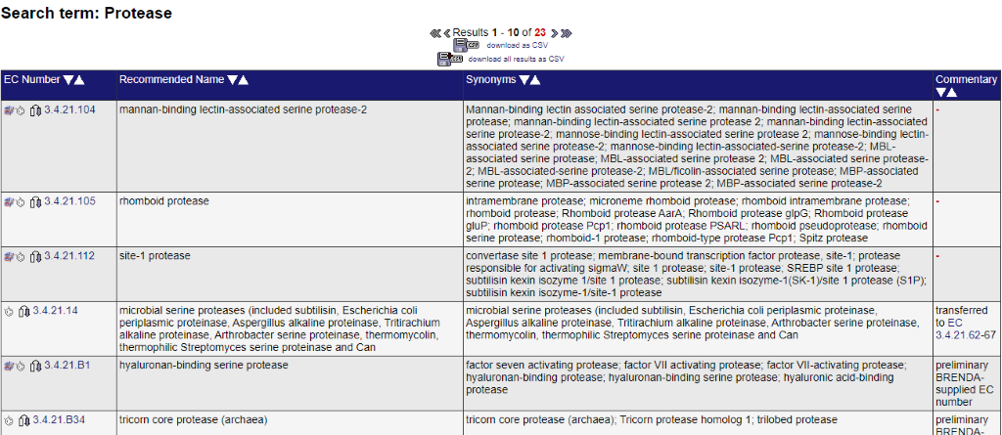

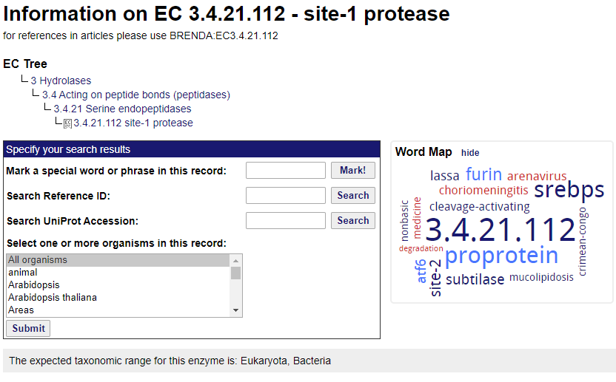

The enzyme appears in viruses and cellular organisms. **Protease** refers to a group of **enzymes** whose catalytic function is to hydrolyze peptide bonds of proteins. They are also called **proteolytic enzymes** or proteinases.

There are various parameters mentioned.

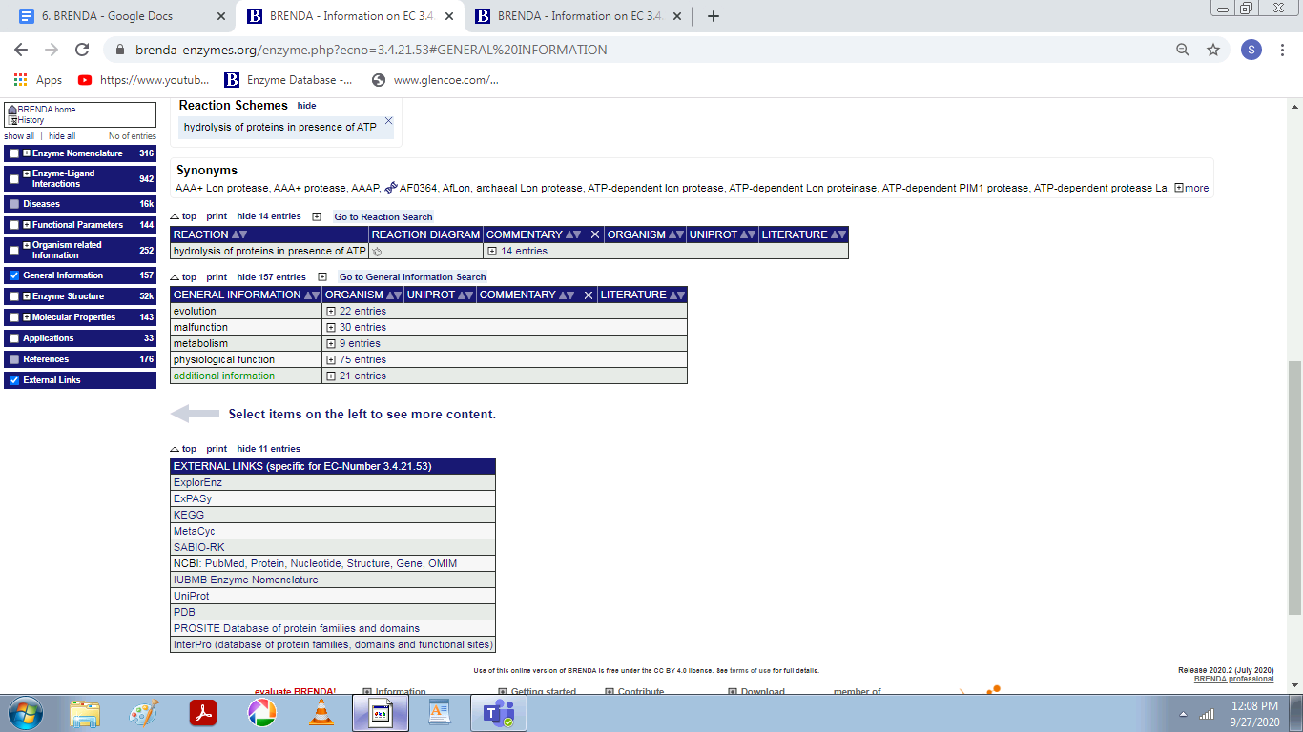

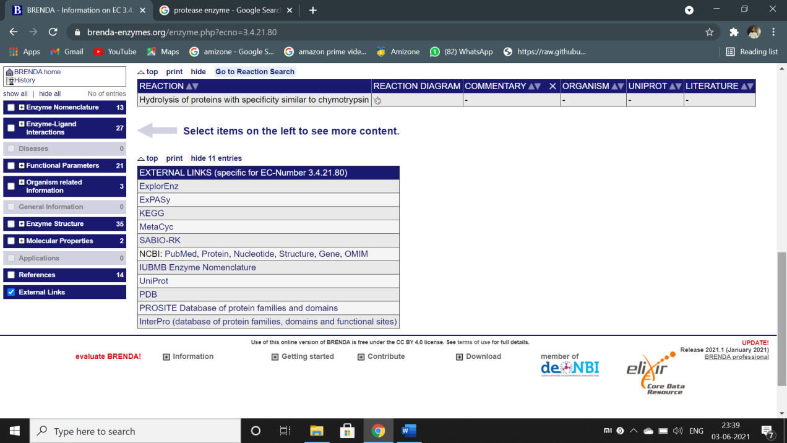

**Figure – external links to refer to other databases.**

**2. LIPASE**

**Lipase**, any of a group of fat-splitting enzymes found in the [blood](https://www.britannica.com/science/blood-biochemistry), gastric juices, pancreatic secretions, intestinal juices, and adipose tissues. Lipases hydrolyze [triglycerides](https://www.britannica.com/science/triglyceride) (fats) into their component [fatty acid](https://www.britannica.com/science/fatty-acid) and [glycerol](https://www.britannica.com/science/glycerol) molecules.

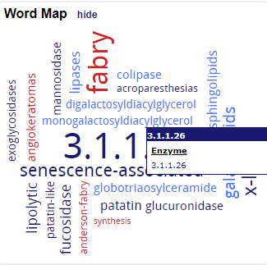

The enzyme appears in viruses and cellular organisms

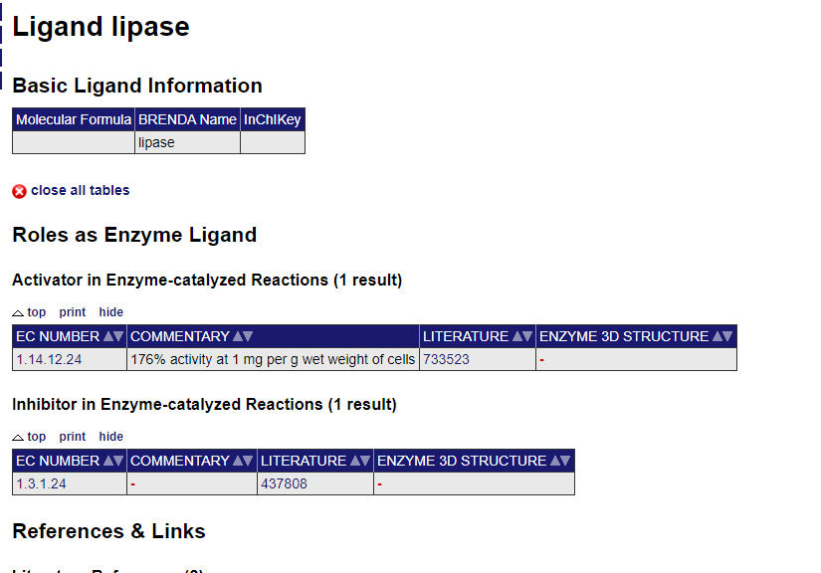

There are various external links and references in BRENDA. There are journals authors mentioned for each reference.

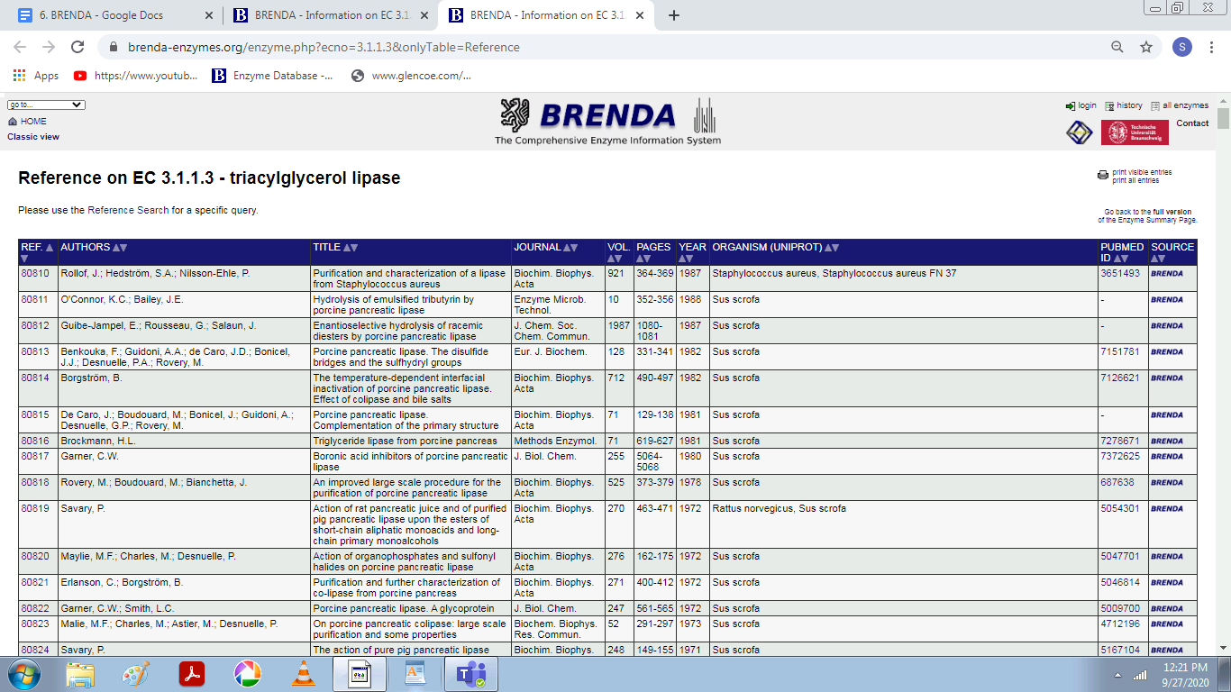

**3. DNA POLYMERASE**

A DNA polymerase is a member of a family of enzymes that catalyze the synthesis of DNA molecules from nucleoside triphosphates, the molecular precursors of DNA. These enzymes are essential for DNA replication and usually work in groups to create two identical DNA duplexes from a single original DNA duplex.

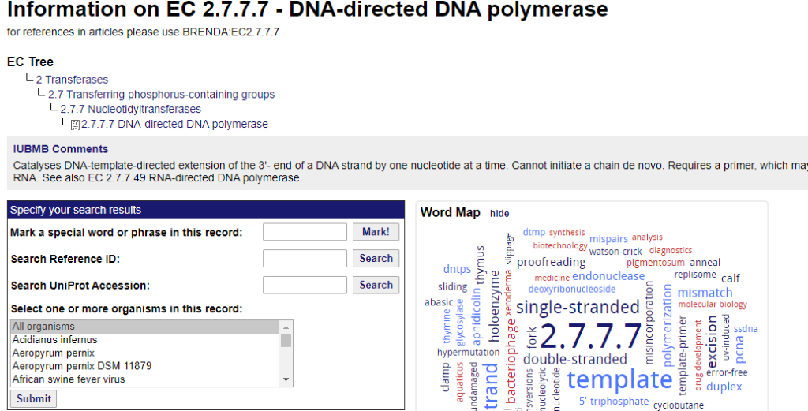

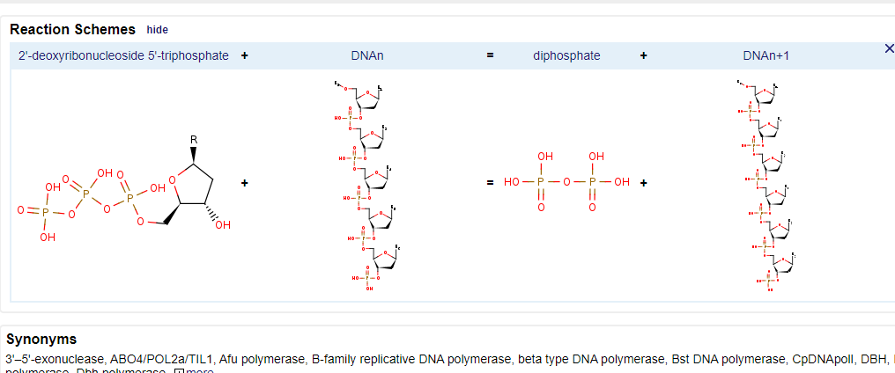

**4. DNA LIGASE**

DNA ligase is a DNA-joining enzyme. If two pieces of DNA have matching ends, ligase can link them to form a single, unbroken molecule of DNA.

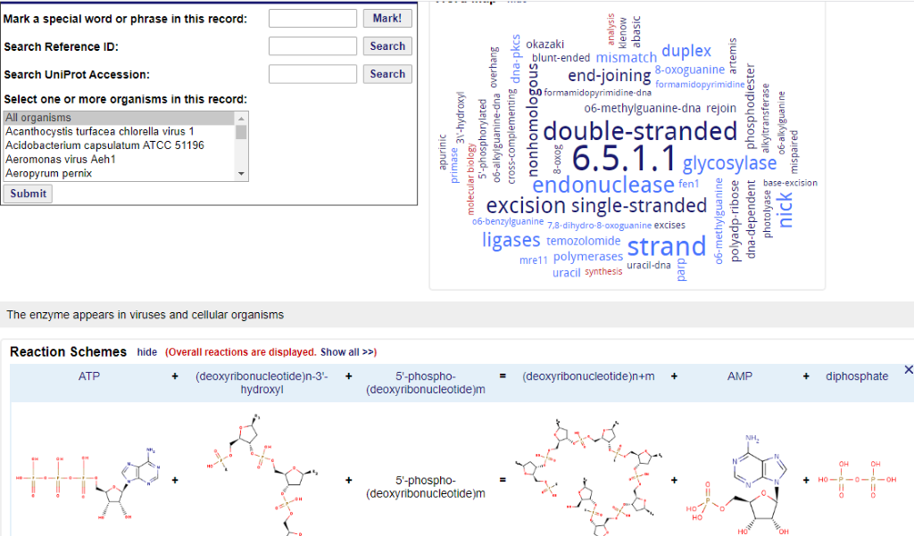

**5. SUCRASE**

Sucrase, also called Invertase, any member of a group of enzymes present in yeast and in the intestinal mucosa of animals that catalyze the hydrolysis of cane sugar, or sucrose, to the simple sugars glucose and fructose.

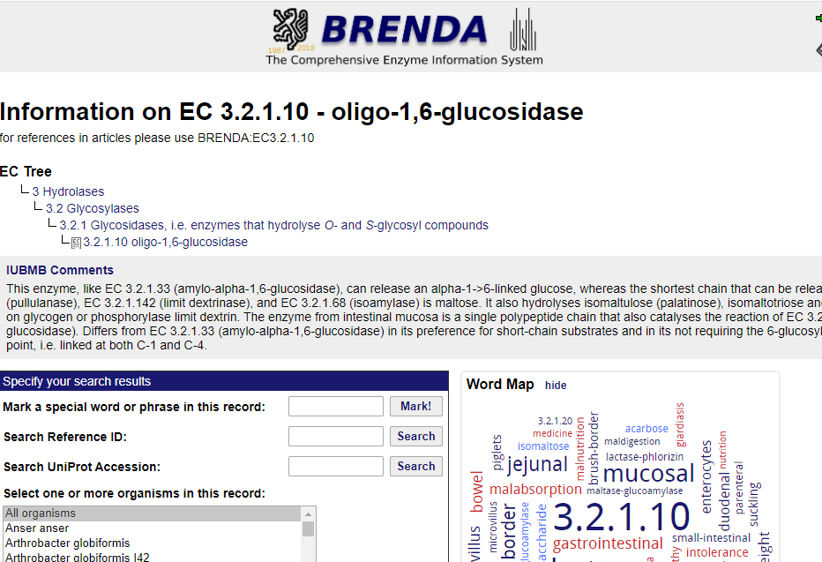

**6. AMYLASE**

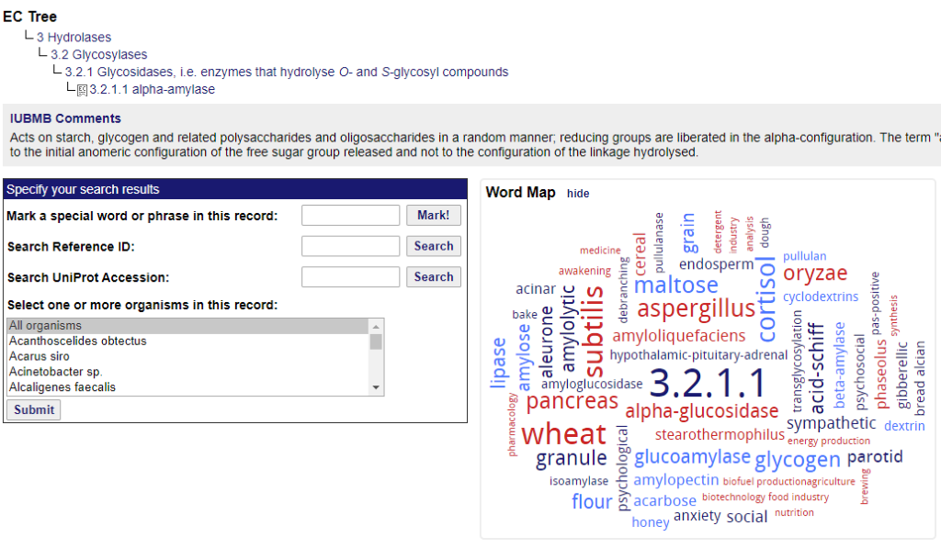

**6. TRYPSIN**

