**EXPERIMENT 8**

**AIM:** To download and study the SBML file of yeast glycolysis by Teusink B. et al from BioModels database (BIOMD0000000064)

SBML definition:

Systems Biology Markup Language (SBML) is a xml (eXtensible Markup Language) based language. It is a description language for simulations in systems biology. SBML is suitable for representing biochemical networks, which includes cell signaling pathways, metabolic pathways, biochemical reactions, gene regulation, and many others. It is a represented format of computational models. Modeling process involves the following steps. SBML allows models of uniformed complexity to be represented. Each type of model is described using a specific type of data structure which organizes the relevant information. The data structures conclude how the resulting model is encoded in XML.

Levels in SBML:

In SBML Level 1 Version 2, the term specie has been replaced with the species throughout the speciﬁcation. Models written in SBML Level 1 Version 2 format should use the new spelling. SBML Level 1 Version 2 should accept both spellings on input for all elements and attributes where the term occurs. Each species in the pathway is replaced by species id ,like in glycolysis glucose can be represented as [S1]. In this level, all the enzymes are represented away from the reactions [mentioned separately].

In SBML Level 2, the species spelling will be removed entirely and only species will be used. Finally, note that the deﬁnition of Species in SBML requires a species in a model to be located within a compartment. That compartment should define any species. One exception in this case is degenerative models does not have any species or reactions.

SBML Level 1 supports non-spatial biochemical models and the operations that are possible in existing analysis or simulation tools. The potential features that have been intentionally omitted from the language deﬁnition in Level 1. We expect that subsequent release of SBML will add the possible features which are not included in Level1. As mentioned above, SBML Level 1 provides the most basic foundations for modeling biochemical networks. Some of the signiﬁcant features that are missing from Level 1; these will be included in the next Level of SBML.

In SBML, level 3 is defined as a latest version which is having a defined core set of features and optional packages adding features to the core. In this approach model can declare which feature sets they use and software tools they can declare which packages they support. SBML Level 3 package development is today an ongoing activity

The additional features that are likely be included in SBML Level 2 or 3 are Arrays, connections, Database Interoperability, Geometry, Submodels, component Identification, References, Diagrams.

Example of SBML file format is shown below.

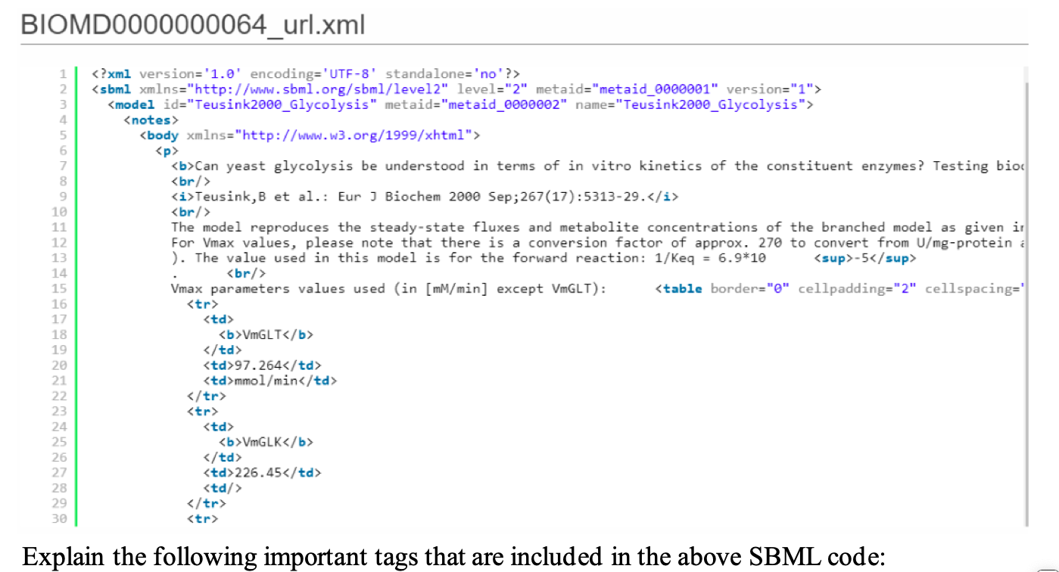

**Body**: It defines the information and details about the model.

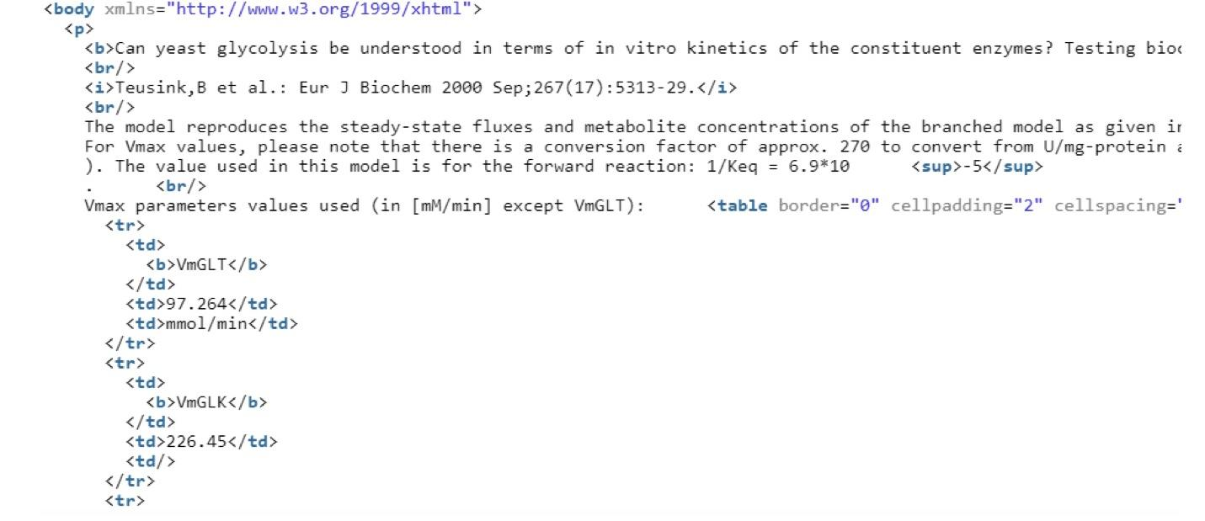

**End of the body:**

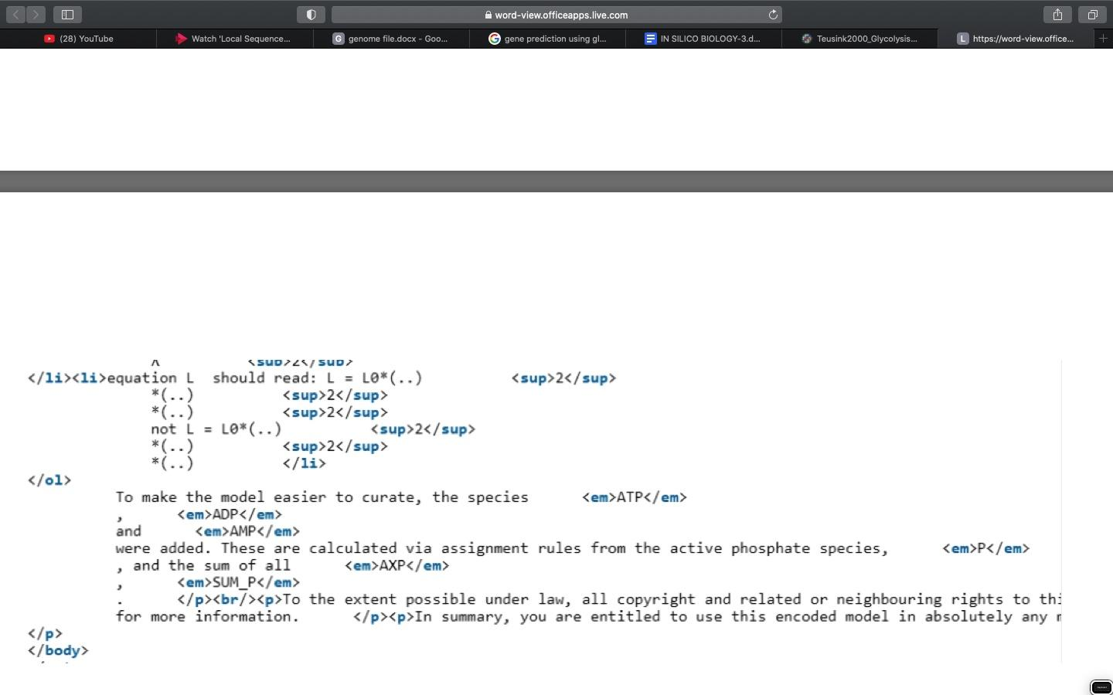

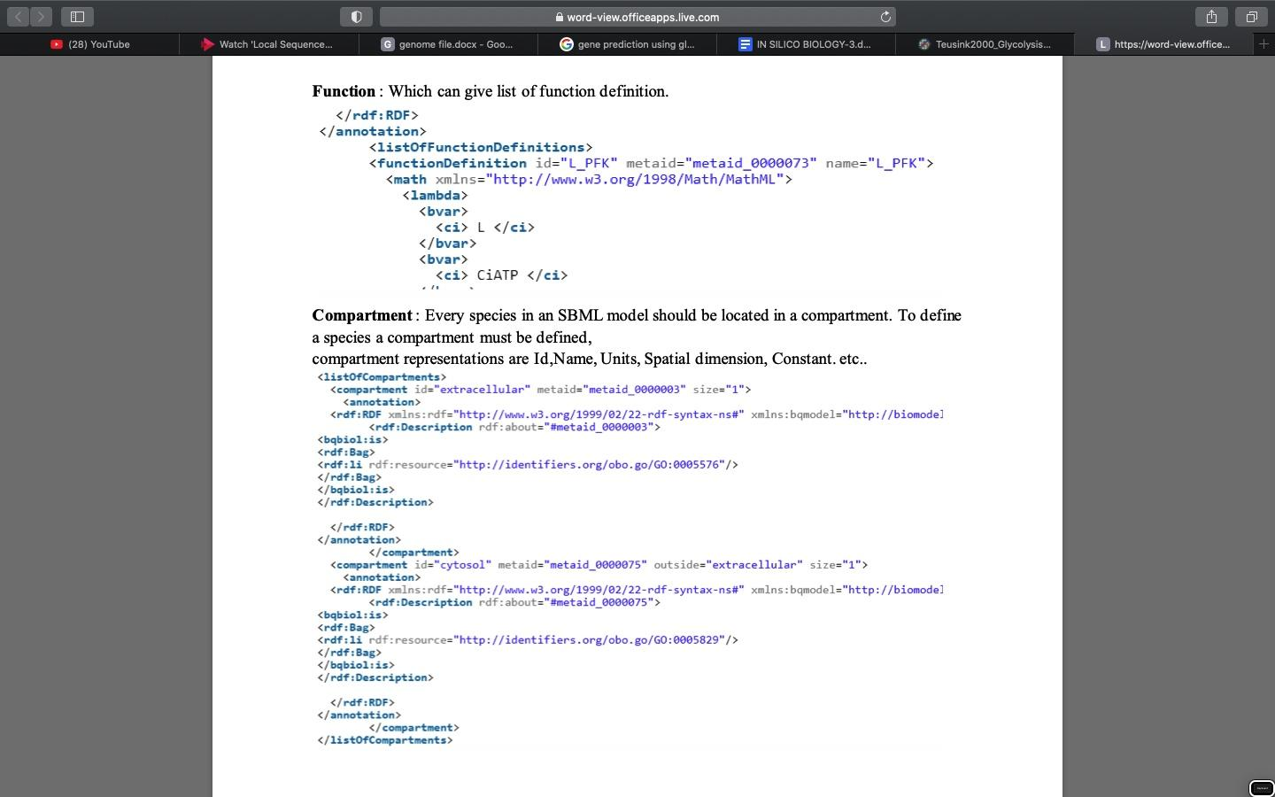

**Species: It corresponds to the objects or substances in the model.**

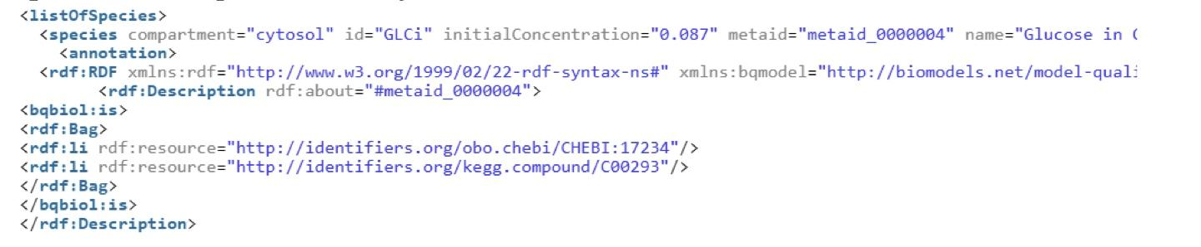

**Parameters : It represents the different parameters required to develop a model.**

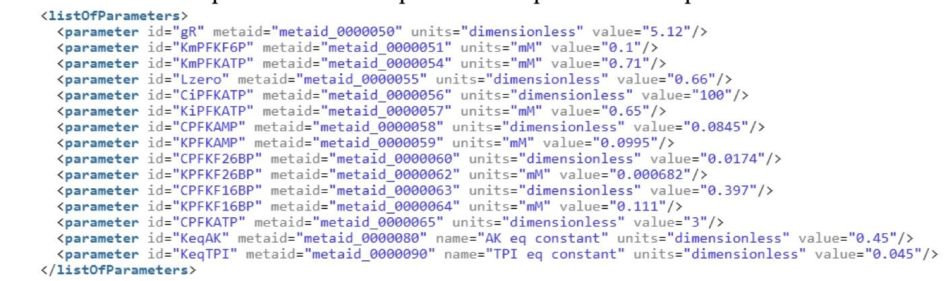

**RULES:**

1. **Rate rule:**

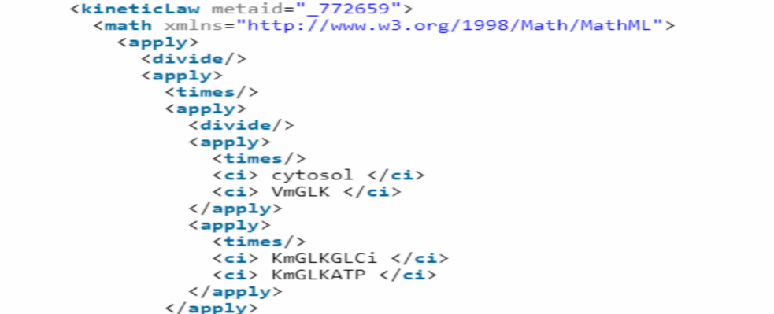

1. **Algebraic rule**

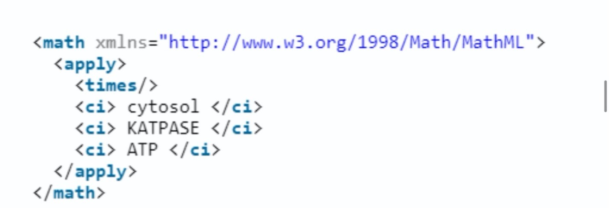

**3.Assignment rule :** 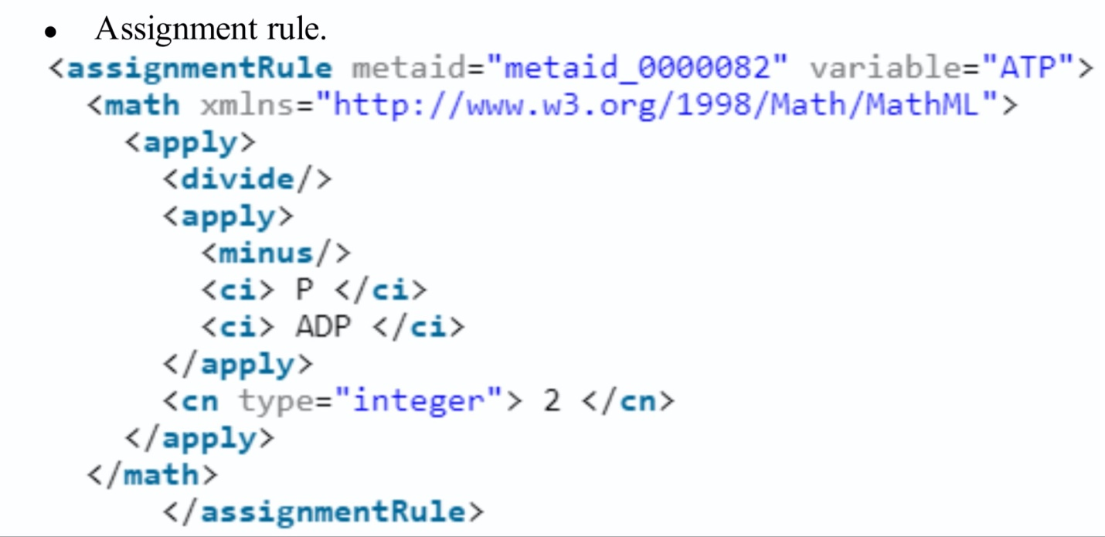

**REACTION:**

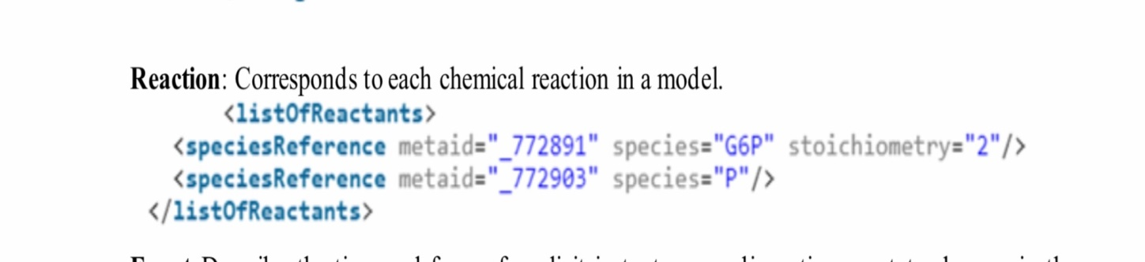

**Event:** Describe the time and form of explicit instantaneous discontinuous state changes in the model.

**Product:** It describes the end product of the reactions in the model.

**Modifier**: Represents the enzymes ( inhibitor / catalyst)