**EXPERIMENT – 9**

**AIM:** To explore *E. coli* metabolic model in MetaNetX

**MetaNetX**

**URL-** <http://metanetx.org>

**Theory-** MetaNetX.org is a website for accessing, analysing and manipulating genome-scale metabolic networks (GSMs) as well as biochemical pathways. It consistently integrates data from various public resources and makes the data accessible in a standardized format using a common namespace. Currently, it provides access to hundreds of GSMs and pathways that can be interactively compared (two or more), analysed (e.g. detection of dead-end metabolites and reactions, flux balance analysis or simulation of reaction and gene knockouts), manipulated and exported. Users can also upload their own metabolic models, choose to automatically map them into the common namespace and subsequently make use of the website’s functionality.

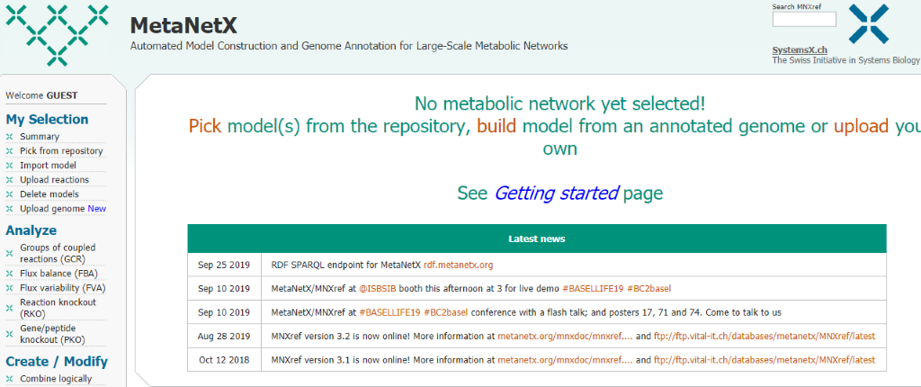

Figure – home page of MetNetx.

**Procedure-**

1. To explore E coli metabolic pathway, we first have to choose a model from the repository through pick from repository option from left column options.

2. Select the E. coli species. Any interested strain can be selected and also more than one model can also be picked.

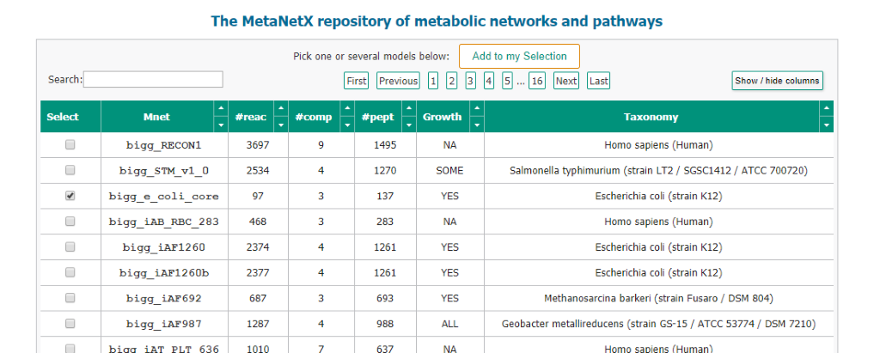

3. After selecting click on Add to my Selection button and choose the column number whose information you want to collect.

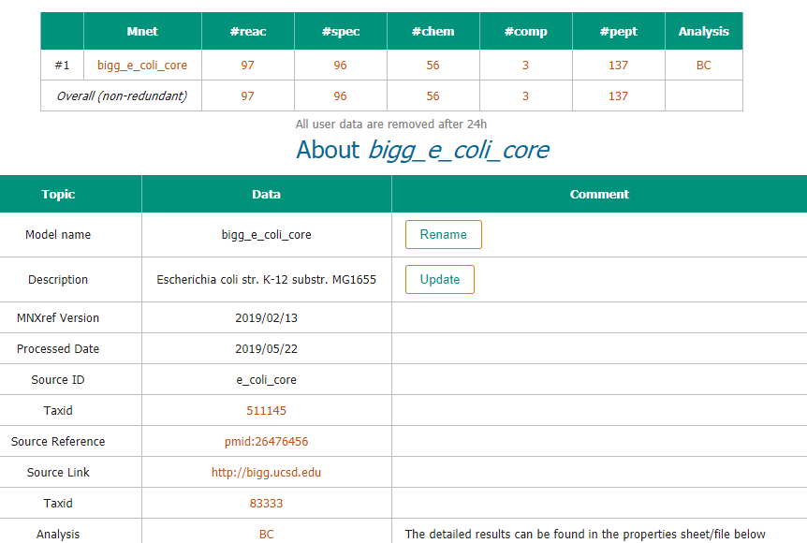

4. For the reactions involved we can choose #reac option and get the following results.

