# AI-Powered Detection of Deepfakes and Fake News

## **Introduction**

The rapid advancement of AI technology has made it easier to generate fake narratives using **deep fake videos** and **fake news articles**. These manipulated media pieces spread misinformation, mislead audiences, and contribute to **political, social, and economic instability**.

Deepfake videos, created using **Generative Adversarial Networks (GANs)**, can synthesize realistic yet fake video and audio, making it difficult for the average user to differentiate between real and fabricated content. The increasing sophistication of AI-based editing tools has allowed deepfakes to become more convincing, making their detection a challenging task.

Similarly, **fake news articles** utilize deceptive wording, fabricated facts, and misleading headlines to manipulate public opinion or influence behaviors. They are commonly disseminated through **social media, digital news platforms, and even reputable websites**.

To counteract this growing threat, this document proposes **AI-driven solutions** to detect deep fake videos and identify fake news. These solutions integrate **deep learning, Natural Language Processing (NLP), and blockchain technology** to improve detection accuracy and prevent the spread of false narratives.

## 2. **Deepfake Video Detection System**

### **2.1 Proposed Solution**

The deep fake detection system combines **advanced deep learning models, motion analysis, and blockchain verification** to assess the authenticity of video content.

### **Key Components of the Solution:**

1. **Facial Recognition & Motion Analysis**: Identifies unnatural **facial expressions, blinking patterns, and movement inconsistencies**. Many deep fake videos fail to mimic realistic **eye blinks, facial muscle contractions, and head movements**.
2. **Audio-Visual Inconsistency Detection**: Uses **waveform synchronization techniques** to analyze whether spoken words match lip movements.
3. **Blockchain-based Verification**: Ensures content integrity by storing video metadata on a **decentralized ledger**, preventing tampering and ensuring authenticity.

### **Challenges in Detecting Deep Fakes:**

* **Rapid Evolution of AI**: New deepfake generation techniques, such as **Diffusion Models**, are improving **realism**, making detection increasingly difficult.
* **Adversarial Attacks on Detection Models**: Attackers can use **adversarial AI techniques** to bypass detection models by **introducing subtle modifications to deep fake videos**.
* **Edge AI for On-Device Detection**: Implement **on-device deepfake detection** using mobile-friendly models like **TensorFlow Lite** or **ONNX**, enabling detection without relying on cloud services.

### **2.2 Algorithm for Deep Face Detection**

#### **Preprocessing:**

* Extract video frames at **fixed intervals**.
* Use **MTCNN (Multi-task Cascaded Convolutional Networks)** or **Haar Cascades** for **face detection**.

#### **Feature Extraction:**

* Apply **CNN-based models** like **XceptionNet or ResNet-50** to analyze **facial patterns**.
* Identify **face embeddings** to detect inconsistencies in facial movements.

#### **Motion & Lip-Sync Analysis:**

* Use **Long Short-Term Memory (LSTM) models** to track **smoothness and realism of movements**.
* Detects **lip-sync mismatches** using **Wav2Lip models** to verify whether **spoken words match lip movements**.

#### **Audio-Visual Correlation:**

* Extract **voice features** using **Mel-Frequency Cepstral Coefficients (MFCCs)**.
* Cross-check **speech and face movements** to detect **AI-generated synthetic voices**.

#### **Verification via Blockchain:**

* Store **video metadata** in a **blockchain ledger** for reference and validation.
* Compare newly uploaded videos against existing entries for **authenticity verification**.

### **2.3 Flowchart**

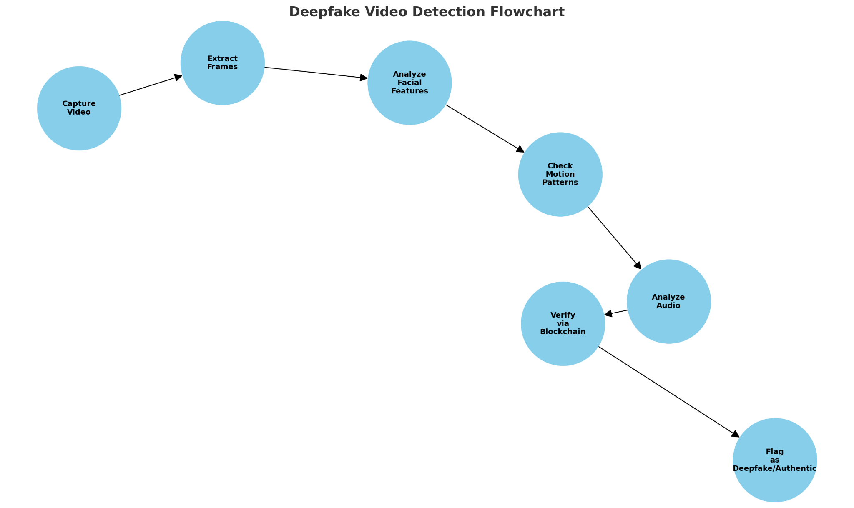

## 3. **Fake News Detection System**

### **3.1 Proposed Solution**

The **fake news detection system** integrates **Natural Language Processing (NLP), fact-checking APIs, and credibility scoring mechanisms** to evaluate the authenticity of news articles.

### **Key Components of the Solution:**

1. **Content Analysis**: Uses **BERT, GPT, and RoBERTa deep learning models** to evaluate **linguistic patterns** and detect **misinformation indicators** such as **biased narratives, emotionally charged language, and hyperbole**.
2. **Source Verification**: Cross-checks information with **Google Fact-Check API, PolitiFact, and Snopes** to confirm authenticity.
3. **User Feedback & Crowdsourcing**: Enables **community-driven credibility scoring** and reporting of **suspicious articles**.

### **Challenges in Detecting Fake News:**

* **Fake News in Different Languages**: Most fake news detection models focus on English, but **misinformation exists in multiple languages**, requiring **multilingual NLP models**.
* **Social Media Spread & Virality**: Fake news spreads **faster than real news**, making **real-time detection essential** for mitigation.
* **Network Analysis of Fake News Propagation**: Analyzing **how fake news spreads** across social networks using **graph-based AI models** can improve detection.

### **3.2 Algorithm for Fake News Detection**

#### **Data Preprocessing:**

* **Tokenization, stop-word removal, and stemming.**
* Convert text into **numerical representations** using **TF-IDF, Word2Vec, or BERT embeddings**.

#### **Content Analysis:**

* Apply deep learning models like **BERT, RoBERTa** to detect **manipulative language patterns**.
* Identify **emotion-laden text, exaggerated claims, and misleading headlines**.

#### **Source Verification:**

* Compare **article sources** with a **database of trusted sources**.
* Use **fact-checking APIs (Google Fact-Check API, PolitiFact API)** for **real-time verification**.

#### **Cross-Referencing with News Aggregators:**

* Validate news against **reputable sources (BBC, Reuters, NYT, etc.)**.
* Assign **credibility scores** based on **fact-match percentage**.

#### **User Feedback System:**

* Allow users to **report suspicious articles**.
* Use **reinforcement learning** to improve **model accuracy over time**.

### **3.3 Flowchart**

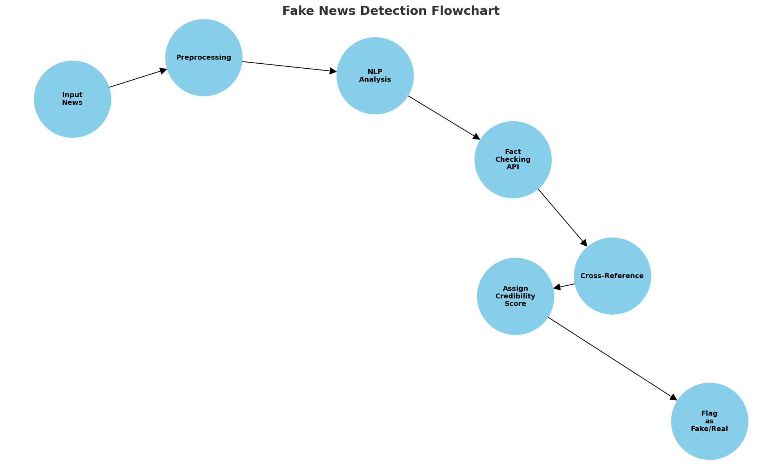

## 4. **Implementation and Technical Framework**

* **Deep Face Detection Tech Stack:** Python (TensorFlow, PyTorch, OpenCV), MongoDB, Ethereum Blockchain, React.js, Flask API.
* **Fake News Detection Tech Stack:** Python (NLTK, SpaCy, Transformers), MySQL, Fact-Check APIs, React.js, Flask API.

## 5. **Anticipated Outcomes**

### **Expected Benefits:**

1. **Increased Trust in Online Media**: Users will be able to verify **video authenticity before sharing**.
2. **Reduced Spread of Fake News**: AI-powered **automatic detection** will **flag false information** before it reaches a large audience.
3. **Scalability**: The solution can be **expanded to social media platforms, news portals, and governmental fact-checking agencies**.
4. **Integration with Law Enforcement**: Helps in detecting and preventing the spread of **harmful or criminal misinformation**.
5. **Improved Media Literacy**: Educates users about **how to recognize manipulated content**.

## 6. **Conclusion**

By integrating **AI-driven deep face detection and fake news verification**, this solution contributes to a more **reliable digital information ecosystem**. However, continuous **advancements in adversarial AI and misinformation tactics** require ongoing **research and updates** to improve detection accuracy.