Top 5 Richest Authors of All Time

1. Elisabeth Badinter – Net Worth: $1.3 Billion

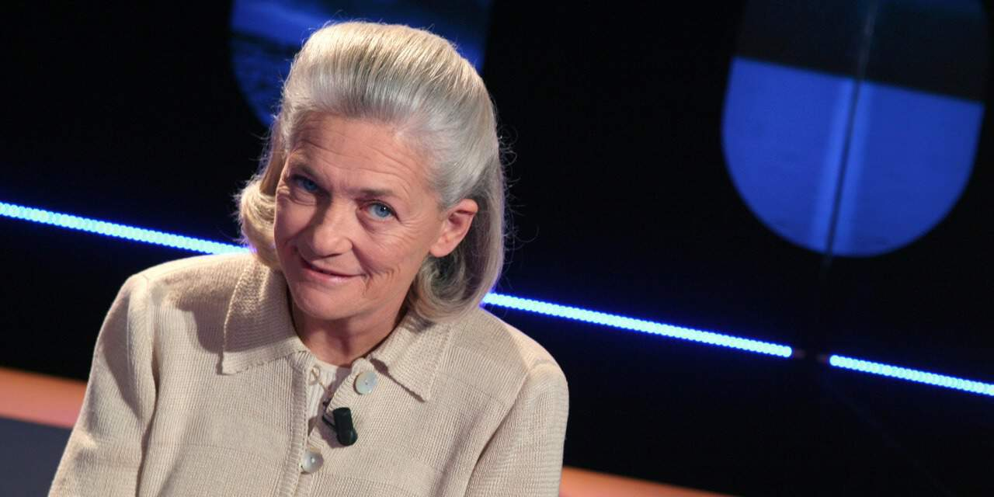

French philosopher, author and historian Elisabeth Badinter, best known for her philosophical treaties on feminism and women’s role in society stands today as the richest author of all time. One of her last books, The Conflict: How Modern Motherhood Undermines the Status of Women, has become a bestseller in Europe after spurring heated debate back in 2010.

With only around two dozen books sold, she might not sound like the bestselling author you were expecting to find at the number one spot on this list. The thing is that she inherited much of her fortune through 19 million shares in the advertising and public relations giant Publicis Groupe.

Her net worth in 2019 was estimated at $1.3 billion, leading her to become the richest author of all time, even though it’s not through best sellers that she got there.

1. J.K. Rowling – Net Worth: $1 Billion

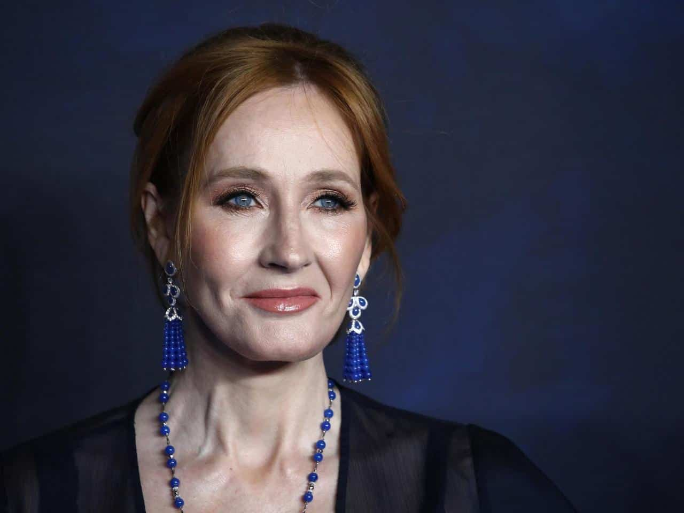

British author J.K. Rowling, Joanne Kathleen Rowling, is the world-famous creator of the highly successful Harry Potter book series, which has gathered such a following that the Harry Potter franchise has also become the highest-grossing film series of all time.

With multiple awards won and more than 500 million copies sold worldwide, the Harry Potter series has become the best-selling book series in history.

It should then come as no surprise that J.K. Rowling’s net worth has hit the mark of $1 billion.

1. James Patterson – Net Worth: $560 Million

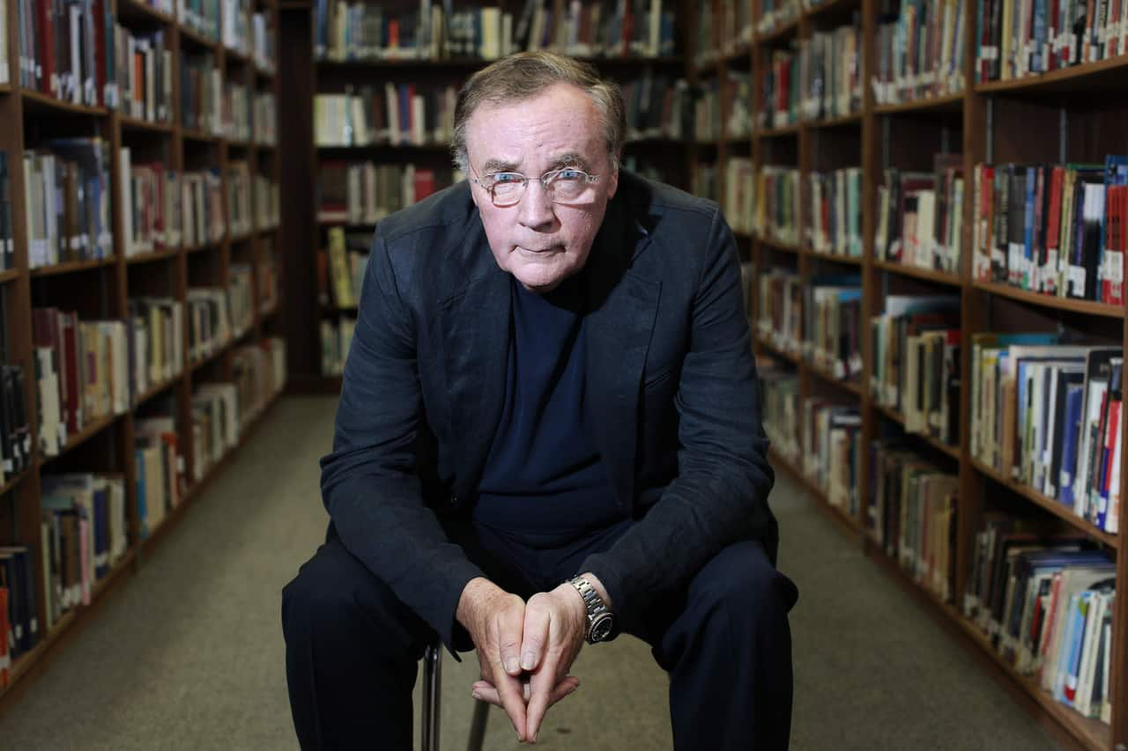

Well known for his thriller novels, of which he’s sold over 300 million copies all over the world, the American author James Patterson holds the record, a Guinness World Record in fact, for the most New York Times bestsellers by a single author.

His novels make for one in 17 of all hardcover novels ever sold in the United States. With such a huge success, it shouldn’t be any wonder as to how his net worth got where it is today. He’s amassed a whooping $560 million, thus becoming the third richest author in the world.

1. Stephen King – Net Worth: $400 Million



One of the most popular authors in the world, especially when it comes to horror, supernatural fiction, fantasy and suspense, Stephen King has reached success with books like The Shining or IT, which have further been adapted for the screen.

His 58 novels have sold more than 350 million copies worldwide, amassing a huge following from his fans worldwide, and a net worth that is estimated at $400 million in 2019.

1. Nora Roberts – Net Worth: $390 Million



Nora Roberts is known for her romance novels. Since she took on writing in the late 70s, scoring high with her 1985 bestseller Playing the Odds, she’s written over 200 novels. Today, she’s the fifth richest author in the world, with a wealth of no less than $390 million.