Cross-Domain Generalization of LSTM and GRU Networks: A Comparative Study on Traffic and Hydrological Time Series Forecasting

Sharw Prajapati
B.Tech. (Artificial Intelligence and Data Science)
University School of Automation and Robotics
Guru Gobind Singh Indraprastha University
Delhi, India
ssharwprajapati@gmail.com
Dr. Anuj Kumar
Assistant Professor (Supervisor)
University School of Automation and Robotics
Guru Gobind Singh Indraprastha University
Delhi, India

Abstract—LSTM and GRU are the two recurrent networks most often chosen for time series forecasting, but they are usually compared on one dataset with one training run, so a reported winner may not hold elsewhere. This paper compares them on two univariate series with very different behaviour: hourly westbound traffic volume on Interstate 94 and daily discharge of the Potomac River. Both networks use the same architecture, optimiser and early stopping rule. Each model was trained with several random seeds and compared with persistence, seasonal and linear baselines, and with three input window lengths. Both networks cut RMSE by about 70 percent on traffic and about 20 percent on river flow relative to persistence, and by about 40 and 10 percent relative to a linear Ridge model. At the main window lengths LSTM had slightly lower RMSE and MAE on both datasets, and GRU has 24 percent fewer parameters, but no difference between the two was statistically significant. Changing the window changed which network came first, again without significance. A single run first suggested the opposite ranking at the main window. In these experiments, window length and seed variation mattered at least as much as the choice of cell.
Keywords—LSTM, GRU, time series forecasting, traffic volume, river discharge, cross-domain comparison

Introduction
Forecasting the next value of a series from its own history is a routine task in transport planning, water management and many other fields. Recurrent neural networks suit it well, because they read a window of past observations in order and carry information forward. Long Short-Term Memory (LSTM) [1] and the Gated Recurrent Unit (GRU) [2] are the two gated designs people reach for first. An LSTM cell keeps a separate memory cell controlled by three gates. A GRU merges that memory into the hidden state and uses two gates, so it has fewer parameters and should be cheaper to train.
Many studies compare the two, and their conclusions differ. Some find LSTM more accurate, others find GRU more accurate or simply faster (see Section II). Part of the disagreement is probably real, since datasets differ. Part of it may be noise: a recurrent network trained twice on the same data with different random seeds does not give identical errors, and a small gap seen in one run can disappear or reverse in the next.
This paper asks a narrow question. If LSTM and GRU are given matched settings, does the better one stay the same when the data or the input window changes, and is the difference larger than seed-to-seed variation? To find out, we train both on two series from different domains. One is hourly traffic with sharp daily and weekly cycles. The other is daily river discharge, which is smooth and seasonal but has sudden flood peaks. Our contributions are:
- A like-for-like comparison of LSTM and GRU on two contrasting real series, with identical architecture, training rules and data handling.
- Multi-seed results reported as mean and standard deviation, with Welch t-tests, instead of a single run.
- Comparison with persistence, seasonal and Ridge regression baselines, to show how much the networks add beyond simple models.
- A look-back window study with three window lengths per dataset, and a record of how the traffic data was cleaned so the experiment can be repeated.

Related Work
Hochreiter and Schmidhuber introduced the LSTM to avoid the vanishing gradient problem of plain recurrent networks [1]. Cho et al. proposed the GRU as a lighter gated unit in the context of machine translation [2]. Chung et al. tested both against plain recurrent units on sequence modelling tasks and reported that gated units did better, without a clear separation between LSTM and GRU [3]. Greff et al. compared eight LSTM variants on speech, handwriting and music tasks and found that none improved significantly on the standard LSTM [4].
Applied comparisons point in different directions. For short-term PM2.5 prediction, Kristiani et al. compared CNN, RNN, LSTM, GRU, Bi-LSTM and Bi-GRU models and found the lowest RMSE with LSTM [5]. For electrical load, Abumohsen et al. compared LSTM, GRU and RNN and reported GRU as the most accurate [6]. Das studied the same Interstate 94 traffic dataset we use and found that neither model won consistently: GRU did better with short input windows and LSTM did better when long sequences mattered [7]. In hydrology, Kratzert et al. showed that LSTM networks can model rainfall–runoff relationships [8]. Velarde et al. released an open implementation of LSTM and GRU forecasters and found that on a stock price series both networks performed about as well as a baseline that repeats the last value [9].
Two broader works shape how we evaluate. Hewamalage et al. review recurrent networks for forecasting and stress careful evaluation against standard benchmarks [10]. Zeng et al. showed that a one-layer linear model beat several Transformer-based forecasters on long-horizon benchmarks, a reminder to include simple baselines [11]. We follow both points by adding persistence, seasonal and Ridge baselines.
Most of the studies above work with one dataset or domain at a time. In the studies we reviewed, few repeat training over several seeds or test whether an observed gap is statistically meaningful. The present work follows that gap rather than proposing a new model. Because Das [7] already compares LSTM and GRU on the traffic data, our traffic result is best read as a replication with multiple seeds, and the contribution lies in setting it beside a river series under identical conditions.

Methodology

Datasets
The traffic series comes from the Metro Interstate Traffic Volume dataset [12], which holds hourly westbound traffic counts from an automatic recorder on Interstate 94 between Minneapolis and St. Paul, Minnesota. The raw file has 48,204 records. Of these, 7,629 repeat a timestamp that already appeared (the same hour logged with a different weather description), so we kept the first record of each hour. A gap of 307 days in 2015 and 2016, along with other outages, makes the early part of the data unusable. The longest stretch with only short gaps runs from 14 April 2016 to 30 September 2018. It spans 21,599 hours, of which 195 were missing. The missing hours were filled by linear interpolation; no gap was longer than 10 hours.
The river series is the daily mean discharge, in cubic feet per second, at U.S. Geological Survey station 01646500 on the Potomac River near Washington, DC [13], from 1 January 2000 to 31 December 2023. It has 8,766 daily values and none are missing. Only the target variable is used for both series, so the task is univariate and identical in form across domains. Table I summarises the two series.
- Datasets Used
 | Traffic | River
Source | UCI repository | USGS station 01646500
Frequency | Hourly | Daily
Period | Apr 2016 – Sep 2018 | Jan 2000 – Dec 2023
Observations | 21,599 | 8,766
Main window | 24 steps (1 day) | 30 steps (30 days)
Character | Sharp daily and weekly cycles | Smooth, seasonal, flood spikes

Preprocessing
Each series was split in time order into 70 percent training, 15 percent validation and 15 percent test data, with no shuffling. A min–max scaler was fitted on the training part only and then applied to all three parts, so nothing from later periods leaks into training. A sliding window of w past values was used to predict the next value (one-step-ahead forecasting). The main windows were w = 24 for traffic and w = 30 for river flow, which gave 15,095, 3,240 and 3,240 training, validation and test windows for traffic, and 6,106, 1,315 and 1,315 for the river. Predictions were converted back to original units before any error was computed.

Models
Both networks were built in TensorFlow/Keras with the same layout: a recurrent layer of 64 units that returns its full sequence, dropout of 0.2, a second recurrent layer of 32 units, dropout of 0.2 and a single-unit dense output. The only difference is the cell type. This gives 29,345 trainable parameters for the LSTM model and 22,305 for the GRU model, a reduction of 24 percent.

Training and Evaluation
Both models used the Adam optimiser [14] with a learning rate of 0.001, mean squared error loss, batch size 32 and at most 100 epochs. Training stopped when validation loss had not improved for 8 epochs, and the best weights were restored. Nothing was tuned separately for either dataset. Training ran on a free Google Colab session with a T4 GPU. At the main windows every model was trained with seeds 0 to 4. For the window study we added windows of 12 and 48 hours for traffic and 7 and 60 days for the river, each with seeds 0 to 2. We report the mean and standard deviation over seeds.
On the test set we computed three errors, where y is the actual value, ŷ the prediction and n the number of test windows:
RMSE = √[ (1/n) Σ (yᵢ − ŷᵢ)² ] (1)
MAE = (1/n) Σ |yᵢ − ŷᵢ| (2)
MAPE = (100/n) Σ |(yᵢ − ŷᵢ) / yᵢ| (3)
Zero-valued targets were left out of MAPE. We also recorded training time and parameter count. Three baselines were evaluated on the same test windows: persistence, which predicts the last value in the window; a seasonal baseline for traffic, which repeats the value from 24 or 168 hours earlier; and a Ridge regression (regularisation 1.0) fitted on the training windows of each series. Differences between LSTM and GRU across seeds were tested with Welch’s two-sample t-test.

Results and Discussion

Accuracy
Table II gives the test errors at the main windows and Fig. 1 compares RMSE with the baselines. On traffic, both networks beat persistence by a wide margin: RMSE falls from 800.4 to 231.8 for LSTM and 240.4 for GRU, a reduction of about 71 and 70 percent. They also beat the seasonal baselines (weekly repetition gives RMSE 560.5; daily repetition gives 990.8, worse than persistence) and Ridge regression (400.4), by about 42 and 40 percent in RMSE. Ridge is close to the weekly seasonal baseline in MAE (267.8 against 267.5), which suggests that much of the traffic pattern is linear and weekly.
- Test Errors, Mean ± Std over Five Seeds
Data | Model | RMSE | MAE | MAPE (%) | Time (s)
Traffic | LSTM | 231.8 ± 7.1 | 164.2 ± 8.7 | 8.45 ± 1.44 | 202 ± 39
 | GRU | 240.4 ± 11.7 | 168.7 ± 10.6 | 8.39 ± 1.54 | 164 ± 48
 | Ridge | 400.4 | 267.8 | – | –
 | Seasonal | 560.5 | 267.5 | – | –
 | Persistence | 800.4 | 577.1 | – | –
River | LSTM | 3335 ± 40 | 1227 ± 66 | 13.6 ± 2.0 | 69 ± 15
 | GRU | 3367 ± 45 | 1330 ± 178 | 18.1 ± 5.6 | 64 ± 32
 | Ridge | 3737.8 | 1578.0 | – | –
 | Persistence | 4170.5 | 1433.7 | – | –

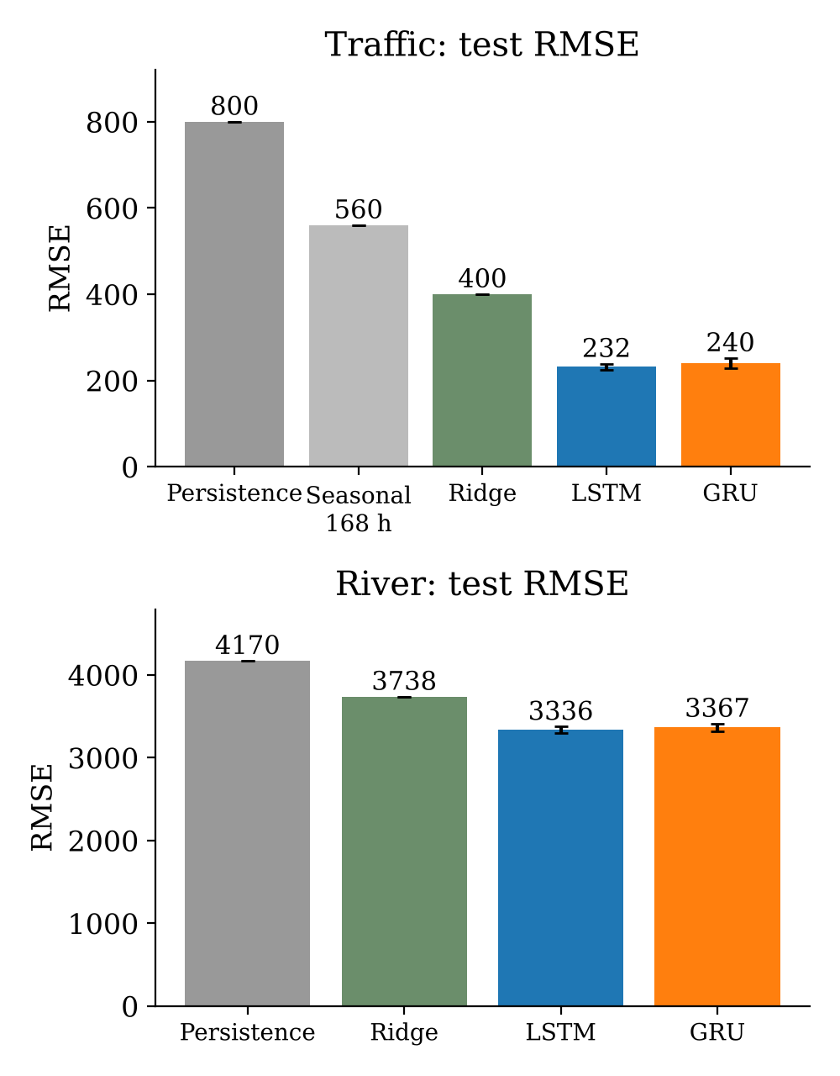
- Test RMSE of the baselines and the two networks at the main windows (bars for LSTM and GRU: mean over five seeds, error bars: standard deviation). Seasonal is the weekly repetition baseline.
On the river the gain is smaller. RMSE drops from 4,170.5 (persistence) and 3,737.8 (Ridge) to 3,335.5 for LSTM and 3,367.0 for GRU, about 20 and 19 percent below persistence and about 11 and 10 percent below Ridge. Ridge has a lower RMSE than persistence but a higher MAE (1,578 against 1,434), while LSTM reaches 1,227 and GRU 1,330. Day-to-day river flow changes slowly, so yesterday’s value is already a strong forecast, and neither network improves much on it at flood peaks.
Between the two networks the differences are small. LSTM has the lower RMSE and MAE on both datasets. On traffic, MAPE is practically the same (8.45 versus 8.39 percent). On the river, GRU’s MAPE is higher and much more variable (18.1 ± 5.6 percent), which is expected because MAPE is dominated by low-flow days where the denominator is small.

Is the Gap Real?
Table III lists Welch t-test p values for the five-seed results. Every one is above 0.2, so we cannot say that either model is better in accuracy or in training time on these data. With five seeds the test has little power, so this should be read as no clear difference found, not as proof that the models are equal.
- Welch t-Test p Values, LSTM vs GRU
Data | RMSE | MAE | Train time
Traffic | 0.205 | 0.478 | 0.201
River | 0.276 | 0.280 | 0.669

The need for several seeds shows up in our own experiments. In the first single run (seed 42), GRU had the lower RMSE on both datasets: 230.4 against 236.7 on traffic and 3,391 against 3,453 on the river. Averaged over five seeds the order reversed. The standard deviations in Table II (7 to 45 RMSE units) are as large as the gaps themselves, which is why a single run can favour either model.

Efficiency and Learning Behaviour
The one clear difference is size: the GRU has 24 percent fewer parameters. Training time did not separate the models. GRU was faster on average on traffic (164 s against 202 s) and about equal on the river, but the spread between runs is large and the p values are 0.201 and 0.669. Training time depends on how many epochs early stopping allows and on the load of the shared GPU, so these timings are rough. Fig. 2 shows validation loss for one run of each model. The GRU starts lower and settles faster in the first few epochs, then both reach the same level and stay flat, with no sign of overfitting.
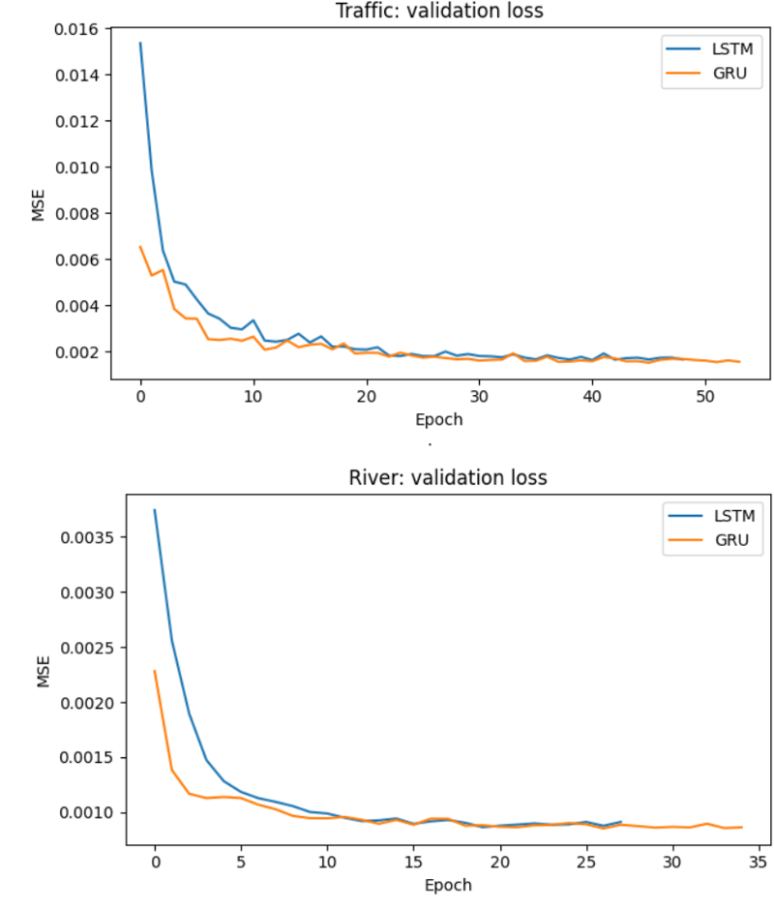
- Validation loss per epoch for one LSTM and one GRU model (seed 42): traffic (top) and river (bottom).

Forecast Quality
Fig. 3 compares predictions with the actual test values. On traffic, both models follow the daily cycle closely and miss sudden isolated drops. On the river they follow the seasonal level but underestimate or overshoot the size of flood peaks. In both cases the predicted curve trails the actual one by about a step, which is typical of one-step forecasting, where a value close to the previous one is already a good guess. It also explains why persistence is hard to beat by a large margin on the river.
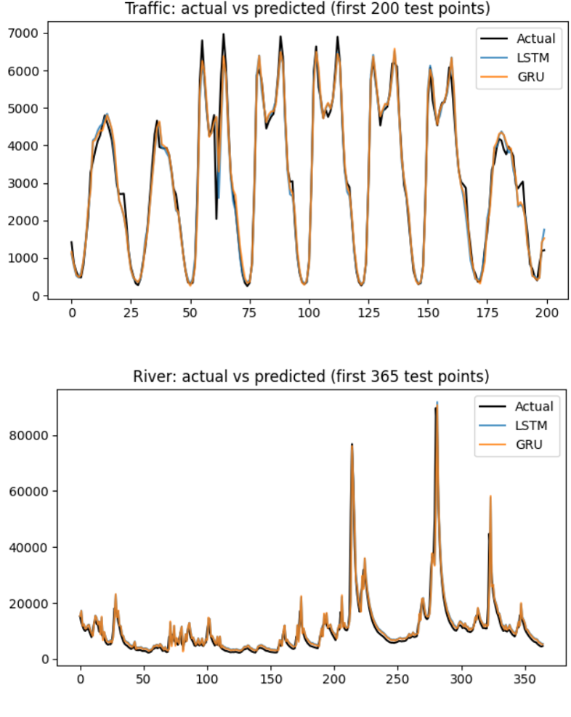
- Actual and predicted values on the first part of the test set: traffic, 200 hours (top); river, 365 days (bottom).

Effect of the Look-Back Window
Table IV and Fig. 4 show test RMSE for three window lengths per dataset. The values at 24 hours and 30 days are the five-seed results from Table II; the others use three seeds. On traffic, a longer window helps both networks: LSTM falls from 249.7 at 12 hours to 226.0 at 48 hours, and GRU from 252.1 to 222.1. The ranking changes along the way. LSTM is ahead at 12 and 24 hours, and GRU is ahead at 48 hours (p = 0.084, the smallest in the study but still above 0.05).
- Test RMSE by Look-Back Window
Data | Window | LSTM | GRU | p
Traffic | 12 h | 249.7 ± 10.0 | 252.1 ± 11.3 | 0.796
 | 24 h | 231.8 ± 7.1 | 240.4 ± 11.7 | 0.205
 | 48 h | 226.0 ± 2.2 | 222.1 ± 2.0 | 0.084
River | 7 d | 3454 ± 133 | 3391 ± 32 | 0.501
 | 30 d | 3335 ± 40 | 3367 ± 45 | 0.276
 | 60 d | 3335 ± 17 | 3367 ± 62 | 0.466

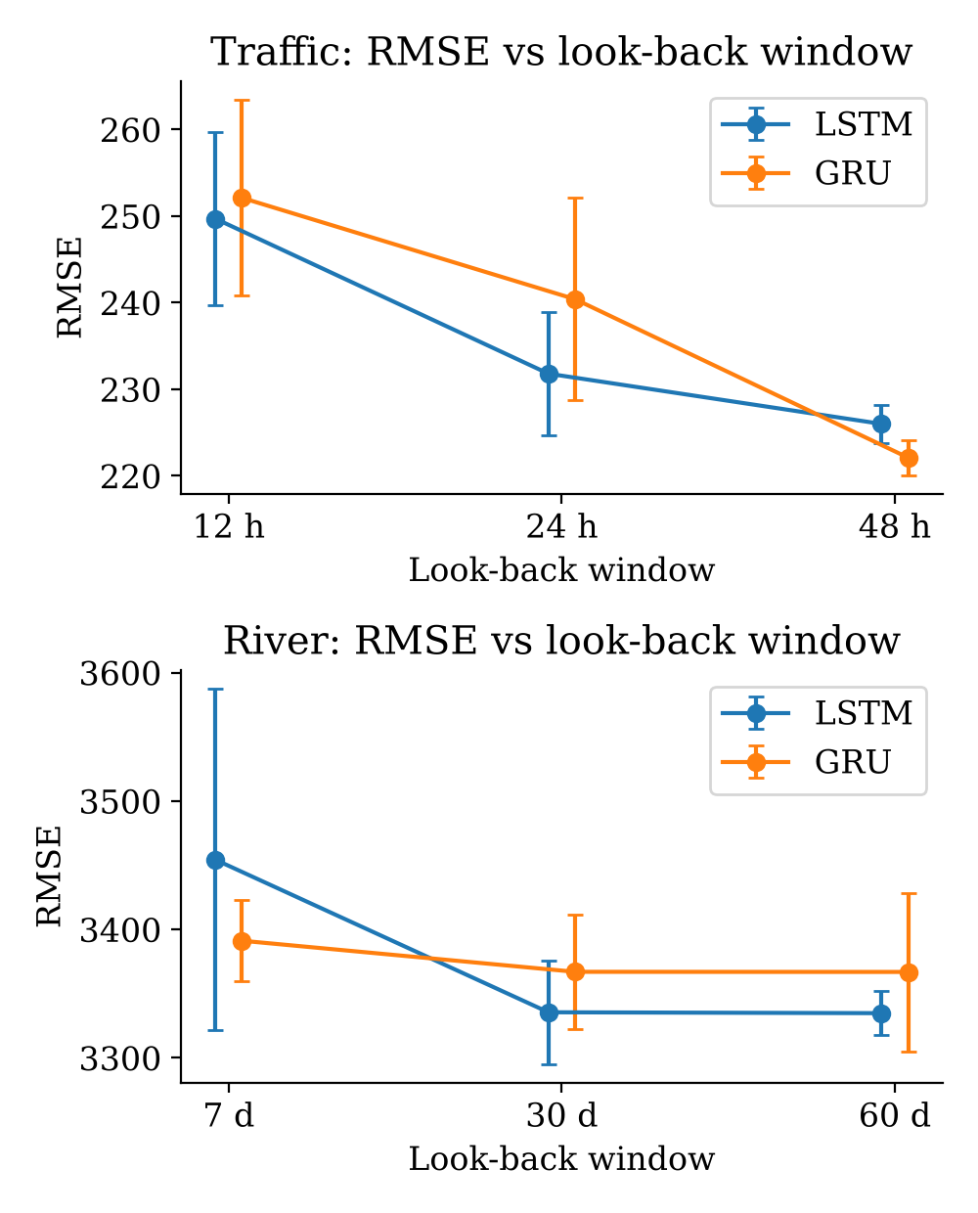
- Test RMSE against look-back window for LSTM and GRU (mean over seeds, error bars: standard deviation): traffic (top) and river (bottom).
On the river, GRU is ahead at 7 days (3,391 against 3,454, with one LSTM seed at 3,607), and LSTM is ahead at 30 and 60 days by about one percent. Going beyond 30 days gave little extra accuracy. For the river this is the pattern Das [7] reported for traffic, with GRU better on short windows and LSTM on long ones, but the traffic series shows the opposite order, so we cannot claim a rule. With three seeds per cell the tests have little power, and none of the differences is significant.

Does the Better Model Depend on the Domain?
At the main windows the answer is no: the small LSTM advantage in RMSE and MAE has the same direction on both series, and the GRU’s smaller size holds in both. The window study complicates this. The ranking changes with window length, and the direction of the change is not the same on traffic as on the river. Together with the p values, this means we found no evidence that either cell is better for either domain. It fits studies that report no consistent winner [3], [7]. What did matter was the input window and the seed. This is a statement about two series and one fixed configuration, and tuning could change the ranking.

Limitations
The study uses one traffic location and one river station, both univariate, and forecasts one step ahead. Hyperparameters were not searched. Five seeds at the main windows and three at the others limit statistical power, and only three window lengths were tried per dataset. Window lengths of 24 hours and 30 days are not equivalent in time span. The Ridge model used a default setting and no non-recurrent neural model was tested, so the results say nothing about whether a transformer or a tree-based model would do better. Traffic data from before April 2016 was discarded because of missing data, and the 195 interpolated hours may slightly smooth the series.

Conclusion
We compared LSTM and GRU on hourly traffic volume and daily river discharge under identical settings, with several seeds per model, three baselines and three window lengths. Both networks beat persistence and Ridge regression clearly on traffic and modestly on the river. At the main windows LSTM was slightly ahead in RMSE and MAE on both series and GRU was smaller by 24 percent, but no difference in accuracy or training time was statistically significant, and the ranking changed with the window length. For these two datasets the input window and seed variation mattered at least as much as the choice of cell, so a lighter GRU is a reasonable default when memory is tight. Future work should add more domains and stations, multi-step horizons, tuned windows and non-recurrent baselines, and should keep repeating training over several seeds.

Code Availability
The notebook used for all experiments will be shared at [repository link to be added].

References
- S. Hochreiter and J. Schmidhuber, “Long short-term memory,” Neural Computation, vol. 9, no. 8, pp. 1735–1780, 1997, doi: 10.1162/neco.1997.9.8.1735.
- K. Cho et al., “Learning phrase representations using RNN encoder–decoder for statistical machine translation,” in Proc. 2014 Conf. Empirical Methods in Natural Language Processing (EMNLP), Doha, Qatar, 2014, pp. 1724–1734, doi: 10.3115/v1/D14-1179.
- J. Chung, C. Gulcehre, K. Cho, and Y. Bengio, “Empirical evaluation of gated recurrent neural networks on sequence modeling,” arXiv:1412.3555, 2014.
- K. Greff, R. K. Srivastava, J. Koutník, B. R. Steunebrink, and J. Schmidhuber, “LSTM: A search space odyssey,” IEEE Trans. Neural Netw. Learn. Syst., vol. 28, no. 10, pp. 2222–2232, 2017, arXiv:1503.04069.
- E. Kristiani, H. Lin, J.-R. Lin, Y.-H. Chuang, C.-Y. Huang, and C.-T. Yang, “Short-term prediction of PM2.5 using LSTM deep learning methods,” Sustainability, vol. 14, no. 4, art. 2068, 2022, doi: 10.3390/su14042068.
- M. Abumohsen, A. Y. Owda, and M. Owda, “Electrical load forecasting using LSTM, GRU, and RNN algorithms,” Energies, vol. 16, no. 5, art. 2283, 2023, doi: 10.3390/en16052283.
- L. C. Das, “Traffic volume prediction using memory-based recurrent neural networks: A comparative analysis of LSTM and GRU,” arXiv:2303.12643, 2023.
- F. Kratzert, D. Klotz, C. Brenner, K. Schulz, and M. Herrnegger, “Rainfall–runoff modelling using long short-term memory (LSTM) networks,” Hydrology and Earth System Sciences, vol. 22, no. 11, pp. 6005–6022, 2018.
- G. Velarde, P. Branez, A. Bueno, R. Heredia, and M. Lopez-Ledezma, “An open-source and reproducible implementation of LSTM and GRU networks for time series forecasting,” arXiv:2504.18185, 2025.
- H. Hewamalage, C. Bergmeir, and K. Bandara, “Recurrent neural networks for time series forecasting: Current status and future directions,” Int. J. Forecasting, vol. 37, no. 1, pp. 388–427, 2021.
- A. Zeng, M. Chen, L. Zhang, and Q. Xu, “Are transformers effective for time series forecasting?,” in Proc. AAAI Conf. Artificial Intelligence, vol. 37, no. 9, 2023, pp. 11121–11128, doi: 10.1609/aaai.v37i9.26317.
- J. Hogue, “Metro interstate traffic volume,” UCI Machine Learning Repository, 2019, doi: 10.24432/C5X60B.
- U.S. Geological Survey, “National Water Information System: Web interface, station 01646500, daily discharge (parameter 00060),” https://waterdata.usgs.gov/nwis (accessed Oct. 26, 2026).
- D. P. Kingma and J. Ba, “Adam: A method for stochastic optimization,” in Proc. Int. Conf. Learning Representations (ICLR), 2015, arXiv:1412.6980.

