**Assignment 1 Brief:**

1. Copy the folder “301_A1” into Ubuntu desktop and set current directory to cd Desktop/301_A1

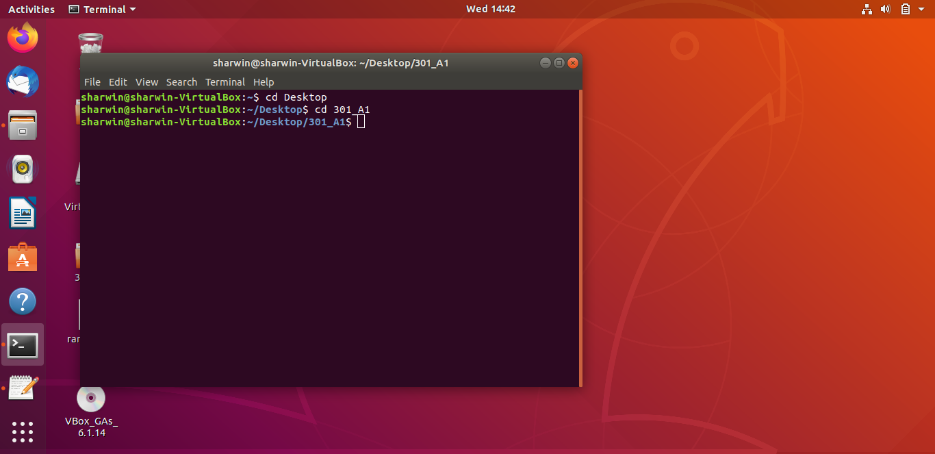

These are the files in the folder 301_A1. It contains 2 .pem files(public and private keys) 1 pye file,4 python files and 3 txt files. “ransomKeyRecovery.py” and “ransomFileRecovery.py” are the recovery programs.

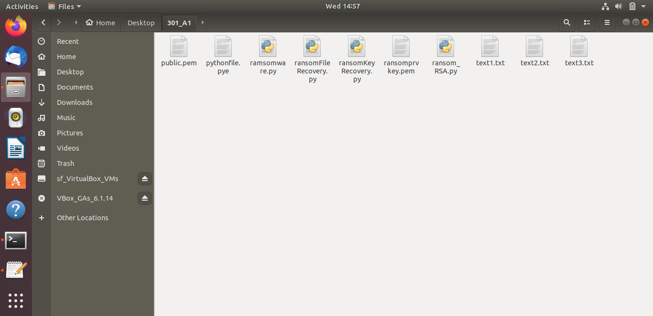

Original data in the text1.txt,text2.txt,text3.txt

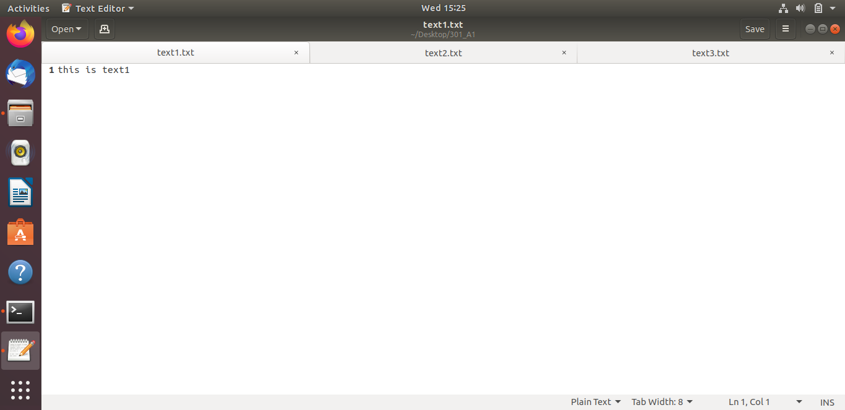

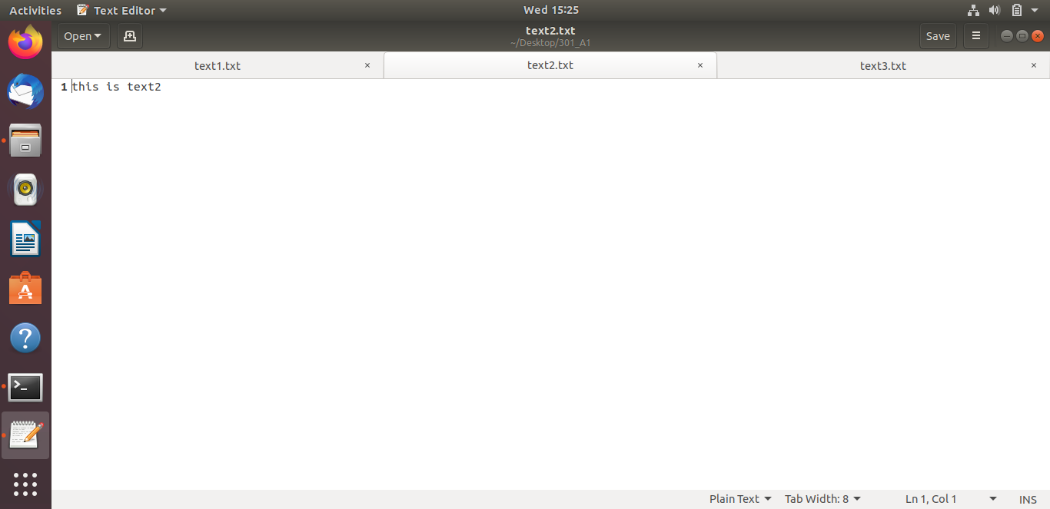

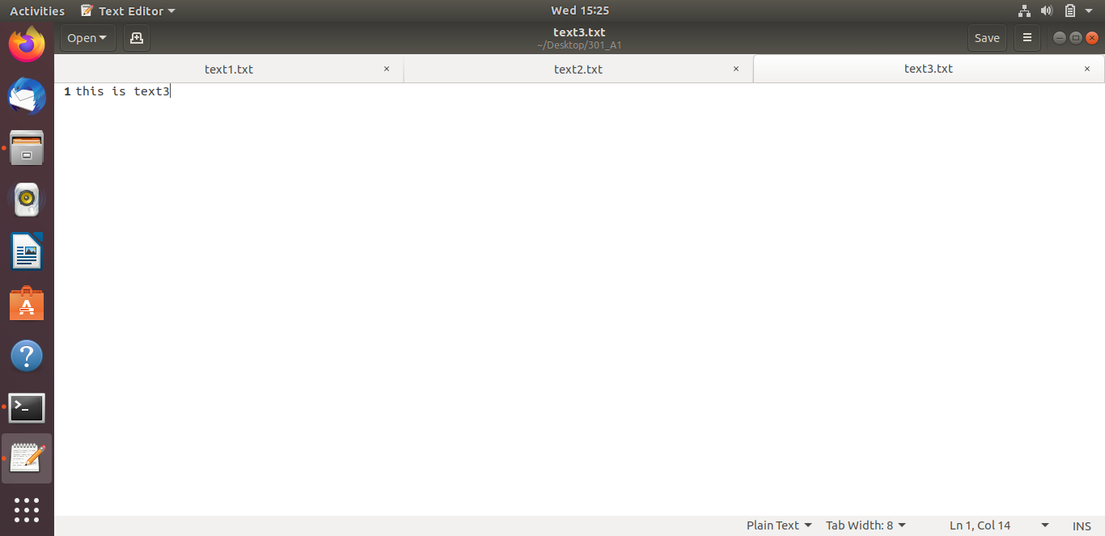

When we run the “ransom_RSA.py” to generate the public and private keys by the command “python3 ransom_RSA.py”. It will create 2 files, “public.pem” and”ransomprvkey.pem”.

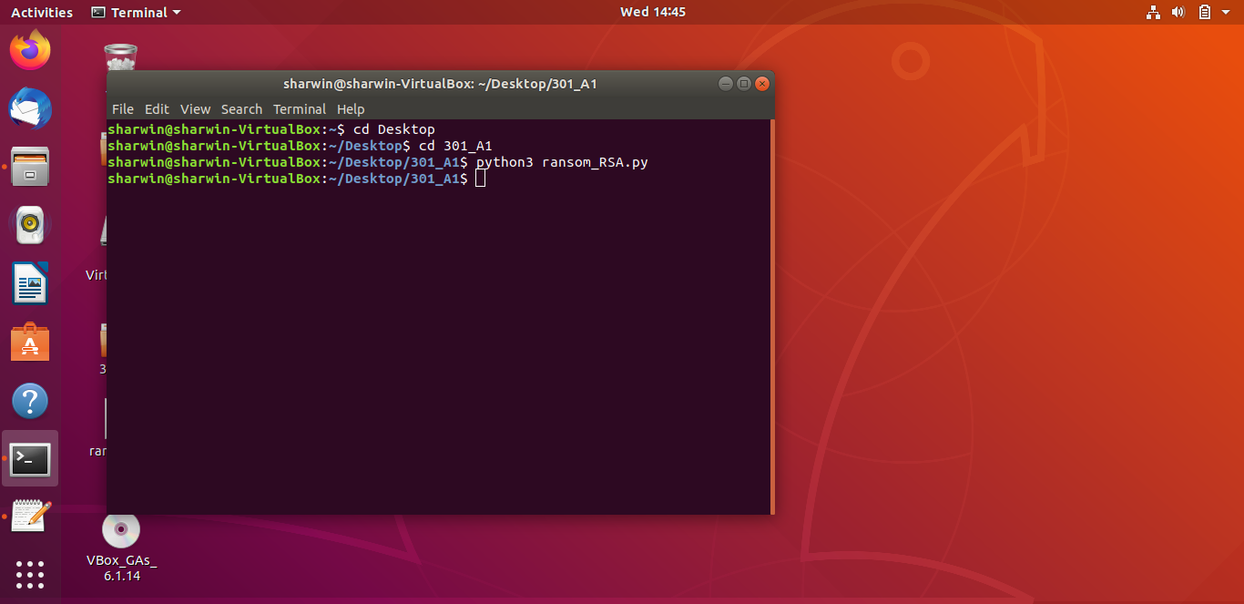

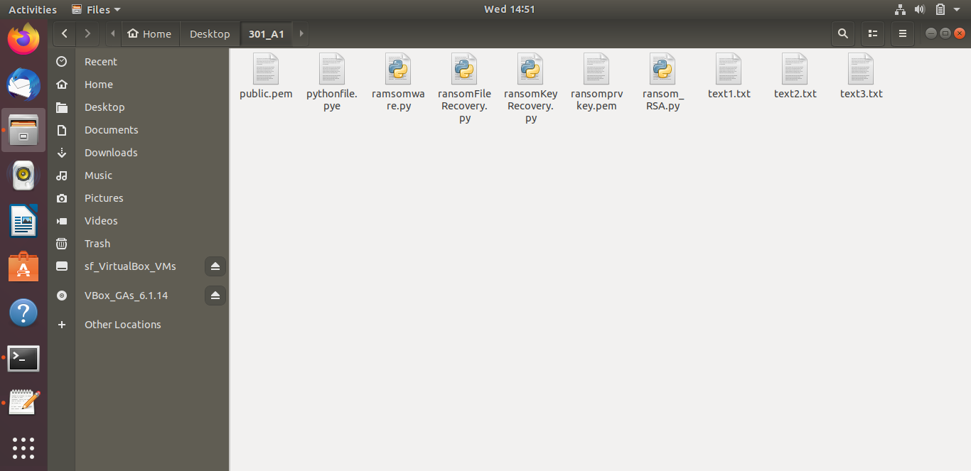

**Running the ransomware program(ENCRYPTION)**

1)First, we run “ramsomware.py”(cd python3 ramsomeware.py) to encrypt the 3 .txt files, replicate the ransomware program to the “pythonfile.pye” with its contents commented. It will also generate a “key.bin” containing the encrypted AES key as well as “cipher_iv.txt” containing the IV.

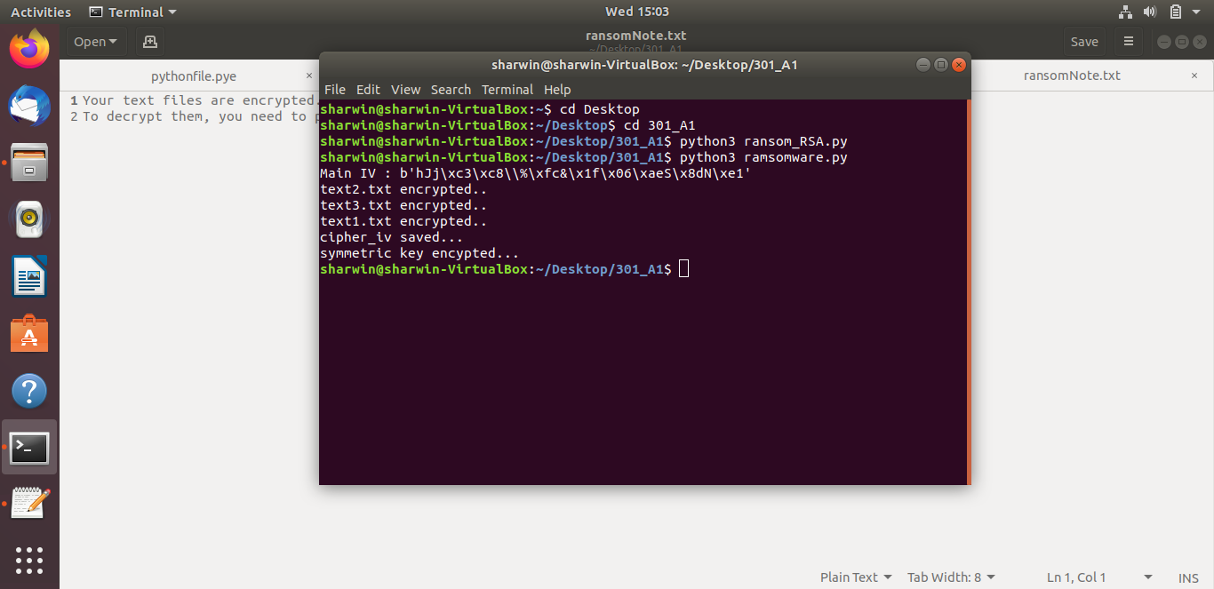

A text editor will be generated containing the ransom note

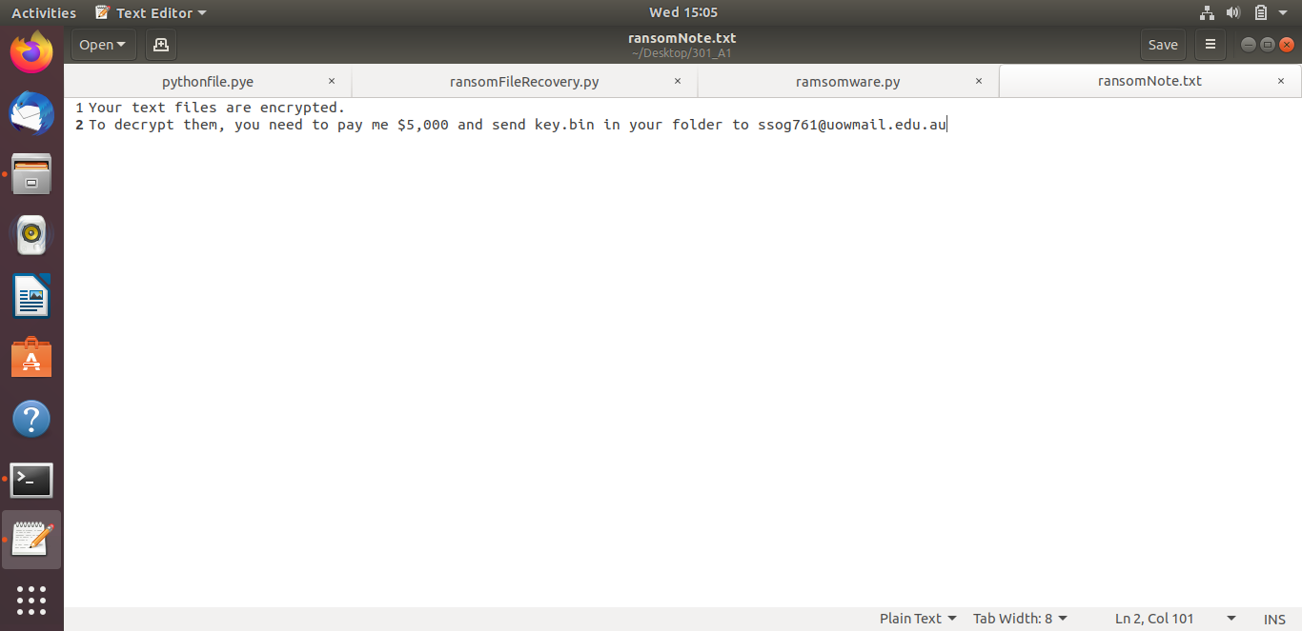

These are the files in the “301_A1”folder upon running “ransomware.py”.Note that the .txt files have been changed to .enc and its data encrypted. “pythonfile.pye” has also been modified.

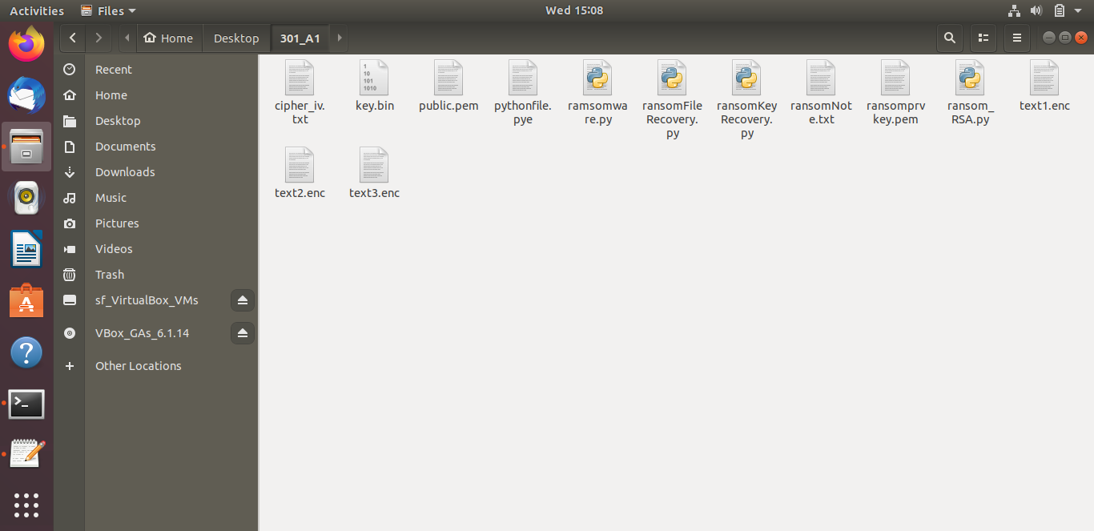

pythonfile.pye

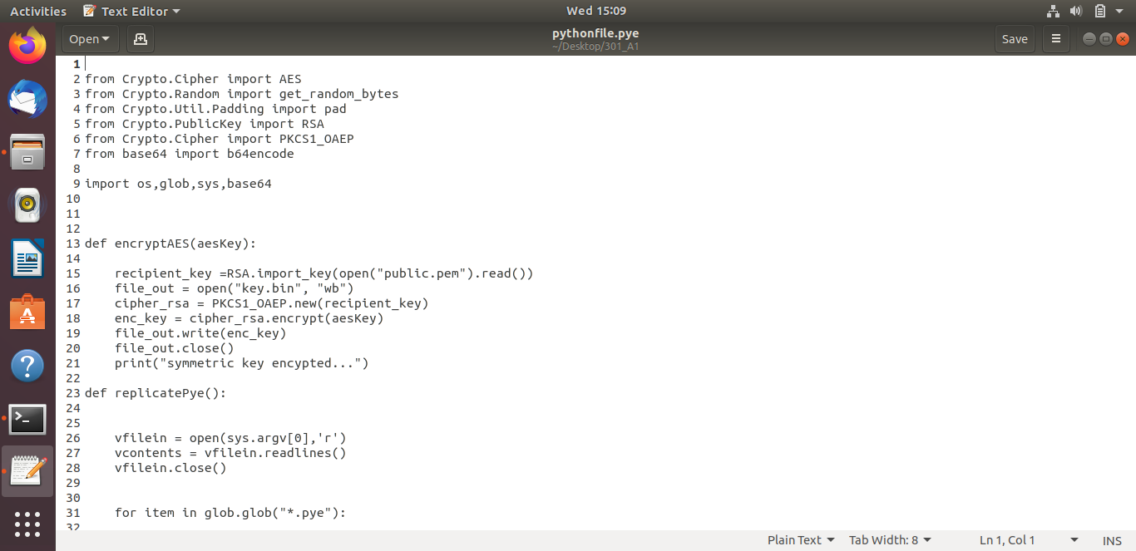

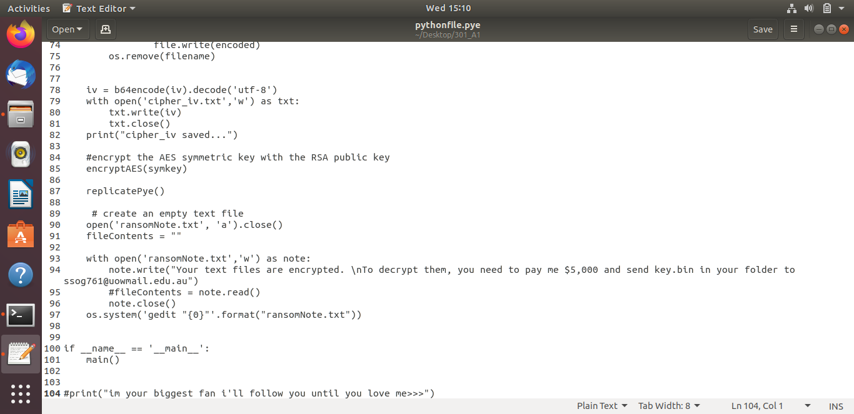

encrypted text file

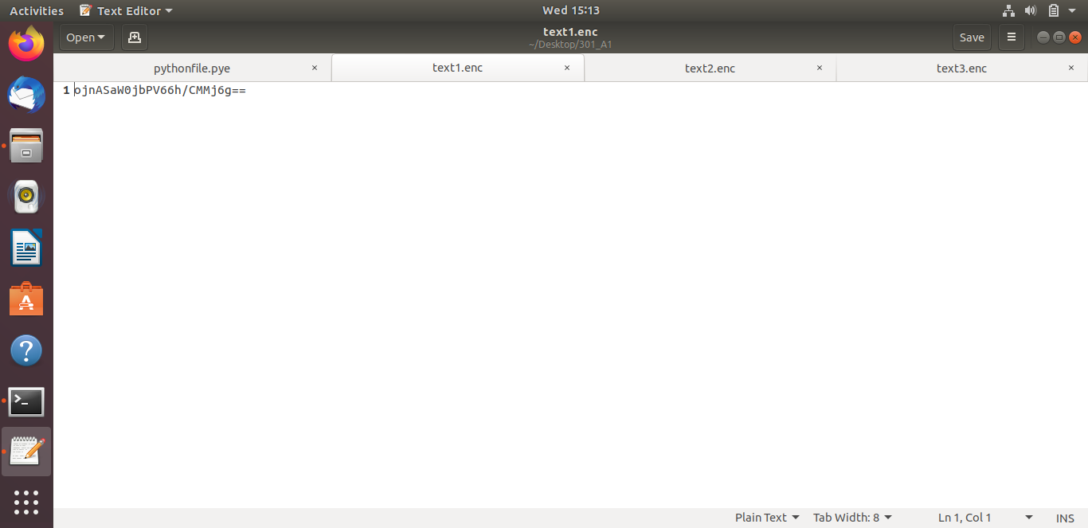

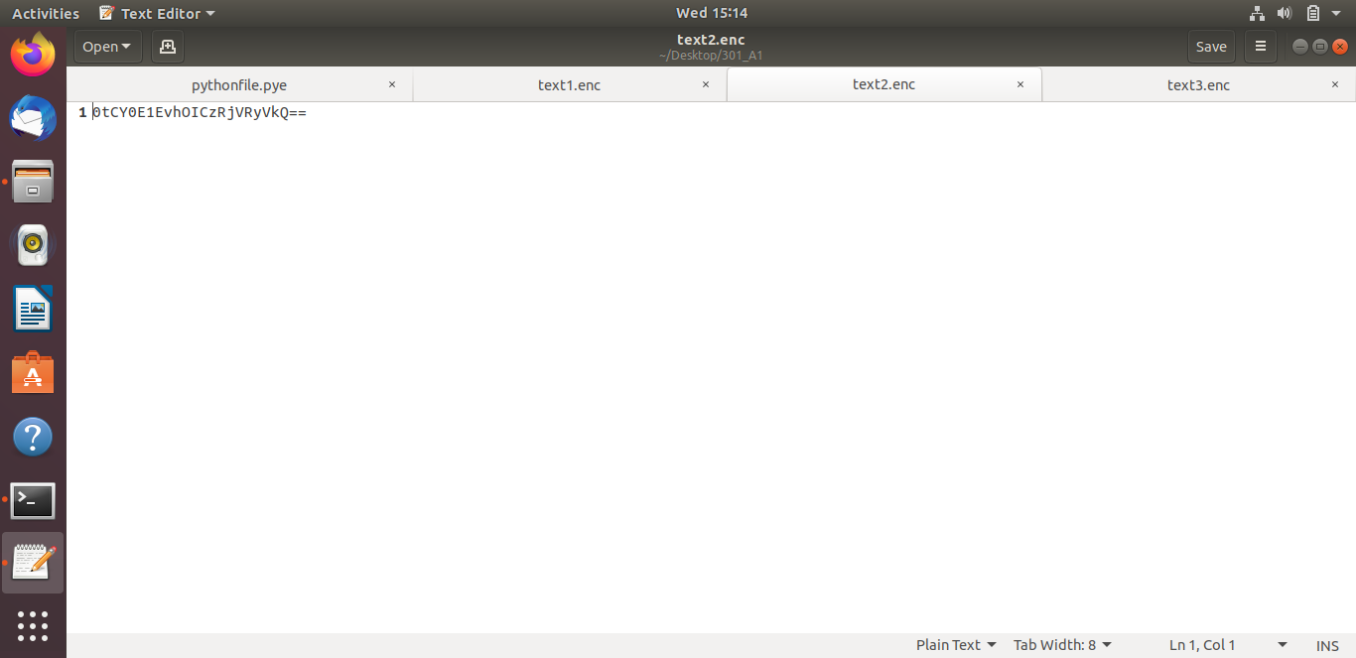

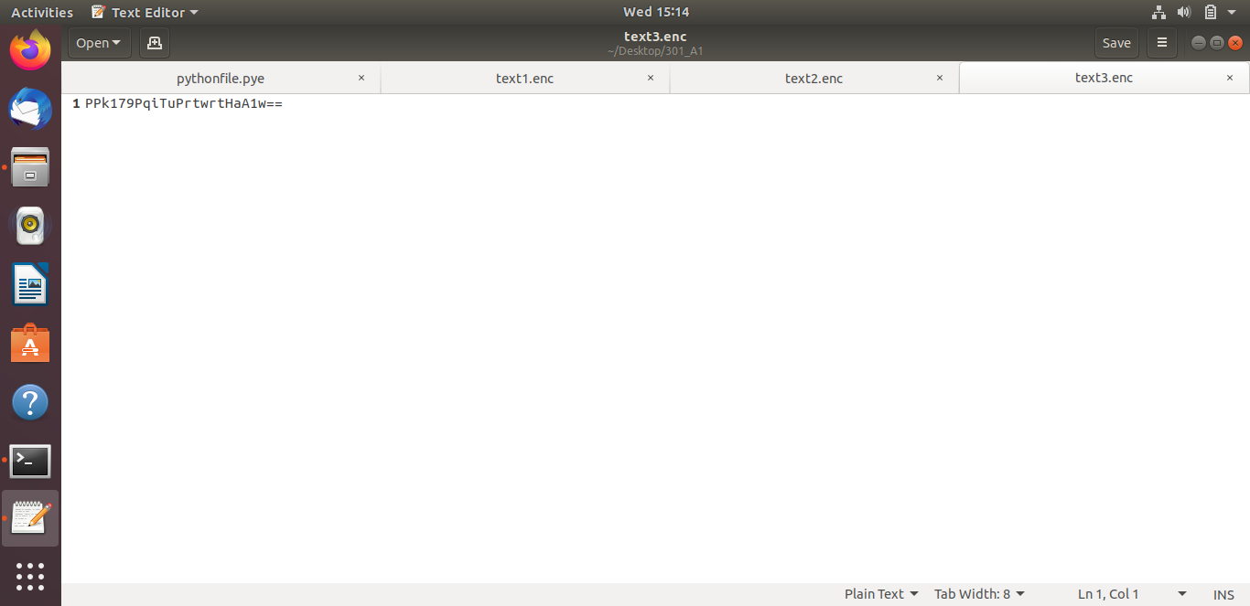

**Runnning the recovery programs(DECRYPTION)**

First run “ransomKeyRecovery.py”.This file will decrypt the AES key from “key.bin” and saves the key into a file called “key.txt”

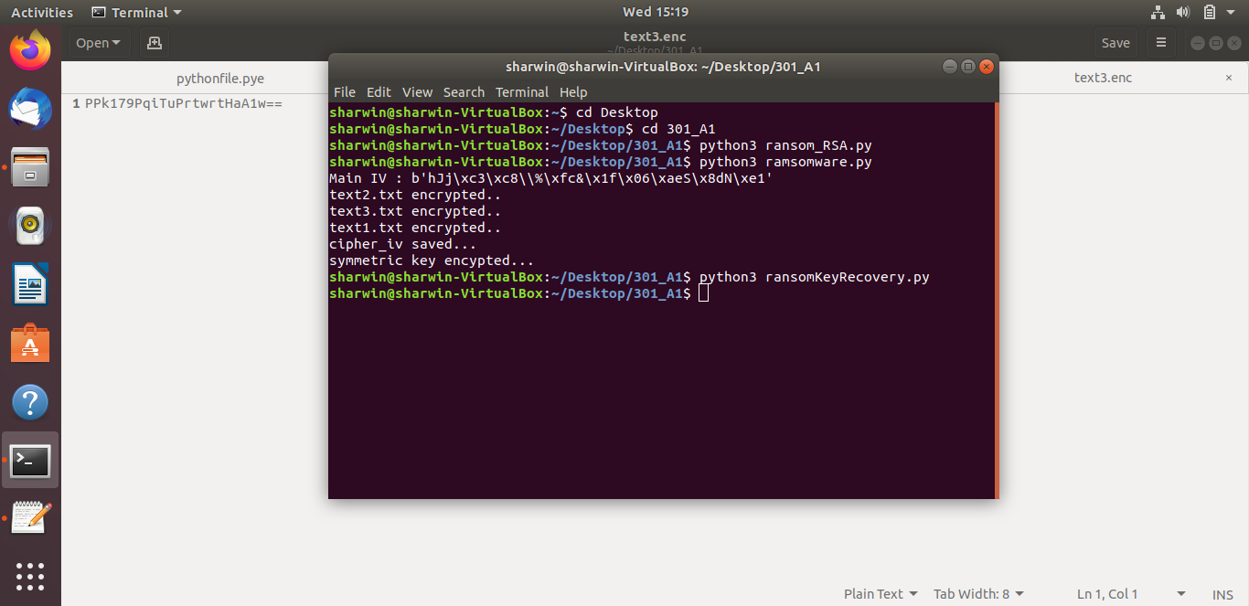

“key.txt” is in the 301_A1 folder

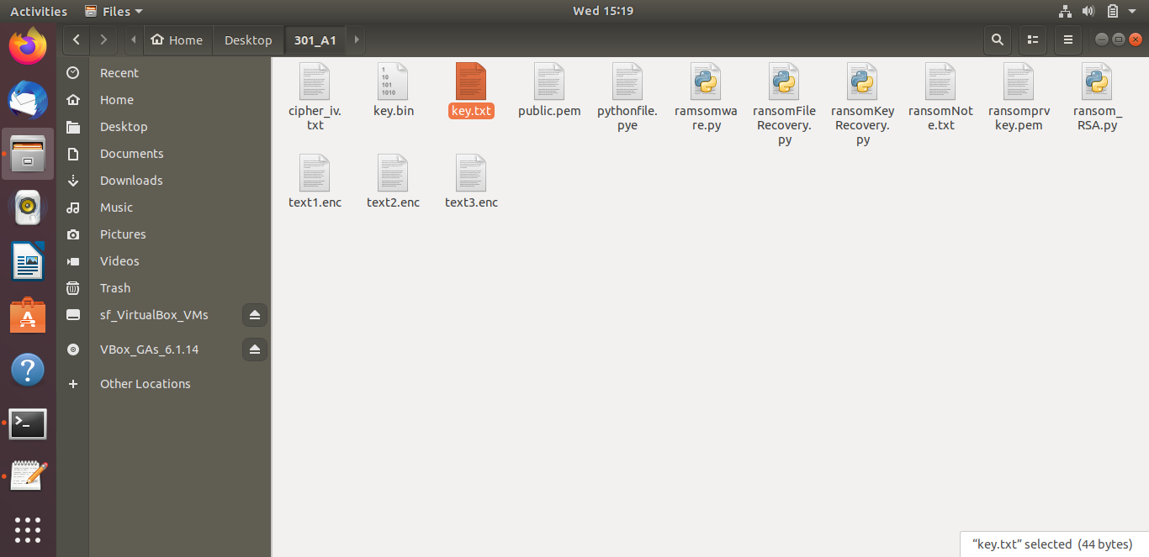

Next we run “ransomFIleRecovery.py” to decrypt the encrypted text files. The .enc files will be changed to its original data

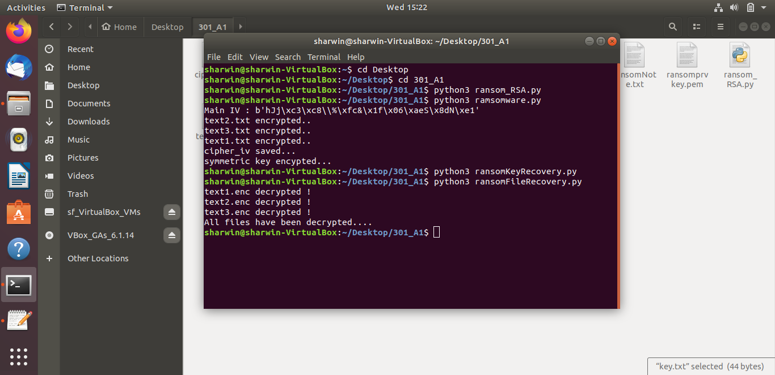

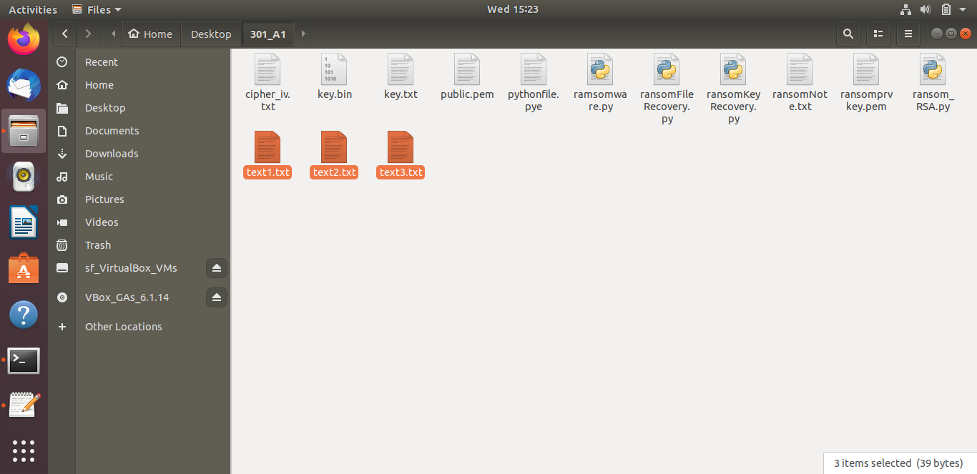

File data have be decrypted

