Introduction
Computers have gone from being blackboxes that take specially formated input and produce computer-formatted output that has to be interpreted by a human, to become more and more integrated with the regular life.
It has also evolved from complex systems that require professional training to seemingly simple devices usable even by a child.
What are the driving factors between this development, and how will it affect future interface designs?

History
The first computers used punched cards for input. This was later replaced with keyboards and terminals to speed up the process of computer input/output and this process was mostly technology-driven.
When the personal computer was introduced, making computers accessible to larger groups of people, the focus was changed from large main frame computers to desktop computers which introduced the user-centric approach to computers.
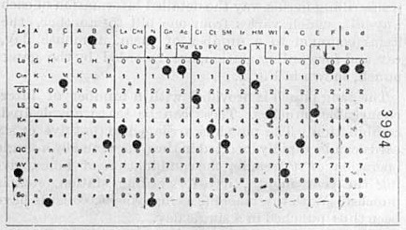
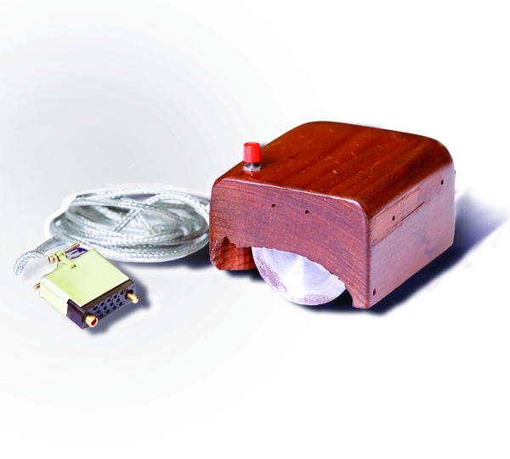
Current
The current trend in human-computer interface development displays an even larger focus on making the computers transparent to the users.
Since the progression towards a more human-centric development began, many different input devices, like the touch-screens and voice recognition have been introduced, and are being used for tasks previously performed at a terminal-type computer.
These systems do not necessarily replace the previous computer systems, instead the spectrum of computer interfaces in use is broadening. Desktop and laptop computers are being replaced in areas were new technology is more suited, while they still remain in areas were new input systems have yet, if ever, to outperform the previous systems.
It is also evident that some of the current systems are outperforming eachother in different areas. An example is that voice recognition has become more and more used in simple query-based tasks, with technologies like Apple’s Siri voice recognition system, where touchscreen-based systems were previously prominent.
Future
Computers have gone from a technology-centric design with a unified interface, to a large number of context-specific interfaces designed for more and more diverse tasks.
With the these interfaces the computers themselves become such an integrated part of the process they are part of that they become invisible to the user. It is likely that this trend will continue and that computers with custom-designed interfaces will appear in almost every aspect of our lives.
This will likely reduce the terminal-type computer, which has dominated the market for over 40 years, from an all-purpose system to the typewriter on which it is based.
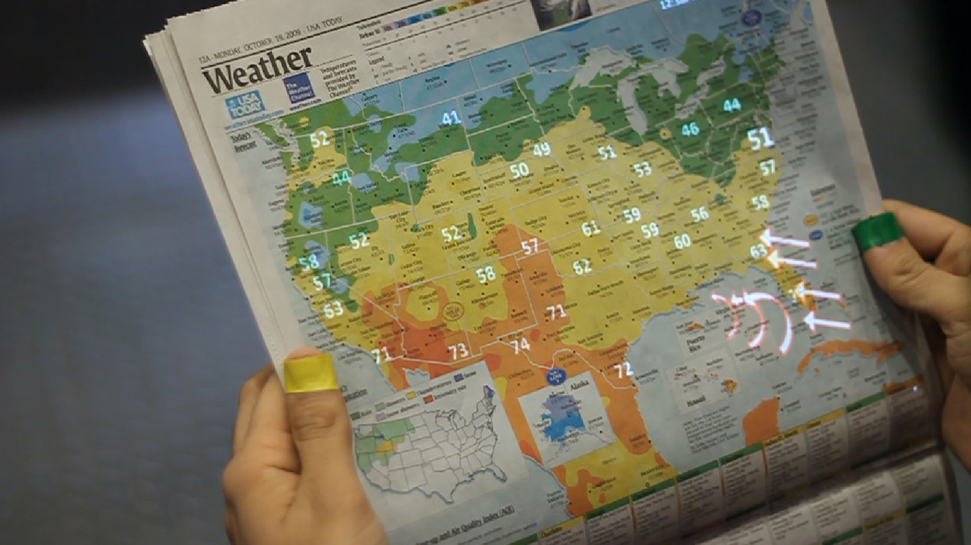
The gap created will be filled by better suited and transparent devices more adapted to perform the current and future tasks computers will be used for.

F&S från slidesen:

F: Fokusera på ett budskap – vad ska alla komma ihåg?
S: Att utvecklingen blir allt mer användarcentrerad och att interfacen blir mer och mer osynliga.

F: Berätta budskapet med bilder och diagram.
S: Vi lär ha lite bilder på historiska, nuvarande och framtida. Kanske utvecklingen på ett visst område eller så.

F: Postern ska vara övertydligt ordnad.
S: Intro-History-Current-Future är väldigt tydligt.

F: Postern ska ge kontaktinformation.
S: Längst upp.

F: Postern ska vara ett stöd för att berätta om din forskning.
S: Sammanfattar våran artikel.

F: Postern ska inte ge några onödiga detaljer
S: Bara de stora dragen på utvecklingen är med på postern.

F: Undvik krångligt språk
S: Jag tycker iallafall att det är lättläst nu.

F: Spara på fackorden.
S: Gjort i mesta möjliga mån.

F: En slagkraftig rubrik
S: Rubriken är mycket tydlig om vad den handlar om, och rätt inspirerande också-

F: Berätta med enkla och tydliga bilder. Bilderna ska vara självförklarande, bild och bildtext separerade.
S: Behöver bättre bilder. Gillar musen dock. Måste även skriva bildtext TODO.

F: Tydlig ordning, kolumner, luft. Slagkraftiga rubriker.
Tycker ordningen är bra, tre kolumner känns lagom och det är lagom mycket luft. Kanske ska kolla lite på rubrikerna dock, dom kanske ska göras “roligare”. TODO.

F: Använd korta textblock, aktiva meningar, och stryk allt som inte förstärker ditt budskap.
S: Med tanke på vårt ämne tror jag textblocken är så korta dom kan bli för att vara informativa.

