**COMPUTER NETWORKS**

**Assignment 3 Report**

**22CS10025**

**G SAI SHASANK**

Note:

* This analysis is done with the input file as file3.txt.
* At the time of analysis, the buffer size at the client side was 100 bytes and at the server side was 100 bytes.
* Except for the packets of the file data transfer and three-way handshake, you can see some more packets in the pcap files. These packets are for differentiating between process/acknowledgment of a process completion/start.

**Q1: What are the source and destination IP addresses and ports? Share the screenshots to justify your answer.**

A1: (While the data transfer takes place from the client to server and vice versa for the case where the data transfer takes place from the server to the client)

* Source IP address: 127.0.0.1
* Destination IP address: 127.0.0.1
* Source Port No: 47032
* Destination Port No: 20000

**Associated Screanshot:**

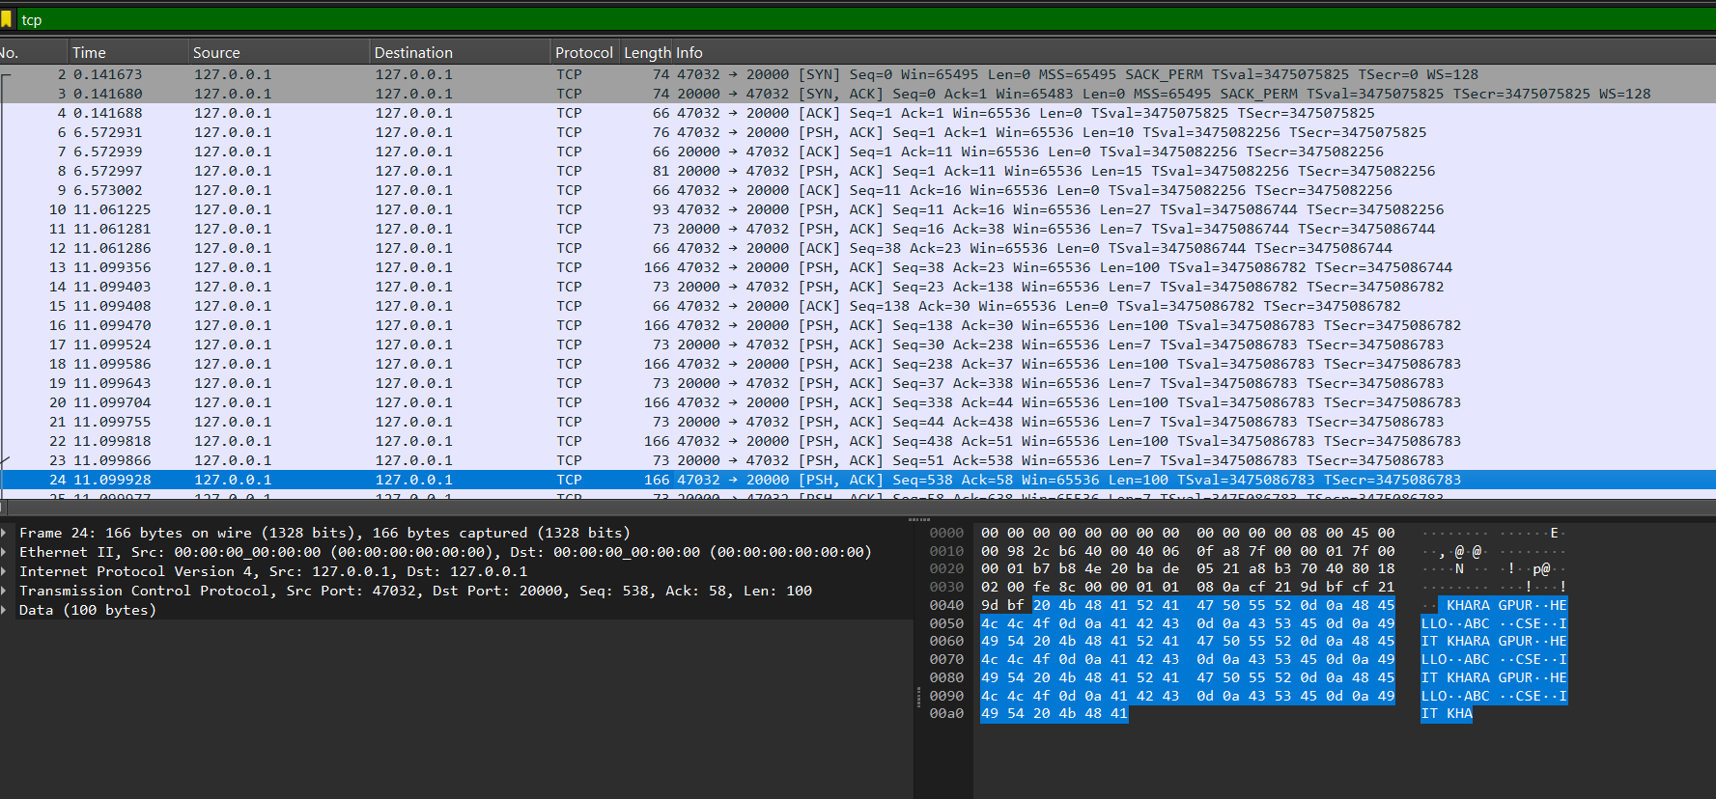

Note: No packet will get the size more than 166( 100 for data and 66 for other information of packet)

**Q2: Inspect the Three-way handshaking procedure and capture all packets exchanged for it. Attach the necessary screenshots to demonstrate it**.

A2: In the above question's screenshot, the first 3 packets belong to the three-way handshake process.

In a Three-way handshake process:

**Step 1: SYN (Synchronize)**

The client initiates the connection by sending a TCP packet to the server with the SYN (Synchronize) flag set. This packet contains an initial sequence number (ISN) chosen by the client.

* Here the ISN from the client side is 2830332701.
* **Associated screenshot**:

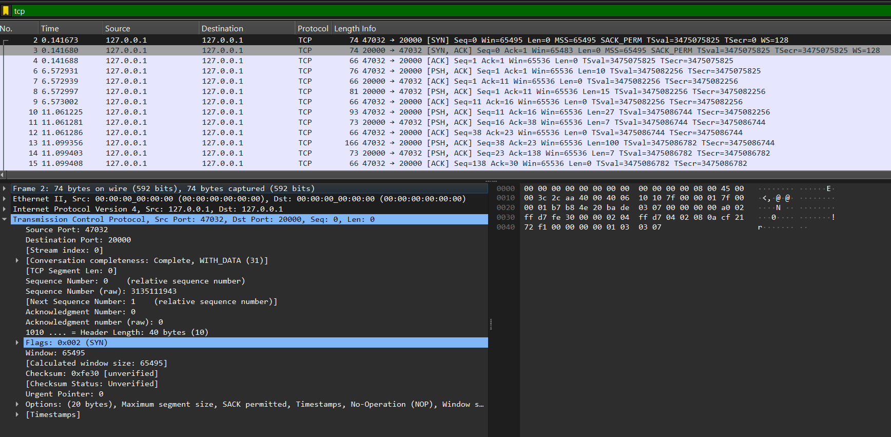

**Step 2: SYN-ACK (Synchronize-Acknowledge)**

Upon receiving the SYN packet, the server responds with its own TCP packet. This packet has both the SYN and ACK flags set, acknowledging the client's SYN and proposing its own initial sequence number (ISN).

* Here the ISN from the server side is 3135112750.
* **Associated screenshot**:

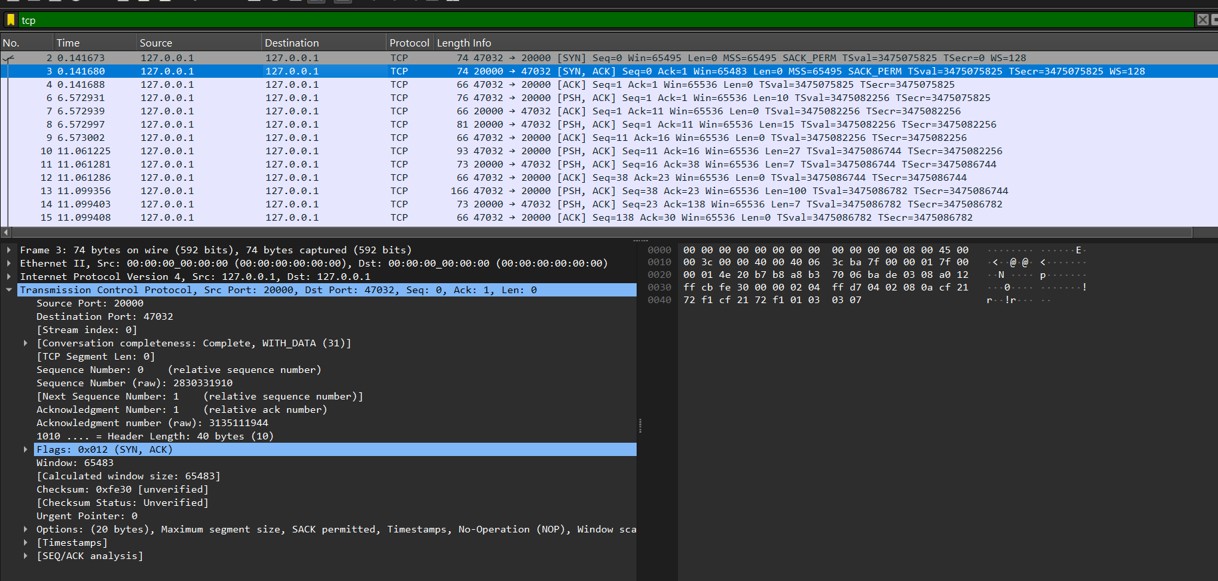

**Step 3: ACK (Acknowledge)**

The client then sends a final TCP packet to the server with the ACK flag set, acknowledging the server's SYN. At this point, both the client and server have established a reliable, full-duplex communication channel.

* You can see in the screenshot that the ACK flag is set.
* **Associated screenshot**:

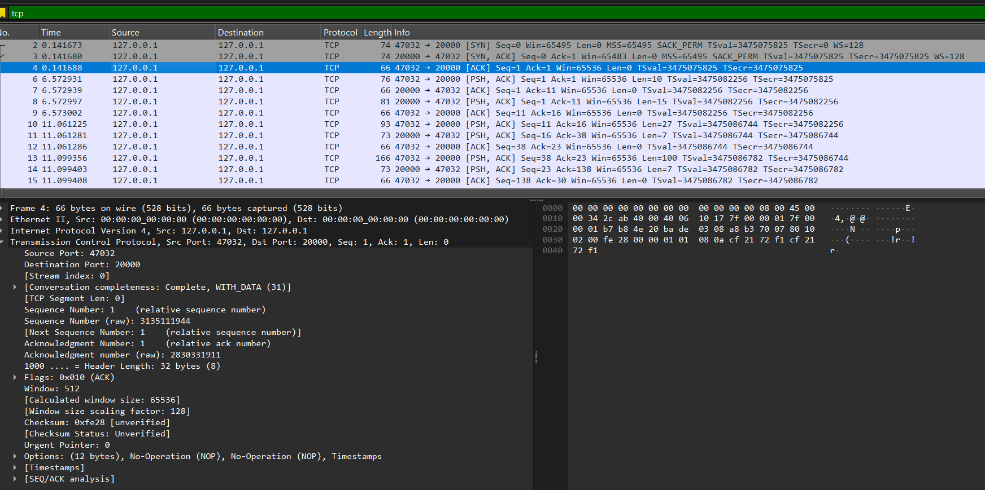

**Q3: Inspect the connection closure procedure and capture all packets exchanged for it. Attach the necessary screenshots to demonstrate it.**

A3: The last 3 packets in the first question's screenshot are the packets responsible for the connection closure procedure.

The TCP connection closing procedure using 3 packets involves:

1. **FIN (Finish**)

One party (either client or server) initiates the connection closure by sending a FIN packet. This packet has the FIN flag set to '1' and indicates that the sender has no more data to transmit.

* In the screenshot below, we can see that the client starts the connection termination process.
* **Associated screenshot:**

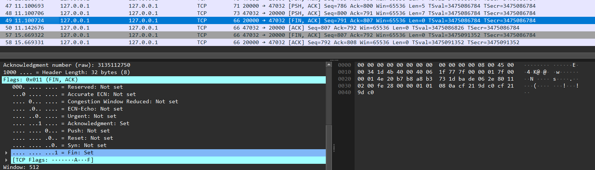

**2. FIN-ACK**

Upon receiving the FIN packet, the other party responds with a FIN-ACK packet. This packet acknowledges the receipt of the FIN and also indicates that this party is ready to close its side of the connection.

**3. ACK (Acknowledge)**

The party that initiated the closure sends a final ACK packet to acknowledge the receipt of the FIN-ACK. This completes the connection termination process.

**Q4: Inspect the traffic and count the number of packets exchanged for the transfer of a file (related to data only) between client and server. Plot a graph ‘file size vs the number of packets’ based on your observation.**

A4:

|  |  |
| --- | --- |
| File size( in bytes ) | Packets |
| 33 | 20 |
| 353 | 37 |
| 705 | 51 |
| 1025 | 63 |
| 1409 | 75 |
| 2017 | 99 |
| 2817 | 137 |

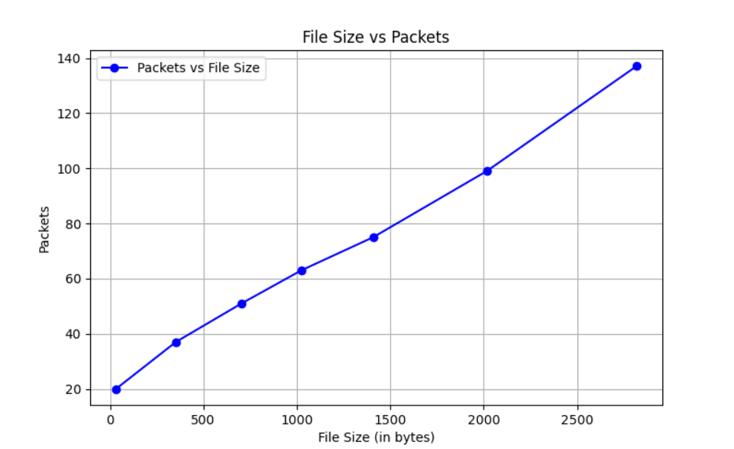

**Q5: Measure the total time taken for the file transfer, its encryption, and sending it back from the server to the client. Plot a graph ‘file size vs time’ based on your observation and attach the necessary screenshots**.

A5:

|  |  |
| --- | --- |
| File size( in bytes ) | Time ( in m.sec ) |
| 33 | 0.432 |
| 353 | 0.804 |
| 705 | 1.337 |
| 1025 | 1.502 |
| 1409 | 1.229 |
| 2017 | 1.466 |
| 2817 | 2.045 |

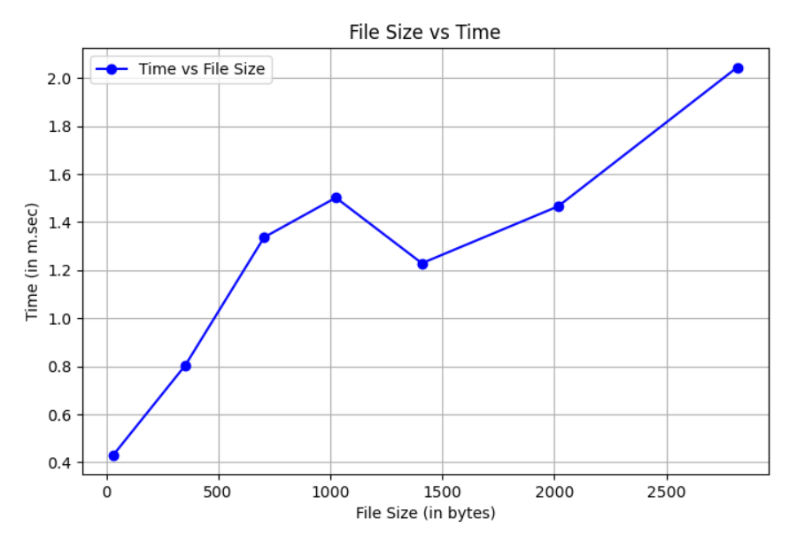

● Total file transfer time from client to server: **1.337ms** (file size: 705 bytes).

● **Associated screenshot:**

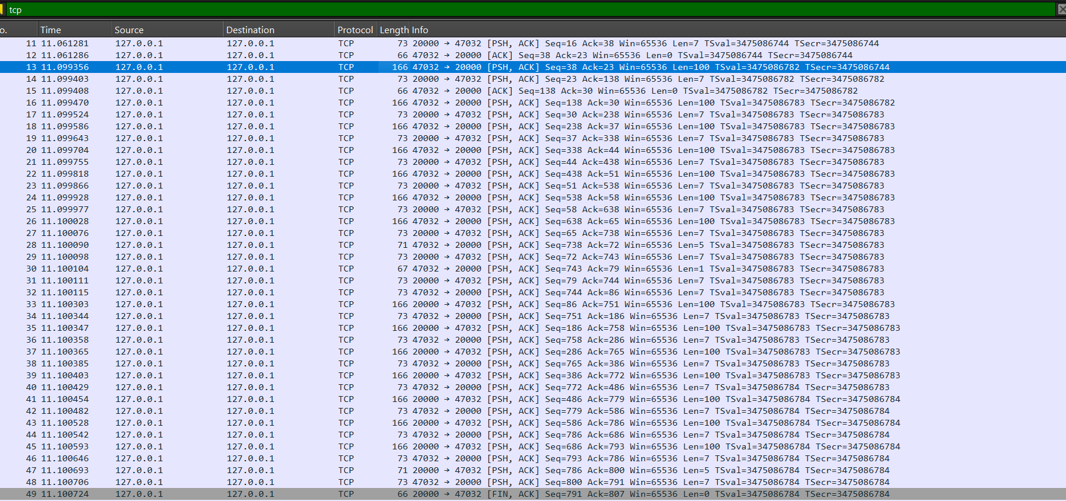

**Q6: Calculate the average packet size exchanged during data communication? Take reference from the plotted graph in the previous question**.

A6:

Average packet size (approximately): (calculated based on file1 and file 7)

= (y2-y1)/(x2-x1)

= (2817-33)/(137-21)

= 24 bytes of data per packet