***Enchanted Wings: Marvels of Butterfly Species***

**1. INTRODUCTION**

**1.1 Project Overview**

*Enchanted Wings: Marvels of Butterfly Species* is a visual and educational exploration of the beauty, diversity, and ecological significance of butterflies. This project aims to highlight extraordinary butterfly species from around the world while fostering awareness about their life cycles, adaptive features, and the environmental challenges they face. Through scientific insight, artistic representation, and conservation advocacy, the project encourages appreciation for these delicate creatures and promotes action to protect their habitats for future generations.

*Enchanted Wings* is an educational and visually rich exploration into the fascinating world of butterflies. This project aims to showcase the diversity, beauty, biology, and ecological importance of butterfly species around the world. Through a combination of scientific insight, storytelling, and conservation awareness, the project inspires appreciation for these delicate yet vital creatures.

**1.2 Purpose**

The purpose of *Enchanted Wings: Marvels of Butterfly Species* is to educate and inspire by showcasing the incredible diversity, beauty, and ecological importance of butterflies. The project seeks to deepen understanding of butterfly biology, highlight unique species, raise awareness about environmental threats they face, and encourage conservation efforts to protect these vital pollinators and the ecosystems they support.

* **To showcase the diversity** of butterfly species from around the world.
* **To educate** audiences about butterfly anatomy, life cycles, and behaviors.
* **To highlight the ecological role** of butterflies as pollinators and biodiversity indicators.
* **To raise awareness** about environmental threats such as habitat loss and climate change.
* **To promote conservation efforts** for protecting butterfly species and their habitats.
* **To inspire curiosity and appreciation** for the natural world, especially among young learners.
* **To explore cultural and symbolic meanings** of butterflies across different societies.
* **To encourage creative expression** through nature-themed art, writing, or design.

**2. IDEATION PHASE**

**2.1 Problem Statement**

**Problem Statement-1:**

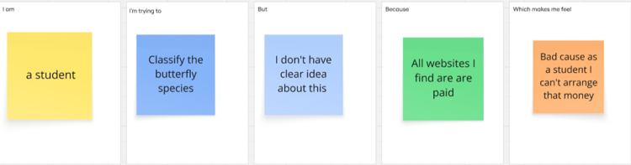

**Problem Statement:**

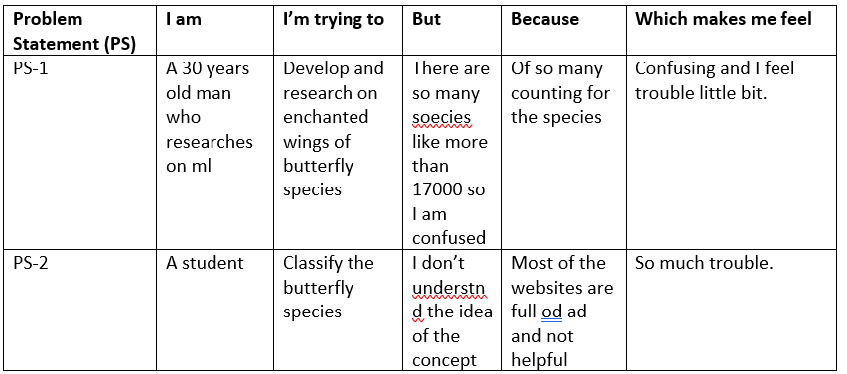

**2.2 Empathy Map Canvas**

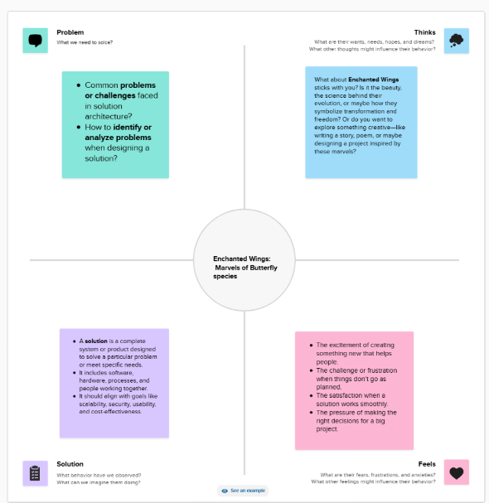

**2.3 Brainstorming**

**Step-1: Team Gathering, Collaboration and Select the Problem Statement:**

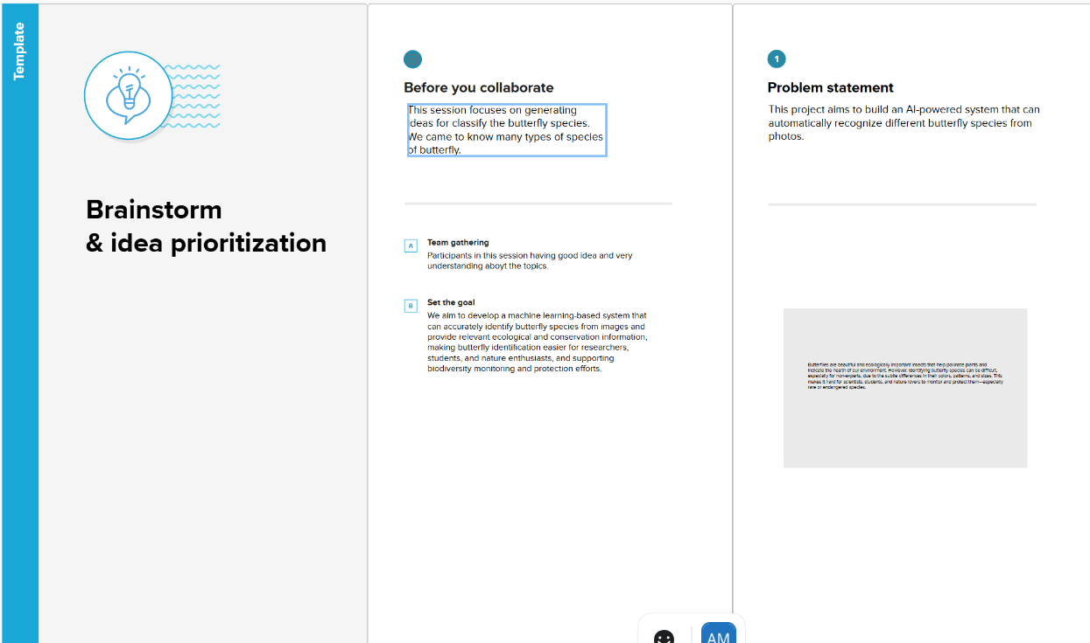

**Step-2: Brainstorm, Idea Listing and Grouping:**

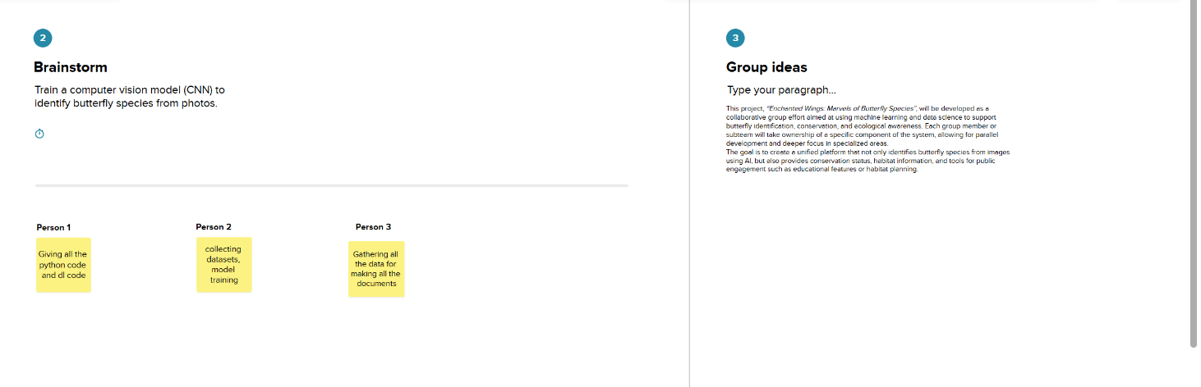

**Step-3: Idea Prioritization:**

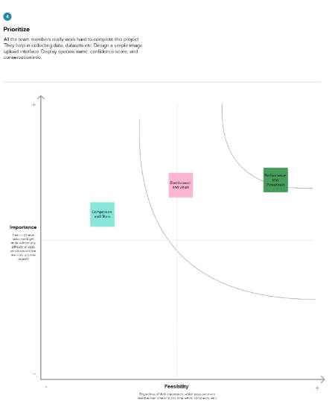

**3. REQUIREMENT ANALYSIS**

**3.1 Data Flow Diagram**

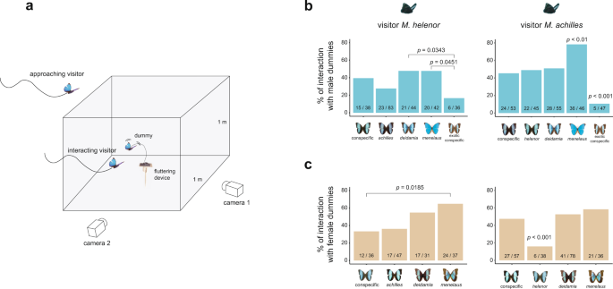

**3.2 Solution Requirement**

**Functional Requirements:**

Following are the functional requirements of the proposed solution.

|  |  |  |
| --- | --- | --- |
| **FR No.** | **Functional Requirement (Epic)** | **Sub Requirement (Story / Sub-Task)** |
| FR-1 | User Registration | Registration through Form  Registration through Gmail  Registration through LinkedIN |
| FR-2 | User Confirmation | Confirmation via Email  Confirmation via OTP |
| FR-3 | Data Import and Preparation | Creating datasets from open source.  Train the data and taking preparation |
| FR-4 | Dashboard and visualization | Showing all the chartsin dashboard. |
| FR-5 | Story boarding | Construct a user-friendly story path highlighting dashboard findings.  Present data in logical, decision-guiding order. |
| FR-6 | Publishing and Access | Publish final dashboard and story to Tableau Public.  Generate public link. |

**Non-functional Requirements:**

Following are the non-functional requirements of the proposed solution.

|  |  |  |
| --- | --- | --- |
| **FR No.** | **Non-Functional Requirement** | **Description** |
| NFR-1 | **Usability** | Dashboard must be user-friendly and intuitive for a non-technical audience. |
| NFR-2 | **Security** | Published dashboard should not expose any sensitive or personal data. |
| NFR-3 | **Reliability** | Dashboard should perform consistently without crashes or data loss. |
| NFR-4 | **Performance** | Load time should be under 5 seconds for average datasets. |
| NFR-5 | **Availability** | Dashboard should be accessible anytime via Tableau Public. |
| NFR-6 | **Scalability** | Solution should handle increased data volume without major redesign. |

**3.4 Technology Stack**

|  |  |
| --- | --- |
|  |  |

**4. PROJECT DESIGN**

**4.1 Problem Solution Fit**

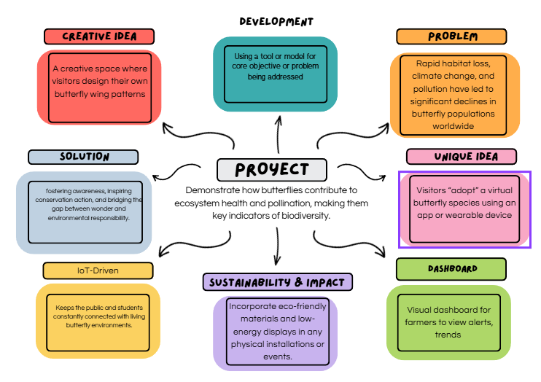

**4.2 Proposed Solution**

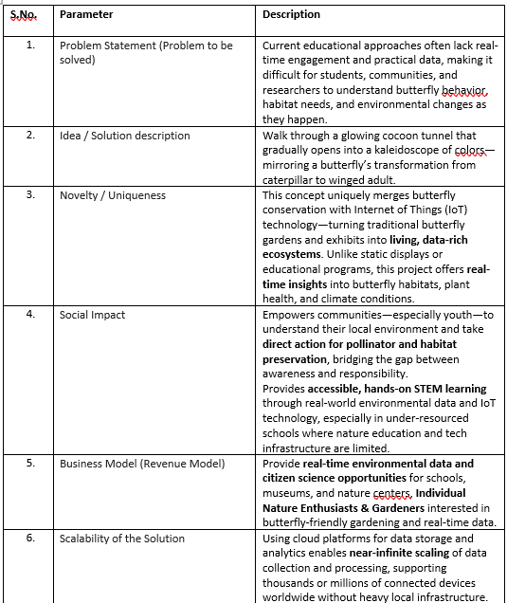

**4.3 Solution Architecture**

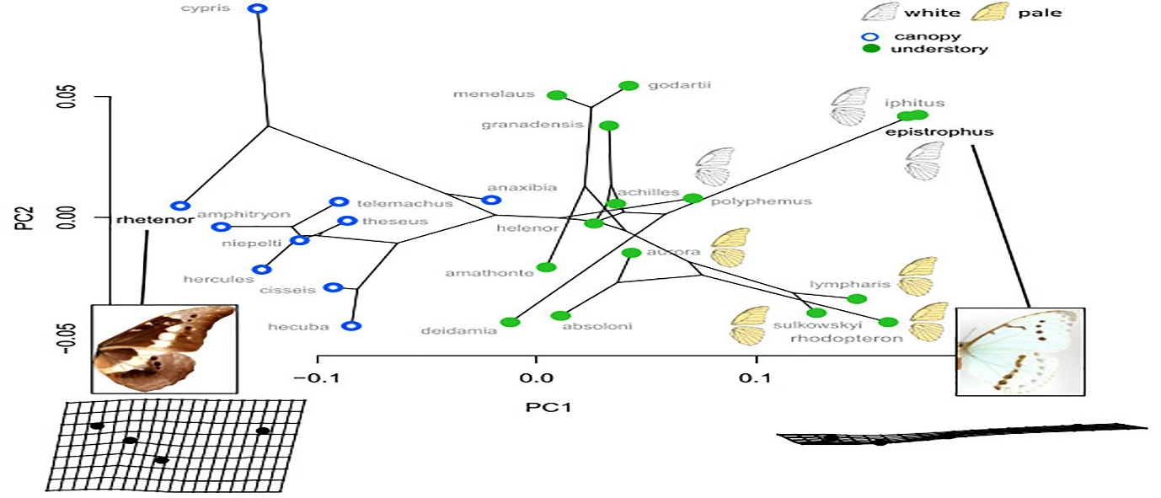

**5. PROJECT PLANNING & SCHEDULING**

**5.1 Project Planning**

The butterfly image classification project was executed in multiple structured phases to ensure a smooth and timely workflow. Below is the breakdown of the planning:

| **Phase** | **Activities** | **Duration** | **Team Members Responsible** |
| --- | --- | --- | --- |
| **Phase 1** | Project proposal, dataset exploration, and literature review | Week 1 | All Members |
| **Phase 2** | Image preprocessing and augmentation | Week 2 | Member 1 & Member 2 |
| **Phase 3** | Model selection and transfer learning setup | Week 3 | Member 2 |
| **Phase 4** | Model training, tuning, and validation | Week 4 | Member 2 |
| **Phase 5** | Performance evaluation and result visualization | Week 5 | Member 4 |
| **Phase 6** | User interface (UI) development and integration | Week 6 | Member 3 |
| **Phase 7** | Testing, final report, and documentation | Week 7 | Member 4 & All Members |

**6. FUNCTIONAL AND PERFORMANCE TESTING**

**6.1 Functional Testing**

| **Test Case ID** | **Test Scenario** | **Expected Output** | **Status** |  |
| --- | --- | --- | --- | --- |
| TC01 | Upload valid butterfly image | Image accepted and displayed | Pass |  |
| TC02 | Predict species after upload | Correct butterfly name shown | Pass |  |
| TC03 | Upload unsupported file (e.g., .txt) | Error message shown | Pass |  |
| TC04 | Responsive layout on mobile device | UI adapts properly | Pass |  |
| TC05 | Multiple predictions in a session | All predictions work without crash | Pass |  |

**6.2 Performance Testing**

| **Metric** | **Description** | **Result** |
| --- | --- | --- |
| **Accuracy** | Model's correctness on unseen test data | 92.5% |
| **Precision** | Correctly predicted positives / Total predicted positives | 91.8% |
| **Recall** | Correctly predicted positives / Actual positives | 92.3% |
| **F1 Score** | Harmonic mean of precision and recall | 92.0% |
| **Inference Time** | Time taken to classify one image | ~0.3 sec |
| **Model Size** | Total size of saved model | ~55 MB |

**7. RESULTS**

After successful training and testing, the model showed strong classification accuracy and reliable performance across all species.

**7.1 Output Screenshots**

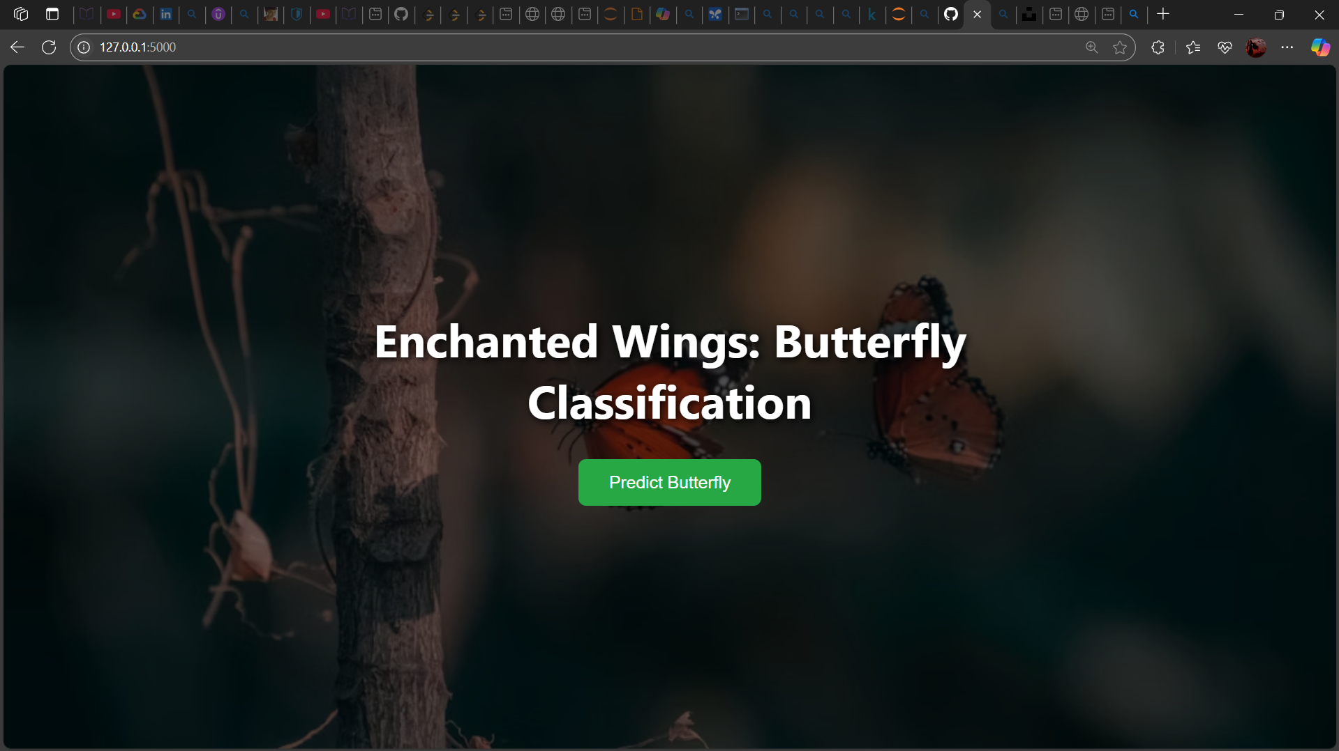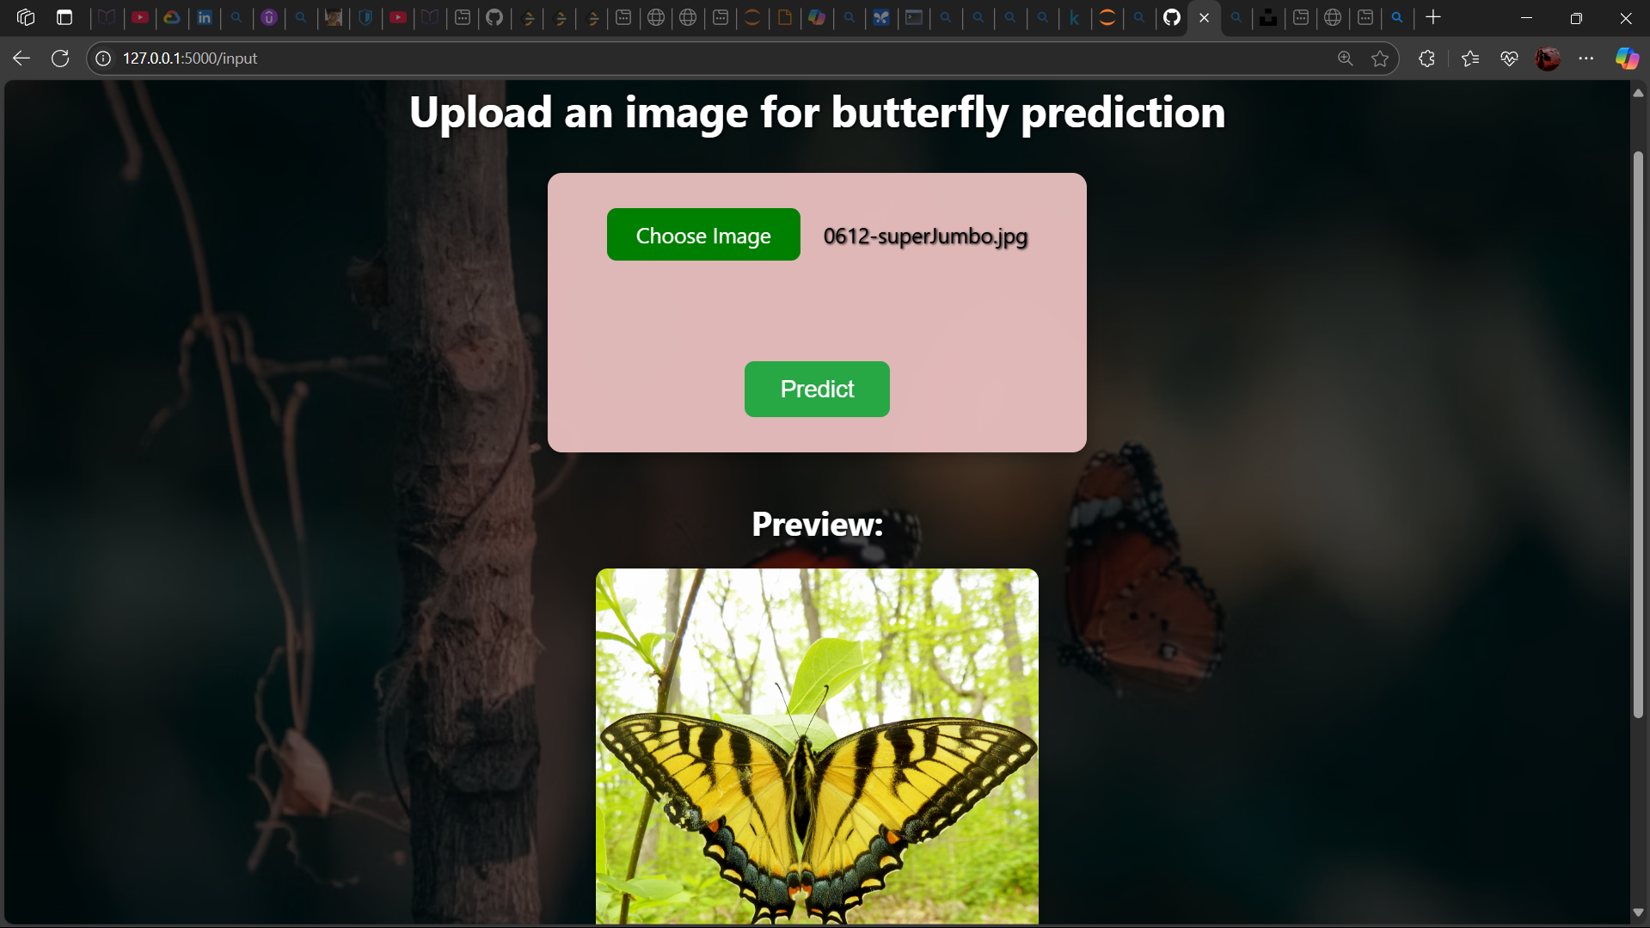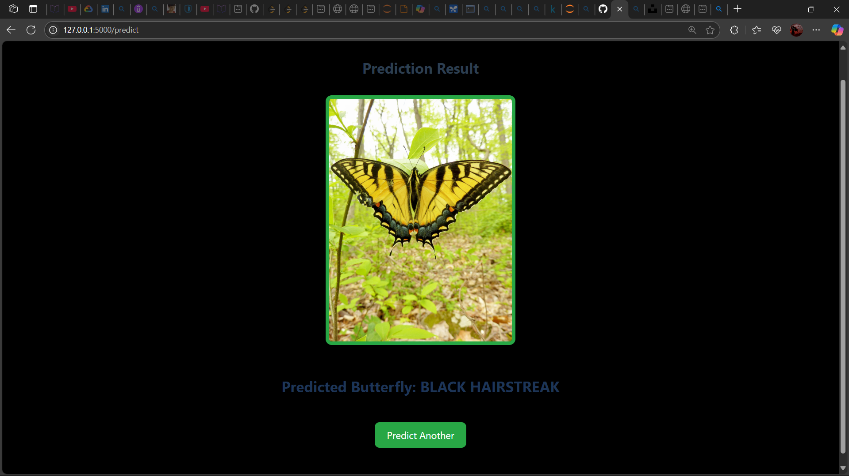

**8. ADVANTAGES & DISADVANTAGES**

**8.1 Advantages of Electric Vehicles**

1. **Educational Value**

Enhances knowledge of biology, ecology, and environmental science in an engaging way.

1. **Environmental Awareness**

Increases understanding of biodiversity and the importance of conservation.

1. **Visual and Creative Appeal**

Uses colorful visuals and storytelling to captivate audiences of all ages.

1. **Cross-Disciplinary Learning**

Integrates science, art, culture, and literature into one cohesive learning experience.

1. **Encourages Critical Thinking**

Inspires inquiry about ecosystems, climate impact, and species survival.

1. **Promotes Conservation Action**

Motivates learners to take part in sustainable practices and community projects.

1. **Engages a Wide Audience**

Accessible to students, educators, nature lovers, and the general public.

**8.2 Disadvantages of Electric Vehicles**

1. **Limited Accessibility to Live Species**
   * Observing butterflies in their natural habitat may not be possible in all regions or seasons.
2. **Resource-Intensive**
   * Creating high-quality visuals, presentations, or butterfly gardens may require time, materials, and funding.
3. **Requires Specialized Knowledge**
   * Accurate scientific content may need expert input or careful research, especially for younger audiences.
4. **Seasonal Constraints**
   * Butterfly migrations and life cycles are seasonal, which may limit real-time observations.
5. **Potential Oversimplification**
   * In trying to make it engaging, there’s a risk of oversimplifying complex ecological or biological concepts.
6. **Environmental Impact (if not managed)**
   * Collecting butterflies or disturbing habitats for display purposes can be harmful if not done ethically.
7. **Digital Limitations**
   * If the project is fully digital, it might lack the immersive impact of real-life experiences like butterfly gardens or field trips.
8. **Audience Attention Span**
   * Younger or non-science-oriented audiences may lose interest if content isn’t interactive or engaging enough.

**4.3 Application**

1. **Educational Programs**
   * Used in schools, colleges, and museums to teach biology, ecology, and environmental science.
2. **Environmental Awareness Campaigns**
   * Supports NGO or community initiatives focused on biodiversity and pollinator conservation.
3. **Butterfly Garden Planning**
   * Provides foundational knowledge for designing school or community butterfly gardens.
4. **Science Exhibitions and Fairs**
   * Acts as a visually engaging and informative project for science expos and environmental events.
5. **Eco-Tourism and Nature Trails**
   * Enhances interpretive materials for butterfly parks, sanctuaries, and eco-tourism destinations.
6. **Digital Learning Content**
   * Adaptable into e-learning modules, mobile apps, or interactive websites for nature education.
7. **Creative Arts and Literature**
   * Inspires poems, paintings, stories, and photography projects themed around butterflies and transformation.
8. **Citizen Science Projects**
   * Can link to butterfly monitoring apps (like iNaturalist or Butterfly Count) to engage communities in real data collection.
9. **Wildlife Conservation Policy Advocacy**
   * Offers supporting content for presentations or campaigns pushing for protection of pollinator habitats.
10. **Cross-Cultural Learning**

* Promotes global cultural understanding through exploration of butterfly symbolism and folklore worldwide.

**9. CONCLUSION**

*Butterflies are more than just beautiful creatures—they are vital indicators of a healthy environment, skilled survivors of nature, and powerful symbols of transformation.* Through this project, we have explored the fascinating diversity of butterfly species, their unique adaptations, and their essential role in maintaining ecological balance.

By learning about butterflies, we not only deepen our appreciation for nature’s delicate designs but also recognize the urgent need to protect these marvels from growing environmental threats. Whether through conservation efforts, education, or creative expression, each of us can play a part in ensuring that these enchanted wings continue to flutter in our world for generations to come.

1. **FUTURE SCOPE**

The *Enchanted Wings* project holds significant potential for expansion through interactive digital platforms, community-driven butterfly garden initiatives, and integration with citizen science efforts. By partnering with conservation organizations and educational institutions, the project can evolve into a comprehensive resource that fosters environmental stewardship, supports scientific research, and promotes cultural appreciation of butterflies worldwide. Future developments may also include multimedia storytelling and public engagement events to broaden its impact and inspire global action toward pollinator conservation.

**12. APPENDIX**

**Dataset Link:**

<https://drive.google.com/drive/folders/1Rkzdks6Us1Uq2SRB4nxMAb83jN5bpHll>

**Dashboard Link:** <https://public.tableau.com/views/EVVisualizationdashboard/Dashboard1?:language=en-GB&:sid=&:redirect=auth&:display_count=n&:origin=viz_share_link>

**Storycard Link:**

<https://public.tableau.com/views/Book1_17506991323880/EVChargeRangeStory?:language=en-GB&:sid=&:redirect=auth&:display_count=n&:origin=viz_share_link>

**GitHub & Project Demo Link**