**통계프로그래밍언어2**

**학과 : 전기공학과**

**학번 : 201724570**

**이름 : 정석규**

**Problem1-1**

**# Code**

LIBNAME mysas '/home/u59401758/library';

DATA mysas.score;

INPUT ID MID FINAL;

CARDS;

1 78 88

2 75 80

3 86 79

4 92 88

5 88 93

6 67 90

7 86 77

8 80 87

9 95 86

10 79 90

; RUN;

**# Result**

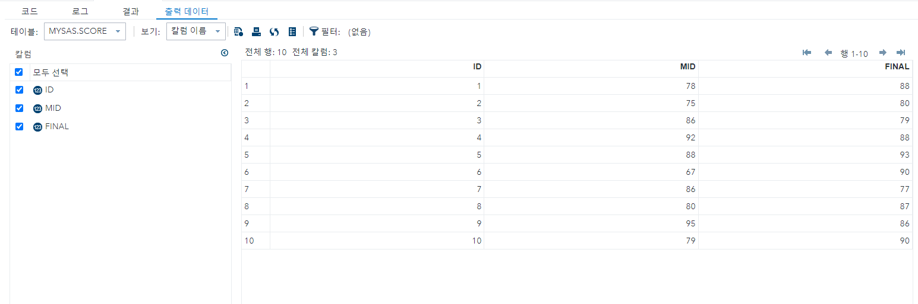

**Problem1-2**

**# Code**

DATA mysas.score1;

SET mysas.score;

tot = MID + FINAL;

avg = MEAN(MID, FINAL);

avg = ROUND(avg, 0.1);

RUN;

**# Result**

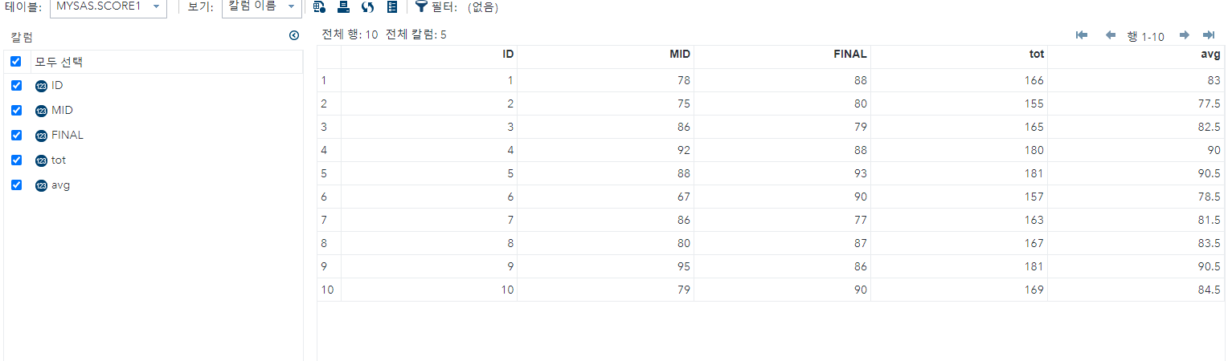

**Problem1-3**

**# Code**

PROC MEANS DATA = mysas.score1 MAXDEC = 2 MEAN STD CV RANGE;

VAR tot avg;

TITLE '>>>총점과 평균의 기술통계량<<<';

RUN;

**# Result**



총점의 평균은 166.4, 표준편차는 9.49이고 평균의 평균은 84.2, 표준편차는 4.74이다.

**Problem1-4**

**# Code**

ATA mysas.score2;

SET mysas.score1;

IF avg >= 90 THEN grade = 'A';

IF avg >= 80 and avg < 90 THEN grade = 'B';

IF avg >= 70 and avg < 80 THEN grade = 'C';

IF avg >= 60 and avg < 70 THEN grade = 'D';

IF avg < 60 THEN grade = 'E';

RUN;

PROC FREQ DATA = mysas.score2;

TABLES grade;

RUN;

**# Result**

**Problem2-1**

**# Code**

PROC IMPORT DBMS=EXCEL

DATAFILE= '/home/u59401758/Dataset/climate.xlsx'

OUT = mysas.country

REPLACE;

SHEET='Sheet1$';

GETNAMES=yes;

RUN;

DATA mysas.country1;

SET mysas.country;

IF climate = '' THEN DELETE;

RUN;

**# Result**

**Problem2-2**

**# Code**

DATA mysas.country2;

SET mysas.country1;

IF climate <= 4 THEN climate2 = 'HOT';

IF climate >= 5 THEN climate2 = 'WARM';

RUN;

**# Result**

**Problem2-3**

**# Code**

DATA mysas.country3;

SET mysas.country2;

IF climate <= 3 THEN climate3 = 'TROPICAL';

IF climate >= 4 and climate <= 6 THEN climate3 = 'SUBTROPICAL';

IF climate >= 7 THEN climate3 = 'TEMPERATE';

RUN;

**# Result**

**Problem2-4**

**# Code**

DATA mysas.country4;

SET mysas.country3(KEEP = density gdp pop_incr crop climate);

RUN;

**# Result**

**Problem2-5**

**# Code**

DATA mysas.country4;

IF density = '' THEN density = MEAN(density);

IF gdp = '' THEN gdp = MEAN(gdp);

IF pop_incr = '' THEN pop_incr = MEAN(pop_incr);

IF crop= '' THEN crop = MEAN(crop);

**# Result**

**Problem2-6**

**# Code**

PROC MEANS DATA = mysas.country4 MAXDEC=2 MEAN STD CV RANGE;

VAR density gdp pop_incr crop;

RUN;

**# Result**

**Problem2-7**

**# Code**

PROC MEANS DATA = mysas.country3 MAXDEC=2 MEAN STD CV RANGE;

CLASS climate2;

VAR denisty gdp pop_incr crop;

RUN;

**# Result**

**Problem2-8**

**# Code**

PROC MEANS DATA = mysas.country3 MAXDEC=2 MEAN STD CV RANGE;

CLASS climate3;

VAR density gdp pop_incr crop;

RUN;

**# Result**