**Energy Optimization for HVAC and Lighting Units in Commercial Non-Residential Building**

**Ideas**

1. Ambient Lighting Control taking to account the outdoor sun-light and Occupant Preference
2. Demand Control Ventilation (CO2)
3. Optimization of Centralized HVAC – Using Weather prediction and Inputs from Occupants and Number of Occupants and Occupancy trends
4. Localization of Centralized HVAC operation
5. AI Based Sensor and Actuator Placement Optimization
6. PIR Controlled Lighting
7. Cost optimization using localized Sustainable Energy Sources and Energy Pricing trends.

**Implementation (As of 31.10.2023)**

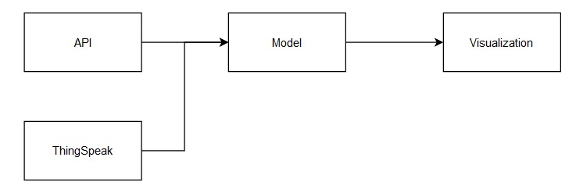

**Fig.1. Overview**

1. 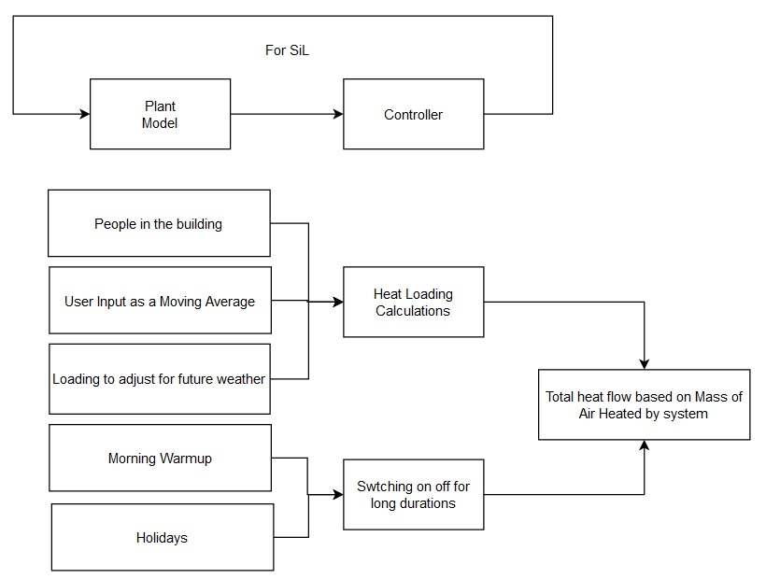Optimization of Centralized HVAC – Using Weather prediction and Inputs from Occupants and Number of Occupants and Occupancy trends

**Fig.2. HVAC Control System Depiction**

1. Ambient Lighting Control taking to account the outdoor sun-light and Occupant Preference

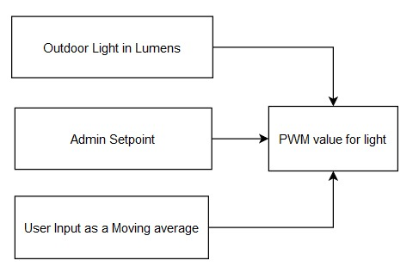

**Fig.3. Lighting Control System Depiction**

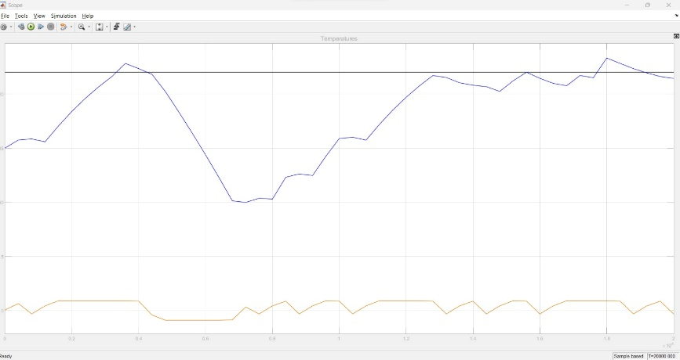**Results**

**Fig.4. Model Output for HVAC**

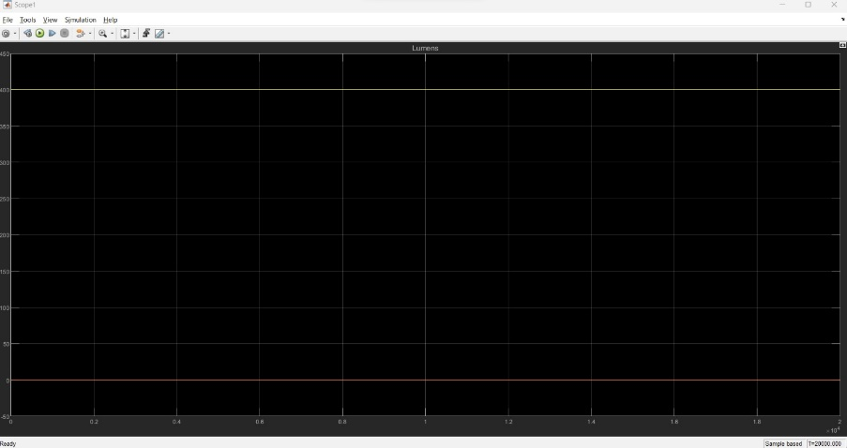[Black -> Reference voltage. Set by admin, Blue-> Actual Room Temp. Yellow-> Intensity at which the system is operating]

**Fig.5. Illuminance within the building**

[Yellow – 400Lumens]

**Cost Calculation (Estimate)**

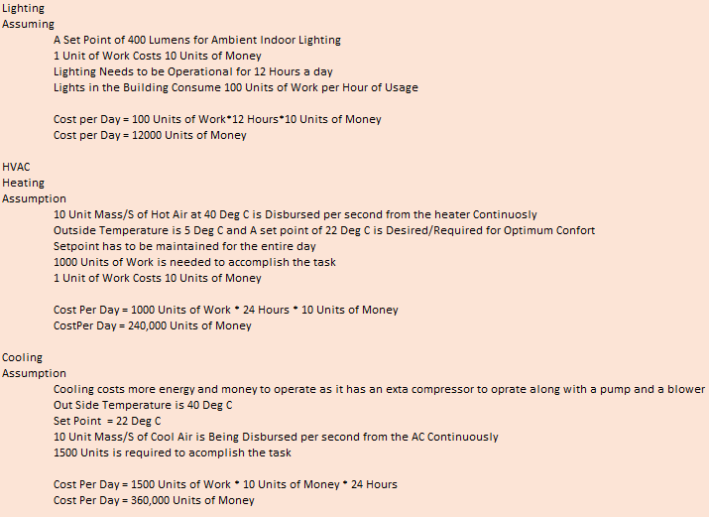

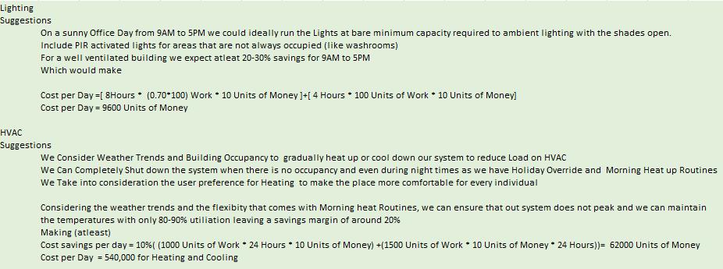

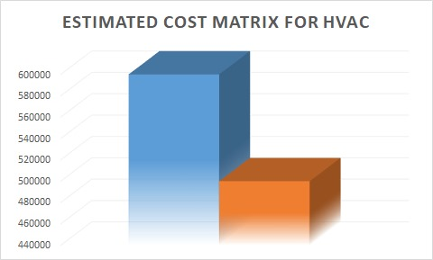

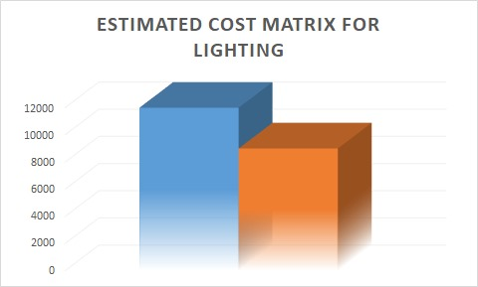

**Fig4. Cost Matrix [Blue->Without Optimization; Orange -> With Model]**