StockFlow

Enterprise Inventory Management System

SUBMITTED BY: SHASHAANK DUGGAL
Bachelor of Technology, 3rd year
v1.0

Executive Summary:

StockFlow is an enterprise-grade inventory management platform designed to support multi-warehouse inventory tracking, product management, procurement workflows, audit logging, inventory reservations, reporting, and role-based access control.
The system is designed using modern enterprise software engineering principles and follows a layered architecture to ensure scalability, maintainability, security, and operational reliability.

Technology Stack

A React web app wired with Spring Boot backend for responsiveness.
PostgreSQL for Database with Redis cache handling
Docker for container

TABLE OF CONTENTS

- Introduction

- Executive Summary
    - Project Overview
    - Business Problem Statement
    - Proposed Solution
    - Project Objectives
    - Scope
- Stakeholder Analysis
    - Internal and External Stakeholders
    - Stakeholder Responsibilities
- User Personas & Access Model
    - Overview
    - System admin persona
    - Warehouse manager persona
    - Inventory Staff Persona
    - Auditor Persona
    - Supplier Persona
    - User access matrix
    - Visibility layers
    - Role-based Access control model
- Functional Requirements
    - Authentication Requirements
    - Product management requirements
    - Inventory management requirements
    - Purchase Order requirements
    - Audit Logging requirements
    - Reporting requirements
    - Notification requirements
- Business Rules
    - Inventory rules
    - Security rules
    - Purchase order rules
    - Audit rules
    - Reporting rules
- Core Business Scenarios
    - User Authentication and Access control
    - Product Registration and Catalog Management
    - Inventory Stock-in process
    - Inventory Stock-out process
    - Warehouse Stock transfer
    - Purchase order creation and approval
    - Inventory Reservation
    - Low Stock monitoring & alerts
    - Audit logging and compliance tracking
    - Reporting and analytics
    - Notification management
    - Barcode/QR based Inventory operations
- System Architecture
    - Architecture overview
    - Module breakdown
    - Technology Stack
- System Design
    - Domain model
    - Service Layer design
    - Package structure
- Workflow Design
    - Login workflow
    - Product registration window
    - Stock in workflow
    - Stock out workflow
    - Stock transfer workflow
    - Purchase order workflow
    - Inventory reservation workflow
- Database design
    - Database overview
    - Entity descriptions
    - Table relationships
    - Constraints
    - Data Integrity rules
- Security Design
    - Authentication Architecture
    - JWT Workflow
    - Role based access control
    - Password Encryption
    - API security
    - Audit Security
- API Design
    - Authentication APIs
    - Product, Inventory and Warehouse APIs
    - Purchase Order APIs
    - Reporting APIs
    - Error Handling Standards
- Deployment Architecture
    - Deployment Overview
    - Deployment Diagram
    - Docker Containers
    - Infrastructure Components
- Reporting & Analytics
    - Dashboard metrics
    - Inventory valuation
    - Low stock reports
    - Warehouse utilization
    - Audit reports
- Risks & Assumptions
    - Technical Risks
    - Operational Risks
    - Assumptions
    - Mitigation Strategies
- Future Enhancements
    - Barcode Scanner Integrations
    - Inventory Forecasting
    - Kafka Event Streaming
    - Microservice Migrations
    - Mobile Application
- Conclusion
    - Project Summary
    - Key Learnings
    - Final Remarks
APPENDIX A: GLOSSARY
APPENDIX B: API SAMPLES
APPENDIX C: ADDITIONAL DIAGRAMS

1 Executive Summary

  - Project Overview

StockFlow is an enterprise-grade Inventory Management System designed to streamline inventory operations across multiple warehouse locations. The platform provides centralized control over products, warehouses, inventory transactions, procurement workflows, supplier relationships, audit tracking, and reporting activities.
The system is intended to simulate real-world enterprise inventory operations commonly found in manufacturing, retail, logistics, and distribution organizations. By integrating inventory management processes into a single platform, StockFlow improves operational visibility, inventory accuracy, and process accountability.
The application follows a modern client-server architecture consisting of a React frontend, Spring Boot backend, PostgreSQL database, Redis caching layer, and JWT-based authentication mechanism.

  - Business Problem Statement

Many organizations continue to manage inventory through spreadsheets, disconnected software systems, or manual processes. These approaches often introduce operational inefficiencies and increase the likelihood of inventory-related errors.
Common challenges include:
- Inaccurate inventory records
- Inventory shortages and stockouts
- Overstocking and dead inventory
- Lack of visibility across warehouse locations
- Manual purchase order tracking
- Limited auditability of inventory movements
- Weak access control mechanisms
- Delayed operational reporting
These challenges can negatively impact business performance, operational efficiency, and customer satisfaction.

  - Proposed Solution

StockFlow addresses these challenges by providing a centralized inventory management platform capable of managing inventory operations across multiple warehouses.
The system provides:
- Product catalog management
- Multi-warehouse inventory tracking
- Inventory stock-in and stock-out processing
- Warehouse transfer management
- Purchase order workflows
- Supplier management
- Inventory reservation capabilities
- Audit logging and compliance tracking
- Notification and alert management
- Reporting and analytics dashboards
By automating operational workflows and enforcing business rules, the platform improves inventory accuracy and organizational visibility.

  - Project Objectives

The primary objectives of StockFlow are:

Business Objectives

- Improve inventory accuracy
- Reduce inventory discrepancies
- Increase operational visibility
- Improve procurement efficiency
- Strengthen auditability and compliance

Technical Objectives

- Implement enterprise-grade architecture
- Demonstrate secure authentication and authorization
- Support scalable inventory operations
- Maintain transactional consistency
- Provide modular and maintainable system design

Learning Objectives
- Apply software engineering principles
- Design enterprise business workflows
- Implement layered backend architecture
- Develop secure REST APIs
- Understand inventory domain modelling

  - Scope of the System

In Scope

The following functionality is included within the scope of the system:
- User authentication and authorization
- Role-based access control
- Product management
- Category management
- Supplier management
- Warehouse management
- Inventory tracking
- Inventory reservation
- Stock transfer operations
- Purchase order management
- Audit logging
- Reporting and analytics
- Notification management

Out of Scope

The following functionality is not included in the current implementation:
- Accounting integration
- Payroll management
- Customer relationship management
- Shipping carrier integration
- Financial reporting
- ERP integration
- Multi-tenant architecture

2 Stakeholder Analysis

2.1 Internal Stakeholders

System Administrator
The System Administrator is responsible for configuring and maintaining the platform. This stakeholder manages user accounts, role assignments, system settings, and platform security.
Key Responsibilities:
- User management
- Role assignment
- Security administration
- System monitoring
- Access control management
Warehouse Manager

The Warehouse Manager oversees warehouse operations and inventory health across one or more warehouse locations.

Key Responsibilities:

- Inventory monitoring
- Purchase order approvals
- Stock transfer authorization
- Warehouse utilization management
- Operational reporting

Inventory Staff

Inventory Staff perform day-to-day inventory activities within warehouse environments.

Key Responsibilities:

- Stock-in operations
- Stock-out operations
- Inventory updates
- Product handling
- Barcode scanning operations

Auditor

The Auditor is responsible for ensuring compliance, transparency, and accountability across inventory operations.

Key Responsibilities:

- Audit log reviews
- Transaction verification
- Compliance validation
- Operational reporting
- Investigation support

2.2 External Stakeholders
Suppliers

Suppliers provide products and inventory to the organization and participate in procurement workflows.

Key Responsibilities:

- Product delivery
- Purchase order fulfillment
- Shipment coordination
- Supply chain communication

Management

Management personnel use information generated by the system to support strategic decision-making.

Key Responsibilities:

- Performance monitoring
- Inventory valuation review
- Business reporting analysis
- Operational planning

Future Integration Systems

Future enterprise systems may integrate with StockFlow.

Examples include:

- ERP systems
- Financial systems
- Shipping providers
- Forecasting platforms
- Mobile applications

2.3 Stakeholder Responsibilities

Stakeholder | Primary Responsibility
System  Administrator | Platform configuration and security
Warehouse  Manager | Inventory supervision and approvals
Inventory  Staff | Daily inventory operations
Auditor | Compliance and audit review
Supplier | Inventory supply and procurement support
Management | Reporting and business oversight

3 User Personas and Access Model

3.1 System Users Overview

The StockFlow platform supports multiple categories of users. Each user type performs a specific set of responsibilities and is granted access only to the functionality required for their role.
The system follows the principle of least privilege, ensuring that users have access only to the resources necessary to perform their assigned tasks.
The primary user roles supported by the platform are:
- System Administrator
- Warehouse Manager
- Inventory Staff
- Auditor
Each role operates within defined permission boundaries enforced through Role-Based Access Control (RBAC).

3.2 System Admin Persona
Description

The System Administrator is responsible for overall platform administration, security management, user provisioning, and system configuration.

Primary Objectives

- Manage user accounts
- Configure roles and permissions
- Maintain platform security
- Monitor operational activity
- Review audit records

Accessible Modules

- Dashboard
- User Management
- Role Management
- Product Management
- Warehouse Management
- Reports
- Audit Logs
- System Settings

Restricted Activities

The System Administrator does not participate in physical warehouse operations such as stock receiving or product dispatching.

3.3 Warehouse Manager Persona
Description

The Warehouse Manager supervises inventory operations within one or more warehouse locations and is responsible for inventory health and operational efficiency.

Primary Objectives

- Monitor inventory levels
- Approve purchase orders
- Manage warehouse transfers
- Respond to inventory alerts
- Review operational reports

Accessible Modules

- Dashboard
- Inventory Management
- Purchase Orders
- Warehouses
- Reports
- Notifications

Restricted Activities

The Warehouse Manager cannot manage system users or modify platform-level configuration settings.

3.4 Inventory Staff Persona

Description

Inventory Staff perform day-to-day warehouse operations and inventory transactions.

Primary Objectives

- Receive inventory
- Dispatch inventory
- Update stock records
- Perform inventory reservations
- Execute barcode scanning operations

Accessible Modules

- Products
- Inventory
- Barcode Operations
- Transaction History

Restricted Activities

Inventory Staff cannot approve purchase orders, access audit logs, manage users, or modify system settings.

3.5 Auditor Persona

Description

The Auditor is responsible for compliance validation, transaction verification, and operational accountability.

Primary Objectives

- Review inventory movements
- Verify audit records
- Generate compliance reports
- Investigate operational anomalies
Accessible Modules

- Audit Logs
- Reports
- Transaction History
- Analytics Dashboard

Restricted Activities
Auditors operate in a read-only capacity and cannot modify inventory data or perform operational transactions.

3.6 Supplier Persona (Future Enhancement)

Description

Suppliers represent external organizations responsible for fulfilling purchase orders and delivering inventory.

Potential Objectives

- View purchase orders
- Confirm shipments
- Update delivery status
- Respond to procurement requests

Potential Modules
- Supplier Portal
- Purchase Orders
- Delivery Tracking

This functionality is considered a future enhancement and is not included in the current system implementation.

3.7 User Access Matrix

Feature | Admin | Manager | Staff | Auditor
Login | Yes | Yes | Yes | Yes
Product Management | Yes | Yes | Yes | View Only
Inventory Management | Yes | Yes | Yes | View Only
Purchase Order Approval | Yes | Yes | No | View Only
Stock Transfer | Yes | Yes | No | View Only
Reports | Yes | Yes | No | Yes
Audit Logs | Yes | View Only | No | Yes
User Management | Yes | No | No | No
System Settings | Yes | No | No | No

3.8 Visibility Layers

The StockFlow platform implements multiple visibility layers to ensure users only access relevant information.

Administrative Layer
Accessible exclusively by System Administrators.
Includes:
- User Management
- Role Configuration
- System Configuration
- Security Controls

Operational Layer
Accessible by Warehouse Managers and Inventory Staff.
Includes:
- Products
- Inventory
- Warehouses
- Purchase Orders

Compliance Layer
Accessible by Auditors.
Includes:
- Audit Logs
- Reports
- Transaction History

Shared Layer
Accessible by all authenticated users.
Includes:
- Authentication
- Personal Profile
- Notifications

4 Functional Requirements

4.1 Introduction

Functional requirements define the capabilities and services that the StockFlow platform must provide to its users.

These requirements describe the behavior of the system and establish the expected functionality for inventory operations, warehouse management, procurement workflows, security, reporting, and auditing.

Each requirement is assigned a unique identifier for traceability throughout the software development lifecycle.

4.2 Authentication Requirements

FR-001 User Login
The system shall allow registered users to authenticate using valid credentials.

FR-002 JWT Authentication
The system shall generate a JSON Web Token (JWT) upon successful authentication.

FR-003 Session Authorization
The system shall validate user permissions before granting access to protected resources.

FR-004 Role Assignment
The system shall assign a role to each authenticated user.

FR-005 Logout
The system shall support secure session termination.

4.3 Product Management Requirements

FR-006 Product Creation
The system shall allow authorized users to create new product records.

FR-007 SKU Generation
The system shall generate unique SKU identifiers for products.

Example:
SKU-EL-2026-0001

FR-008 Product Update
The system shall allow authorized users to update product information.

FR-009 Product Search
The system shall support searching products by SKU, name, category, or supplier.

FR-010 Product Categorization
The system shall support product categorization for inventory organization.

4.4 Inventory Management Requirements
FR-011 Stock-In Operations
The system shall support inventory receiving operations.

FR-012 Stock-Out Operations
The system shall support inventory dispatch operations.

FR-013 Inventory Adjustment
The system shall support inventory quantity corrections by authorized users.

FR-014 Inventory Reservation
The system shall support reservation of inventory for future transactions.

FR-015 Inventory Availability Calculation
The system shall calculate available inventory using:
Available Stock = Total Stock - Reserved Stock
FR-016 Damaged Inventory Tracking
The system shall support recording damaged inventory separately from available inventory.

4.5 Warehouse Management Requirements

FR-017 Warehouse Creation
The system shall support creation and management of warehouse locations.

FR-018 Multi-Warehouse Support
The system shall maintain inventory independently for each warehouse.

FR-019 Warehouse Transfer
The system shall support inventory transfer between warehouses.

FR-020 Warehouse Visibility
The system shall provide warehouse-specific inventory views.

4.6 Purchase Order Requirements

FR-021 Purchase Order Creation
The system shall allow users to create purchase orders.

FR-022 Purchase Order Approval
The system shall require manager approval before purchase order execution.

FR-023 Supplier Assignment
The system shall associate suppliers with purchase orders.

FR-024 Goods Receiving
The system shall support receiving inventory against approved purchase orders.

FR-025 Purchase Order Closure
The system shall support completion and closure of fulfilled purchase orders.

4.7 Supplier Management Requirements

FR-026 Supplier Registration
The system shall maintain supplier information.

FR-027 Supplier Performance Tracking
The system shall support monitoring supplier delivery performance.

FR-028 Supplier Search
The system shall support supplier lookup and filtering.

4.8 Audit Logging Requirements

FR-029 Audit Record Creation
The system shall generate audit records for critical operations.

FR-030 User Activity Tracking
The system shall record user activity associated with system transactions.

FR-031 Historical Record Retention
The system shall maintain historical audit information.

FR-032 Audit Search
The system shall allow auditors to search audit records.

4.9 Reporting Requirements

FR-033 Inventory Reports
The system shall generate inventory summary reports.

FR-034 Low Stock Reports
The system shall identify products below reorder thresholds.

FR-035 Inventory Valuation Reports
The system shall support inventory valuation calculations.

FR-036 Warehouse Utilization Reports
The system shall generate warehouse utilization statistics.

FR-037 Audit Reports
The system shall generate compliance and audit reports.

4.10 Notification Requirements

FR-038 Low Stock Notifications
The system shall notify managers when stock levels fall below predefined thresholds.

FR-039 Purchase Order Notifications
The system shall notify relevant users when purchase orders require approval.

FR-040 Inventory Alerts
The system shall generate operational inventory alerts.

4.11 Barcode and QR Requirements

FR-041 Barcode Generation
The system shall generate barcode identifiers for products.

FR-042 Barcode Scanning
The system shall support barcode-based inventory operations.

FR-043 QR Code Support
The system shall support QR-based product identification.

4.12 Data Export Requirements

FR-044 CSV Export
The system shall support CSV export of reports.

FR-045 Excel Export
The system shall support Excel export of reports.

FR-046 PDF Export
The system shall support PDF export of reports.

5 Business Rules

5.1 Introduction

Business rules define the policies, constraints, validations, and operational guidelines that govern system behavior.

These rules ensure data integrity, inventory accuracy, operational consistency, and regulatory compliance throughout the StockFlow platform.

Unlike functional requirements, business rules specify the conditions under which system operations are permitted or restricted.

All workflows, APIs, database transactions, and user actions must comply with the business rules defined in this chapter.

5.2 Inventory Rules

BR-001 Non-Negative Inventory

Inventory quantities shall never become negative.
If a stock-out request exceeds available inventory, the operation shall be rejected.

BR-002 Inventory Reservation Priority

Reserved inventory shall not be available for stock-out operations until the reservation is released or fulfilled.

BR-003 Available Inventory Calculation

Available inventory shall be calculated as:
Available Inventory = Total Inventory - Reserved Inventory

BR-004 Warehouse Isolation

Inventory records shall be maintained independently for each warehouse location.
Inventory belonging to one warehouse shall not automatically affect another warehouse.

BR-005 Damaged Inventory Segregation

Damaged inventory shall be recorded separately from available inventory.
Damaged inventory shall not contribute to available stock calculations.

BR-006 Mandatory Inventory Transaction Logging

Every inventory modification shall generate an inventory transaction record.
Examples include:
- Stock In
- Stock Out
- Stock Transfer
- Inventory Adjustment
- Inventory Reservation

5.3 Product Management Rules

BR-007 Unique SKU Requirement

Every product shall possess a unique SKU identifier.
Duplicate SKU values shall not be permitted.

BR-008 Mandatory Product Classification

Each product shall belong to a category before becoming active within the system.

BR-009 Supplier Association

Every product shall be associated with at least one supplier.

BR-010 Product Deactivation Protection

Products involved in active inventory transactions shall not be permanently deleted.
Instead, they shall be marked as inactive.

5.4 Warehouse Rules

BR-011 Warehouse Transfer Validation

Inventory transfers shall only occur when sufficient stock exists within the source warehouse.

BR-012 Transfer Atomicity

Warehouse transfers shall execute as a single database transaction.
Either the entire transfer succeeds or the entire transfer fails.
Partial transfers are not permitted.

BR-013 Warehouse Existence Validation

Transfers may only occur between valid and active warehouses.

5.5 Purchase Order Rules

BR-014 Approval Requirement

Purchase orders exceeding predefined thresholds shall require managerial approval.

BR-015 Supplier Validation

Purchase orders may only be issued to active suppliers.

BR-016 Inventory Receiving Restriction

Inventory may only be received against approved purchase orders.

BR-017 Purchase Order Closure

Purchase orders may only be closed after all associated receiving operations have been completed.

5.6 Security Rules

BR-018 Authentication Requirement

Users shall authenticate before accessing protected resources.

BR-019 Role-Based Authorization

All protected operations shall be governed by role-based access control policies.

BR-020 Password Encryption

Passwords shall never be stored in plain text.
All passwords shall be encrypted before persistence.

BR-021 Session Validation

All API requests shall be validated using active authentication tokens.

BR-022 Administrative Access Restriction

Administrative functions shall only be accessible to users assigned the Administrator role.

5.7 Audit Rules

BR-023 Audit Trail Requirement

Every critical business operation shall generate an audit record.

BR-024 Audit Immutability

Audit records shall not be modified after creation.

BR-025 Audit Metadata Requirement

Audit records shall contain:
- User Identifier
- Timestamp
- Operation Type
- Entity Modified
- Previous Value (if applicable)
- New Value (if applicable)

BR-026 Audit Visibility Restriction

Audit records shall only be accessible to authorized personnel.

5.8 Reporting Rules

BR-027 Real-Time Data Usage

Reports shall use current system data whenever possible.

BR-028 Low Stock Threshold Monitoring

Products falling below reorder thresholds shall be identified automatically.

BR-029 Inventory Valuation Consistency

Inventory valuation calculations shall use standardized pricing methods.

5.9 Notification Rules

BR-030 Low Stock Notification Trigger

Low stock notifications shall be generated whenever inventory falls below configured thresholds.

BR-031 Purchase Order Approval Notification

Managers shall receive notifications for purchase orders awaiting approval.

BR-032 Critical Alert Prioritization

Critical operational alerts shall receive higher notification priority than informational messages.

5.10 Data Integrity Rules

BR-033 Mandatory Transaction Records

All inventory operations shall generate corresponding transaction records.

BR-034 Foreign Key Integrity

Relationships between products, warehouses, suppliers, and transactions shall remain valid at all times.

BR-035 Transaction Rollback

Failed inventory operations shall automatically rollback all associated database changes.

6 Core Business Scenarios

6.1 Introduction’

Core business scenarios represent the primary operational workflows supported by the StockFlow platform.

These scenarios illustrate how users interact with the system to perform inventory operations, warehouse management, procurement activities, reporting, auditing, and notification handling.

Each scenario is derived from the functional requirements defined in Chapter 4 and is governed by the business rules established in Chapter 5.

The objective of this chapter is to provide a process-level understanding of system behavior from a business and operational perspective.

Scenario Documentation Structure

Each scenario in this chapter follows a standardized format to ensure consistency and traceability throughout the system design.

Every scenario contains:
Purpose
Defines the business objective of the scenario.

Actors
Identifies the users or system components involved in the workflow.

Trigger
Defines the event that initiates the scenario.

Preconditions
Conditions that must be satisfied before the scenario can begin.

Functional Requirements Referenced
Lists all functional requirements associated with the workflow.
Example:
- FR-011 Stock-In Operations
- FR-029 Audit Record Creation

Business Rules Referenced
Lists all business rules governing the workflow.
Example:
- BR-001 Non-Negative Inventory
- BR-006 Mandatory Inventory Transaction Logging

Main Flow
Describes the standard execution path of the scenario.

Alternative Flow
Describes valid variations of the primary workflow.

Exception Flow
Describes system behavior when failures occur.

Postconditions
Defines the resulting system state after successful completion.

Associated Diagram
Provides a visual representation of the workflow.
Each diagram shall be referenced using a figure number.

Example:
Figure 6.1 – User Authentication Workflow
Figure 6.2 – Product Registration Workflow
Figure 6.3 – Inventory Stock-In Workflow

Scenario Index

6.2 User Auth and Access Control

6.1

6.3 Product Registration & Catalog Management

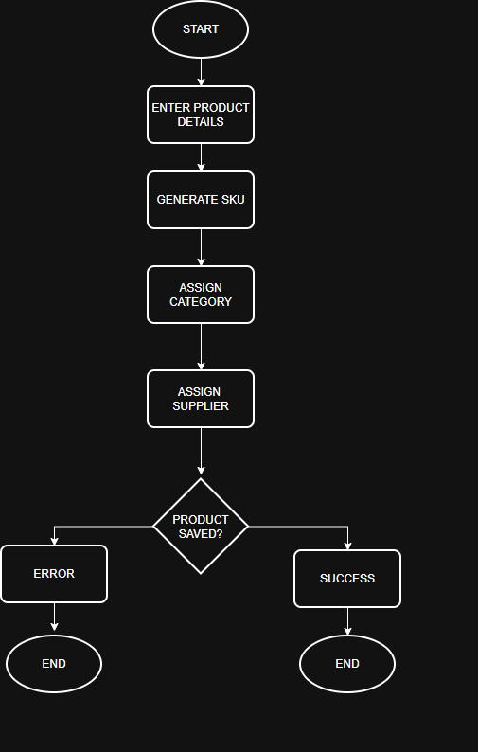 6.2

6.4 Inventory Stock-In Process

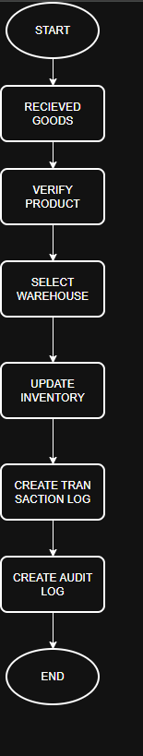 6.3

6.5 Inventory Stock-Out Process

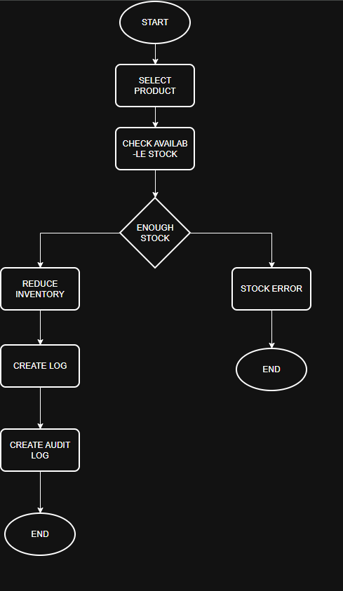 6.4

6.6 Warehouse Stock Transfer

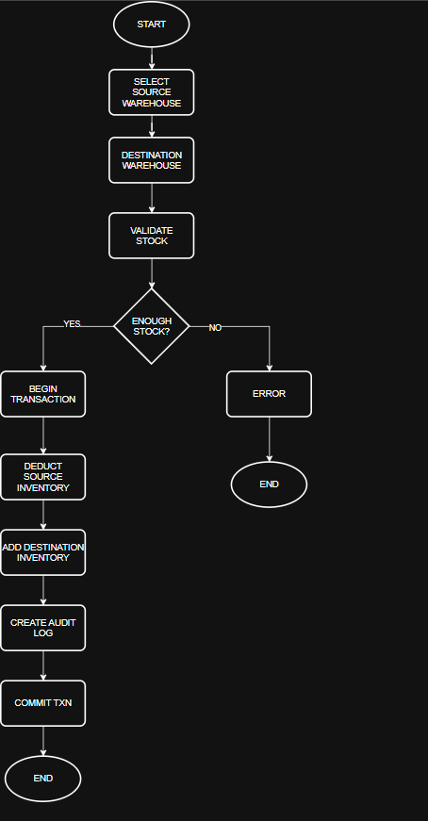 6.5

6.7 Purchase Order Creation & Approval

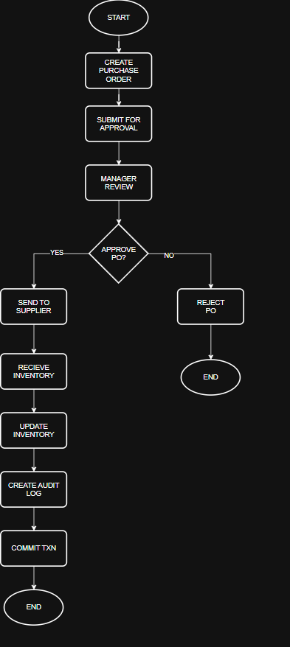 6.6

6.8 Inventory Reservation

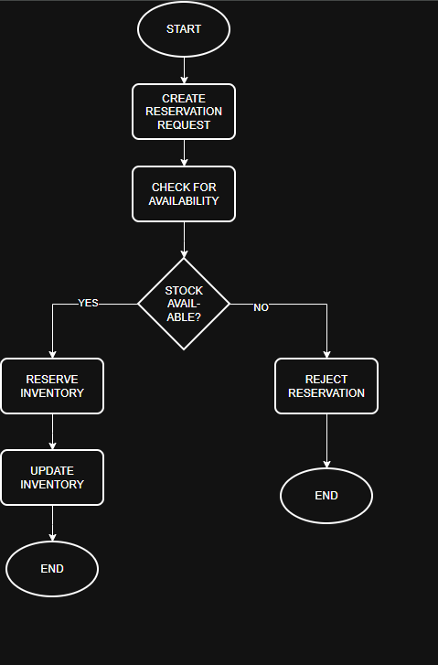 6.7

6.9 Low Stock Monitoring & Alerts

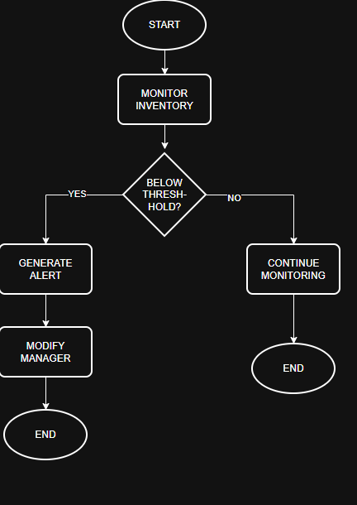 6.8

6.10 Audit Logging & Compliance Tracking

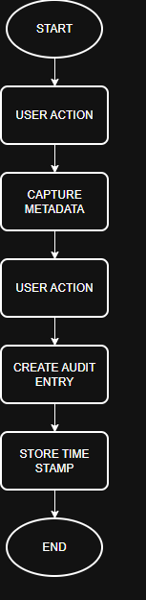 6.9

6.11 Reporting & Analytics

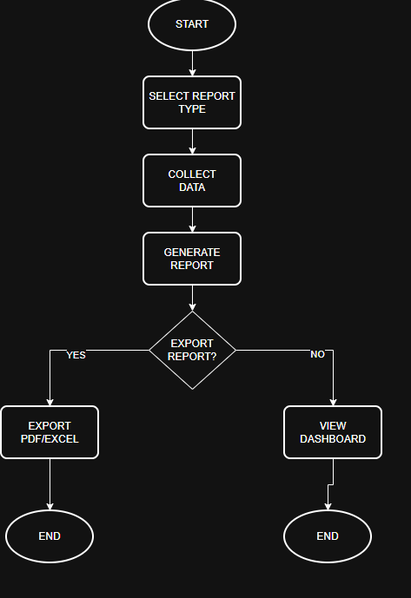 6.10

6.12 Notification Management

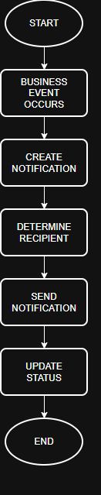 6.11

6.13 Barcode / QR-Based Inventory Operations

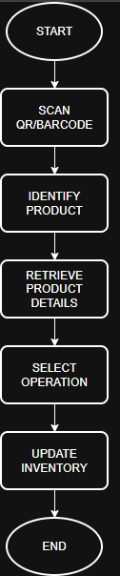 6.12

7 System Architecture

7.1 Architecture Overview

StockFlow follows a layered client-server architecture designed to separate presentation, business logic, data access, and persistence concerns.

The architecture promotes maintainability, scalability, security, and modular development while supporting enterprise inventory management workflows.

The system consists of the following major layers:
- Presentation Layer
- Application Layer
- Business Logic Layer
- Data Access Layer
- Database Layer

These layers communicate through clearly defined interfaces to ensure loose coupling and ease of maintenance.

7.2 Module Breakdown

The StockFlow platform is divided into multiple functional modules.

Authentication Module
Responsible for:
- User authentication
- JWT generation
- Session validation
- Role management

Product Management Module
Responsible for:
- Product creation
- Product updates
- Category management
- SKU generation

Inventory Management Module
Responsible for:
- Stock In
- Stock Out
- Inventory Reservation
- Inventory Adjustment

Warehouse Management Module
Responsible for:
- Warehouse creation
- Warehouse monitoring
- Warehouse transfers

Purchase Order Module
Responsible for:
- Purchase order creation
- Approval workflows
- Goods receiving
- Purchase order closure

Supplier Management Module
Responsible for:
- Supplier registration
- Supplier tracking
- Supplier performance monitoring

Audit Module
Responsible for:
- Activity logging
- Transaction history
- Compliance tracking

Reporting Module
Responsible for:
- Inventory reports
- Valuation reports
- Utilization reports
- Audit reports

Notification Module
Responsible for:
- Low stock alerts
- Purchase order notifications
- Operational alerts

7.3 Technology Stack

Layer | Technology
Frontend | React
Backend | Spring Boot
Database | PostgreSQL
Authentication | JWT + Spring Security
Cache | Redis
API Documentation | Swagger/OpenAPI
Containerization | Docker
Version Control | Git & GitHub

7.4 Architectural Principles

The StockFlow platform follows the following architectural principles:

Separation of Concerns
Each module is responsible for a specific business function.

Single Responsibility
Each service performs one well-defined responsibility.

Modularity
System components can be modified independently.

Security First
Authentication and authorization are enforced throughout the application.

Auditability
Critical business operations generate audit records.

Scalability
The architecture supports future growth through modular expansion and service separation.

8 System Design

8.1 Introduction

System design defines the internal structure of the StockFlow platform and illustrates how business entities, services, repositories, and supporting components interact to fulfill system requirements.

This chapter focuses on the logical organization of the application and serves as the bridge between business requirements and implementation.

8.2 Domain Model

The domain model defines the major business concepts represented within the application.

User Domain
Responsible for authentication, authorization, and access control.
Primary Entities:
- User
- Role

Product Domain
Responsible for product catalog management.
Primary Entities:
- Product
- Category
- Supplier

Inventory Domain
Responsible for stock management.
Primary Entities:
- Inventory
- Warehouse
- Inventory Transaction

Procurement Domain
Responsible for purchasing workflows.
Primary Entities:
- Purchase Order
- Purchase Order Item

Audit Domain
Responsible for compliance and traceability.
Primary Entities:
- Audit Log

8.3 Service Layer Design

The service layer contains the business logic responsible for processing user requests and enforcing business rules.

Authentication Service
Responsibilities:
- User authentication
- JWT generation
- Role validation

Product Service
Responsibilities:
- Product creation
- Product updates
- SKU generation

Inventory Service
Responsibilities:
- Stock In
- Stock Out
- Inventory Reservation
- Stock Transfer

Purchase Order Service
Responsibilities:
- Purchase order creation
- Approval processing
- Goods receiving
Audit Service
Responsibilities:
- Activity logging
- Audit record generation

Notification Service
Responsibilities:
- Alert generation
- Notification delivery

8.4 Package Structure

The backend follows a layered package organization.

com.stockflow

├── controller
├── service
├── repository
├── entity
├── dto
├── mapper
├── security
├── config
├── exception
└── util

Benefits
- Improved maintainability
- Clear separation of responsibilities
- Simplified testing
- Easier scalability

8.5 Utility Components

JWT Utility
Responsible for:
- Token generation
- Token validation
- Claim extraction

SKU Generator
Responsible for:
- Unique SKU creation
- Product identification

Validation Utility
Responsible for:
- Input validation
- Business rule verification

Audit Utility
Responsible for:
- Audit record formatting
- Metadata generation

8.6 Design Principles

The StockFlow platform follows standard object-oriented and enterprise design principles.

Single Responsibility Principle
Each class performs one clearly defined responsibility.

Separation of Concerns
Presentation, business logic, and persistence layers remain independent.

Encapsulation
Business logic is protected within service components.

Reusability
Shared functionality is centralized within utility and service components.

Maintainability
The design promotes easy modification and extension.

9 Workflow Design

9.1 Introduction

Workflow design defines the sequence of activities performed within the StockFlow platform to execute business operations. These workflows ensure that system processes are executed consistently, securely, and in accordance with defined business rules.

The workflows described in this chapter represent the operational behavior of the system and provide a process-oriented view of inventory management activities.

9.2 Authentication Workflow

The authentication workflow validates user credentials and establishes a secure session using JWT-based authentication.

The process begins when a user submits login credentials. The system validates the credentials, retrieves role information, generates an authentication token, and grants access to authorized resources.

This workflow serves as the entry point for all protected functionality within the platform.

9.3 Product Registration Workflow

The product registration workflow allows authorized users to create and maintain product records.

The process involves collecting product information, assigning categories and suppliers, generating a unique SKU, validating submitted data, and storing the product within the inventory catalog.

Successful completion of this workflow makes the product available for inventory operations.

9.4 Inventory Stock-In Workflow

The stock-in workflow manages the receipt of inventory into warehouse locations.

The workflow begins when inventory is received from suppliers or procurement operations. The system validates the product and warehouse information, updates inventory levels, records transaction history, and generates audit records.

This workflow ensures accurate tracking of incoming inventory.

9.5 Inventory Stock-Out Workflow

The stock-out workflow manages inventory dispatch and consumption activities.

Before inventory is released, the system validates stock availability and business constraints. Once validated, inventory quantities are updated and transaction records are generated.

This workflow prevents inventory inconsistencies and unauthorized stock reductions.

9.6 Warehouse Transfer Workflow

The warehouse transfer workflow facilitates inventory movement between warehouse locations.

The process validates source inventory availability, confirms destination warehouse validity, performs inventory adjustments, and records transfer transactions.

The workflow ensures that inventory movement remains traceable and transactionally consistent.

9.7 Purchase Order Workflow

The purchase order workflow governs procurement activities from purchase request creation through inventory receipt.

The process includes purchase order creation, approval processing, supplier assignment, inventory receiving, and order closure.

This workflow ensures controlled and auditable procurement operations.

9.8 Inventory Reservation Workflow

The inventory reservation workflow allocates inventory for future use without immediately reducing physical stock quantities.

Reserved inventory is separated from available inventory and remains unavailable for other operational transactions until released or fulfilled.

This workflow improves inventory planning and allocation accuracy.

9.9 Audit Logging Workflow

The audit logging workflow records critical system activities and business operations.

Whenever a significant transaction occurs, the system captures metadata including user information, timestamps, operation types, and affected entities.

This workflow supports compliance, accountability, and operational transparency.

9.10 Notification Workflow

The notification workflow manages the generation and delivery of operational alerts.

Notifications may be triggered by low stock levels, purchase order approvals, inventory exceptions, or other significant business events.

The workflow ensures that relevant stakeholders receive timely information regarding system activities.

9.11 Reporting Workflow

The reporting workflow generates business intelligence and operational reports.

The process gathers data from inventory, procurement, warehouse, and audit modules before generating reports for managerial review and decision-making.

This workflow provides visibility into operational performance and inventory health.

10 Database Design

10.1 Introduction

The database serves as the central repository for all operational data within the StockFlow platform.

The database design supports inventory management, warehouse operations, procurement workflows, audit tracking, user management, and reporting activities.

The schema has been designed to ensure data consistency, transactional integrity, scalability, and maintainability.

10.2 Database Overview

StockFlow utilizes PostgreSQL as its primary relational database management system.

The database is responsible for storing:
- User information
- Roles and permissions
- Product catalog data
- Warehouse information
- Inventory records
- Supplier information
- Purchase orders
- Inventory transactions
- Audit logs
- Notification records

The database follows normalization principles to reduce redundancy and improve maintainability.

10.3 Core Entities

The system consists of several core business entities.

User
Stores authentication and user profile information.
Primary Responsibilities:
- User identification
- Authentication
- Authorization

Role
Defines user permissions and access levels.
Examples:
- Administrator
- Warehouse Manager
- Inventory Staff
- Auditor

Product
Represents inventory items managed by the system.
Stores:
- Product details
- SKU
- Category
- Supplier associations

Category
Provides logical grouping of products for organization and reporting.

Supplier
Stores information about inventory vendors and procurement partners.

Warehouse
Represents physical inventory storage locations.
Each warehouse maintains its own inventory records.

Inventory
Stores product quantities for specific warehouse locations.
Tracks:
- Available stock
- Reserved stock
- Damaged stock

Purchase Order
Represents procurement requests issued to suppliers.
Tracks:
- Approval status
- Supplier information
- Receiving activities

Inventory Transaction
Records all inventory movement activities.
Examples:
- Stock In
- Stock Out
- Transfer
- Adjustment
- Reservation

Audit Log
Stores historical records of critical business operations.
Supports:
- Compliance
- Investigation
- Accountability

10.4 Data Relationships

The database structure establishes relationships between entities to support business operations.

Key relationships include:
- One Role may be assigned to many Users.
- One Category may contain many Products.
- One Supplier may provide many Products.
- One Warehouse may contain many Inventory records.
- One Product may exist in multiple Warehouses.
- One Purchase Order may contain multiple Purchase Order Items.
- One Product may participate in many Inventory Transactions.
- One User may generate many Audit Records.

These relationships ensure efficient data organization and retrieval.

10.5 Constraints and Validation Rules

Database constraints are implemented to maintain data integrity.

Primary Key Constraints
Each table contains a unique primary key.
This ensures unique identification of records.

Foreign Key Constraints
Foreign key relationships maintain referential integrity between related entities.
Invalid references are not permitted.

Unique Constraints
Unique constraints are applied to:
- User Email
- Product SKU
- Role Name
These constraints prevent duplicate business records.

Not Null Constraints
Critical business fields must contain valid values.
Examples include:
- Product Name
- SKU
- User Email
- Warehouse Name

10.6 Transaction Management

The StockFlow platform utilizes database transactions to ensure consistency during complex operations.

Examples include:
Warehouse Transfers
Inventory deduction and inventory addition occur within a single transaction.

Purchase Order Receiving
Inventory updates and purchase order updates execute together.

Inventory Adjustments
Inventory modifications and audit logging occur atomically.
If any operation fails, the entire transaction is rolled back.

10.7 Data Integrity Strategy

The platform implements multiple mechanisms to protect data quality.

These include:
- Referential integrity enforcement
- Validation rules
- Transaction rollback mechanisms
- Audit tracking
- Input validation
- Business rule enforcement

Together, these mechanisms ensure accurate and reliable inventory data.

10.8 Database Performance Considerations

Several design decisions have been implemented to improve performance.

Indexing
Indexes should be applied to:
- Product SKU
- User Email
- Purchase Order Number
- Warehouse Identifier
- Inventory Transaction Timestamp

Pagination
Large datasets should be retrieved using pagination to reduce query load.

Optimized Queries
Frequently accessed inventory and reporting data should utilize optimized query structures.

11 Security Design

11.1 Introduction

Security is a critical component of the StockFlow platform. The system is designed to protect sensitive inventory information, prevent unauthorized access, maintain data integrity, and ensure accountability across all business operations.

The security architecture combines authentication, authorization, encryption, session management, and audit logging to establish a secure operational environment.

11.2 Authentication Architecture

StockFlow utilizes JWT-based authentication to verify user identity and manage secure access to protected resources.

The authentication process begins when a user submits valid login credentials. Upon successful validation, the system generates an authentication token that is used for subsequent requests.

This approach enables stateless authentication while reducing server-side session management overhead.

11.3 User Authentication

User authentication is performed using registered credentials stored within the system.

Authentication objectives include:
- User identity verification
- Secure access control
- Session establishment
- Unauthorized access prevention
Only authenticated users may access protected system functionality.

11.4 JWT-Based Architecture

The platform utilizes JSON Web Tokens (JWT) for authorization management.

Each token contains:
- User Identifier
- User Role
- Token Expiration Information

The token is attached to protected API requests and validated before access is granted.

Benefits include:
- Stateless authentication
- Improved scalability
- Reduced server overhead
- Simplified session management

11.5 Role-Based Access Control (RBAC)

StockFlow implements Role-Based Access Control to manage permissions throughout the application.

Access decisions are based on assigned user roles rather than individual user configurations.

Supported roles include:
- Administrator
- Warehouse Manager
- Inventory Staff
- Auditor

Each role is granted a predefined set of permissions aligned with operational responsibilities.

This approach improves security while simplifying permission management.

11.6 Password Security

User passwords are never stored in plain text.
Passwords are encrypted before being stored within the database.

Security objectives include:
- Credential protection
- Password confidentiality
- Resistance to unauthorized disclosure

Industry-standard password hashing mechanisms are utilized to strengthen credential security.

11.7 API Security

All protected API endpoints require successful authentication and authorization.

API security controls include:
- JWT validation
- Role verification
- Input validation
- Request authentication

Unauthorized requests are automatically rejected.

11.8 Input Validation

Input validation is implemented to prevent invalid or malicious data from entering the system.

Validation controls include:
- Required field validation
- Data type validation
- Length restrictions
- Business rule verification

Input validation protects both application logic and database integrity.

11.9 Audit Security

Critical business operations generate audit records that support traceability and accountability.

Audit records capture:
- User activity
- Operation type
- Timestamp
- Affected entity
- System changes

Audit logs are protected from unauthorized modification and are accessible only to authorized personnel.

11.10 Session Security

User sessions are controlled through token-based authentication.

Session security measures include:
- Token expiration
- Token validation
- Protected endpoint access
- Reauthentication requirements

These controls reduce the risk of unauthorized session usage.

11.11 Security Best Practices

The StockFlow platform follows several security best practices:
- Principle of Least Privilege
- Role-Based Access Control
- Secure Password Storage
- Input Validation
- Audit Logging
- Protected API Endpoints
- Transaction Monitoring

These practices contribute to a secure and reliable application environment.

11.12 Security Risks and Mitigation

Unauthorized Access

Risk:
Unauthorized users attempt to access protected resources.
Mitigation:
JWT authentication and RBAC authorization.

Credential Theft

Risk:
User credentials become compromised.
Mitigation:
Password encryption and secure authentication controls.

Data Manipulation

Risk:
Unauthorized modification of inventory records.
Mitigation:
Audit logging and role-based permissions.

Invalid Input

Risk:
Malicious or invalid data affects system behavior.
Mitigation:
Comprehensive input validation and business rule enforcement.

12 API Design

12.1 Introduction

Application Programming Interfaces (APIs) enable communication between the frontend, backend services, and supporting system components within the StockFlow platform.

The platform utilizes RESTful APIs to provide secure and standardized access to business functionality.

All APIs exchange data using JSON and follow consistent request and response structures.

12.2 API Architecture

The StockFlow platform follows a REST-based architecture.

The React frontend communicates with the Spring Boot backend through HTTP requests.

Each API endpoint is responsible for a specific business capability and is protected through authentication and authorization controls.

API design principles include:
- Stateless communication
- Resource-oriented endpoints
- Consistent response formats
- Secure access control
- Clear error handling

12.3 Authentication APIs

Authentication APIs manage user login and session control.

Login API
Purpose:
Authenticate users and generate JWT tokens.
Endpoint:
POST /api/auth/login

Logout API
Purpose:
Terminate authenticated sessions.
Endpoint:
POST /api/auth/logout

12.4 Product APIs

Product APIs manage product catalog operations.

Create Product
POST /api/products

Update Product
PUT /api/products/{id}

View Products
GET /api/products

Search Products
GET /api/products/search

These endpoints support product lifecycle management and inventory organization.

12.5 Inventory APIs

Inventory APIs support stock management operations.

Stock In
POST /api/inventory/stock-in

Stock Out
POST /api/inventory/stock-out

Inventory Reservation
POST /api/inventory/reserve

Inventory Adjustment
POST /api/inventory/adjust

These endpoints maintain inventory accuracy and transaction history.

12.6 Warehouse APIs

Warehouse APIs manage warehouse operations and inventory movement.

Create Warehouse
POST /api/warehouses

View Warehouses
GET /api/warehouses

Warehouse Transfer
POST /api/inventory/transfer

These APIs support multi-warehouse inventory management.

12.7 Purchase Order APIs

Purchase Order APIs manage procurement workflows.

Create Purchase Order
POST /api/purchase-orders

Approve Purchase Order
POST /api/purchase-orders/{id}/approve

Receive Inventory
POST /api/purchase-orders/{id}/receive

Close Purchase Order
POST /api/purchase-orders/{id}/close

These APIs support procurement and inventory replenishment activities.

12.8 Reporting APIs

Reporting APIs generate operational and management reports.

Inventory Report
GET /api/reports/inventory

Low Stock Report
GET /api/reports/low-stock

Warehouse Utilization Report
GET /api/reports/warehouse-utilization

Audit Report
GET /api/reports/audit

These APIs provide business insights and decision-support information.

12.9 Standard API Response Format

Successful responses follow a consistent structure.

Example:
{
"success": true,
"message": "Operation completed successfully",
"data": {}
}
This structure improves API usability and frontend integration.

12.10 Error Handling Standards

Failed requests return standardized error responses.
Example:
{
"success": false,
"message": "Insufficient inventory available",
"errorCode": "INV_001"
}

Common HTTP status codes include:
Status Code | Description
200 | Success
201 | Resource Created
400 | Bad Request
401 | Unauthorized
403 | Forbidden
404 | Resource Not Found
500 | Internal Server Error

12.11 API Documentation Strategy

The platform utilizes OpenAPI (Swagger) documentation to provide API specifications and testing capabilities.

API documentation includes:
- Endpoint descriptions
- Request parameters
- Response structures
- Authentication requirements
- Error codes

This improves developer productivity and integration efficiency.

13 Deployment Architecture

13.1 Introduction

Deployment architecture defines how the StockFlow platform is hosted, executed, and maintained in a production environment.

The deployment design focuses on reliability, scalability, maintainability, and ease of deployment while supporting enterprise inventory management operations.

The platform is deployed using containerized services to ensure consistent behavior across development, testing, and production environments.

13.2 Deployment Overview

The StockFlow platform follows a three-tier deployment model consisting of:
- Frontend Layer
- Backend Layer
- Database Layer

Each layer performs a dedicated function within the application architecture.

The frontend provides the user interface, the backend processes business logic, and the database stores persistent business data.

13.3 Frontend Deployment

The frontend application is developed using React.

Responsibilities include:
- User Interface Rendering
- User Interaction Handling
- API Communication
- Dashboard Visualization

The frontend communicates with backend services through REST APIs.
Recommended deployment platforms include:
- Vercel
- Netlify
- Nginx Server

13.4 Backend Deployment

The backend application is developed using Spring Boot.

Responsibilities include:
- Business Logic Processing
- Authentication and Authorization
- Inventory Management
- Procurement Operations
- Reporting Services

The backend exposes REST APIs consumed by the frontend application.
Recommended deployment platforms include:
- Render
- Railway
- AWS EC2
- Azure App Service

13.5 Database Deployment

PostgreSQL serves as the primary database system.

Responsibilities include:
- Persistent Data Storage
- Transaction Management
- Data Integrity Enforcement
- Reporting Data Retrieval

The database stores all operational and historical business information.

Recommended deployment options include:
- PostgreSQL Cloud Services
- AWS RDS
- Azure Database for PostgreSQL
- Self-Hosted PostgreSQL

13.6 Redis Deployment

Redis is utilized as the caching layer within the system.

Responsibilities include:
- Frequently Accessed Data Caching
- Session Optimization
- Performance Enhancement
- Reduced Database Load

Redis improves response times and system scalability.

13.7 Docker Containerization

The StockFlow platform utilizes Docker to package application components into isolated containers.

Containerization provides:
- Environment Consistency
- Simplified Deployment
- Improved Portability
- Easier Scaling

Primary containers include:
- Frontend Container
- Backend Container
- PostgreSQL Container
- Redis Container

13.8 Environment Configuration

Sensitive application settings are managed through environment variables.

Examples include:
- Database Credentials
- JWT Secret Keys
- API Configuration
- Redis Configuration
- Application Settings

This approach improves security and deployment flexibility.

13.9 CI/CD Strategy

Continuous Integration and Continuous Deployment practices improve software quality and release efficiency.

Recommended CI/CD workflow:
- Code Commit
- Automated Build
- Automated Testing
- Docker Image Creation
- Deployment to Target Environment

GitHub Actions may be used to automate deployment activities.

13.10 Production Readiness Considerations

Several measures are implemented to support production deployment.

Logging
Application events and errors are recorded for troubleshooting and monitoring.

Monitoring
System health and application performance are continuously monitored.

Backup Strategy
Regular database backups are performed to protect critical business data.

Security
All production services utilize secure authentication, authorization, and encrypted communication.

13.11 Scalability Considerations

The deployment architecture supports future system growth.

Potential scaling strategies include:
- Horizontal backend scaling
- Database optimization
- Load balancing
- Distributed caching
- Microservice migration

These approaches enable the platform to handle increased workload demands.

14 Reporting and Analytics

14.1 Introduction

Reporting and analytics provide operational visibility into inventory activities, warehouse performance, procurement processes, and system usage. The reporting module enables stakeholders to monitor key performance indicators (KPIs), identify operational issues, and make informed business decisions using real-time system data.

14.2 Reporting Objectives

The reporting module is designed to:
- Monitor inventory health
- Improve operational visibility
- Support management decision-making
- Identify stock shortages and excess inventory
- Analyze warehouse performance
- Track procurement activities
- Review audit history

14.3 Dashboard Overview

The dashboard provides a consolidated view of important operational metrics.

Key dashboard components include:
- Total Products
- Total Warehouses
- Available Inventory
- Reserved Inventory
- Low Stock Alerts
- Pending Purchase Orders
- Recent Inventory Transactions
- Active Suppliers
The dashboard presents summarized information to enable quick monitoring of business operations.

14.4 Inventory Reports

Inventory reports provide detailed information regarding product availability across warehouse locations.

Available reports include:
- Current Inventory Report
- Available Stock Report
- Reserved Stock Report
- Damaged Inventory Report
- Inventory Movement Report

These reports support inventory planning and operational decision-making.

14.5 Warehouse Reports

Warehouse reports provide insights into warehouse utilization and inventory distribution.
Available reports include:
- Warehouse Inventory Summary
- Warehouse Capacity Utilization
- Inter-Warehouse Transfer Report
- Warehouse Performance Report

These reports help optimize warehouse operations and resource allocation.

14.6 Procurement Reports

Procurement reports monitor purchasing activities and supplier performance.

Available reports include:
- Purchase Order Summary
- Pending Purchase Orders
- Completed Purchase Orders
- Supplier Performance Report
- Goods Received Report

These reports assist in evaluating procurement efficiency.

14.7 Audit Reports

Audit reports provide visibility into system activities and operational history.
Available reports include:
- User Activity Report
- Inventory Transaction History
- Audit Log Report
- Security Activity Report

These reports support compliance, accountability, and investigation requirements.

14.8 Performance Metrics

The reporting module tracks several operational metrics.

Examples include:
- Inventory Accuracy
- Warehouse Utilization
- Average Stock Level
- Product Availability
- Purchase Order Completion Rate
- Supplier Delivery Performance
- Inventory Turnover

These metrics help evaluate overall business performance.

14.9 Data Export

Generated reports can be exported for external use and record keeping.

Supported formats include:
- PDF
- Microsoft Excel
- CSV

Export functionality allows reports to be shared, archived, or further analyzed.

14.10 Business Benefits

The reporting module provides several operational advantages, including:

- Improved inventory visibility
- Faster managerial decision-making
- Better warehouse planning
- Increased procurement transparency
- Enhanced operational monitoring
- Improved compliance reporting

15 Risks and Assumptions

15.1 Introduction

Every enterprise software system is subject to technical, operational, and security risks that may impact its performance, reliability, and maintainability. Identifying these risks during the design phase enables the implementation of appropriate mitigation strategies and supports long-term system stability.

This chapter outlines the primary risks, assumptions, and mitigation measures considered during the design of the StockFlow platform.

15.2 Technical Risks

Database Failure
Unexpected database failures may interrupt inventory operations and lead to temporary service unavailability.

Mitigation
- Regular database backups
- Transaction management
- Recovery procedures

Application Downtime
Unexpected server failures may prevent users from accessing the platform.

Mitigation
- Health monitoring
- Containerized deployment
- Automated restart mechanisms

Performance Degradation
Large inventory datasets and increasing transaction volumes may affect system performance.
Mitigation
- Database indexing
- Pagination
- Redis caching
- Query optimization

15.3 Security Risks

Unauthorized Access
Unauthorized users may attempt to access protected resources.

Mitigation
- JWT Authentication
- Role-Based Access Control (RBAC)
- Protected API endpoints

Credential Compromise
User credentials may be exposed through weak security practices.

Mitigation
- Password encryption
- Secure authentication
- Session expiration

Data Manipulation
Unauthorized modification of inventory records may compromise data integrity.

Mitigation
- Audit logging
- Transaction validation
- Role-based permissions

15.4 Operational Risks

Operational errors may occur during daily inventory activities.

Examples include:
- Incorrect stock quantities
- Duplicate product entries
- Invalid warehouse transfers
- Incorrect purchase orders

Mitigation
- Input validation
- Business rule enforcement
- User confirmation before critical operations
- Audit trail generation

15.5 Project Assumptions

The design and implementation of StockFlow are based on the following assumptions:
- All users are authenticated before accessing the system.
- Each product has a unique SKU.
- Every warehouse operates independently.
- Database connectivity remains available during normal operations.
- Users perform actions according to their assigned roles.
- Inventory transactions follow established business rules.

15.6 Limitations

The current implementation excludes several advanced enterprise capabilities.

These include:
- ERP integration
- Multi-tenant architecture
- Mobile application support
- AI-based inventory forecasting
- Distributed microservices architecture
- Third-party logistics integration

These features are considered potential future enhancements.

15.7 Risk Mitigation Strategy

The StockFlow platform minimizes operational and technical risks through:
- Layered architecture
- Role-based security
- Transaction management
- Database constraints
- Audit logging
- Input validation
- Standardized workflows
- Regular backup strategies

These measures improve reliability, maintainability, and overall system resilience.

16 Future Enhancements

16.1 Introduction

The current implementation of StockFlow provides a robust foundation for enterprise inventory management. However, additional features and architectural improvements can further enhance the platform's scalability, usability, and business value.

This chapter outlines potential enhancements that may be incorporated in future versions of the system.

16.2 Barcode and QR Code Integration

Future versions of the platform may support barcode and QR code generation and scanning for faster inventory operations.

Potential capabilities include:
- Barcode generation for products
- QR code support
- Mobile device scanning
- Rapid inventory updates
- Reduced manual data entry

16.3 Inventory Forecasting

Inventory forecasting can assist organizations in predicting future stock requirements using historical inventory trends.

Possible enhancements include:
- Demand forecasting
- Reorder recommendations
- Seasonal inventory analysis
- Inventory consumption trends
These features may improve procurement planning and reduce stock shortages.

16.4 Notification Enhancements

The notification module may be expanded to support multiple communication channels.

Potential features include:
- Email notifications
- SMS alerts
- Push notifications
- Real-time in-application notifications

This would improve operational awareness and response times.

16.5 Microservices Architecture

The current monolithic architecture can be migrated to a microservices-based architecture as system requirements grow.

Potential service separation includes:
- Authentication Service
- Inventory Service
- Procurement Service
- Reporting Service
- Notification Service

This would improve scalability, fault isolation, and deployment flexibility.

16.6 Third Party Integration

Future versions may integrate with external enterprise systems.

Examples include:
- ERP systems
- Accounting software
- Logistics providers
- Payment gateways
- Business intelligence platforms
These integrations would improve operational efficiency and reduce manual processes.

16.7 Mobile Application

A dedicated mobile application may be developed to support warehouse personnel and field operations.

Potential functionality includes:
- Barcode scanning
- Inventory lookup
- Stock updates
- Purchase order approval
- Real-time notifications
This would improve mobility and operational efficiency.

16.8 Advanced Analytics

Future reporting capabilities may include advanced business intelligence features.

Examples include:
- Interactive dashboards
- Predictive analytics
- Inventory trend analysis
- Supplier performance analytics
- Operational KPI monitoring
These features would support strategic decision-making.

16.9 Cloud Deployment

Future deployments may utilize cloud-native infrastructure to improve availability and scalability.

Potential improvements include:
- Auto-scaling
- Load balancing
- Managed database services
- Distributed caching
- Automated backups
Cloud deployment would increase reliability while reducing infrastructure management efforts.

17 Conclusion

17.1 Project Summary

StockFlow was designed as an enterprise-grade Inventory Management System that demonstrates the principles of modern software engineering, secure application development, and scalable system architecture.

The platform integrates inventory management, warehouse operations, procurement workflows, audit logging, reporting, and role-based access control into a unified solution capable of supporting real-world business processes.

Throughout the project, emphasis was placed on designing a maintainable, modular, and secure application rather than simply implementing basic CRUD operations.

17.2 Objectives Achieved

The primary objectives of the project have been successfully addressed.

These include:
- Secure user authentication and authorization
- Multi-warehouse inventory management
- Product and supplier management
- Purchase order processing
- Inventory reservation
- Audit logging
- Reporting and analytics
- Layered enterprise architecture
- RESTful API design
- Database normalization and transaction management
The implementation demonstrates how enterprise software systems can be designed to support complex operational workflows while maintaining security, scalability, and reliability.

17.3 Learning Outcomes

The development of StockFlow provided practical experience in multiple areas of software engineering.

Key learning outcomes include:
- Enterprise application architecture
- Business process modeling
- Object-oriented system design
- Database design and normalization
- REST API development
- Authentication and authorization
- Role-Based Access Control (RBAC)
- Transaction management
- Audit logging
- Software documentation
- Deployment planning
These concepts collectively contribute to the development of production-ready software solutions.

17.4 Future Scope

The modular architecture adopted by StockFlow allows the platform to evolve as business requirements expand.

Potential future improvements include:
- Cloud-native deployment
- Microservices architecture
- AI-based inventory forecasting
- Mobile application support
- Barcode and QR code integration
- ERP integration
- Real-time event streaming
- Advanced business intelligence dashboards
These enhancements would further strengthen the platform's scalability and enterprise capabilities.

17.5 Final Remarks

StockFlow demonstrates that effective inventory management extends beyond maintaining stock records. Modern enterprise systems require secure access control, well-defined business workflows, reliable transaction management, comprehensive auditability, and meaningful reporting to support organizational operations.

By combining these principles within a structured software architecture, the project provides a practical representation of an enterprise inventory management platform while reinforcing fundamental concepts of software engineering and system design.

The knowledge gained throughout the design and implementation of StockFlow establishes a strong foundation for developing larger, more sophisticated enterprise applications in the future.

Document Conclusion

This Software Requirements Specification and System Design Document has presented the complete analysis, architecture, workflows, security model, database design, deployment strategy, and implementation considerations for the StockFlow Enterprise Inventory Management System.

The document serves as a comprehensive reference for understanding the business objectives, technical design, and operational behavior of the platform, providing a structured foundation for future development, testing, deployment, and maintenance.

