Home Automation User Guide

May 2019

Version 1.01

Email: usuhomeautomation@gmail.com

Document Revisions

|  |  |  |
| --- | --- | --- |
| Date | Version Number | Document Changes |
| 04/29/2019 | 0.1 | Initial Draft |
|  |  |  |
|  |  |  |
|  |  |  |
|  |  |  |
|  |  |  |
|  |  |  |
|  |  |  |
|  |  |  |

Table of Contents

1 Introduction 4

1.1 Scope and Purpose 4

1.2 Process Overview 4

2 Setting up the Hardware 5

2.1 Light Controller Installation 5

2.1.1 Install the light switch and relay 5

2.1.2 Attach the Controller 6

2.2 Laundry Controller Installation 6

2.3 Home Controller Installation 6

3 Using the Application 7

3.1 Logging in 7

3.2 Lighting System 8

3.2.1 Turning on a light 8

3.2.2 Renaming a light 8

3.2.3 Setting a timer 8

3.3 Laundry System 9

3.3.1 Enable notifications 9

3.4 Logging out 10

4 Troubleshooting 11

# Introduction

## Scope and Purpose

This product is a Home Automation System that allows you to control your lights and receive notifications when the laundry machine is finished.

This guide will show you how to set up the controllers for the lights, laundry machines, and how to use the application.

## Process Overview

1. Setting up the hardware
   1. Light controller installation
   2. Laundry machine controller installation
   3. Home controller installation
2. Using the Application
   1. Logging in
   2. Using the light system
   3. Using the laundry system
   4. Logging out
3. Report
4. Troubleshoot

# Setting up the Hardware

This process with guide you how to install the controllers for the lights, laundry, and overall system. A new light switch for your system with the lighting controller inside will be installed. Sensors will be attached to your laundry machines.

Tools needed: screw driver, wire nuts, drill

## Light Controller Installation

Here you will install a new light switch and connect your other switches to relays. The box for the light switch must be 2 gage or more (holds 2 or more switches).

### Install the light switch and relay

WARNING: This step deals with dangerous high voltage electricity. Make sure all power is off to the area you are working in. Make sure all connections are tight.

1. Before starting, in the breaker box, flip the breaker to off for the outlet(s) you will be working on.
2. Flip the light switch to verify the power is off.
3. Unscrew the faceplate for the light switch.
4. Unscrew the light switch you are going to replace.
5. For the incoming power wires, attach the black wire (hot) to one of the black screws. Attach the white wire(neutral) to the white screw on the right. Connect ground to the green screw.
6. Cut a 4-inch piece of wire and attach it to the top left brass screw.
7. Place the other end of the 4-inch wire into the NC port of the relay.
8. For the outgoing power wires, attach the black wire (hot) to the other black screw. Attach the white wire to the C port on the relay. Connect ground to the green screw.
9. Screw the switch back into the wall but leave the face plate off.

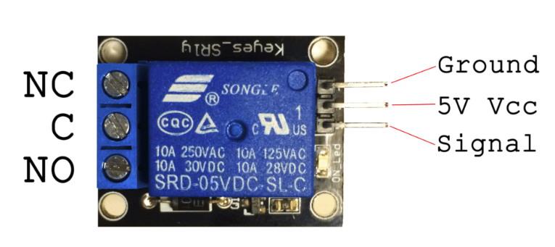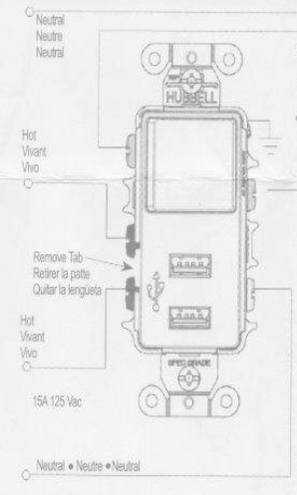

### Attach the Controller

1. From the controller to the relay, attach the brown wire to the ground pin. Attach the red wire to the 5V Vcc pin. Attach the orange wire to the signal pin. This can be repeated for any other nearby relays.
2. If needed, drill a hole in the face plate for the USB wire to feed into the box. A faceplate with a small hole taking up the 2nd switch spot can also be used.
3. Plug the micro-USB into the controller and feed the cable back out through the face plate.
4. Plug in the cable into the USB outlet.
5. Screw in the face plate.
6. Flip the breaker to turn the power back on.

## Laundry Controller Installation

This process attaches the laundry controller and the two sensors to the back of your laundry machines. There are 3 parts (1 controller, 2 sensors).

WARNING: These magnets are very strong. Be careful with them around other electronic devices.

1. Attach the controller to the back of one of the machines. Place it where sensors will be able to reach both machines.

NOTE: You may have to adjust the location of these sensors to find a good vibration spot on each machine.

1. Attach the Washer sensor to the back of the washing machine.
2. Attach the dryer sensor to the back of the drying machine.
3. Plug the micro-USB into the controller and the AC wall adapter. Plug the adapter into a nearby wall outlet.

## Home Controller Installation

1. Connect the ethernet cable between the controller and your router.
2. Plug in the power cable for the controller a nearby outlet.

NOTE: If the device doesn’t seem to start up correctly, you will need to attach a keyboard, mouse, and monitor and click on the Home Automation icon on the desktop.

# Using the Application

This process will tell you how to use the Home Automation android application to control each system.

Assuming the application is already installed on user’s phone.

Required: Operating system Lollipop 5.1 or newer.

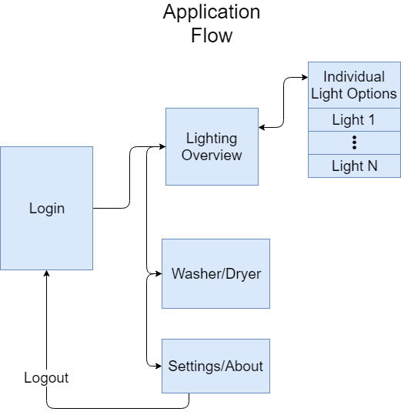

## Logging in

1. Skip to Step 4 if you have previously signed in before.
2. Click on the Google Sign in button to associate your Google account with the app (optional).
3. If you do not want to sign in with Google, you can manually enter the System ID each time.
4. Enter the 9-digit alphanumeric code for the system ID found on the home controller. If you have logged in, this will be saved.
5. Tap CONTINUE to proceed to the lighting page.

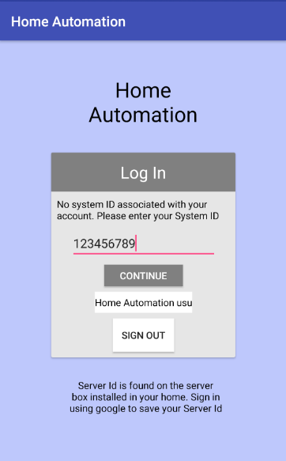

## Lighting System

### Turning on a light

1. Navigate to the Lighting tab.
2. Tap the switch in the same row as the light you want to turn on.
3. Pink switch means the light is currently on.
4. White switch means the light is currently off.

### Renaming a light

1. Navigate to the Lighting tab.
2. Tap on the gear icon for the light you want to adjust.
3. Enter a new name in the New Name textbox.
4. Tap SAVE to keep these changes and return to the Lighting page.
5. Tap the back button to exit without saving. A pop-up message will ask to confirm before exiting.

### Setting a timer

1. Navigate to the Lighting tab.
2. Tap on the gear icon for the light you want to adjust.
3. Tap on the Timer switch to activate the timer.
4. Pink switch means the light is currently on.
5. White switch means the light is currently off.
6. Set a start time or select default.
7. Manually enter a time in the format HH:MM AM or PM.
8. SUNSET button can be pressed to set the time appropriate for that time of year.
9. Set an end time or select default.
10. Manually enter a time in the format HH:MM AM or PM.
11. SUNRISE button can be pressed to set the time appropriate for that time of year.
12. Tap SAVE to keep these changes and return to the Lighting page.
13. Tap the back button to exit without saving. A pop-up message will ask to confirm before exiting.
14. Timer icon will appear next to the light when the timer is enabled.

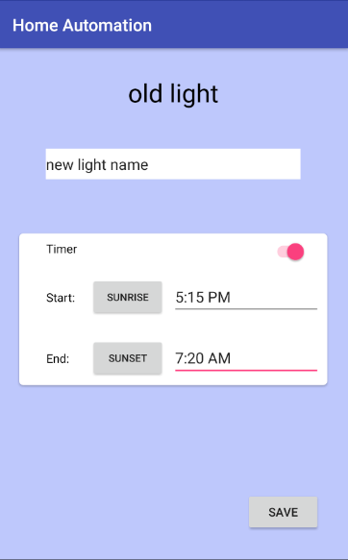 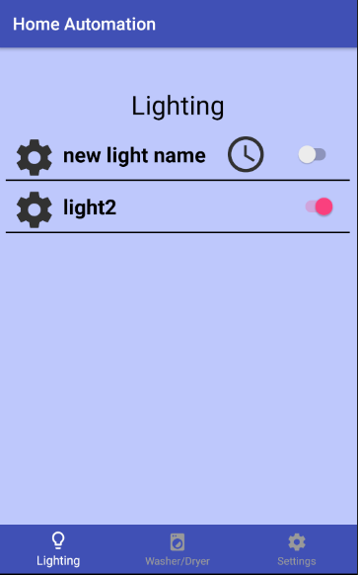

## Laundry System

### Enable notifications

1. Navigate to the Washer/Dryer tab.
2. Tap the stopwatch icon to toggle notifications.
3. Notifications are turned off.
4. Notifications are turned on.

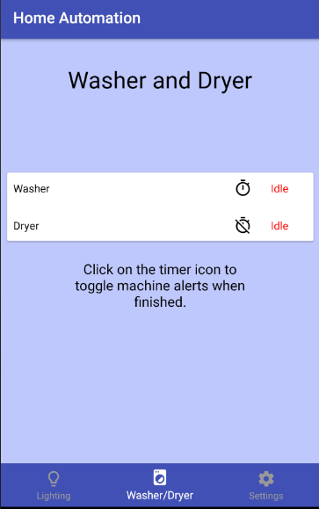

## Logging out

1. Navigate to the Settings page.
2. Tap LOG OUT button.
3. This will remove your google account and return to the Login page.

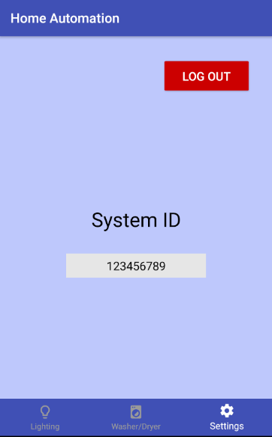

# Troubleshooting

|  |  |
| --- | --- |
| **Problem** | **Solution** |
| No response from the system | Verify the phone is connected to the internet and try again. |
|  | Verify the internet the Home Controller is connected to is functioning. |
| The light is not turning on | Verify the connections for the rewired light switch are tight. |
|  | Verify the house wiring is plugged into the C and NC ports of the relay. |
|  | Verify the lighting controller has power and no loose components. |
| Laundry status is not updating | It can take up to a minute for the status to change. |
|  | Move the sensor to another section of the machine with more vibration. |
|  | Using a small screwdriver, twist the dial in the center of the center clockwise. |
| App crashes while logging in | On login screen, press sign out to remove your account. Reconnect your account. You will need to re-enter the System ID and your notification settings are cleared. |