1. Data sheet
   1. Memory map
      1. Cortex M4’s memory map Section 2.4.1
      2. What table number indicates the memory map of Cortex-M4 processor? Table 2-4
   2. Each Peripheral has a specific memory address, what is the base memory address of GPIO_A (general input/output port A)? Start: 0x4000.4000 End: 0x4000.4FFF
   3. Each peripheral has a number of registers that control its functionality. For a given peripheral, it’s often easier to use the offset of a register with respect to the peripheral base address rather than the absolute address of the register. A peripheral’s registers and their associated offsets are usually summarized in a register map
      1. Which section describes the General-Purpose Input / Output (GPIO) register map? Section 10.4
      2. What is the table number for the GPIO register map? Table 10-6
   4. The register map table in the TI documentation contains the name, offset, and description of a register. Which register corresponds to the direction of a GPIO port? Write down the name of this register, its memory offset, and the absolute address for port A of this register
      1. GPIODIR
      2. 0x400
      3. 0x4000.4000
   5. Click the page number of the GPIODIR register on the register map table.
      1. What binary value corresponds to an output? 1
      2. If pins 0, 4, and 7 were inputs, but the rest were outputs, what would the state of this register (in binary values)? 0110 1110
      3. What would be the state of this register using hexadecimal values? 0x6E
   6. Which timer is located at memory address 0x4003.2000? 16/32 bit Timer 2
   7. Find the register map for General Purpose Timers. Which register is located at offset 0x068? Provide a brief description of this register. GPTMTBPV, GPTM Timer B Prescale value
   8. On this board, a few pins are wired together. Record the pins that are wired together. (Hint: Look in the Tiva™ C Series TM4C123G LaunchPad Evaluation Board User's Guide found on the Lab Supplements page) PD0 tied to PB6. PD1 tied to PB7
2. Introduction to the MDO3014 Mixed Domain Oscilloscope
   1. Read through the following sections of the MDO3000 Series Mixed Domain Oscilloscopes User Manual:
      1. Get Acquainted with the Instrument (pages 36—53)
      2. Appendix C: P6316 General-Purpose Logic Probe Information (pages 203– 207)
      3. Setting Up Digital Channels to Using MagniVu (pages 79—82)
      4. Trigger Setup (pages 87—93)
      5. Analyze Waveform or Trace Data (pages 122—130)
      6. Save and Recall Information (pages 160—166)
   2. Answer the following questions:
      1. Name three potential uses for the logic analyzer.
         1. Interprets signals on your target system to the oscilloscope
         2. Measure resistance
         3. Measure capacitance
      2. A properly configured trigger will remove guesswork and chance from  
         capturing the output behavior of a signal.
         1. Write down how you would configure the trigger to capture on a falling edge.
            1. Push trigger, select falling edge, select the channel you are setting up as the source, push autoset
         2. Write down how you would configure the trigger to capture on a  
            rising edge.
            1. Push trigger, select rising edge, select the channel you are setting up as the source, push autoset
      3. How do you change the sample period of the logic analyzer?
         1. Turn the outer zoom knob on the Wave inspector area
      4. Change the sample period to 200ns
3. Set Up the Board
   1. Open Keil uVision.
   2. Download the Lab 0 zip file, unzip, and open SP.uvproj under ‘blinky’ directory.
   3. Build the project. Project -> Build.
   4. Plug in the microcontroller (use the debug port). There is a switch near the top  
      left that will turn it on.
   5. Flash the project to the board. Flash -> Download.
   6. Press the RESET button located on the microcontroller.
   7. The program is now running.
      1. What is the program doing?
         1. Nothing, just a green light turned on
      2. Press SW1 and observe the behavior of the microcontroller.
      3. Now press SW2 and observe. Estimate the rate at which the lights are  
         Flashing.
         1. 1 blink per 50 ms
   8. Use the logic analyzer and triggers to measure the rate of the flashing light. DO  
      NOT connect the logic analyzer without talking with the TA first. Your board will  
      burn out. Hint: The light power line is connected to pin F1.
      1. In order to connect the logic analyzer to your board, the Logic Probe must  
         be connected.
      2. Change the logic analyzer settings (Hint, refer to the ‘Setting Up Digital  
         Channels’ section of the scope user manual). Change the format so the  
         analyzer only looks at pin 0 of the pod kit
      3. Use the logic analyzer to obtain the timing for SW1. (Hint: use falling edge  
         trigger)
         1. Obtain screenshot of the logic analyzer timing verification.

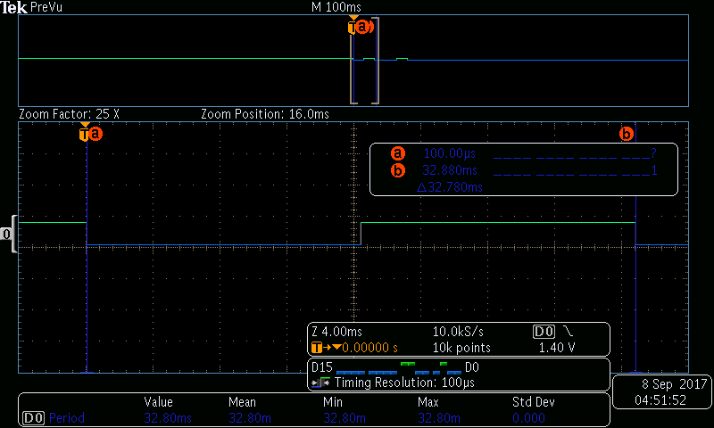

* + - 1. Draw the waveform.
      2. Record the amount of time between flicker states (Hint: try both  
         an automatic measurement and the cursors [section 'Taking  
         Manual Measurements with Cursors' pages 132–136])
         1. 32.780 ms
    1. Use the logic analyzer to obtain the timing for SW2. (Hint: use rising edge  
       trigger)
       1. Obtain screenshot of the logic analyzer timing verification.

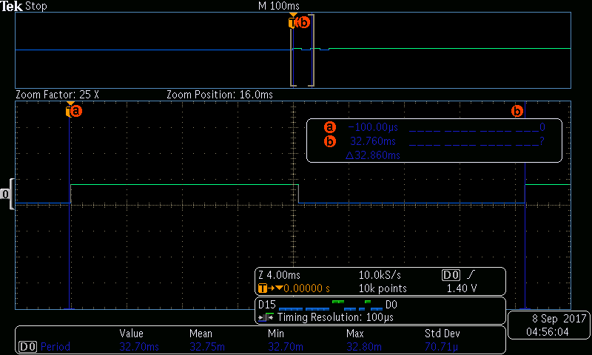

1. Using the Analog Comparator of the TM4C123GH6PM Microcontroller
   1. The analog comparator will convert a voltage to a digital value. Read about these  
      in chapter 19 of the datasheet.
   2. Open the project in the 'comparator' folder.
   3. The project contains code which will turn on a light when the voltage on analog  
      comparator C1 (found in Table 19-1) rises above a certain level. What are the pin  
      assignments for this configuration?
   4. Chapter 19 gives information about the configuration of this peripheral. Which  
      register stores the information about internal reference?
      1. ACREFCTL
   5. Use the system viewer to Select Peripherals -> System Viewer -> COMP to show  
      the analog comparator registers. Run the program and observe the configuration  
      of the register found in step d.
   6. Using the information from the above register, determine the RNG value and the  
      VREF value.
      1. RNG 1
      2. VREF 0x07
   7. Finally, determine the actual internal voltage reference which will activate the  
      Light.
      1. 1.044 V
   8. Test your answer with a voltage source. To avoid damage to your board, start  
      the voltage at 0.
      1. Turns on at 1.03V

Limitations and issues

1. Installing drivers
2. Capturing a window of the behavior of the blinking light

Conclusion

During this lab we have become familiar with the use of the oscilloscope, uVision software, some of the basic uses of the logic probe, learned how to use the data sheet, and analyse the contents of a register.