INTERNATIONAL CYBERSECURITY AND
DIGITAL FORENSICS ACADEMY

Week 1 Practical Laboratory
Information Security Governance in Action
GlobalHealth Connect (GHC) — Executive Governance Simulation

Student Information

Course | GRC102 – Information Security Governance
Module | Module 1 – Principles of Information Security Governance
Prepared By | Natasha Ashlee Shasha
Registration Number | C11/26/CGRCE/17577
Cohort / Batch | COHORT 11
Email Address | c11.cgrce2617577@icdfa.edu.ng
Date Submitted | 11 September 2026

Contents
Student Information 1
TASK 1 - GOVERNANCE BLUEPRINT 3
Evidence Item 1 – Current-State Governance Gap Assessment. 3
Gap Assessment Summary 3
PROPOSED SECURITY GOVERNANCE ORGANISATIONAL STRUCTURE 4
Evidence Item 2: Proposed Security Governance Organisational Structure 4
Governance Structure Explanation 5
RACI Matrix 7
Evidence Item 3: Information Security Governance RACI Matrix 7
Governance Principles and Accountability 9
Evidence Item 4: Governance Principles and Accountability 9
TASK 2 — INFORMATION SECURITY CHARTER 11
Evidence Item 5: Information Security Charter 11
Evidence Item 6: Memo to the CFO 15
TASK 3 — BOARD REPORTING AND SECURITY METRICS 16
Evidence Item 7: Board Executive Summary 16
Evidence Item 8: Selected Security Metrics for Board Oversight 19
Evidence Item 9: Priority Risks and Recommendations 21
Evidence Item 10: Rationale for Board-Level Metrics 23
TASK 4: SECURITY STEERING COMMITTEE 24
Evidence Item 11: Security Steering Committee Terms of Reference 24
Evidence Item 12: Security Steering Committee — First Meeting Agenda 27
Evidence Item 13: Briefing Note to the CEO 30
TASK 5 — INFORMATION SECURITY GOVERNANCE MATURITY 32
Evidence Item 14: Information Security Governance Maturity Assessment 32
EVIDENCE ITEM 15: 12–18 MONTH GOVERNANCE MATURITY ROADMAP 36
Evidence Item 16: Board Executive Summary — Governance Maturity 41
REFERENCES 42

TASK 1 - GOVERNANCE BLUEPRINT

Evidence Item 1 – Current-State Governance Gap Assessment.
Governance Area | Current-State Weakness | Business/Risk Impact | Priority
Policy & Documentation | Policies are inconsistent, inherited from acquisitions and not always current. | Creates uncertainty about security requirements and increases the possibility of inconsistent practices and compliance gaps. | High
Roles & Accountability | Security ownership and accountability are unclear. | Important security decisions may be delayed or responsibilities may be overlooked, making it difficult to hold people accountable. | High
Risk Management | Security risk management is reactive and there is no formal proactive assessment process. | Emerging risks may not be identified early enough, increasing the likelihood of incidents and business disruption. | Critical
Metrics & Reporting | Technical security metrics exist but are not consistently translated into business impact. | The Board may not receive enough information to understand the organisation's actual security posture or make informed investment decisions. | High
Training & Awareness | Annual training is mandatory, but employee engagement is low. | Employees may not fully understand their security responsibilities, increasing human-related security risks. | Medium
Compliance | Compliance preparation is mainly audit-driven rather than continuously monitored. | GHC may identify compliance gaps late and become more exposed to regulatory and reputational consequences. | High

Gap Assessment Summary
GHC's main governance weakness is that information security activities are being managed in a reactive and fragmented way rather than through a clearly defined governance structure. The recent growth of the organisation, two acquisitions and the data-leakage near-miss have increased the need for clear accountability, consistent policies and proactive risk management.
The proposed governance structure should therefore focus on clearly assigning responsibilities, improving Board and executive oversight, establishing a formal risk management process and ensuring that security information is translated into business impact. This will help GHC protect patient information while continuing to support growth, innovation and regulatory compliance.

PROPOSED SECURITY GOVERNANCE ORGANISATIONAL STRUCTURE

Evidence Item 2: Proposed Security Governance Organisational Structure
Purpose of the Proposed Structure
The proposed governance structure establishes clear accountability for information security while maintaining strong alignment between business leadership, technology, compliance, and operational functions. The structure provides a clear escalation and reporting path from operational security activities to executive leadership and the Board. It also creates formal coordination between the information security governance function and the business and technology teams.
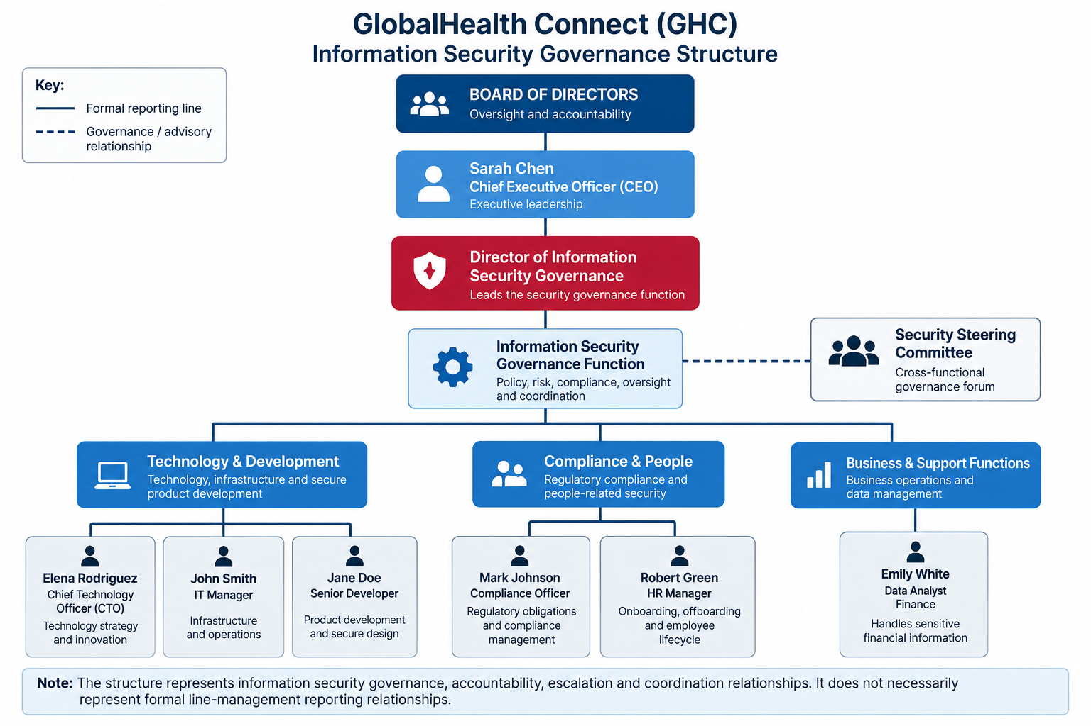

Note: The structure represents information security governance, accountability, escalation, and coordination relationships. It does not necessarily represent formal line-management reporting relationships.

Governance Structure Explanation
The proposed structure establishes the Board and CEO as the senior levels of security oversight and accountability, with the Director of Information Security Governance responsible for coordinating the organisation's information security governance activities. This creates a clear escalation path for significant security risks, governance issues and decisions while ensuring that information security remains aligned with organisational objectives.
The governance function maintains working relationships with technology, IT operations, compliance, HR, development and finance. This cross-functional approach ensures that security is not treated as the responsibility of the IT department alone. Technology teams support implementation, Compliance provides regulatory oversight, HR supports the employee access lifecycle, Development incorporates security into products and innovation, and Finance contributes business and financial risk perspectives.
The structure also supports transparency by establishing clear ownership and communication channels. The Security Steering Committee provides a formal forum for resolving cross-functional security issues and escalating significant matters through the governance structure. This approach directly addresses the current gaps in accountability, risk management and coordination identified in the current-state assessment.

RACI Matrix

Evidence Item 3: Information Security Governance RACI Matrix

Purpose of the RACI Matrix
The RACI matrix clarifies ownership and accountability for key information security governance activities across GHC. It helps address the current uncertainty around roles and responsibilities by clearly identifying who is Responsible, Accountable, Consulted and Informed for each activity.
Governance Activity | CEO | Director of Information Security Governance | CTO | IT Manager | Compliance Officer | HR Manager | Senior Developer | Finance/Data Analyst
Information Security Policy Approval | A | R | C | C | C | I | C | I
Enterprise Security Risk Review | A | R | C | C | C | I | C | C
Incident Response Planning | I | A/R | C | R | C | C | C | I
Security Governance Reporting | I | A/R | C | C | C | I | I | C
Security Awareness & Training | I | A | C | C | C | R | C | I
Regulatory Compliance Monitoring | I | A | C | C | R | I | I | C
Access Management & User Lifecycle | I | A | C | R | C | R | C | I
Secure Product Development | I | A | C | C | C | I | R | I

RACI Interpretation
The RACI matrix establishes clear ownership across key security governance activities and reduces the risk of responsibilities being overlooked or duplicated. The Director of Information Security Governance has a central accountability role in coordinating governance activities, while the CEO retains executive accountability for major security decisions and enterprise risk.
The matrix also demonstrates that information security is a cross-functional responsibility. The CTO and IT Manager contribute to technology and operational security, the Compliance Officer provides regulatory input, HR supports the employee lifecycle and awareness activities, and the Senior Developer contributes to secure product development. Finance is consulted where security decisions may affect sensitive financial information or business risk.
This structure supports accountability and transparency by ensuring that each major governance activity has an identified owner and that relevant stakeholders are involved in decisions affecting their areas.

Governance Principles and Accountability

Evidence Item 4: Governance Principles and Accountability

Governance Principle | How GHC's Structure Supports It | Evidence / Mechanism | Expected Benefit
Accountability | The structure establishes clear ownership for security decisions and activities. The Director of Information Security Governance coordinates the governance function, while the CEO retains executive accountability and relevant functional leaders own responsibilities within their areas. | Governance organisational structure and RACI matrix. | Reduces unclear ownership, duplicated responsibilities and gaps in decision-making.
Transparency | The governance structure creates clear reporting and escalation channels from operational and functional teams through the governance function to executive leadership and the Board. | Governance reporting structure, RACI assignments and formal security reporting. | Enables leadership and the Board to understand security issues, risks and decisions and provides greater visibility of GHC's security posture.
Business Alignment | Security governance involves business, technology, compliance, HR, development and finance rather than treating security as an IT-only responsibility. This allows security decisions to consider GHC's growth, operational efficiency, customer trust, innovation and regulatory objectives. | Cross-functional governance relationships and participation of business and technology stakeholders. | Ensures security investments and decisions support GHC's strategic objectives while avoiding unnecessary barriers to growth and innovation.
Risk Management | The governance function provides a formal mechanism for identifying, reviewing, escalating and monitoring information security risks. Relevant stakeholders can contribute their expertise when risks affect technology, compliance, people, products or business operations. | Enterprise security risk reviews, RACI responsibilities and executive escalation. | Moves GHC from a reactive approach toward proactive identification and management of security risks.

Overall Governance Impact
The proposed governance structure provides GHC with a more formal and coordinated approach to information security governance. Clear accountability, defined reporting relationships and cross-functional involvement ensure that security decisions are not isolated within the IT function. The structure also provides a mechanism for security risks to be escalated to the appropriate level of management and, where necessary, to the Board.
This approach is particularly important following GHC's rapid growth, acquisitions and recent data-leakage near-miss. By establishing clear ownership and integrating security with business decision-making, GHC can strengthen customer trust, support regulatory compliance and enable continued innovation while managing information security risks more effectively.

TASK 2 — INFORMATION SECURITY CHARTER

Evidence Item 5: Information Security Charter
The purpose of this Charter is to give GHC a clear and formal direction for managing information security. The Charter also gives the security governance function the authority to coordinate security activities and make sure security supports the organisation's business goals. This is important because GHC has grown quickly, completed two acquisitions and recently experienced a contained data-leakage near-miss.
Section | Information Security Charter
Purpose | The purpose of this Charter is to establish a clear approach to information security at GlobalHealth Connect (GHC). It sets out how security will be managed, who is responsible for security decisions and how security issues will be reported and escalated. The Charter is intended to protect GHC's patient information, business information, systems and reputation while supporting business growth, innovation and reliable service delivery.

Section | Information Security Charter
Scope | This Charter applies across GHC and covers employees, contractors, systems, applications, data, technology infrastructure and third-party services used by the organisation. It covers information security activities including security policies, risk management, access management, incident response, security awareness, compliance, reporting and the security of new products and services. The Charter also applies to information and systems involved in GHC's expansion, acquisitions and regional operations.

Section | Information Security Charter
Authority | The Charter is approved by the appropriate executive leadership and provides the Information Security Governance function with the authority to coordinate security activities across GHC. The Director of Information Security Governance is responsible for coordinating the governance process, reporting significant risks and issues to executive management and escalating matters that require senior management or Board attention. Business and technology leaders are expected to support security requirements within their areas of responsibility.

Role | Responsibilities
Board of Directors | Provides oversight of information security and receives updates on significant risks, security performance and major issues requiring Board attention.
Sarah Chen – CEO | Provides executive leadership and ensures information security supports GHC's business objectives, reputation and growth.
Director of Information Security Governance | Coordinates the information security governance function, oversees security governance activities, reports significant risks and ensures that responsibilities are clearly assigned.
Elena Rodriguez – CTO | Provides technology leadership and ensures security is considered when making technology, product and innovation decisions.
John Smith – IT Manager | Supports the implementation and operation of security controls across IT infrastructure and systems.
Mark Johnson – Compliance Officer | Monitors healthcare regulatory obligations and provides guidance on compliance requirements.
Robert Green – HR Manager | Supports security requirements relating to employees, including onboarding, offboarding and employee responsibilities.
Jane Doe – Senior Developer | Supports secure product development and ensures security considerations are included when developing key products and features.
Emily White – Data Analyst, Finance | Provides business and financial information to support security-related analysis and decision-making where appropriate.
Security Steering Committee | Provides a cross-functional forum for discussing security issues, resolving disagreements and making recommendations on matters that affect different areas of GHC.

Principle | What It Means at GHC
Accountability | Everyone with a security responsibility should understand what they are responsible for and who owns the final decision.
Risk-Based Decision Making | GHC will identify and assess security risks and use the results to decide which risks need immediate attention and which can be managed through normal business processes.
Protection of Patient Information | Protecting patient information is a key priority because GHC's services depend heavily on customer trust and the secure handling of sensitive health information.
Business Alignment | Security decisions should support GHC's business goals rather than unnecessarily slowing down growth, innovation or service delivery.
Compliance | GHC will take its healthcare and data-protection obligations seriously and aim to identify compliance gaps before they become major problems.
Continuous Improvement | Security processes will be reviewed regularly so that GHC can improve its approach as the organisation grows, changes and introduces new technology.
Security Awareness | Employees should understand their role in protecting GHC information and systems, rather than seeing security as the responsibility of the IT department alone.

Section | Information Security Charter
Reporting Structure | The Director of Information Security Governance will coordinate regular security reporting to the CEO and provide significant risk and security updates to the Board through the appropriate executive reporting process. The Director will also work with the CTO, IT Manager, Compliance Officer, HR Manager, Development and Finance to collect relevant information and identify issues that require attention. The Security Steering Committee will provide a formal forum for cross-functional security discussions and recommendations. Significant security incidents, major risks and issues that could affect GHC's customers, reputation, regulatory position or business operations should be escalated to executive leadership.

Section | Information Security Charter
Review and Approval | This Charter will be reviewed at least annually and whenever there are major changes to GHC's business, technology, regulatory requirements, organisational structure or risk environment. Changes to the Charter should be reviewed by the Information Security Governance function and relevant stakeholders before being submitted for approval. The CEO and Board should provide the appropriate level of approval based on the significance of the changes.

GHC recognises that information security is an organisation-wide responsibility. The organisation is committed to protecting patient information, maintaining customer trust, supporting reliable operations, meeting its regulatory responsibilities and enabling secure innovation. This Charter provides the foundation for a consistent and accountable approach to information security governance across GHC.

Evidence Item 6: Memo to the CFO

To: | Marcus Thorne – Chief Financial Officer
From: | Director of Information Security Governance
Date: | 11 September 2026
Subject: | Information Security Charter and Business Alignment

The Information Security Charter provides GHC with a clear and formal approach to managing information security across the organisation. It defines who is responsible for security decisions, how security issues are reported and how important risks are escalated. This supports GHC's 2026 strategic goals by making sure security is considered as the organisation expands its client base, enters two regional markets and introduces new features and AI-driven solutions. It also supports customer trust by making the protection of patient information a clear organisational priority and helps GHC take a more proactive approach to its regulatory responsibilities.
From a financial perspective, the Charter helps GHC make better decisions about security investments because it provides a clearer link between security risks and business priorities. Instead of investing in security without understanding the business need, management can use identified risks, reporting and accountability to prioritise areas that could have the greatest effect on operations, customers, compliance or the organisation's reputation. The Charter therefore supports better use of resources while helping GHC reduce the likelihood and potential impact of major security incidents.
Regards,
Director of Information Security Governance
GlobalHealth Connect

TASK 3 — BOARD REPORTING AND SECURITY METRICS

Evidence Item 7: Board Executive Summary

Overall Security Posture | Requires Management Attention
  🔴
Overall Assessment | GHC's security posture is showing increasing pressure. Security events and high-risk incidents have increased steadily over the six-month period, while the percentage of critical vulnerabilities being patched has fallen from 67% to 55%. Although security training completion has improved from 45% to 70%, this improvement has not yet translated into a reduction in phishing activity or high-risk incidents.
Board Attention Required | The main areas requiring attention are vulnerability remediation, increasing security incidents and the organisation's ability to keep pace with its growing risk exposure.

Key Messages for the Board

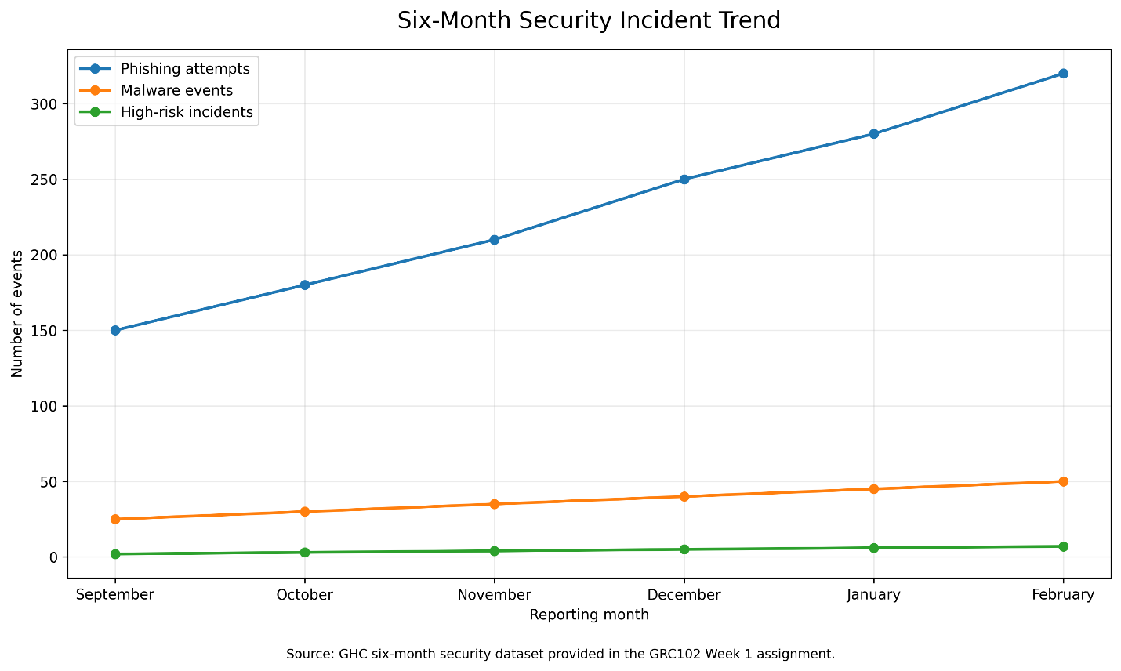
1. Security events are increasing
Reported phishing attempts increased from 150 in September to 320 in February, more than doubling during the period. Malware events also increased from 25 to 50.
2. High-risk incidents are increasing
High-risk incidents increased from 2 in September to 7 in February. This is a significant concern because it shows that the organisation is experiencing a growing number of security issues that could have a greater impact on business operations and customer trust.
3. Critical vulnerability patching is getting worse
The percentage of critical vulnerabilities patched fell from 67% in September to 55% in February. At the same time, the number of critical vulnerabilities identified increased from 15 to 40. This means GHC is facing a larger remediation workload while its patching rate is declining.
4. Training is improving, but the risk indicators are still increasing
Security training completion increased from 45% to 70%, which is positive. However, phishing activity and high-risk incidents continued to increase during the same period. GHC should therefore assess whether the current training is effectively changing employee behaviour and reducing security risk.

Priority Area | Board-Level Concern
Vulnerability Management | Critical vulnerabilities are increasing while the percentage patched is declining.
Security Incidents | High-risk incidents increased from 2 to 7 over the reporting period.
Phishing Risk | Phishing activity more than doubled from 150 to 320.
Employee Security Awareness | Training completion improved, but the increase in phishing and incidents suggests that completion alone may not be enough.
Business Risk | Increasing security activity and incidents could affect customer trust, regulatory obligations, operations and GHC's planned growth.

The last point is particularly important because GHC's strategic goals include protecting patient information, maintaining customer trust, expanding into two regional markets and introducing AI-driven solutions.
Board Conclusion
The six-month results indicate that GHC's security risk requires increased management attention. The organisation is experiencing higher levels of phishing, malware and high-risk incidents, while its ability to patch critical vulnerabilities has declined. The improvement in training completion is encouraging, but the overall trend shows that additional action is required.
Management should prioritise improving critical vulnerability remediation, strengthening controls against phishing and reviewing the effectiveness of security awareness activities. These actions will help GHC manage its current security exposure while supporting its wider objectives of customer trust, regulatory compliance, operational reliability and continued growth.

Evidence Item 8: Selected Security Metrics for Board Oversight
The following five metrics were selected because they provide the Board with a balanced view of GHC's security exposure, vulnerability management, employee readiness and significant security events. The metrics focus on areas that can affect customer trust, business operations, compliance and the organisation's ability to achieve its strategic objectives.
Metric | Current Status (February) | Six-Month Trend | Business Commentary | Board Attention
Phishing Attempts | 320 | Increased from 150 → 320 | Phishing activity more than doubled during the six-month period. This increases the risk of employees being tricked into revealing information or providing access to systems. | High
Critical Vulnerabilities Patched | 22 of 40 (55%) | Patching rate declined from 67% → 55% | GHC is identifying more critical vulnerabilities while the percentage being patched is falling. This creates a growing exposure that could affect systems and customer information. | Critical
Security Training Completion | 70% | Increased from 45% → 70% | Training completion has improved significantly. However, the continued increase in phishing and high-risk incidents suggests that completion alone may not mean employees are better protected against threats. | Medium
High-Risk Incidents | 7 | Increased from 2 → 7 | High-risk incidents have more than tripled. This indicates that GHC needs to understand the causes and ensure that incidents are identified, contained and resolved quickly. | Critical
Malware Events | 50 | Increased from 25 → 50 | Malware events have doubled over the period. Although this is mainly an operational concern, the trend provides an indication that GHC's overall exposure to security threats is increasing. | High

Why These Five Metrics Were Selected
These five metrics were selected because together they give the Board a clear picture of GHC's current security position. Phishing attempts and malware events show the level of security activity affecting the organisation, while critical vulnerabilities patched show whether GHC is keeping up with weaknesses that could be exploited. High-risk incidents provide an indication of events that may have a greater effect on the organisation, and security training completion provides a view of employee preparedness.
These metrics are also useful because they can be connected to business concerns rather than focusing only on technical details. Increasing security events, rising high-risk incidents and declining vulnerability patching can affect customer trust, operations, compliance and GHC's ability to grow safely. Training completion is included because employees play an important role in protecting the organisation, particularly against threats such as phishing.

Evidence Item 9: Priority Risks and Recommendations
Based on the six-month security trends, two priority areas require immediate management attention: the increasing number of security incidents and the growing backlog of critical vulnerabilities. These issues could affect GHC's operations, customer trust, regulatory responsibilities and ability to support continued growth.
Priority Risk/Issue | Evidence from the Data | Potential Business Impact | Priority
Increasing security incidents and phishing activity | Phishing increased from 150 to 320, malware increased from 25 to 50, and high-risk incidents increased from 2 to 7. | Greater likelihood of compromised accounts, disruption, loss of information, customer trust issues and increased incident response costs. | Critical
Growing critical vulnerability backlog | Critical vulnerabilities identified increased from 15 to 40, while the percentage patched declined from 67% to 55%. 18 of the 40 vulnerabilities remained unpatched in February. | Unpatched critical vulnerabilities could be exploited and may result in system disruption, data exposure, compliance issues and reputational damage. | Critical
The figures are taken directly from the GHC six-month dataset provided in the assignment.
Actionable Recommendations
Recommendation | Action Required | Expected Outcome | Suggested Owner
1. Strengthen vulnerability management | Prioritise the 18 remaining critical vulnerabilities, establish clear remediation deadlines, track progress through regular management reporting and escalate overdue critical vulnerabilities. | Reduce the number of critical vulnerabilities and improve the patching rate, reducing GHC's exposure to exploitation. | IT Manager / CTO
2. Strengthen phishing and security awareness controls | Review the current security awareness programme, provide targeted phishing education and reinforce employee reporting of suspicious messages. Use the increasing phishing trend to identify areas where additional awareness is needed. | Reduce employee exposure to phishing and improve the organisation's ability to identify and report suspicious activity. | Director of Information Security Governance / HR Manager

Management Message
The Board should focus on reducing the growing security exposure rather than looking only at individual incident numbers. The most immediate concern is the combination of increasing security incidents and a growing number of critical vulnerabilities. Management should therefore prioritise vulnerability remediation and strengthen measures aimed at reducing phishing-related risk.
The improvement in training completion from 45% to 70% is positive, but the continued increase in phishing activity shows that GHC should look beyond completion rates and assess whether employees are applying what they have learned. Regular reporting should therefore focus on whether security actions are actually reducing risk, rather than simply showing whether activities have been completed.

Evidence Item 10: Rationale for Board-Level Metrics

The five selected metrics are suitable for Board oversight because they provide a simple view of GHC's overall security position and show areas that could affect the organisation's business objectives. Phishing attempts and malware events show the level of security activity affecting the organisation, while high-risk incidents show whether significant security issues are increasing. Critical vulnerabilities patched shows whether GHC is keeping up with important security weaknesses, and security training completion provides an indication of employee preparedness.
These metrics are useful to the Board because they can be linked to business concerns such as customer trust, protection of patient information, operational reliability, regulatory responsibilities and safe business growth. They also show both positive and negative trends. For example, training completion improved during the period, while phishing activity, malware events and high-risk incidents increased and the critical vulnerability patching rate declined. This gives the Board enough information to understand where management attention and investment may be required without focusing on unnecessary technical details.

Selected Metric | Why the Board Should Care
Phishing Attempts | Shows the level of exposure to a common threat that can affect employees, systems and information.
Critical Vulnerabilities Patched | Shows whether GHC is addressing important weaknesses that could expose systems and patient information.
Security Training Completion | Shows whether employees are receiving the required security awareness and helps management assess preparedness.
High-Risk Incidents | Shows whether significant security events are increasing and may require management intervention.
Malware Events | Shows the level of malicious activity affecting GHC and whether the organisation's overall threat exposure is increasing.

TASK 4: SECURITY STEERING COMMITTEE

Evidence Item 11: Security Steering Committee Terms of Reference
Purpose
The Security Steering Committee (SSC) provides a formal forum for GHC to discuss, review and resolve information security issues that affect more than one business or technology function. The committee helps ensure that security decisions are balanced with business needs, operational requirements, compliance obligations and GHC's strategic objectives.

Section | Terms of Reference
1. Purpose | The Security Steering Committee provides a formal forum for discussing and resolving cross-functional information security issues. It ensures that security decisions consider business needs, technology, compliance, people and operational requirements.
2. Scope | The Committee will consider significant information security risks, policies, incidents, compliance matters, security projects, security awareness, access management, technology risks and other issues that require input from different departments.
3. Membership | Chair: Director of Information Security Governance. Members: CEO or CEO representative, CTO, IT Manager, Compliance Officer, HR Manager, Senior Developer and Finance/Data Analyst where relevant. Other subject matter experts may be invited when their input is required.
4. Responsibilities | Review significant security risks; review and recommend security policies; resolve cross-functional security disagreements; monitor major security issues; review security performance and trends; support security investment decisions; ensure security remains aligned with GHC's business objectives; and escalate significant matters to executive management or the Board when required.
5. Meeting Cadence | The Committee will meet monthly as a standard meeting. Additional meetings may be called when there is a significant security incident, urgent risk, major policy issue or important security decision requiring cross-functional input.
6. Decision Authority | The Committee can review issues, agree recommendations and coordinate actions within its defined responsibilities. Decisions requiring executive approval, significant financial investment, changes to business strategy or Board-level attention will be escalated to the appropriate executive authority.
7. Reporting | The Director of Information Security Governance will document key decisions, actions and outstanding issues. Significant risks and matters requiring executive attention will be reported to the CEO, with relevant matters escalated to the Board.
8. Review of Terms of Reference | The Terms of Reference will be reviewed annually or when there are significant changes to GHC's organisation, business activities, technology environment or security requirements.

Initial Issue for Committee Review
Password Policy Conflict
The Committee's first major issue will be the disagreement between the IT Manager and CTO regarding the proposed password policy. The proposed policy requires 16-character complex passwords to be changed every 30 days and does not include password-manager integration. The CTO has proposed a more balanced approach using multi-factor authentication (MFA) and secure password management.
The Committee will review both approaches based on security risk, employee usability, operational impact, business requirements and the overall security objectives of GHC. The aim is to reach a documented and practical recommendation rather than allowing the disagreement to remain an informal departmental issue.

Decision-Making Approach
When the Committee considers a security issue, members will first identify the business problem and the security risk involved. Each relevant stakeholder will be given an opportunity to provide their view and supporting information. The Committee will then consider the security benefits, business impact, cost, operational effect and compliance requirements before agreeing on a recommendation.
Where the Committee cannot reach an agreement, the issue will be escalated to the appropriate executive authority with the different options, risks and recommendations clearly documented.

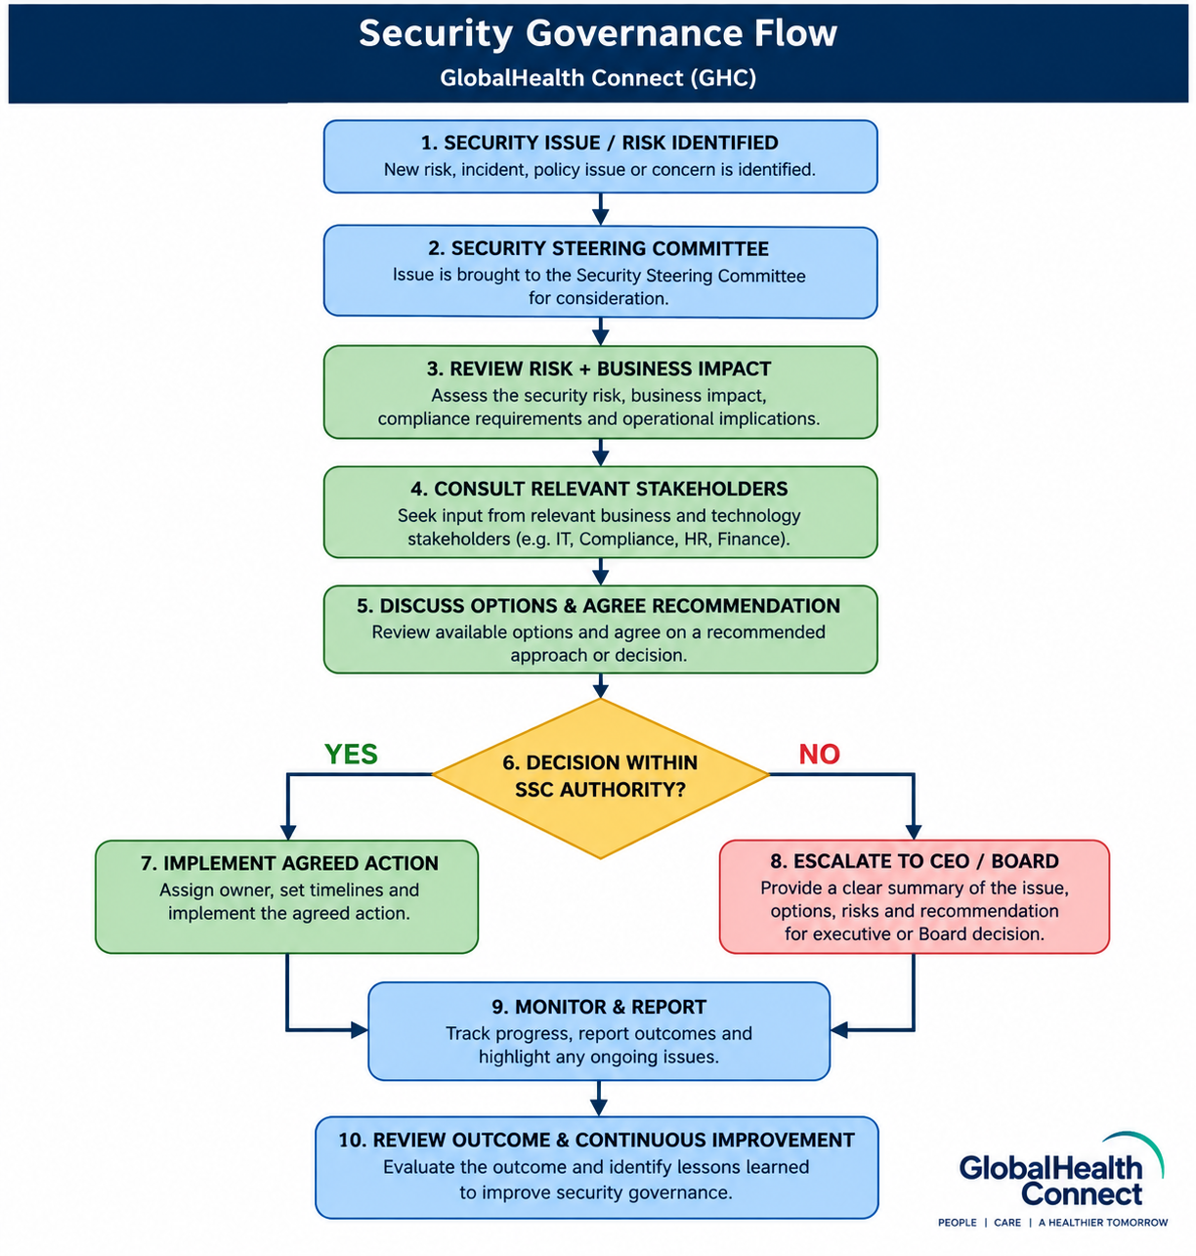

Evidence Item 12: Security Steering Committee — First Meeting Agenda

GLOBALHEALTH CONNECT (GHC)
SECURITY STEERING COMMITTEE
FIRST MEETING AGENDA
Meeting Detail | Information
Meeting | Security Steering Committee – Inaugural Meeting
Date | To Be Confirmed
Time | To Be Confirmed
Location | GHC Head Office / Virtual Meeting
Chair | Director of Information Security Governance
Meeting Purpose | Establish the Committee and address the initial password policy disagreement.

Agenda
No. | Agenda Item | Lead | Time
1 | Welcome and introduction of Committee members | Chair | 5 mins
2 | Confirm purpose, scope and responsibilities of the Security Steering Committee | Chair | 10 mins
3 | Review current information security governance priorities | Director of Information Security Governance | 10 mins
4 | Password Policy Conflict – 16-character passwords and 30-day changes vs MFA and password management | CTO / IT Manager | 25 mins
5 | Discussion of security, business and operational impact of the proposed approaches | All Members | 15 mins
6 | Agree preferred approach and required next steps | Committee | 10 mins
7 | Review actions, owners and deadlines | Chair | 10 mins
8 | Any other business | All Members | 5 mins
9 | Closing and confirmation of next meeting | Chair | 5 mins

Key Agenda Item: Password Policy Conflict
The Committee will review the proposed password policy requiring 16-character complex passwords to be changed every 30 days without password-manager integration. The IT Manager supports the proposed approach, while the CTO has raised concerns and prefers a balanced approach using multi-factor authentication (MFA) and secure password management.
The discussion will consider the security benefits, effect on employees, operational impact, cost, ease of implementation and how the proposed approach supports GHC's wider security and business objectives. The Committee will aim to agree on a practical recommendation and assign clear owners and deadlines for the next steps.
Expected Meeting Outcomes
By the end of the meeting, the Committee should have:
- Confirmed the purpose and responsibilities of the Security Steering Committee.
- Reviewed the current password policy proposals.
- Considered the security and business impact of each approach.
- Agreed on a preferred password policy recommendation or identified the additional information required before making the decision.
- Assigned owners and deadlines for implementing the agreed actions.
- Identified any issue that needs to be escalated to the CEO or Board.
Action Items
Action | Owner | Due Date | Status
Review current password policy and identify gaps | IT Manager | To be confirmed | Open
Assess MFA and password-manager option | CTO | To be confirmed | Open
Review compliance and employee-related considerations | Compliance Officer / HR Manager | To be confirmed | Open
Present final recommendation to SSC | Director of Information Security Governance | Next SSC meeting | Open

Evidence Item 13: Briefing Note to the CEO

BRIEFING NOTE
To: | Sarah Chen – Chief Executive Officer
From: | Director of Information Security Governance
Date: | 11 September 2026
Subject: | Security Steering Committee and Cross-Functional Security Decision-Making

Purpose
This briefing note explains how the proposed Security Steering Committee (SSC) will help GHC resolve information security issues that involve different departments and ensure that security decisions remain aligned with the organisation's business objectives.
Briefing
The Security Steering Committee will provide GHC with a formal place to discuss and resolve security issues that cannot be effectively handled by one department alone. For example, the current disagreement between the CTO and IT Manager over the proposed password policy can be brought to the Committee for structured discussion. Rather than allowing the disagreement to remain between two individuals, the SSC will consider the security risk, business impact, operational requirements, employee impact and compliance considerations before agreeing on a recommendation. This allows the different stakeholders to contribute their views while keeping the final decision focused on GHC's overall interests.
The SSC will also help ensure that information security remains connected to GHC's wider strategy. Security decisions should support customer trust, operational reliability, regulatory responsibilities, business growth and innovation rather than simply adding controls without considering their impact. The Committee will document decisions, assign owners and monitor agreed actions, while matters requiring executive approval or Board attention will be escalated appropriately. This gives management greater visibility of security risks and provides a consistent way of making security decisions as GHC continues to grow and introduce new technology.
Recommended Action
I recommend that the Security Steering Committee be formally established and that its Terms of Reference be approved. The Committee's first meeting should focus on the password-policy disagreement and use the agreed governance process to reach a documented recommendation.
Regards,
Director of Information Security Governance
GlobalHealth Connect

TASK 5 — INFORMATION SECURITY GOVERNANCE MATURITY

Evidence Item 14: Information Security Governance Maturity Assessment
Current-State Maturity Assessment
The maturity assessment below evaluates GHC's current information security governance position across six key areas. The assessment uses the simplified five-level maturity model provided in the assignment and is based on the current-state evidence in the GHC scenario.

Level | Maturity | Meaning
1 | Ad Hoc | Informal, reactive and inconsistent. Processes are not clearly defined.
2 | Initial | Some processes exist but they are inconsistently documented or applied.
3 | Defined | Processes are documented, standardised, communicated and have clear responsibilities.
4 | Managed | Processes are measured, monitored and reviewed against targets.
5 | Optimising | Continuous improvement is embedded and the organisation adapts quickly.

Domain | Current Evidence | Current Level | Maturity Rating | Main Gap | What Level 3 Would Look Like
Policy & Documentation | Policies are inconsistent, some were inherited from acquisitions and they are not always current. | 2 | Initial | Policies are not consistently maintained or standardised across GHC. | Policies are documented, current, standardised and communicated across the organisation.
Roles & Responsibilities | Ownership and accountability for information security are unclear. | 1 | Ad Hoc | People do not have clearly defined security responsibilities and ownership. | Security responsibilities are clearly assigned, documented and communicated to relevant staff.
Risk Management | Risk management is mainly reactive and there is no formal proactive assessment process. | 1 | Ad Hoc | GHC does not have a consistent process for identifying and assessing risks before they become issues. | A documented and standard risk assessment process is used across the organisation with clear ownership.
Metrics & Reporting | Technical security metrics exist, but they are not consistently translated into business impact. | 2 | Initial | Management and the Board do not always receive security information in a form that supports business decisions. | Standard security reports translate security performance and risks into clear business information.
Training & Awareness | Annual security training is mandatory, but employee engagement is low. | 2 | Initial | Training exists but employee engagement and effectiveness need improvement. | A documented and consistent awareness programme is communicated across GHC and responsibilities are clear.
Compliance | Compliance activities are mainly driven by audits rather than continuous monitoring. | 2 | Initial | GHC may identify compliance gaps late because monitoring is not continuous. | Compliance responsibilities, processes and monitoring activities are documented, standardised and communicated.

Overall Maturity Assessment
GHC's current information security governance maturity is generally between Level 1 and Level 2, with the largest weaknesses in roles and responsibilities and risk management. Policy and documentation, metrics and reporting, training and awareness, and compliance are currently at Level 2 because some processes exist but are not consistently applied or embedded across the organisation.
The most urgent areas for improvement are Roles & Responsibilities and Risk Management, which are currently at Level 1. GHC needs to establish clear ownership, accountability and a consistent approach to identifying and assessing security risks. The organisation should then standardise its policies, reporting, training and compliance processes so that all six domains reach at least Level 3 – Defined.
Current Maturity vs Target
Domain | Current | 12–18 Month Target
Policy & Documentation | 🟠 2 – Initial | 🟢 3 – Defined
Roles & Responsibilities | 🔴 1 – Ad Hoc | 🟢 3 – Defined
Risk Management | 🔴 1 – Ad Hoc | 🟢 3 – Defined
Metrics & Reporting | 🟠 2 – Initial | 🟢 3 – Defined
Training & Awareness | 🟠 2 – Initial | 🟢 3 – Defined
Compliance | 🟠 2 – Initial | 🟢 3 – Defined

Why I chose these scores
Policy & Documentation = 2
Processes exist, but they're inconsistent and outdated in places.
Roles & Responsibilities = 1
The scenario explicitly says ownership/accountability is unclear. That's a basic governance weakness.
Risk Management = 1
It's reactive and there is no formal proactive assessment process. That fits Ad Hoc.
Metrics & Reporting = 2
Metrics exist. The problem is that they aren't consistently translated into business impact. So GHC has something in place, but it isn't mature.
Training & Awareness = 2
Training exists and is mandatory, but engagement is low. Again, that's an existing but inconsistent/weak process.
Compliance = 2
Compliance isn't absent—it is being addressed through audits. But it's reactive rather than continuously monitored.

EVIDENCE ITEM 15: 12–18 MONTH GOVERNANCE MATURITY ROADMAP
Roadmap Objective
The objective of this roadmap is to move GHC from its current Level 1–2 maturity position to at least Level 3 – Defined across all six information security governance domains within 12–18 months. The roadmap focuses on establishing clear ownership, improving risk management, standardising policies, strengthening compliance and security awareness, and improving security reporting.

Initiative | Timeline | Objective | Key Activities | Measurable Expected Outcome | Responsible Owner
1. Establish Security Governance & Accountability | Months 1–3 | Establish a clear governance structure and make security responsibilities clear across GHC. | Formally establish the Security Steering Committee; approve the Information Security Charter; define security roles and responsibilities; develop and approve the RACI matrix; establish security reporting and escalation channels. | Security governance structure approved; Charter approved; RACI completed; Security Steering Committee operational; security responsibilities communicated to relevant teams. | Director of Information Security Governance
2. Implement Proactive Risk Management | Months 3–6 | Move GHC from a mainly reactive approach to a consistent and proactive way of identifying and managing security risks. | Develop a formal risk management process; create a security risk register; conduct an organisation-wide security risk assessment; assign risk owners; establish risk review and escalation processes. | Formal risk management process approved; initial organisation-wide risk assessment completed; risk register established; risks have assigned owners and treatment actions. | Director of Information Security Governance / CTO
3. Standardise Policies & Strengthen Compliance | Months 6–12 | Ensure security policies are current, consistent and supported by regular compliance monitoring. | Review existing and inherited policies; remove outdated policies; develop or update key security policies; establish policy review dates; create a compliance monitoring process; track compliance gaps and corrective actions. | Current and standardised policies in place; outdated policies removed; policy review schedule established; compliance monitoring process operational; improved audit readiness. | Compliance Officer / Director of Information Security Governance
4. Strengthen Security Awareness & Board Reporting | Months 9–15 | Improve employee security awareness and provide management and the Board with clearer information about security risks and performance. | Review the current awareness programme; introduce more engaging and targeted awareness activities; provide phishing-focused education; develop standard security reports; link security metrics to business impact; establish regular management and Board reporting. | Increased employee engagement; improved training participation; standard security reporting established; security metrics consistently linked to business impact; regular reporting to management and Board. | HR Manager / Director of Information Security Governance
5. Measure, Review & Embed Continuous Improvement | Months 15–18 | Confirm that the governance improvements are working and ensure the new processes become part of normal GHC operations. | Review progress against the maturity targets; conduct an internal governance review; identify remaining gaps; review effectiveness of policies and processes; update the roadmap based on lessons learned; establish regular maturity reviews. | All six governance domains reach at least Level 3 – Defined or have documented actions to close remaining gaps; governance review completed; continuous improvement process established. | Director of Information Security Governance / Executive Management

Maturity Journey
GHC will progress through the roadmap in stages rather than attempting to improve all areas at once. The first three months will focus on establishing the governance foundation and clarifying accountability. Months 3–6 will focus on introducing proactive risk management, followed by policy and compliance improvements from months 6–12. Security awareness and Board reporting will then be strengthened, with the final stage focused on measuring progress and embedding continuous improvement.
The roadmap is designed to address the weaknesses identified in the maturity assessment and move all six domains towards Level 3. Level 3 is considered the immediate target because it represents a point where processes are documented, standardised, communicated and supported by clear responsibilities.

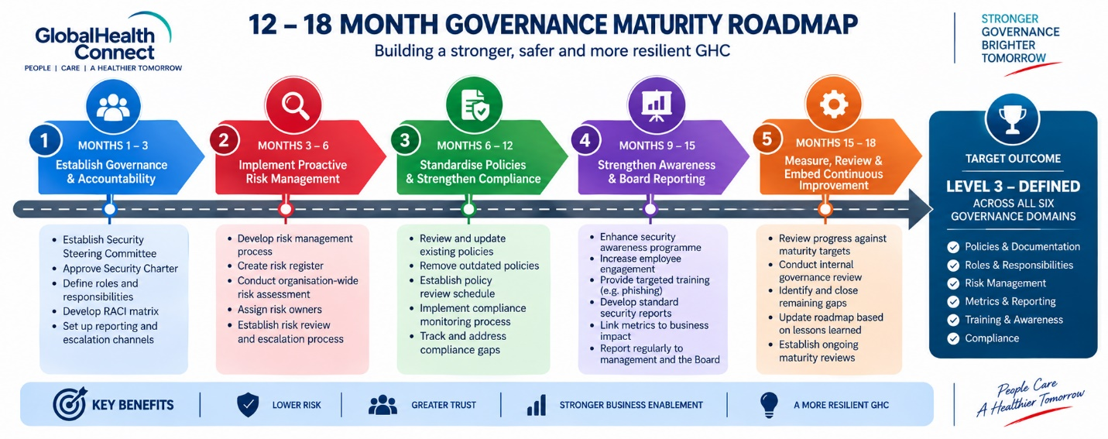

Maturity Domain | Main Roadmap Initiative Addressing It
Policy & Documentation | Initiative 3 – Standardise Policies & Strengthen Compliance
Roles & Responsibilities | Initiative 1 – Establish Security Governance & Accountability
Risk Management | Initiative 2 – Implement Proactive Risk Management
Metrics & Reporting | Initiative 4 – Strengthen Security Awareness & Board Reporting
Training & Awareness | Initiative 4 – Strengthen Security Awareness & Board Reporting
Compliance | Initiative 3 – Standardise Policies & Strengthen Compliance

Evidence Item 16: Board Executive Summary — Governance Maturity
Executive Summary
GHC's current information security governance maturity is generally between Level 1 (Ad Hoc) and Level 2 (Initial) across the six assessed areas. The main weaknesses are in roles and responsibilities and risk management, where processes are largely informal and reactive. Other areas, including policy and documentation, metrics and reporting, training and awareness, and compliance, have some processes in place but they are not yet consistently applied across the organisation. This position reflects GHC's rapid growth, acquisitions and the need to move away from an ad-hoc approach to a more structured and consistent way of managing security.
The proposed 12–18 month roadmap focuses on establishing clear ownership, introducing a more proactive risk management process, improving policies and compliance monitoring, strengthening employee security awareness and improving management and Board reporting. The target is to achieve at least Level 3 (Defined) across all six domains, meaning that security processes are documented, standardised, communicated and supported by clear responsibilities. Reaching this level will give GHC a stronger foundation for managing security as the organisation continues to grow, enter new markets and introduce new technology.

Board-Level Priorities
Priority | What the Board Should Support
Clear Accountability | Support the formal assignment of security responsibilities and ownership across GHC.
Proactive Risk Management | Support the introduction of a consistent organisation-wide risk assessment process.
Standardised Policies | Ensure security policies are reviewed, updated and consistently applied following GHC's growth and acquisitions.
Better Security Reporting | Require security reporting to clearly show business impact, risks and areas requiring management attention.
Security Culture | Support improved employee engagement with security awareness rather than relying only on annual training completion.

Board Conclusion
The maturity assessment shows that GHC has a foundation to build on, but its current approach is not yet consistent enough to support the organisation's continued growth safely. The proposed roadmap provides a practical path towards Level 3 maturity and should be treated as a business improvement programme rather than an IT-only initiative.

REFERENCES
International Organization for Standardization (ISO) (2018) ISO 31000:2018 Risk management — Guidelines. Geneva: ISO.
International Organization for Standardization (ISO) and International Electrotechnical Commission (IEC) (2022) ISO/IEC 27001:2022 Information security, cybersecurity and privacy protection — Information security management systems — Requirements. Geneva: ISO.
National Institute of Standards and Technology (NIST) (2024) The NIST Cybersecurity Framework (CSF) 2.0. Gaithersburg, MD: NIST.
ISACA (2019) COBIT 2019 Framework: Governance and Management Objectives. Schaumburg, IL: ISACA.

