INTERNATIONAL CYBERSECURITY AND
DIGITAL FORENSICS ACADEMY

Week 3 Lab Assignment

Roles , Responsibilities and Accountability
ICDFA Security Policy Manual Development Project
Course | GRC102 – Information Security Governance
Module | Module 1 – Principles of Information Security Governance
Prepared By | Natasha Ashlee Shasha
Registration Number | C11/26/CGRCE/17577
Cohort / Batch | COHORT 11
Email Address | c11.cgrce2617577@icdfa.edu.ng
Date Submitted | 25 September 2026

Contents
TASK 1: GOVERNANCE ARCHITECTURE AND STAKEHOLDER MAP 3
1.1 Governance Gap Assessment 3
1.2 Stakeholder Map 5
1.3 Security Governance Organisation Chart 8
1.4 Proposed Governance Flow 9
1.5 Consultant Justification 10
TASK 2: GOVERNANCE RESPONSIBILITY AND AUTHORITY MATRIX 12
2.1 Cross-Functional Governance Responsibility Matrix 12
2.2 Role Profiles / Responsibility Cards 14
2.3 Conflict Resolution Note 20
TASK 3: SECURITY GOVERNANCE COMMITTEE ECOSYSTEM 21
B. Security Governance / Steering Committee 22
C. Specialised Working Group — Incident Response Working Group 23
3.4 Terms of Reference — Security Governance Committee 26
3.6 Sample Committee Decision Log 29
3.7 12-Month Governance Calendar 29
TASK 4 — RACI ACCOUNTABILITY MATRIX 31
4.1 TechGlobal RACI Matrix 31
4.2 Problematic RACI Assignments 33
4.3 RACI Implementation Guide 34
TASK 5 — CYBER-RISK ESCALATION & SEGREGATION OF DUTIES 35
5.1 Major Cyber-Risk Escalation Workflow 35
5.2 Escalation Threshold Table 36
5.3 Segregation-of-Duties / Accountability Weakness Register 37
5.4 Decision Recording and Assurance 38
REFERENCES 39

TASK 1: GOVERNANCE ARCHITECTURE AND STAKEHOLDER MAP

1.1 Governance Gap Assessment
TechGlobal's current governance model is heavily IT-centric and relies on informal decision-making. This creates several weaknesses because security decisions are not consistently separated between operational execution, risk oversight, executive decision-making and Board oversight. The following gaps should be addressed.
No. | Current Governance Weakness | Business / Risk Consequence
1 | Security decision-making is concentrated with the IT Director | Concentrating security ownership, operational decisions and risk decisions in one function can create conflicts of interest and weak independent challenge. Important risks may be accepted for operational convenience rather than evaluated at enterprise level.
2 | No formal security governance committee structure | There is no consistent forum where security, risk, legal, finance, HR and business leaders can collectively review major security issues. This can result in fragmented decisions and delayed escalation.
3 | Limited CEO and Board visibility into cyber risk | Senior leadership may not have sufficient information to understand material cyber risks, regulatory exposure, financial impact or whether security investment is aligned with business priorities.
4 | Business units make security decisions inconsistently | Different offices or departments may apply different security practices and risk tolerances. This creates inconsistent control implementation and makes enterprise-wide assurance more difficult.
5 | No reliable escalation path for material cyber risk | Significant risks may remain at operational level for too long, delaying executive intervention and potentially increasing financial, regulatory or operational consequences.
6 | Unclear accountability and decision rights | When ownership is informal, employees may be uncertain about who approves security policies, accepts risk, authorises major investments or makes decisions during serious incidents.
7 | Insufficient cross-functional involvement | Security decisions may be made without appropriate input from Legal, Finance, HR, Risk or business leadership, even when an issue has regulatory, financial, people or operational consequences.
8 | Weak separation between security operations and risk oversight | The same function may identify a problem, recommend its treatment and effectively decide whether the risk is acceptable. This reduces independent challenge and accountability.

Key governance issue
The central problem is therefore not simply that TechGlobal lacks security controls. The bigger issue is that the organisation lacks a formal governance structure that clearly separates:
Operational execution → Security governance → Enterprise risk oversight → Executive decision-making → Board oversight
This distinction is important because TechGlobal is already a large organisation operating across five offices. The informal model described in the scenario is therefore difficult to scale consistently. The brief itself identifies concentration of authority, inconsistent control ownership, weak oversight and limited Board visibility as consequences of the current model.

1.2 Stakeholder Map
The proposed governance model should involve the eight core governance roles identified in the assignment, together with Business Unit Leaders, because the scenario specifically requires business units to participate in governance.
Stakeholder | Authority / Influence | Primary Interest | Information Needed | Governance Contribution
Board of Directors | Highest oversight authority; sets risk appetite and provides governance oversight | Material cyber risk, regulatory exposure, reputation, assurance and accountability | Material cyber risks, major incidents, risk trends, regulatory exposure, security performance and assurance results | Provides oversight, challenges executive management, approves/oversees risk appetite and receives material cyber-risk reporting
CEO | Executive authority over organisational priorities and business performance | Business growth, strategic alignment, acceptable risk and performance | Enterprise cyber-risk position, major incidents, financial exposure, security investment needs and key decisions | Ensures cybersecurity is aligned with business strategy and coordinates executive decision-making
CISO | Security governance leadership and subject-matter authority | Security strategy, policy, risk oversight, programme effectiveness and security performance | Security metrics, risk assessments, incidents, vulnerabilities, control performance and programme status | Leads security governance, develops strategy, coordinates security programme and provides security advice to executives and Board
CRO / Risk | Enterprise risk oversight and challenge | Risk methodology, risk acceptance, treatment and aggregation | Cyber-risk assessments, risk ratings, treatment plans, residual risk and risk trends | Integrates cyber risk into enterprise risk management and provides independent challenge on risk decisions
Legal / Compliance | Legal and regulatory advisory authority | Regulatory duties, contractual obligations, privacy, evidence and notification | Regulatory requirements, contractual obligations, incident facts and potential legal exposure | Advises on legal obligations, privacy and regulatory notification and ensures decisions consider applicable requirements
Finance | Financial governance and budget influence | Budget, financial exposure, investment prioritisation and financial controls | Security costs, financial impact of incidents, investment cases and loss estimates | Supports security investment decisions, evaluates financial exposure and provides financial governance
HR | Authority over people-related governance processes | Joiner/mover/leaver controls, awareness, conduct and disciplinary processes | Personnel risks, security training, access changes and disciplinary matters | Supports workforce security, awareness, disciplinary processes and people-related security controls
IT / Technology | Operational and technical implementation authority | Secure technology delivery, control implementation and service continuity | Security requirements, vulnerabilities, architecture decisions, incidents and remediation priorities | Implements technical controls, operates technology securely and provides operational evidence to security governance
Business Unit Leaders | Authority over business operations and local decisions | Operational performance, local risk and business continuity | Business impact, security requirements, risks, incidents and control responsibilities | Own business-level risks, implement required controls and participate in governance without creating separate security silos

Important design principle
The CISO should lead security governance, but should not become the sole owner of every security decision.
For example:
- CISO → provides security expertise and governance leadership.
- CRO/Risk → provides enterprise risk oversight and challenge.
- Legal → determines legal/regulatory implications.
- Finance → evaluates financial implications and investment.
- Business Units → own business impacts and operational risks.
- CEO → makes executive-level decisions.
- Board → provides oversight for material risk and organisational accountability.
That creates a much stronger separation of responsibilities than the current IT-centric model.

1.3 Security Governance Organisation Chart
This is the structure I would use for TechGlobal.
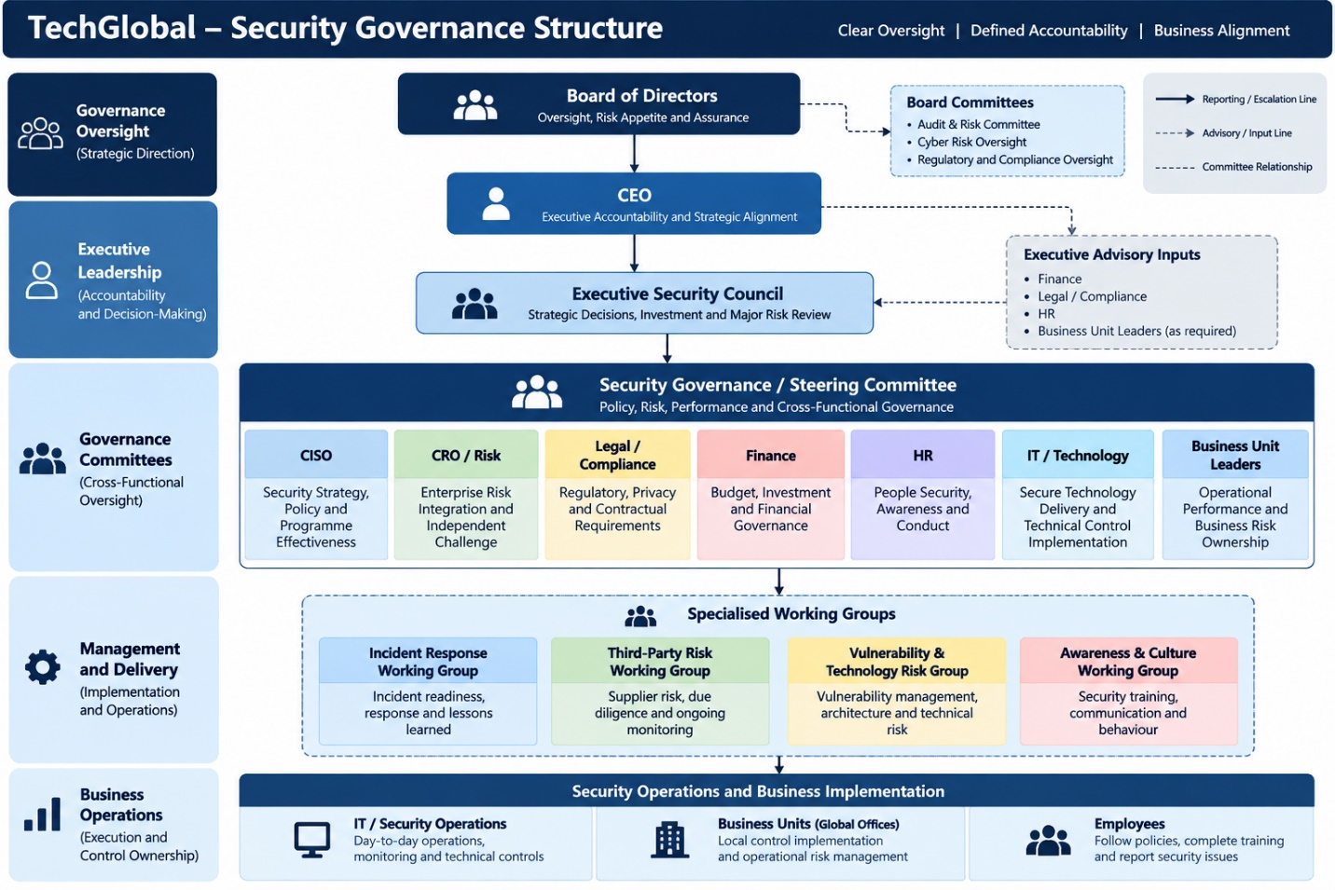
How the reporting and communication works
The important point is that not every relationship shown is a direct reporting relationship.
For example:
- The CISO reports security governance information to executive management and provides material cyber-risk reporting to the Board through the established governance route.
- CRO/Risk provides independent enterprise-risk oversight rather than becoming part of day-to-day security operations.
- Legal, Finance and HR provide specialist governance input.
- IT remains responsible for technical implementation and operations.
- Business Unit Leaders remain responsible for business-level implementation and operational risk.
- The Security Governance Committee becomes the central cross-functional forum for resolving security governance issues.
- Specialised working groups deal with detailed issues and escalate significant matters upward.
This prevents the organisation from simply replacing the IT Director-centric model with a CISO-centric model.

1.4 Proposed Governance Flow
The governance model can be summarised as:
Operational level
IT + Security Operations + Business Units
⬇
Identify risks, vulnerabilities, incidents and control issues.
Governance level
CISO + CRO/Risk + Legal + Finance + HR + relevant Business Leaders
⬇
Assess business impact, regulatory exposure, financial implications and risk treatment.
Executive level
CEO + Executive Security Council
⬇
Make strategic decisions, prioritise investment and address risks exceeding operational authority.
Board level
Board of Directors
⬇
Oversee material cyber risk, risk appetite, major incidents, assurance and accountability.
This creates the escalation and communication path that the scenario currently lacks.

1.5 Consultant Justification
Why the Proposed Governance Structure is Appropriate for TechGlobal
TechGlobal requires a governance structure that reflects the size and complexity of the organisation. With approximately 2,500 employees operating across five global offices, security decisions can no longer depend primarily on informal arrangements within the IT function. The existing model concentrates decision-making with the IT Director, provides limited visibility to senior leadership and allows business units to make security decisions inconsistently.
The proposed model addresses this problem by separating oversight, governance, risk management and operational execution. The Board remains responsible for high-level oversight and receives information about material cyber risks, regulatory exposure, major incidents and assurance. The CEO provides executive accountability and ensures that cybersecurity decisions support business objectives rather than being treated purely as a technical issue.
The CISO becomes the central security governance leader. The CISO is responsible for developing security strategy, coordinating the security programme, monitoring security performance and providing security advice to executives. However, the CISO does not independently own every risk decision. This is important because effective governance requires challenge and separation of responsibilities.
The CRO/Risk function provides enterprise-risk integration and independent challenge. This means cyber risks can be assessed alongside other organisational risks and that risk acceptance is not simply determined by the team responsible for implementing security controls. Legal and Compliance provides advice on regulatory, contractual and privacy requirements, while Finance evaluates financial exposure and security investment. HR addresses workforce-related security responsibilities such as awareness, conduct and joiner/mover/leaver processes. These responsibilities directly reflect the stakeholder concerns identified in the assignment brief.
IT continues to play an important role but moves from being the informal owner of security governance to being a key technology implementation and operational control owner. This allows IT to focus on secure technology delivery, technical control implementation and service continuity while security governance provides independent oversight.
Business Unit Leaders are also incorporated into the model. This is important because cybersecurity risk ultimately affects business operations. Business leaders should therefore participate in risk discussions and remain accountable for implementing controls within their areas rather than creating separate security silos.
The proposed Security Governance/Steering Committee provides the cross-functional forum that TechGlobal currently lacks. It creates a structured environment where security, risk, legal, financial, people and business considerations can be considered together. More specialised Working Groups can handle detailed areas such as incident response or third-party risk and escalate significant matters to the main governance committee.
The structure is also scalable. As TechGlobal grows, additional business units, technology teams or specialised working groups can participate without changing the overall governance architecture. The organisation therefore gains a consistent enterprise-wide governance model while retaining flexibility at operational level.
Most importantly, the proposed structure establishes a clear pathway:
Operational teams → Security Governance → Executive Management → Board
This improves accountability and ensures that material risks can move beyond operational teams when they exceed defined thresholds. It also gives senior management and the Board better visibility of the organisation's cyber-risk position.
Overall, the proposed model moves TechGlobal from informal, IT-centric security decision-making toward formal, cross-functional security governance. It establishes clearer decision rights, stronger independent challenge, improved executive visibility and a structured route for escalating material cyber risks.

TASK 2: GOVERNANCE RESPONSIBILITY AND AUTHORITY MATRIX

2.1 Cross-Functional Governance Responsibility Matrix

Role | Purpose | Core Responsibilities | Decision Authority | Reports / Escalates To | KPIs / Evidence
Board | Provide strategic oversight and accountability for material cyber risk | Risk appetite, major cyber-risk oversight, assurance and accountability | Approves risk appetite and oversees material cyber-risk decisions | Receives reports from CEO and governance structures | Board cyber-risk reports; material incident reports
CEO | Provide executive accountability and strategic direction | Business alignment, security priorities, major risk decisions and executive coordination | Makes executive decisions within delegated authority and escalates material risks to Board | Board | Major risk decisions; security investment progress
CISO | Lead security governance and the security programme | Security strategy, policies, risk oversight, security performance and reporting | Owns security governance decisions within delegated authority | CEO / Executive Security Council; material risks to Board | Security KPI dashboard; risk register; incident metrics
CRO / Risk | Integrate cybersecurity into enterprise risk management | Risk assessment, risk treatment, risk acceptance and enterprise risk aggregation | Provides risk challenge and oversees risk methodology | CEO / relevant executive governance forum | Cyber-risk register; residual-risk reporting
Legal / Compliance | Ensure security decisions consider legal and regulatory requirements | Regulatory duties, privacy, contracts, evidence and notification | Advises on legal/regulatory requirements and notification decisions | CEO / relevant governance committee | Compliance reports; regulatory assessments
Finance | Provide financial governance over cybersecurity | Budget, financial exposure, investment prioritisation and financial controls | Controls/approves financial decisions within delegated authority | CEO / executive management | Security budget; investment cases; loss estimates
HR | Manage people-related security governance | Awareness, conduct, disciplinary processes and joiner/mover/leaver controls | Makes people-related decisions within HR authority | CEO / relevant management | Training completion; disciplinary records; access lifecycle evidence
IT | Implement and operate technology securely | Technical controls, secure infrastructure, remediation and service continuity | Makes operational technology decisions within approved standards | CISO / CIO or executive management structure | Vulnerability closure; control implementation; availability
The role allocation reflects the stakeholder responsibilities in the assignment scenario, particularly the distinction between security leadership, enterprise risk, legal requirements, financial governance, people governance and technology delivery.

2.2 Role Profiles / Responsibility Cards
1. Board of Directors
Purpose:
Provide oversight and ensure that material cybersecurity risks are properly understood and governed.
Key responsibilities:
- Approve/oversee organisational risk appetite.
- Review material cyber risks and major incidents.
- Challenge executive management on security performance.
- Ensure appropriate assurance and accountability.
Decision authority:
Oversight and approval of matters reserved for the Board, particularly material risk.
Reporting:
Receives cyber-risk and major incident reporting from executive management.
KPIs / Evidence:
- Board cyber-risk reporting completed on schedule.
- Number of material risks escalated and reviewed.

2. CEO
Purpose:
Ensure cybersecurity supports business strategy and receives appropriate executive attention.
Key responsibilities:
- Provide executive accountability for cybersecurity.
- Align security priorities with business objectives.
- Resolve major cross-functional security decisions.
- Escalate material matters to the Board.
Decision authority:
Executive decisions within delegated authority and organisational risk limits.
Reporting:
Reports to the Board.
KPIs / Evidence:
- Closure of executive-level security decisions.
- Progress against approved security priorities.

3. CISO
Purpose:
Lead security governance and coordinate the organisation's security programme.
Key responsibilities:
- Develop cybersecurity strategy and policies.
- Monitor security risks and control effectiveness.
- Coordinate major incident governance.
- Provide security reporting to executives and the Board.
Decision authority:
Security governance decisions within delegated authority.
Reporting:
CEO / Executive Security Council, with material risks escalated through the governance structure.
KPIs / Evidence:
- Security control effectiveness.
- Critical incident response and remediation performance.

4. CRO / Risk
Purpose:
Ensure cybersecurity risks are managed as part of enterprise risk management.
Key responsibilities:
- Maintain the cyber-risk methodology.
- Challenge risk assessments and treatment decisions.
- Monitor residual and aggregated cyber risk.
- Support appropriate risk acceptance.
Decision authority:
Risk oversight and challenge within the enterprise risk framework.
Reporting:
CEO / executive risk governance.
KPIs / Evidence:
- Percentage of material cyber risks with current treatment plans.
- Timeliness of risk reviews.

5. Legal / Compliance
Purpose:
Ensure security decisions meet legal, regulatory, privacy and contractual obligations.
Key responsibilities:
- Interpret regulatory requirements.
- Advise on privacy and contractual obligations.
- Support breach notification decisions.
- Ensure appropriate evidence is preserved.
Decision authority:
Legal and regulatory advice within professional authority.
Reporting:
CEO / relevant governance committee.
KPIs / Evidence:
- Regulatory assessments completed.
- Regulatory notifications completed within required timelines.
6. Finance
Purpose:
Provide financial oversight of cybersecurity investment and exposure.
Key responsibilities:
- Support security budgeting.
- Assess financial impact of cyber incidents.
- Review security investment proposals.
- Monitor financial controls related to security.
Decision authority:
Financial approval within delegated authority.
Reporting:
CEO / executive management.
KPIs / Evidence:
- Security budget utilisation.
- Percentage of approved security investments delivered.

7. HR
Purpose:
Manage people-related security responsibilities.
Key responsibilities:
- Security awareness and training.
- Joiner/mover/leaver processes.
- Employee conduct and disciplinary procedures.
- Support investigations involving employees.
Decision authority:
Personnel and disciplinary decisions within HR policy and applicable requirements.
Reporting:
CEO / relevant management.
KPIs / Evidence:
- Security awareness completion rate.
- Timely completion of joiner/mover/leaver access actions.

8. IT
Purpose:
Implement and operate secure technology environments.
Key responsibilities:
- Implement technical security controls.
- Maintain secure infrastructure.
- Remediate vulnerabilities.
- Maintain service continuity and provide operational evidence.
Decision authority:
Operational technology decisions within approved architecture, policies and standards.
Reporting:
CISO and relevant executive technology management.
KPIs / Evidence:
- Critical vulnerability remediation within target time.
- Security control implementation rate.

2.3 Conflict Resolution Note
Because TechGlobal previously concentrated security authority within IT, several areas could create overlapping authority. The governance model should resolve these conflicts through clear decision rights, independent challenge and documented approvals.
Potential Conflict | Risk Created | Resolution
CISO vs CRO/Risk – Risk acceptance | Security may recommend treatment while Risk independently challenges or accepts the residual risk. If roles are unclear, accountability becomes confused. | CISO provides the security assessment and recommendation; CRO/Risk provides independent risk challenge. Risk acceptance follows the organisation's delegated authority and risk appetite.
CISO vs IT – Security control implementation | IT may prioritise operational availability or convenience over security requirements. | CISO defines security requirements and standards; IT implements the technical controls and provides evidence of implementation.
CISO vs Legal – Regulatory notification | Security may focus on technical facts while Legal must consider regulatory and contractual obligations. | CISO provides incident facts and technical impact; Legal/Compliance advises on notification obligations and coordinates the legal/regulatory decision.
Finance vs CISO – Security investment | Finance may focus on cost while Security focuses on risk reduction. | CISO provides the security business case and risk justification; Finance evaluates affordability, financial impact and investment controls; executive management makes the final prioritisation decision.
Conflict-resolution principle
The solution should not create unnecessary bureaucracy. Instead, each decision should have:
One clear owner → defined supporting roles → appropriate independent challenge → documented decision
This gives TechGlobal accountability without returning to the previous model where too much authority was concentrated within IT.

TASK 3: SECURITY GOVERNANCE COMMITTEE ECOSYSTEM
3.1 Committee Structure
TechGlobal should use a three-level governance structure supported by specialised working groups.
A. Executive Security Council
Purpose:
Provide strategic oversight of cybersecurity, major risks, investment priorities and significant security decisions.
Chair: CEO
Core members:
- CEO
- CISO
- CRO / Risk
- Legal / Compliance
- Finance
- IT
- HR
- Business Unit representative, where required
Key responsibilities:
- Review significant cyber risks.
- Review major security incidents.
- Prioritise cybersecurity investment.
- Resolve cross-functional governance issues.
- Review security programme performance.
- Escalate material risks to the Board.
Frequency: Monthly, with emergency meetings when required.

B. Security Governance / Steering Committee
Purpose:
Provide the main cross-functional forum for translating strategy into security governance decisions and monitoring implementation.
Chair: CISO
Core members:
- CISO
- CRO / Risk
- Legal / Compliance
- Finance
- HR
- IT / Technology
- Business Unit Leaders
Key responsibilities:
- Review security policies and standards.
- Review cyber-risk assessments.
- Monitor security control performance.
- Review vulnerability and remediation trends.
- Review third-party security risks.
- Coordinate business-unit security requirements.
- Prepare matters requiring Executive Security Council attention.
Frequency: Monthly.

C. Specialised Working Group — Incident Response Working Group
For TechGlobal, I recommend an Incident Response Working Group because security incidents require rapid coordination between technical, business, legal, risk and communication functions.
Chair: CISO / Security Operations Lead
Members:
- Security/IT
- Legal / Compliance
- CRO / Risk
- HR where employees are involved
- Finance where financial impact exists
- Relevant Business Unit
- Communications/Corporate Affairs where appropriate
Responsibilities:
- Review incident readiness.
- Coordinate incident-response procedures.
- Conduct exercises.
- Review lessons learned.
- Track corrective actions following major incidents.
- Escalate material incidents through the governance structure.
Frequency: Monthly readiness review, plus incident-specific meetings when required.

3.2 Committee Interaction Diagram
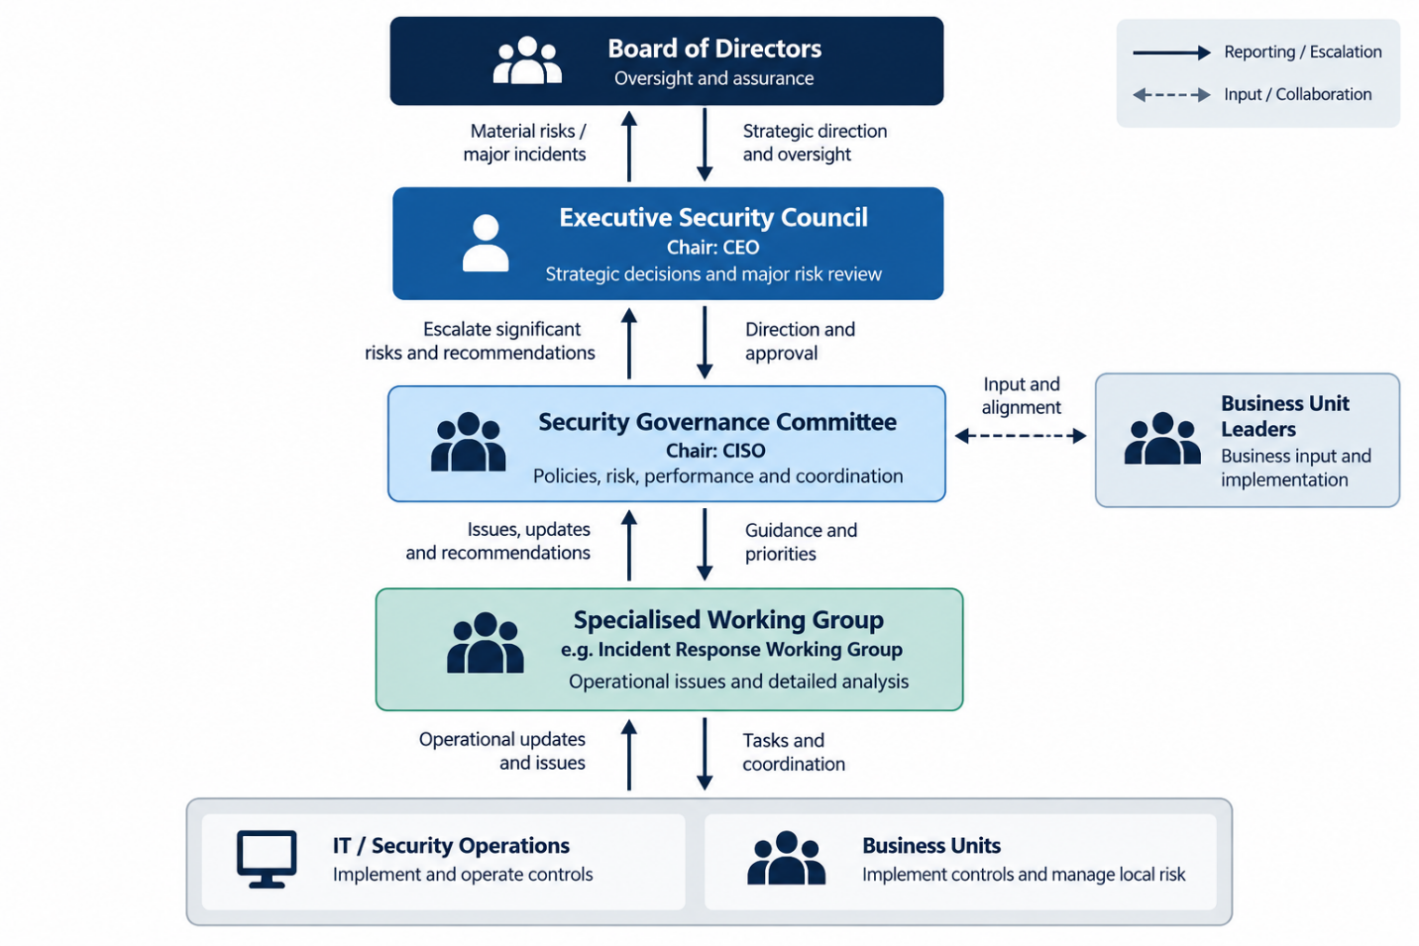How the structure works
The Working Group handles detailed operational issues and prepares recommendations.
The Security Governance Committee reviews those issues from a cross-functional governance perspective.
Where an issue has significant business, financial, regulatory or enterprise-risk implications, it moves to the Executive Security Council.
Where a matter becomes material to the organisation's risk appetite, reputation, regulatory position or strategic position, the Executive Security Council escalates it to the Board.
This creates the required flow from operational forums to executive management and, where necessary, the Board.

3.3 Business Unit Participation
Business Units should participate in governance without creating separate security structures.
Each Business Unit should:
- Nominate a security/governance representative.
- Attend the Security Governance Committee when relevant.
- Report significant local security risks.
- Implement approved security controls.
- Participate in incident response.
- Track remediation actions.
- Provide business-impact information during risk assessments.
Business Units should not create their own independent security policies or risk-acceptance processes where these conflict with the enterprise framework.
Instead:
Central governance sets the enterprise direction, while Business Units own implementation and local business risk.
This gives the organisation consistency while still allowing individual offices to address their operational requirements.

3.4 Terms of Reference — Security Governance Committee
Committee Name
TechGlobal Security Governance / Steering Committee
Purpose
To provide cross-functional governance over cybersecurity strategy, risk, controls, compliance, security performance and business alignment.
Objectives
The Committee will:
- Monitor the organisation's cybersecurity risk position.
- Review security policies and governance standards.
- Monitor security programme performance.
- Review significant vulnerabilities and remediation.
- Review third-party security risks.
- Coordinate business-unit security requirements.
- Escalate significant matters to the Executive Security Council.
Membership
Role | Committee Responsibility
CISO | Chair and security governance leadership
CRO / Risk | Enterprise risk oversight and challenge
Legal / Compliance | Regulatory, privacy and contractual advice
Finance | Financial impact and investment
HR | People-related security governance
IT / Technology | Technical implementation and operational matters
Business Unit Leaders | Business impact and local risk ownership
Meeting Frequency
Monthly, with additional meetings when a significant security issue requires urgent review.
Quorum
At least the CISO, CRO/Risk or delegate, and two relevant functional representatives, including the relevant business owner where a business-specific decision is being made.
Decision-Making
Decisions should be based on:
- Security risk.
- Business impact.
- Regulatory/legal requirements.
- Financial impact.
- Available controls and treatment options.
Material decisions outside the Committee's authority are escalated to the Executive Security Council.
Reporting
The Committee provides:
- Monthly governance updates.
- Risk and control summaries.
- Significant incident updates.
- Outstanding decision/action reports.

3.5 Sample Committee Agenda
TechGlobal Security Governance Committee
Meeting: Monthly Governance Meeting
Duration: 90 minutes
Time | Agenda Item | Owner
5 min | Opening and confirmation of previous actions | CISO
10 min | Cyber-risk dashboard | CRO / Risk
10 min | Security programme and KPI update | CISO
10 min | Major incidents and lessons learned | IT / Security
10 min | Vulnerability and remediation status | IT
10 min | Regulatory / privacy matters | Legal
10 min | Third-party security risks | CISO / Procurement or relevant owner
10 min | Business Unit security issues | Business Unit Leaders
10 min | Decisions requiring Committee approval | Committee
5 min | Actions, owners and deadlines | CISO

3.6 Sample Committee Decision Log
Date | Decision / Issue | Decision Owner | Decision | Rationale | Actions / Owner | Review Date
06 Oct 2026 | Critical vulnerability affecting multiple offices | CISO | Prioritise immediate remediation | Vulnerability presents elevated operational and security exposure | IT to remediate; CISO to verify closure | 20 Oct 2026
03 Nov 2026 | Third-party supplier with unresolved security findings | CRO / Risk | Require remediation plan before accepting residual risk | Supplier risk exceeds normal tolerance without additional controls | Vendor owner + CISO to agree treatment plan | 01 Dec 2026
01 Dec 2026 | Security awareness completion below target | HR / CISO | Launch targeted awareness intervention | Low completion creates increased people-related security exposure | HR to conduct campaign; CISO to monitor completion | 15 Jan 2027
This satisfies the requirement for at least three example decision entries.

3.7 12-Month Governance Calendar
Month | Key Governance Activity | Primary Forum
January | Annual cybersecurity strategy and risk priorities | Executive Security Council
February | Security policy and standards review | Governance Committee
March | Incident-response exercise | Incident Response Working Group
April | Third-party security risk review | Governance Committee
May | Security awareness and workforce risk review | Governance Committee
June | Mid-year cyber-risk and investment review | Executive Security Council
July | Vulnerability and security architecture review | Governance Committee
August | Business Unit security maturity review | Governance Committee
September | Incident-response readiness exercise | Incident Response Working Group
October | Regulatory/privacy and compliance review | Governance Committee
November | Cybersecurity budget and investment planning | Executive Security Council
December | Annual security performance, lessons learned and next-year priorities | Executive Security Council / Board
Recurring activities
In addition to the monthly focus areas above:
- Monthly: Security Governance Committee.
- Monthly: Cyber-risk and KPI reporting.
- Monthly: Incident-response readiness monitoring.
- Quarterly: Executive Security Council review.
- Quarterly: Material cyber-risk reporting to the Board.
- Annually: Governance structure and Terms of Reference review.

TASK 4 — RACI ACCOUNTABILITY MATRIX

4.1 TechGlobal RACI Matrix
Activity | Board | CEO | CISO | CRO/Risk | Legal | Finance | HR | IT | BU Leader
1. Cybersecurity strategy approval | A | R | R | C | C | C | I | C | C
2. Security policy approval | I | A | R | C | C | I | C | C | C
3. Enterprise cyber-risk assessment | I | I | R | A | C | I | I | C | C
4. Risk acceptance | I | C | R | A | C | C | I | C | C
5. Security budget approval | C | A | R | C | I | R | I | C | C
6. Security architecture approval | I | I | A | C | C | I | I | R | C
7. Third-party security review | I | I | A | C | C | C | I | R | R
8. Access governance | I | I | A | C | I | I | C | R | C
9. Incident response governance | I | A | R | C | C | C | C | R | C
10. Material incident escalation | I | A | R | C | C | C | I | R | C
11. Regulatory notification decision | I | C | R | C | A | I | I | C | I
12. Security awareness programme | I | C | A | I | C | I | R | C | R
13. Vulnerability remediation oversight | I | I | A | C | I | I | I | R | C
14. Business continuity / recovery governance | I | A | C | C | C | C | C | R | R
15. Board cyber-risk reporting | A | C | R | C | C | I | I | C | I

4.2 Problematic RACI Assignments
1. IT as Accountable for security architecture
Making IT accountable for the overall security architecture could create a conflict because IT is also responsible for implementing the technology.
Resolution: CISO remains Accountable, while IT is Responsible for implementation.
2. CISO as Accountable for risk acceptance
The CISO provides the security assessment and recommendation, but should not independently accept enterprise risk.
Resolution: CRO/Risk is Accountable for risk acceptance, with the CISO Responsible for the security assessment.

3. Legal and Security both making the regulatory notification decision
Security determines the technical facts, while Legal determines the legal and regulatory implications.
Resolution: Legal is Accountable, CISO is Responsible, and relevant stakeholders are consulted.

4. Business Units being excluded from security decisions
If Business Unit Leaders are simply informed, security decisions may not reflect operational realities.
Resolution: Business Unit Leaders are Consulted or Responsible where implementation affects their operations.

4.3 RACI Implementation Guide
Managers should use the RACI matrix as a decision and accountability tool, not simply as a reference document.
During planning
Before starting a security activity, identify the Responsible person and confirm who is Accountable for the final outcome.
During approvals
The Accountable role makes or owns the final decision. Consulted roles provide input before the decision is made.
During incidents
Use the RACI to immediately identify who is responsible for the response, who has authority to make decisions and who must be informed or consulted.
Where roles conflict
Managers should not allow multiple people to assume accountability for the same decision. Escalate unclear ownership to the CISO, CRO/Risk or CEO depending on the issue.
Documentation
Major decisions should record:
- Activity/issue
- Accountable person
- Decision made
- Key consultation
- Actions and owner
- Review or escalation date
This creates a clear audit trail and prevents responsibility from being lost between departments.

TASK 5 — CYBER-RISK ESCALATION & SEGREGATION OF DUTIES

5.1 Major Cyber-Risk Escalation Workflow
TechGlobal should use a three-level escalation model:
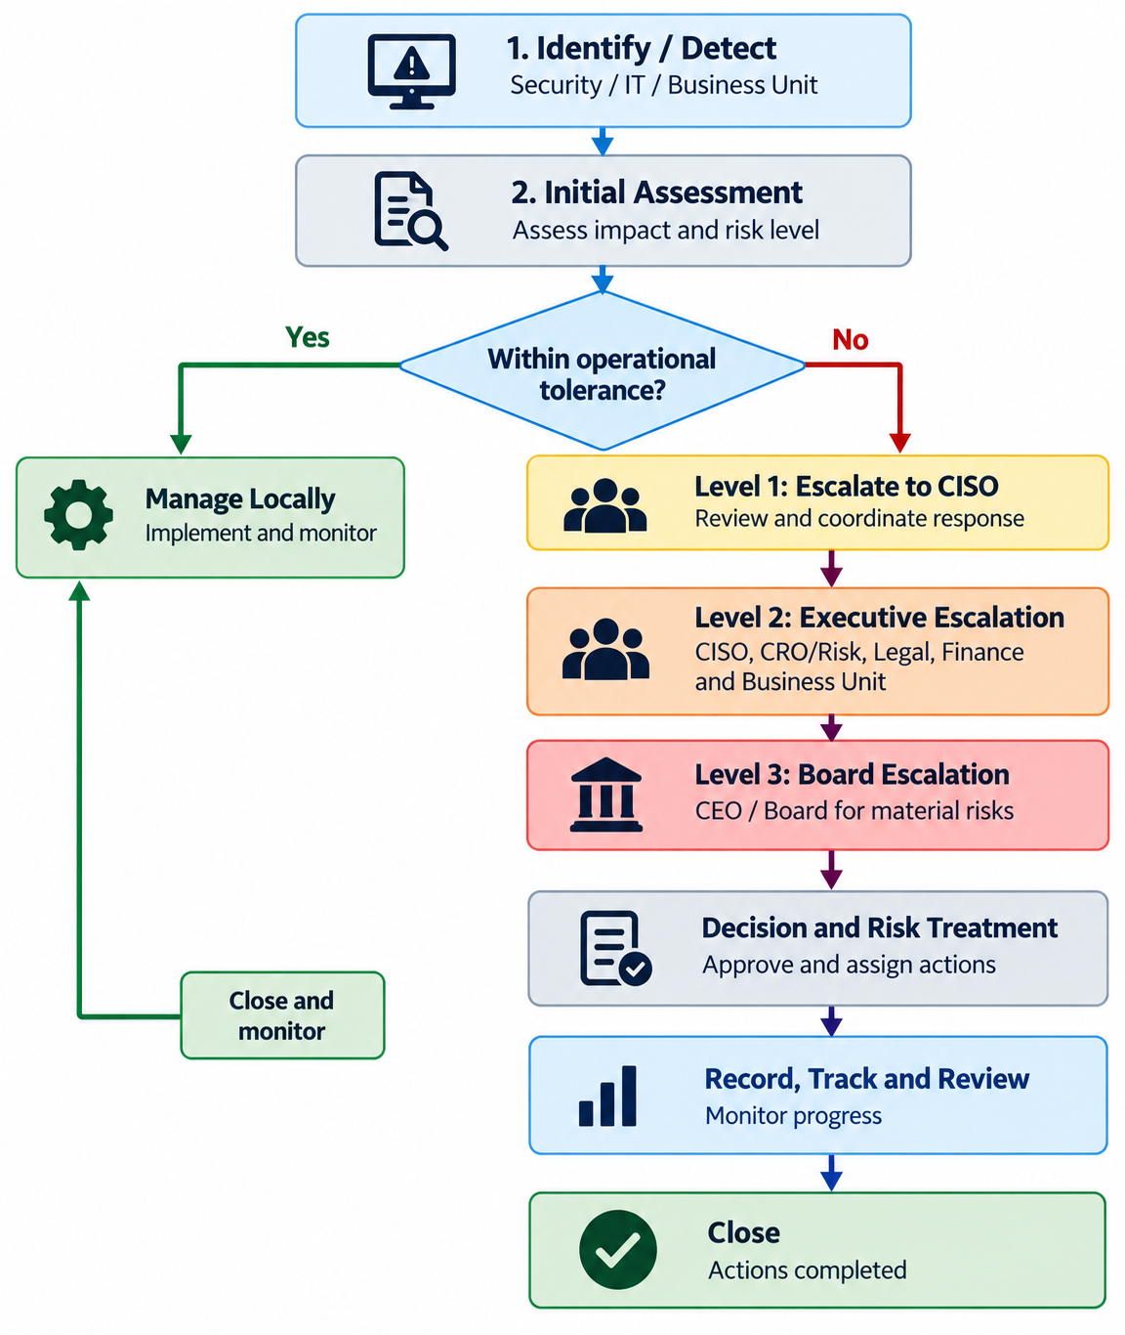

Escalation triggers
An issue should be escalated when it involves:
- Significant financial impact
- Sensitive or important business information
- Regulatory or legal exposure
- Major operational disruption
- High or critical cyber risk
- Risk exceeding approved tolerance
- Significant third-party exposure
- Potential reputational impact

5.2 Escalation Threshold Table

Level | Example Trigger | Decision Authority | Required Notification | Target Response
Level 1 – Operational | Low/moderate risk that can be managed within existing controls and risk tolerance | IT / Security / Business Unit | CISO as required | Normal operational timeframe
Level 2 – Executive | High risk, significant business impact, serious vulnerability, major service disruption or risk approaching/exceeding tolerance | CISO + Executive Security Council / CEO | CRO, Legal, Finance and affected Business Unit | Same day / urgent
Level 3 – Material / Board | Material financial, regulatory, operational or reputational impact; major incident; significant risk beyond organisational tolerance | CEO / Board according to delegated authority | Board, relevant executives and required functions | Immediate escalation

The exact thresholds should be defined in TechGlobal's approved risk appetite and incident-management procedures rather than relying only on informal judgement.

5.3 Segregation-of-Duties / Accountability Weakness Register
ID | Weakness / Conflict | Risk Created | Roles Involved | Recommended Control
1 | IT identifies a security risk and also accepts the risk | Operational convenience may override independent risk assessment | IT / CRO / CISO | IT provides technical assessment; CRO/Risk provides independent challenge and risk acceptance
2 | CISO both recommends and approves high-value security investments | Security priorities could be approved without sufficient financial challenge | CISO / Finance / CEO | CISO provides business case; Finance reviews financial impact; CEO approves within delegated authority
3 | IT requests and approves privileged access for its own staff | Excessive or inappropriate access could be granted without independent review | IT / CISO / HR | Require appropriate approval and periodic privileged-access review
4 | IT manages a third-party relationship and independently determines the supplier's security risk | Commercial priorities could influence security-risk decisions | IT / CISO / CRO / Legal | Independent security review with CRO/Risk and Legal input before material risk acceptance
5 | One person investigates an employee security incident and determines disciplinary action | Evidence could be incomplete or disciplinary decisions could lack consistency | IT / Security / HR | Security establishes technical facts; HR manages disciplinary process with appropriate Legal input
These controls are designed to reduce conflicts without creating unnecessary layers of approval.

5.4 Decision Recording and Assurance
All significant cyber-risk decisions should have a documented decision record.
The record should capture:
- Date and issue
- Risk/incident description
- Business impact
- Risk rating
- Evidence considered
- Decision made
- Decision owner
- Consulted stakeholders
- Actions and responsible owners
- Due date
- Review date
- Escalation status
Assurance process
The CISO should maintain the security governance decision log and monitor outstanding actions.
The CRO/Risk should periodically review whether risk decisions remain within the organisation's risk appetite.
The Security Governance Committee should review significant open decisions and overdue actions.
Material decisions should be escalated to the Executive Security Council and Board where required.
Completed decisions should remain available as evidence for internal assurance, audits, regulatory reviews and future governance assessments.
This creates an auditable trail showing what was decided, who decided it, why it was decided and whether the agreed action was completed.

REFERENCES

Task 1: NIST CSF 2.0 + COBIT 2019 + COSO
Task 2: COBIT 2019 + ISO/IEC 27001
Task 3: COBIT 2019 + NIST CSF 2.0 + NIST SP 800-61 Rev. 3
Task 4: COBIT 2019 + ISO/IEC 27001
Task 5: NIST CSF 2.0 + NIST SP 800-61 Rev. 3 + COSO

