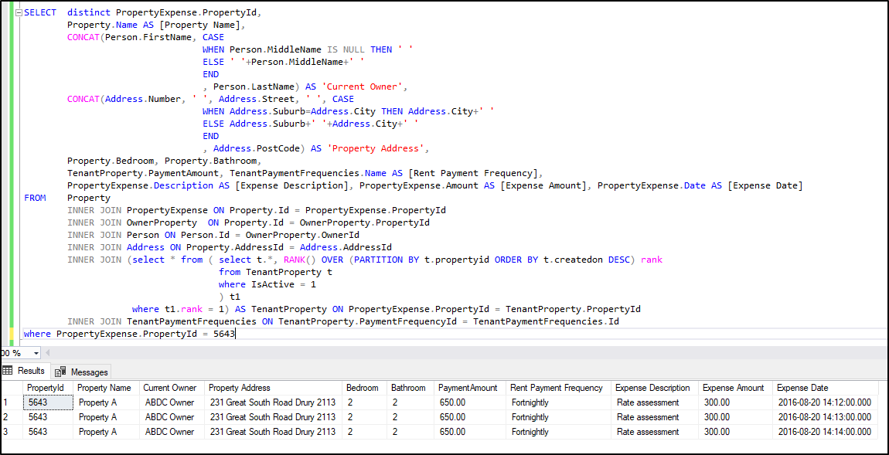

Query –

SELECT distinct PropertyExpense.PropertyId,

Property.Name AS [Property Name],

CONCAT(Person.FirstName, CASE

WHEN Person.MiddleName IS NULL THEN ' '

ELSE ' '+Person.MiddleName+' '

END

, Person.LastName) AS 'Current Owner',

CONCAT(Address.Number, ' ', Address.Street, ' ', CASE

WHEN Address.Suburb=Address.City THEN Address.City+' '

ELSE Address.Suburb+' '+Address.City+' '

END

, Address.PostCode) AS 'Property Address',

Property.Bedroom, Property.Bathroom,

TenantProperty.PaymentAmount, TenantPaymentFrequencies.Name AS [Rent Payment Frequency],

PropertyExpense.Description AS [Expense Description], PropertyExpense.Amount AS [Expense Amount], PropertyExpense.Date AS [Expense Date]

FROM Property

INNER JOIN PropertyExpense ON Property.Id = PropertyExpense.PropertyId

INNER JOIN OwnerProperty ON Property.Id = OwnerProperty.PropertyId

INNER JOIN Person ON Person.Id = OwnerProperty.OwnerId

INNER JOIN Address ON Property.AddressId = Address.AddressId

INNER JOIN (select \* from ( select t.\*, RANK() OVER (PARTITION BY t.propertyid ORDER BY t.createdon DESC) rank

from TenantProperty t

where IsActive = 1

) t1

where t1.rank = 1) AS TenantProperty ON PropertyExpense.PropertyId = TenantProperty.PropertyId

INNER JOIN TenantPaymentFrequencies ON TenantProperty.PaymentFrequencyId = TenantPaymentFrequencies.Id

where PropertyExpense.PropertyId = 5643