TASK 1 – SAP ABAP VIRTUAL INTERNSHIP
Topic: Order to Cash Process – My Analysis
Name: Shashank Vangapalli
Date: 8 October 2026
Document Type: Business Process Analysis and Initial ABAP System Design
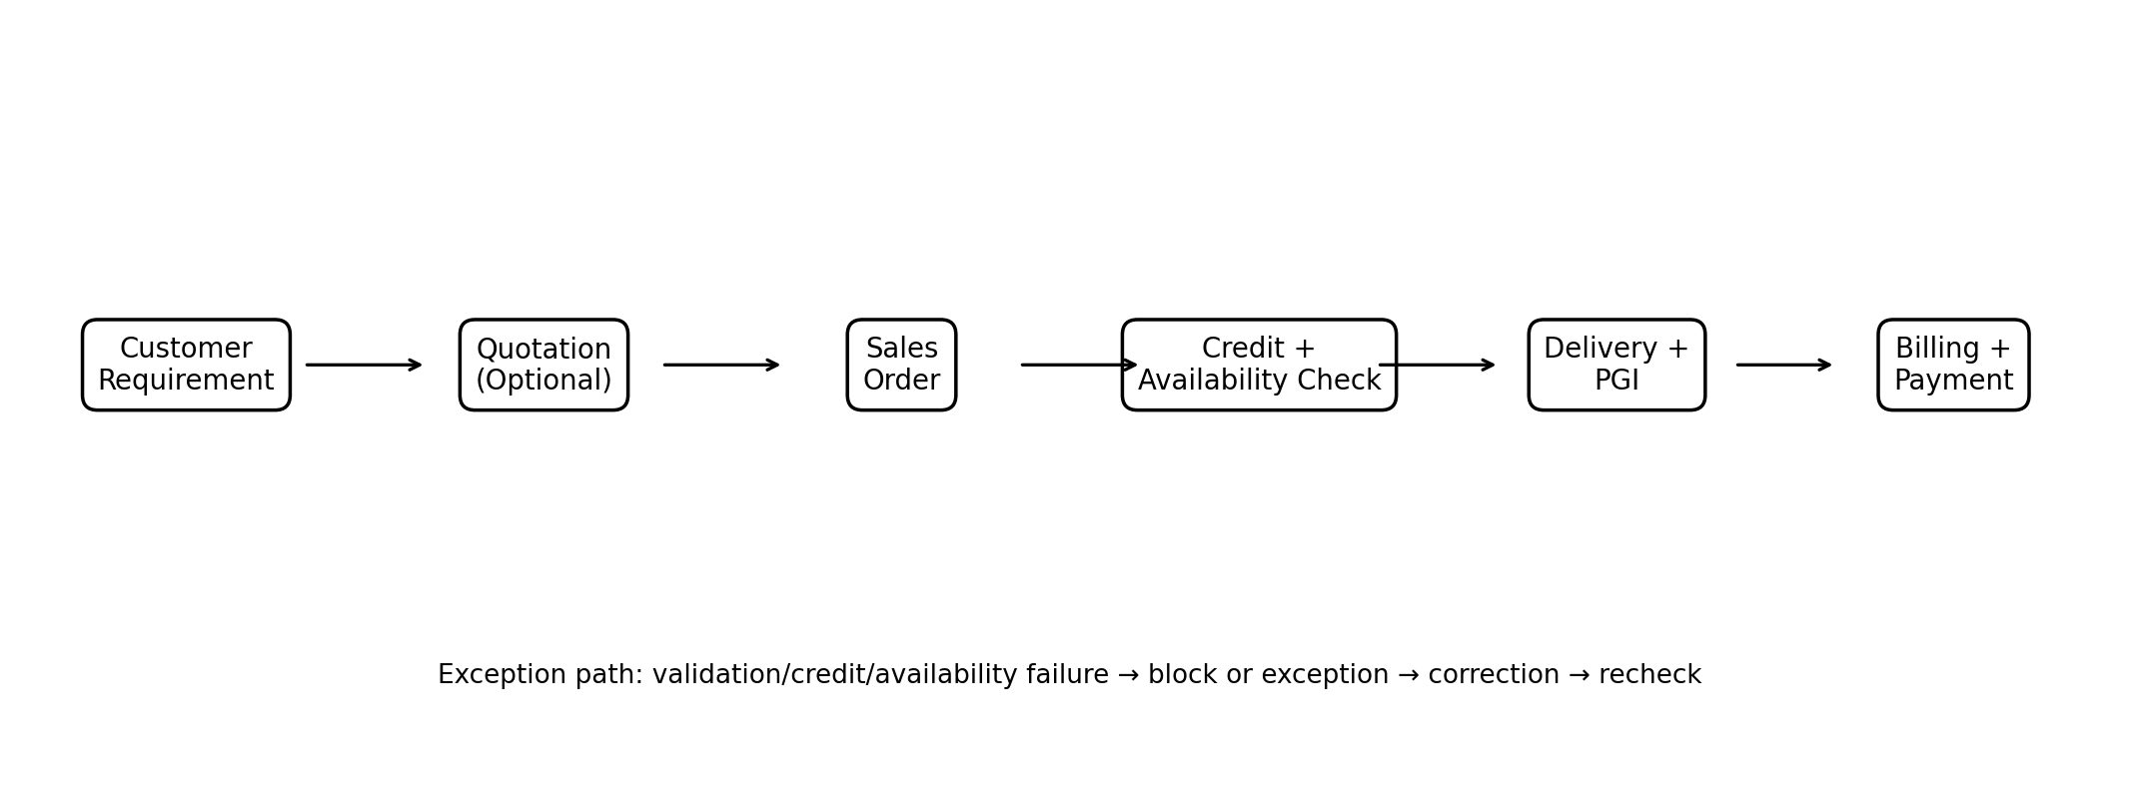
Figure 1. Proposed Order-to-Cash process flow

1. Introduction and Executive Summary
I chose the Order-to-Cash (O2C) process for this task because it is a common end-to-end business process in SAP environments. For this hypothetical requirement-gathering exercise, I considered a small electronics business in Chandanagar, Hyderabad, selling laptops and mobile phones. The business is assumed to use Excel, phone calls and WhatsApp for parts of its order process. Because information is handled manually, the business can face problems such as incorrect order details, unclear stock availability, delayed approvals, and difficulty tracking the status of an order.
The purpose of this document is to think like an ABAP intern during the early stages of a real project. I first describe the business process, then identify the problems, collect functional requirements, and finally propose an initial technical solution. I am not treating this as a production implementation. The ABAP objects described later are proposed design objects that could be developed after the requirements are approved and the target SAP system is confirmed.
The proposed solution focuses on an Order Monitoring and Validation application. The design uses standard SAP business processing where possible and uses custom ABAP mainly for validation, reporting, monitoring and controlled extensions. For an S/4HANA-oriented environment, CDS-based data models can be considered for reusable data access. AMDP is mentioned only as an optional technique for calculations that genuinely benefit from database-side processing; it should not be added just because it is a modern technology.
This document therefore covers the business process, challenges, functional requirements, technical architecture, integration points, ABAP object design, exception handling and testing. The diagrams are included to make the proposed solution easier to understand.

2. Business Process Analysis
The business scenario starts when a customer asks the sales team for a product and price. If a formal quotation is required, the sales team can create a quotation using the relevant SAP sales-process functionality. After the customer accepts the offer, a sales order is created. In a classic SAP SD environment, VA01 is commonly used for sales-order creation. Customer and material information comes from the relevant master-data objects, while sales-order header and item information is represented by SAP's sales-order data model, historically including structures such as VBAK and VBAP.
After the order is created, the system performs the configured business checks. One important check is credit management. The exact mechanism depends on the SAP release and configuration; in modern S/4HANA landscapes, SAP Credit Management/FSCM may be used rather than treating FD32 as the complete automated credit-check process. Another important check is availability. Stock quantity can be stored at storage-location level in data such as MARD, but ATP/availability checking is a business function and should not be reduced to simply reading MARD.
If the order is ready for fulfillment, an outbound delivery is created using the standard delivery process. In a classic SD system, VL01N can be used for delivery creation. The warehouse then performs picking and packing as applicable, followed by Post Goods Issue (PGI). PGI performs the relevant goods-movement processing for the delivery; the custom solution should not directly manipulate standard stock tables.
After fulfillment, billing is created using the standard billing process, for example through VF01 where appropriate. Billing information is represented by the billing document data model, historically including VBRK and VBRP. The customer payment is then handled by the finance process. In a classic FI scenario, F-28 may be used for incoming payment posting, depending on the organization's configuration and process.
The important point for this design is that the custom ABAP solution monitors and supports the process rather than replacing standard SAP SD, MM and FI processing.

3. Challenges I Found
For this hypothetical business, I identified several challenges that the proposed solution should address. The first is credit risk. If customer outstanding amounts and credit exposure are not checked consistently, the business may accept orders that should require review or approval. The second is stock visibility. If sales staff rely on spreadsheets or informal messages, they may promise a product that is not available at the required location. The third is manual data entry. Re-entering customer, product, quantity and price information can introduce mistakes.
The fourth challenge is the lack of a consolidated operational report. The owner or sales manager may want to know which orders are newly created, blocked, ready for delivery, delivered or billed. Without a central view, staff may need to contact other people to obtain this information. The fifth challenge is delay. If approvals are handled through email or WhatsApp, an order can remain pending even though the business information is already available. The sixth challenge is traceability. The business needs to know when an important value was changed and which authorized user performed the change.
The proposed ABAP solution addresses these challenges through validation, status monitoring and controlled reporting. For example, a report can identify orders that have been created but do not yet have the expected downstream document. It can also identify credit or availability exceptions when the relevant SAP process exposes that status.
Two examples show the expected benefit. Example one: a customer requests a laptop, but the configured availability check cannot confirm the requested quantity. The order can be identified as an exception instead of sales staff relying on a spreadsheet. Example two: an order has been created and approved but no delivery has been created. The monitoring report can highlight the order so the sales or warehouse team can investigate.
The goal is therefore not to make every SAP step custom. The goal is to reduce manual monitoring and give users reliable information while allowing standard SAP processing to remain responsible for the actual business transactions.

4. System Architecture Plan
I propose a three-layer architecture for the initial design. The first layer is the Presentation Layer. For the first version, an executable ABAP report can provide a selection screen and ALV output through SAP GUI. A future version could expose appropriately modeled data to a Fiori application. The UI should not contain database-specific business logic.
The second layer is the ABAP Application Layer. This is where validation, status determination and application-specific business rules are organized. A service class can separate business logic from the report. Methods can be used for retrieving order information, validating selection criteria, determining process status and preparing exception messages. Standard SAP APIs or released interfaces should be preferred when the custom solution needs to trigger standard business processing. BAdIs can be considered when an approved enhancement point is genuinely required.

The third layer is the Data and Database Layer. The solution can use ABAP SQL for database access and CDS view entities where a reusable semantic data model is useful. In an S/4HANA environment, the database is SAP HANA, but the custom ABAP code should use supported ABAP data-access mechanisms rather than directly manipulating database tables. Standard business data such as sales orders, deliveries and billing documents should remain under standard SAP application processing.
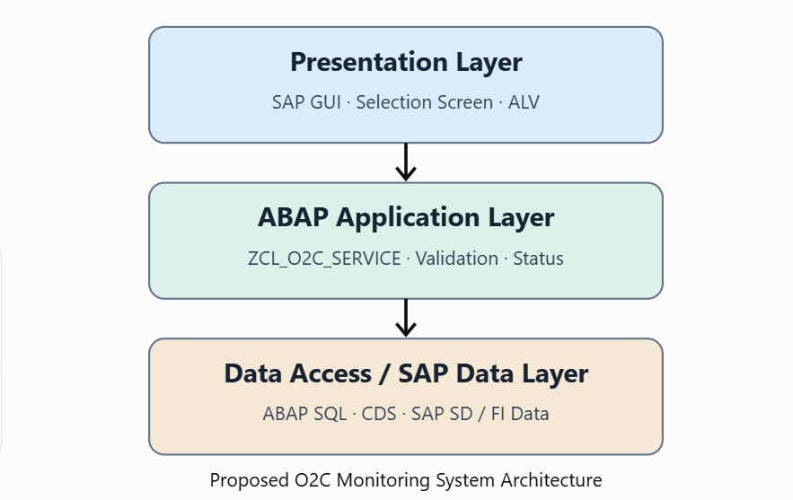
Security is also part of the architecture. Sales users, warehouse users and finance users should receive only the functions and information appropriate to their roles. Authorization checks should be designed according to the target SAP authorization model. The architecture is scalable because the presentation, application logic and data-access responsibilities are separated.
AMDP is not mandatory in this design. It should only be introduced if there is a specific calculation or data-processing requirement that benefits from database-side execution and the target environment supports it appropriately. This avoids using advanced technology without a business reason.

5. Functional Requirements – What the Client Needs

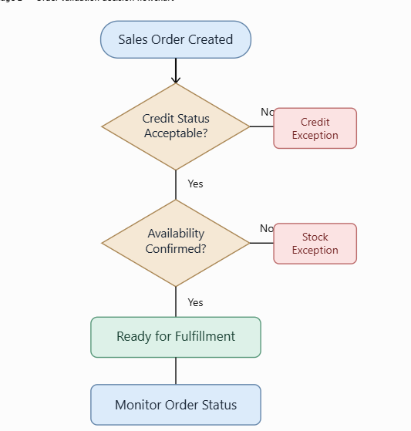

Based on the hypothetical requirement-gathering exercise, the client needs a solution that improves order visibility and reduces manual checking. The first requirement is controlled sales-order processing. Users should be able to capture or monitor order information while mandatory business information is validated. The second requirement is credit-related control. Where credit management is configured, the solution should display or respect the resulting credit status and prevent unauthorized processing of blocked orders.
The third requirement is availability visibility. Users should be able to understand whether the requested quantity can be fulfilled according to the configured availability process. If alternative plant or fulfillment options are part of the business design, those options can be presented to the user rather than being assumed automatically.
The fourth requirement is delivery monitoring. Once an order is ready for fulfillment, users should be able to see whether an outbound delivery exists. The fifth requirement is fulfillment status, including relevant picking/packing and PGI status where available. The sixth requirement is billing status so users can identify whether the expected billing document has been created.
The seventh requirement is an operational dashboard or ALV report showing order status. The eighth is optional bulk-upload support for creating orders from structured files. If bulk creation is required, the design should use an approved API/BAPI or released interface and include validation, error handling and application logs. It should not directly insert into standard SAP tables.
The ninth requirement is customer communication when business documents are completed. The tenth is document attachment for customer purchase orders where the SAP document-management design supports it. The eleventh is change traceability. Standard SAP change documents, application logs or other approved audit mechanisms should be evaluated before creating a completely custom log.
These requirements should be confirmed with real business users before development. In this assignment they are intentionally treated as requirements for a hypothetical client.
ID | Functional Requirement | Priority
FR-01 | Validate and monitor sales-order information | High
FR-02 | Respect configured credit status/blocking | High
FR-03 | Display availability/fulfillment status | High
FR-04 | Monitor delivery and PGI status | High
FR-05 | Monitor billing status | High
FR-06 | Provide order-status dashboard/ALV | High
FR-07 | Optional controlled bulk order upload | Medium
FR-08 | Provide customer communication/event notification | Medium
FR-09 | Support document attachment where configured | Medium
FR-10 | Provide appropriate change/audit traceability | High

6. Technical Details – Initial ABAP Design
The proposed implementation assumes an S/4HANA-compatible ABAP environment, but the exact SAP release and available APIs must be confirmed before development. The first custom program can be named ZPR_O2C_REPORT. It can contain a selection screen using sales order, customer and date-range criteria and can display results using an ALV framework such as CL_SALV_TABLE for a simple report.
A service class such as ZCL_O2C_SERVICE can contain application-specific methods such as GET_ORDER_DATA, VALIDATE_SELECTION, DETERMINE_STATUS and BUILD_EXCEPTION_MESSAGE. Separating these methods from the report makes the solution easier to test and maintain. The data can be represented using a local structure or a DDIC structure such as ZSTR_O2C_STATUS, with an internal table such as GT_O2C_STATUS.
For reusable semantic reporting, CDS view entities can be considered. One view could model sales-order information, while additional views could represent delivery and billing status. The exact sources should be based on the target S/4HANA release and released data models rather than assuming that classic tables are always the preferred interface.
If the application needs to create a sales order programmatically, an appropriate released API or supported BAPI can be evaluated. BAPI_SALESORDER_CREATEFROMDAT2 is a well-known classic interface for sales-order creation in relevant SAP environments, but its suitability must be checked against the target S/4HANA release and development standards. The custom program must handle returned messages and commit/rollback behavior appropriately.
For enhancements, a suitable released BAdI or enhancement point should be selected after confirming the requirement. A classic USEREXIT may exist in older SD implementations, but the design should not automatically choose a user exit when a supported enhancement mechanism is available.
The design also avoids direct UPDATE/INSERT operations against standard SAP application tables. For example, the program should not directly update VBFA, VBAK, stock tables or billing tables. Standard SAP processing, supported APIs and business transactions should create and update standard business data.
An application log or custom Z table may be considered for genuinely custom processing information. If ZT_O2C_LOG is created, it should store only information that standard SAP logging does not already provide.
Illustrative report structure:
REPORT zpr_o2c_report.
SELECT-OPTIONS:
s_vbeln FOR vbak-vbeln,
s_kunnr FOR vbak-kunnr,
s_erdat FOR vbak-erdat.
START-OF-SELECTION.
"Validate selection criteria
"Read required business data using supported ABAP SQL/CDS
"Determine order/delivery/billing status
"Display results using an ALV framework

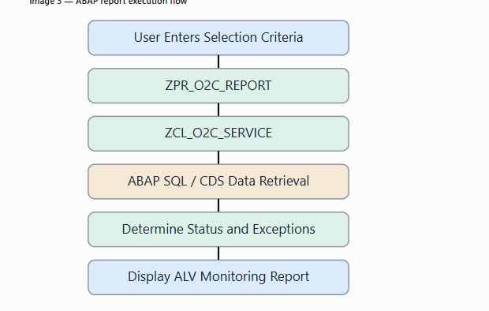

7. Integration Points
The O2C process crosses several SAP business areas, so integration must be described carefully. The first integration is within Sales and Distribution. Sales-order processing creates the commercial document and subsequent delivery and billing processes use the relevant document flow. The custom monitoring solution should read and interpret the standard document relationships; it should not directly update document-flow tables such as VBFA.
The second integration is with inventory and logistics. Availability checking considers the relevant SAP availability and fulfillment logic. Although storage-location stock can be represented in data such as MARD, the custom report should not treat MARD as a replacement for the complete ATP process. During PGI, standard SAP delivery processing performs the relevant goods movement. Movement type 601 is commonly associated with goods issue for outbound delivery, but the custom solution should not simply call a stock-reduction BAPI to imitate PGI.
The third integration is with Finance. When billing is created, the configured SAP billing process can generate the corresponding accounting document. The finance team can then use standard accounting transactions and reports to review customer receivables and incoming payments. The custom ABAP solution should monitor these results rather than directly creating accounting entries unless a separately approved business requirement exists.
A fourth possible integration is external order entry. If an e-commerce website needs to create orders in SAP, the architecture should use an appropriate released API or service interface rather than allowing the website to write directly to SAP tables. In an S/4HANA environment, APIs/OData/RAP-based approaches can be considered according to the target release.

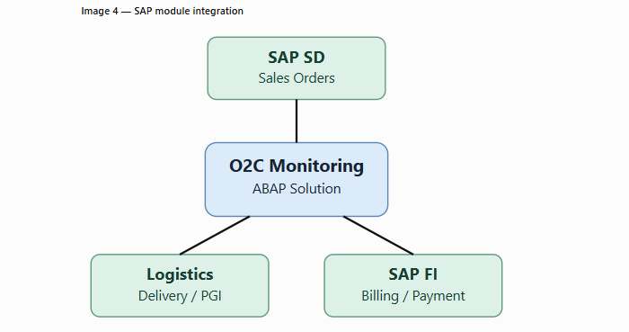
Email notification can be implemented using the organization's approved communication framework; CL_BCS is a classic ABAP option, but the exact approach should follow the system's supported architecture. Invoice printing can use the configured SAP output-management/form technology, such as Adobe Forms where appropriate. Attachments can use the organization's document-management or attachment framework. These integrations should be designed only after the business and system requirements are confirmed

8. Initial ABAP Object Design
The initial object design translates the requirements into possible SAP development objects. The main executable report can be ZPR_O2C_REPORT. Its responsibility is to collect selection criteria, call the application logic and present the result. It should not contain all business logic in one large program.
The main service class can be ZCL_O2C_SERVICE. Possible methods are GET_ORDER_DATA, VALIDATE_SELECTION, DETERMINE_STATUS and BUILD_EXCEPTION_MESSAGE. A separate data-access class could be introduced if the project becomes larger. The purpose of this separation is to make the code easier to understand and unit test.
For reporting, CDS view entities such as ZCDS_SO_STATUS or similar names can be designed according to the organization's naming standard. The exact CDS definitions should use released and appropriate data sources for the target S/4HANA system. An AMDP class such as ZCL_AMDP_O2C is optional rather than mandatory. It should only be created if a real performance-sensitive database calculation justifies it.
A custom table such as ZT_O2C_LOG can be considered for custom application events that are not already covered by standard SAP logs or change documents. Typical fields could include document number, process step, status, timestamp, user and message. However, the project should first check whether standard application logging is sufficient.
The development package can be ZO2C_PACKAGE, subject to the organization's namespace and naming standards. Authorization should be designed using the existing SAP role and authorization framework rather than assuming that a custom role alone provides security. Unit-test classes should be created for reusable application logic.
The overall flow is: report → service logic → supported data-access/API layer → standard SAP business process → result/status → ALV output. This keeps the custom solution focused on the actual requirement and avoids unnecessary modification of standard SAP data.
Object Type | Proposed Object | Purpose
Executable Report | ZPR_O2C_REPORT | Selection screen and monitoring output
Service Class | ZCL_O2C_SERVICE | Business/application logic
CDS View Entity | ZCDS_SO_STATUS | Reusable sales-order status model
CDS View Entity | ZCDS_DEL_STATUS | Reusable delivery status model
Optional AMDP Class | ZCL_AMDP_O2C | Only for justified DB-side calculations
Custom Table | ZT_O2C_LOG | Custom application events if standard logging is insufficient
Package | ZO2C_PACKAGE | Development object organization

9. Conclusion
To conclude, this task helped me understand how an ABAP developer can approach a business requirement before starting development. I selected a hypothetical Order-to-Cash scenario and analyzed the process from customer requirement through sales order, credit and availability checks, delivery, goods issue, billing and payment. I then identified common business problems such as manual entry, unclear stock visibility, credit risk, delayed processing and lack of a consolidated status report.
The proposed solution is an initial design rather than a complete production implementation. The main custom component is an order-monitoring and validation report supported by reusable ABAP application logic. Standard SAP functionality remains responsible for the actual creation and processing of sales orders, deliveries, goods movements, billing and financial postings. This is important because custom ABAP should extend or monitor standard SAP processes rather than directly manipulate standard application tables.
The technical design introduces concepts such as ABAP SQL, internal tables, ALV reporting, CDS view entities, service classes, supported APIs and authorization checks. AMDP is included only as an optional technique for a justified performance requirement. The design also considers integration with SD, logistics and FI, while avoiding direct updates to standard tables such as VBAK, VBFA, stock tables or billing tables.
In the next phase, the requirements would be reviewed with actual business users, the target SAP release would be confirmed, appropriate released APIs and data models would be selected, and the proposed objects would be developed and tested. This approach reflects the normal progression from requirement gathering to functional design, technical design, development, testing and deployment. The exercise therefore gave me practical understanding of how an ABAP solution can be designed around a real business process.

References / Research Sources
- SAP Help Portal – Sales and Distribution / Order-to-Cash documentation
- SAP Help Portal – ABAP SQL and Open SQL documentation
- SAP Help Portal – ABAP CDS documentation
- SAP Help Portal – ABAP classes, internal tables and ALV-related documentation
- SAP Help Portal – SAP S/4HANA extensibility and released API guidance
- SAP Community – General discussions and examples related to SAP SD and O2C

Important Scope Note
This document describes a hypothetical business scenario for an internship design exercise. Statements about business interviews, actual implementation, or production configuration should not be interpreted as completed activities. The proposed technical objects and interfaces are design suggestions and must be validated against the actual SAP release, configuration, released APIs, authorization model and project standards before development.

